

Entrepreneurial Perspectives (LCDB7001_LON)

How entrepreneurship skills influence the growth of the firm? A case of retail business organisation in the UK.

Student name: Hemanta pun
Student ID: 1810795

Module Leader: Dr. Gladius Kulothungan
Date: 5thsptember 2019
Table of content: pg no.
1.0 Background and context…………………………………………………3-5
2.0 Aims and Objectives……………………………………………………...5
2.1 Objective…………………………………………………………...……………5

2.2 Research Questions…..................................................................................5-6

3.0 Literature review………………………………………………….………6
3.1 Concept of entrepreneurship………………………………………...………..6-7
3.2 Skills for entrepreneurs……………………………………..……..…………..7-9
4.0 Overview of SME’s in the UK…………………………………………..9-10
5.0 Model of the entrepreneurship process………………………………10
5.1 The opportunity Factor……………………………………….……………….11
5.2 The Resources Factor………………………………………..………..…11
5.3 The Team Factor……………………………………………….…………11
6.0 Theories of entrepreneurship………………………………..…………12
6.1 Classical Theory………………………………………………………………12
6.2 Noe- classical Theory………………………………….…………………12
7.0 Research Methodology…………………………………...……………12-14
8.0 Literature review………………………………………...………………14-15
9.0 Skills required for managing SME’s in the UK ……..………………15-17
10.0 Access of data sources for the investigation……………………….17
10.1 Google Scholar………………………………………………........…………17
10.2 ProQuest entrepreneurship database ………………………………17
11.0 Conclusion ……………………………………………………………17
References
Appendix

1.0 Background and context:
Small businesses are essential for economic growth, individual personality development and offering opportunities for labours. In developing nations, fundamental barriers to economic development are the scarcity of workers, capital or land. This scarcity can control dynamic entrepreneurs that have a mechanism to bring in the market and facilitate economic growth. Entrepreneurial activity and skills also play a vital role to bring high propensity in the market. Rae (2012) stated that entrepreneurship is defined as the main pillars of economic growth, while small scale business has a high intensity to bring changes at the social and economic level. Economic development depends on the entrepreneurship activities in the region proposed by local bodies or central government authorities. Entrepreneurs are born commonly prevalent myth in society, but they are created. Hence it is well understood that entrepreneurs are created using a diverse range of training and nurturing them with appropriate interventions. These programs are intended to develop critical skills and abilities needed to be successful entrepreneurs. Lichtenstein and Lyons (2001) proposed that entrepreneurship training and education is a knowledge-based investment in human capital for achieving sustainable economic development and growth. Kutzhanova, Lyons and Lichtenstein (2009) addressed that firms’ competitive and sustainable advantage stems from its entrepreneurial capabilities, management abilities and technical knowledge and higher adoption power of changing the business environment. Verheul et al. (2011) admitted that the importance of entrepreneurship skills and abilities is significant for the survival of the business and its sustained growth. Orisanaye (2004) stated that in developing nations, the government had conducted programs and activities to enhance knowledge, skills and abilities and behaviour of an individual.
Scase (2000) defined skills as a practical action or an ability to perform in certain ways to achieve some specific objectives. Everyone has some hidden skills, but the exploration of these skills is associated with adequate training and development educational programs. Powers and abilities enforce individual to take actions in a manner that it leads something innovative in business areas. Through education and training program, individuals acquire some knowledge which helps them to achieve to attain business objectives. Entrepreneurship skills are developed with changing business circumstances and offering practical experience through pilot projects. Kelley, Bosma and Amorós (2010) argued that situations play a significant role to make entrepreneurs, and only a few of them are guided to move in those areas. Iyer and Doucette (2003) proposed that famous entrepreneurs in the world are the outcomes of their situations and circumstances; they are not intended to be an entrepreneur in their life.
Various countries are facing challenges to initiate entrepreneurship in the world. Encouraging entrepreneurship became a prominent goal of various nations because the importance of entrepreneurship and its integration with economic growth has been highlighted by several researchers (Bruyat and Julien, 2001). It has been identified that education and training help to cultivate skills among people which helps to grow business. Henry, Hill and Leitch (2003) presented that the aims of training and entrepreneurship education are to bring entrepreneurship capacity and mindsets among people who directly influence economic development and creativity.
At the global level, governments are taking positive steps to increase the entrepreneurship environment because new businesses have a direct impact on employment levels. Entrepreneurship has a direct benefit to society and economic growth, and it offers the advantage to fulfil individual requirements irrespective to age, race, class, gender, and sexual orientation. Kelley, BosmaandAmorós (2010) stated that analysing the relationship between economic growth and entrepreneurship is quite complicated and complicated, while many of the agencies and policies vary with country to country. Haynie et al. (2010) believed that only a few organisations are increasingly generating jobs and individual fulfilment while small scale enterprises do not have much attention to improving economic position in the economy. The primary concern of this research proposal is to identify the entrepreneurship skills that are essential for business growth in the retail industry.
Davidsson, Delmar and Wiklund (2006) most of the retail business supermarket chains are developed from family-owned small business which shows that family environment is a significant driver to develop entrepreneurship skills among people. Small businesses are vital for economic development and generally considered where less than 100 employees are working. Freitas and von Tunzelmann (2008) revealed that more than 85% of jobs are created in the UK by small scale business in the retail industry.

2.0 Aims and Objectives:
This study is aiming to analyse the influence of entrepreneurship skills and abilities on business growth. Business is continuously manager after founder exists and how it lead competitive advantage are complex to understand. This study will emphasise over core skills and abilities needed to grow business and achieve competitive positions in the industry.
2.1 Objectives:
- To understand the role of entrepreneurship skills and abilities in business growth
- To analyse the barriers and constraints in business growth
- To recognise the set of skills need to achieve competitive business advantage.
- To develop the relation between entrepreneurship skills and business growth in the retail industry
2.2 Research questions:
- What is the role of entrepreneurship skills and abilities in business success?
- What are the significant barriers that restrict business to grow in the retail industry?
- What are the various skills needed to achieve a competitive business advantage in the retail industry?
- What is the relation between entrepreneurship skills and business growth in the retail industry?
In a competitive business environment, entrepreneurs are considered as national assets to bring change in economic growth and their abilities and skills are significantly essential to build a cohesive environment. Aims and objective of the research proposal are an indispensable requirement which guides for developing the study. Aims and objective give an idea to choose appropriate tools and techniques for conducting the survey. Proper development of the targets and purpose is the primary responsibility of the researcher; thus researcher has to frame the research topic properly.
The research aim is defined as a lengthy statement which comprises core theme of the study and shows researcher intention, and it directly integrates with the expected outcomes that’s why it is an essential component of the study. Primary aims of this study are to identify the critical skills needed to be an entrepreneur and how these skills lead business growth in small scale business. The retail industry is one of the highest growing industries in the world, and small entrepreneurs are learning from the environment to improve their business. Haynie et al. (2010) stated that government initiative for developing entrepreneurship environment is found in a few nations, but entrepreneurs are taking the support of small credit companies to establish their own business. They are facing challenges and trouble to achieve the expected outcomes from business lack of sufficient entrepreneurship skills. Research aims and objective are the primary blocks to determine the scope, conceptual requirement and direction to develop a proposal and further study. Goals and objectives of the project answer the questions which generally come after reading the research title.

3.0 Literature review:
The proposal is based on various concepts and theories that are undertaken here for understanding the core theme of the research. Entrepreneurs’ skills are essential and how these skills are interlinked with business growth is the primary consideration of this proposal. Primarily, significant theories of entrepreneurship have been discussed, such as the rational choice theory, interpretative theory and some model of entrepreneurship process have been discussed here. These are some major theories that are widely accepted at entrepreneurs’ level.

3.1 Concept of entrepreneurship:
Entrepreneurship word is rooted in the Latin phrase pretender and apprehension. Entrepreneurship is a well known defined system for an individual or collectives which is intended to accomplish some specific goal. Entrepreneurs are curious to develop advance from ideas so that the new venture can be created. There is another thing which is applied entrepreneurship, which emphasise on innovation. Innovative is associated with risk and proactive about its competitors. Entrepreneurship is essential to growing the economy and sustainable business environment, which leads to sound living standard in society.
Entrepreneurial skill is a collection of technical, management and personal skills which are used at a different level to manage situations. There is no clear established set of skills, but as much as entrepreneurs learn to manage the business, they involved in skill set (Haynie et al., 2010). These skills have a direct impact on economic, personal and social lives. More than 2.3 million business houses were started in the EU and several jobs (30.6 million) created for people in 2012. However, people interest to be an entrepreneur is declining in the current era in Europe in comparison to other international competitors. Many EU-28 countries have taken dynamic steps to attract individual towards business and boosting their knowledge by offering informative programs and free training session. These programs are more explicitly within the education curriculum so that young people can give their support to develop an entrepreneurship environment in the economy (European Commission, 2013).

3.2 Skills for entrepreneurs:
Entrepreneurship is ‘an individual’s ability and power to transform the ideas and thought into actions so that new venture can be created and develop jobs, products or services to lead competitive business advantage. Entrepreneurship skills are the set of creativity, innovation and risk-taking abilities, which helps entrepreneurs to take some vital decision related to business. Entrepreneurs also can plan and manage projects to achieve some specific objectives (Haynie et al., 2010). Entrepreneurship skills play an essential role in expressing innovation, growth and competitive advantage. Entrepreneurial spirit helps the individual to develop new business enterprise and lead sustainability in business success. However, entrepreneurship skills also integrated with several benefits in that business. These skills not only useful in creating change in the industry but also in personal life for creativity, initiative, tenacity, teamwork, and overall understanding of the responsibility.

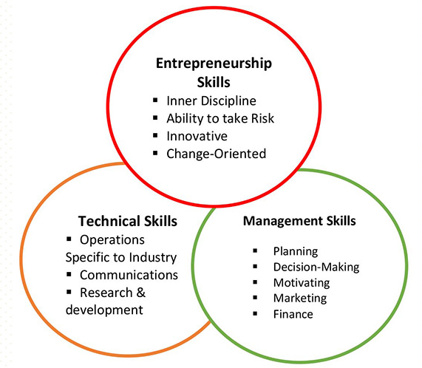
Figure 1- Skills for entrepreneurs Source- (Coon, 2004)

It has been mentioned by Barringer, Jones and Neubaum (2005) that entrepreneurship skills are associated with the psychological state of an individual. People have the patience to better their continuous efforts and show their optimistic approach. Inner discipline is essential among entrepreneurs, which assist them in showing his beauty of personality in front of followers.
Risk-taking ability is essential among entrepreneurs. Risk is defined as the possibility of failure or loss or another adverse effect to take any specific actions. Risk cannot be separated from the entrepreneurship process because of every step and decision at entrepreneurship level associated with risk. Risk has a direct impact on entrepreneurs’ behaviour because many of the people do not take the risk to be an entrepreneur and lost the chance to be a successful businessman.
An entrepreneur should be innovative to develop new ideas and implementing it for better performance in the organisation. Innovation and creativity lead success and competitive business advantage. Whole entrepreneurship process revolved around new ideas and exploration of new thoughts (Haynie et al., 2010). Entrepreneur gives the feasible idea and innovative practices in business to fight against competition. Innovativeness allows the entrepreneur to think novel ways for developing the quality of product and services.
Change and turmoil is a nature of the business; customer demand is frequently changing day by day and managing their order. Entrepreneurs have to adapt changes accordingly so that business can be sustained for the long run.
Barringer, JonesandNeubaum (2005) pointed out that entrepreneur adaptability is one of the practical skills which enable them to offer innovative product and services in the market to fulfil the advance need of customers. The versatility of the technology, norms and new policies to make business compatible with the environment is essential in the current period.
Only entrepreneurship skills among good entrepreneurs are not sufficient, but they must have managerial skills and technical skills to understand the changing world business environment. Advancement in technology and management aspects is natural in business; hence, knowledge of these areas is essential to lead new ideas and policies in the industry.

4.0 Overview of SMEs in the UK:
UK SME enterprises are growing with rapid rate since last year due to increased opportunity for growth by making less investment in the business. There are 5.7million SME enterprises in the UK since 2018, which is accounted as 99.9% of the overall private business sector. These business enterprises are giving jobs for 60% people of all private-sector employees in the UK. Total 16.3 million people are working in these enterprises in the UK. SME contribution is significantly considerable in UK economic growth every year. Instead of various challenges in the SME industry, increasing population in the UK is thankful for growing large numbers of SME in the UK (Merchant savvy, 2019).
Interestingly, the highest birth rate is among sole enterprises with no employees (See appendix). There is a direct relation between growing enterprises and increasing people attention towards business studies; they are gaining abilities and skills to develop small and medium enterprises (Sanga, Kasubi and Kisumbe, 2014). Governments offering low credits, which are necessary for starting a business but still people, are unable to access all these facilities due to schemes ineffectiveness. Growing numbers of SME are struggling for finance and switching towards alternative finance options like as crowdfunding and business angels to attract the investment they need to build.

5.0 Model of the entrepreneurship process:
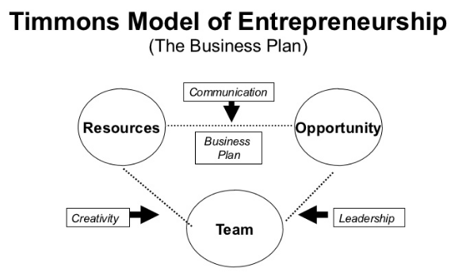
Figure 2- Timmons model of entrepreneurship Source- (Blank, 2009)

This model comprises three significant factors of entrepreneurship process like as teams, opportunities and resources for developing successful entrepreneurs. Success in business depends on the balance among these three factors in entrepreneurs.
Entrepreneurs search for an opportunity and shape opportunity in high potential ventures by developing a team and collecting required resources so that new venture can be started successfully. Higher risk potential engaged with entrepreneurship process because they have the risk of their career, investment risk and profit/loss in business. Process of entrepreneurs starts from opportunity, not money, not the team and not from any business strategy. Genuinely, the opportunity is most important than talent, capacity and the resources available. The business plan gives language to communicate among these three factors.

5.1 The Opportunity Factor:
Timmons model believes that business plan, strategy and money are not the primary initiators of any business but successful entrepreneurship process is based on the grabbing of the right opportunity. Opportunities have a higher significance which provides a place to apply the talent and capacity by the team because success involves in identifying the right opportunity for business. A great idea does not behind a successful business in every situation until favourable chance to support it. A divine purpose is observed in the opportunity to position the product and services to add value in customers’ needs.
5.2 The Resources Factor:
The model believes that available resources can reduce the risk of starting a new business and boost up the minimal requirement as a way to achieve competitive business advantage. Significant advantages of the resources factor are:
- Minimisation of market cost
- Involving discipline and leanness in business culture.
- Developing creative resources with less amount of money and other resources available.
Entrepreneurs’ primary objective is to ‘minimise and control’ not to ‘maximise and own’. Entrepreneurs manage resources includes building a useful resource base and drawing up a proper business plan through a “fit and balance” method that used to balance the existing resources team and potential opportunity.
5.3 The Team Factor:
Placing the right people and recognising the opportunity and arranging resources is also essential to develop a successful business venture. Size of the team should be contingent on the size of business opportunity. As per this model, a good squad leads to great business success and vice versa. A good team has the power to open the door of potential by identifying opportunity and handle the pressure of competition and growth. The primary role of the group is:
- Applying creativity to remove the uncertainty and doubt of existing opportunity.
- Offering pleasant leadership environment to manage the existing resources.

6.0 Theories of entrepreneurship:
Several theories of entrepreneurship like the sociological theory of entrepreneurship, a psychological theory of entrepreneurship, economic entrepreneurship theory and some other. Here the economic theory of entrepreneurship has been discussed to understand how this theory help to bring entrepreneurship environment in the economy.

6.1 Classical Theory:
The classical theory concerned on free trade, specialisation, and competition. Economic theories of entrepreneurs have been developed by Richard (1817) and Smith (1776). Britain’s industrial revolution is mainly caused by developing an economical approach of entrepreneurship which started in 1700 and ended by the 1830s. These theories described the directing role of entrepreneurs in the supply chain and production operation in a competitive business environment (Coon, 2004). Classical theorists believed that three modes of production are land, capital and labour. The dynamic disturbance generates by entrepreneurs at the initial stages have been avoided by this theory (Cromie, 2000).

6.2 Neo-classical Theory:
This model of neo-classical has come into existence due to the criticisms of the classical model and indicated that economic model concerned on the pure exchange, reflect an optimal ratio, and has been inspired by the economic system which has been closed. Exchange of participant, event of exchange and influence of the exchange are mainly concerned in this economic system. Importance of exchange is the primary consideration of these theories, and it diminished marginal utility by creating the impetus for entrepreneurship (Clausen, 2006).
Criticism also placed against these theories are aggregate demand ignores the individual activities, and no future value of innovation die to exchange can be accounted for as outcomes.

7.0 Research methodology:
That is the first data-based study which is effectively concerning over-analysing the influence of entrepreneurship skills on business growth. The current period, most of the enterprises are not top in the industry due to some distinctive factors and talent they have to manage the existing resources. These talented employees are the leaders and have the potential to apply their skills for achieving the set target in business. Primary data will be collected from 25 entrepreneurs of SME in the UK to analyse how skills are essential to lead success in business.
The research method is an integral part of the study, which comprises knowledge about the tools and techniques used at different stages in research (Stentz, Plano Clark and Matkin, 2012). The main objective of choosing a specific machine is to answer the particular research questions and to solve the research problems. This research study is concerning the analysis of entrepreneurship skills to influence business growth. Quantitative data collection method has been chosen in this study under the mono research strategy. This research method is easy to collect data from respondents using numerical (coded) value, which can quickly process for data analysis. Quantitative data is pure to manage and less expensive to develop the study. For the collection of primary data, the survey-questionnaire method will be used using closed-ended questions.
Williams & May (2000) stated that research philosophy is another crucial aspect of study which concerns with the nature of the sources and creation of knowledge about the research undertaking concepts. Research philosophy is a way by which data collected, analysed and interpret for outcomes. Positivism research philosophy will be used in this study to understand the entrepreneur's mindset while selecting the specific quantitative value (Novikov and Novikov, 2013).
Yin and Davis (2007) stated that positivism research philosophy is based on quantifiable observations that can be analysed using statistical or mathematical tools. Following the empiricist view, knowledge exists among human experiences. This study is independent of human intervention or does not entertain human interest within the study. Tuli (2011) argued that the positivist research approach generally integrates with deductive research approach to use the concept and developing specific views on the elements or situations (Wahyuni, 2012). Data gathering is an essential aspect of any study because it associated with various unethical issues that generally observed in the research world.
The population of this research study would be the small scale entrepreneurs in the UK those are started SME businesses (Scotland, 2012). These all have some skills that are required to influence business growth or leading long term business sustainability. Non-random sampling techniques would be used to select entrepreneurs from UK and sample size for this study would be 25. Entrepreneurs started their business since the last five years are preferred because their skills are more valuable to influence business growth.
Data analysis is a significant part of the study because it concerned with developing outcomes to resolve the existing problems and answering the framed questions (Teddlie and Tashakkori, 2011). In this study, statistical data analysis method would be used, which will code collected data and analyse through SPSS software. Presentation of collected data would stimulate using tables and graph which are easy tools to understand the outcomes of the study (Saunders, Lewis and Thornhill, 2012).

8.0 Literature gap:

Definition of entrepreneurship process and its varying perspectives Entrepreneurship is defined as a process of creating a scalable business venture which used to achieve such specific objective and goal by filling the gap of customers’ demand. Although the significant theory of modern entrepreneurship believes that business is an independent venture set up by an individual or a group of likeminded peoples. Generally, businesses are developed for individuals. Entrepreneurship is relatively clouded in limited scope in the previous era, but modern business perspective comprises idea, thoughts and any opportunity that create change for fulfilling individual or groups’ requirement. Entrepreneurs have limited skills that are regarded as developing new ideas and creative thinking to improve some product or services that satisfy the social needs, but now business is involved in nature. Entrepreneurs have to understand the requirement of suppliers, stakeholders and customers, which needs a diverse range of skills to maintain their interest in the business. In the modern era, entrepreneurs must have managerial skills, technical knowledge, market understanding, and analysing the social environment. The diverse range of skills are introduced by various educational institutions to encourage an entrepreneurial ecosystem in the economy still development of skills is never-ending. Entrepreneurs have to manage good relationships with stakeholders, and he should know about finance and accounting.
In the modern era of business, the need of consumers, employees and stakeholders are changing and fulfilling their obligations; entrepreneurs have to learn various new skills that balance among different business aspects. The current business scenario is different from the last five decades ago due to the global trade environment, engagement of government control and public interest in the business. Government making consumer aware of new business models and they are highly useful to be an entrepreneur but gap observed in their skills and capabilities which are an essential part of businessman. Being a success in business not only depends on idea generation or findings good business model but opportunity and team of talented members and cost-effective resources are essential to set up a new business venture.

9.0 Skills required for managing SME in the UK:
The UK is considered a place where more than 4.9 million small businesses are initiated in recent years, which are employing more than 15 million people cumulatively generating a turnover of £1.6 trillion. These businesses are fulfilling consumer demand in a diverse range of areas. In the small scale industry, where less than 250 (0-249) employees are working considered under SMEs. SME in the UK makeup 99.8% of all London’s private sector businesses and have provided an excellent opportunity for people to serve in this industry, and it reported 49.8% of all London employment (2.3 million) till 2012. SMEs are highly growing business enterprises in the UK and made 47.7% of business turnover (excluding financial & insurance industry), which is accounted as to £430 billion.
In last four to five-decade ago, leadership and management are two well-known concepts for strategic management or entrepreneurship, but it became common for all executives because increased job responsibility make every employee as managers and leaders except labour. Managing resources, human capital, building relationships with suppliers, customers and stakeholders are becoming more sophisticated, which need more skills and capabilities to balance business aspects.
Business complexity created change in entrepreneurship skills and abilities to handle a diverse range of business functions and taking the right decision at a different level. Entrepreneurs have to understand

Entrepreneurial characteristics and the importance of entrepreneurial mindsets
The highly competitive nature of the modern business environment has compelled individuals engaging in an entrepreneurial venture to possess certain traits and qualities with regards to scaling and growing the investment significantly. The primary among them is the ability to think based on a high cognitive competency along with the ability to make decisions with a specific foresight and resilience. Independent ventures, especially in developing economies like Bangladesh, go through a significant period of struggle due to the low levels of consumer confidence. As argued by Terjesen, Hessels and Li (2016), this requires the individuals behind the venture to be highly self-motivated and possess the ability to take risks in the most calculated manner possible. Networking and communication are other highly integral parts when considering the overall entrepreneurial mindset.
The global nature of the modern business environment has created a system whereby organisations and economies alike are interlinked to a large extent, whether it is in terms of resource and knowledge transfer or the availability and accessibility of labour and workforce. As mentioned by McKelvey and Lassen (2018), flexibility and adaptability are other critical components with regards to developing an entrepreneurial mindset, as new ventures inherently require a high degree of flexibility to accommodate the dynamic nature of consumer trends and preferences. Any form of rigidity within the managerial structures or the business decision can significantly hider the flow of operations within the venture and influence it negatively in an internalised manner.
Management and proper allocation of resources are also highly relevant, as the availability is a serious issue when considering entrepreneurial ventures in developing nations like that of Bangladesh. Majority of the conventional markets are either saturated or dominated by significant multinationals, against which smaller establishments would find it increasingly difficult to compete against each other. That further progresses the argument with regards to the ability to innovate and foresee the utility of a product in the future context. Most successful organisations that started as entrepreneurial ventures have established themselves based on their ability to solve a distinct societal gap or need. The products or the services offered by these successful ventures have gone on to bridge these gaps to a large extent, and this has been the critical factor when considering the rise and growth of SME’s in a global perspective (Gedik, MimanandKesici, 2015).

10.0 Access of data sources for the investigation:
To develop knowledge about the entrepreneurship and their skills, various data sources have been accessed. Online and library sources are most useful to support this study. This research has compared multiple sources of data and described some valuable data sources in brief.
10.1 Google Scholar: This is great sources for accessing data online, which comprises journals, articles and online books. Google Scholar also has scan-shot of various studies that used as facts in the research study. This Google search engine has multiple options to search for data as per the manual time frame and using some specific. This online search engine gives customised services by setting options and using different terms in the search option.
10.2 ProQuest entrepreneurship database: This database allows users to access various theories and models which are useful in entrepreneurship. This source has a wide range of data from world universities and publishing houses which help users to access different terms and concept.

11.0 Conclusion:
Changing customer need forcing management to serve with innovative and distinctive way. Entrepreneurs need various skills to start the business and running it smoothly. The active entrepreneur has a diverse range of skills to influence management and handle business situations. The right decision, effective communication and risk-taking abilities are the essential skills among entrepreneurs to grab the opportunity in the competitive business world. The complex business environment needs various kinds of skills to handle business issues. The study is based on entrepreneurship skills and its impact on business growth, and it has been observed in the literature that skills positively influence business growth and success.

References:

Barringer, B.R., Jones, F.F. andNeubaum, D.O. (2005). A Quantitative Content Analysis of the Characteristics of Rapid-Growth Firms and their Founders. ELSEVIER, Science Direct.Journal of Business Venturing, Vol. 20, pp 663–687.
Blank, S. (2009). Timmons Model of Entrepreneurship (The Customer Development Class 1 And 2. Slideshare, September 6. (Online) Available at: https://www.slideshare.net/sblank/090409-class-1-and-2/36-Timmons_Model_of_Entrepreneurship_The[Accessed: 3 September 2019].
Bruyat, C. and Julien, P.A. (2000). Defining the Field of Research in Entrepreneurship. ELSEVIER Science Inc.Journal of Business Venturing, Vol 16(2), pp 165-180.
Clausen, T.H. (2006), “Who identifies and Exploits entrepreneurial opportunities”, Centre for Technology, Innovation and Culture. The University of Oslo.
Coon, D. (2004). Introduction to Psychology, 9th ed. Minneapolis: West Publishing Company.
Cromie, S. (2000). “Assessing entrepreneurial inclination: Some approaches empirical evidence" — European Journal of Work and Organizational Psychology, Vol. 9(1), pp.7-30.
Davidsson, P., Delmar, F. and Wiklund, J. (2006). Entrepreneurship as Growth: Growth as Entrepreneurship In ‘Entrepreneurship and the Growth of Firms’. Edward Elgar Publishing, United Kingdom, England, Cheltenham, pp. 21-38
European Commission (2012).Rethinking education: Investing in skills for better socio-economic outcomes (COM) 2012 669 Final. International Cooperation and development.
European Commission (2013). Communication from the commission to the European Parliament, The Council, The European Economic and Social Committee and the committee of the regions.Entrepreneurship 2020 action plan: Reigniting the entrepreneurial spirit In Europe, (COM) 2012 795 final.
Freitas, B., Isabel, M. and Von Tunzelmann, N. (2008). Mapping Public Support for Innovation: A Comparison of Policy Alignment in the UK and France. ELSEVIER. Research Policy, Vol. 37(9), pp 1446–1464.
Haynie, J. M., Shepherd, D. A., Mosakowski, E. and Earley, P. C. (2010). A Situated Metacognitive Model of the Entrepreneurial Mindset. ELSEVIER, Science Direct. Journal of Business Venturing, Vol. 25, pp 217–29.
Henry, C., Hill, F. and Leitch, C. (2003).Entrepreneurship Education and Training: The Issue of Effectiveness. Ashgate,
Iyer, S. and Doucette, W.R. (2003). The influence of environmental attributes on the relationship between entrepreneurial orientation and performance in independent community pharmacies. Journal of Pharmacy Marketing and Management, Vol.15 (2), pp.25-46.
Kelley, D.J., Bosma, N. andAmorós, J. E. (2010).Global Entrepreneurship Monitor: 2010 Global Report. Babson College, Wellesley, MA.
Kutzhanova, N., Lyons, T.S. and Lichtenstein, G.A. (2009). Skill-Based Development of Entrepreneurs and the Role of Personal and Peer Group Coaching in Enterprise Development.Economic Development Quarterly, Vol. 20(10), pp.1-18.
Lichtenstein, G.A. and Lyons, T.S. (2001). The Entrepreneurial Development System: Transforming Business Talent and Community Economies. Economic Development Quarterly, Vol. 15, pp 3-20.
Merchant Savvy (2019). UK SME Data, Stats & Charts. (Online) Available at: https://www.merchantsavvy.co.uk/uk-sme-data-stats-charts/
[Accessed: 2 September 2019].

Novikov, A.M. and Novikov, D.A. (2013). “Research Methodology: From Philosophy of Science to Research Design”. CRC Press.
Rae, D. (2012). Enterprise & Entrepreneurship Education: The New Curriculum Guidelines in Ireland and the UK – ISBE Conference. Dublin, November 6.
Sanga, D., Kasubi, J. andKisumbe, L. (2014). A Challenge of Business Record-Keeping for Tanzania Small and Medium Enterprises (SMEs): A Case of Madukani Ward Dodoma Region. European Journal of Business and Management; Vol.6 (38), pp.82-87.
Saunders, M., Lewis, P. and Thornhill, A. (2012). “Research Methods for Business Students”, 6th ed. Pearson Education Limited.
Scase, R. (2000).Entrepreneurship and Proprietorship in Transition: Policy Implications for the Small- and Medium-size Enterprise Sector. Working Papers No. 193. Helsinki: United Nations University World Institute for Development Economics Research.
Scotland, J. (2012). Exploring the philosophical underpinnings of research: Relating ontology and epistemology to the methodology and methods of the scientific, interpretive, and critical research paradigms. English Language Teaching, Vol.5 (9), p.9.
Stentz, J.E., Plano Clark, V.L. and Matkin, G.S. (2012). "Applying Mixed Methods to Leadership Research: A Review of Current Practices". The Leadership Quarterly, Vol.23, pp. 1173-1183.
Teddlie, C. and Tashakkori, A. (2009).Foundation of Mixed Methods Research: Integrating Qualitative and Quantitative Approaches in the Social and Behavioural Sciences. Sage Publications Ltd., London.
Teddlie, C. and Tashakkori, A. (2011). Mixed methods research. The Sage handbook of qualitative research, Vol.2 (1), pp.285-300.
Tuli, F. (2011). The basis of the distinction between qualitative and quantitative research in social science: a reflection on ontological, epistemological and methodological perspectives, Ethiopian Journal of Education and Sciences, Vol.6 (1), pp. 97-108.
Verheul, I., Thurikb, R., Grilled, I. and van der Zwanb, P. (2011). Explaining preferences and actual involvement in self-employment: Gender and the entrepreneurial personality. Journal of Economic Psychology, Volume 33(2), pp.325–341.
Wahyuni, D. (2012). The research design maze: understanding paradigms, cases, methods and methodologies. Journal of applied management accounting research, Vol.10 (1), pp. 69-80.
Williams, M. and May, T. (2000).Introduction to the philosophy of social research. London: Routledge
Yin, R.K. and Davis, D. (2007). Adding new dimensions to case study evaluations: The case of evaluating comprehensive reforms. New directions for evaluation, Vol.2007 (113), pp.75-93.

Appendix 1 – UK business sector by number of employees
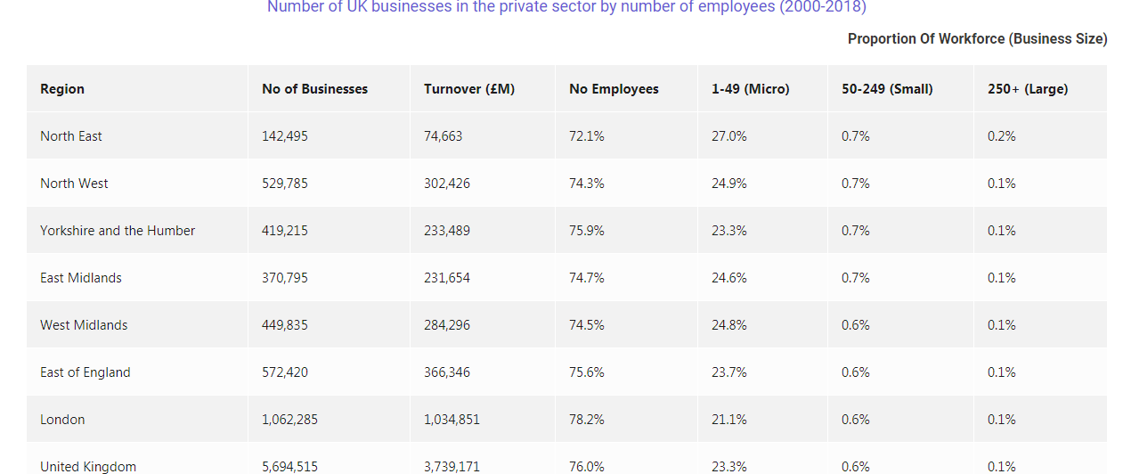

Appendix 2- Most significant challenges SME faced in 2018
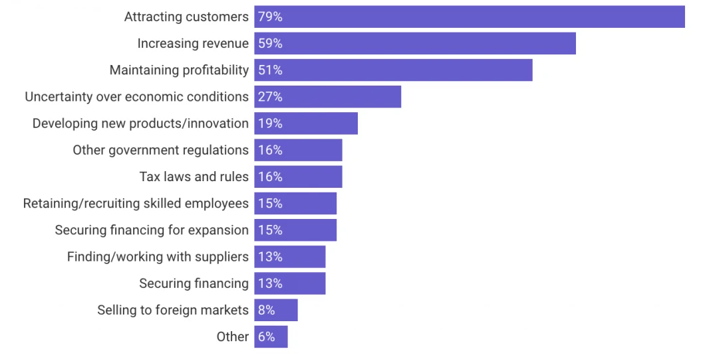

Appendix 3-Growth of UK business in the private sector
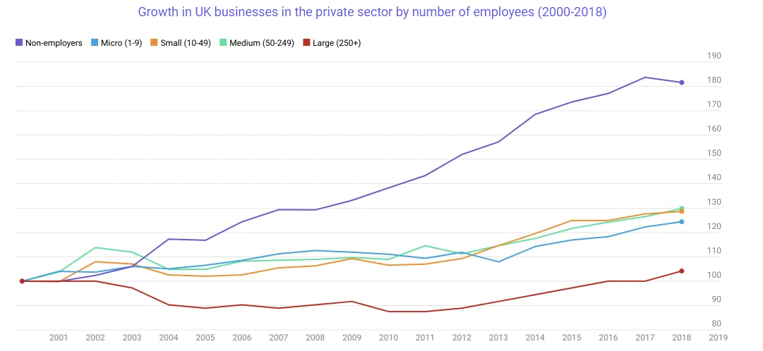
Source- Merchant Savvy (2019). UK SME Data, Stats & Charts. (Online) Available at: https://www.merchantsavvy.co.uk/uk-sme-data-stats-charts/
[Accessed: 2 September 2019].

