Name: Qudsia Bano
Student Number: 2423297
Module Code And Title: LCHS4003 Introduction to Health and Social Care
Lecturer’s Name: Farah Islam
Assignment Title: Component 1

Task 1: Poster
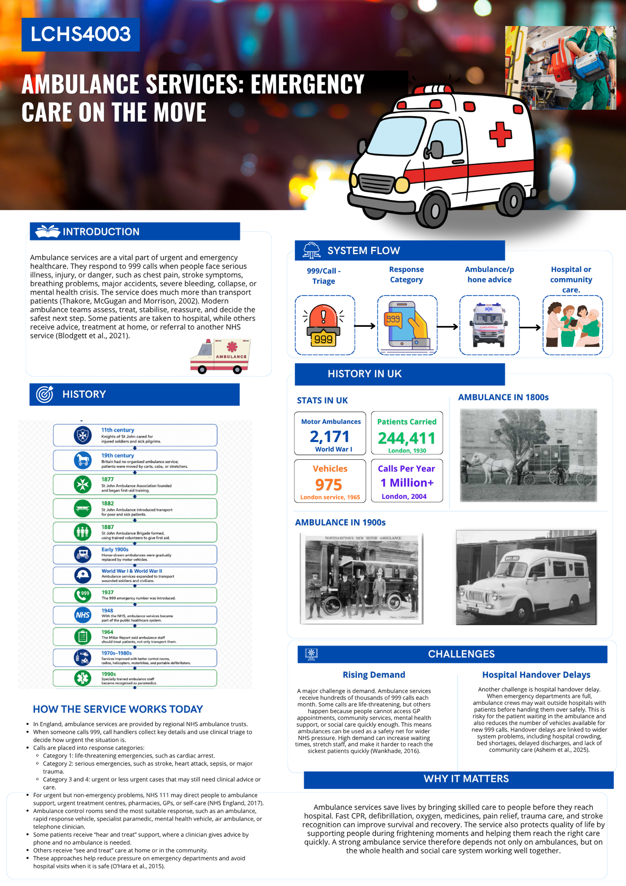

Task 2: Essay
Community disability services are aimed at helping such people to lead independent and safe lives within their own communities. Some examples of community services for people with disabilities can be personal care, assisted living, day programs, advocacy, direct payments, assistive technology, transportation assistance, respite services, and education, employment and social activity access. The idea is not just to provide basic care but to ensure that individuals are respected and included in society (Kendall, Buys and Larner, 2000).
Traditionally, individuals with disabilities within the United Kingdom faced exclusion within the wider community. Individuals who have either physical, learning, and other disabilities are sent to long-term hospitals, institutions, and dependency on family members (Ince et al., 2022). In doing so, it portrayed the medical perspective on disability, which sees disability as a personal problem or limitation. Eventually, there was a shift in attitude, whereby campaigns demonstrated that environmental factors within the society were more disabling than the limitation itself. This marked the rise of the social perspective on disability (Goering, 2015).
One major policy that contributed to these policies is the Chronically Sick and Disabled Persons Act 1970 where arrangements were made for improved welfare provisions for the disabled persons, and there was an encouragement of local authorities to assess and support those individuals with disabilities (GOV.UK, 2020). Another major policy came in 1990 through the NHS and Community Care Act where responsibility was placed on local authorities who had to evaluate the needs and provide care for individuals in their communities (GOV.UK, 2019). Another significant act is the Equality Act 2010 where protection against discrimination was provided for the disabled people. Another policy is Building the Right Support where efforts have been made to reduce inpatient care for people with learning disabilities and autistic people (Government Equalities Office, 2022).
Today, the provision of such services is normally done via the social care departments of local authorities, sometimes in conjunction with the NHS, voluntary agencies, housing and private care agencies. A person may get a needs assessment according to the provisions of the Care Act 2014, and thereafter a care and support plan. Some individuals may have a personal budget or a direct payment enabling them to select and organize their own services (NHS, 2023).
However, the system does not always operate effectively or equally. For instance, an advantage of the system is that disability services in the community enable people to stay near their family, friends, and environment as opposed to institutional care where people are confined to the institution. Supported living, personal assistance, and community life activities can increase self-confidence while decreasing isolation. Person-centered planning also honors individual wishes unlike disability (Hunt et al., 2022; Kendall, Buys and Larner, 2000).
However, there are many difficulties. Budgetary restrictions in adult social care can lead to the provision of services that limit their support to basic personal care only and not to social inclusion at large. The requirements for eligibility can be high, and there are cases where people have to wait for assessment, devices, home adaptation, and accommodation (Glasby et al., 2023). There is poor coordination among health, social care, education, and housing services. In cases where people have more complicated needs, it can result in a lot of stress both for the clients and their families. Direct payments contribute to people's independence but can lead to additional bureaucracy in certain cases (Kendall, Buys and Larner, 2000).
Community-based disability services matter in that they may have the potential to make a real difference to quality of life. Effective support allows the disabled individual to shower, get dressed, move about, communicate, learn, work, form relationships, and participate in the community. They may prevent the carer from suffering burnout through respite care and shared responsibilities. Most significantly, community-based disability services question the notion that disabled individuals ought to be kept out of sight or left out entirely. But for community-based disability services to be successful, it is important that they be adequately funded and person-centered (Kendall, Buys and Larner, 2000).

References
Asheim, A. et al. (2025) ‘Does Delayed Response Due to Busy Ambulances Impact Risk of Death and Hospital Service Use?: A Cohort Study of 240,000 Medical Emergencies’, Epidemiology, 36(6), pp. 830–840. Available at: https://doi.org/10.1097/ede.0000000000001894.
Blodgett, J.M. et al. (2021) ‘Alternatives to direct emergency department conveyance of ambulance patients: a scoping review of the evidence’, Scandinavian Journal of Trauma, Resuscitation and Emergency Medicine, 29(1). Available at: https://doi.org/10.1186/s13049-020-00821-x.
Glasby, J. et al. (2023) ‘Building a better understanding of adult social care’, BMJ, 382, p. e073720. Available at: https://doi.org/10.1136/bmj-2022-073720.
Goering, S. (2015) ‘Rethinking disability: The social model of disability and chronic disease’, Current Reviews in Musculoskeletal Medicine, 8(2), pp. 134–138. Available at: https://doi.org/10.1007/s12178-015-9273-z.
GOV.UK (2020) Chronically Sick and Disabled Persons Act 1970, Legislation.gov.uk. Available at: https://www.legislation.gov.uk/ukpga/1970/44/contents (Accessed: 19 June 2026).
Gov.UK (2019) National Health Service and Community Care Act 1990, Legislation.gov.uk. Available at: https://www.legislation.gov.uk/ukpga/1990/19/contents (Accessed: 19 June 2026).
Government Equalities Office (2022) Disability: Equality Act 2010 - Guidance on matters to be taken into account in determining questions relating to the definition of disability (HTML), GOV.UK. GOV.UK. Available at: https://www.gov.uk/government/publications/equality-act-guidance/disability-equality-act-2010-guidance-on-matters-to-be-taken-into-account-in-determining-questions-relating-to-the-definition-of-disability-html (Accessed: 19 June 2026).
Hunt, X. et al. (2022) ‘Community Support for Persons with Disabilities in Low- and Middle-Income Countries: A Scoping Review’, International Journal of Environmental Research and Public Health, 19(14), p. 8269. Available at: https://doi.org/10.3390/ijerph19148269.
Ince, R. et al. (2022) ‘“Why are we stuck in hospital?” Understanding delayed hospital discharges for people with learning disabilities and/or autistic people in long‐stay hospitals in the UK’, Health & Social Care in the Community, 30(6). Available at: https://doi.org/10.1111/hsc.13964.
Kendall, E., Buys, N. and Larner, J. (2000) ‘Community-based Service Delivery in Rehabilitation: The Promise and the Paradox’, Disability and Rehabilitation, 22(10), pp. 435–445. Available at: https://doi.org/10.1080/09638280050045901.
NHS (2023) Introduction to care and support - Social care and support guide, nhs.uk. Available at: https://www.nhs.uk/social-care-and-support/introduction-to-care-and-support/ (Accessed: 19 June 2026).
NHS England (2017) NHS England Ambulance Response Programme, England.nhs.uk. Available at: https://www.england.nhs.uk/urgent-emergency-care/improving-ambulance-services/arp/ (Accessed: 19 June 2026).
Northampton NHS (2020) The History of the Ambulance Service. Available at: https://www.northamptongeneral.nhs.uk/About/OurHistory/History-of-Ambulance.pdf (Accessed: 19 June 2026).
O’Hara, R. et al. (2015) ‘DECISION MAKING AND SAFETY IN AMBULANCE SERVICE TRANSITIONS’, Emergency Medicine Journal, 32(5), pp. e2.1-e2. Available at: https://doi.org/10.1136/emermed-2015-204880.4.
Pollock, A. (2013) ‘Ambulance services in London and Great Britain from 1860 until today: a glimpse of history gleaned mainly from the pages of contemporary journals’, Emergency Medicine Journal, 30(3), pp. 218–222. Available at: https://doi.org/10.1136/emermed-2011-200086.
Thakore, S., McGugan, E.A. and Morrison, W. (2002) ‘Emergency ambulance dispatch: is there a case for triage?’, JRSM, 95(3), pp. 126–129. Available at: https://doi.org/10.1258/jrsm.95.3.126.
Wankhade, P. (2016) ‘Staff Perceptions and Changing Role of pre-hospital Profession in the UK Ambulance Services’, International Journal of Emergency Services, 5(2), pp. 126–144. Available at: https://doi.org/10.1108/ijes-02-2016-0004.

