STUDENT NAME: Sevdelina Vodenicharova
STUDENT CODE: 1906359
BUSSINESS SKILLS
*Employability skills in the Hospitality Industry*

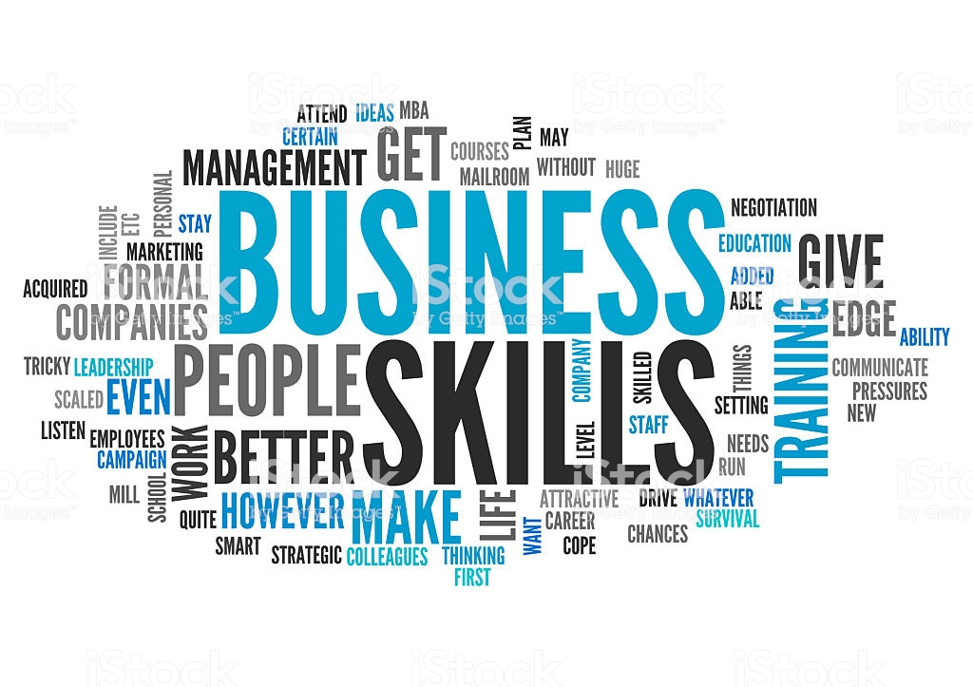

TABLE OF CONTENTS
- INTRODUCTION…………………………………………………………………………page 3
- EMPLOYABILITY SKILLS EVALUATION…………………………………………page 3
- SWOT analysis…………………………………………………………………………page 3-4
- Personal Development Plan……………………………………………………page 5
- Conclusion………………………………………………………………………………page 5
- References ……………………………………………………………………………page 6

Introduction
Within the today’s assignment there is going to be a strong analyse of my current employability skills having attached to it a personal SWOT analysis and a PDP, which will put in evidence the assumptions made across the employability skills.
The employability skills are playing a massive role in everyone’s life and this because these are “a set of abilities that and knowledge that all individual should possess with the aim of ensuring that they are capable to have an effective workplace” (OCR 2018). Some of the most important employability skills are communication skills, presentations skills, time management, reliability, team working and problem solving. These being some of the most important skills that are currently required in all environments (Duszynski M. 2020).
The SWOT analysis is the analysis that tests the strengths, weaknesses, opportunities and threats of a person/company with the aim of testing their areas of improvements (Hitt et al. 2012), this meaning that the SWOT analysis will be the critical analysis that will go further telling the things that I need to work on and the things that I need to maintain as well.
BODY 1- EMPLOYAILITY SKILLS EVALUATION
The employability skills are more than just important because they are the ones that everyone need when planning to get into a job. In addition to that, my main skills that helped me go through many interviews is that I have managerial skills and communication skills as well as team working skills.
The managerial skills have developed because of the job I had in small business within which I had to work with the micro and macro economy and to deal with all the issues that were coming through. In addition to that I did develop the skill of managing such situations and keep communicating effectively with people around in my team and out of my team to find quick solutions and to maintain everything in a good state. “Communication involved the exchange of ideas, opinions and information having a specific aim” (Seiler W. & Beall M 2005).
SWOT analysis
The SWOT analysis is the strategical analysis that analyses the STRENGHTS, WEAKNESSES, OPPORTUNITIES and THREATS of a company or individual (McGee, Thomas H. and Wilson D. 2010) ,with the aim of testing what needs to be worked on for continuous improvement. Within the following lines I will analyse in detail my personal SWOT with the aim of outlining my current capabilities and employability state.
1.STRENGHTS
Thinking about strengths my main strengths is that I am able to work as a manager and this because I developed managerial skills from the jobs I had before in small business within which I was required to work with micro and macro economy, to work within teams so keep everything under control. Thinking about my managerial skills and linking it to the profession I want to perform in the hospitality industry, the managerial skills are vital in any role in the hospitality industry regarding to the fact that there is continuous need of dealing with the guest’s inquiries.
Another important skill that I have, that is as well very important in the hospitality industry is related to the cooking skills, which are perfect when planning to get employed in the kitchen. I am talking about the variety of skills because of the constant confusion of the department that would fit me the most.
2. Weaknesses
The main and the most important weakness that is dragging me down all the time is the English communication as it is not fully developed yet. The reason why my weaknesses are related to the English skills is because the English language has never been my first language and I am trying my best to improve my skills every day. Another reason why my English skills are the problem is because I am sometimes struggling to effectively communicate with people around and I could struggle to make myself clear to people.
Another important weakness that I have is that sometimes I am struggling to show much confidence towards other people, especially now when people could take me as a joke most of the time.
3.Opportunities
The main opportunity that I took and still taking to myself was opened to me when I took the decision of coming to the university. Next to that I consider that the university has highly pushed me forwards learning better English and accumulating more and more skills all the time. I consider that the University is a good place to find opportunities in especially because it is offering a placement that is hardly supporting me to build experience that is more than needed and requested by all the employers.
Another opportunity that I consider that I have took to myself is because of my workplace and this because I have to communicate effectively with everyone at work in order to maintain a good team working continuously avoiding such arguments between us.
4. Threats
The threat that stops me the most is the limited time to spend on working effectively to improve everything that I need. The reason why I have not enough time to spend on everything that I need to be because I have kids and a job that I cannot miss on. Another thing to mention about my threats is that I am not well-informed about the things that I can do to improve my current state continuously. Because I am not well-informed about the resources and the tolls that would be supportive for me to carry on practicing speaking English especially, I cannot effectively work on it.

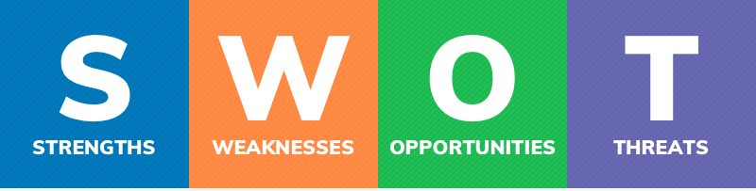

PERSONAL DEVELOPMENT PLAN (PDP)
Personal development plan in its definition is based on a long-term goal that is set for people that are looking forward improvement. Within the PDP people are identifying how they are going to achieve the specific goal and how long will it take for the goal to be successfully achieved (Manjtelow J. 2007). Before starting to design the personal development plan, everyone must design the career objective analysing exactly what the goal is, why is the goal important how the goal will support them through their career, what strategies they will use to achieve the goal and when the goal will be achieved.
MY PERSONAL DEVELOPMENT PLAN:
The main goal, which is currently the biggest and the final goal that I have, and this is to start working as a manager in the hotel. Considering my current situation and the skills that I have I need to follow specific procedures that will then push me towards success and hopefully I will be able to achieve my goal of becoming a manager in the Hotel. The first and the main thing that I have to is to hardly work on my English speaking and this because as a manager I need to be able to communicate with people in the hotel and out of the hotel as well I need to prove that I am the role model for the employees that are under my attention. After I improve my English skills, I will be focused on working hard to successfully go well through university, meet all the deadlines and be productive within everything.
Another important thing that is part of my development and plays a huge role in it is the placement I will undertake as it is set by the university at the Marriott hotel, time within I will developing my practical abilities in a variety of departments in a variety of postures having a variety of tasks to complete to ensure that I am well-accumulating the practical abilities.
Conclusion
As a conclusion in the Hospitality industry many skills such as managerial skills, punctuality, communication, presentation skills, flexibility, stress management, customer service and many other are key skills that are needed by everyone that is planning to go and work in the hospitality industry. In addition to that referring to my personal analysation of my current skills, the conclusion is that I hardly need to be working in everything that I find helpful for me.

REFERENCES
Duszynski M. (2020), “Top 10 employability skills”, found on: https://zety.com/blog/employability-skills, [17/03/2020]
OCR (2018), “The OCR guide to employability”, found on: https://www.ocr.org.uk/Images/168823-the-ocr-guide-to-employability.pdf [17/03/2020]
Hitt M.; Ireland R. & Hoskisson R. (2012), “Strategic management cases: competitiveness and globalisation”, found on: https://www.researchgate.net/publication/272353031_SWOT_Analysis [17/03/2020]
McGee, J., Thomas, H. and Wilson, D. (2010) Strategy: Analysis and Practice, McGraw-Hill, Maidenhead, UK
Seiler W. & Beall M. (2005), “Communication: Making connections” [available on: https://www.researchgate.net/publication/257716668_Communication_Skills_among_University_Students/link/00b4952803f5702a4a000000/download, accessed on: 18/03/2020]

