

MBA
ENTREPRENURESHIP
LCMB7004
VASILIOS TAVLARIDIS

NAME : MISHAB CHANDAPARAMBIL
Student ID: 2243796
Word Count: 2571

TABLE OF CONTENTS

1. OVERVIEW OF BUSINESS IDEA………………………………………………………..3
2. IDENTIFYING AND ADDRESSING THE GAP…………………………………………..3
3. LOCATION AND LEGAL ENTITY…………………………………………………………5
4. SWOT ANALYSIS……………………………………………………………………….…..5
5. TARGET MARKET AND STRATEGIES……………………………………………….….8
6. BUDGET PLAN AND EXTERNAL FUNDING SOURCES…………………………….10
7. REFERENCES…………………………………………………………...…………………12

1. OVERVIEW OF BUSINESS IDEA
Global warming and the resulting impact on the economy is the key concern in this 21st century. According to Marchant (2021), climatic changes will reduce global GDP growth to 18% by 2050.
The company will be focusing on the production of solar-powered electric vehicles. The solar-powered electric vehicle will use sunlight to generate energy, observe this sunlight, and convert it into energy, a solar panel with photovoltaic cells will be used as the roof for the car. The car will be able to charge even through moonlight, street lights, and so on but the energy absorbed will be very low. The car will have a power storage facility using which the excess power absorbed during the day can be stored thereby enhancing energy efficiency (Sendy, 2023). The introduction of solar-powered electric vehicles can be attributed to the changing preferences and attitudes of the customers, and the increasing demand for EVs, which is expected to grow by 35% by 2023 (IEA, 2023).
2. IDENTIFYING AND ADDRESSING THE GAP
The solar-powered electric vehicle segment is gaining market at global level and it is expected that by 2032 the market will grow by 20.2%. The increasing demand and preference for solar-powered electric vehicles in the global market can be attributed to the increasing concern of customers towards environmental pollution, degradation, resource depletion, rising carbon emission, and the resultant health hazards, and so on (Precedence, 2022)
Figure 1: Market for solar vehicles-Global level
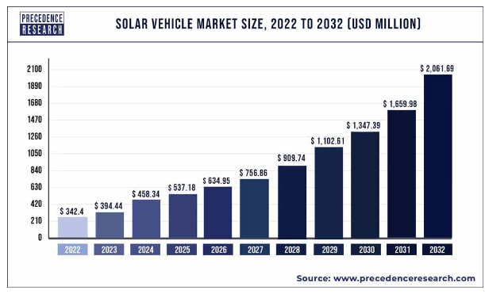
Source: precedenceresearch.com
While analyzing the trend of Electric Vehicles in the Indian market are mostly powered by battery, fuel cell, and hybrid mode. Whereas the presence of solar-powered electric cars in the Indian market is considerably absent (Sun, 2023). For instance, Vayve Mobility is the 1st company to introduce solar-powered electric cars into the Indian market, and the 1st solar-powered car model ‘Eva’ is expected to be launched by 2024 (Jain, 2023). Whereas the Solar-powered electric vehicle market of the US accounts for $ 146 million (Fortune, 2023). The distinction between the Indian and the US solar-powered EV market depicts the gap existing in Indian EV market.
Figure 2: USA market
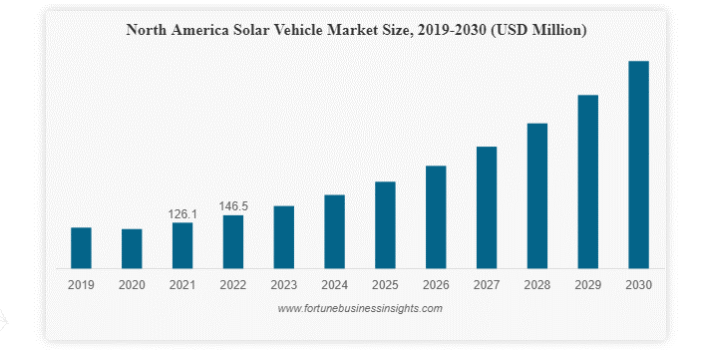
Source: fortunebusinessinsights.com
Considering the demand or preferences of consumers in India, it can be identified that more than 70% of the consumers have a preference for electric cars, and 48% of people want to shift to Electric cars (McKinsey, 2023) but are restrained by elements such as high cost, low availability, fewer options or varieties, refuelling and electricity-related constraints, noise pollution and environmental impact, and so on.
Figure 3: Consumer preference
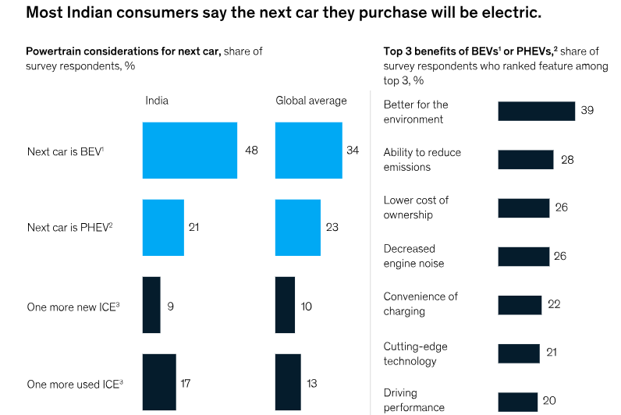
Source: mckinsey.com
By conducting the gap analysis through the market and consumer preference analysis it was very evident that factors such as the high cost of EV cars, limited models and choices, lack of proper awareness among the consumers, anxieties about the range and charging possibilities, possible negative impact upon the environment are the key concerns of the consumers which hinders the shift of consumers into EVs (Deccanchronicles, 2023). More than 70% of consumers willing to shift to EV indicates the desire of the people to adopt environment-friendly and sustainable modes of transportation but the lack of effective solutions.
With the introduction of solar-powered electric cars, the concerns relating to environmental degradation, pollution, and anxieties relating to range and charging facilities can be addressed. Solar-powered electric vehicles are considerably quiet therefore, eliminating the possibility of oil pollution, the vehicle can be charged in sunlight, streetlights, and moonlight and the excess charge will be stored in the cell battery therefore, the fear of frequent charging and requirements of charging infrastructure can be addressed. Using high-capacity photovoltaic cells in the solar panel and incorporating of rechargeable battery with high storage capacity will enhance the range and efficiency of the car. This stored power can also be used for other operating facilities of the car such as operating air conditioning, fan, light powering (Hunt, 2023), and so on.
3. LOCATION AND LEGAL ENTITY
In India, most of the sales and demand for EVs (more than 60%), are from the Northern States of the country such as Uttar Pradesh, Gujrat, and Rajasthan (Cleanmobilityshift, 2023). Therefore, focusing on the key locations of these states will be beneficial for the company in capturing a larger consumer base. High preference and demand for EVs from these regions indicate the preference of the consumers to shift from conventional vehicles and energy concepts, it also indicates that these people will have a certain level of awareness and knowledge about different types of EV cars, their specifications, features, and so on. Further, India is a tropical country, which has a good balance of different climates and every region in the country gets an average to moderate level of temperature throughout the whole year (unacademy, 2023), therefore, adopting solar-powered electric vehicles will be an efficient strategy.
Table 1: PESTLE
PESTLE | Description
Political | - 100% FDI is possible (EV, 2023).  - Monetary incentives and subsidies for companies (ToI, 2023).  - Legal restrictions for company establishments are low.
Economical | - Growing economy and rising demand, highly resilient economy (Worldbank, 2023).  - Decline in unemployment rate (PTI, 2023) resulting in high disposable income.
Social | - Emergence of India as a most populous country (Hannah, 2023).  - Large number of govt. policies and changing consumer patterns towards climatic change and environmental protection (UNICEF, 2023).
Technological | - Innovation-oriented country, India ranks 32 in the innovation index of 2023 (PIB, 2023).  - An incremental technology incentive trend in the country (Investindia, 2023).
Environmental | - Policies like reduction in road tax, electricity at subsidized rates, and so on (ToI, 2023).  - Policies addressing different environmental issues such as air pollution, deforestation, environmental degradation, and so on  - Existence of different pollution control boards like CPCB, policies like Environmental protection act 1986, and so on (ICED, 2023).
Legal | - Tax exemption for production and purchases of EVs.  - Policies such as Mudra loans, PMMY schemes for raising funds (Pradhan, 2023).
Source: self-developed.
Considering the legal status of the company, it would be better for the company to be a Limited Company-LTD. This can be accounted to the facts that, in India establishing and operating a Ltd. company is very easy, there is no need for several mandatory registrations prescribed under the Companies Act of 2013, and it is less costly and easier to sue other parties, there is no requirement of minimum capital investment and so on. The Private. Ltd. companies in India ensure a complete separation between owners, managers, and operators thereby enhancing the operating efficiency of the company. Further, Private. Ltd. companies act as an attractive investment destination owing to their potential for growth. In India, the tax burden of Private Ltd. companies is very low, in most cases, companies are exempted from income tax payments or are provided with subsidies, and so on (Setindiabiz, 2023).
4. SWOT ANALYSIS
Swot analysis aids in developing a proper insight into the company and planning the activities accordingly (Gurl, 2017).
Figure 4: SWOT
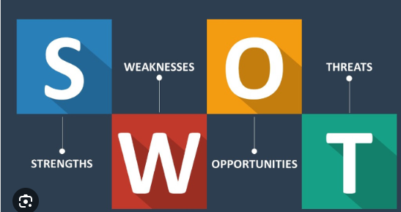
Source: medium.com
Strength:-
- Low cost for ownership: The company will be established as an Ltd. firm because of that the company will get exemptions from tax payments, the sector allows the formation of companies without any minimum capital investments, facilitating low-cost ownership (Setindiabiz, 2023).
- Large consumer base: The sales and demand data of the existing EV companies in the location indicates the general consumer preference trend towards different types of EV cars, and the features of solar-powered EVs such as easiness in charging, storage capacity, zero-emission, and pollution will attract a large number of consumers.
- Products at various price ranges: in the current market EV cars are considered a bit expensive, a good quality- performing car on average will cost more than 50 lakh (CarDheko, 2023). In such a scenario, this company will be offering solar-powered electric cars at different price ranges (from 5-6 lakh onwards), which will definitely attract more customers to the product (Desidime, 2023).
Weaknesses
- Charging and range-related issues: One of the key concerns relating to EVs in the Indian market is about the charging facilities. The charging infrastructures are very limited in the country i.e., only 5254 charging points are operational now whereas the required number is 46,397 (Bharadwaj, 2023). This problem can be addressed by solar-powered EVs because it doesn’t need any particular charging point and the high-powered reserve battery in the vehicle will help in storing surplus energy.
- Dominance of two-wheelers and three-wheelers:- In the Indian market most of the customers prefer two-wheelers and three-wheelers, this is mainly due to the price-related factors and low availability of choices in EV car segments (Sun, 2023). Since the cost or price of solar-powered EVs is low capturing the market will be easier.
Opportunities
- Impact of fossil fuels: The rising price and negative impact of fossil fuels on the economy and the environment are increasing the demand for EVs in the market (Al-Ghaili, et al., 2022). Solar-powered cars provide an opportunity to shift the fossil fuel-based economy to a zero-carbon emission economy.
- Favourable government policies: The Indian government has adopted several policies to promote the EV sector in the country, this includes exemption from taxation, making the EV manufacturing sector 100% FDI possible sector, and so on (EV, 2023), these policies will also benefit the solar-powered electric car production.
- Potential competitors are low: 1st solar-powered electric car model ‘Eva’ is expected to be launched by 2024. Since the level of competition is practically low, it will generate a competitive advantage for the company in the Indian market (Jain, 2023).
Threat
- Solar panel import crisis: Covid-19 pandemic, and the resultant shutdown in international transport and trade, wars such as Russia-Ukraine, Israel-Palestine, and the resultant export-import crisis, and so on (Baruah, 2023) will have a negative impact because in case of solar panels India is import depended (PTI, 2023).
- Rise of alternative vehicle options: In this 21st century, with the advancement of science and technology people are trying to find new and more efficient alternatives. Some of the alternatives to electric vehicles charged by electricity or battery are, cars powered by hydrogen, hybrid fuels, and so on (Contestabile, et al., 2011).

5. TARGET MARKET AND STRATEGIES
The market segmentation involves the process of identifying and classifying the potential customers into different sections. This segmentation will help the company in targeting customers effectively with proper strategies (Dolnica, 2022).

Figure 5: Market segmentation

Source: notifyvisitors.com
Based upon the market analysis and customer preference analysis, it was identified that In India, the northern region seems to have a high potential market for solar-powered electric cars. Further, the presence of a number of EV manufacturing and selling companies in this region enhances the suitability of the area for establishing a solar-powered electric car company there.
Table 2: Market Segmentation
Demographic | Behavioural | Geographic | Psychographic
- Age  - Income | - Buying habits | - Region  - Density | - Interest  - Attitude
Source: self-developed
The company will be targeting people belonging to the age group of 30-50 since in India they have a high preference for solar-powered cars compared to any other age group (JETIR, 2014). The EV cars of the company are available at different price ranges such as below 20 Lakhs, below 35-50 Lakhs, and above 1 Cr, whereas solar-powered electric cars are comparatively cheaper that the lowest price is 5-6 lakh (desidime, 2023). Therefore, the company will able to accommodate and serve customers of different income levels. The company has chosen the Northern region or states of India after analyzing the buying habits, and EV sales trend. The people in this region have a high preference for solar-powered cars as compared to other Indian regions, this can be attributed to low cost, high level of subsidy, high preference for e-rickshaws (cargo & passenger), and so on (JMK, 2023). Further, the interesting fact is that the northern states are the most populous and highly dense regions in India highlighting a large consumer base and high potential market (Kumar, 2023).
In this 21st century, where the level of competition is very high and consumers have high demands and preferences about the products it is important for the company to adopt efficient and effective strategies to capture the potential market.
- In the case of solar-powered cars, it is important to make customers aware of the specialties, features, and benefits of the products, here advertising through social media will be an efficient strategy.
- A video advertisement through social media platforms like Facebook, YouTube, X, and so on will be able to generate mass awareness and publicity in a short time (Hanaysha, 2023). This will be effective as the number of internet users in the country is increasing (Majumdar, 2023).
- Developing a company website and updating about the vehicles, models, features, future prospects, offers, and discounts will definitely influence and attract consumers. Accurate and consistent updating will also increase customer loyalty and engagement towards the company and its products (Lim and Rasul., 2022).
6. BUDGET PLAN AND EXTERNAL FUNDING SOURCES
Identifying suitable funding sources, and planning the finances accordingly plays a fundamental role in the success development, and stability of a company. Adequate financial sources and their stability aid in attaining the organizational goals efficiently (Patel, 2023).
Table 3: Financial Plan
Budget for car manufacturing plant
Expenditure | Cost calculation
Revenue | -----------------------
Model 1 | Rs. 5,00,000
Model 2 | Rs. 30,00,000
Model 3 | Rs. 50,00,000
Plant cost | Rs. 100,00,000
Land and Building | Rs. 50,00,000
Furniture and office supplies | Rs. 10,00,000
Licensing cost | Rs. 5,00,000
Selling and marketing cost | Rs. 20,00,000
Insurance cost | Rs. 8,00,000
Repairs and maintenance | Rs. 10,00,000
Personnel cost
Training cost | Rs. 6,00,000
Wages | Rs. 25,00,000
Operating income | ---------------------
Source: self-developed.
External Funding source:-
Government grants: With the objective of boosting their environmental protection, and climatic change, and boosting the EV market Indian government has introduced various funding programs. For instance, the FAME II scheme provides a 40% incentive upon EV production, the total budget of the FAME II scheme is 10,000 crore (Bhutani, 2023). Since the government has been introducing several such schemes, grants, and policies for promoting EV manufacturing in the country, it can be considered a key source of external funding.
Crowdfunding can be used as another efficient, fast external funding source. Crowdfunding will benefit the company based on the facts that, in India crowdfunding has legal backing and there are multiple platforms operating for crowdfunding purposes like the Ketto crowdfunding platform. The easiness of collecting or pooling large amounts of funds, in a short time, from reliable sources enhances the dependability on this external funding source (ketto, 2023).
Another safe and traditional source of external funding for the company is bank loans. India has a well-established system of banking which includes the Public sector, and private sector banks. For establishing and starting a new venture in the country, it is easier to avail of non-security and non-collateral loans and have much more flexible and easier repayment structures and programs (Pradhan, 2023). The easiness and flexibility in availing loans and the flexibility in repayment and tenures make it a reliable and attractive source of external funding.
Further, there are many government-linked bank loan schemes available in India to facilitate entrepreneurship and business development. Mudra loans under the PMMY scheme and, the Stand-up India scheme are some of such schemes (Pradhan, 2023). These schemes facilitate easy credit with low collaterals and flexible tenures.
Building a new business or a product involves identifying the needs and demands of the customers, potential markets, the existing condition of the market and the existing gap, available facilities, proper segmentation and targeting of the potential market, identifying appropriate and efficient funding sources, and so on.

7. REFERENCES
Al-Ghaili, A.M., Kasim, H., Aris, H. and Al-Hada, N.M., (2022). ‘Can electric vehicles be an alternative for traditional fossil-fuel cars with the help of renewable energy sources towards energy sustainability achievement?’. Energy Informatics, 5(4), pp.1-23.
Baradwaj, R (2023). ‘EV Infrastructure in India: What to Expect By 2030’, bolt.earth [Online]. Available from: https://bolt.earth/blog/indian-ev-charging-infrastructure-by-2030. Accessed on: 26 October 2023.
Baruah, R (2023). ‘What is India doing to meet its increasing power demand’, livemint.com [Online]. Available from: https://www.livemint.com/industry/energy/mint-explainer-what-is-india-doing-to-meet-its-rising-power-demand-11692010004467.html#:~:text=Power%20demand%20has%20increased%20in,has%20been%20estimated%20at%204.9%25. Accessed on: 26 October 2023.
Bhutani, C (2023). ‘FAME II: India's EV sector looks for hope from govt to extend subsidy scheme’, btMAG.com [Online]. Available from: https://www.businesstoday.in/magazine/deep-dive/story/fame-ii-indias-ev-sector-looks-for-hope-from-govt-to-extend-subsidy-scheme-391207-2023-07-25. Accessed on: 26 October 2023.
CarDheko (2023). ‘Electric Cars in India’, cardekho.com [Online]. Available from: https://www.cardekho.com/new-electric+cars. Accessed on: 25 October 2023.
Cleanmobilityshift (2023). ‘Just 6 states in India account for 60% of EV sales in 2023 so far’, cleanmobilityshift.com [Online]. Available from: https://cleanmobilityshift.com/market-trends/just-6-states-in-india-account-for-60-of-ev-sales-in-2023-so-far/#:~:text=However%2C%20a%20recent%20analysis%20shows,in%20the%20country%20in%202023. Accessed on: 25 October 2023.
Contestabile, M., Offer, G.J., Slade, R., Jaeger, F. and Thoennes, M., (2011). ‘Battery electric vehicles, hydrogen fuel cells and biofuels. Which will be the winner?’. Energy & Environmental Science, 4(10), pp.3754-3772.
Deccanchronicles (2023). ‘Barriers to the Adoption of Electric Vehicles: Evidence from India’, deccanchronicles.com [Online]. Available from: https://www.deccanchronicle.com/business/in-other-news/280623/barriers-to-the-adoption-of-electric-vehicles-evidence-from-india.html. Accessed on: 25 October 2023.
Desidime (2023). ‘Cheapest EV in India with Solar Charging to launch soon! Worth buying?’, desidime [Online]. Available from: https://www.desidime.com/news/cheapest-ev-in-india-with-solar-charging-to-launch-soon-worth-buying-or-not#:~:text=This%20cheapest%20electric%20solar%20car,in%20September%20last%20year%2C%202022. Accessed on: 27 October 2023.
Dolnicar, S., (2022). ‘Market segmentation for e-tourism’. In Handbook of e-Tourism (pp. 849-863). Cham: Springer International Publishing.
EV (2023). ‘Investment in Indian Electric Mobility Industry Surges’, EVreports.com [Online]. Available from: https://evmarketsreports.com/investment-in-indian-electric-mobility-industry-surges/. Accessed on: 25 October 2023.
Fortunebusinessinsights (2022). ‘Solar vehicle maket, size, & share’, fortunebusinessinsights.com [Online]. Available from: https://www.fortunebusinessinsights.com/solar-vehicle-market-104333. Accessed on: 25 October 2023.
Gurl, E., (2017). ‘SWOT analysis: A theoretical review’.
Hanna, P (2023). ‘India overtakes China to become world’s most populous country’, theguardian.com [Online]. Available from: https://www.theguardian.com/world/2023/apr/24/india-overtakes-china-to-become-worlds-most-populous-country. Accessed on: 25 October 2023.
Hanaysha, J.R., (2022). ‘Impact of social media marketing features on consumer's purchase decision in the fast-food industry: Brand trust as a mediator’. International Journal of Information Management Data Insights, 2(2), p.100102.
Hunt, J (2023). ‘Solar Panel Cars: The Future of Sustainable Transportation?’, Environmentenergyleader.com [Online]. Available from: https://www.environmentenergyleader.com/2023/02/solar-panel-cars/. Accessed on: 27 October 2023.
ICED (2023). ‘Major Environment Policies and Legislations’, iced.org [Online]. Available from: https://iced.cag.gov.in/?page_id=256. Accessed on: 26 October 2023.
IEA (2023). ‘Demand for electric cars is booming, with sales expected to leap 35% this year after a record-breaking 2022’, iea.org [Online]. Available from: https://www.iea.org/news/demand-for-electric-cars-is-booming-with-sales-expected-to-leap-35-this-year-after-a-record-breaking-2022. Accessed on: 24 October 2023.
InvestIndia (2023). ‘Schemes for Electronics Manufacturing’, Investindia.gov [Online]. Available from: https://www.investindia.gov.in/schemes-for-electronics-manufacturing. Accessed on: 25 October 2023.
Jain, V (2023). ‘Vayve Mobility Unveils India’s First Ever Solar Powered Electric Car “Eva”, e-vehiclesinfo.com [Online]. Available from: https://e-vehicleinfo.com/vayve-mobility-unveils-indias-first-ever-solar-powered-electric-car-eva/. Accessed on: 27 October 2023.
JETIR (2014). ‘A Study on Consumer Buying Behaviour towards Electric Vehicles in Bagalkot’, jetir.org [Online]. Available from: https://www.jetir.org/papers/JETIR2209133.pdf. Accessed on: 26 October 2023.
JMK (2023). ‘Uttar Pradesh: Leading the EV transition in India’, Jmkresearch.com [Online]. Available from: https://jmkresearch.com/uttar-pradesh-leading-the-ev-transition-in-india/#:~:text=The%20state%20of%20U.P.,in%20the%20state%20during%202022. Accessed on: 26 October 2023.
Ketto (2023). ‘Is Crowdfunding Legal & Safe In India? Legal Crowdfunding Options | Ketto’, ketto.org [Online]. Available from: https://www.ketto.org/blog/is-online-crowdfunding-legal-in-india#:~:text=People%20Frequently%20enquire%20whether%20Crowdfunding,through%20its%20Online%20Crowdfunding%20Platform. Accessed on: 26 October 2023.
Kumar, A (2023). ‘Top 10 Most Populated States In India’, PW [Online]. Available from: https://www.pw.live/exams/defence/top-10-most-populated-states-in-india/. Accessed on: 26 October 2023.
Lim, W.M. and Rasul, T., (2022). ‘Customer engagement and social media: Revisiting the past to inform the future’. Journal of Business Research, 148, pp.325-342.
Majumdar, R (2023). ‘52% of Indian population had internet access in 2022, says report’, theeconomictimes [Online]. Available from: https://economictimes.indiatimes.com/tech/technology/52-of-indian-population-had-internet-access-in-2022-says-report/articleshow/99964704.cms. Accessed on: 26 October 2023.
Marchant, N (2021). ‘This is how climate change could impact the global economy’, WEF [Online]. Available from: https://www.weforum.org/agenda/2021/06/impact-climate-change-global-gdp/. Accessed on: 24 October 2023.
McKinsey (2023). ‘Consumers are driving the transition to electric cars in India’, McKinsey.com [Online]. Available from: https://www.mckinsey.com/industries/automotive-and-assembly/our-insights/consumers-are-driving-the-transition-to-electric-cars-in-india. Accessed on: 25 October 2023.
Pradhan, D (2023). ‘How To Get A Loan To Start A Business From The Government’, Forbes [Online]. Available from: https://www.forbes.com/advisor/in/business-loan/how-to-get-a-loan-to-start-a-business-from-the-government/. Accessed on: 26 October 2023.
PIB (2023). ‘India retains 40th rank in the Global Innovation Index 2023’, pib.com [Online]. Available from: https://pib.gov.in/PressReleasePage.aspx?PRID=1961576#:~:text=India%20retains%2040th%20rank%20out,2015%20to%2040%20in%202023. Accessed on: 25 October 2023.
Precedence, R (2022). ‘Solar Vehicle Market’, precedenceresearch.com [Online]. Available from: https://www.precedenceresearch.com/solar-vehicle-market#:~:text=The%20global%20solar%20vehicle%20market,20.2%25%20from%202023%20to%202032. Accessed on: 27 October 2023.
PTI (2023). ‘Unemployment in India fell to 6-year low during July 2022-June 2023: Government’, PTI.org [Online]. Available from: https://www.indiatoday.in/business/story/india-unemployment-rate-falls-6-year-low-july-2022-june-2023-government-data-2446838-2023-10-10. Accessed on: 25 October 2023.
Sendy, A (2023). ‘Do solar panels work on cloudy days or at night?’, solarreviews [Online]. Available from: https://www.solarreviews.com/blog/do-solar-panels-work-on-cloudy-days-or-at-night#:~:text=Do%20solar%20panels%20work%20at,the%20output%20is%20very%20low. Accessed on: 26 October 2023.
Setindiabiz (2023). ‘Top 10 Benefits of Private Limited Company Registration’, setindiabiz.com [Online]. Available from: https://www.setindiabiz.com/learning/benefits-of-private-limited-company#:~:text=Private%20Limited%20Companies%20are%20not,in%20a%20court%20of%20law. Accessed on: 26 October 2023.
Sun, S (2023). ‘Operational EV in India 2023, by type’, statista [Online]. Available from: https://www.statista.com/statistics/1320419/india-operational-ev-by-type/. Accessed on: 25 October 2023.
ToI (2023). ‘EV policies in India’, ToI.com [Online]. Available from: https://timesofindia.indiatimes.com/blogs/voices/ev-policies-in-india/. Accessed on: 25 October 2023.
UNICEF (2023). ‘Climate Change and Environmental Sustainability’, unicef.org [Online]. Available from: https://www.unicef.org/india/what-we-do/climate-change. Accessed on: 25 October 2023.
WorldBank (2023). ‘India’s Growth to Remain Resilient Despite Global Challenges’, worldbank.org [Online]. Available from: https://www.worldbank.org/en/news/press-release/2023/10/03/india-s-growth-to-remain-resilient-despite-global-challenges#:~:text=In%20this%20context%2C%20the%20World,and%20waning%20pent%2Dup%20demand. Accessed on: 25 October 2023.

