Report

Understand and solving the problem of profit decline in TM Lewin

Student name and number:
Paul Enache: 2129433
Module: Problem Solving and Decision Making
Module Code: BMSW4004
Lecturer Name: Chijioke Uba

Table of content

Introduction………………………………………………………………………………………3
Nature of the profit decline…………………………………………………………………….4
Impact of profit decline…………………………………………………………………………4
Find the causes using PESTLE and Fishbone diagram……………………………………5
PESTLE Analysis to identify external causes……………………………………………….6
Cause and effect of profit decline using Fishbone Diagram………………………………..6
Possible solutions identified……………………………………………………………………7
Possible solution using Grid Analysis …………………………………………………………7.
Action plan, monitoring and evaluation……………………………………………………….8
Action plan to implement the solution …………………………………………………………9.
Monitoring plan………………………………………………………………………………….11
Evaluation……………………………………………………………………………………….12
Conclusion………………………………………………………………………………………13
References………………………………………………………………………………………14

Introduction

The process of finding, analysing, and addressing a problem or issue is known as problem solving. It entails employing logical and creative thinking skills to discover underlying difficulties, generate viable solutions, assess those solutions, and select the most successful one. Problem-solving can be used to a wide range of situations, from personal difficulties to complicated commercial dilemmas.
The process of selecting a plan of action from among multiple choices is known as decision-making. It entails examining data, considering prospective outcomes, and weighing options before deciding on the best course of action. Decisions can be made at any level, from personal preferences to organisational tactics.
Problem solving and decision making are interrelated processes that often go hand in hand. When faced with a problem, individuals or organizations must analyse the situation and generate potential solutions. The next step is to evaluate those solutions and choose the best course of action, which involves deciding.
The goal of this report is to investigate the causes and consequences of declining profitability for TM Lewin, a UK formalwear retail, and to provide strategies to increase profit.


Problem solving and decision making.

Nature of the profit decline

TM Lewin is a distinguished British apparel manufacturer that has specialised in crafting high-quality formal wear for men. In recent years, the company has been grappling with a decline in profitability that has had a significant impact on its employees and overall business operations.
The decline in formal shirt purchases as more people worked from home, as well as the restrictions on large gatherings, presented difficulties for the shirt manufacturer. Men's clothing, particularly formalwear, was one of the retail industries' hardest hit during the pandemic, with demand for suits and formal tailoring plummeting due to work-from-home restrictions, event limits, and other pandemic difficulties.
The primary cause of the company's falling profitability was the pandemic. This well-known British firm has suffered significant pandemic implications. Earnings have unavoidably declined because of supply chain challenges, growing inflation, and the cost of living, all of which have an impact on client purchasing.

Impact of profit decline

After a financial loss at the outset of the epidemic, the clothing brand, known for its workwear, has only been operating online since 2020.
As a result of the administration, more than 600 people were laid off, and all 150 locations were closed.
Men's apparel, particularly formalwear, was one of the hardest hit retail businesses during the pandemic, as demand for suits and formal tailoring was reduced by work-from-home policies and event limits. Despite major reorganisation at the start of the outbreak, the pandemic has had a devastating impact on this well-known British company. Profits will undoubtedly fall due to supply chain concerns, inflation, and the current cost-of-living pressure on consumer purchases.

Find the causes using PESTLE and Fishbone diagram

The reasons of every problem must be discovered before it can be solved.
Next, I will use PESTLE Analysis and a Fishbone Diagram to find the causes.
A PESTLE Analysis investigates the primary external factors that influence an organisation (Political, Economic, Social, Technological, Legal, and Environmental). It can be used by managers and experts in human resources to aid in their decision-making in a variety of situations.

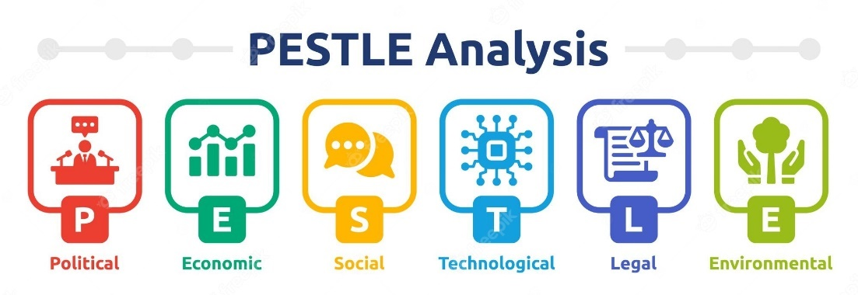
PESTLE Analysis

The fishbone diagram is a handy tool for identifying potential sources of an issue and visualising their relationships. This tool can help issue solvers better understand the variables that contribute to a problem and develop tailored solutions to address those factors.
I will use these two models to investigate the factors that contributed to TM Lewin's declining profitability.

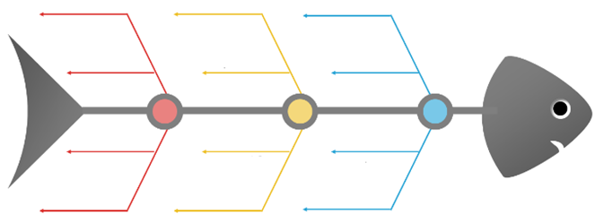
Fishbone diagram

PESTLE Analysis to identify external causes

Political | Economic | Social | Technological
Brexit  Lockdown legislation  Government regulations and policies  Taxes | Raising inflation  Covid pandemic  Exchange rates  Cost of living  Interest rates | Changes in societal and cultural trends  Changes in consumer spending habits  Shifts in fashion trends and attitudes.  Language | Online shopping  Digital marketing  Innovation

Cause and effect of profit decline using Fishbone Diagram

Possible solutions identified.

PESTLE Analysis and Fishbone Diagram reveal these causes:
- Cost increases
- Covid 19
- Consumer purchasing habits change.
The next solutions target these causes:
- Online sales
- New products

Possible solution using Grid Analysis

Grid analysis is a decision-making tool that is used to evaluate and select the best alternative from a set of alternatives. It is also referred to as a decision matrix or a Pugh matrix. Grid analysis is developing a table or grid that compares each alternative to a set of criteria or factors crucial in the decision-making process. The criteria can be qualitative or quantitative, with weights indicating their relative importance.
Each alternative is scored on each criterion, and the scores are multiplied by the relevant weight to yield a weighted score for each option. The total weighted score for each choice is then obtained by adding all weighted scores. The option with the highest total weighted score is deemed the best option.
Grid analysis has a wide range of applications, including business, engineering, and personal decision-making. It is especially effective when there are several possibilities to pick from and when the decision involves multiple elements to consider. It enables a disciplined and systematic approach to decision-making, lowering the danger of making biased or subjective choices.
Below, I have used Grid Analysis to help me to choose one solution for implement to increase the profitability in TM Lewin.

Factors  Weights | Cost increases  4 | Covid 19  5 | Consumer purchasing habits change.  3 | Total
Online sales | 2  8 | 3  15 | 1  3 | 26
New products | 2  8 | 1  5 | 3  9 | 22

The solution that I will implement is the online sales that received the highest score following the Grid Analysis.

Action plan, monitoring and evaluation.

A detailed plan of action that describes the steps, deadlines, resources, and responsibilities required to achieve certain goals or objectives is known as an action plan. It is a tool that assists individuals or organisations in directing their efforts and resources towards certain goals.
A well-designed action plan includes precise and quantifiable goals as well as the steps necessary to attain those goals. It also includes deadlines for each stage and lists the resources required to carry out the strategy.
Monitoring and evaluation (M&E) is the process of tracking and evaluating a project's or program's progress towards its goals and objectives. M&E is crucial because it helps determine whether a project or programme is on track, whether alterations or adjustments are required, and whether the anticipated goals have been reached.

Monitoring is the process of tracking progress towards specific goals or indicators, whereas evaluation is the process of determining the overall efficacy of a programme or project. Both are critical to ensuring that the action plan is carried out properly and efficiently.
Monitoring and evaluation should be incorporated into the action plan from the start, with defined targets, indicators, and data collection techniques identified. Frequent data reporting and analysis should also be included in the plan to allow for continuing assessment of progress and identification of any necessary plan revisions.
A successful action plan with clear objectives, dates, resources, and responsibilities, as well as rigorous monitoring and assessment, can assist individuals or organisations in achieving their goals and measuring their performance.


Action Plan
Action plan to implement the solution
The first step in putting a solution into action is to create an Action Plan.
An Action Plan defines the tasks that must be taken prior to executing the selected solution.
The solution to be implemented: online sales.
Outcome: TM Lewin's profit increased.

Action  (What) | Description  (How) | Timeframe  (When) | Staff responsible  (Who)
Identify the company sales | Analyse the company's sales data and customer behaviour to understand what's causing the decrease in profits. | 06/03/2023-  13/03/2023 | Sales Manager
Set up the online shop | This will give customers the ability to browse and purchase products online. | 14/03/2023-  21/03/2023 | IT Manager
Develop a marketing strategy | Create a marketing plan that uses strategies such as paid advertising, email marketing, search engine optimization (SEO), and social media marketing. | 22/03/2023-  29/03/2023 | Marketing Manager
Ensure customer satisfaction | Ensure that the online store is user-friendly and easy to navigate.  Offer customer support via chat, email, or phone to address any issues customers might have.  Make sure the online store has thorough product descriptions and clear images to assist customers in making knowledgeable purchases. | 30/03/2023-  06/04/2023 | Marketing Manager
Optimize the online store | Continuously optimize the online store based on customer feedback and sales data. Monitor sales data to identify which products or services are selling well and which ones aren't. Use this information to adjust the online store, such as changing product offerings, pricing, or promotions. | 07/04/2023-  14/04/2023 | Sales Manager,  IT Manager
Analyse the results | Regularly analyse the results of the online sales solution. Look at metrics like traffic, conversion rates, and average order value to gauge the effectiveness of the solution. | 15/04/2023-  22/04/2023 | Sales Manager,  Marketing Manager

Monitoring plan

Action | Description | Timeframe | Staff responsible
Set up Key Performance Indicators (KPIs) | KPIs to set up for online sales solution are website traffic, conversion rates, average order value, customer retention rates, and revenue generated. | Daily | Marketing Manager
Track and analyse KPIs | It's important to regularly track and analyse the established KPIs to understand how the online sales solution is performing. Analyse the data to gain insights into customer behaviour and preferences and use this information to optimize the online sales solution. | Daily | Marketing Manager
Monitor customer feedback | Monitor customer feedback, including comments on social media, product reviews, and customer service interactions.  Use this feedback to identify areas of improvement and address customer concerns.  Implement changes based on customer feedback to improve the online sales experience and build customer loyalty. | Daily | Marketing Manager
Conduct regular competitor analysis | Keep an eye on the competition and monitor their online sales strategies. Analyse their pricing, promotions, product offerings, and customer engagement tactics. | Daily | Marketing Manager

Evaluation

Setting clear goals, identifying the right metrics, establishing a baseline, implementing the solution, monitoring the metrics, analysing the data, marketing adjusting, and reviewing and adjusting the evaluation plan are all necessary steps in determining the success of an online sales solution for TM Lewin company with decreased profits. Following these steps will allow us to assess the efficacy of the online sales solution and make data-driven decisions to improve the financial health of the company.
KPIs are a critical tool for companies to use in monitoring and evaluating their progress towards attaining their objectives.

KPI to follow for increasing profitability on TM Lewin:
The percentage of website visitors who complete a desired action, like making a purchase or filling out a form, is measured by the conversion rate KPI.
Average Order Value (AOV) calculates the typical amount of money spent by customers on each order.
Customer Lifetime Value (CLTV) is a KPI that calculates how much a customer will ultimately spend on the brand's goods during their lifetime.
Return on Ad Spend (ROAS) is a KPI that assesses how much money is made from advertising in relation to how much is spent on it.
Gross Margin is a KPI measures the portion of revenue that is left over after deducting the cost of goods sold.
Customer loyalty and satisfaction are measured by the Net Promoter Score (NPS), a KPI, which asks customers how likely they are to recommend the business to others.

The problem | Profit decrease on TM Lewin
The chosen solution | Online sales
Outcome | TM Lewin's profit increased.

Conclusion

Profitability is an important indicator of the financial health and success of a company, and is often used by investors, analysts, and managers to evaluate the performance of a business.
Financial measures such as net profit margin, return on investment (ROI), and return on equity are commonly used to assess profitability (ROE). These ratios allow us to compare a company's profitability to that of other companies in the same industry or sector, as well as to previous performance.
To remain competitive and attract investors, a company must maintain a sustainable level of profitability over the long run. Yet, a company's profitability must be balanced with other criteria such as growth, market share, and customer satisfaction.

References

Kotlar, J. et al. (2014) ‘Profitability Goals, Control Goals, and the R&D Investment Decisions of Family and Nonfamily Firms’, The Journal of product innovation management.
Krantz, S.G. (Steven G. (1997) Techniques of problem solving. Providence, R.I: American Mathematical Society.
Larson, J.R. (2013) Group problem-solving and decision-making. London: Henry Stewart Talks.
Marmol, T. del, Feys, B. and Probert, C. (2015) PESTLE analysis. Translated by C. Probert. Namur: Lemaitre Publishing.
Paley, N. (2019) Timeless Leadership Truths the Origins and Applications of Business Strategy. Milton: Productivity Press.
Pressman, A. (2019) Design thinking: a guide to creative problem solving for everyone. New York: Routledge.
Yankelevitch, S. (2022) Root Cause Analysis: Getting to the Root of Business Problems. Carpenteria, CA: linkedin.com.
Waxman, M. (2016) Social Media Marketing for Small Business. Carpenteria, CA: linkedin.com.
Wickelgren, W.A. (1974) How to solve problems: elements of a theory of problems and problem solving. San Francisco: W. H. Freeman and Company.
Ziegenfuss, J.T. (2002) Organization and management problem solving a systems and consulting approach. Thousand Oaks, Calif: SAGE.
https://scholar.google.com

