My name: Chengfeng Zhou
Student ID: 2206399
Module name: Contemporary Issues In Management
Assignment Title: Assignment 1

Contents
1. Introduction 1
2. Main findings 2
2.1 Role of managers in contemporary organisations 2
2.2 Challenges experienced by Tesco’s managers 3
2.3 Management theories 5
2.4 Mainstream vs critical theory in the context of Tesco 6
3. Conclusion 9
4. Recommendations 9
Reference list 12
Appendix 15

Executive Summary
This present report considers Tesco’s case study to analyse the contemporary issues in management. From the case study of Tesco, it has been received that Tesco’s managers have been facing various issues in their functional areas like human resource management and strategic management. The major issues encountered by Tesco’s managers are lack of flexible working hours, huge work pressure and well-being issues. The roles of managers in contemporary organisations are explained through Fayol’s theory. The classical approach to management has been discussed in this section with reference to scientific management theory, Max Webber’s bureaucratic management approach and human relations approach. When it comes to the mainstream vs critical management theory, it has been received that mainstream theory relies on shift of power from managers to bottom line employees while critical management studies mainly shed light on business ethics, CSR, educating managers in post bureaucracy etc. It has been received that critical management studies offer alternatives to mainstream management. The classical approach to management is mainstream management theory, which provides a different viewpoint on teamwork from critical management studies. In the recommendation section, an action plan has been developed, which will address the above contemporary issues in Tesco’s management. These recommendations are developed based on comparative analysis of mainstream vs critical management theory.

1. Introduction
The report aims at identifying management issues and challenges of Tesco application of critical management and mainstream management studies/ theories/ frameworks. It also provides suitable recommendations for eliminating these management challenges. The basic issues faced by managers of Tesco indicate high work pressure and stress, mental and physical well-being deterioration and no flexibility in working hours.
Tesco is one of the leading multinational retailers which employ more than 345,000 people. Their primary mission is to serve customers daily with healthy, sustainable and affordable food for enjoying a better standard of living. It was founded in 1919 and is headquartered in England UK. Currently it has approximately 5,000 retail stores throughout the world enjoying a net income of 6.147 billion GBP and a revenue worth 57.887 billion GBP. It is a public limited company with share price of 229.40p (Tesco Plc, 2022).

2. Main findings

2.1 Role of managers in contemporary organisations
According to one of the early management thinkers, Henry Fayol, managers have to perform five activities to bring success in an organisation (Wren, Bedeian and Breeze, 2002). Hence, the role of contemporary managers can be discussed with this theory.
2.1.1 Planning: Planning is one of the major managerial roles that allows them to forecast the future of an organisation for a better business outcome (Grey, 2008). However, this is the most difficult task of managers, in which the managers must take active part. In Tesco, the managers are responsible to make business decision like production, technology adoption etc. based on the available resources (Tesco Plc, 2021).
2.1.2 Organising: Organising is the activity by which a firm receives everything required for its operation like personnel, raw materials, capital and technology (Wren, Bedeian and Breeze, 2002). In Tesco the store managers are responsible to manage these resources for making a flawless store operation (Tesco, 2021).
2.1.3 Leading: Contemporary managers are responsible to lead their subordinates (Parker and Ritson, 2005). In Tesco, the contemporary mangers are responsible for organising meetings, conducting periodic inspection and leading team for stimulating a positive working atmosphere (Tesco Plc, 2021).
2.1.4 Co-ordinating: When it comes to coordinating, managers are liable for coordinating with staff in different departments to facilitate the work and make the functioning of the organisation more successful (Smith and Boyns, 2005). In Tesco the managers are liable to hold daily meetings so that they can observe proportional spending in terms of market demand, production needs and available financial resources (Tesco, 2021).
2.1.5 Controlling: Controlling means compliance with everything that happens in a firm (Grey, 2008). In Tesco the managers are responsible to address errors in the operating system and share detail information to inspection agencies to check this error (Tesco Plc, 2021).
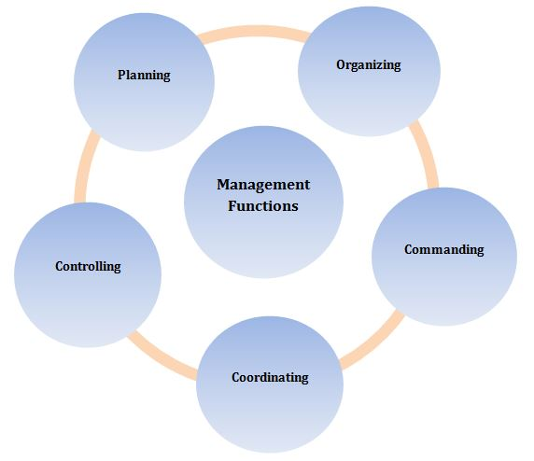
Figure 1: Functions of managers in contemporary organisations
(Source: Wren, Bedeian and Breeze, 2002)

2.2 Challenges experienced by Tesco’s managers
2.2.1 High work pressure
According to Linstead, Fulop, and Lilley (2009), high work pressure is always a major contemporary issue in human resource management. In Tesco the store managers have been suffering from huge stress due to high work pressure. The new CEO of Tesco has received many complaints about Tesco’s dysfunctional stores making managers sick. The data shows that two managers of Tesco’s London store have gone long term sick leave due to high work pressure, four managers have submitted their resignation letter and two managers have stepped down (Edwards, 2014). Some of Tesco’s customer assistant managers claimed that there is poor management in Tesco, high work stress and no sense of direction that force them to leave this organisation.
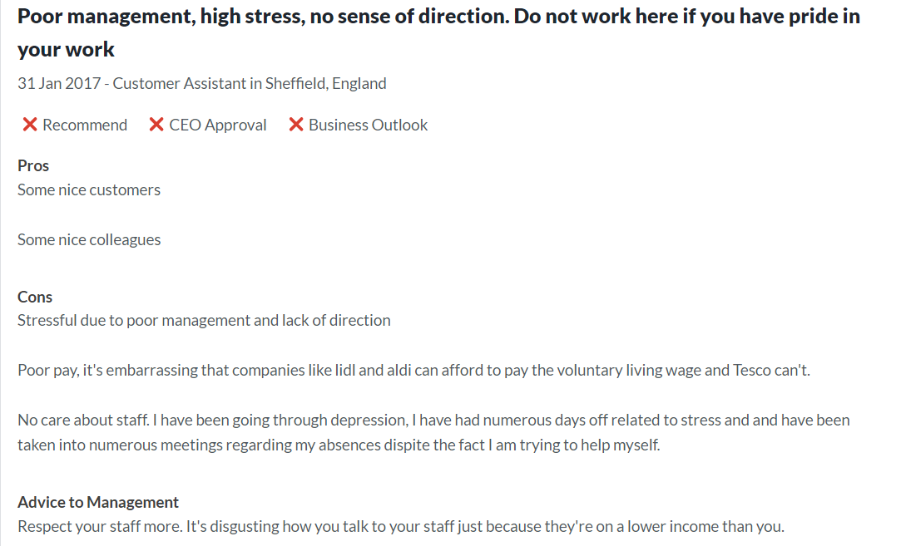
Figure 2: Feedback of Tesco’s staff
(Source: Glassdoor, 2022)
2.2.2 Lack of flexibility
Flexibility issues refer to fixed shifting hours, lack of dual shifting etc. which lead to employee burnout and job dissatisfaction (Smith, Gilmer and Stockdale, 2019). In Tesco, there is fixed shifting hour that means employees have no flexible working hours. Due to lack of flexible working in Tesco, the managers face challenges in terms of empowering employees as the work schedule is designed by the company hierarchy without asking employees about how much they comfortable with this fixed shift pattern (Tesco Plc, 2021).
2.2.3 Well-being of employees
Managing well-being of employees has become a major contemporary issue in today’s management. Employee wellbeing refers to employee health, benefits and interest (Vrontis and Christofi, 2020). In 2026, Tesco was accused for safety breach in its workplace. Tesco was fined £116,000 and ordered to pay £10,000 for its employee injury in store (Norwich, 2019). In 2016, when an employee was cleaning Tesco’s store, a hazardous chemical came in contact with his skin and suffered from chemical burns. This employee did not wear protective equipment. This incident claimed that Tesco’s store managers failed to comply with COSH (Control of Substances Hazardous to Health) Regulation. On the other hand, many Tesco’s managers faced real term pay cut after Covid-19 outbreak. Tesco team managers who earn about £30,000 per year has received only 3% hike in their salary due to high inflation rate after this pandemic (Goldfingle, 2022).

2.3 Management theories
2.3.1 Classical approach to management
The classical management approach sheds light on employee social or physical needs over job satisfaction (Carroll and Gillen, 2019). This approach suggest that more stress should be given to production instead of human being. This classical approach includes various theories among which bureaucratic management, human relations approach and scientific management are chosen for analysing the contemporary issues in Tesco’s management system.
2.3.1.1 Scientific management
The scientific management theory mainly focuses on work efficiency through scientific analysis instead of using Rule of Thumb method. This theory indicates that the relationship between management workers should be harmonious and management and workers must understand the value of each other (Waring, 2016).
2.3.1.2 Bureaucratic management
Max Webber is the founder of bureaucratic management approach. He believed that bureaucratic organisation can address management inconsistencies in an organisation and in a bureaucratic organisation resource can be effectively utilised. In a bureaucratic structure there is specific rules and regulation to control management activities (Beetham, 2018).
2.3.1.3 Human Relations approach
Human relations approach puts more emphasis on people rather than economies. According to this theory, human relations are vital for motivating staff and by building a good relationship with staff managers can address the physiological and social needs of employees. Human relations approach mainly shed light on motivational theories among which Maslow’s hierarchy of needs is widely used to reduce management issues by motivating employees (Bruce and Nyland, 2011).

2.4 Mainstream vs critical theory in the context of Tesco
According to Alvesson, Bridgman and Wilmott (2011), mainstream managers organise their talent in a centralised and standardised manner, led by motivating employees to accomplish organisational objectives. On the contrary, the critical management study (CMS) provides a range of alternatives to mainstream management (Bronner, 2011). Being a part of classical approach to management, scientific management theory triggers organisation’s productivity through scientific analysis (Waring, 2016). In Tesco, the managers did not address lack of flexibility in the workplace, which means they failed to understand that fixed scheduling may create a burden for employees as they have to work under a tight schedule. Based on the scientific management theory, it can be said that the problem associated with fixed scheduling in Tesco can be overcome by enhancing the understanding between managers and employees. Based on the scientific management theory, it can be said that Tesco’s managers need to develop a harmonise relationship with employees so that they can communicate the importance of fixed scheduling with employees. Critical management studies proponents challenge this view of mainstream management, which puts more emphasis on the value of social relationship in the workplace. Is essentially instrumental (Alvesson and Willmott, 1992).
According to CMS, instrumentalism is helps to improve business performance by building social relations in an organisation however, this is associated with other concerns like issues with employee safety, absence of democracy etc (Linstead, Fulop, and Lilley, 2009). CMS proponents indicate that business education is more valuable than instrumentalism to improve managerial roles in terms of questioning employees for understanding their needs instead of just developing a social relationship with them. When it comes to CMS vs scientific management theory in the context of Tesco, CMS suggests that Tesco’s managers must focus on business education to develop employee skill instead of building a harmonious relationship with them. This business education will help Tesco’s managers to make employee flexible in any working environment like working in tight schedule or working in a fixed shift.
Another major example of classical management approach is bureaucratic management approach, which refers to standardised process, many rules authority hierarchy and labour division (Beetham, 2018). Based on these bureaucratic principles, it can be said that if Tesco follows these principles, then the managers can address issues present in their existing management like non-compliance issue, real terms pay cut and high work pressure. As per the bureaucratic management approach, having a standardised process for designing job, working system, salary structure and employee health policy can help Tesco’s managers to eliminate errors in these management systems. For instance, in a bureaucratic structure approval comes from many decisions makers step by step (Alvesson and Willmott, 1992). Hence, if Tesco’s managers suggest any salary structure, health policy or wok design then it would be approved by top to bottom level managers thus, there will be no chance for sudden change in these decisions. These will maintain consistency in Tesco’s management decision. However, the mainstream management also identified some issues with bureaucratic management like low employee morale, lack of freedom and poor motivation. Tesco’s managers may encounter these problems if they follow this bureaucratic approach for managing their contemporary issues (Tesco, 2021). Contradictorily, CMS shed light on educating managers in the post bureaucracy, which will help them to create relaxation for employees in a bureaucratic structure by controlling them through professional freedom (Alvesson, Bridgman and Wilmott, 2011). In Tesco, educating managers in post bureaucracy can help them to control all functional areas by giving freedom to employees like taking their work-related decisions through designing their job on their own. CMS proponents highlight the importance of reflexibility, which means how accounts of managers influenced by the social position or power of managers (Malachowski, 2001). CMS mainly focuses on corporate citizenship or corporate responsibilities to deal with the unethical management practices in an organisation (Alvesson and Willmott, 1992). However, the mainstream management theories like bureaucratic approach and scientific management theories do not focus on corporate citizenship for addressing contemporary issues in management.
Unlike mainstream management, CSM indicates that by aligning the organisational strategy with CSR, companies can deal with the contemporary issues like employee rights issue, safety issue, low employee morale etc. Tesco failed to comply with COSH and this company led managers to face real term pay cut, which is unethical (Norwich, 2019). Hence, these management issues can be addressed well by adopting CSR practices. For instance, by Tesco can set an ethical standard like setting criteria of what are right and wrong for employees. Real time pay cut, lack of flexible shift and high work pressure are never right for improving employee morale. Hence, setting these criteria can help Tesco to address their contemporary issues in management. As commented by Alvesson and Willmott (1992), CSM provides a framework to help managers understand and manged organised work while mainstream management theory or classical approach enables managers to plan via measurable objectives and rationally designed organisational strategies. In other words, Linstead, Fulop, and Lilley (2009), argued that CMS focuses on knowledge while mainstream management relies on power. In the context of Tesco, the mainstream management theories believe that decisions must be taken by top level executives while CMS indicate that decisions can be taken collaboratively by sharing knowledge. Knowledge sharing will help Tesco’s managers to take decisions related to workplace flexibility, health and safety and work design by taking employee feedback.
Human Relations theory is applied to enhance workplace productivity through worker satisfaction. According to Maslow’s hierarchy of needs, managers must identify the physiological and social needs of employees for satisfying them ((Bruce and Nyland, 2011)). Based on this principle of mainstream management, it can be said that Tesco’s managers need to design an effective health and safety policy, implement flexible working environment and wages structure to motivate employees. The entire decision will be made by a shift in managerial control that means the decision-making power must be shifted from managers to workers, who collectively engaged in self-management team. Hence, the mainstream theory relies on increasing team autonomy to manage contemporary issues in management. Conversely, the critical management theory stated that team work can increase control upon employees by increasing team expectation (Linstead, Fulop, and Lilley, 2009). As criticised by Alvesson, Bridgman and Wilmott (2011), critical management theory presents an idealised view on non-economic life, which is not effective for managing business issues. Unlike, CMS, the mainstream management relies more on group autonomy, which may help Tesco’s managers to solve its contemporary issues in management like lack of flexible working, high work pressure and compliance issue by developing a group work where employees will help managers to take decision related to these issues.

3. Conclusion
Tesco's managers frequently face problems with their well-being, a lack of flexible work schedules, and intense job pressure. In this part, the scientific management theory, Max Webber's bureaucratic management approach, as well as human relations perspective have all been used to examine the classical managerial approach. It has been reported that when it comes to mainstream vs. critical management thought, the former emphasises the transfer of power from managers to bottom-line workers, whereas the latter focuses mostly on corporate ethics, CSR, training managers in post-bureaucracy, etc. Critical management studies are said to provide alternatives to conventional administration. They have a different perspective on teamwork than mainstream management theory, which is the traditional method of management.

4. Recommendations
In order to address high work pressure, well-being issue and lack of flexibility in the workplace the following action plan has been developed based on the analysis of mainstream vs critical theory of management.
Issues | Actions to be taken | Time frame | Impact on Tesco’s management
High work pressure | Setting boundaries: When Tesco’s managers are facing too much work pressure, they need to set some boundaries in terms of accepting limited calls and replying to urgent emails only rather than taking seek leaves  Seek support: Tesco’s managers can seek help from their colleagues while the work pressure is too high | 2-3 months | By answering to limited calls and emails, Tesco’s managers can manage their work stress and reduce work pressure for a certain period.  Asking help from others can help these managers to share their work load while it becomes hard to manage. This not only helps them to divide their work but also enables them to gain knowledge, which is t a major principle of CMS.
Lack of flexibility | Embracing a positive work culture includes dual shift or flexible hours | 3 months | A positive work culture will include dual shift, flexible working hours etc., which will help Tesco’s managers to address employee grievance for working under a tight schedule
Compliance issue | Maintaining ethics in business by aligning CSR practices with managerial roles | 3-4 months | By sharing information with audit agencies as well COSH can help Tesco’s managers to make a fair review of their current health and safety practices. This will help them to organise and control their safety policy through incorporating CSR practices into this policy formulation.
Real time pay cut | Reshaping Human Rights policies and offering a fixed basic pay increase | 6 months | A review of the existing Human Rights practices in Tesco will enable the managers to address employee perspective toward real-time pay cut and introduce a fixed basic pay increase for every designation

word count：2623

Reference list
Alvesson, M. and Willmott, H. (1992) Critical Management Studies, London: Sage Pubs.
Alvesson, M. Bridgman, T. and Wilmott, H. (2011) The Oxford handbook of critical management studies. Oxford OUP.
Beetham, D. (2018). Max Weber and the theory of modern politics. John Wiley & Sons.
Bronner, S.E. (2011). Critical Theory: A Very Short Introduction, New York (Oxford University Press) 2011, 144 pp. opus4.kobv.de, [online] 2(1). Available at: https://opus4.kobv.de/opus4-Fromm/frontdoor/index/index/docId/27511 [Accessed 9 Nov. 2022].
Bruce, K. and Nyland, C. (2011). Elton Mayo and the Deification of Human Relations. Organization Studies, [online] 32(3), pp.383–405. doi:10.1177/0170840610397478.
Carroll, S.J. and Gillen, D.J. (2019). Are the classical management functions useful in describing managerial work?. In Managerial Work (pp. 291-304). Routledge.
Edwards, J. (2014). Workers At Tesco, Britain’s Most Disastrous Supermarket, Tell Us Their Anguish In Heartbreaking Emails. [online] Business Insider. Available at: https://www.businessinsider.in/retail/workers-at-tesco-britains-most-disastrous-supermarket-tell-us-their-anguish-in-heartbreaking-emails/articleshow/41544497.cms [Accessed 9 Nov. 2022].
Glassdoor (2022). Tesco - Poor management, high stress, no sense of direction. Do not work here if you have pride in your work. [online] Glassdoor. Available at: https://www.glassdoor.sg/Reviews/Employee-Review-Tesco-RVW13559262.htm [Accessed 9 Nov. 2022].
Goldfingle, G. (2022). Tesco managers face real-terms pay cut - Retail Gazette. [online] www.retailgazette.co.uk. Available at: https://www.retailgazette.co.uk/blog/2022/10/tesco-managers-pay-cut/ [Accessed 9 Nov. 2022].
Grey, C. (2008). A very short fairly interesting and reasonably cheap book about studying organizations. Sage.
Linstead. S., Fulop, and Lilley, S. (2009) Management and Organization: A Critical Text, Basingstoke: Palgrave Macmillan.
Linstead. S., Fulop, and Lilley, S. (2009) Management and Organization: A Critical Text, Basingstoke: Palgrave Macmillan.
Malachowski, A. (2001) Business Ethics: Critical Perspectives on Business and Management, London: Routledge.
Norwich (2019). Tesco ordered to pay £125,000 for Health & Safety Breach. [online] QMS. Available at: https://www.qmsuk.com/news/tesco-ordered-to-pay-125000-for-health-safety-breach [Accessed 9 Nov. 2022].
Parker, L.D. and Ritson, P.A. (2005). Revisiting Fayol: Anticipating Contemporary Management. British Journal of Management, [online] 16(3), pp.175–194. doi:10.1111/j.1467-8551.2005.00453.x.
Smith, E.F., Gilmer, D.O. and Stockdale, M.S. (2019). The importance of culture and support for workplace flexibility: An ecological framework for understanding flexibility support structures. Business Horizons, [online] 62(5), pp.557–566. doi:10.1016/j.bushor.2019.04.002.
Smith, I. and Boyns, T. (2005). British management theory and practice: the impact of Fayol. Management Decision, [online] 43(10), pp.1317–1334. doi:10.1108/00251740510634895.
Tesco (2021). Annreports | Tesco annual report 2020 and earlier. [online] Annreports. Available at: https://www.annreports.com/tesco/ [Accessed 9 Nov. 2022].
Tesco Plc (2021). Board. [online] Tesco PLC. Available at: https://www.tescoplc.com/about/board-board-committees-and-executive-committee/board/ [Accessed 9 Nov. 2022].
Tesco Plc (2022). Tesco PLC. [online] Tesco plc. Available at: https://www.tescoplc.com/ [Accessed 9 Nov. 2022].
Vrontis, D. and Christofi, M. (2020). Contemporary Issues in Management and Marketing Research. Business Perspectives and Research, [online] 8(1), pp.2–3. doi:10.1177/2278533719860036.
Waring, S.P. (2016). Taylorism transformed: Scientific management theory since 1945. UNC Press Books.
Wren, D.A., Bedeian, A.G. and Breeze, J.D. (2002). The foundations of Henri Fayol’s administrative theory. Management Decision, [online] 40(9), pp.906–918. doi:10.1108/00251740210441108.

Appendix


