

Assessment Component 2

Lecturer Name: Bianca Sanfilippo

Student Name: Ronke Olomola

Student Number: 1916047

Course Name: Mental Disorders & Psychopathology

Course Code: BMH6006

Date of Submission: 29/04/2022

Word Count: 3,261

Table of Content
Page Number

General Anxiety Disorder 3

Schizophrenia 7

Childhood Autism 12

Conclusion 15

Reference 16

Appendix 21

Introduction
This report will be discussing in details the following conditions; General anxiety disorder, Schizophrenia, and Childhood Autism all these conditions can be found in the ICD 10 manual (WHO, 2010). The classifications, diagnosis, treatment, guidance, and principle of care measurements of rehabilitation of these conditions will be focused upon. Finally, recommendations will be discussed as regards each of these conditions.

General Anxiety Disorder
Classification under the classification disorder ICD (WHO, 2010): ‘F40 – F48’ Neurotic stress- related and somatoform disorders General anxiety is under F41.1

This Photo by Unknown Author is licensed under CC BY-NC-ND
Definition
General anxiety disorder is a mental health condition which affects both female and male, it presents itself as individuals feeling anxious and uneasy. NHS (2020a) explain that general anxiety ranges from mild to severe. It is a long-term condition.
Statistics of people suffering from general anxiety disorder in the United Kingdom
6 in 100 people in the United Kingdom suffer from general anxiety disorder (MIND, 2022)
5.9% of adults in the United Kingdom are experiencing generalised anxiety disorder within a given week (Anxiety UK, 2019)
Generalised anxiety disorder trebled from 4.95% to 14.88% among men aged 18 to 24 and more than doubled from 9.08% to 21.69% among those aged 25 to 35 and rose to a lesser degree among those aged between 35 to 54 (Campbell, 2020).

Appendix 2 is a graph that trends in generalised anxiety disorders and symptoms in primary United Kingdom population-based cohort study. The trends show that there has been a rise in the number of people suffering from this disorder since 1998 to 2018.

Diagnosis, Signs and Symptoms of General Anxiety Disorder
Patients are diagnosed by professionals such as General Practitioners, who carry out physical examinations such as, blood tests to rule out other health problems that could be the issue. Questionnaires as well are used, such as GAD-7. General anxiety disorder is identified by unlimited uneasiness about different things. (Public Health England, 2019). This is a condition that can only be diagnosed by a qualified healthcare professional, the symptoms must have been going on for at least six months before an individual can be diagnosed with general anxiety disorder.
The reason why a professional should diagnose is to make sure that the right diagnosis is made. NICE (2020) explains that signs include continuous agitation, tremor, muscle tension, sweating, wooziness, palpitations, and vertigo. Some individuals may suffer from insomnia and panic attacks (Royal college of psychiatrists, 2020).

Current Treatment for General Anxiety Disorder
There are levels of general anxiety disorder which are mild, moderate, and severe hence this will decide which treatment will be given to the patient. Hebert and Dugas (2019) explain that Cognitive-behavioural Treatment is one of the main treatments used for treating this disorder, it is a lengthy treatment and consists of up to 14 to 16 sessions also the usefulness of worry problem–solving training is one of the skills taught in coping with this condition. The use of medication for treating general anxiety disorder is one of the last results. Sertraline an SSRI group of medications is the recommended first-line therapy and is known to be quite effective. (Slee et al pp.160, 2020)
The royal college of psychiatrists (2020) explains that individuals can utilise cognitive behavioural treatment within a group of clients or by an individual, by watching a video. NHS (2021) explain that a combination of therapy and medication is normally the best form of treatment for general anxiety disorder, and it is a very treatable disorder.
Aetiology of General Anxiety Disorder
There are various factors that can cause general anxiety disorder, such as a family history of the individual having this disorder. External causes such as loss or having to deal with unfavourable situations. NIH (2022) highlights that general anxiety disorder could be caused by individuals that have a family history of the disorder, and hence have a greater risk of suffering from it. NICE (2020) highlights that research carried out demonstrated that individuals that had a family history of general anxiety disorder had five times more chance of being affected.

Measurements of Rehabilitation
People who suffer from general anxiety disorder can be supported by monitoring their condition, it is important that individuals seek help early, and one of the ways that professionals are able to monitor if the individual is improving is by the individual filling in GAD 7 assessment forms with each visit that they see the professional and these forms are compared to see if there is improvement or if the treatment is not working. Please see appendix 1 for the GAD 7 assessment form.

Guidance and Principle of care For Individuals suffering from General Anxiety
It is important that health care professionals form a partnership with patients that are been treated for general anxiety disorder, openness and honesty is very important and remembering to carry the patient along. Patient centred care is very crucial as it allows the patient to be enlightened and knowledgeable about their condition and to make informed choices. NICE (2019) recommends that healthcare professionals uphold the dignity of their patients and answer any questions that patient may have, building a relationship with the patient is highly recommended.

Recommendations
There are various other ways which can be used in treating general anxiety disorder, alternative treatments such as acupuncture has been recommended as one of such treatments. Clinical research studies demonstrate that acupuncture is a valid treatment for anxiety disorders without any known considerable side effects. (Amorim et al p. 36, 2018).

Schizophrenia Classification under the International classification disorder ICD 10 (2010): ‘F20 – F29’ Schizotypal and delusional disorders (F20.9)

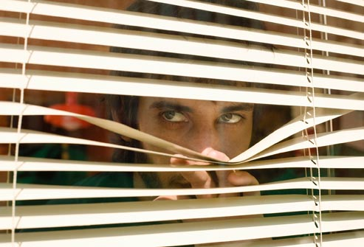
This Photo by Unknown Author is licensed under CC BY-NC

Definition
The word schizophrenia comes from the Greek word skhizen which means ‘split’ and phren which means ‘mind. (Ashok et al, pp. 1, 2012). Schizophrenia is a mental health disease that affects individuals of all class, race, and gender. NHS (2020) explain schizophrenia as a severe mental health disorder which is long term and causes a range of psychological symptoms. There are two main symptoms that affect individuals that suffer from schizophrenia these are hallucination and delusion.

Statistics of people suffering from schizophrenia in the United Kingdom
Approximately 24 million people are affected worldwide with schizophrenia 1 in 300 people (0.32%) worldwide (WHO, 2020).
Schizophrenia affects 1 in every 100 people over the course of their life most often between the age of 15 to 35 in the United Kingdom (Royal college of psychiatrists, 2020).
Schizophrenia and bipolar disorders are illnesses that affect around 2% of the population in the United Kingdom (Saleh, pp. 16, 2021).

Appendix 3 shows a graph of United Kingdom Schizophrenia epidemiology by gender year per 10,000. (reserachgate.net).

Diagnosis and Symptoms of Schizophrenia
Schizophrenia can only be diagnosed by a healthcare professional, such as a General Practitioner, who will carry out a detailed assessment, once it is established that the individual has the problem the patient is referred to a psychiatrist who specialises in such mental health conditions. Zhang et al (2019) explain that schizophrenia is a serious mental health condition that affects about 1% of the world population, it can affect cognitive defect, hallucinations, delusions, and psychosis. It is unknown the cause of schizophrenia, however it is believed that a combination of genetic and environmental factors can contribute to it affecting individuals. NHS (2020) agrees with this line of thought and states that a combination of genetic and environmental factors attribute to this mental health disorder. The symptoms that occur with individuals that suffer from this condition are:

Positive Symptoms
Hallucination: Individuals seeing, hearing, and feeling things that are not real. Casarella (2020) also agrees with this line of thought and states that people with schizophrenia might , perceive, discren, smell, or feel things no one else, experiences.
Delusion: Individuals believing things that are not real as stated by Mayo Clinic (2022) individuals believing that they are going to be harmed.

Negative Symptoms
This is when an individual that has schizophrenia does not have facial expressions that normal individuals have such as facial expressions, Pietrangelo (2020) agrees with this line of thought and highlights that those that suffer from this condition lack facial expression, interest in the world and emotional response.
Psychosis
This is when an individual suffering from schizophrenia has a significant difference to a person’s ideas, mood, and behaviour. NICE (2021a) agree with this idea and explains that ‘psychosis involves a number of symptoms associated with significant alternations to a person’s perception, thoughts mood and behaviour’.

Cognitive Symptoms
Individuals who suffer from schizophrenia are known to be affected with their cognition, the way they process information is slower and the ability to problem solve is limited as stated by Alkan, Davis, and Evans (2021) argue that those who suffer from schizophrenia have been found to have issues with visual learning, and social cognition.

Current Treatment for Treating Schizophrenia
Schizophrenia is best treated with a combination of talking therapy and medication. According to NHS (2022) Treatment for each patient needs to be individualised, a combination of talking therapy and medication is often effective. Schizophrenia is said to be very difficult to treat as one medication is said not to be effective. (Stepnicki et al p. 102, 2021) highlight that the treatment for schizophrenia is more effective with multi targeted drugs. The following treatments are recommended for schizophrenia:

Talk Therapies (Cognitive behaviour therapy)
Medications: up to 3 in 10 people with schizophrenia do not respond to two or more dopaminergic antipsychotics also Clozapine is argued to be under used in healthcare for the treatment of schizophrenia. (Lally, Gaughran and Curran, p.117, 2016).
Arts and creative therapy
Family interventions (Mind, 2022)
Aetiology of Schizophrenia
It has been known that there are various things that can cause individuals to suffer from this mental health disorder such as:
Drug taking
Family history of mental health issues
WHO (2022) emphasize that a combination of genes and a range of environmental factors may cause schizophrenia?
Holland (2020) explain that the following issues could cause schizophrenia:
Structural Changes in the brain
Chemical changes in the brain
Pregnancy or birth complications
Childhood trauma
Appendix 4 is a picture showing the risk factors that can cause schizophrenia.

Measurements of Rehabilitation for Patient Suffering from Schizophrenia
The way in which an individual suffering from schizophrenia can be measured as regards their rehabilitation is by using the Quality indicator for rehabilitative care (QuIRC-SA), it is used for individuals who suffer from long term mental health conditions. Killaspy et al (2016) express the importance of this tool and state mental health rehabilitation focus on people that have serious and complicated issues. The Quality indicator for rehabilitative care is a tool which assists in measuring the quality of life the client is having by measuring these with the aid of, Quality indicator for rehabilitative care (QuIRC-SA). Appendix 5 shows a copy of ‘Quality Indicator for Rehabilitative care (QUIRC-SA) form. It is important that individuals that suffer from schizophrenia are kept from self-harm, avoid complications, and have a good quality of life, they should be able to review the treatment they are having and make sure that it is working. Lifelong skills such as been able to carry out activities of daily living independent is important.

Guidance and Principle of Care for Patients Suffering from Schizophrenia
Empathy is very important when dealing with patients with this condition, it is very important that health care professionals are always upholding the dignity of the patient and remember to communicate with their patient effectively and listen to their fears and attempt to answer their patients’ questions. It is a very trying period for both the patient and their family hence reassurance and understand is of utmost importance. So that vulnerable individuals that suffer from schizophrenia are not treated unfairly there are acts in place that the government emphasizes must be used when dealing with such patients these are Human Right Acts (1998), Equality Act (2010), Data protection Act (2018) , Care Act (2014), Mental Health Act (2007) and Mental Capacity Act (2005) All these Acts have been put in place so that individuals are treated with respect, dignity, and fairness.

Information received by professionals must be used for what they have been collected for and once not in use must be deleted from their system, this is to make sure that information of patients is kept secure. If patients have the mental capacity to make decisions as regards their care, it is paramount that they are listened to and respected. (Mental Capacity Act 2005).

Recommendation
It is often important that patients suffering from schizophrenia can use alternative treatments to alleviate the symptoms that they have due to the condition. It has been argued that some patients prefer to use psychosocial strategies for treating the symptoms that arise due to schizophrenia (Copper et al 2020). It is sometimes requested by patients that they would prefer to use alternative treatments hence has become more acceptable for patients to now include other ways of treating their conditions instead of relying solely on medication. Melo-Dias et al (2019) explain that progressive muscle relaxation has been found to be useful in decreasing anxiety and improve well – being in adults diagnosed with schizophrenia.
Childhood Autism
Classification (F80- F89 Disorders of psychological development, ICD, 2010) F84.0

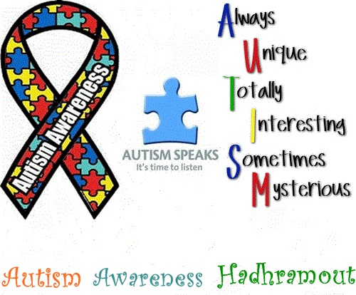
This Photo by Unknown Author is licensed under CC BY-NC-ND

Definition
The autism society (2022) highlight that autism is a complex and lifelong condition, which can be noticed from childhood. It is a condition that individuals are born with and do not recover, it can only be managed. It affects every part of the child’s life, physical, mental, and social. There are spectrums to the condition hence. NHS (2022) highlights that those that suffer from autism are not sick and do not have a disease, but their brain works differently.

Statistics of people suffering from Childhood Autism in the United Kingdom
1 to 2% of the United Kingdom population, which is 1 per 100 children, which are around 100,000 children in the UK suffer with autism. (Hey, 2021)
1 in 57 (1.76%) children in the UK are on the autistic spectrum (Mathews, 2021)
The British Medical Association (2022) highlights that 1 in 100 in the UK had been diagnosed with been on the spectrum of autism.
NINDS (2021) argue that boys are more affected with autism than girls. Appendix 6 is a chart showing the rise in the number of pupils with autism.

Aetiology of Childhood Autism
There is no known cause of autism as stated by The National Autistic Society (2022) Evidence shows that it maybe genetic, it is further stressed the way a child is brought up does not cause a child to become autistic. NHS (2019) explain that more than one child in a family can be affected with autism, which shows that it can be passed from a parent to a child.

Signs and Symptoms of Autism
The signs that demonstrate that a child may have autism are:
Not making eye contact with individuals
Does not respond to their name at the age of 9 months
Non facial expression
Repeats words repeatedly
Having obsessive interests
(CDC, 2022)
Some autistic patients suffer from issues such as anxiety and hallucinations (Rentergem et al 2021).
Diagnosis of Childhood Autism
Once a parent observes a child has signs of autism it is imperative that they consult a healthcare professional with their concerns. A General practitioner or a health visitor would be the first point of call and various tests will be carried out, such as performing a blood test to make sure the right diagnosis, it is always helpful for a child to be diagnosed as soon as possible for them to get the necessary support.

Great Ormond Street Hospital (2022) explain that children are normally diagnosed with autism by more than one healthcare professional. If the child is under five years old the special educational needs (SENCO) staff at the child’s school can be approached for support and help where there are concerns. For a child to be diagnosed with autism a detailed assessment needs to be undertaken by an autism specialist. The Autism Diagnostic interview – Revised is also used. Appendix 7 is a sample of an ADI – R Form

Current treatments for childhood Autism
Jia liang, Haiyan and Huiying (2021) express that treatment for children who have autism can be divided into categories which are behavioural and communication approaches, dietary approaches, and medication, complementary and alternative medication. There are various treatments that are used to assist in alleviating the symptoms of autism, however it is a condition that cannot be cured but with good care and support children that suffer from autism can live a good life. There are some treatments that do not work and have no research to back its effectiveness. NHS (2019) highlights that there are some treatments for treating Autism which are harmful, these are bleaching (chlorine dioxide), vitamins, minerals, diet supplements and Gamar an injection made from blood cells.

Measurements of Rehabilitation for Childhood Autism
Measurements of rehabilitation ‘Childhood Autism Rating Scale (CARS) and observation is the main tool used to measure how children that have autism are coping with their condition and this is utilised to see if the therapy used is working effectively. CARS is a simple and not costly tool which is used in various developed countries. (Stevanovic, 2021, p. 2544,). There is also an effective observation, called ADOS - ‘Autism Diagnostic Observation Schedule’. This assists in measuring if the treatment and therapy given to the autistic child is effective or not. (Carruthers et al, 2020, p.411) explains that the goals for many autism interventions those for young children include improving social and communication skills also managing restricted and repetitive behaviours. Appendix 8 is a copy of a childhood autism rating scale. Appendix 9 is a copy of an Autism Diagnostic Observation Schedule. Constant reviewing of the child is paramount to make sure that there is progress.

Guidance and Principle of Care for Children with Autism
It is paramount that children that have autism are treated with respect and dignity, due to their condition it is important that they are not neglected or denied the care that they deserve. NICE (2021b) explains that all autistic children have the opportunity access health and social care services no matter what their intellectual ability is. To make sure that children have the correct care, and their needs are met.
A Therapeutic environment assists greatly in getting a better result when caring for children with autism. Autism Society (2016) highlights that to help children with autism adapt to their environment is one aspect of a comprehensive treatment approach. The Equality Act (2010) makes sure that individuals such as autistic children are treated the same as other individuals. This makes sure that due to the difficulties them may with communicating due to their conditions, this will not stop them from getting the right support that is required for their comfort.

Recommendations
Kaplan (2012) stress that many parents that have autistic children utilise alternative and complementary therapies. It has become quite popular for parents to try other ways in improving their children’s symptoms. Lynch (2019) expresses that relaxation helps to elevate anxiety in children with autism.

Conclusion
This report has focused on three different conditions that can be found in the ICD manual, it has discussed the causes, symptoms, treatments and how they can be evaluated to see the progress of the treatment that the individuals receive. Patient centre care has been recommended for all the patients that have general anxiety, schizophrenia, and childhood autism.

Reference
Alkan, E. et al (2021) ‘Cognitive impairment in schizophrenia: relationships with cortical thickness in fronto – temporal regions and dissociability from symptom severity’ npj schizophrenia 20 (7) https://doi.org/10.1038/s41537-021-00149-0
Amorim, D.et al (2018) ‘Acupuncture and electroacupuncture for anxiety disorders: a systematic review of the clinical research’ Complementary Therapies In Clinical Practice 31 pp. 31 – 37 https://www.sciencedirect.com/science/article/pii/S1744388118300689
Anxiety UK (2019), ‘Key facts and figures’ Anxiety UK(online) available at https://www.anxietyuk.org.uk/wp-content/uploads/2019/08/Key-Facts-and-Figures-2019.pdf [Accessed on 26 March 2022]
Ashok, H. A. et al (2012) ‘Paul Eugen Bleuler and the origin of the term Schizophrenia [SCHIZOPRENIEGRUPPE]’ Indian Journal of Psychiatry 54 (1) pp. 1 – 6 https://www.ncbi.nlm.nih.gov/pmc/articles/PMC3339235/
Autism Society (2022) ‘What is Autism’ Autism Society (online) available at https://www.autism-society.org/what-is/ [Accessed on 17 April 2022]
Autism Society (2016) ‘Environmental modifications for children with autism? How to shape the environment to boost success’ Autism Society [blog] 7 December. Available at https://www.autism-society.org/environmental-modifications-children-autism-shape-environment-boost-success/ [Accessed on 18 April 2002]
British Medical Association (2022) ‘Autism spectrum disorder’ British Medical Association (online) available at https://www.bma.org.uk/what-we-do/population-health/improving-the-health-of-specific-groups/autism-spectrum-disorder [Accessed on 17 April 2022]
Campbell, D. (2020), ‘UK has experienced expulsion in anxiety since 2008 study finds’ The Guardian available at https://www.theguardian.com/society/2020/sep/14/uk-has-experienced-explosion-in-anxiety-since-2008-study-finds [Accessed on 27 March 2022]
Carruthers, S. et al (2020) ‘Utility of the Autism Diagnostic Observation Schedule and the brief observation of social and communication change for measuring outcomes for a parent – mediated early autism intervention’ Autism Research 14 (2), p. 411 – 425. https://doi.org/10.1002/aur.2449
Casarella, J. (2020) ‘What causes schizophrenia?’ WebMD (online) available at https://www.webmd.com/schizophrenia/what-causes-schizophrenia [Accessed on 11 April 2022]
Care Act (2014) Legislation. Gov. UK (online) available at www.legislation.gov.uk [Accessed on 17 April 20222]
CDC – Centre for Disease Control and Prevention (2022) ‘Screening and Diagnosis of Autism Spectrum Disorder’ Autism spectrum disorder (online) available at https://www.cdc.gov/ncbddd/autism/screening.html [Accessed on 21 April 2022]
Centres for Diseases control and Prevention (2022) ‘Signs and Symptoms of Autism Spectrum Disorder’ Centres for Diseases control and Prevention (online) available at https://www.cdc.gov/ncbddd/autism/signs.html [Accessed on 17 April 2022]
Clinical Partners (2021) ‘Why are more boys diagnosed with autism than girls? Multiple factors at play and more research needed’ Clinical Partners (online) available at https://www.clinicalpartners.co.uk [Accessed on 21 April 2022]

Copper, E. R. et al (2021) ‘Opinion piece: The case for establishing a minimal medication alternative for psychosis and schizophrenia’ Psychological, social, and integrative approaches 13 (3) http://doi.org/10.1080/17522439.2021.1930119
Data Protection Act (2018) Legislation. Gov. UK (online) available at www.legislation.gov.uk [Accessed on 17 April 20222]
D’ Arrigo, T (2020) ‘What are the symptoms of schizophrenia’ Web Med (online) available at https://www.webmd.com/schizophrenia/schizophrenia-symptoms [Accessed on 11 April 2022]
Equality Act (2010) Legislation. Gov. UK (online) available at www.legislation.gov.uk [Accessed on 17 April 20222]
Great Ormond Street Hospital for children (2022) ‘Autism Spectrum’ National Health Service (online) available at https://www.gosh.nhs.uk/conditions-and-treatments/conditions-we-treat/autism/ [Accessed on 17 April 2022]
Hebert, A, E. and Dugas, J, M. (2019) ‘Behavioural experiments for intolerance of uncertainty challenging the unknown in the treatment of generalised anxiety’ Cognitive and behavioural practice 26 (2) doi:10.1016/cbpra.2019.07.007
Hey, L. (2021) ‘Autism in the UK: prevalence, assessment and the impact of the covid 19 pandemic’ horgrefe (online) available at https://www.hogrefe.com/uk/article/autism-in-the-uk-prevalence-assessment-and-the-impact-of-the-covid-19-pandemic [Accessed on 17 April 2022]
Holland, K. (2020) ‘6 causes of schizophrenia that may surprise you’ Healthline https://www.healthline.com/health/schizophrenia-causes
Human Right Act (1998) Legislation. Gov.UK (online) available at www.legislation.gov.uk [Accessed on 17 April 20222]
Jialiang, H. Haiyan, Z. and Huiying, Z. (2021) ‘Research on the auxiliary treatment system of childhood autism based on virtual reality’ Journal of Decision Systems https://doi.org/10.1080/12460125.2021.200351
Kaplan, A. (2013) ‘Complementary and alternative treatments for autism spectrum disorders’, Psychiatric Times, 30 (3) https://www.psychiatrictimes.com/view/complementary-and-alternative-treatments-autism-spectrum-disorder
Killaspy, H. et al (2016) ‘Adaptation of quality indicator for rehabilitative care (QuIRC) for use in mental health supported accommodation services (QuIRC-SA)’ BMC psychiatry 101 (16) https://bmcpsychiatry.biomedcentral.com/articles/10.1186/s12888-016-0799-4
Lally, J. Gaughran, F. and Curran, R. S. (2016) ‘Treatment – resistant schizophrenia: current insights on pharmacogenomics of antipsychotics’ Pharmacogenomics and Personalized Medicine (9) p. 117 – 129 https://www.ncbi.nlm.nih.gov/pmc/articles/PMC5106233/#:~:text=Up%20to%2030%25%20of%20people,is%20underused%20in%20clinical%20practice.
Lynch, C. (2019) ‘Relaxation training for kids on the autism spectrum’, Psychology Today, [blog] 3 June. Available at https://www.psychologytoday.com/gb/blog/autism-and-anxiety/201906/relaxation-training-kids-the-autism-spectrum [Accessed on 18 April 2022]
Mathews, F. (2021) ‘Autism rates increase’ Newcastle University (online) available at https://www.ncl.ac.uk/press/articles/archive/2021/03/autismratesincrease/ [Accessed on 18 April 2022]
Mayo Clinic (2022) ‘Schizophrenia symptoms and causes’ Mayo Clinic (online) available at https://www.mayoclinic.org/diseases-conditions/schizophrenia/symptoms-causes/syc-20354443 [Accessed on 22 April 2022]
Melo-Dias, C. et al (2019) ‘Schizophrenia and progressive muscle relaxation – A systematic review of effectiveness’ Heliyon 5 (4) https://doi.or/10.1016/j.heliyon.2019.e01484
Mental Capacity Act (2005) Legislation. Gov.UK (online) available at www.legislation.gov.uk [Accessed on 17 April 20222]
Mental Health Act (2007) The Mental Health Act 1983, Amended in 2007 (online) available at http://www.mentalhealthwales.net/the-mental-health-act-1983-amended-in-2007/
MIND (2022), Mental health facts and statistics (online) available at https://www.mind.org.uk/information-support/types-of-mental-health-problems/statistics-and-facts-about-mental-health/how-common-are-mental-health-problems [Accessed on 26 March 2022]
MIND (2022) What treatments are there for schizophrenia (Online) available at https://www.mind.org.uk/information-support/types-of-mental-health-problems/schizophrenia/treatment/ [Accessed on 11 April 2022]
Mayo Foundation for medical education and research (2022) Schizophrenia (online) available at https://www.mayoclinic.org/diseases-conditions/schizophrenia/symptoms-causes/syc-20354443 [Accessed on 11 April 2022]
NAS - National Autistic Society (2022) The Cause of autism (online). Available at https://www.autism.org.uk/advice-and-guidance/what-is-autism/the-causes-of-autism [Accessed on 17 April 2022]
NHS -National Health Service (2016) Fake and harmful autism treatment (online). Available at https://www.nhs.uk/conditions/autism/autism-and-everyday-life/fake-and-harmful-treatments/ [Accessed on 19 April 2022]
NHS - National Health Service (2019) What is Autism (online). Available at https://www.nhs.uk/conditions/autism/what-is-autism/ [Accessed on 17 April 2022]
NHS -National Health Service (2021) Overview – generalised anxiety disorder in adults (online) available at https://www.nhs.uk/mental-health/conditions/generalised-anxiety-disorder/overview/ [Accessed on 27 March 2022]
NHS- National Health Service (2022a) Overview – Schizophrenia (online). Available at https://www.nhs.uk/mental-health/conditions/schizophrenia/overview/ [Accessed on 29 March 2022]
NHS -National Health Service (2022b) Treatment – Schizophrenia (online). Available at https://www.nhs.uk/mental-health/conditions/schizophrenia/treatment/ [Accessed on 11 April 2022]
NICE- National Institute for Health and Care Excellence (2022), When should I suspect generalised anxiety disorder? (online). Available at https://cks.nice.org.uk/topics/generalized-anxiety-disorder/diagnosis/diagnosis/ [Accessed on 27 March 2022]
NICE - National Institute of Health and Excellence (2020)’Generalised anxiety disorder in adults (online) available at https://www.nice.org.uk/guidance/cg113/evidence/anxiety-full-guidance-pdf-136340461 [Accessed on 27 March 2022]
NICE- National Institute of Health and Care Excellence (2019) Generalised anxiety disorder and panic disorders in adults : Management (Online) available at https://www.nice.org.uk/guidance/cg113/chapter/1-Guidance#principles-of-care-for-people-with-generalised-anxiety-disorder-gad [Accessed on 11 April 2022]
NICE - National Institute for Health and Care Excellence (2021a) Psychosis and Schizophrenia (online). Available at https://cks.nice.org.uk/topics/psychosis-schizophrenia/ [Accessed on 11 April 2022]
NICE - National Institute of Health and Care Excellence (2021b) General principles of care autism spectrum disorder in under 19s: support and management (online) available at https://www.nice.org.uk/guidance/cg128 [Accessed on 11 April 2022]

NIMH - National Institute of Mental Health (2022), Generalised anxiety disorder: when worry gets out of control (online). available at https://www.nimh.nih.gov/health/publications/generalized-anxiety-disorder-gad [Accessed on 27 March 2022]
NINDS – National Institute of Neurological Disorders and Stroke (2020) Single mutation leads to big effects on autism – related gene (online) available at https://www.ninds.nih.gov/News-Events/News-and-Press-Releases/Press-Releases/Single-mutation-leads-big-effects-autism-related [Accessed on 11 April 2022]
Pietrangelo, J, L. (2020) ‘What are the ‘negative “symptoms of Schizophrenia?’ Healthline (online) available at https://www.healthline.com/health/mental-health/negative-symptoms-of-schizophrenia [Accessed on 18 March 2022]
PHE - Public Health England (2019. Guidance working age adults (online). Available athttps://www.gov.uk/government/publications/better-mental-health-jsna-toolkit/6-working-age-adults [Accessed on 18 March 2022]
Rentergem, V. A. et al (2021) ‘A systematic review of research on autism spectrum disorder’ Clinical Psychology Review 87 (1) https://doi.org/10.1016/j.cpr.2021.102033
Royal college of psychiatrists (2020) Anxiety, panic and phobias video clip panic attacks available at https://www.rcpsych.ac.uk/mental-health/problems-disorders/anxiety-panic-and-phobias [Accessed on 27 March 2022]
Royal college of psychiatrists (2020), Schizophrenia (online) available at https://www.rcpsych.ac.uk/mental-health/problems-disorders/schizophrenia [Accessed on 29 March 2022]
Saleh, A. et al (2021), ‘Birth seasonality of schizophrenia and bipolar disorder? A review of inpatient records’ Journal of Affective Disorders (28) p. 15 – 18 https://www.sciencedirect.com/science/article/pii/S0165032721002159
Slee, A. et al. (2021), ‘Trends in generalised anxiety disorder and symptoms in primary care: UK population-based cohort study’ British Journal of Psychiatry p. 158 – 164 18 (3) https://pubmed.ncbi.nlm.nih.gov/32895062/
Stevanovic, D. et al (2021) ‘Measurement invariance of the childhood Autism Rating Scale across six countries’ Autism Research, 14 (12), p. 2544 2554 https://doi.org/10.1002/aur.2586
Stepnicki et al (2021) ‘Multi – target drug design strategies for the treatment of schizophrenia’ Expert Opinion on Drug Discovery p. 101 -114 16 (1) https://www.tandfonline.com/doi/abs/10.1080/17460441.2020.1816962
WHO - World Health Organisation (2022) Schizophrenia (online) available at https://www.who.int/news-room/fact-sheets/detail/schizophrenia [Accessed on 11 April 2022]
WHO - World Health Organisation (2010) ‘ICD-10 - International Statistical Classification of Diseases and Related Health Problems’ 10th Revision (Online) Available at: https://icd.who.int/browse10/2010/en#/V [accessed on 1 March 2022]
Zhang, L. et al (2019) ‘EEG Signals Classification Using Machine Learning for the Identification and Diagnosis of Schizophrenia’ Medicine and Biology Society. Annual International Conference p. 4521–4524. https://doi.org/10.1109/EMBC.2019.8857946

Appendix one
Below is a copy of a GAD 7 Assessment
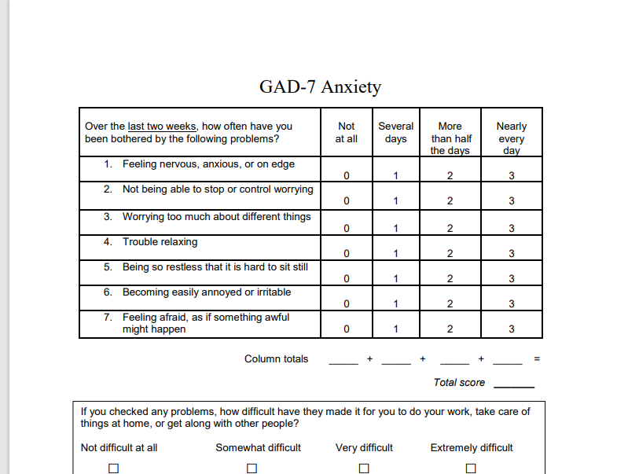

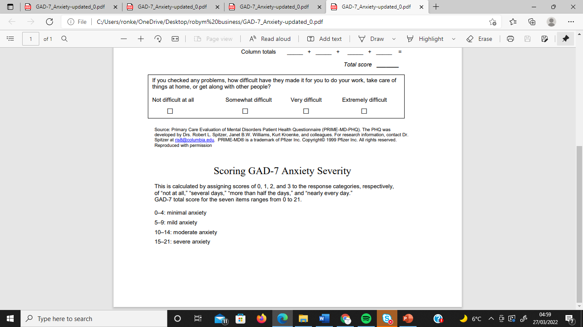

Cambridge University press
Appendix two
A graph that trends in generalised anxiety disorders and symptoms in primary United Kingdom population-based cohort study.

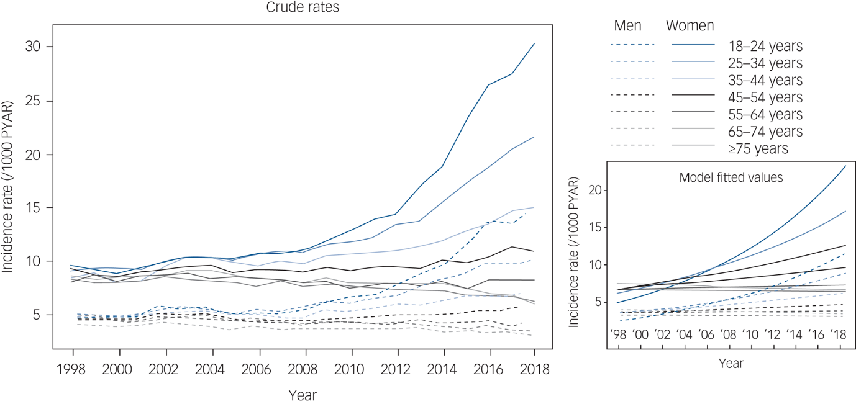
Cambridge University press

Appendix 3

A graph of United Kingdom Schizophrenia epidemiology by gender year per 10,00. Which shows the rise of numbers from the year 1994 to 1998
(reserachgate.net)

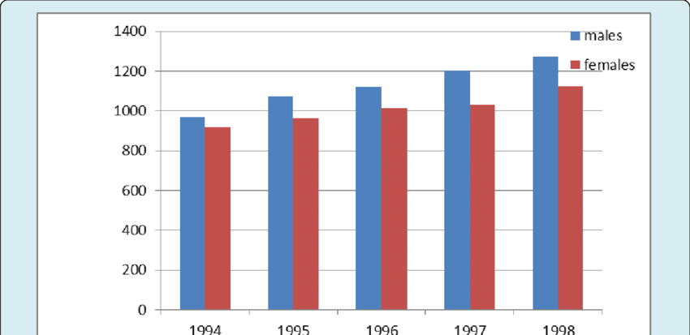

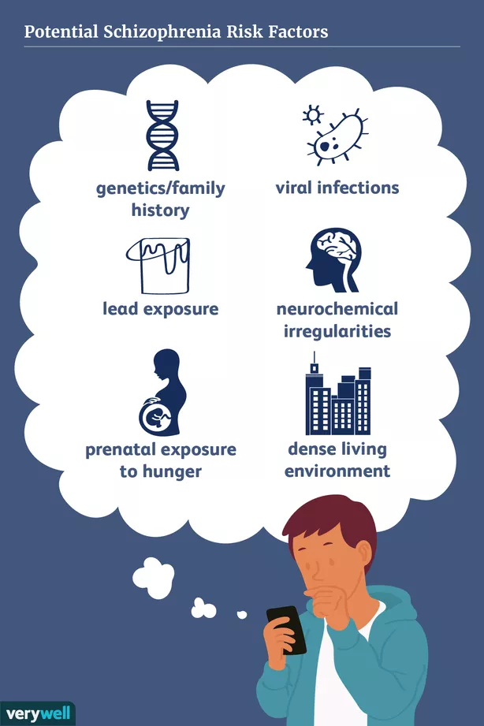
Appendix 4 is a picture showing the risk factors that can cause schizophrenia
Appendix 5
A copy of a Quality Indicator for Rehabilitative care (QUIRC-SA) form (StudyRes)

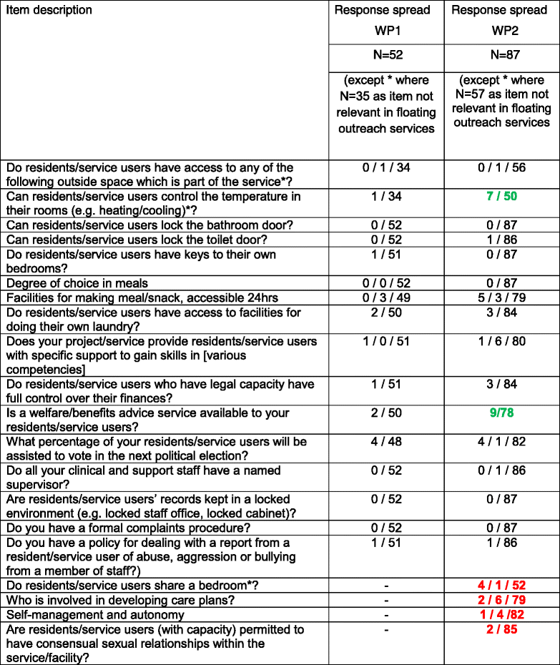

Appendix 6
A chart showing the rise in the number of pupils with autism from the year 2010 – 2019 (StudyRes)

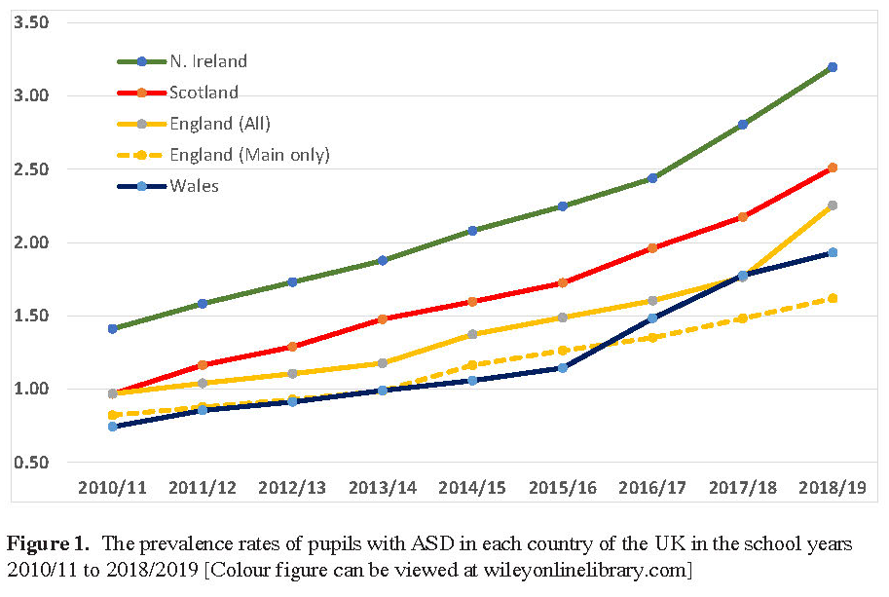

Appendix 7

A Sample of An ADI- R Form (StudyRes)

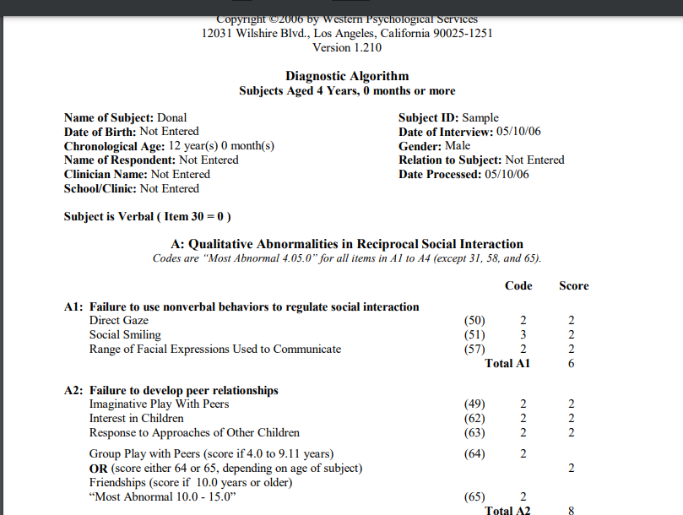

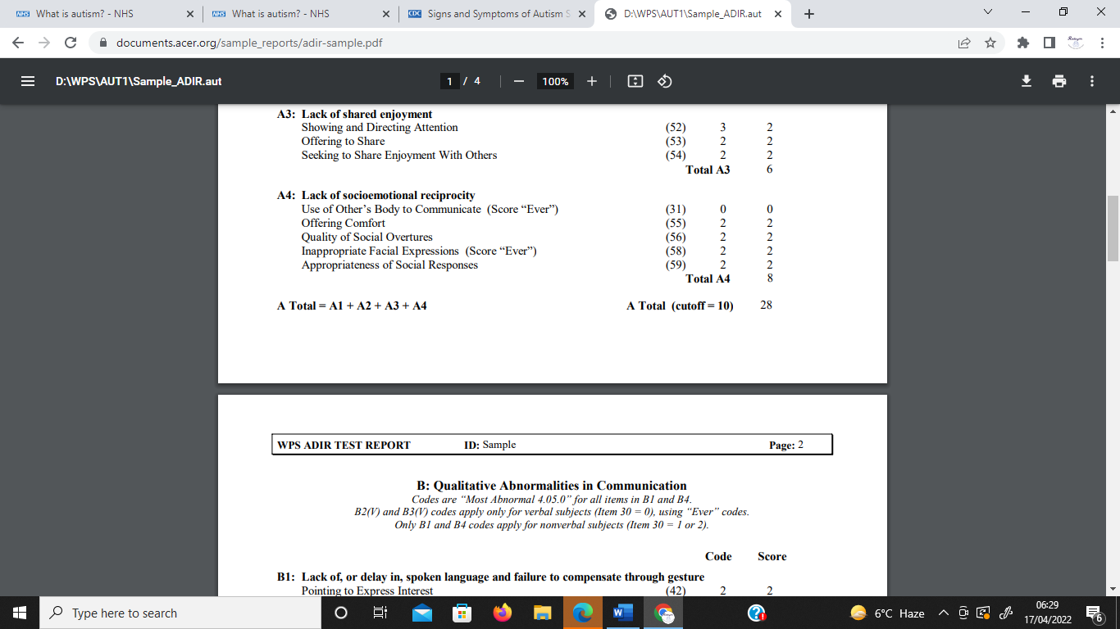

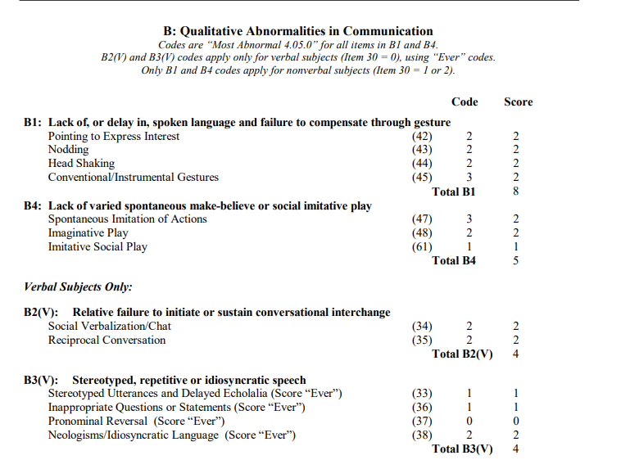

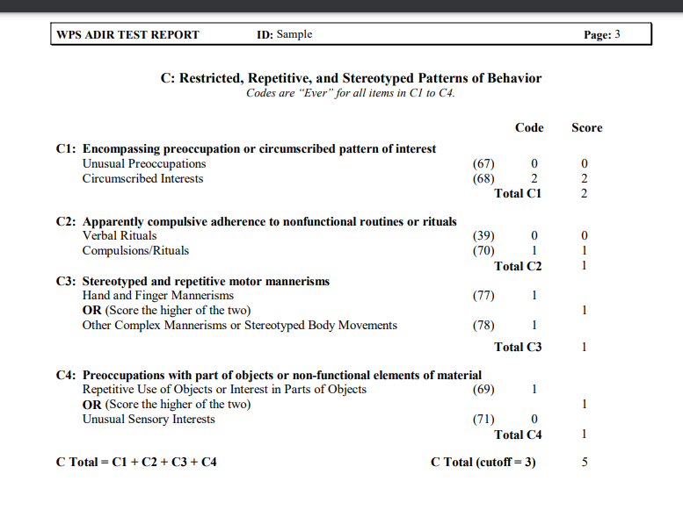

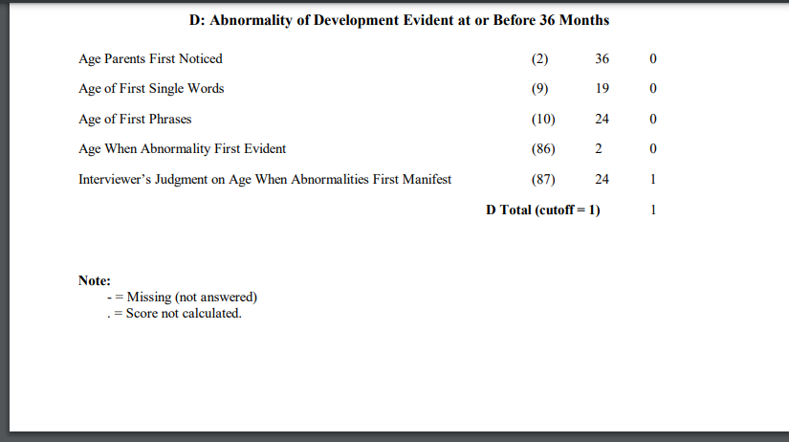

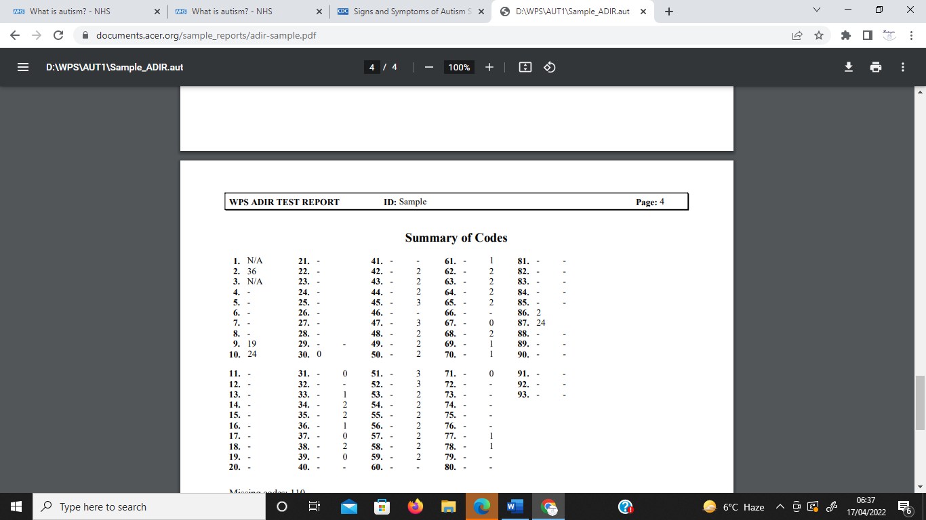

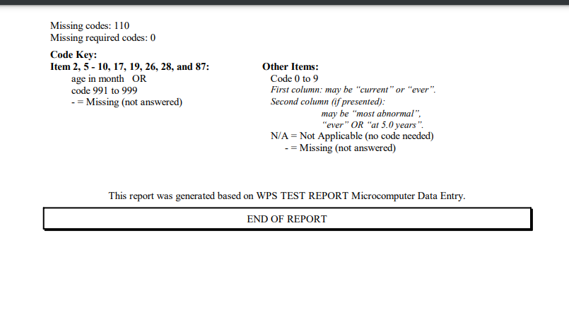

(StudyRes)

Appendix 8 A Childhood Autism Rating Scale

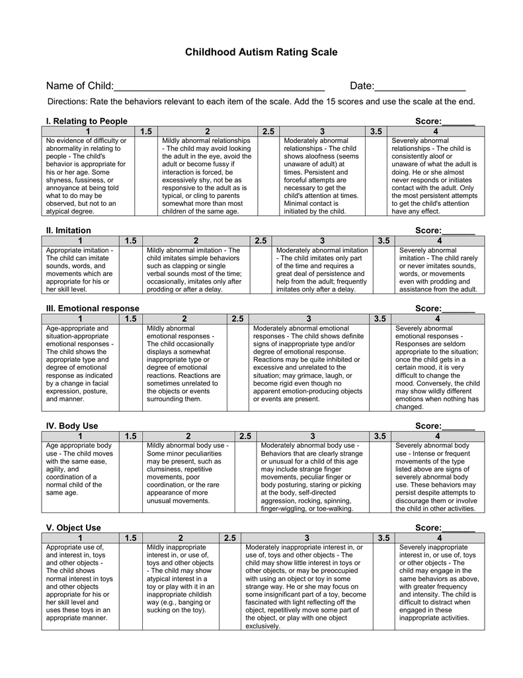
(StudyRes)

Appendix 9
A copy of an Autism Diagnostic Observation Schedule

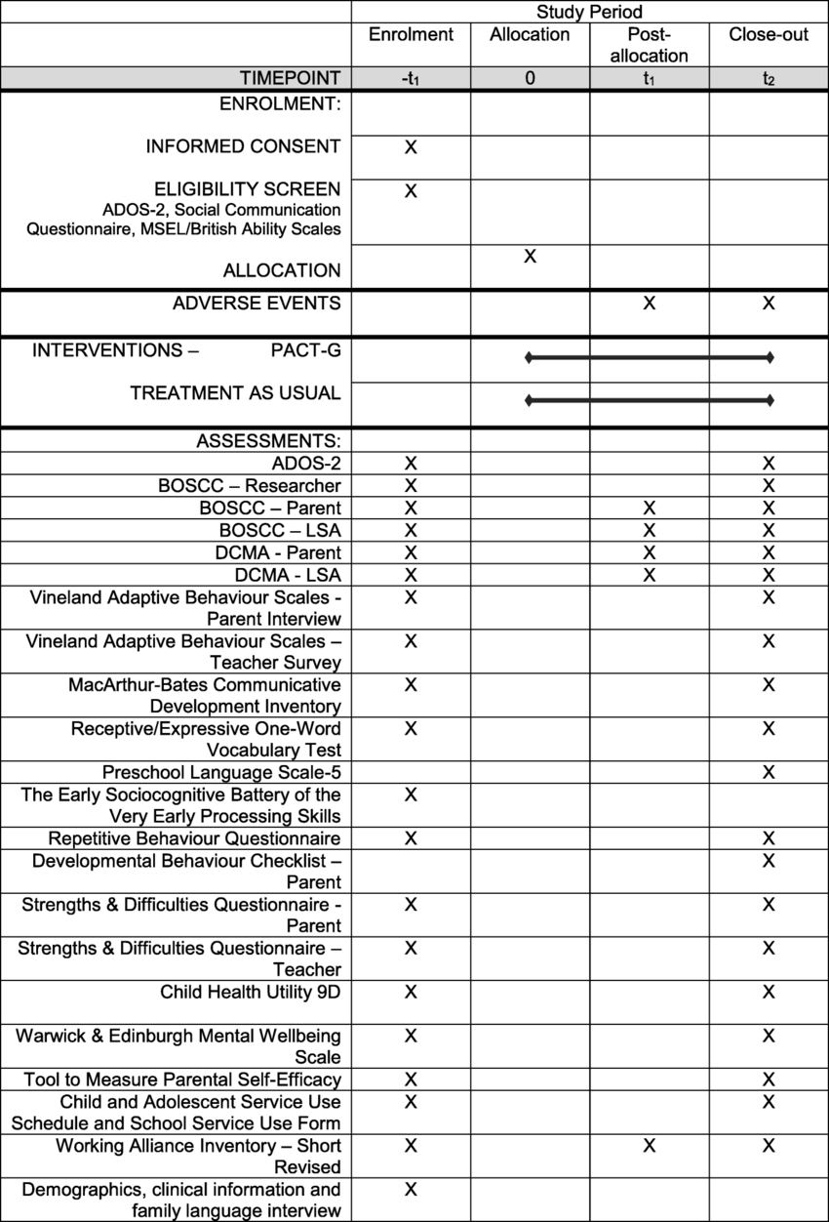
(StudyRes)

