UNIVERSITY OF WALES TRINITY SAINT DAVID



LEVEL 5 ASSESSMENT
Component 2: Written Assignment (Report)

Programme | BSc Health and Social Care
Module | Changemakers: Building your Personal Brand for Sustainable Employment
Module code | BMHP5015
Assignment title | Employability Development Report: Care Coordinator
Student name
Student number
Word count | 1901 words
Submission date | 19 July 2026

Chosen role: Care Coordinator, Dashwood Primary Care Network

Report Contents
Report contents 2
1. Introduction 3
2. Current vacancy and person specification 3
3. Analysis of employability skills 6
4. Evaluation of my current skills 7
5. Personal brand, professional identity and networking 8
6. Value I could add to the role 8
7. Five-year action plan and timeline 9
8. Communicating my skills to an employer 10
9. Conclusion 11
Reference list 12

1. Introduction
This report focuses on the role of Care Coordinator in a UK Primary Care Network. I selected the current vacancy for Dashwood Primary Care Network in High Wycombe. NHS Jobs (2026) advertised the post as a full-time role with a salary range of £24,784.50 to £25,500 WT. The advert closes on 31 July 2026. This role interests me because it links health care, social care and community support. It also gives direct contact with patients while using organisation, teamwork and digital skills.
The report first analyses the employability skills needed for the role. It then compares these skills with my current abilities. Finally, it sets out a five-year action plan. It also explains how I will build a personal brand, develop a professional identity and create a useful employment network.

2. Current vacancy and person specification
FedBucks Ltd are looking to appoint a Care Coordinator to join Dashwood Primary Care Network, in High Wycombe (HP13 6SL). This is a 1-year fixed term role on a 22.5 hour per week pro rata basis with salary of £24,784.50–£25,500 per annum, NHS pension, 33 days annual leave (inc bank) and an Employee Assistance Programme. Responsibilities include: coordinating care for vulnerable people, supporting multidisciplinary teams, communicating with GP surgeries, care homes and outside agencies, visiting patients in the community, ensuring accurate records and co-ordinating referrals and the wellbeing of the patient.
The vacancy asks for experience in health care, social care or a patient-facing support role and ideally a Level 2 Health & Social Care qualification. It also asks for compassion, clear communication, good administration, attention to detail, IT skills, confidentiality and safeguarding awareness. NHS England (2023a) adds that care coordinators should assess changing needs, manage risk, support shared decisions and work safely within clear boundaries. Therefore, the role is not only administrative. It requires judgement, trust and a person-centred approach.
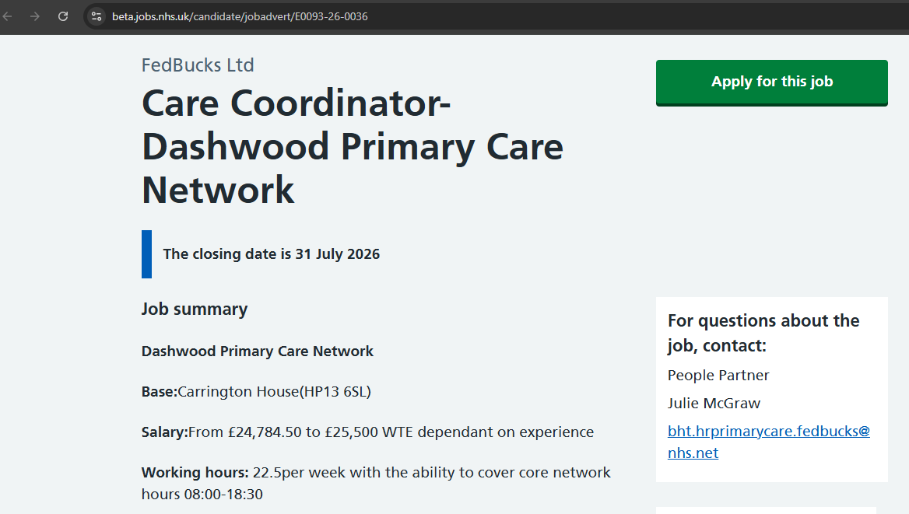
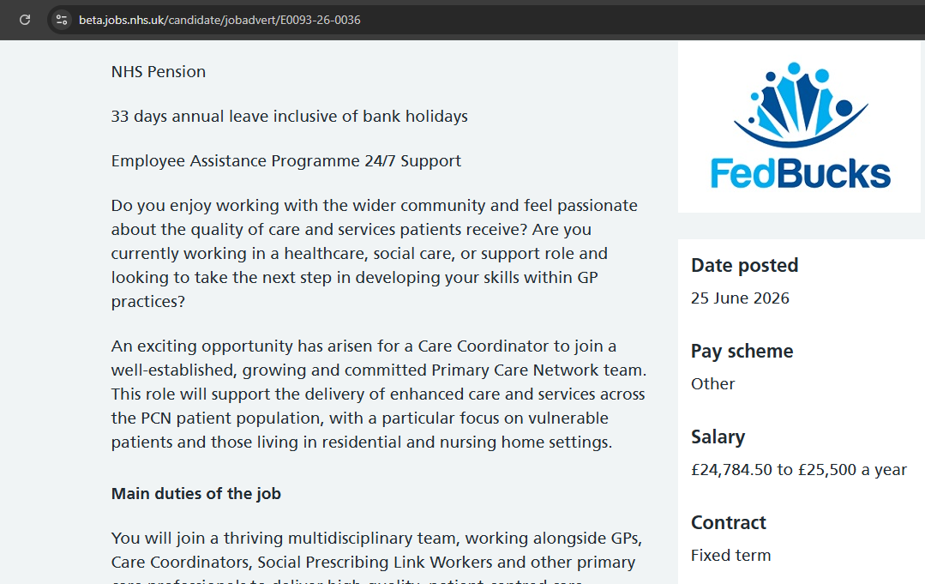
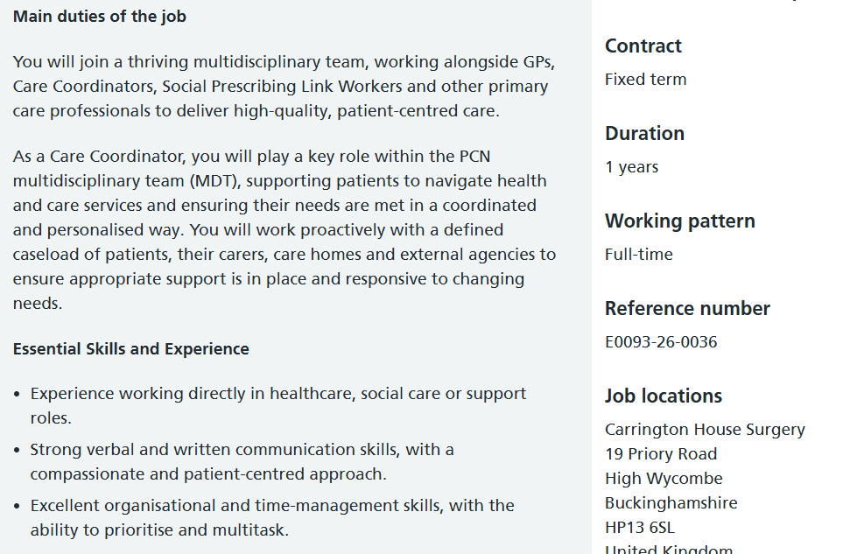
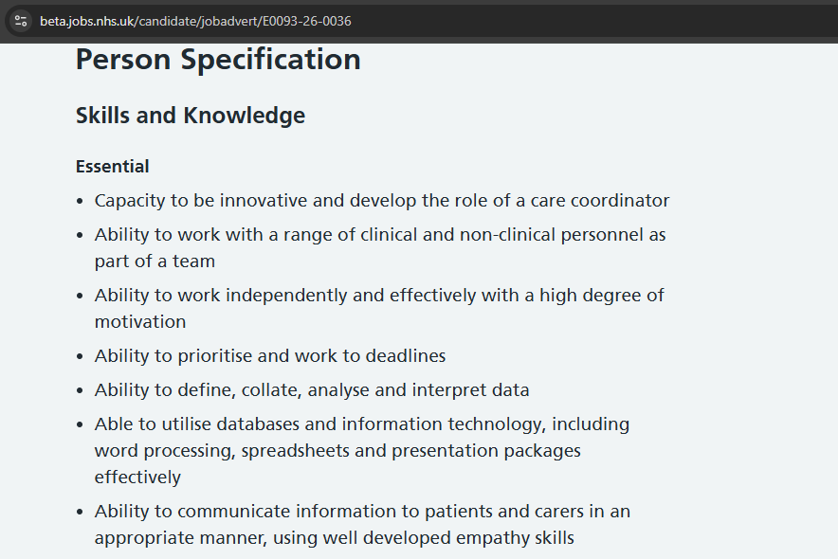
Figure 1. Recreated vacancy evidence extracts from the current NHS Jobs advert (NHS Jobs, 2026 available at: https://beta.jobs.nhs.uk/candidate/jobadvert/E0093-26-0036).

3. Analysis of employability skills
Communication and empathy are the most important skills. Patients may feel worried, confused or frustrated. A coordinator must listen carefully, use simple words and check understanding. The person must also speak professionally with GPs, care homes and voluntary organisations. Succi and Canovi (2020) found that employers place high value on communication and other soft skills. In this role, poor communication can delay care or cause a patient to miss support. Empathy is also important because the coordinator is often the first point of contact. NHS England (2014) places compassion, respect and dignity at the centre of NHS values.
Organisation and time management are also essential. A coordinator may manage many patients, tasks, calls and referrals at the same time. Each task may have a different level of urgency. The person must keep accurate records, follow up actions and meet deadlines. NHS England (2023b) states that care coordinators support appointments, referrals and navigation across services. This means that good planning affects patient safety as well as efficiency.
Teamwork is required because care coordination happens across professional and organisational boundaries. NHS England (2026a) describes care coordinators as members of the Primary Care Network team who work closely with GPs and other professionals. A good coordinator must understand different roles, share relevant information and challenge concerns in a respectful way. The person must also know when a problem is outside their competence and needs clinical advice.
Person-centred practice is another core skill. NHS England (2026b) explains that care coordinators connect people with the right team at the right time. NHS England (2026c) states that personalised care planning should focus on what matters to the person, not only on a diagnosis. The Care Quality Commission (2025a) also requires care to be based on assessed needs and preferences. Therefore, the coordinator should involve patients in decisions and avoid making assumptions about their goals.
Safeguarding, confidentiality and equality are legal and ethical requirements. Great Britain (2014) places duties on services to protect adults at risk of abuse or neglect. The Information Commissioner's Office (2024) explains that health information is special category data and needs strong protection. Great Britain (2010) also requires fair treatment and reasonable adjustments. A coordinator must notice risk, follow reporting procedures, protect records and communicate in an inclusive way.
Digital and data skills are now part of safe care. The vacancy asks for Microsoft Office, Excel, PowerPoint, Teams and the ability to analyse and report data. Skills for Care (2026a) explains that digital skills include finding, recording and sharing information safely. These skills help with caseload tracking, population health searches and service reports. However, accuracy matters more than speed. A wrong entry can affect later decisions.

4. Evaluation of my current skills
I used a simple skills matrix, a SWOT by Pickton & Wright (1998) review and feedback from university group work. I also used Gibbs' cycle because Gibbs (1988) explains that it moves reflection from description to an action plan.
My main strengths are empathy, patience, willingness to learn and respect for different backgrounds. My university work has helped me explain ideas, listen to other views and complete tasks with a group. I can use Word, PowerPoint, email and Teams with confidence. I also understand basic person-centred care, equality and professional conduct through my BSc Health and Social Care studies.
My developing skills are professional telephone communication, advanced Excel, formal record writing and managing several urgent tasks. I need more practice in writing short, factual case notes. I also need stronger knowledge of UK primary care pathways, local community services and referral rules. My largest gap is direct experience of managing a real caseload. I also need verified training in safeguarding, information governance and personalised care coordination.
This assessment shows that I have a suitable values base, but I am not yet fully job-ready. Tomlinson (2017) argues that employability depends on knowledge, social networks, identity, personal qualities and experience. A degree alone is therefore not enough. I need practical evidence that shows how I use my skills with real people and services.
Table 1: Personal skills audit
Skill | Current rating | Current evidence | Main development need
Communication and empathy | 4/5 | University presentations, listening and group work. | Patient calls, difficult conversations and concise case notes.
Teamwork | 4/5 | Shared tasks and feedback in group activities. | Experience in a real multidisciplinary team.
Organisation | 3/5 | Meets study deadlines and plans assignments. | Caseload priorities, follow-up systems and urgent tasks.
Digital skills | 3/5 | Word, PowerPoint, email and Teams. | Advanced Excel and NHS clinical systems.
Safeguarding and confidentiality | 2/5 | Basic academic understanding. | Accredited training and workplace application.
Primary care knowledge | 2/5 | General health and social care knowledge. | Local pathways, referrals and community resources.

5. Personal brand, professional identity and networking
My personal brand will be: “A calm, organised and compassionate health and social care graduate who connects people with the right support.” This statement is short and relevant to the vacancy. It also reflects the NHS values of compassion, respect and working together.
Gorbatov, Khapova and Lysova (2019) found that personal branding can improve perceived employability when it is clear and credible. My brand must therefore be supported by evidence, not only claims. I will use the same professional message in my CV, LinkedIn profile, cover letters and interview answers. I will post short reflections on person-centred care, health inequalities and community support. I will never share confidential information.
I will build my network through university tutors, classmates, careers advisers, local NHS recruitment events, Primary Care Network staff and voluntary organisations. The National Careers Service (2026a) states that networking can provide opportunities, support and reputation. I will ask one health professional to act as a mentor and request feedback every three months. I will also join online groups linked to personalised care and primary care careers. My goal is to build genuine relationships, rather than contact people only when I need a job.

6. Value I could add to the role
My unique selling point is the combination of compassion, cultural awareness, academic knowledge and growing digital ability. I can add value by making information easier for patients to understand. I can also support accurate follow-up and help teams notice patients who may be missed. My interest in both health and social care is useful because many patient problems involve housing, money, family support or loneliness as well as illness. I would bring a calm manner and a strong focus on completing agreed actions.

7. Five-year action plan and timeline
My development plan is realistic and will be reviewed every six months. In the first six months, I will complete safeguarding, data protection and basic care coordination learning. The Personalised Care Institute (2026) offers accredited training that develops communication, shared decision making and care planning. I will also improve Excel and practise writing case notes.
Within one year, I will gain regular voluntary or paid experience in a GP practice, care home, charity or community service. I will keep a reflective log and collect evidence of communication, teamwork and problem solving. The Chartered Institute of Personnel and Development (2022) explains that continuing professional development should improve practice and address gaps.
During years one and two, I will apply for entry roles such as health care assistant, patient services adviser, social prescribing support worker or care coordinator assistant. I will ask for shadowing with a care coordinator and learn local referral pathways. I will also complete the two-day accredited Care Coordinator course and request a mentor.
During years two and three, I will aim to secure a Care Coordinator post. I will use supervision to improve caseload management, safeguarding decisions and personalised care plans. The Care Quality Commission (2025b) states that services need suitably qualified, competent and experienced staff. I will therefore keep certificates, feedback and examples of safe practice in a digital portfolio.
During years three to five, I will deepen my knowledge of long-term conditions, care homes, health inequalities and population health data. I will seek responsibility for a small improvement project, such as reducing missed reviews or improving referral follow-up. By year five, I aim to be an experienced Care Coordinator who can support new staff and progress towards a senior coordination or service improvement role.
Table 2: Five-year action plan
Time | Action and resources | Evidence | Success measure
0-6 months | Complete safeguarding, data protection, Excel and PCI core learning. Practise case-note writing. | Certificates, sample notes and improved Excel exercises. | Complete all courses and reach at least 80% in practice tests.
6-12 months | Gain regular voluntary or paid patient-facing experience. Find a mentor. | Reflective log, supervisor feedback and two STAR examples. | At least 80 hours of relevant experience and quarterly feedback.
Year 1-2 | Apply for entry health or care roles. Shadow a coordinator. Complete two-day care coordination training. | Updated CV, training record and pathway map. | Secure an entry role or structured placement.
Year 2-3 | Apply for Care Coordinator posts and use supervision to develop caseload skills. | Interview feedback, portfolio and care-plan examples. | Gain a Care Coordinator role and meet probation goals.
Year 3-5 | Lead a small service improvement project and develop specialist knowledge. | Project results, CPD record and peer feedback. | Show measurable improvement and readiness for senior duties.

8. Communicating my skills to an employer
I will communicate my skills to employers through a targeted two-page CV, a clear LinkedIn profile, a cover letter and a digital portfolio. The National Careers Service (2026b) explains that a CV should present a personal profile, education, work experience and references. Therefore, I will update my CV for every vacancy and use words from the job description and person specification. I will give evidence of my communication, teamwork, organisation, digital and problem-solving skills. My LinkedIn profile will include a professional photograph, a strong headline, relevant qualifications, voluntary experience and examples of health and social care learning.
I will also prepare a cover letter that explains why I want the role and how my values match the organisation. Prospects (2025) states that applications should use specific examples of skills that are relevant to the vacancy. I will use the STAR method to explain the situation, task, action and result. During interviews, I will describe what I did, why I acted, the outcome and what I learned. Skills for Care (2026) highlights that care employers assess values, behaviours and attitudes. Therefore, I will show compassion, respect, honesty, responsibility and commitment to person-centred care through real examples from study, work or volunteering.

9. Conclusion
In conclusion, the Care Coordinator role fits my interest in joined-up and person-centred care. I already have useful values, communication skills and academic knowledge. However, I need stronger practical experience, care coordination training, safeguarding knowledge, Excel skills and caseload confidence. A clear personal brand, a professional network and a reviewed five-year plan will help me close these gaps. My final aim is to become a trusted coordinator who helps patients receive timely, safe and understandable support.

Reference list
Care Quality Commission (2025a) Regulation 9: Person-centred care. Available at: https://www.cqc.org.uk/guidance-regulation/providers/regulations-service-providers-and-managers/health-social-care-act/regulation-9 (Accessed: 14 July 2026).
Care Quality Commission (2025b) Regulation 18: Staffing. Available at: https://www.cqc.org.uk/guidance-regulation/providers/regulations-service-providers-and-managers/health-social-care-act/regulation-18 (Accessed: 14 July 2026).
Chartered Institute of Personnel and Development (2022) What is continuing professional development (CPD)? Available at: https://www.cipd.org/en/learning/cpd/about/
Gorbatov, S., Khapova, S.N. and Lysova, E.I. (2019) “Get noticed to get ahead: The impact of personal branding on career success”, Frontiers in Psychology, 10, 2662. Available at: https://doi.org/10.3389/fpsyg.2019.02662
Gibbs, G. (1988) Learning by Doing: A Guide to Teaching and Learning Methods. Oxford: Oxford Polytechnic. https://thoughtsmostlyaboutlearning.wordpress.com/wp-content/uploads/2015/12/learning-by-doing-graham-gibbs.pdf
Great Britain (2010) Equality Act 2010. London: The Stationery Office. Available at: https://www.legislation.gov.uk/ukpga/2010/15/contents (Accessed: 14 July 2026).
Great Britain (2014) Care Act 2014. London: The Stationery Office. Available at: https://www.legislation.gov.uk/ukpga/2014/23/contents (Accessed: 14 July 2026).
Information Commissioner’s Office (2024) What is special category data? Available at: https://ico.org.uk/for-organisations/uk-gdpr-guidance-and-resources/lawful-basis/special-category-data/what-is-special-category-data/ (Accessed: 14 July 2026).
National Careers Service (2026a) Careers advice: networking, mentoring and developing skills. Available at: https://nationalcareers.service.gov.uk/careers-advice (Accessed: 14 July 2026).
National Careers Service (2026b) How to write a CV. Available at: https://nationalcareers.service.gov.uk/careers-advice/cv-sections (Accessed: 14 July 2026).
NHS England (2014) NHS values in action and making a difference. Available at: https://www.england.nhs.uk/2014/02/nhs-values-in-action/ (Accessed: 14 July 2026).
NHS England (2023a) Workforce development framework for care co-ordinators. Available at: https://www.england.nhs.uk/long-read/workforce-development-framework-for-care-co-ordinators/ (Accessed: 14 July 2026).
NHS England (2023b) Additional roles: A quick reference summary. Available at: https://www.england.nhs.uk/long-read/additional-roles-a-quick-reference-summary/ (Accessed: 14 July 2026).
NHS England (2026a) Expanding our workforce. Available at: https://www.england.nhs.uk/gp/expanding-our-workforce/ (Accessed: 14 July 2026).
NHS England (2026b) Care co-ordinators. Available at: https://www.england.nhs.uk/personalisedcare/workforce-and-training/care-co-ordinators/ (Accessed: 14 July 2026).
NHS England (2026c) Personalised care and support planning. Available at: https://www.england.nhs.uk/personalisedcare/pcsp/ (Accessed: 14 July 2026).
NHS Jobs (2026) Care Coordinator - Dashwood Primary Care Network, job reference E0093-26-0036. Available at: https://beta.jobs.nhs.uk/candidate/jobadvert/E0093-26-0036 (Accessed: 14 July 2026).
Pickton, D.W. and Wright, S. (1998) ‘What’s SWOT in strategic analysis?’, Strategic Change, 7(2), pp. 101–109. https://doi.org/10.1002/%28SICI%291099-1697%28199803%2F04%297%3A2%3C101%3A%3AAID-JSC332%3E3.0.CO%3B2-6
Personalised Care Institute (2026) Accredited training menu: Care coordination. Available at: https://www.personalisedcareinstitute.org.uk/accredited-training-menu-care-coordination-new/ (Accessed: 14 July 2026).
Prospects (2025) Write a successful job application. Prospects. https://www.prospects.ac.uk/careers-advice/applying-for-jobs/write-a-successful-job-application/ (Accessed: 14 July 2026).
Skills for Care (2026a) Core digital skills in social care. Available at: https://www.skillsforcare.org.uk/resources/documents/Support-for-leaders-and-managers/Managing-a-service/Digital/Core-digital-skills-in-social-care.pdf (Accessed: 14 July 2026).
Skills for Care (2026) Values-based recruitment. Skills for Care. https://www.skillsforcare.org.uk/Recruitment-support/Values-based-recruitment/Values-based-recruitment.aspx (Accessed: 14 July 2026).
Succi, C. and Canovi, M. (2020) “Soft skills to enhance graduate employability: comparing students and employers’ perceptions”, Studies in Higher Education, 45(9), pp. 1834-1847. Available at: https://doi.org/10.1080/03075079.2019.1585420
Tomlinson, M. (2017) “Forms of graduate capital and their relationship to graduate employability”, Education + Training, 59(4), pp. 338-352. Available at: https://doi.org/10.1108/ET-05-2016-0090

