Name: Nosheen Rashid
Student ID: 2409358
Module 4003
Poster about mental health



Introduction
Community Mental Health Services (CMHS) in England are essential in assisting adults and older individuals with significant mental health challenges, aiming to do so as close to their homes as possible. They are structured to deliver comprehensive, easily accessible, and coordinated care within local communities, which decreases the need for inpatient facilities and enhances long-term well-being. The NHS Long Term Plan highlights the need to update community mental health services, broaden access, and enhance quality through innovative integrated care models. Community Mental Health Teams (CMHTs) are vital parts of Community Mental Health Services (CMHS). These teams comprise various professionals, including social workers, psychiatrists, psychologists, nurses, occupational therapists, and support staff, who are responsible for evaluating, treating, and providing ongoing support for adults with severe mental illnesses (SMI).

CMHTs provide:
• Therapeutic sessions for mental well-being
• Medication management
• Physical health monitoring
• Crisis intervention
• Support with employment, housing, and social needs
• Coordination with primary healthcare and voluntary organisations

The newly proposed community mental health model in the NHS Long Term Plan and Community Mental Health Framework aims to create a more individualised, trauma-informed, and comprehensive approach to care. This includes access to talking therapies, physical health evaluations, Individual Placement and Support (IPS) to facilitate employment, as well as assistance for co-occurring issues like substance use and self-harm.(NHS England, 2024).

History of Community Mental Health Services in England
Historically, mental health treatment in England primarily occurred in large institutional facilities. Beginning in the 1980s, a national policy shift toward deinstitutionalisation aimed to help individuals with mental health challenges reintegrate into their local communities. By the early 2000s, Community Mental Health Teams (CMHTs) had become the norm for community-oriented services.

In the last twenty years, there has been an increased variety of community services available, including Early Intervention in Psychosis (EIP), crisis response teams, personality disorder services, and rehabilitation programs. While this growth has enhanced access, it has also resulted in fragmentation and varying care pathways. In 2019, NHS England launched the Community Mental Health Framework, which set in motion a major transformation initiative to consolidate these disparate services and improve collaboration among different sectors. This framework continues to shape present-day policies and practices.(RC PSYCH ROYAL COLLEGE OF PSYCHIATRISTS,n.d.)

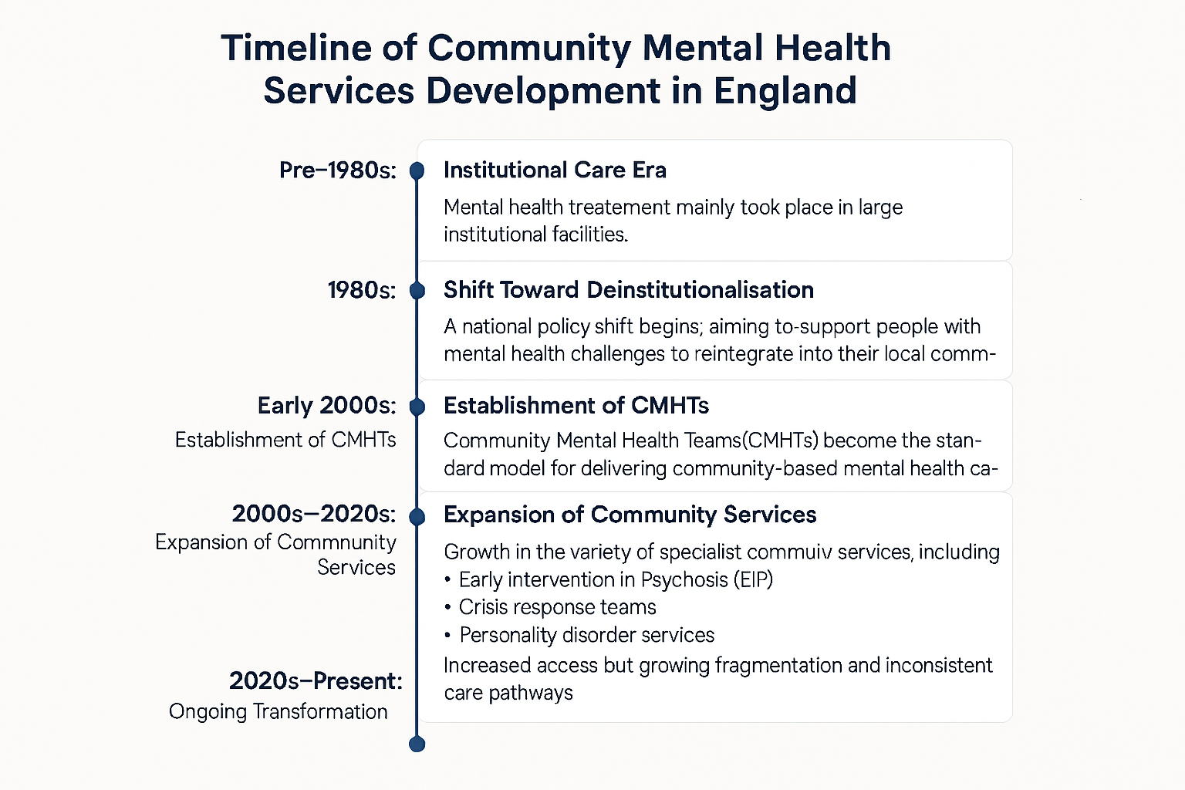
Current Functioning of Community Mental Health Services
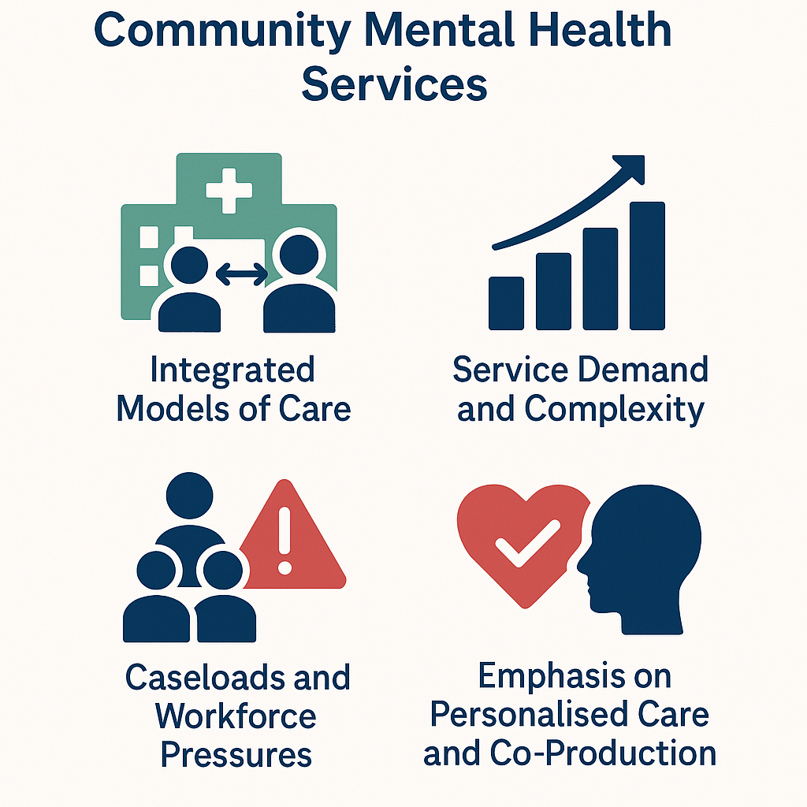

Current Functioning of Community Mental Health Services
1. Integrated Models of Care
Since 2019, Integrated Care Systems (ICSs) have been funded to develop new models of primary and community care. These models are built around Primary Care Networks (PCNs), embedding mental health practitioners in GP practices and enabling smoother transitions across the care system. By 2023/24, these models were expected to expand access to psychological therapies, improve physical health checks, and increase provision of specialist services.(NHS England, 2024).
2. Service Demand and Complexity
The demand for mental health services is steadily increasing, with an average of 453,930 new referrals to secondary mental health services each month in 2024/25, a 15% rise compared to 2022/23. Additionally, individuals are experiencing more complex needs due to issues such as the rising cost of living, housing instability, and social inequalities. (RC PSYCH ROYAL COLLEGE OF PSYCHIATRISTS, n.d.)
3. Caseloads and Workforce Pressures
The 2025 NHS Benchmarking survey revealed that adult community mental health teams are now supporting an average of 1,028 individuals per 100,000 of the population, indicating a notable increase compared to previous years. This rise suggests a growing recognition of the need for mental health services within communities. However, the survey also highlighted ongoing challenges with workforce shortages, as these continue to be a critical issue not only within community mental health teams but also in inpatient services. The persistent vacancy rates hinder the ability to provide adequate support and resources for individuals in need, further exacerbating the pressures on the mental health care system. (Collins, 2025).
4. Emphasis on Personalised Care and Co-Production
Services increasingly prioritise personalised, trauma-informed support and involve people with lived experience in service design. Evidence highlights that high-quality care includes addressing wider needs such as housing, employment, and physical health, aligning with holistic community-based support goals (Community Mental Health Services, 2025).

Challenges Faced by Community Mental Health Services
Challenge 1: Increasing Demand, Long Waiting Times, and Resource Pressures
CMHS face rising demand, longer waiting lists, and limited capacity. For example:
- More than 450,000 new referrals per month (2024/25). (Cqc.org.uk, 2024)
- Children and young people face long delays, with 27% waiting over 18 weeks for treatment as of 2025. (Collins, 2025).
Factors worsening demand include:
- COVID-19 aftereffects
- Austerity and funding constraints
- Social determinants such as unemployment and housing challenges
- These pressures lead to care delays, which can worsen mental health conditions and push people into crisis. [(Cqc.org.uk, 2024)

Challenge 2: Workforce Shortages and Variability in Care Quality
- The Care Quality Commission highlights persistent recruitment and retention issues, leading to burnout, skill gaps, and reduced capacity for high-quality care(Cqc.org.uk, 2024)
Workforce data from 2025 show:
- 14% vacancy rates in community services for young people, and
- 21% in adolescent inpatient care. (Collins, 2025).
- National reports emphasise that variability in commissioning results in uneven service quality across England, meaning a person’s access to care depends heavily on where they live(Cqc.org.uk, 2024)

These challenges hinder the goals of the Community Mental Health Framework, which relies on a well-resourced, skilled workforce and consistent system-wide collaboration.

Conclusion
Community Mental Health Services in England are undergoing a major transformation aimed at creating more integrated, holistic, and person-centred models of care. While progress has been significant—particularly in expanding access and developing new community-based models—demand pressures, workforce shortages, and inequalities continue to constrain service effectiveness. Sustained investment, long-term workforce planning, and system-wide reform remain essential to delivering high-quality, accessible mental health care.

References:
Cqc.org.uk. (2024). Mental health - Care Quality Commission. [online] Available at: https://www.cqc.org.uk/publications/major-report/state-care/2024-2025/access/mh.
Collins, M. (2025). Mental health services in the UK in 2025: what the latest NHS Benchmarking survey tells us - Centre for Mental Health. [online] Centre for Mental Health. Available at: https://www.centreformentalhealth.org.uk/mental-health-services-in-the-uk-in-2025-what-the-latest-nhs-benchmarking-survey-tells-us/.
Community Mental Health Services. (2025). Available at: https://www.nhsconfed.org/system/files/2025-03/nhs_confederation_submission_to_hscsc_inquiry_on_community_mental_health_services.pdf.

Garratt, K. (2021). Mental health policy in England. [online] Parliament.uk. Available at: https://researchbriefings.files.parliament.uk/documents/CBP-7547/CBP-7547.pdf.

NHS England (2024). NHS England Community Mental Health Services. [online] England.nhs.uk. Available at: https://www.england.nhs.uk/mental-health/adults/cmhs/.
CQC (2022). Care Quality Commission. [online] https://www.cqc.org.uk/. Available at: https://www.cqc.org.uk/.

RC PSYCH ROYAL COLLEGE OF PSYCHIATRISTS. The Community Mental Health Framework for Adults and Older Adults | Royal College of Psychiatrists. [online] Available at: https://www.rcpsych.ac.uk/improving-care/nccmh/service-design-and-development/community-framework (Accessed on 15/01/2026).

