11a Exercises for functions

1. I would like to create a program with the following output:

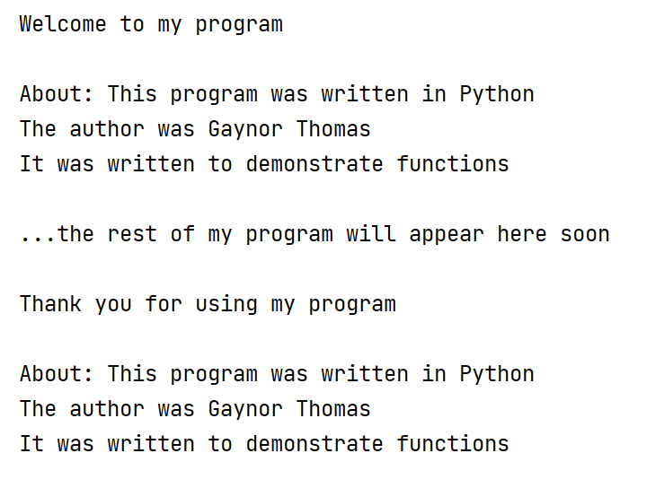

The program above is written entirely in the main part of the Python program. But some of this program is repetitive, and would be a good candidate for a function.

Identify which parts are repetitive, and re-write the program with a function and function calls. You decide the name of the function

Solution:

def about():
print("About: This program was written in Python")
print("The author was Gaynor Thomas")
print("It was written to demonstrate functions")
print("Welcome to my program\n")
about()
print("\n...the rest of my program will appear here soon\n")
print("Thank you for using my program\n")
about()

2. We will write a "call centre" program which incorporates functions.

Here is a skeleton program:

print("1. Compliment")
print("2. Insult")
print("3. Joke")
print("Enter choice")
choice = int(input())
if choice==1:
# elif choice==2:
# elif choice==3:

else:
print("Out of range")
print("End of program")

We will add in functions to get the "call centre" program to work.

For example, here is a function for option 1 - Compliment:

def compliment():
print("You look lovely today")

print("1. Compliment")
print("2. Insult")
print("3. Joke")
print("Enter choice")
choice = int(input())
if choice==1:
compliment() # call function compliment()
# elif choice==2:
# elif choice==3:
print("End of program")

Sample output:

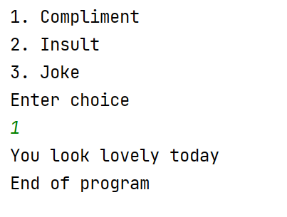

Add functions for insult() and joke() so that the menu works for all options.

Solution:

def compliment():
print("You look lovely today")
def insult():
print("I don't like your car")
print("It is a rust bucket")
def joke():
print("How many software engineers does it take to change a light bulb?")
print("None, it's a hardware problem")
print("1. Compliment")
print("2. Insult")
print("3. Joke")
print("Enter choice")
choice = int(input())
if choice==1:
compliment()
elif choice==2:
insult()
elif choice==3:
joke()
print("End of program")

3a. Draw a star using the Turtle library.

Remember, the starter code for Turtle is:

import turtle
myTurt = turtle.Turtle()

turtle.done()

(Note: Make the angle of turn 144°)

It should look something like this:

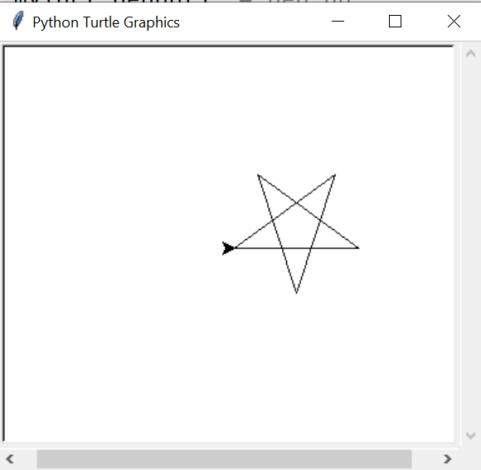

Solution

import turtle
myTurt = turtle.Turtle()

for counter in range(0, 5):
myTurt.forward(100)
myTurt.left(144)

turtle.done()

3b Draw two stars. The second should be at point (-100, 200) as shownin the picture below (use goto to move the turtle)

Hint: how can you use a function to help you?

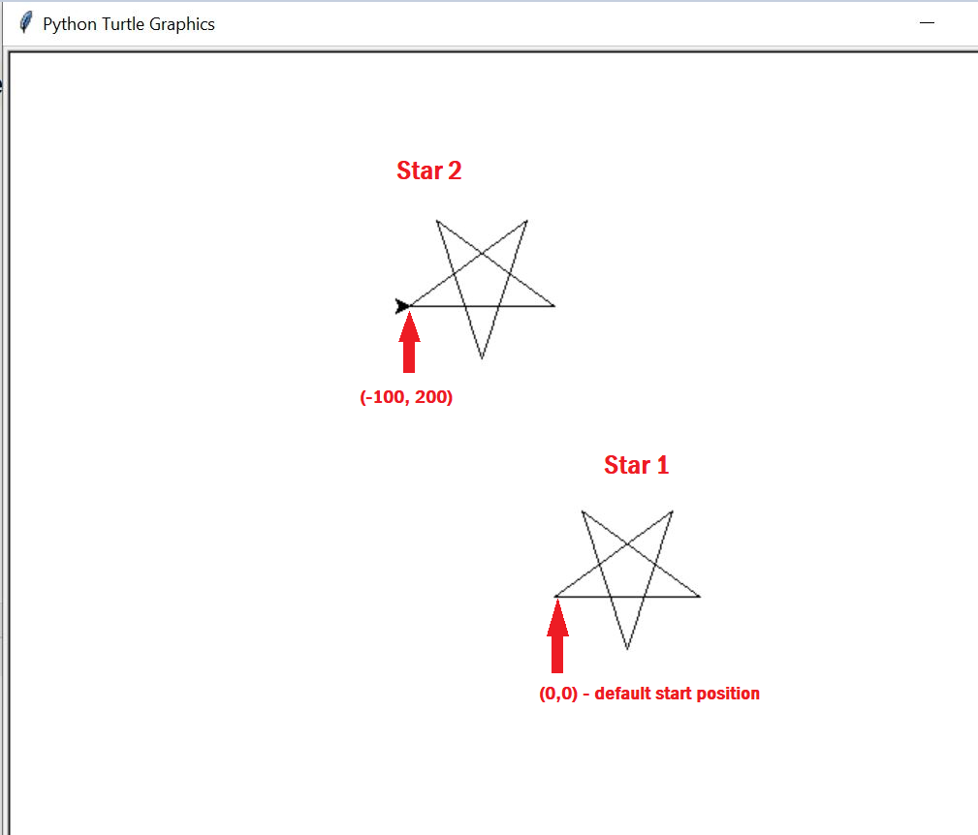

Solution:

def drawstar():
myTurt.pendown() # pen down ready to draw
for counter in range(0, 5):
myTurt.forward(100)
myTurt.left(144)
myTurt.penup() # pen up ready to move
import turtle
myTurt = turtle.Turtle()
drawstar() # call function for Star 1
myTurt.goto(-100, 200) # move
drawstar() # call function for Star 2
turtle.done()

3c Extend your program to draw 4 stars at the locations marked below:

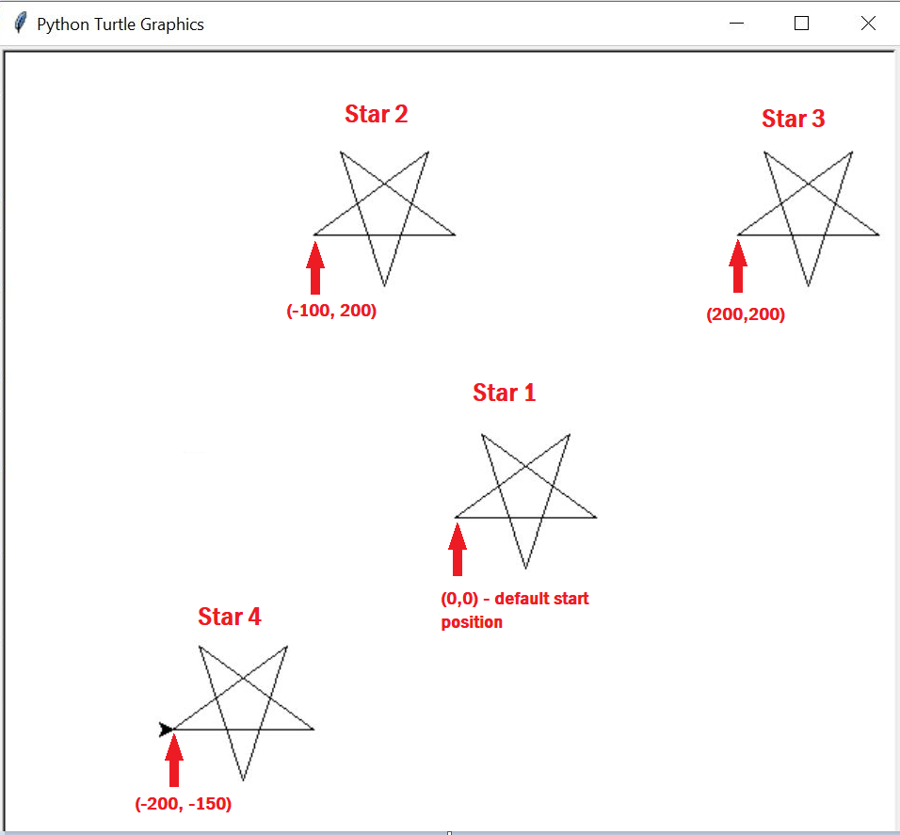

Solution:

def drawstar():
myTurt.pendown() # pen down ready to draw
for counter in range(0, 5):
myTurt.forward(100)
myTurt.left(144)
myTurt.penup() # pen up
import turtle
myTurt = turtle.Turtle()
drawstar()
myTurt.goto(-100, 200) # move
drawstar()
myTurt.goto(200, 200) # move
drawstar()
myTurt.goto(-200, -150)
drawstar()
turtle.done()

3d (Extension) Using your function from above:

- Draw a star in a random position

- Draw 10 randomly-placed stars

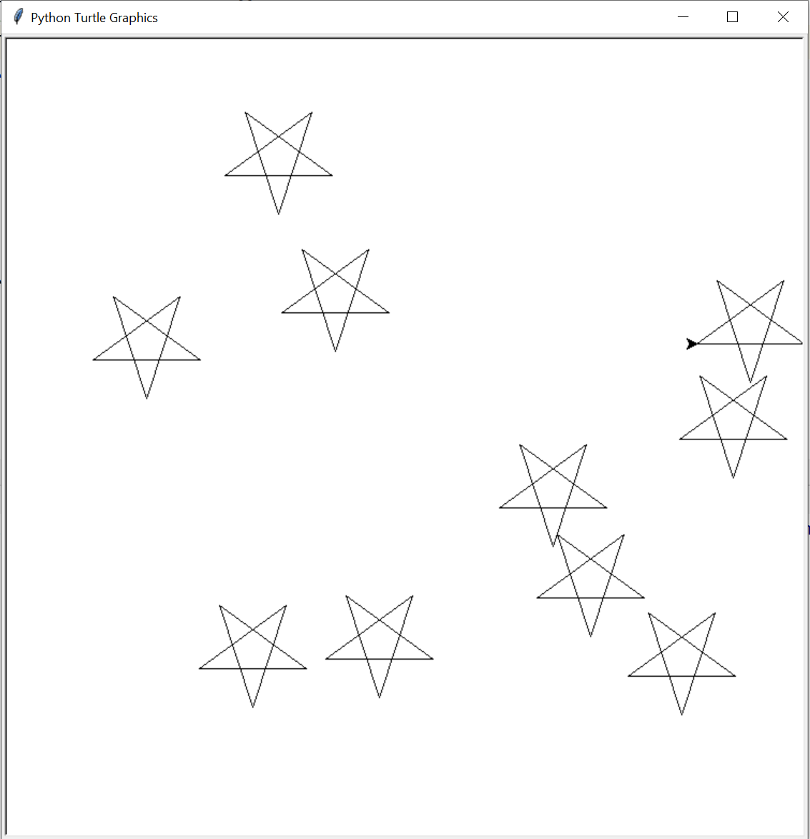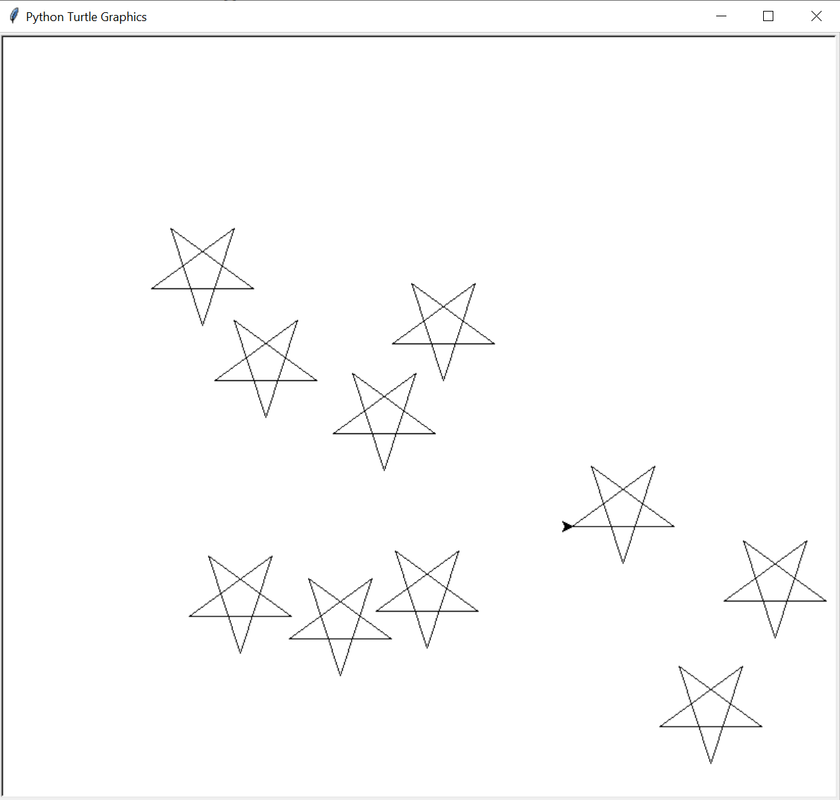

Solution:

def drawstar():
myTurt.pendown() # pen down ready to draw
for counter in range(0, 5):
myTurt.forward(100)
myTurt.left(144)
myTurt.penup() # pen up
import turtle
import random
myTurt = turtle.Turtle()
myTurt.penup()
for counter in range(0, 10):
x = random.randint(-300, 300)
y = random.randint(-300, 300)
myTurt.goto(x, y) # move
drawstar()
turtle.done()

