Foreign Languages and Cultural Awareness

Assessment 2
Intercultural Competence Report

Module code: BMIH5003
Lecturer: Heidi Prosser
Student: Raluca Simonca 2210053

Wordcount:1056 words

Executive summary
The report describes expansion in the business operations and services of Diversity Hotel & Spa that is located in UK and moving towards France. The entrance in new market is difficult for the company by learning new culture and custom of the customers. The services in the UK are different as compared to the services in France. Therefore, the report offers in-depth understanding of the cultural resources, diversity, realism management, and intercultural communication of France for introducing new hotel business in the hospitality industry France. It was challenges whereas, the hotel management gain some of the opportunities in the new market of France. The organization is effective for learning cultural differences within the country with the application of Hofstede Framework in the analysis. The Hofstede Framework and country analysis on global management helped to understand the difficulties and opportunities in the new market from the UK.

Table of Contents

Executive Summary
Introduction
Discussion
Culture Overview
Cultural Diversity
Cultural Realism
Intercultural Communication
Cultural Comparison between UK and France
Globe Country Analysis
Conclusion
Recommendations
References

Introduction
The report describes an Assistant General Manager of Diversity Hotel & Spa in London. The hotel chain decides to expand the services in the new market where the General Manager is asked to visit and learn about new market of France for the expansion. The manager is trained to learn about the hotel personnel within the selected operations and standards of the brand that are helpful for making grand opening in the new location (Dowming, 2019). The research examines the incorporation of cultural intelligence and sensitivity into the business management practises of France. French is the official language of France, while English is often utilised for communication. The local population predominantly utilises the French language for their communicative needs.

Discussion

Culture Overview
France provides a rich and diverse cultural heritage that is associated with the influenced art, literature, philosophical things, fashion, and cuisine in all over the world. The concept of French culture is characterized with the appreciation for the arts, intellectual thinking, and a commitment for the preservation of the cultural heritage (Blanc, 2019). The influence of French culture is seen in all parts of the world. The language makes a significant force to shape different aspects of the cultural landscape worldwide.

Cultural Diversity
The cultural diversity in the French hotel industry reflects on the multifaceted identity of country to the visitors and guests. There are differences in the regional cuisines, lots of architectural styles, and different inclusive services for the foreigners from all over the world (Cartier, 2019).
French hotels focus on the satisfaction of the guests with providing a rich and diverse cultural experience contributing towards the allure of France as a destination.

Cultural Realism
France hotel industry determines cultural realism that helps in making significant and reliable experience. The hotel industry of France follows a diverse culinary system for the guests with large number of cuisines presents to the cultural heritage (Blanc, 2019).

Intercultural Communication
The intercultural communication in French hotel industry is associated with the wider and efficient hospitality for guests and visitors. The hotel industry aims to welcome different visitors from the world with diverse backgrounds. The management hire staff from different background that helps in adopting different cultures within operations. French food is famous in the market that allocates success in the economy of the country through tourism development.
Cultural Comparison
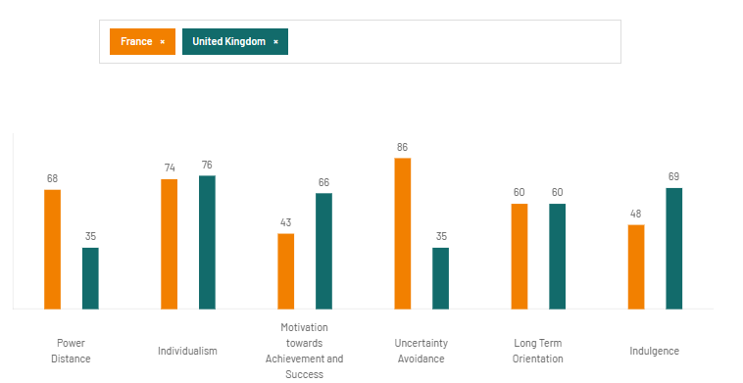
Source: (UK and France Cultural Comparison, 2022)

The comparison between UK and France using Geert Hofstede Cultural Model is elaborated as below:
- Power Distance:
UK: Lower power distance. It prefers the equality and a belief in the value of decentralized decision-making.
France: Moderate to higher power distance. It defines hierarchical structure, but not as higher as in other cultures.
2. Individualism vs. Collectivism:
UK: Individualistic cultural system. Defines personal achievements, and people are expected to taking care of the immediate family.
France: Somewhat individualistic in nature. While personal achievements are valued, there is also a stronger sense of community and collective management.
3. Masculinity vs. Femininity:
UK: Moderately masculine system. Success, achievement, and material rewards are emphasized, and not the extreme extent.
France: Moderately masculine system. It focuses on success and competition, but also a rewarding for quality of life.
4. Uncertainty Avoidance:
UK: Lower uncertainty avoidance. Tolerance for ambiguity and making effective attitude toward rules and change.
France: Moderate uncertainty avoidance. Providing clear rules, but not as strong as in some other cultures.
5. Long-Term Orientation vs. Short-Term:
Both the UK and France are generally considered for the short-term orientation. There is a focus on quick results, traditions, and societal values.
6. Indulgence vs. Restraint:
UK: Indulgent culture. It focuses on enjoying life and relaxed.
France: Indulgent culture. Like UK, there is an emphasis to enjoy life and leisure.

GLOBE Country Analysis
France
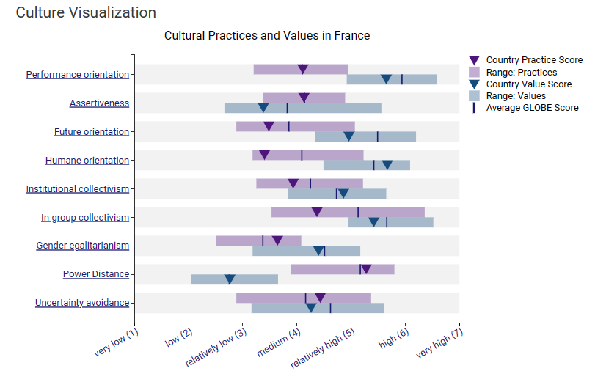
Source: (Culture Visualization, 2020)
France is a country of different culture and presenting attractive landscapes, cool locations, and allocated customs. The country exhibits a higher level of group collectivism and performance orientation, while displaying a smaller level of power distance in terms of learning and accepting diverse cultural values. (Culture Visualization, 2020).
United Kingdom
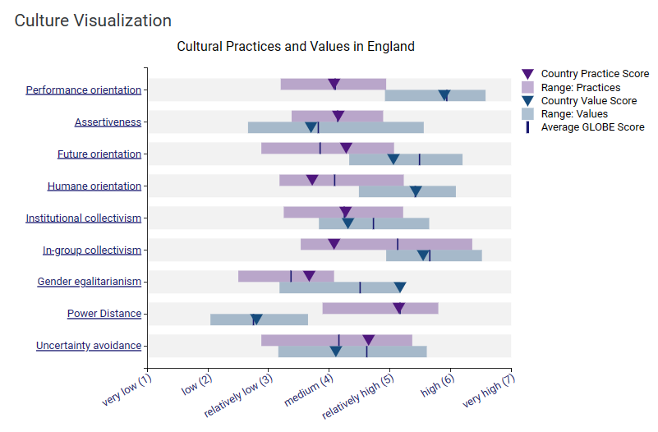
Source: (Culture Visualization, 2020)
The graphic above illustrates the contrasting cultural features between the UK and France. In the UK, performance orientation is seen to be at a moderate level for managing practises and higher for achieving value. In contrast, power distance is lower, which is a similar assessment to that of France.
France
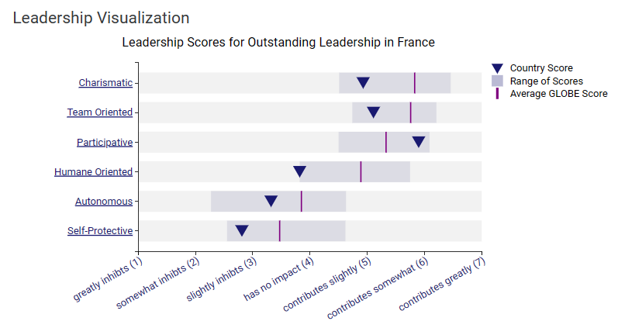

Source: (Leadership Visualization, 2020)
The figure above illustrates that France is a country that effectively implements participative leadership styles and emphasises team orientation, making it a formidable force in leadership and management. The government lacks robust self-protective and autonomous measures, which hinders the ability to effectively sustain services and activities in the market. (Leadership Visualization, 2020).
United Kingdom
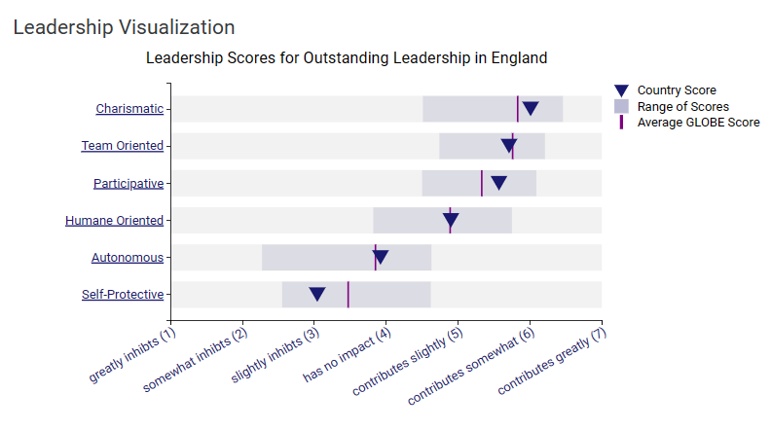
Source: (Leadership Visualization, 2020)
When comparing France with the UK, it is evident that the leadership visualisation in the UK differs in terms of values and conventions. The UK enforces a greater emphasis on factors like as charisma, team orientation, and engagement, while the management of self-protection and autonomy has a minimal influence or no impact at all.

Conclusion

The services of Diversity Hotel & Spa have been well-received in the competitive market, which has prompted the decision to expand into the new market of France. The paper has outlined the study of cultural disparities between the United Kingdom and France, with the aim of enhancing relationships, fostering positive behaviour, and promoting hotel services through efficient communication in the field of business management. Both countries have distinct approaches in their services for the promotion of global cultural policies and the implementation of initiatives to mitigate cross-cultural disparities in the hospitality industry.

Recommendations
- Training and Development: The general manager of Diversity Hotel & Spa France will be responsible to arrange training and development program for the employees to learn about different cultures and values in the new market.
- The training sessions will be helpful to gain understanding on the new customs, traditions, and ways of communication to create stronger relationships with guests and visitors.
- Cultural Awareness Practices: The general management of France Hotel will be responsible to arrange practices and workshops for the provision of cultural awareness and sensitivity in the services. The workshops will be helpful for the employees to maintain effectiveness in the differences and reduction of challenges due to the cultural conflicts and issues.

References
Blanc, G. (2021). Modernization before industrialization: cultural roots of the demographic transition in France. Available at SSRN 3702670.
Chartier, R. (2019). The cultural uses of print in early modern France. Princeton University Press.
Culture Visualization. (2020). Culture Visualization. Retrieved from Globe2020: https://globeproject.com/results/countries/PRT?menu=list#country
Downing, J. (2019). French muslims in perspective: Nationalism, post-colonialism and marginalisation under the republic. Springer.
Eringa, K., Caudron, L.N., Rieck, K., Xie, F. and Gerhardt, T., 2015. How relevant are Hofstede’s dimensions for inter-cultural studies? A replication of Hofstede’s research among current international business students. Research in Hospitality Management, 5(2), pp.187-198.
Gröschl, S. and Barrows, C.W., 2003. A cross-cultural comparison of French and British managers: An examination of the influence of higher education on management style. Tourism and Hospitality Research, 4(3), pp.228-246.
Groschl, S. and Doherty, L., 2006. The complexity of culture: Using the appraisal process to compare French and British managers in a UK-based international hotel organisation. International journal of hospitality management, 25(2), pp.313-334.
Leadership Visualization. (2020). Leadership Visualization. Retrieved from Globe 2020: Results - France GLOBE Project
Manrai, L.A. and Manrai, A., 2011. Hofstede’s cultural dimensions and tourist behaviors: A review and conceptual framework. Journal of Economics, Finance & Administrative Science, 16(31), p.23.
Pizam, A., Pine, R., Mok, C. and Shin, J.Y., 1997. Nationality vs industry cultures: which has a greater effect on managerial behavior?. International journal of hospitality Management, 16(2), pp.127-145.
UK and France Cultural Comparison. (2022). The Country Comparison Tool. Retrieved from Hofstede Insight: Country comparison tool (hofstede-insights.com)

