Programme : Master of Business Administration
Module: Human Capital Management
Module code : LCMB7023
Student Name : Suresh Devabhai Modhvadiya
Student id : 2615474

Table of Contents
TASK A: Designing Innovative Working Practices 3
1.1 Critical Evaluation of Traditional Work Design and Contemporary Innovative Working Practices 3
1.2 Recommended Innovative Working Practices for NHSX 10
TASK B: Breeding an Environment Where Talent May Grow 12
2.1 Development of a strategic talent ecosystem 12
2.2 Comprehensive talent growth strategy 16
2.3 Measuring the effectiveness of the talent growth strategy 17
TASK C: Reflective Report 18
References 21

TASK A: Designing Innovative Working Practices

1.1 Critical Evaluation of Traditional Work Design and Contemporary Innovative Working Practices
Traditional work design versus NHSX's requirements
NHSX's traditional work design is characterised by formal reporting relationships, centralised authority, vertical decision-making, and standardised responsibilities. The structure can be valuable in the healthcare organisation as clinical safety, patient data, and regulatory compliance need accountability. Moreover, the centralisation can develop decision-making issues where work is highly knowledge-intensive. It is mostly dependent on rapid interaction between different specialists. It is mostly effective for NHSX, and its workforce develops AI-enabled digital health platforms across the UK, India, and the UAE. The main issue is not that hierarchy should disappear (Gallup, 2026). The decisions need to stay centralised, and this needs to be maintained for specialist teams. The total workforce spans almost 1.38 million full time equivalents (FTE) and over 1.54 million in total headcount (NHS England, 2026).
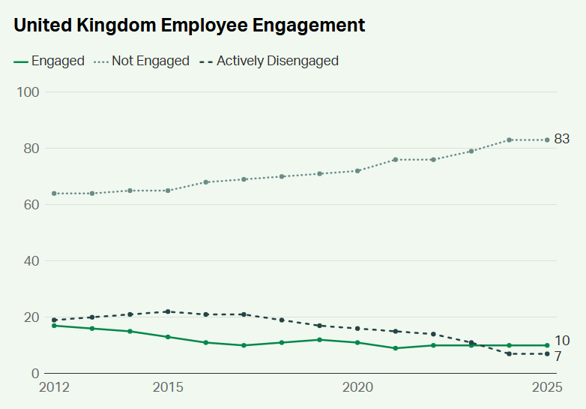
Figure 1: The employee engagement in the UK
(Source: Gallup, 2026)
Dimension | Traditional Hierarchical Work Design | HPWS | HIWS
Core logic | This is related to control, formal authority, and vertical coordination | This is integrated with the HR practices as designed to develop employee capability and organizational performance. | Employee participation, information sharing, and related to the problem-solving process.
Decision-making | This is mostly based on senior and managerial levels. | This is related to employee capability and performance responsibilities (NHS England, 2026). | More decentralised, with employees involved in the operational decisions.
Employee role | This is mostly responsible for implementing defined tasks and managerial decsions. | The skilled contributor is expected to apply the capabilities to achieve the performance objectives. | To get input on decisions and enhance continuous improvement.
NHSX relevance | This provides accountability for clinical safety and data governance. | This supports AI skills development and career development. | Supports the innovations, employee voice and cross functional problem solving process.
Main limitations | Can develop decision-making delays, silos, and limited autonomy of the employee (GOV.UK, 2026). | This increases work intensity if performance targets are prioritised. | This needs trust, transparency, and capability for the decision boundaries.
Table 1: Comparative evaluation of work-design approaches
(Source: Self-developed)
The UK Government's AI labour market survey 2025 showed 97% of surveyed respondents showed at least one AI skills gap. The technical skills gaps were reported by 57% of businesses. Almost 30% identified the non-technical skills gap (GOV.UK, 2026). Moreover, for NHSX, 28% of organisations said that the technical skills shortage had affected their ability to achieve business goals. Furthermore, 88% of the organisations surveyed used on-the-job training. AI use increased from 3% of AI hires in 2020 to 19% in 2025 (GOV.UK, 2026).
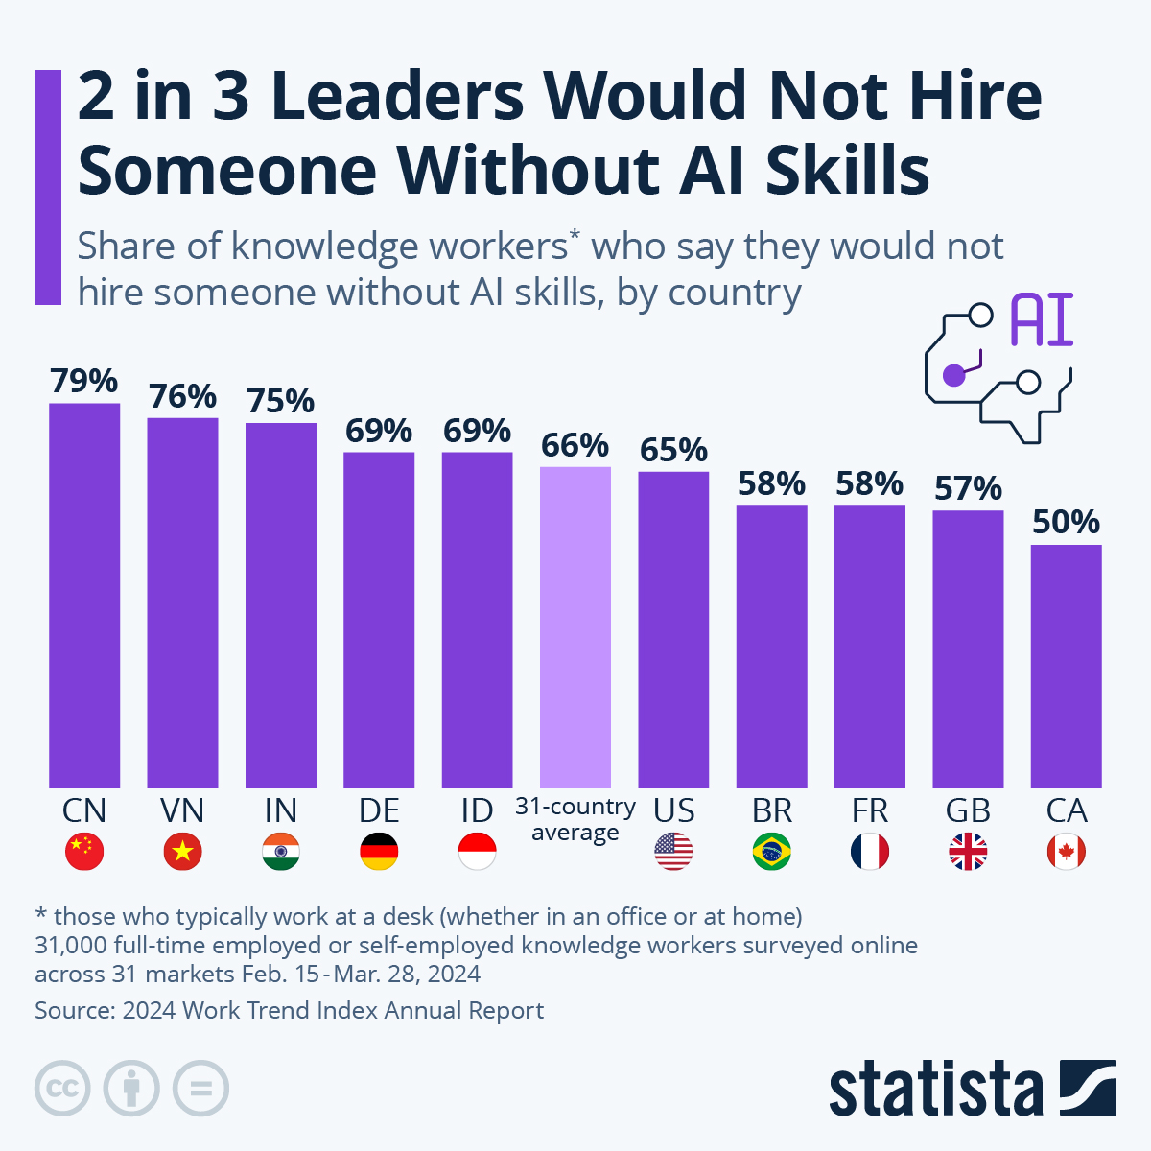
Figure 2: Leaders Would Not Hire Someone Without AI Skills
(Source: Statista, 2025)
On the other hand, knowledge cannot be determined within the functional departments. HIWS can enhance employee involvement and knowledge sharing as employees participate more actively in the problem-solving process. Moreover, participation is not automatically effective. Without any proper decision rights and information transparency, employee involvement can create consultation without genuine influence.
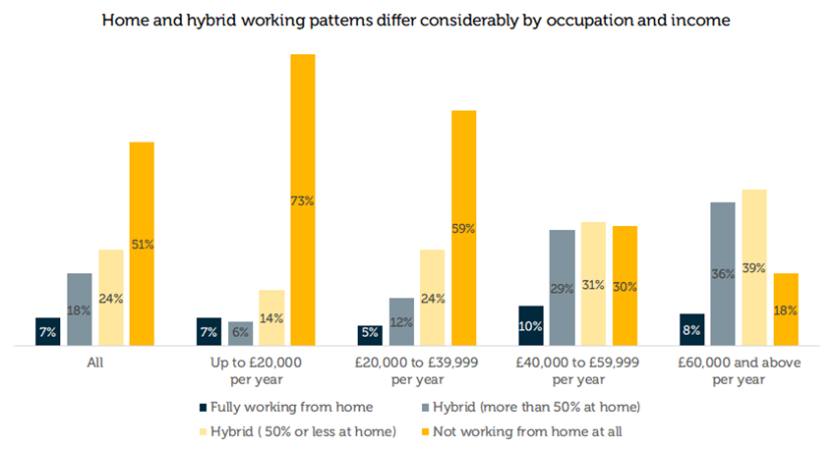
Figure 3: Home and hybrid working patterns are different from the occupational income
(Source: CIPD, 2026)
CIPD's 2025 Hybrid working practices research found that 91% of UK employers offered some form of flexible working. Almost 74% reported having hybrid working in the workplace. The research also showed that 41% of employees believed increased home and hybrid working had improved organisational productivity (CIPD, 2025). Almost 16% believed it had reduced productivity. Also CIPD also found that 3% of employees reported to leave a job due to insufficient flexible working. This is mostly related to almost 1.1 million UK workers.
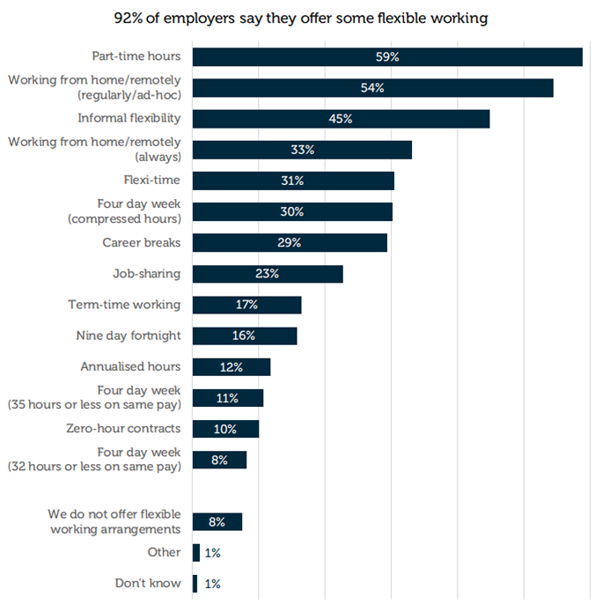
Figure 4: Wide availability of flexible working within the organisations
(Source: CIPD, 2026)
For NHSX, potential benefits include:
- Higher access to specialist talent.
- Flexibility across the UK/India/UAE.
- Improved attraction and retention.
Potential limitations include:
- Lack of informal knowledge sharing.
- Issues in managing international teams.
- Lack of organisational connection
Stage | NHSX application | Management requirement
Forming | Develop the cross-functional AI clinical product teams. This involves technical, clinical, product, UX, and cybersecurity expertise. | Develop the objectives, responsibilities, decision rights, and governance requirements (Reidy et al., 2025).
Storming | To manage the disagreements related to clinical safety, technical process, and the speed of innovation. | This enhances the psychological safety and decision-making process.
Norming | Develops shared communication practices and documentation standards. | Develops trust, accountability, and collaboration across the locations.
Performing | Provide teams with the higher autonomy to solve problems. | Remove organisational issues related to clinical, regulatory,
Table 2: Implementing Tuckman's Team Development Model
(Source: Self-developed)

1.2 Recommended Innovative Working Practices for NHSX
Practice | Recommendations | Integrated effect and theoretical integration
Cross-functional collaboration | Developed project-based AI clinical product squads can comprise the clinical AI and data specialists process. | It reduces the functional silos and accelerates the exchange process. This supports HIWS with the "Sociotechnical Systems Theory".
Hybrid and flexible working | Task-based hybrid working with remote working can help in complex developments. The development of common collaboration hours across the UK, India, and the UAE (CPID, 2025). | This helps to preserve flexibility by reducing the knowledge-sharing problem. The research of CIPD (2025) shows 41% of employers reported increased productivity in hybrid working.
Employee autonomy | The operational decsions are related to skilled teams to ensure clinical safety. | Develop bounded autonomy and higher employee empowerment. The combined HIWS with HPWS by giving skilled employees (Kelshiker et al., 2025).
Agile project teams | Organisational innovation related to developmental cycles, rapid experimentation, and clinical feedback. | This improves responsiveness and continuous learning. Agile working with HIWS and HPWS can increase responsibility.
Agile project teams | Develop a secure digital workplace and project management tools. | Connects geographically dispersed employees and supports Sociotechnical Systems Theory.
Table 3: Recommendations with evidence
(Source: Self-developed)
The strong evidence for the recommendations is the UK Government's AI labour market survey. This showed that 97% of them identified one AI skills gap (CPID, 2025). This directly supports cross-functional teams and flexible working within the company. For example, clinical risk decisions need not simply be delegated, as NHSX operates in digital healthcare. On the other hand, routine product experimentation, workflow improvements, and technical problem-solving can be delegated to skilled teams (Fleming et al., 2025).

TASK B: Breeding an Environment Where Talent May Grow

2.1 Development of a strategic talent ecosystem
Learning Organisation (Senge)
Kerin (2022) emphasised that continuous organisational learning is possible through five core disciplines such as systems thinking, personal mastery, mental models, shared vision, along with team learning. Those principles can help an organisation to strengthen the ability of employees, knowledge exchange, and adaptability perceptions. In the case of NHSX, the development of the collaborative learning opportunities across the UK, UAE, and India can address the fragmented communication level as well as limited innovation. However, learning initiatives can be ineffective if the hierarchical management strictly restricts the participation and employees lack opportunities for applying the acquired knowledge. Hence, organisational learning mostly requires the supportive leadership along with adequate resources rather than relying mostly on the formal training most.
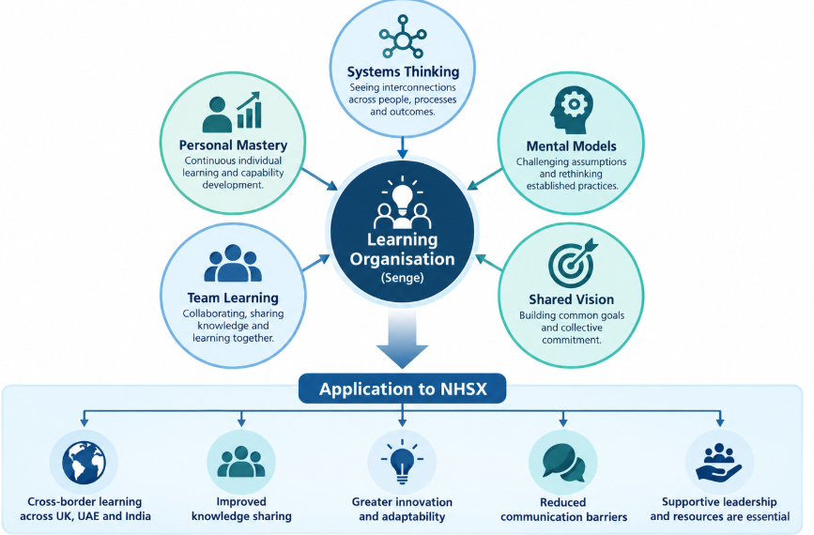
Figure 5: Components of Learning Organisation (Senge)
(Source: Self-developed)
Growth Mindset (Dweck)
Sigmundsson and Haga (2024) mainly distinguished the fixed and growth mindsets, which suggests that individuals who have strong beliefs that their capabilities can develop seem to be more receptive to the challenges as well as learning opportunities. Business firms can encourage this perception through the adequate constructive feedback, along with coaching and recognition of the professional improvement. The report shows that 84% of the surveyed employees stated that learning adds greater purpose to their work (Linkedin, 2025). In NHSX, growth-oriented management can encourage the employees for developing the emerging AI and adequate healthcare technology competencies. Apart from that, emphasising the effort of individuals without developmental resources can cause unrealistic expectations. Hence, growth mindset initiatives must be supported by the accessible training and offering greater career opportunities.
Psychological Safety (Edmondson)
Edmondson and Bransby (2023), identified psychological safety as the most essential condition that enables the employees for expressing concerns, acknowledge mistakes and exchange ideas. This type of environment can be relevant for strengthening organisational learning and innovation by facilitating constructive discussion. NHSX can benefit from certain management practices that support the area of open communication among geographically diverse teams. However, through psychological safety, it is not possible to eliminate the professional accountability. It has been identified that only 37% of the surveyed UK employees believed that their managers were good enough to allow employees or representatives for influencing the final decisions (CIPD, 2025). Therefore, growth mindset initiatives must be supported properly.
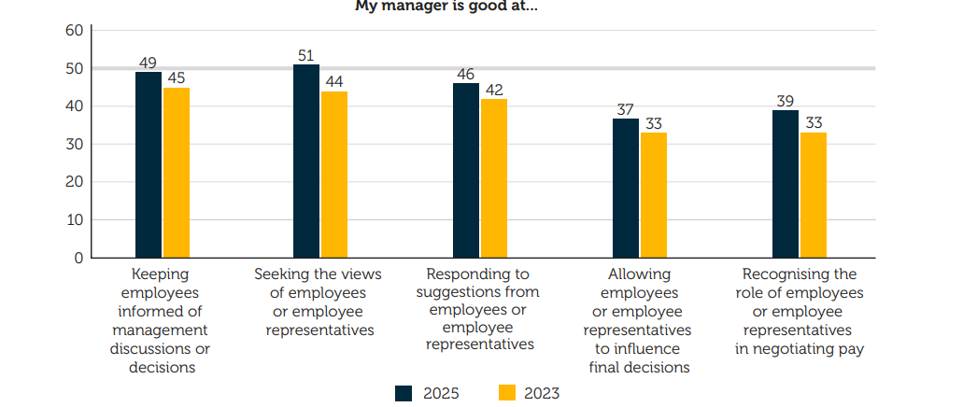
Figure 6: % of employees who say their managers are good at enabling voice
(Source: CIPD, 2025)
Talent Management Frameworks
Strategic talent management strongly connects the workforce abilities with the organisational objectives through professional development, recruitment, career progression and succession planning (Collings et al., 2022). Only 14% of organisations are now able to meet their highest talent-velocity classification (Linkedin, 2026). For the NHSX, “transparent career pathways” and “competency-based development” can address the dissatisfaction related to restricted advancement opportunities. Hence, an inclusive approach must consider the employee potential suitably.
Job Crafting Theory
Stanton and Ng (2023), stated that job crafting as employees eventually reshape the aspects of their task areas, workplace connections, and perceptions related to professional responsibilities. At the NHSX, such high flexibility in the project responsibilities can encourage the technical workers to contribute towards innovation and knowledge-sharing aspects. However, unrestricted job crafting can develop inconsistent responsibilities and hence, managerial coordination is highly required.
Self-Determination Theory
Ryan and Deci (2022), identified that competence, autonomy, as well as relatedness are the core psychological needs that support both motivation and wellbeing. For the NHSX, employee involvement in project decisions could strengthen the engagement and reduce such high dependency on the hierarchical approvals. On the contrary, autonomy without proper expectations and technical support can raise workload pressure.
Employee Experience (EX)
Employee experience mostly encompasses the interaction of employees with the core organisational practices, technology, leadership and workplace culture throughout the employment (Morgan, 2017). NHSX can strengthen the employee experience through the adequate onboarding, transparent communication, development programmes, and well-being support in international operations. The report shows that 20% of employees worldwide were actively engaged, whereas 64% were not engaged, as well as 16% were actively disengaged (Gallup, 2026). Moreover, only 34% of employees are thriving, and 56% of employees are struggling (figure below). Hence, sustainable talent development mostly requires the coordinated organisational learning.
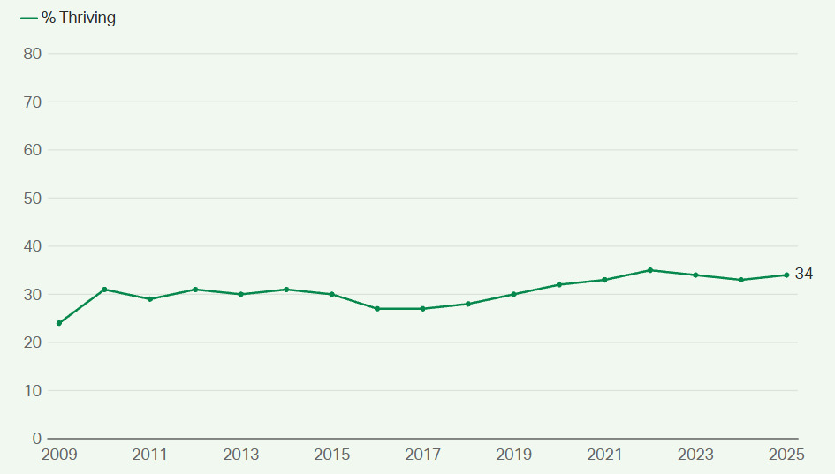
Figure 7: Employees thriving in life
(Source: Gallup, 2026)

2.2 Comprehensive talent growth strategy
Growth strategies | Application to NHSX | Expected contribution
Continuous learning | Ensure professional development in AI, cybersecurity, and digital healthcare, along with leadership, supported by the mentoring. | Strengthen the future workforce abilities as well as knowledge sharing.
Carrer progression | Introduce the transparent promotion criteria and individual development plans. | Improve the career visibility along with supporter retention.
Psychological safety | Encourage the constructive feedback and employee participation. | Support the innovation areas and communication while managing the clinical accountability.
Employee autonomy | Allow the employees greater influence over the project responsibilities and work methods. | Develop motivation and professional abilities.
Wellbeing and retention | Review the workload distribution along with managerial support as well as access to the wellbeing resources. | Support the sustainable performance and reduce the workplace pressures.
Table 4: Talent growth strategy for the firm
(Source: Self-developed)

2.3 Measuring the effectiveness of the talent growth strategy
Performance measurement needs to examine whether the development activities improve the abilities of the employees along with organisational outcomes. NHSX requires baseline data for developing the meaningful targets:
Measurement area | Proposed KPI | Method of evaluation
Learning and development | “Skill proficiency improvement” | Before and after the competency assessments
Employee retention | “Voluntary employee turnover rate” | Record the HR workforce quarterly
Carrer progression | “Internal vacancy fill rate” | Internal recruitment as well as vacancy records
Psychological safety | "Employee psychological-safety survey score” | Conduct surveys to measure confidence levels
Employee well-being | “Workload sustainability score” | Conduct anonymous surveys and review the workload
Table 5: Measuring effectiveness of the growth strategy
(Source: Self-developed)
Metrics need to be reviewed quarterly for identifying the particular differences across the locations of NHSX. Training participation alone is not sufficient enough as an evidence of the capability growth. Hence, it is essential to keep a strong focus on the KPIs to measure the effectiveness suitably.

TASK C: Reflective Report
The Gibbs’ reflective cycle has been taken into focus for conducting the reflective report:
Description
As a future HRM (Human Resource Management) professional, I explored AI as an effective strategic resource to analyse the organisational challenges as well as supporting the evidence-based decisions. During my HRM assessment, I used the AI for three particular activities, such as examining employee development theories, identifying the statistics on the workforce published within 2022-2026, and exploring the performance indicators regarding the talent management at the NHSX. Those experiences helped me for understanding how the AI can properly assist with the workforce planning and adequate organisational analysis. However, to make effective HR decisions, it is essential to keep focus on professional judgement, ethical responsibilities and individual circumstances.
Feelings
Previously, I was quite interested in the ability of AI for organising the complex information as well as explain the unfamiliar concepts related to HR properly. Rapid responses developed from AI seemed to be useful enough while examining the motivation levels of employees, retention along with organisational development. However, identification of the limitations associated with AI generated information made me feel even more conscious to cross check the information properly. I also recognised that technological efficiency not always guarantee the ethically appropriate decisions especially when the career of employees and their well-being are involved.
Evaluation
My first experience consisted of using AI for investigating different theories like growth mindset, self-determination theory and so on. This effectively supported my understanding regarding how the organisational conditions strongly influence the performance level of employees although simplified explanations require greater academic investigation. Secondly, AI helped me for locating the 2025 and 2026 workforce research through which theoretical concepts were aligned with existing employment challenges. Thirdly, AI also helped to explore the potential indicators for learning, engagement and employee retention.
Analysis
Those experiences evaluated that AI mostly strengthened the HR analytical capabilities. AI supported workforce analysis can reveal the skill shortage and development requirements that enabled more informed strategic planning. However, statistical assessment does not fully represent the emotional well-being and employee aspirations. Moreover, historical workforce data can also contain the inequalities which influence automated recommendations. Above all, I understand that professional HR competence requires the critical evaluation, responsible interpretation and empathy rather than dependence on technological outputs.
Conclusion
Overall, exploration of AI ultimately strengthened my awareness level regarding the evidence-based HR decision making and highlighted the particular areas for further development. I also understood that AI can strongly support the research as well as organisational analysis whereas human oversights are also crucial while interpreting the evidence and making certain decisions affecting employees. This reinforced the necessity to combine the digital literacy with the communication, ethical reasoning and greater professional accountability.
Action plan
Over the next 6 months, I will strengthen my HR analytics abilities through the structured training in the Power BI, Excel and interpretation of workforce data. I will also develop my understanding level on responsible AI usage by investigating the data protection, ethical HR practices and algorithm bias. I also plan to review the professional research on a regular basis. For strengthening my interpersonal abilities, I will seek adequate feedback on the communication area along with decision-making through the practical scenarios of HR.

References
CIPD, (2025). Work Index 2025. [Online] Available at: https://www.cipd.org/globalassets/media/knowledge/knowledge-hub/reports/2025-pdfs/8868-good-work-index-2025-report-web1.pdf [Accessed on 21/9/2026]
Collings, D.G., Vaiman, V. and Scullion, H., (2022). Talent management: A decade of developments. https://www.emerald.com/books/edited-volume/14059/chapter/84940145
CPID (2025), Briefing | Flexible and hybrid working practices in Scotland in 2025. Available at: https://www.cipd.org/uk/views-and-insights/thought-leadership/insight/flexible-hybrid-working-scotland/ [Accessed on: 02/10/2026]
CPID (2025), Flexible and hybrid working practices in 2025. Available at: https://www.cipd.org/en/knowledge/reports/flexible-hybrid-working/ [Accessed on: 02/10/2026]
Edmondson, A.C. and Bransby, D.P., (2023). Psychological safety comes of age: Observed themes in an established literature. Annual review of organizational psychology and organizational behavior, 10(1), pp.55-78. https://www.annualreviews.org/content/journals/10.1146/annurev-orgpsych-120920-055217?crawler=true&mimetype=application/pdf
Fleming, W., Coutts, A., Pochard, D., Trivedi, D., and Sanderson, K. (2025). Human-centered design and digital transformation of mental health services. JMIR human factors, 12, e66040. https://humanfactors.jmir.org/2025/1/e66040
Gallup (2026), State of the Global Workplace: United Kingdom Country-Level Data. Available at: https://www.gallup.com/workplace/707546/state-global-workplace-united-kingdom-country-level-data.aspx [Accessed on: 02/10/2026]
Gallup, (2026). Global Data Summary — State of the Global Workplace 2026. [Online] Available at: https://www.gallup.com/workplace/697904/state-of-the-global-workplace-global-data.aspx [Accessed on 20/9/2026]
GOV.UK (2026), AI Labour Market Survey 2025 report. Available at: https://www.gov.uk/government/publications/ai-labour-market-survey-2025-report [Accessed on: 02/10/2026]
GOV.UK (2026), AI Labour Market Survey 2025 report: executive summary. Available at: https://www.gov.uk/government/publications/ai-labour-market-survey-2025-report/ai-labour-market-survey-2025-report-executive-summary [Accessed on: 02/10/2026]
Kelshiker, M.A., Bächtiger, P., Mansell, J., Kramer, D.B., Nakhare, S., Almonte, M.T., Alrumayh, A., Petri, C.F., Peters, A., Costelloe, C. and Falaschetti, E., 2025. Triple cardiovascular disease detection with an artificial intelligence-enabled stethoscope (TRICORDER): design and rationale for a decentralised, real-world cluster-randomised controlled trial and implementation study. BMJ open, 15(5), p.e098030. https://www.nature.com/articles/s41746-026-02495-8_reference.pdf
Kerin, T., (2022). Creating a learning organisation. Chemical Engineering Transactions, 90, pp.781-786. https://www.cetjournal.it/cet/22/90/131.pdf
Linkedin, (2025). The rise of career champions. [Online] Available at: https://business.linkedin.com/learn/resources/workplace-learning-report [Accessed on 21/9/2026]
Linkedin, (2026). The talent velocity advantage.. [Online] Available at: https://learning.linkedin.com/resources/talent-velocity-report [Accessed on 20/9/2026]
Morgan, J., (2017). The employee experience advantage: How to win the war for talent by giving employees the workspaces they want, the tools they need, and a culture they can celebrate. John Wiley & Sons. https://books.google.com/books?hl=en&lr=&id=dxlCDgAAQBAJ&oi=fnd&pg=PP1&dq=Morgan,+J.+(2017)+The+Employee+Experience+Advantage.+Hoboken,+NJ:+Wiley.&ots=Q9jczQcXEm&sig=gaZzv42nfGZPvwTUfF7gFFYr8bY
NHS England (2026), NHS Workforce Statistics - December 2025. Available at: https://digital.nhs.uk/data-and-information/publications/statistical/nhs-workforce-statistics/december-2025 [Accessed on: 02/10/2026]
Reidy, C., Papoutsi, C., Kc, S., Gudgin, B., Laverty, A.A., Greaves, F. and Powell, J., 2025. Qualitative evaluation of the implementation and national roll-out of the NHS App in England. BMC medicine, 23(1), p.20. https://link.springer.com/content/pdf/10.1186/s12916-024-03842-w.pdf
Ryan, R.M. and Deci, E.L., (2022). Self-determination theory. In Encyclopedia of quality of life and well-being research (pp. 1-7). Cham: Springer International Publishing. https://selfdeterminationtheory.org/wp-content/uploads/2023/01/2022_RyanDeci_SDT_.pdf
Sigmundsson, H. and Haga, M., (2024). Growth Mindset Scale: Aspects of reliability and validity of a new 8-item scale assessing growth mindset. New Ideas in Psychology, 75, p.101111. https://www.sciencedirect.com/science/article/pii/S0732118X24000394
Stanton, P. and Ng, E., (2023). Themed editorial: Job crafting–relevance to human resource management. Personnel Review, 52(8), pp.1953-1956. https://www.emerald.com/pr/article-pdf/52/8/1953/2145004/pr-11-2023-919.pdf
Statista (2025), 2 in 3 Leaders Would Not Hire Someone Without AI Skills. Available at: https://www.statista.com/chart/33761/knowledge-workers-on-hiring-someone-with-ai-skills/?srsltid=AU7gw4XVj74DJJkuUWwQt6x3ZIbPzA0Rcrjvk63mT_D4NfZieRw8XL6- [Accessed on: 02/10/2026]

