My Mobile Screenshots.

Below I have attached 6 screenshots of apps which I have downloaded to my mobile phone. These are some of my most frequently used apps and are important in my digital life.
Screenshot 1 -
UWTSD Hub
This app is currently one of my most regularly used and very helpful to me with regards to my studies. Via this app, I can access all my student information and resources, though I mostly use it when I need to check my timetable, view my digital ID, check my student email and/ or access Moodle.
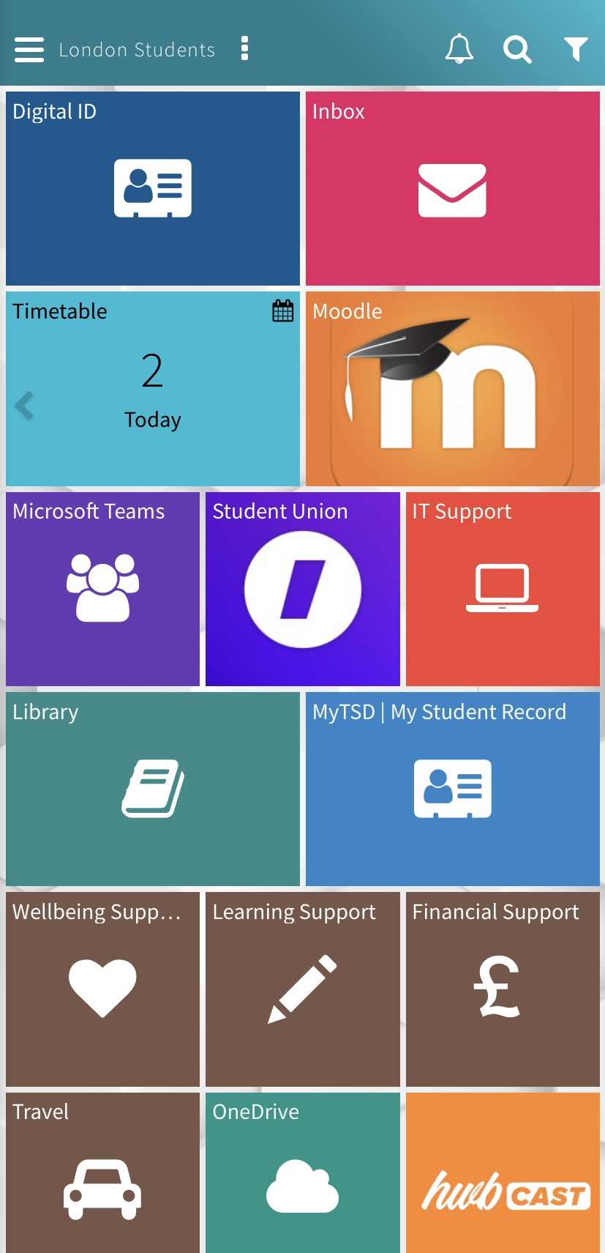

Screenshot 2 -
EDF energy
The EDF energy app is very convenient to me as it contains all the information I require regarding my bills and usage. It alerts me if my smart metre is ever running low on credit and I can make payments easily and quickly via its apple pay feature.
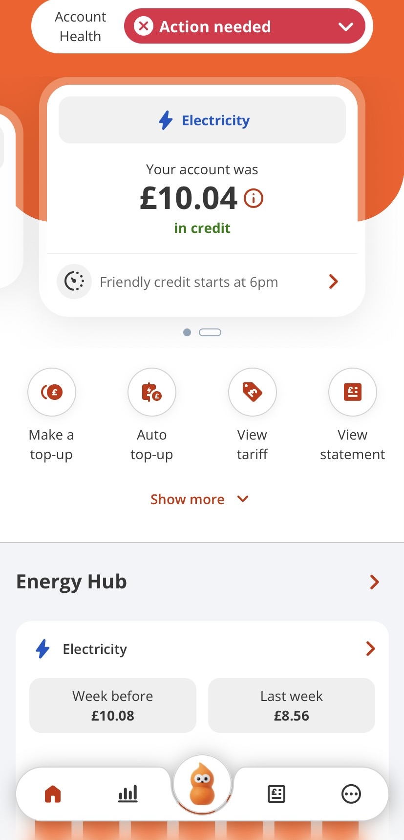

Screenshot 3 -
Lloyds Mobile Banking
This app is extremely important to me as this is where I control all of my finances and having this app allows me to have everything in one place and at my fingertips.
I regularly use the app to check my balance and transactions, make transfers to family and friends and view my card and account details.
However, I am also able to freeze my card if needed, view my statements and set up and manage direct debits.
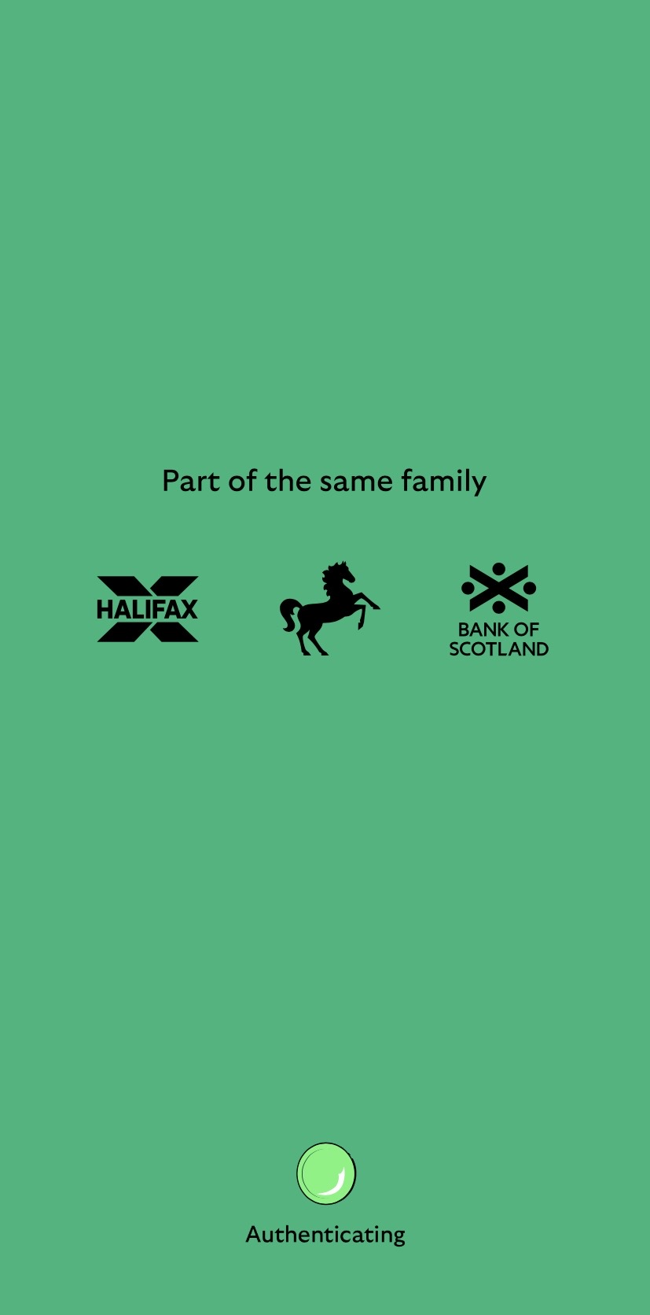

Screenshot 4 -
NEXT
I use this app less frequently than the others but NEXT is my most used online shopping app for clothing. I often use this app to buy clothes for myself and my children as I like the brand but NEXT also offer merchandise made by other popular brands. I also have my address and payment information stored so that I can checkout more easily and quickly.
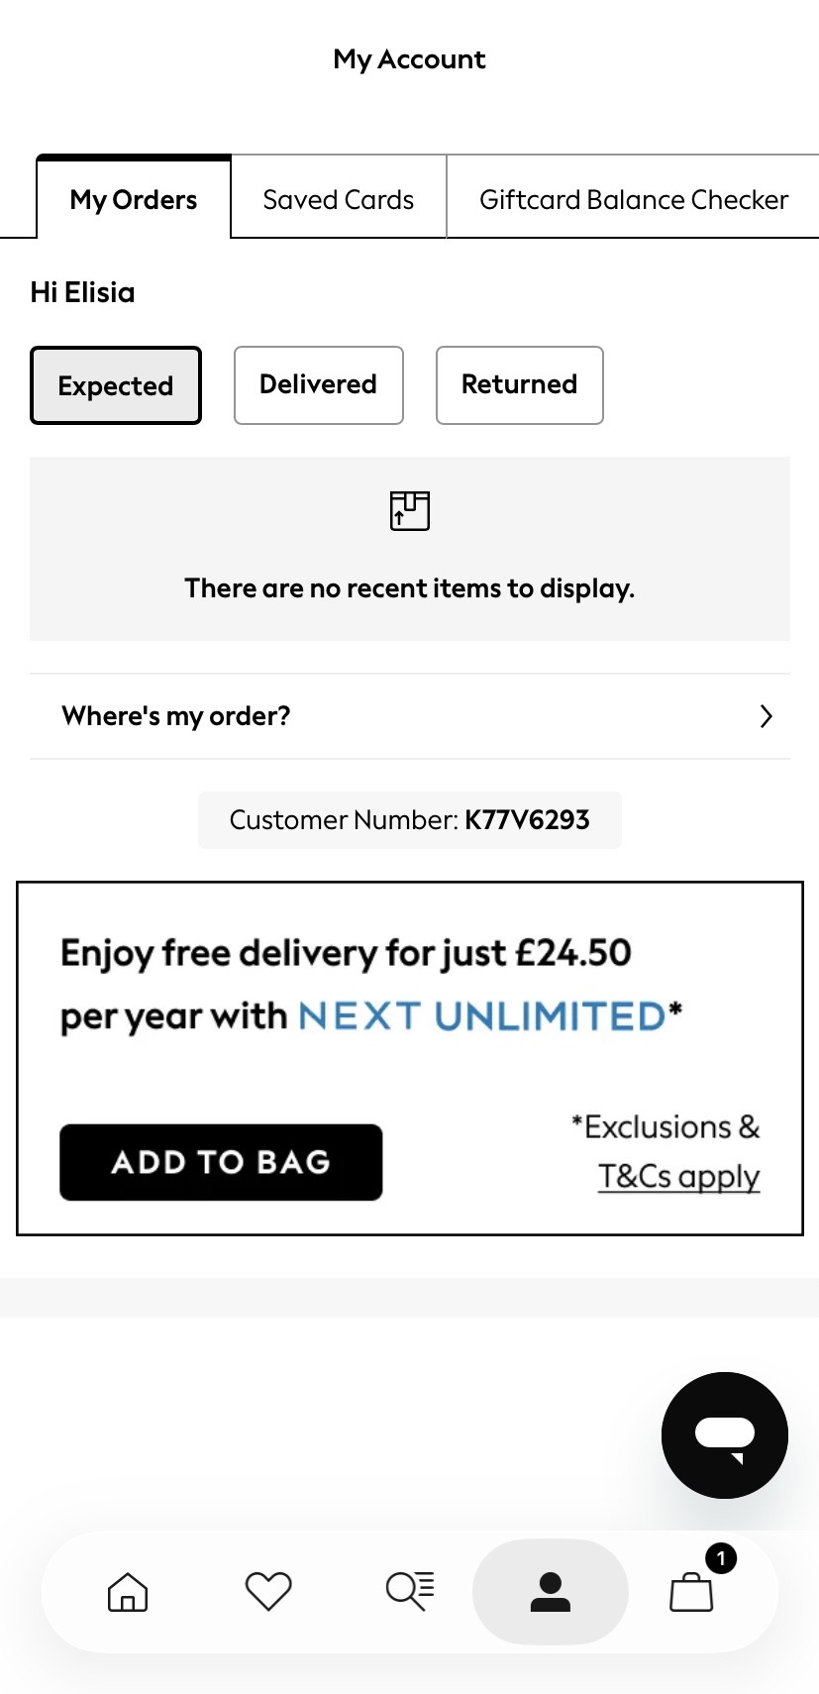

Screenshot 5 -
Apple Maps
I use this app on a regular basis to plan my journeys, find nearby restaurants and entertainment for my children.
I particularly like apple maps as it is accessible; I can save any addresses I wish to and can compare various options for my journey, including walking, public transport and driving.
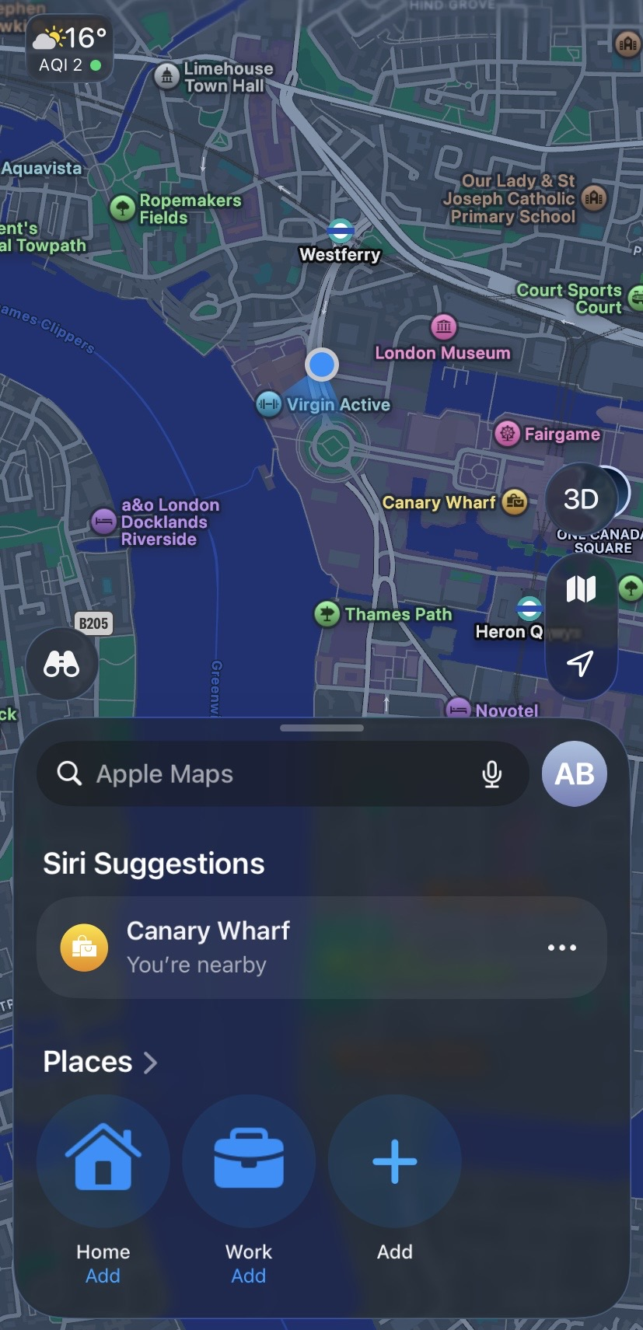

Screenshot 6 -
NHS Healthcare
This NHS app is also important to me as it grants me the ability to keep up to date on mine and my children’s healthcare.
Here, I can view my health conditions, test results, appointments and find documents as well as access NHS advice and check any symptoms myself or my children may have.
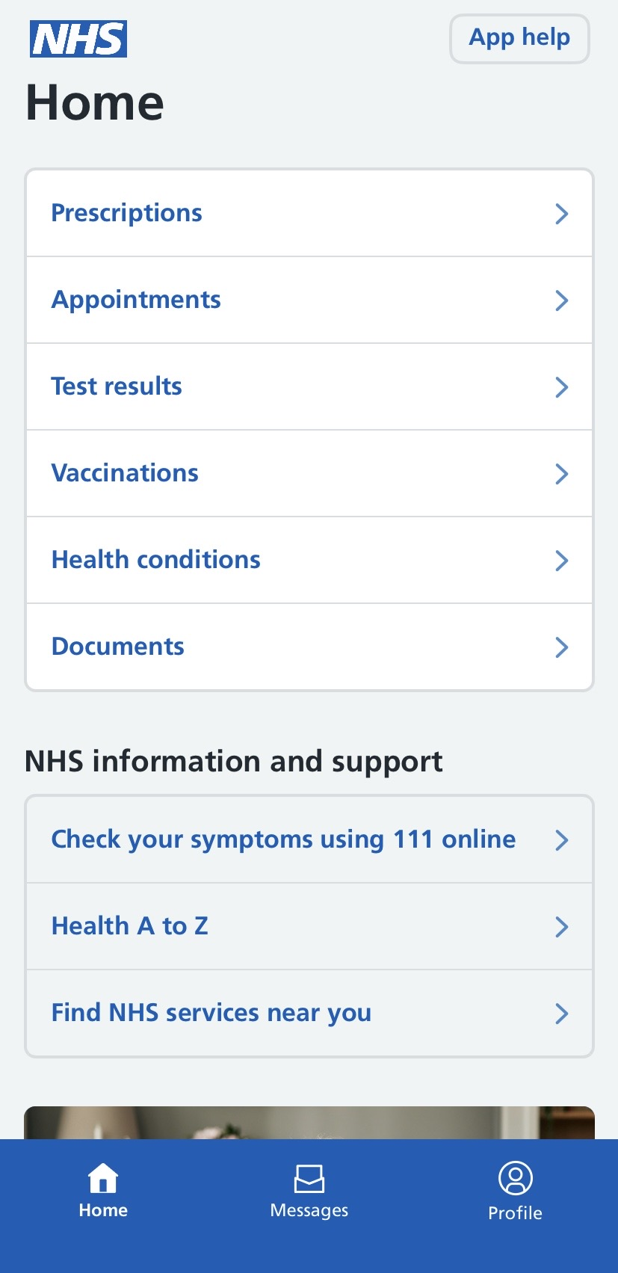

My Short Reflection
Digital skills are important to me as they are currently widely depended on for a variety of different things, especially work related and these skills are generally very important for everyday life.
I use various digital devices on a regular basis and believe that I have good knowledge on how to use these devices as well as their programmes and features.
Devices I use regularly include my iPhone, Alexa, Smart TV, Car Satnav, PlayStation 5 and laptop.
Though I am most confident in operating my iPhone, specifically and tend to use this device and its digital tools most.
Though I believe that I have good general digital skills, I would like to gain more knowledge on programmes surrounding business and extend my knowledge in Microsoft Word, PowerPoint and Excel and I believe that this course can help me to do this.

