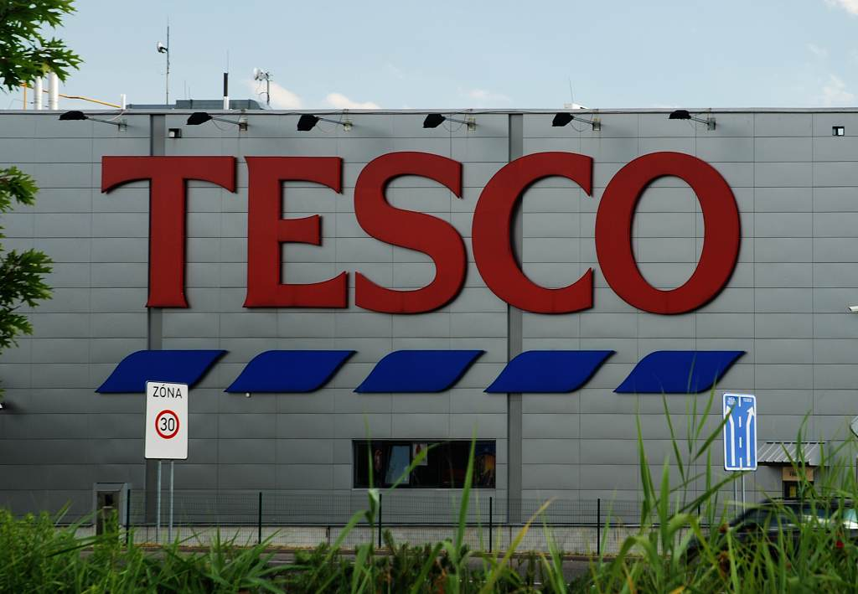  Tesco case Study  Tesco Report | Khuram Khan (1808278)  Certificate of Higher Education
Module code :BMSk4004
module name : Problem solving and decision making problem solving
assingment title : Tesco Report

Table of Contents

Executive summery 1

introduction 2

History of Tesco 3

Pestle Analysis of Tesco 4

Swot Analysis 5

Stake holder Analysis……………………………………………………………………………………………………………………………6

References 7

Executive Summary :
This report is to give a brief view the history of Tesco .This report is created by analysing how Tesco was established and what measure and decision it took to overcome the problems that it(Tesco) faced in past and how Tesco was able to overcome and tackle those all problems and what main steps it took to survive the great competition from other rival supermarkets like Sainsbury’s Asda ,Lidl ,Aldi . This report will provide an overview of how Tesco developed in to a supermarket giant as well as its current product portfolio.
This report will discuss how Tesco has planned and communicated ,Monitored and Revived decisions it took in past to resolve its problems.
This report will describe the current problems that Tesco is facing and what impact those problems are having on Tesco.
The purpose of this report is to come up with possible answer to Tesco’s problem by performing a critical analysis, using PESTLE ,SWOT and perform a Stake Holder analysis to make a list of the Stake Holders in TESCO. Once analysis completed all information from the analysis this report will highlight the main issues and problems that Tesco is facing or has faced in past. All gathered information from this report the will help decision makers in Tesco to resolve the those issues high lighted in this report.

Introduction:
This case study is in relation to Tesco. This will include a brief history from its beginnings up until today. Within this report, internal and external information will be investigated to provide the best possible analysis on how the company is run along with the issues it currently faces. By using different analytic methods, a clear view will be provided in describing the nature of the current climate as well as the previous issues Tesco had faced. Not only this, this report will also include how Tesco tackled their problems in the past and also how they are currently tackling their problems today.

History of Tesco:
Tesco is a well-known, well established worldwide company within the supermarket industry. It has grown from being a small market stall located in East London to the current leading superpower, currently in direct competition with other chains such as ASDA, Sainsburys and Walmart. This global superpower came into prominence after Jack Cohen started trading goods from said stall in 1919. After partnering with T E Stockwell, Jacks first own brand product was Tesco Tea.

History of problems faced by Tesco
Having dived into the history of Tesco, Tesco have had their fair share of problems while on the rise.
Start of new supermarket chains was a big threat and problem that Tesco had to face since it was established .
By the 1960s, more supermarket chains came into existence, meaning Tesco had to deal with competition from all angles. In order to tackle this issue, Tesco made the decision not to only lower their prices in order to attract more customers, however they also started giving out Gren Shield stamps in 1963 in order to reward customers for their loyalty. For every £1 customers spent, stamps were given accordingly.
Jack Cohen’s initial message when starting out was ‘Put affordable food in the reach of everybody’. Sir Ian McLaurin took a giant leap and lowered the prices of over 1500 food items. This helped Tesco beat other competitors in the 1980s and came out on top during the price wars. 2014 was the year when Tesco was shaken due to allegations that it has overstated its profit ,this issue was arisen due to many different internal and external factors.
This was a big damage to Tesco’s reputation and later this matter was passed to serious fraud office for further investigation. At the end of 2014 there was another bad news for shareholders when it was announced by Tesco that its profit will not be as it was expected fall in profit due to Tesco losing its shares to Aldi and Lidl.
Tesco made a statement in December 2014, there will be a fall in profit at the end February 2015 it will fall from £1.9 bn that was expected in 2014( www.bbc.co.uk,2014 ), as Tesco lost its shares to Aldi and Lidl. For this reason, later Tesco announced its profits will be £1.4 bn not 1.9 bn as expected previously
. According to a report by ( www.bbc.co.uk, 2014) “Tesco's core UK market share has fallen to a near 10-year low”. Three former senior directors at Tesco have been charged with fraud in relation to a £263m-plus accounting scandal at the supermarket chain.
Carl Rogbrg , Christopher Bush, John Scouler all were high profile personalities and held high position in Tesco .All of them were charged with one count of fraud and abuse of position also one count of incorrect accounting. . (www.theguardian.com, 2016)

A statement from the Serious Fraud Office said the alleged activity occurred between February and September 2014. . (www.theguardian.com, 2016)

Three of them were summoned to attend at Westminster magistrates court ,On 22 September 2016 and could face up to 10 years in jail if found guilty of fraud by abuse and seven years for false accounting. (www.theguardian.com, 2016)

According to a statement by SFO enquiry into Tesco remained ongoing and it is still possible that further individuals could face action. However, it is understood that former chief executive Philip Clarke, who was questioned under caution by the SFO, will not be charged.

How Tesco solved its Problems in Past:
Problems in past were solved by Tesco by making many decisions that were taken after a problem occurred. Since its start Tesco was quick to explore and adopt to new ideas
Tesco diversified it products and made critical changes to keep up with demand of its customers.
In the 1970s, supermarkets began to revolutionise the way people shopped, and Tesco initiated a massive expansionary strategy, opening stores throughout England.
1990s, was the year when competition in the industry was becoming extreme , during this period Tesco applied numerous effective business strategies that successfully made Tesco hold top position over its business rivals.
Tesco start using new used new marketing strategies like Clubcard which gave Tesco a big advantage over its competitors Reward system also provided important data about how frequently customer use Tesco . BY offering rewards like this Tesco was able to keep its customers happy and help Tesco not only to retain old customers but also make new customers (Tesco.com).
As Tesco being in leadership position of super markets in UK always tried different methods to keep its customers by using well known and tested way to keep customers called reward system . By making it possible that club card points can be exchanged for cash vouchers Tesco become a favourite for customers to do their daily shopping .
Rewards system helped Tesco in more than one way it was one of main reason that .Tesco overtake its closest rival, Sainsbury’s.

Pestle Analysis of Tesco:
PESTEL analysis is a framework or analytical tool that is used by marketers and organisations to examines and monitor the macro-environmental (external marketing environment) factors that have an impact on an organisation. The result from pestle is helps to identify threats and weaknesses .
PESTEL stands for Political, Economic, Social, Technological, Environmental and Legal.
Social Factors
The Way Customers do their shopping are constantly changing with new trends over time. People have very busy life style now and tough schedules to follow this puts lots of pressure on them now customers want to shop from the comfort of their home whenever they can and want fast delivery with flexibility of return policy. Clients wants to shop in one place if possible that give them more freedom to spend time to socialise with family and friends. From social point of view due Tesco mostly relying on UK customers must provide customers with the services that meet their needs and can save time and hassle when shopping at Tesco.
Healthy eating is also a new trend that is very important for Tesco .Tesco must invest more in this area to make sure that customers are able to get all health products when shopping in store or online.
Tesco needs to understand the need for goods and products and services for a wide rang of consumers who come from different backgrounds and may have different beliefs. Kosher ,Halal are two will attract more customers to Tesco products that is social factor currently ignored by Tesco.(karam,2019) Tesco also have responsibility to reduce unhealthy food items that are currently sold by its stores products high in fat, sugar ,salt are putting society at risk and cost NHS millions of pounds yearly. Tesco must promote healthy and organic food and locally sourced products that have less impact on health and environment .
Loyalty of customer is important, and most people like to shop in a store that is close to where they live and have easy access. Many people find it hard to travel that stops them leaving home and they become more socially isolated ,Tesco can offer a free bus for people who have these issues shopping is also a chance to socialise especially for our elderly population if Tesco can offer a service like that that will make a big positive impact of Tesco .
Tesco is not in bad place for having customer loyalty according to a report by (cxm.co.uk) Tesco is on 2nd position for having satisfied customers.
Tesco can create more opportunities to develop close ties and connection with its loyal and new customers.
Technological Factor
Tesco had faced many issues in past due to lack of technological development. Issues like Tax fraud conspiracies rumours spread by competitors that Tesco have poor customer etc are a real threat to Tesco’s reputation and by investing and updating and using Technological advancement has given many new opportunities to Tesco to get customer trust back.
It is critical for Tesco to keep up with development of new technological and adopt any new available technologies to carry out its retail process smoothly by using new technology it is now easy to keep UpToDate information about of sales , stock and remove it after sales. This information makes it easy for retailers to reorder and refill the stocks before it runs out .
Tesco has adopted very well to new payment methods it makes easy to shop flexible payment systems makes it easy for customers to pay for their shopping.
According to the guardian report Tesco is testing new “shop and go” technology that will allow customers to scan and pay for goods using smart phone smartphone this will save them time .
(www.theguardian.com/business/2018)
Environmental Factors:
Most companies are facing immense pressure from government and environmental agencies and campaigners to reduce the carbon foot print and greenhouse gases ,Tesco has responded and have already started investing to tackle these issues for benefit of society and planet
Tesco started encouraging its customer to shop at( tesco.com) it will help reduce fuel consumption and Tesco Van Drivers are also advised to use short routes and collect plastic bags from customers for recycling .
Tesco has shown its commitment to use renewable sources to generate 100% of its electricity by 2030. The company promises to minimize up to 50% carbon footprint by 2020.(Tesco.com,2019)

SWOT analysis of Tesco:

SWOT is contraction that is read as Strengths, Weaknesses, Opportunities and threats. SWOT is an analytical method that was invented by Albert Humphrey who was a management consultant Albert Humphrey at Stanford Research
Institute.(2019,www.lucidchart.com). below are the findings from swot analysis of Tesco which demonstrates the key points of Tesco’s strengths, weaknesses, opportunities and threats.
Strengths | Weaknesses
Opportunities | Threats
(Khuram 2019)
Strengths
Tesco has a very strong Leadership position in the UK . Being one of the well-known brands in the UK supermarket empire is a huge strength and advantage .
Tesco has very successful online operational network this is also strength of Tesco and gives clear advantage over many of its competitors like Lidl ,Aldi
Local presence of Tesco is a strength Wide range product available from Tesco and most house hold products with Tesco’s own branded good quality and reasonable prices makes it one of the largest grocery stores in the UK.
Tesco has leadership position in UK supermarkets with its Increased sales and higher revenue according to its 2018 report
Wide range of affordable household and grocery products and Winner of two grocer gold awards in 2018 .Tesco picked up two Grocer Gold awards at the ceremony held in London on Tuesday 12 June 2019. (tescoplc.com,2019)
Tesco is thriving globally now have more 6800 stores worldwide .Asian market is huge, and Tesco is benefitting from its strong presence in Asian market. As (Baber, 2018) stressed that Tesco is one of big employers in Malaysia
Tesco is one of the major Supermarket in the UK
Tesco was established in 1919 with nearly 100 years and still thriving is strength and advantage of Tesco established
Tesco’s being on top of the list its revenue as a proportion of total UK retail spend in 2017 according to Global Data is 12.5 % ( www.retailgazette.co.uk, 2018) –
After Tesco has announced that it will run 100 % on renewable electricity in the UK will attract more customers due to current campaigns about global warming and renewable use of energy.

Weaknesses:
Tesco will struggle to focus on single market due to its involvement entering different markets around the world .
Divergence into unrelated businesses like Tesco banking Tesco mobile phone and Insurance can make Tesco weaker as these not the markets that Tesco was previously involved in .
Tesco need to make more effort to tackle its impact on environment not having clear environmental policies is a weakness.
Tesco need to plan how it will keep its supply chain UpToDate as things will be totally different after Brexit.
Opportunities:
Alliance with other companies will make Tesco strong
By purchasing more whole sale local suppliers is a great opportunity as right now many small whole sale firms are under extreme pressure due to uncertainty of political situation of UK and EU future relation after Brexit.
Coffee is a big market and café culture is booming this is a possible opportunity for Tesco.
By creating an Alliance with other retail firms especially from Europe can bring good opportunity for Tesco.
Tesco and Carrefou joint buying will bring good opportunities for Tesco and as a result cut in price will attract more customers.
Healthy Eating is another opportunity for Tesco by promoting and investing in this field can bring more revenue to Tesco
Threats
Sainsbury’s, Marks & Spencer ,Morrisons, ASDA ,ALDI all are in competition with Tesco any coalition between those mentioned above is a clear threat for TESCO.
BREXIT is a real threat
Government tax policies after Brexit can pose a real threat to Tesco.
Losing Customer is always the big threats for Tesco.
Any scandal in past like horse meat tax fraud are real threat to Tesco.

Stake Analysis of Tesco:
Stakeholders holder analysis is important, it helps to identify the stake holders and how stake holders can affect a business. Businesses with a clear view and understanding the demands and importance of stake holders can have high chances of success .
We will use Mendlow’s model to identify the main stake holders in Tesco
Mendelow (1991) advises that stakeholder can be divided in to different groups based their ability to impact our organisation and how concerned they are in the organisations accomplishment.
Mendelow(1991) also suggests that we must not forget that some stakeholders may have more power than others ,
According to Mendelow(1991) some stakeholders hold more Power than others, and some have more Interest”
Stakeholders can be anyone who have an interest in a business. They can be individuals and groups or can be an organization that are affected or feel threatened the activity of a business or part of business. Simply stakeholders are anyone who is worries about the welfare and success and survival of those who might be connected or have impact from the activities of a business or its operation .
Tesco’s stake holders are Customers, Employees, Local communities, Suppliers and worker Union all Stakeholders in Tesco have different view and interest in Tesco than shareholders.
Shareholders want more profit while stake holders want a fair deal.
Shareholders can affect how they finance the Tesco while Stakeholders can pressurise to make it work fairly.
High interest stake holders
Employees ,shareholders, Govt
Low interest stake holders
Customers
Suppliers

Possible Business options for TESCO
Tesco is a leading name in UK and international supermarkets around the world .
There many possible options for that Tesco below are the suggestions :
Joint buying with its European partners
Expansions to new market in Asia and North Africa and America
Investing in other parts of the world with small supermarket firms and use its buying power and finances to expend and thrive .
Before Brexit make deals and partnership with European firm.
Extend its operations to many other un explored destination and small parts of the world by starting a partnership with local markets
Start its stores in USA by making partnership with rivals of Walmart group.

References:
Available online at :https://www.bbc.co.uk/news/topics/c77jz3mdmlvt/tesco
[Accessed 21/03/2019]

Available online at : https://www.theguardian.com/business/2016/sep/09/sfo-charges-former-tesco-directors-with-fraud
[accessed at 22.03.2019]
Andrew Simms Tescopoly : How One Shop Came Out on Top and Why it Matters
Available online [Accessed at 23.03.2019)
Available online at : https://www.lucidchart.com/pages/what-is-swot-analysis
[accessed at 24.03.2019]

Available online at https://www.theguardian.com/business/2018/jun/28/tesco-shop-and-go-app-till-free-store[accessed at 23.03.2019]

Available online at https://cxm.co.uk/brand-loyalty-index-ms-voted-customers-favourite-supermarket/[accessed at 24.03.2019]

Available online at https://www.retailgazette.co.uk/blog/2018/04/amazon-now-5th-largest-retailer-uk/[accessed at 24.03.2019]

Available online at https://www.bbc.co.uk/news/business-44679884
[accessed at 24.03.2019]

Available online at https://www.independent.co.uk/environment/tesco-switch-renewable-lectricity-energy-[accessed at 24.03.2019]

Available online at https://sustainability.tescoplc.com/sustainability/sourcing/topics/environment/
[accessed at 25.03.2019]

Available online at https://www.tescoplc.com/.../reducing-environmental-impact-when-sustainably-sourci...
[accessed at 25.03.2019]
Available www.mondaq.com/.../Clean.../Tesco+Fined+8+Million+For+Environmental+And+Saf
[accessed at 25.03.2019]

Available online at Tesco and WWF bid to 'halve environmental impact' of UK groceries [accessed at 25.03.2019]
Available online at https://www.theguardian.com/environment/.../tesco-and-wwf-to-halve-environmental-im
[accessed at 25.03.2019]
Available online at Tesco makes green pledge | Business | The Guardian
[accessed at 25.03.2019]
Available online at https://www.theguardian.com/business/2007/jan/18/supermarkets.retail [accessed at 25.03.2019]

https://www.greenpeace.org.uk/supermarket-score-new-plastic-league-table [accessed at 25.03.2019]
https://friendsoftheearth.uk/sites/default/files/downloads/tesco_agm_2006.
[accessed at 27.03.2019]

https://www.endsreport.com/.../ethical-investors-turn-spotlight-tescos-csr-commitment
[accessed at 27.03.2019]
https://www.bitc.org.uk/resources-training/.../environmental-sustainability
[accessed at 27.03.2019]

