Do you need to know the rules before breaking them?

Ittihkorn Duangchat (P137459)
Submitted in fulfilment of the
Degree of (BA) Hons Graphic Design
Sumitted 13th December 2017

Contents

Introduction ………………………………………………………………………………..3
Chapter One
The History of the Grid and Typesetting ………………………………………5
Chapter Two
The Rules or Not the Rules……………………………………………………...10
Josef Muller Brockmann
Erik Spiekermann
Wim Crouwel.
Chapter Three
An Introduction to David Carson and Neville Brody………………………….17
David Carson
Neville Brody
Chapter Four
Analysis of legibility and Readability……………………………………………23
Conclusion…………………………………………………………………………………25
Reflective…………………………………………………………………………………..28

Introduction
This dissertation will question how important it is to have a formal understanding of rules within design, to be a graphic designer. One source (Shetty) in 2012 has claimed that: “you don’t have to know the rules before breaking them”; however, is it true? (Carson cited in Shetty 2012).
Is it really true that you need to know the rules before you break them? There is a belief that there are several rules that you need to know, such as the grid system, leading, letter spacing and visual hierarchy. Over the period of type design, the typeface was the only design system for organising texts and good design was almost additional to producing types that were readable.

Every design can follow different principles; David Carson’s designs exemplify this by not following a grid or leading systems. This does not mean that he cannot produce good design. However, as stated he never knew what made a good grid system (Roberts, 2005:94) but he has produced incredible work. This was by developing his own style without knowing the organising system. In addition, British designer Neville Brody has inspired many generations from 1980s through to contemporary graphic design. Brody is best known for his inspiring work on The Face Magazine, which was first published in 1981, with his fluent Dada inspired typography with punk anti-establishment methodology and style that developed using similar techniques used by Carson.
The type of font you choose to use along with layout ideas and colour palettes will be the result of good or bad design. (Creative Bloq , 2017)
German contemporary Erik Spiekermann stated that the font is important because the typeface should suit the design and composition, as it has been able to spread the message and communicate well, however the colour palettes should also be considered (Gestalten, 2014).

The Spanish painter Pablo Picasso has stated in contrast to David Carson that you may need to learn every rule before breaking them;
“Learn the rules like a pro, so you can break them like an artist.”
(O'Brien, 2015: 43)

This dissertation will be analysing the work of contemporary designers such as David Carson, Neville Brody, Eric Spiekerman, Wim Crouwel and Josef Muller Brockmann and discuss how these artists have used or not used the rules of typography within their work. This dissertation will compare the work of different designers that think that rules are either important or unimportant for their design process. Erik Spiekerman, believes type is important and needs to also be legible and readable and likes to follow the rules. Spiekerman stated:
“If I break rules without knowing them, even though they are not hard to know, then I'm being childish.” (Gestalten, 2014)

Wim Crouwel always keep his work organised within the grid system structure utilising a simple design. Crouwel was particularly popular as a designer in the 1940s-50s and his work is recognisable for using a grid system.

The rules system has been researched by Kimberly Elam, as a graphic designer author publishing books on the subject (2007) these include the Typographic System and Geometry of Design. Elam has evidenced that graphic designers need to know, particular elements of design for example; Axial, Radial, Grid, Modular, transitional and the Golden Ratio. (Elam, 2001)

Reflective
Rules and typography have always been interesting and it is important to know to get inspiration from modernist, post-modern and contemporary designers and to apply the grid to the construction of typography, poster design and books. We as designer are required to know how it is important the rules and it unquestionable that rule can relate to the design.

Chapter One
The History of the Grid and Typesetting

The grid is mainly used by graphic designers to construct the layout of the design rather like a building’s foundation. The basic convention of the grid system is very simple to use. Similar to how people read books from left to right and then top to bottom, it is subtle form of a vertical and horizontal system.
The grid system has been used by many designers because they are useful for formatting and are regularly used to design multiple page booklets. They aid the designer to produce the work faster and build visual reliability into the work that support the user to find the way around the page. (Roberts, 2005:18-19)

The layout method, spacing and scale system were all investigated back throughout to the modernist era. They took inspiration from science movements just as much as they did with art. The designers stated that the organisation and cleanliness of the grids create symbolic, strong construction utilising functional guidelines. The ideas have come together through a clear set of design rules based on a grid method. (Roberts, 2008:8)

Swiss designers Max Bill and Richard Paul Louhse had tried to develop techniques, investing a methodical system in their works alongside the process of graphic design. However, their contemporaries Emil Ruder and Josef Müller-Brockmann have discussed the rules and regulations of grids in their studious manuscripts, having come together to conclude that the design is very important to the arrangement. They may link entire 2D and 3D designs including type, picture, diagrams and space itself. The passion for perfection had also an awareness to the art. (Roberts, 2008:8)

The ‘Golden Ratio’ defines an exclusive technique. The rectangle boundary contains a set of smaller squares that when placed together in sequence makes the ‘Golden section spiral construction’ (2001). When the squares are proportionally placed in sequence, it forms an equal ratio for which a curved line can be drawn in correct proportion, making the Golden spiral most beneficial tool for designers.
(Elam, 2001: 24-25).
Gyogy Doczi has stated;
The power of the golden section to create harmony arises from its unique capacity to unite different part of a whole so that each preserves its own identity, and yet blends into the greater pattern of a single whole.
(Elam, 2001: 8)
Gyogy Doczi statement explains to designers to understand the rules of the golden section by following this designer can produce incredible work within their own style.
The golden section has similarity to the grid by keep everything organised and structured within the design, moreover, golden section has more curves then straight line such as in geometry. However, Elam has revealed designers’ layout system using golden section including, Jan Tschinhold, Wim Crouwel and Josef Muller Brockmann as these people always kept they designs in position using a systematising style.
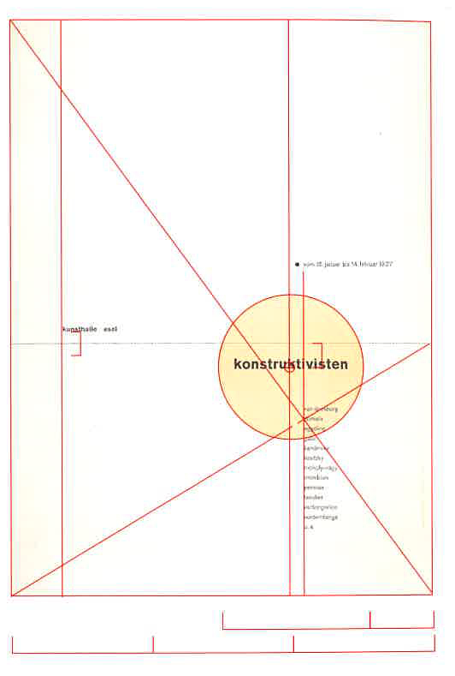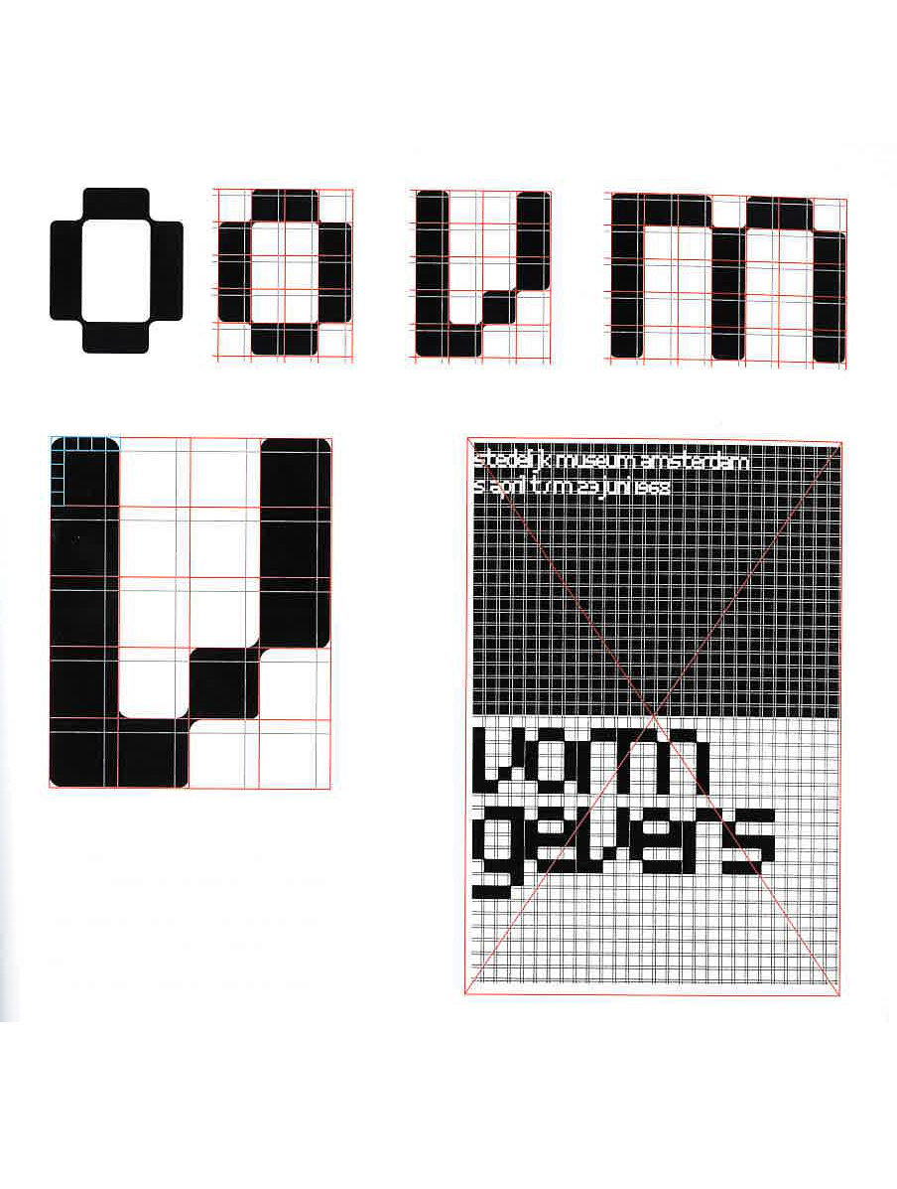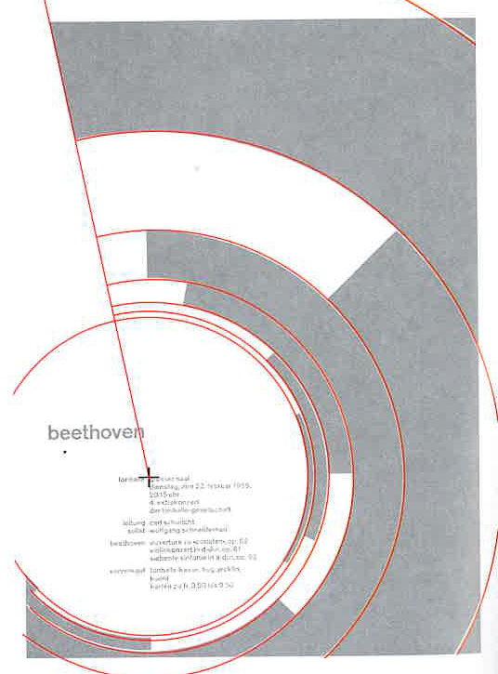
(Fig.1) Left: Konstruktivisten poster by Jan Tschihold, 1937 (Elam, 2001: 67).
(Fig.2) Centre: Vormgever Poster by Wim Crouwel, 1968 (Elam, 2001: 87).
(Fig.3) Right: Beethoven Poster by Josef Muller Brockmann, 1955,
(Elam, 2001: 80).

Brockmann has constructed his design using mathematical systems, creating a grid and a ‘golden section’ including grid and golden section. His famous Beethoven poster design from 1955 (fig.3) was structured to draw your eye towards the golden section using a circular negative space. The result was clean and simple, but drew your attention to the information on the page. (Elam, 2001: 80).

These ideas also translated to the application of typography, in line with how letter type was developed. The lettering responsively relates to how it is arranged on the surface. This era produced ‘a flexible letter type printing system that much of the world has used for the centuries. (Alessio, 2013)
The typography has a powerful system to communicate, as the language can be a message of thinking with what humans’ view. (Rob Carter, 1993: 1)
The art of typography may look straightforward, although it is possible to make ‘mistakes’. Contemporary designers may pick a font and play with size, possibly adjusting the colour, to create the right feel, although this is open to interpretation and error. Designers could make ‘mistakes’ such as insufficient leading, too much positive tracking, using too many faces and weights, failing to set reasonable line lengths and two spaces after a full stop. (Hampton-Smith, 2017)
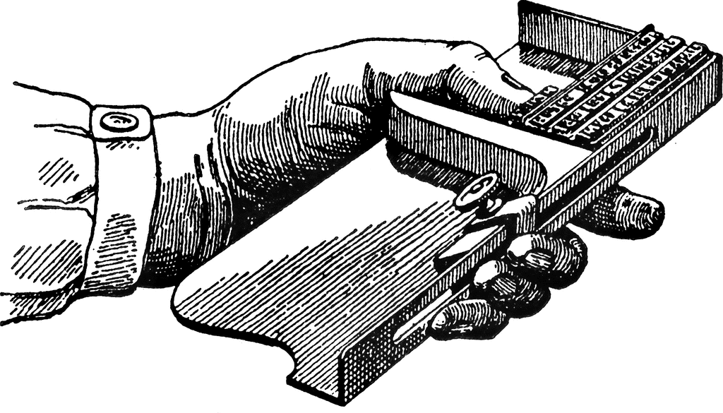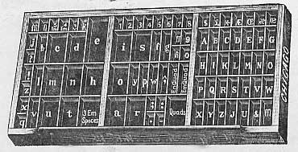
(Fig.4) composing stick (Fig.5) Type case

This relates to the rules of traditional typesetting, set out at this time. The typographers held a composing stick (fig.5) in one hand and the replaced in line of type with other. The final outcome was comprised of typography that was arranged by each letter and each line. (Rob Carter, 1993: 98)

In the 1980s, many letterpress producers had ended their traditional manufacturing process because the technology had begun to move on, and many of the skills relating to typesetting became less relevant. The new trend was debossing and a new product came into the market call photopolymer that was designed for the letterpress. When technological methods were brought in, it became easier for the designers to adapt their designs through twisting, leading or kerning. (Fleishman, 2017)
The setting of metal or wood block types is made very particular because of the awkwardness and the unyielding nature of the material. This very material, and the fact I hand-ink the type surface, gives a very tactile and lively appearance to the finished image. This is not done for ‘effect’ but to strengthen the design and help give meaning to the words. Alan Kitching states (BBC, 2016)

This way of setting typography was the traditional method back in the fifteen century. It was when the rule type has begun and they never change since that period. Every method, never think it as a restriction but always think that it.

Chapter Two
The Rules or Not the Rules

This chapter will discuss the different design organisation methods and how the rules are important and you need to know them. The grid system is the rule that most of the designers use to construct typography to keep a design organised and clean. Josef Müller-Brockmann, Emil Ruder, Karl Gerstner and Wim Crouwel, were grid system inventors and pioneers these and have inspired many generation of designers through the use of the grid system and other techniques. However, this chapter is not going to discuss only grids but also focus on other designers such as typographer Erik Spiekerman, who also applies the rules and thinks that lettering is important and every type should be readable, legible and organised in design.

In 1970, the grid system had become a popular process amongst visual communicators, it was used by graphic designers to set up page layouts and organise text structures. However, designers such as Josef Müller-Brockmann, Emil Ruder and Max Bill questioned the style of that era. The contemporary artists thought that the old method of construction was quite disorganised and they began to develop a grid system that was constructed on lines, that would help the designer to balance the final outcome. (Towers, 2003-2016).

Josef Muller Brockmann
Josef Muller Brockmann (1914-1996) was part of the Swiss graphic design movement during the 1950s and 60s. Brockmann also a has unique style as his techniques are very clean and neat because of his influence from architecture when he was studying at university. Generally, he produces work with lots shapes, with the quantities and spacing suited together for use within a grid structure. Brockmann used numerous sans-serif fonts such as Akzidenz Grotesk Univers and Helvetica. He aimed to produce less pattern and create a modern style, combining these with the basic grid method, as stated in the book Grid systems in Graphic design. (Kraft, 2015)

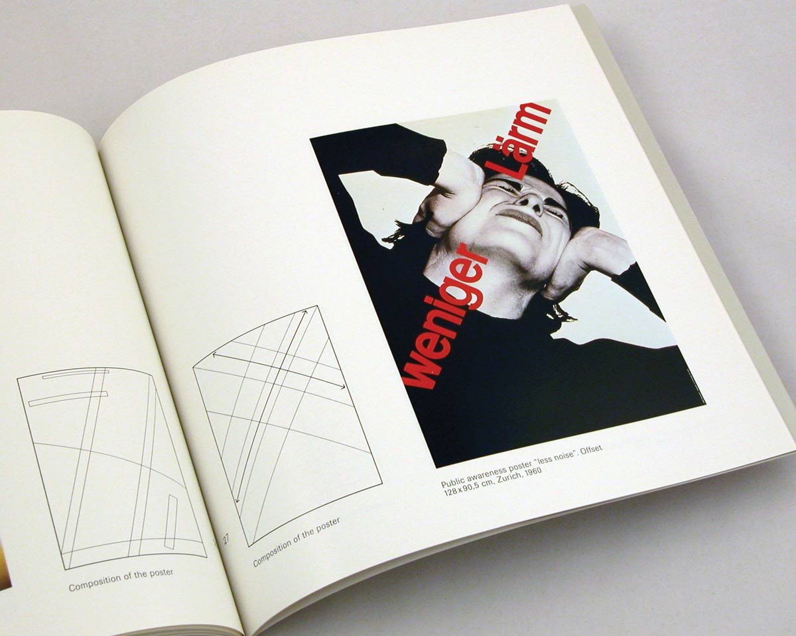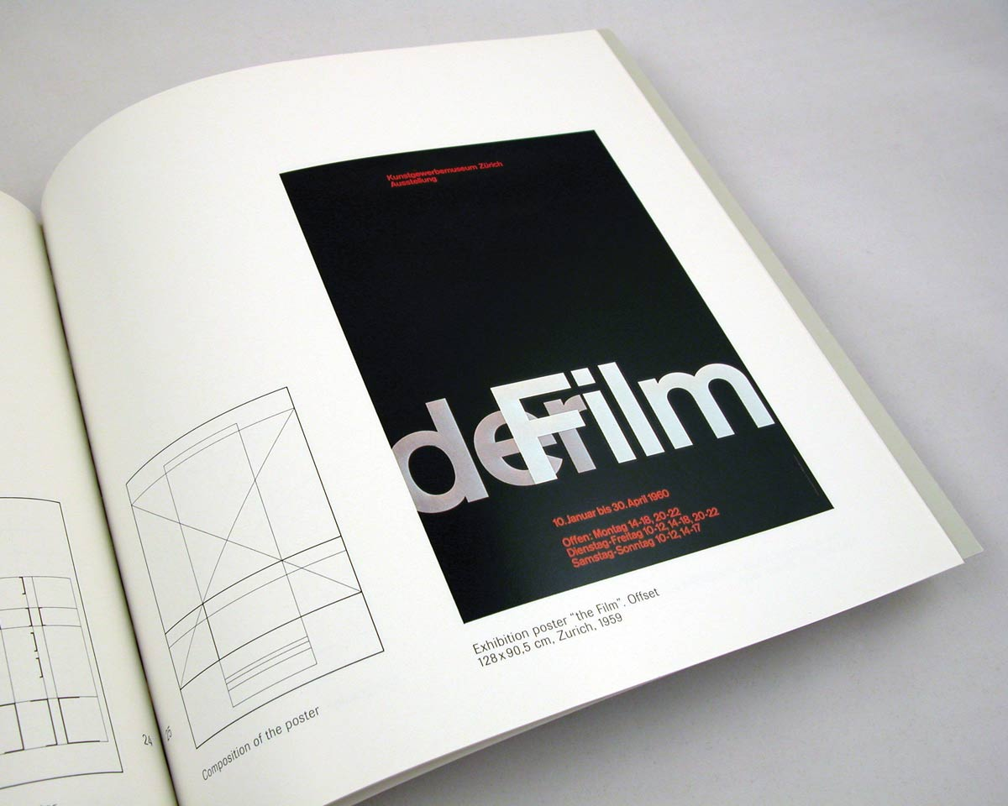
(Fig.6) Left: Public awareness poster “less noise.” 1960. Offset. 128-x 90.5 cm. + composition grid.

(Fig.7) Right: Zürich Museum of Arts and Crafts Exhibition Poster, 1960. Offset. 90.5 cm x 128 cm + composition grid. (Meister, 2013)

Brockmann liked to keep his work very simple and clean, the idea was to make sure typography was practical and legible. Brockmann has stated that his design is “employed so that there is a link (between image and text) that compels attention.” (Meister, 2013)

(Fig.6&7) shows the way Brockmann combined text, image, and structure of the grids. He keeps it clean and simple by the use of grids, to help organise the typeface. (Fig.7) The Der Film design represents the practicality of basic design, using characters and lettering that solve the problem and also use a simplistic way of using tones. The understanding of composition has developed within the organisation of the different elements, combining letter and form has been brought into the design. (Meister, 2013)
Josef Muller Brockmann stated,
information presented with clear and logically set out title, subtitles texts, illustrations, captions will not only be read more quickly and easily, but the information will also be better understood and retained in memory,
By organising, the typography within a framework, he felt he was able to effectively communicate the message through the design. (Rob Carter, 1993: 92)

Erik Spiekermann
Erik Spiekermann (1947 to present), is a graphic designer best known for his typographic work. He also developed the newer methods invented by “post- digital printing” and is associated with traditional letterpress applying laser cut, polymer and metal backed plates. The type plate lets the designer produce work directly on the surface. It was the final effect of printing with the highest of standards, resulting in letterpress outcomes that contain dark ink and a good quality. (Brewer, 2017)

When Spiekermann turned 70 years old, he described that you are never too old to forget developments and was not too old to start learning how to work with a computer. However, he states,
I’m perfectly digital but I haven’t forgotten the analogue. I’m the in between generation. If the next generation doesn’t learn it then a whole culture will be lost, so in a way it’s good to keep it going. (Brewer, 2017)
Spiekermann has explained that, the letterpress is not “hipster” and that he does have deep understanding of the woodblock typeset produced on paper. However, the typesetter’s book is traditional, unlike the values of the letterpress. The letterpress consists of a base which is magnetic and plates made up of nylon, making them durable. This makes the type clean and refined.

Spiekermann working with his team produced the traditional printing machine, and called it “unscientific and total Mickey Mouse outfit”, they tried experimenting and eventually completed the method. The machine was an old-fashioned piece of equipment but they learnt to use it successfully, having gone through many techniques to ensure that they have the right process.
Eric had said:
People call it a revolution but it’s just hacking basically. I remember when we first started it up no one wanted to press the button because we worried it might explode, we were in the corner covering our eyes! (Brewer, 2017)
They have the old traditional type machine and modern front-end, which was very useful for production. It was like going back to the old days by using the conventional rubber rollers and greasy ink and paper and was simple and easy to be use as there was no fixing pins or registration. Even though it was a large piece of equipment, it still was practical and did the job. (Brewer, 2017)

In a recent interview with Gestalten (2014), Erik stated:
Of course type is important! One can't prove it, that's all (Gestalten, 2014).
There is a clear argument for having to know the rules before you break them when working with type to convey a message. However, no matter how many books have been sold with decent typefaces, it is still advertising and the design of the cover grabs the reader’s attention. (Gestalten, 2014)

Every typeface has a function, it not always about ‘looks’, it is the emotion that you bring into the design, as an unappealing design would not sell. In the 1990s, Spiekermann designed transport sign system (fig.8) in Berlin. In the signage system it has to be functional to enable the users to successfully manoeuvre through the transport system, making it easy for each customer when they need to know the exit way and where to buying tickets. Typography was the way to communicate to the public and help them clearly understand. Berlin was full of monochrome, Spiekermann needed to developing it to look like an impressive design and use colour to decorate the location in the city. (Gestalten, 2014)

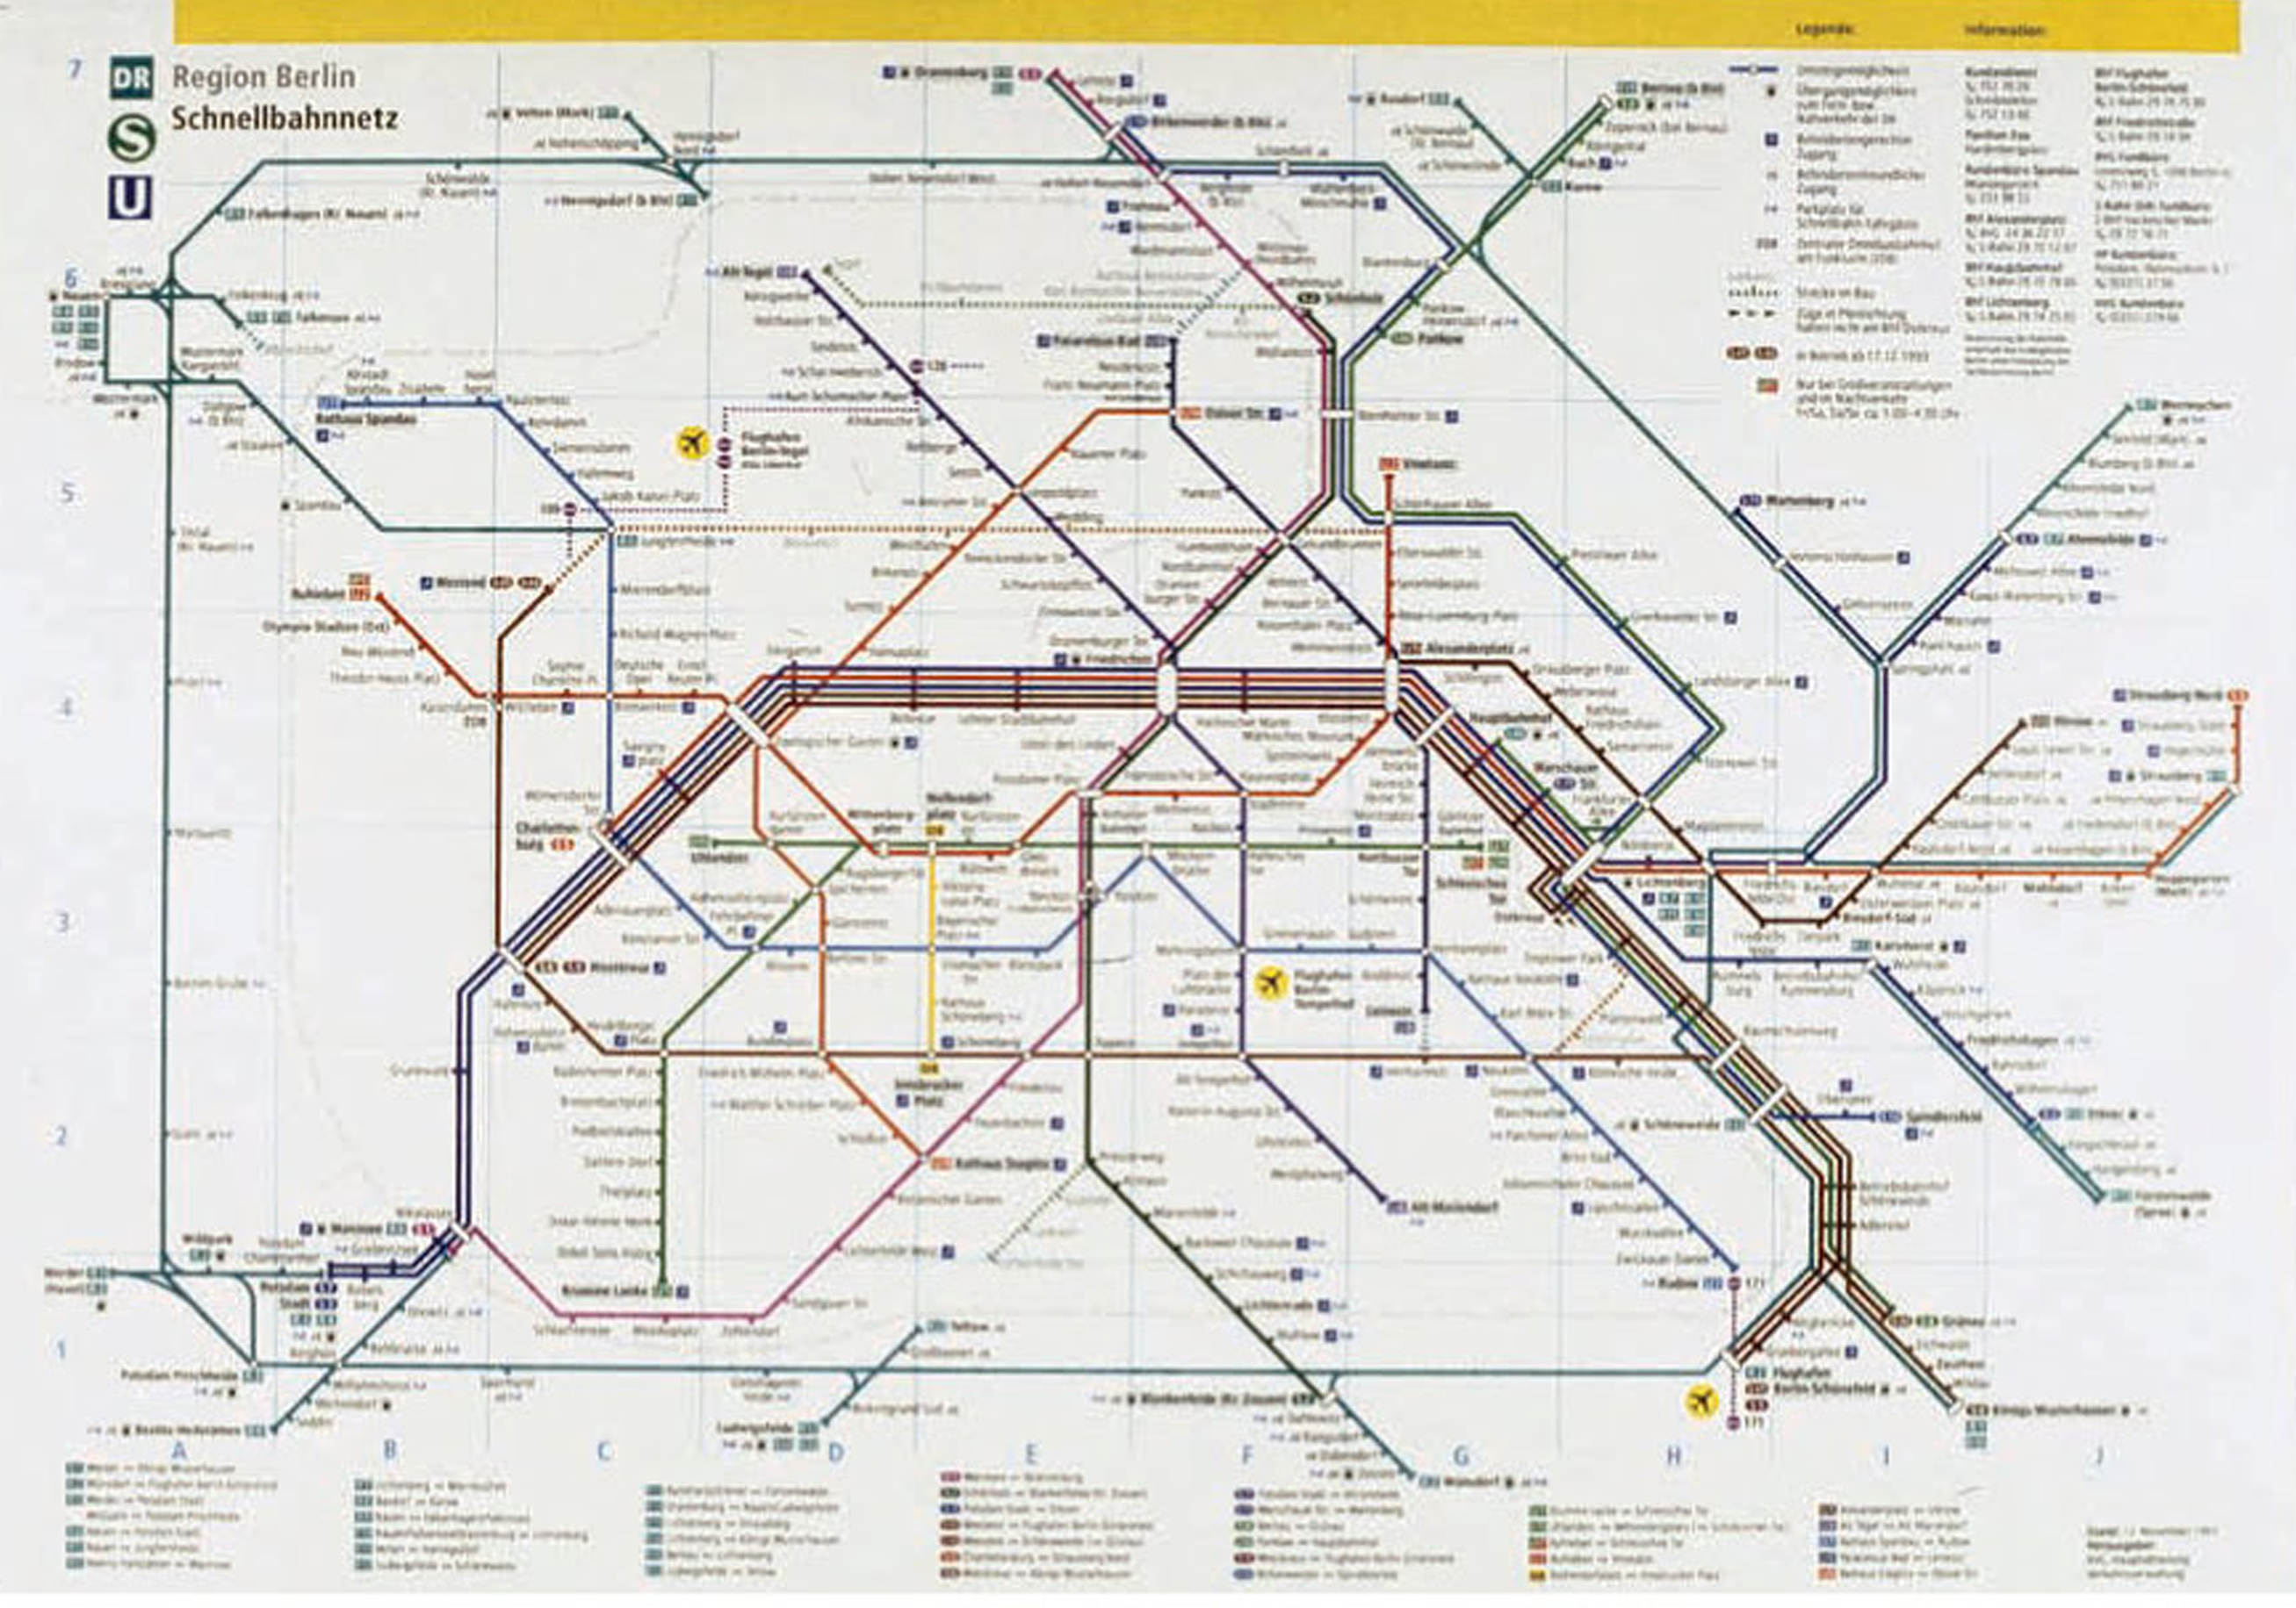
(Fig.8) The Berlin Trasportation System 1990. (Poulin, 2012:216-217)

Spiekermann stated:
` If I break rules without knowing them, even though they are not hard to know, then I'm being childish. (Gestalten, 2014)
His statement is the opposite way of thinking from Carson, who was of the opinion that “Breaking the rules without knowing them first”. Spiekermann believes that it is like a child giving permission to pee on their pants, but if they are not old enough they would not understand that they are not supposed to do that. (Gestalten, 2014)

He stated other designers should know the rules and to always following them.
Spiekerman also stated in the interview that he loves the rules:
I am not rule based, even though I’m German and I love rules
(Hustwit, 2007).

Wim Crouwel.
Wim Crouwel (1928- ) is known as a typographer and designer who used the grid system to organise text layout. Crouwel is one of the most unique designers from the 50’s and 60’s. He was extremely influenced by the workings and teachings of the post-war designers in Switzerland. Crouwel declared that the greatest inspiration was his contemporary and partner, Karl Gerstner. Gerstner developed the prints for the book ‘Designing Programmes’ which was then published in 1963, which soon became extremely popular and an iconic book for designers everywhere appealing to both designers from 1960s to the current day. The book contained the rules of the grid systems and typography. In particular, he claimed that the designer invents the rules and regulations that can aid the choices that affects the end design of the product. (Crouwel, 2011: 65)

Many designers and educators worldwide have taken inspiration by Wim Crouwel, he became one of the really great graphic designers of the 20th century. His work included the importance of practicality and conveying of the messages, generous use of grids, and the use of meaningful typography. (Crouwel, 2011: 65)

Karl Gerstner (1930) was a co-designer and worked with Crouwel and they influenced each other, encouraging the fundamentals of typography, also taking the connection between content and method. As the investigation shows that text, image and hierarchy are structured methods to the layout and is also a necessary guide for designers in applying the grid. (Roberts 2005)
When Crouwel was interviewed at the Helvetica film, he described himself as a modernist designer, and he always followed the rule format from that era. He was influenced from Modernism as he was restricted by that age. (Hustwit, 2007)
I was called ‘gridnik’ because all the time I was talking about grids and giving lecture about them (Roberts,2005 : 78-79).
Crouwel has a strong relationship with grid and he even had a nickname for grids called Gridnik. However, Gridnik is also the typeface the Crouwel like to use for his poster design and use a version of Politene font that was also used by Olivetti 1974. (Glancey, 2011)

Chapter Three
An Introduction to David Carson and Neville Brody

It is true that rules do not need to be known?. This has been proven by Post-modern designer David Carson who has stated that you do not need these, as you can work without the grid system or other formulas. He invented a layout system that involved type and page breaking. When he designed the Ray Gun magazine, he never used a grid structure, formula or format, showing that fun design can be produced without it. However, not knowing grids did not stop him from the start point that every designers always has in reading the brief before development. The Ray Gun magazine design that Carson produced was influenced by Dada typography and the Punk movement using grunge typeface, overlaid text and bold letterform (Scaliatine, 2016).
Neville Brody is a designer that studied at University and he felt his experience did not require this type of education to become a great creator. He believed that self-directing and inspiration by understanding oneself and your own working method develop what was needed. He was also inspirational by setting own rules and influenced by your own environment.

David Carson
David Carson (1954) is one of the most popular designers and the Creative Director of Ray Gun magazine between 1992 and 1999. In his role as Creative Director, he completed 70 issues responsible for cover design, page layouts and typographic usage within the magazine. Carson’s typography is known for overlapping fonts, bold muted colour palettes and a disorganised typeface that is not immediately readable, presenting the designer a focused challenge to the viewer which is also known as ‘grunge typography’. David Carson is the designer that never had any official training and he decided to do what he felt was the right path and what felt intelligent to him. While other designers tried to invent the organisation method such as grid systems, Carson broke the rules and experimented in different ways from Erik Spiekermann or Wim Crouwel. However, he may have tried to used them, but this was not a true representation of his opinions and styles. (Hustwit, 2007)

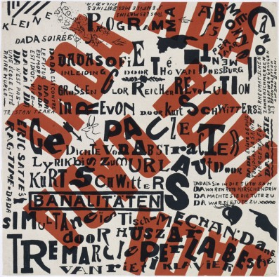
(Fig.9) Theo van Doesburg, art piece during the Dada movement.

Dadaism is the period that design breaks with the developments in 21 Century. However, punk aimed to be defiant and alternative, it has association with rule breaking during legislative and other worries that happened in the 70s.
(Scaliatine, 2016)
The grunge techniques have encouraged Carson, to produce the work without using any system, it is repeatedly proving that an illegible graphic design and structure of the typeface to convey the message by the influence of Dada including the collage, overlay text and urban type. (Dawson, 2012)

Carson’s work is almost not ‘design’, but more like artwork combining graphic element within colour, bold text and multiple typeface. However it is important to understand that he was an experimental designer, influenced by the movements before him including Pop Art and Dada. (Dawson, 2012)

He has developed his own method and skill that broke the rules of graphic design. Carson claims there are two rules that any designer should adhere:
You don’t have to know the rules before breaking them, and never mistake legibility for communication. (Shetty, 2012)
A designer does not always have to be the greatest; however, legibility and readability are important. However, the influence of David Carson designs on other creative designers are massively inspirational and the work produced at Ray Gun Magazine in the 1990s and it is this he develops into a grunge texts style. (Dawson, 2012)
David Carson did not know what the grid was and said,
I need a blank screen to begin designing no guideline, or rules.
However, it was only a few years after when he realised what they were and by then he did not know how he was going use them in his design. Carson became a designer almost by mistake as his career developed and was guided by his love of surfing to work on the professional magazines Surfer and Beach Culture (US) (Roberts, 2005: 94)

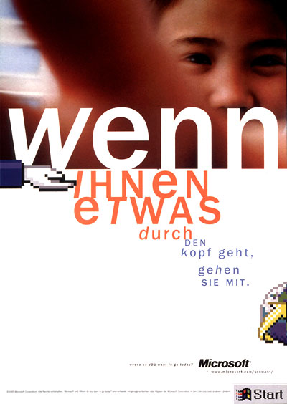
(Fig.10) Worldwide branding campaign, Microsoft. (Carson, 2001)

Carson then took on work with Microsoft (2001), who became major clients. He always works hard to make sure that his designs convey the message communicated by the typeface. This is why Carson does not like using grids; because grid system can be difficult to see because of the distraction of the line within the design (Roberts, 2005: 95). Carson knew well enough that some conditions of working with the grid system were possibly the only way to get the job done. Carson said;
I can’t really argue about a grid on a daily newspaper, it sorts of makes sense. (Roberts, 2005:94)
Although he believed that for most part, the grid system can make you become lazy because designers work with only computer software formatted systems, programmed by technicians. Many designers can produce practical layouts because the current technology makes everything simple. (Roberts, 2005:94)
There are many bold creatively designed magazines, but very few of them stand out such as GQ, Computer Arts and Wired magazine. The problem with a grid is that people use it as crutch and you end up with a lot of boring design.
(Roberts, 2005:94)

Neville Brody
Neville Brody (1957 -) was known as British generation graphic designer in the 1988. He also known as The Face magazine and the cover design has highly respected, it had changed the method between the designers and the reader’s styles. Brody also could be considered one the rules breakers; however, he does have his own set of ‘rules’. You’re ruled by meetings, production times and deadlines, stated by Brody. You also need to understand the progression of communication and consider the language of graphic design. (Butler, 2014)
Every design has their own rules and their work shows different techniques within each design. Brody’s work had unique, influence by the Punk movement and Dada typography. Brody first ideas was founded the contrast surround by ‘Dadaism and Pop art’. In the First World War, Dadaism was involved in the damage of construction. (Wozencroft, 1988:6)
His work with ‘The Face’ Magazine has invented the modern layout of the journal. All the design was structured; by every symbol within the article, however of the impassioned and reasonable to expand the concepts. Brody was experimental designer that like to keep the bleed of the off the page, so he has more room to developing with type and image. As Brody stated:
Oh, let the bleed type off the page (Wozencroft, 1988:96)
Brody’s layout design was very organised, using four column grids but he also keeping the title in the big and bold as he wants the headline to be recognise and standout the most.
The Face was designed combining grid systems and simple design that could be adjusted when it needed to be. When Brody start design magazine, he produces with ‘four column grid’ and he also using the three and two column to guide him and help arranging the page layout. Brody look like the rule breaker but inside his magazine were organising and readable.
When Brody designing The Face, he always keeps the title of the article readable as it ‘need to be recognise’ well. He rules of design spread page magazine is to separate the small text by layout body text in the magazine and then title to keep it organise. (Wozencroft, 1988:96)
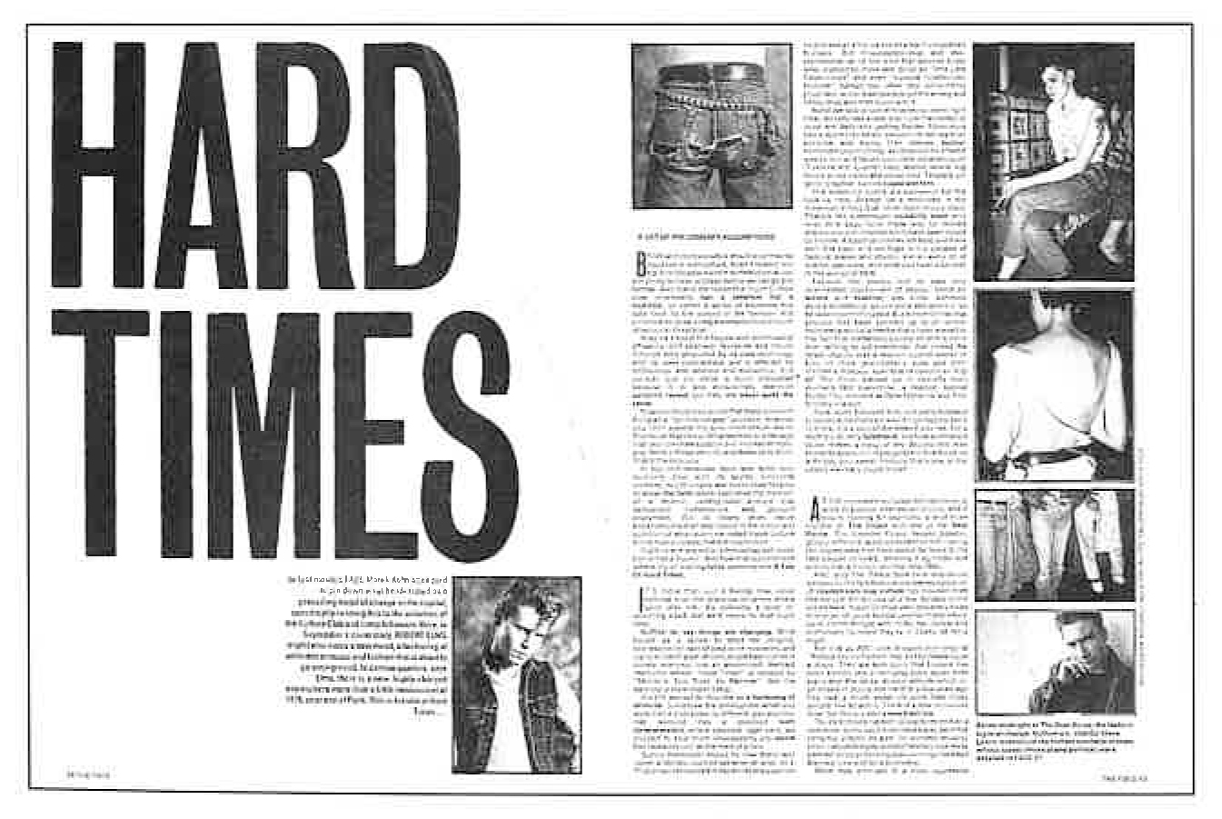
(Fig.12) ‘Hard Time’ spread, The Face, NO.29 September 1982,
(Wozencroft, 1988:96).
The 1980s saw application of typography develop due to ‘phototypesetting’ technology. The 80s was allow Brody to explore the new ideas, new music, new fashion and new design. Technology has made everything easier, even changing the size of text and allowing him to make adjustments. Broody has made significant progress in the 80s as designer for many ‘magazine’ including Cult ‘The Face and City Limits’. (Ovenden, 2017)

Brody is experimental with his designs and he thinks that designers do not need to be trained to become a great producer of type and creativity. Brody citied on the BBC documentary:
We didn’t need to be an highly-trained type designer, we could instruct something to be 10% width for instance. (Ovenden, 2017)

Chapter Four
Analysis of legibility and Readability

The important rules that designers should know is the way of communicating with type, such as legibility, readability and expression. Philip Moggs (1993) has explained that legibility is the clarity with which signs can be deciphered: the way of working out how signs can be understood. David Carson’s work contradicts legibility because his work is understood as bold and collage like but not necessarily readable as he is rules breaker. In addition, Neville Brody could be seen as both for example: ‘The Face Magazine’ was quite readable. Readability is the process of the viewer being able to read eye-catching information and expression is the emotional side shown through different type of art. (Rob Carter, 1993:124)
However, the designers such as Erik Spiekermann always makes sure that his typefaces are readable and legible. Spiekermann stated;
A real typeface needs rhythm, needs contrast, it’s come from handwriting and that’s why I can read your handwriting and you read mine (Hustwit, 2007)
The confusion with legibility in lettering was ignored by the creator. However, the rules that designers follow and study are continuous. The legibility shows the personal asset and power of type that can be produces with readable text. These aspects have ensured that the reader understands the forms of the typefaces without any trouble. (Rob Carter, 1993:85)

In the Helvetica film, Carson has specified misunderstanding legibility:
Do not get confuse with legibility with communication because if something is legible, does not mean it communicates, and more importantly does not mean it communicates the right thing. (Hustwit, 2007)
In his statement above, Carson is stressing the importance of graphic design ’communicating’ and that not all work that is legible, communicates effectively.
(Hustwit, 2007)

Conclusion
This dissertation investigation and question David Carson’s famous statement, ‘You don’t have to know the rules before breaking them’. The question has begun to require that it is the rules are really important to know? It seems all the ‘rules’ were developed by Modernist and Post-Modernist Designer, and they also influence by different object. While other designers develop the organising method, but David Carson broke the rule and experimenting with different formula.

For my investigation into looking at rules of organising method in the graphic such as Grid System and golden section. Emil Ruder, Josef Muller Brockmann, Mix Bill and Richard Louhse, has developed system to make everything organise design and clean. Grid system is very helpful method that use by architecture and design, especially when come to layout in typography or magazine it helps the design readable. Golden Ratio is also the organise tool for designer to following and contracture them within the logos design, typography and poster design. The analysis of the grid system was excusive tool. They do no argue that no designer will not use this method, except David Carson who think that grid was not his style and the claim that is give the destructiveness because the grid lines its overlap the design makes it a little hard to see and that why David Carson say:
I need a blank screen to begin designing no guideline, or rules.
(Roberts, 2005: 94)
From my belief, the grid system was helpful method and I would love to use them but I also do like without using it because of the distraction. Without the grid, it helps me view the object clearly.
These systems were developed before the introduction of digital technology, which has become more popular and easy to use these day. The modernist period exposed how they experiment with the typesetting by hand including the layout method, spacing and scale system. Also to set the type case is not easy to apply as it has to organised by each letter and each line. However, the typeset might be difficult and time set but give the meaning to the word and emotional. The technology approaching the in1980s when traditional typesetting was abandoned and no longer used in contemporary design. Now that digital age has made everything easy, you don’t have to set letter by letter and set the scale, kerning, leading quicker. The 80s when Neville Brody had an opportunity to exposed the news ideas and experimenting different rules for his The Face magazines.

This dissertation had shown an understanding of typography, as it has been developing throughout the century. Typography is impressive method to convey the message. The documentary Mark Ovenden has claimed that:
Typeface so important and shape the way we see the world.
(Ovenden, 2017)
Many bands and signs were design by different font such as Helvetica, Johnston and gill san. Considering the typeface is way to communication and direct human every day (Ovenden, 2017). Also Erik Spiekermann has stated that same thing:
Of course type is important! One can't prove it, that's all (Gestalten, 2014).
There is no other way to prove as the type it the easy to communicate, and the argument that type is natural to human because everybody has to learn how to write, speak and understand each alphabet. Typography it is important but it also how would you produce it as legibility and readability. Erik Spiekerman has claim that every design should be legible and readable, as he is unique designer who like to organise everything and make very understandable well. Legibility reflects the personal skill and influence of type that can produces with readable text. However, David Carson was not thinking of ‘readable’, as his work was about ‘legibility’ but the legible design does not mean that it not communicate. Carson citied that:
Do not get confuse with legibility with communication because if something is legible, does not mean it communicates, and more importantly does not mean it communicates the right thing. (Hustwit, 2007)
I believe that ‘legibility and readability’ are important rules you need to understand and Erik Spiekerman and David Carson, they tried to convey the message within they design with both method but in personal style. However, it not just Carson and Spiekerman but also Wim Crouwel, Mix Bill, Josef Muller Brockmann and Neville Brody that required they design to be readable and legible and which why they were using ‘grid system’ to help them contracture and organising the text.

The investigation has proved that they are rules in graphic, such as gird, golden section, spacing, scale and collage. However David Carson chosen to breaking the rule because he is experimental designer who like to expose with ‘grunge typography’ and same to Neville Brody when he investigate within his The Face magazine. Although Erik Spiekermann who have never broke the rules as he love following to the construction. Erik Spiekermann claim that ‘if you breaking the rule without breaking them’ it like become immature, these rules are out there out there for you to learn, which isn’t hard.

Personal Reflective

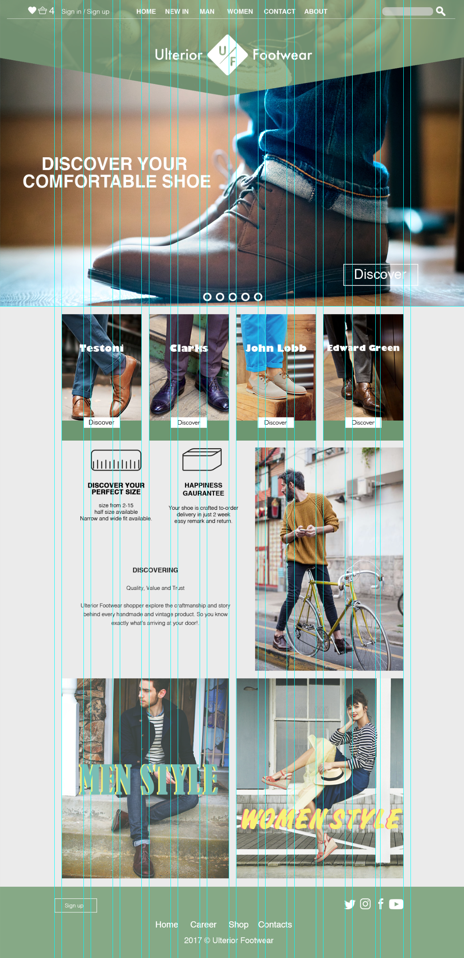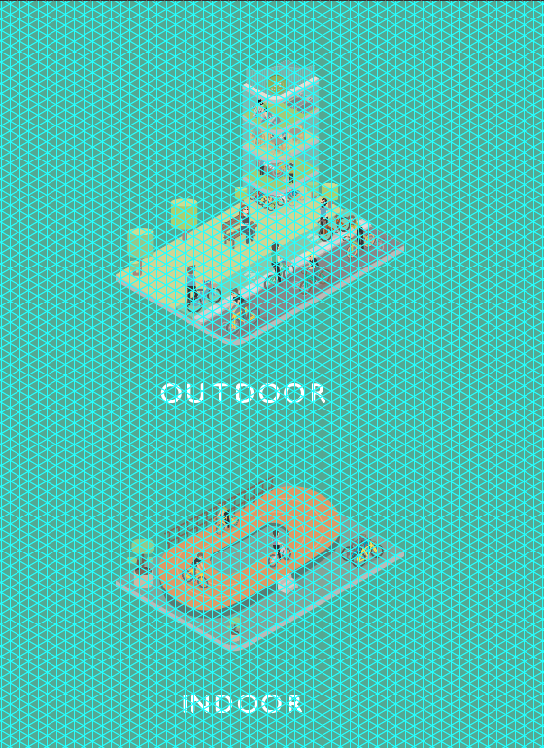
(Fig.11) Left: Ulterior Website design Project (2017)
(Fig.12) Right: Other People’s Shoes Project (2017)

In my personal design, I show the work that has influence me by the grid system to help me structure everything in composition. Using this format made everything easy and organising well, including web design and isometric poster. Somehow, I was thinking the same thing to David Carson that the grids is distracting the view and it is hard to see the object while you are working on the design (fig.12) but in the same time the grid was helpful with keeping my illustration in isometric shape. Also the grid structure was perfectly beneficial to me in web design (fig.11), it kept my content in the structure, made it easy to layout. For my design I consuming with san serif a lots font as it readable and I think it very clean typeface.

Referencing
Books
Carter, R., Day, B. & Meggs, P., 1993. Typographic Design: Form and communication. NY(America): Van Nostrand Reihold.
Crouwel, W., 2011. Wim Crouwel: A Graphic Odyssey: Catalogue. London: Unit Editions.
Dawson, P., 2012. Graphic design rules. London: Frances Lincoln.
Elam, K., 2001. Geometry Of Design. New York: Princeton Architectural Press.
Lupton, E., 2004. Thinking with Type. New York: Princeton Architectural Press.
O'Brien, K., 2015. Character Building: A Mixed-media Approach to Faces and Figures. s.l.:F+W Media, Inc..
Poulin, R., 2012. Graphic Design and Architecture, A 20th Century History: A Guide to Type. Bevely: Rockport.
Purcell, K. W., 2006. Josef Müller-Brockmann. London: Phaidon Press.
Roberts, L., 2005. The designer and the grid. Hove: RotoVision.
Wozencroft, J. & Brody, N., 1988. The Graphic Language Of Neville Brody. s.l.:Rizzoli.

Flims and Documentary
Helvetica. 2007. [Film] Directed by Gary Hustwit. s.l.: s.n.
Two Types - The Faces Of Britain . 2017 [Documentary] Directed by Mark Ovenden. (31 July 2017).

Website
Alessio, J., 2013. Understanding The Difference Between Type And Lettering. [Online]
Available at: https://www.smashingmagazine.com/2013/01/understanding-difference-between-type-and-lettering/
[Accessed 25 11 2017].
BBC, 2016. Typecast: Alan Kitching on the art of letterpress. [Online]
Available at: http://www.bbc.co.uk/programmes/articles/LKH84ry7v5zJWJHk3QDNyZ/typecast-alan-kitching-on-the-art-of-letterpress
[Accessed 25 11 2017].
Brewer, j., 2017. Hacking Heidelberg: how Erik Spiekermann came to reinvent the printing process. [Online]
Available at: https://www.itsnicethat.com/features/erik-spiekermann-reinvents-letterpress-printing-p98a-graphic-design-210817
[Accessed 13 11 2017].
Butler, A., 2014. interview with graphic designer neville brody. [Online]
Available at: https://www.designboom.com/design/interview-with-graphic-designer-neville-brody-10-10-2014/
Carson, D., 2001. worldwide branding campaign, microsoft.. [Online]
Available at: http://www.davidcarsondesign.com/img_temp_la/25d.jpg
[Accessed 7 12 2017].
Creative Bloq , 2017. Typography rules and terms every designer must know. [Online]
Available at: http://www.creativebloq.com/typography/what-is-typography-123652
[Accessed 25 11 2017].
Gestalten, 2014. "Of course type is important! One can't prove it, that's all.". [Online]
Available at: https://news.gestalten.com/news/interview-erik-spiekermann-typography
[Accessed 30 11 2017].
Glancey, J., 2011. Wim Crouwel's extraordinary alphabets. [Online]
Available at: https://www.theguardian.com/artanddesign/2011/apr/07/wim-crouwel-design-museum-typography
[Accessed 7 12 2017].
Hampton-Smith, S., 2017. The 8 biggest typography mistakes designers make. [Online]
Available at: http://www.creativebloq.com/typography/mistakes-41411451
[Accessed 17 10 2017].
Kraft, M., 2015. Swiss Star. [Online]
Available at: https://www.grafik.net/category/heroes/swiss-star
Meister, J., 2013. A firm turn toward the objective josef muller brockmann 1948 1981. [Online]
Available at: http://ilovetypography.com/2013/01/12/a-firm-turn-toward-the-objective-josef-muller-brockmann-1948-1981/#ft7
Roberts, L., 2008. A Brief History of Grids. [Online]
Available at: http://www.graphics.com/article-old/brief-history-grids
[Accessed 08 10 2017].
Scaliatine, D., 2016. The Modern Face of Dada. [Online]
Available at: https://medium.com/@scaliatine/the-modern-face-of-dada-7f1433bc35b0
[Accessed 7 12 2017].
Shetty, S., 2012. The Rise And Fall Of Grunge Typography. [Online]
Available at: https://www.theawl.com/2012/08/the-rise-and-fall-of-grunge-typography/
[Accessed 10 10 2017].
Towers, F., 2003-2016. Some Design Rules are Made To Be Broken. [Online]
Available at: http://www.dwuser.com/education/content/some-design-rules-are-meant-to-be-broken/
[Accessed 17 10 2017].

