

STRATEGIES OF
HYUNDAI

MARKETING MANAGEMENT - II

NAME : MUDIREDDY KOTESHWAR REDDY

STUDENT ID : 2216776
Table of Contents
Introduction 2
PESTEL Analysis 2
Porter’s Five Forces Analysis 4
SWOT analysis 5
Advantages and Disadvantages of SWOT analysis 6
Segmentation, Targeting and Positioning 6
The marketing mix strategy 8
Conclusion 9
Recommendations 9
References 10

Introduction
The purpose of this report is to identify the external and internal factors that impact the marketing strategies during the business extension of the company. Implementation of different effective analytical tools such as PESTEL analysis, SWOT analysis, Porter’s five forces analysis etc (Polyakov and Aleksey 2022) have guided the marketers in aligning the external and internal business environmental factors with the long-term business development process to get a competitive advantage in the targeted market. The segmentation, targeting and positioning also have identified the most potential customers from the market. The selected company for this assignment is Hyundai.

PESTEL Analysis
PESTEL analysis is an effective macro-environmental analysis, that has helped marketers for identifying the external business environmental factors that have impacted the overall business development process. The political, economical, social, legal and environmental factors have impacted the business development process of Hyundai.
Political
The company has targeted to extend the business in the Asian-Pacific markets which have indicated that, the political stability of the countries from the targeted region has ensured the long-term financial growth of the company in the market. Poor political relationship among different countries has affected taxation policies, strict guidelines and government polices that has impacted the sales rate of the company (Lee, Kim, Kim and Choi 2021).
Economical
The outbreak of COVID-19 and economic recession among countries from around the world has affected the gross product development of the countries which has impacted the price determination strategy of the company. However, the present situation of the company has stated that the company has been able to recover the financial growth of the company by increasing its market share.
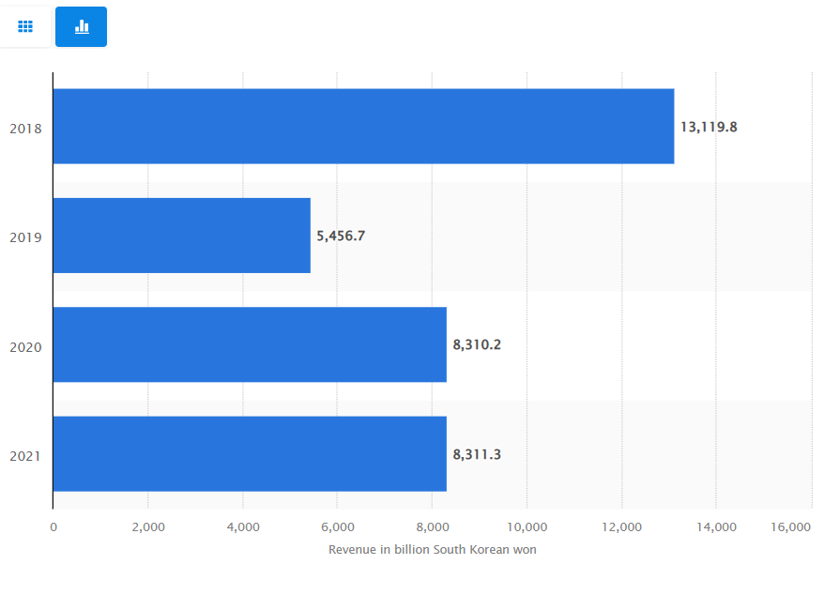
Fig: Revenue of Hyundai Industries
Source: Hyundai Heavy Industries - revenue | Statista
Within the year 2021, Hyundai increased its financial revenue by around 8.3 trillion in the market of South Korea (Statista 2022a).
Social
The increasing concern about sustainable automobiles specifically the importance of utilisation of electric vehicles has motivated customers to move forward with low-carbon emission vehicles particularly after the pandemic, for this reason, the sales rate of Hyundai has been affected. By the end of the decade, the production of electric vehicles will be increased (Forbes 2021).
Technological
The company has targeted to use of alternative strategies to improve the fuel efficiency of the product for reducing carbon emissions. Gasoline Direct Injection has been utilised by the company to implement artificial intelligence within the product development process (Hong and Kim 2018).
Legal
The company has followed different legal policies such as intellectual property rights, discrimination laws, and employment laws within the ethical business policies of the company to increase the performance of the workplace management.
Environmental
Different environmental policies have been followed by the company to reduce carbon emissions as, in the current context, governments from different countries have imposed various environmental protection policies.

Porter’s Five Forces Analysis
This is an effective tool for analysing the competitor analysis, to identify the factors of competitive advantage in the market.
The threat of new entrants
Due to the complexity of the economic scale of the operating industry of Hyundai, the new entrants have to invest a huge amount of capital to get a proper cost advantage (Zhang 2018). Also, the new entrants should establish efficient human resource management to manage the operations of the company. So this force is weaker in this case.
Bargaining power of the suppliers
The suppliers of Hyundai have less control and negotiation power in the industry. There is a huge number of suppliers who offer standardise products to the company, for this reason, the switching cost of the standardise products is low. This force is weaker in the case of Hyundai.
Bargaining power of customers
In the international market, other farms offer similar kinds of products to the customers of Hyundai. However, Hyundai has been able to control the product prices according to the changing market situations which have helped the company to meet the needs of the customers (Sharmelly and Ray 2018). So, the bargaining power of the customers is mainly moderate to low in force.

The threat of substitution of services and products
In the international market, a few substitutes are available. However, in the current context, many manufacturers tend to imitate products with low cost for increasing profitability which can impact the sales rate of the company. However, it is a weaker force in the case of Hyundai.
Rivalry among the competitors
Technological advancement and globalisation have increased the market competition in the operating market of Hyundai. The competitors of the company have included, Toyota Motor Corporation, Volkswagen, GM Motors, Ford Motors, Nissan, Fiat, Honda Motors etc (Kapustin and Grushevenko 2020). Also, the company has to compete with electric car-producing companies like Tesla. Increasing market competition and the increasing demand for electric vehicles have caused high force in this context.

SWOT analysis
Strengths
Advanced marketing is one of the core strengths of Hyundai. To establish a strong brand image in the global market, the company has collaborated with brand ambassadors which have helped the company to get customer recognition in the international market (TR 2019). The concept of influencer marketing has assisted the company to get the image of user-friendly brand image.
The company has implied strong market positioning in the international market that has increased the sales rate of the company.
The company has extended the business to around 190 countries from across the world by increasing the brand value by around $14,295 within the year 2020.
A strong business model with the determination of sustainable corporate social responsibilities has also helped the company to get long-term profitability.
Weaknesses
An increasing number of competitions in the market has impacted the market share of the company.
The focus on the production of fuel-engine cars has impacted the sustainable brand image in the current context.
Opportunities
The increasing economic growth of the developing countries has created new opportunities for the company in the international market.
Hyundai has now implemented effective strategies to produce sustainable hybrid cars at lower costs that would help Hyundai to get a competitive advantage in the market.
Threats
The company must face threats of product substitutes as in the current context, most of the competitors of the company have targeted to produce lower cost high-quality products that could impact the overall performance of Hyundai (Bu, Zhao, Li and Li 2022).
In some cases, the changes in governmental policies also might impact the operational activities of Hyundai. For an instance, the US-China trade war has enforced countries to make changes in import-export policies that could impact the sales rate of the company.

Advantages and Disadvantages of SWOT analysis
The core advantages of SWOT analysis included the identification of the strengths, weaknesses, opportunities, and threats that could impact the productivity and profitability of the companies. It is an effective tool to figure out particular business goals to develop marketing strategies according to the needs of the targeted market. The internal business environmental analysis is very essential to extend the capabilities of human resource management by implementing the most effective strategies to enhance the training and development programs. Identification of the proper strategic choices also guides the marketers of the company to enhance the performance of the marketing campaigns.
The disadvantages of SWOT analysis have demonstrated that it only focuses on an oversimplification of the internal analysis, and a lack of objectivity could impact the overall stakeholder engagement process (Penchev 2021).

Segmentation, Targeting and Positioning
The analysis of the STP model of the company has targeted to analyse the potential customers from the international market that helps to determine the most effective marketing strategies according to the requirements of the target customers. The company has focused on premium price segmentation as the company has planned to enter the foreign market by targeting the high to a medium-income group of people. There are different types of segmentation criteria such as demographic, geographic, psychographic and behavioural market segmentation that have targeted the market segmentation or identification of potential customers from the market (Khan 2018).
Type of Segmentation | Segmentation Criteria | Strategies
Geographic | Region: International Market  Density; Urban and Sub-Urban | Developing strong brand recognition to the targeted customers from the international market.
Demographic | Age: 18 to 60 and above  Gender: Female and Male  Income: High to Middle-income group  Occupation; Executives, Professionals with higher income opportunities
Behavioural | Degree of Loyalty: Switchers a hardcore loyal  Personality: Ambitious and determined  User status: Potential users
Psychographic | Lifestyle: Succeder, explorer, aspirer  Social Class; Higher class and upper middle class

Brand Positioning
The brand positioning of the company has determined the current position of the brand in the targeted market which has helped the company to gain a competitive advantage in the global market according to the positioning of the other competitors of the company. The brand positioning of Hyundai has been determined by analysing the market positioning of the competitors such as Ford, Toyota, Honda, Fiat, etc.

High Quality
Low Quality
High Price
Low Price
Fig: Brand Positioning
Source: (Author-made)
Hyundai has focused to develop marketing strategies according to the strategic perspectives of the company to fulfil the needs of the customers.

The marketing mix strategy
Hyundai has utilised 4P’s marketing mix strategy to enhance the productivity of the customer engagement strategic approaches of the company. It has included different aspects such as product, price, promotion, and place.
Product
Hyundai has targeted to diversify its product portfolio which has helped the company to develop products with different ranges such as Sedan cars, SUVs etc. It has been able to meet the individual differences of the customer requirements of the products. The different ranges of Hyundai passenger cars are, Veloster, Sonata, Verna, i20, i40, Elantra etc. The recreational vehicles of the company have included, Veracruz, Tucson etc.
Price
Hyundai has used a competitive product pricing strategy in the international market. The international competitor of the company is Toyota Motors, Ford Motor Company, GM Korea company etc. The price of the products has varied within different geographic regions (Hieu and Trang 2022).
Place
The company has extended the business to around 190 countries with more than around 5000 dealerships. The company has established a huge number of manufacturing units across different countries. Enhancing the quality of the products with the implementation of advanced technologies. The company has targeted to explore the businesses over the developed countries to get significant profitability from the targeted market (Ismail and Mulyaman 2021).
Promotion and Advertising
The advertising and promotion strategy developed by the company has included offline and online promotional attributes to establish a sustainable brand image. The organisation has released advertisements during the launching of the new car models for creating brand awareness with the collaboration of celebrities. The company also has indulged with digital marketing, TV campaigns and social media marketing within the promotional activities for promoting the cars to the most potential customers (Reddy et al. 2021).

Conclusion
It can be concluded that Hyundai has targeted to establish the business in the international market by conducting proper market analysis using different analytical tools such as PESTEL SWOT, and Porter's Five Forces analysis within the business development process for enhancing the quality of the operational management of the company. The company has invested in advertisements, short films, media reviews etc for engaging more potential customers from the international market.

Recommendations
For increasing the quality of the promotional and marketing attributes of the company, the marketers could use Omnichannel marketing within the marketing attributes. Businesses may create a consistent and smooth customer experience (CX) across all the channels that customers use to interact with their brand, both online and offline, by using an omnichannel strategy for marketing. It will also allow the company to understand the needs of the customers of modern markets, by understanding the current market trends. It guarantees clients have a great experience across all channels and takes into account all of their prior interactions with your business. It also includes influencer marketing strategies to get a competitive advantage in social media marketing. Interactions on social media can affect the customer journey by educating the client about your products (Parajuli 2019).

References
Statista (2022a), Hyundai Heavy Industries - revenue 2018-2021, Available At:< Hyundai Heavy Industries - revenue | Statista/>, [Accessed On: 24th Dec 2022]
Forbes (2021), Number Of Electric Vehicles Is Expected To Surge To 145 Million By The End Of The Decade, Available At:< Number Of Electric Vehicles Is Expected To Surge To 145 Million By The End Of The Decade [Infographic] (forbes.com)/.>, [Accessed On: 24th Dec 2022]
Polyakov, R. and Aleksey, H., 2022, September. Approaches to designing a universal strategic planning evaluation tool. In AIP Conference Proceedings (Vol. 2636, No. 1, p. 040012). AIP Publishing LLC.
Reddy, L.S., Ranjith, P.V., Sabnis, S., Ganatra, V., Shastry, K., Elviona, A., Sin, L.G., Chee, Y.N., Kee, D.M.H., Qianya, W. and Jiaze, W., 2021. Advertising strategies of Hyundai Motors in Indian market. International Journal of Accounting & Finance in Asia Pasific (IJAFAP), 4(1), pp.104-115.
Lee, J., Kim, J., Kim, J. and Choi, S., 2021. Why Localization Is Necessary as a Business Strategy in Emerging Markets: The Case Comparison of Hyundai and Volkswagen. Journal of Open Innovation: Technology, Market, and Complexity, 7(3), p.190.
Hong, B.K. and Kim, S.H., 2018. Recent advances in fuel cell electric vehicle technologies of Hyundai. ECS Transactions, 86(13), p.3.
Zhang, Q., 2018. Strategies in China Heavy-Duty Truck Market from the Perspective of Design Thinking-A Case Study of Sichuan Hyundai. International Journal of Advanced Culture Technology, 6(3), pp.105-116.
Sharmelly, R. and Ray, P.K., 2018. The role of frugal innovation and collaborative ecosystems: The case of Hyundai in India. Journal of General Management, 43(4), pp.157-174.
Kapustin, N.O. and Grushevenko, D.A., 2020. Long-term electric vehicles outlook and their potential impact on electric grid. Energy Policy, 137, p.111103.
TR, B.G., 2019. CUSTOMER SATISFACTION TOWARDS ADVAITH HYUNDAI SALES AND SERVICE.
Bu, J., Zhao, E.Y., Li, K.J. and Li, J.M., 2022. Multilevel optimal distinctiveness: Examining the impact of within‐and between‐organization distinctiveness of product design on market performance. Strategic Management Journal.
Penchev, D., 2021. SWOT analysis as a research method in pedagogy. Педагогика, 93(5), pp.669-678.
Khan, A.J., 2018. A STUDY ON BRAND POSITIONING OF HYUNDAI SUV WITH SPECIAL REFERENCE TO HYUNDAI SANTA FE.
Ismail, A. and Mulyaman, D., 2021. Hyundai Investment on Electric Vehicles in Indonesia: a Push-Pull Factor Analysis. Intermestic: Journal of International Studies, 5(2), pp.375-394.
Hieu, L.Q. and Trang, T.D., 2022. Analysis of Marketing Strategy and Successful Leadership in a Case of Hyundai Motor Company. Mediterranean Journal of Basic and Applied Sciences (MJBAS) Volume, 6, pp.36-47.
Parajuli, S., 2019. Finding requirements and characteristics for omni-channel customer experience.

