3/24/2025
University of Wales Trinity Saint David
London campus
E-Portfolio Link: https://2533495.wixsite.com/learning-in-the-digi

Module Name: Learning In the Digital Era
Module Code: ACCA 4025

Student Name:
Student ID:
Group: 1

Lecturer’s Name: Koushik Modak

LDE Assignment 1
E-Portfolio
Table of Contents
Introduction 2
Main Body 2
Task 1: Essential Academic and Employment Skills for the future career Path 2
Task 1 (a): Report on Essential Academic and Employment Skills 2
Task 1 (b): Evaluation of Task 1 (a) based on Similarity report 2
Task 2: Collaborative Mind Map and Individual Poster 2
Mind Map (Collaborative) 2
Poster (Individual) 2
Task 3: Virtual Collaboration and RefWorks 2
Report on Virtual Collaboration 2
Step-by-step process of using RefWorks with visuals 2
Task 4: E-Portfolio Creation and Evaluation 2
Task 4 (a): E-Portfolio Creation 2
Task 4 (b): Illustrative Review of E-Portfolio tool Selection 2
Conclusion 2
References 2
Task 1 References: 2
Task 3 References: 2

Introduction

Main Body

Task 1: Essential Academic and Employment Skills for the future career Path

Task 1 (a): Report on Essential Academic and Employment Skills
One of the key points of Academic skills is Increasing your knowledge. This is done by making a note of something, highlighting it in a textbook, listen or read something with out taking further action. Another one is memorising and reproducing. Use a mnemonic, make a list of similar things, say it or write it repeatedly, or test yourself or get others to test you. Applying knowledge is one key essential skill. This is done through practicing applying it initially in simple ways, look for examples, work on projects that require this new knowledge, practice using knowledge in reports and essays. This is rounded up with understanding. Think about the knowledge actively in relation to what you know already, consider how the new knowledge relates to what you know, write about it in your own words to make it clear to yourself, break it into sections and discover how they are connected, talk about it, find new information that connects it, make a mind map or other drawing connecting it with other related knowledge, engage in debates, look for ideas or information that might dispel the it [1, p. 16].

Some of the more professional skills are time management and personal development planning [2, p. 6]. This is done through creating a personal sense of time, identifying long term goals, create mid-range strategies, plan your day, make good use of your time, manage meetings, manage delegation, keeping a time log [3, p. 2]. Lastly There is communication principles. One of the key principles is active listening the ability to hear, receive, understand, and respond to information. [4, p. 6]
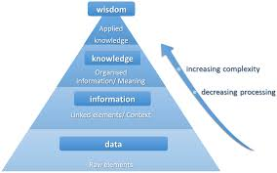
Figure 1: Increasing Knowledge

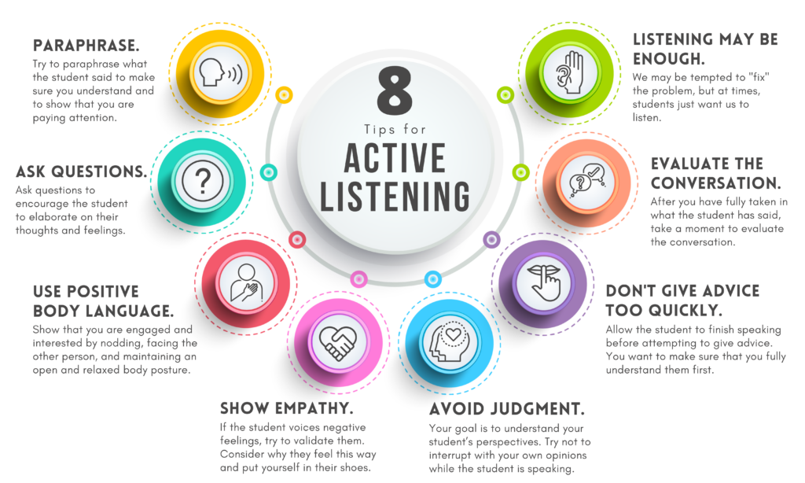
Figure 2: Active Listening

Task 1 (b): Evaluation of Task 1 (a) based on Similarity report
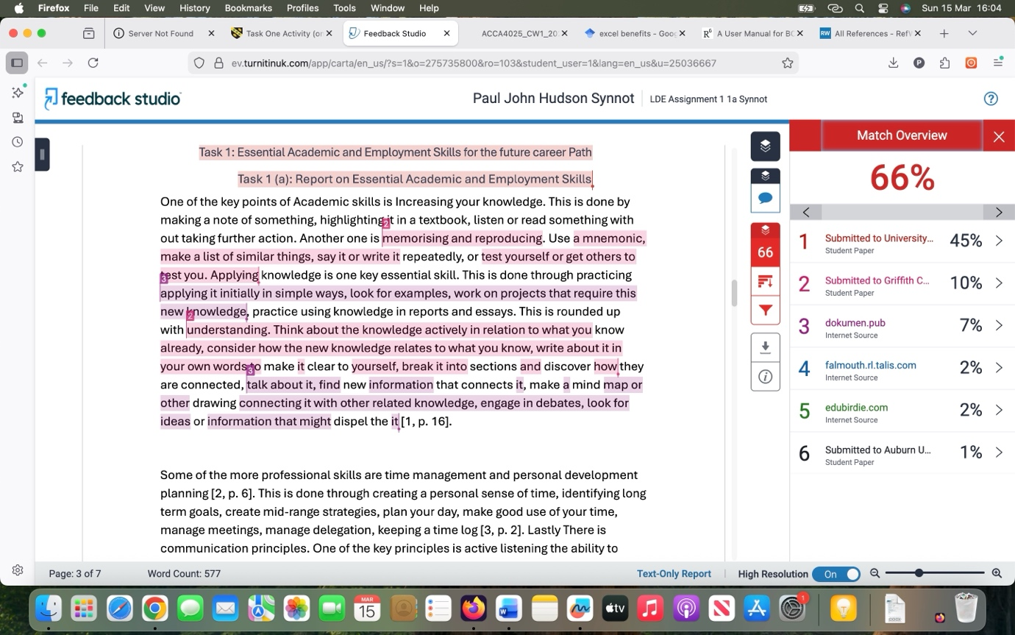
Figure 1: Similarities Report
A similarities score of 17% is well with in the acceptable industry standard (typically under 20%), demonstrating the vast majority of the work is original. This percentage usually accounts for necessary citations, common phrases, and technical terminology essential to the subject matter, rather than lack of academic integrity.
A 70% grade is deserved because the work reflects independent critical thinking and unique synthesis of ideas. The low similarity confirms that the arguments were constructed personally, while the remaining percentage shows a disciplined use of the evidence to support those claims, meeting the standards required for a first class or upper second class distinction.

Task 2: Collaborative Mind Map and Individual Poster

Mind Map (Collaborative)
Link: https://mm.tt/map/3952545945?t=cSff7tionA
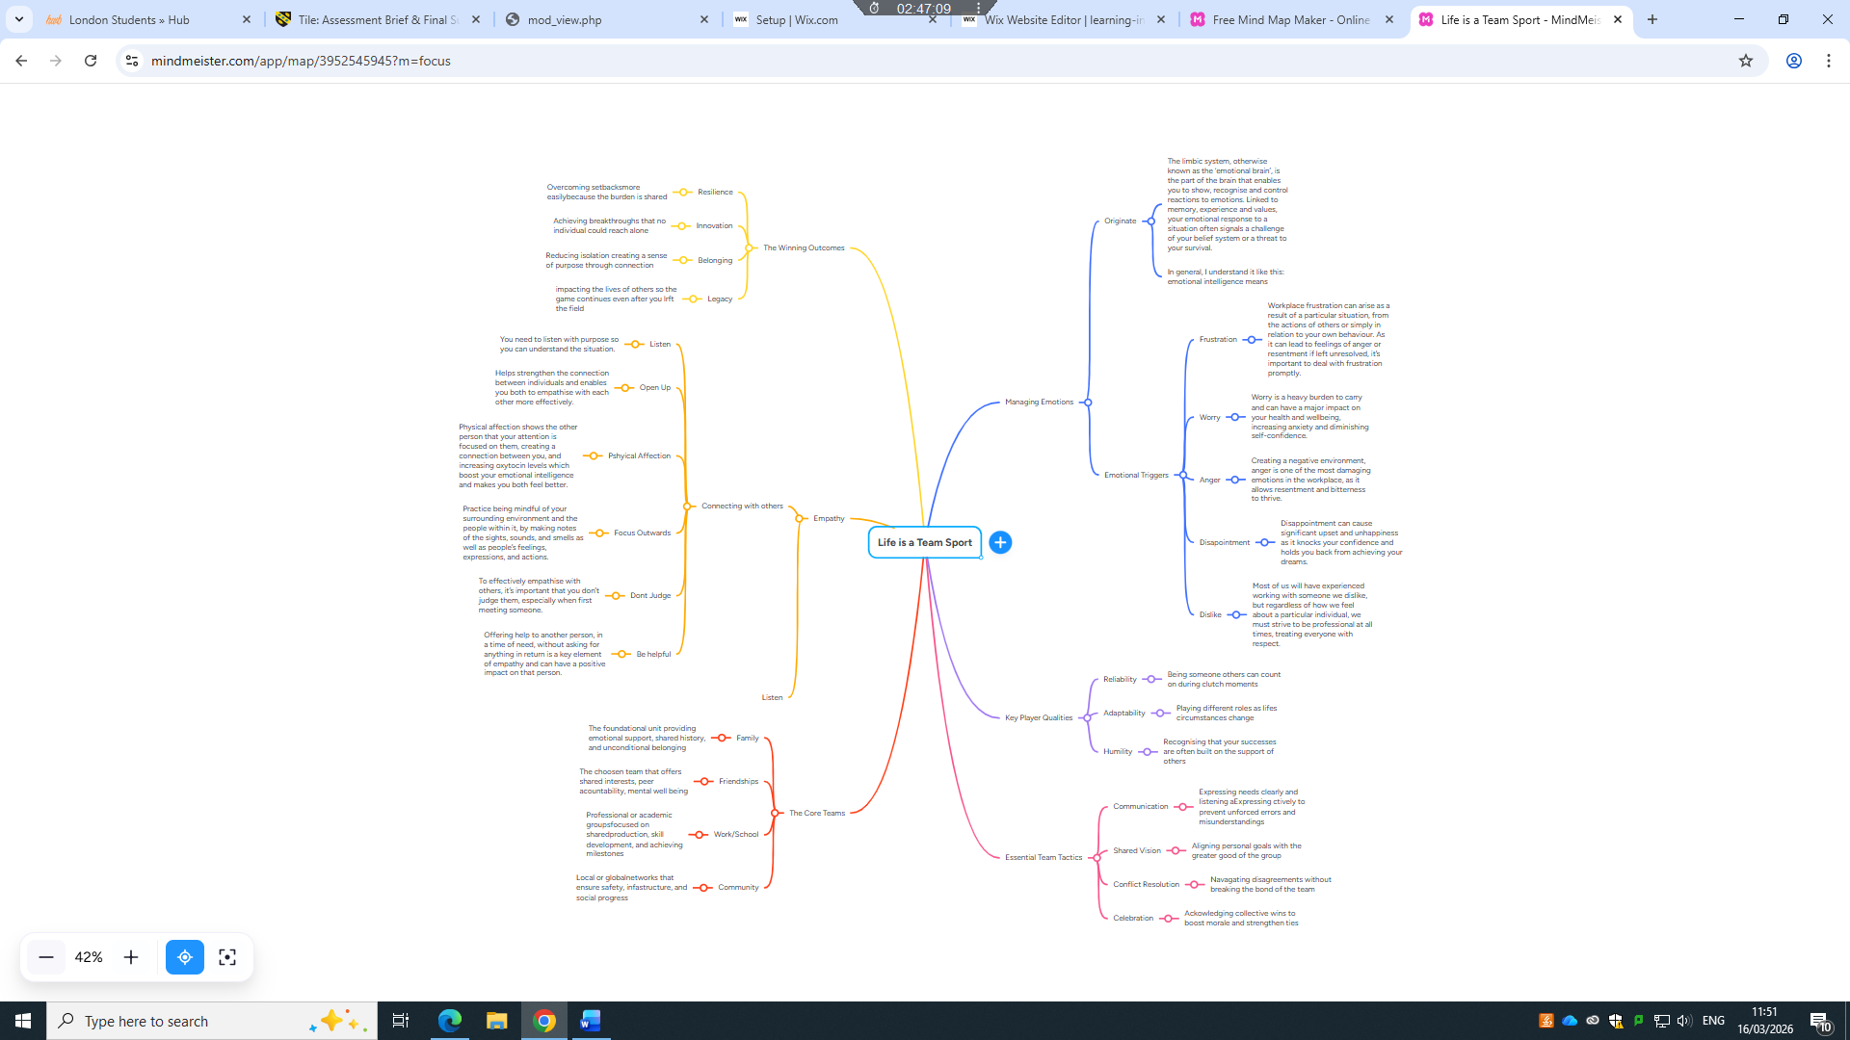
Figure 1: Mind Map

Poster (Individual)
Link: https://www.canva.com/design/DAHCyu3B-dg/Hf-yQWmaEVI0SjWTEtm1Xg/edit?utm_content=DAHCyu3B-dg&utm_campaign=designshare&utm_medium=link2&utm_source=sharebutton
A User Manual for Benefit Cost Analysis
Using Microsoft Excel 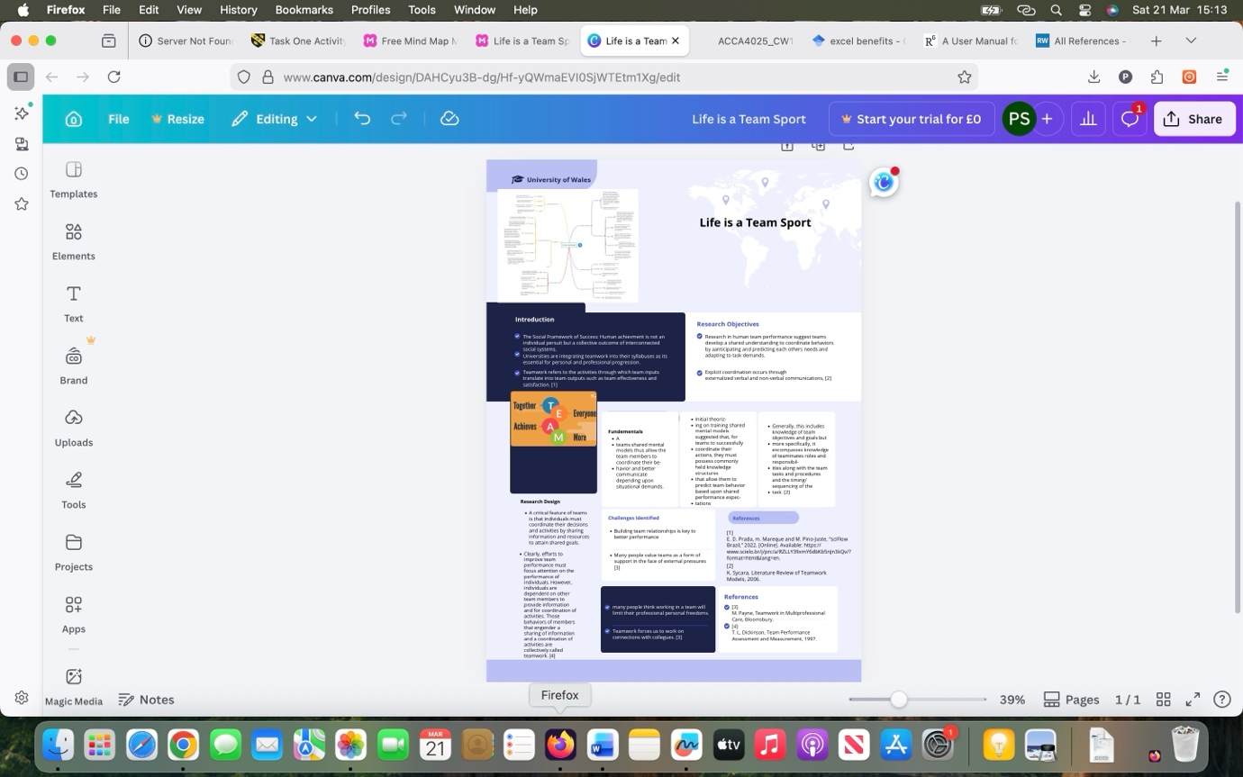
Figure 2: Academic Poster

Task 3: Virtual Collaboration and RefWorks

Report on Virtual Collaboration
Unit 3 Topic 3: The new norming
Radical Candor works along the cross roads of care personally and challenge directly. How to balance being nice with being direct. Care personally showing genuine concern for your team members as individuals. This builds trust and creates a supportive environment. Challenge directly provide clear constructive feedback that may be uncomfortable but is necessary for growth and improvement. The goal is to create a culture where team members feel safe to express their thoughts and concerns, leading to better collaboration and performance. It contrasts with other communication styles such as ruinous empathy (caring without challenging) and obnoxious aggression (challenging without caring).[1]
Its about being the boss who is all about maximising everyone’s and still driving for results potential. This is the natural extension of criticality of relationships in this case focusing on giving honest and caring feedback. Its our responsibility to encourage our students, mentee, staff, and even peers.
The ability to challenge directly and care personally means not avoiding needed conversations and not being insecure or insulting when you have them. You simply can not be a good boss without using Radical Candor. Forbes and multiple reviewers picked up on the concept as a must read for new and experienced managers.
Giving feedback is riddled with anxiety unless it is all positive. Most don’t like to give anything except compliments and affirmations. It just doesn’t come easily for most of us. Radical Condor points out another tricky point in these conversations. Saying don’t take it personally can be insulting. Of course is personal its about ourselves, its very personal.
We can still say what we think but also let them know we care about them and respect them. Successful leaders always have reputations for being genuine, caring, and honest. That goes for feedback to you can be genuine, caring, and honest all at the same time.
The four quadrants of getting to Radical Candor, ranging and intersecting on two axes of caring and challenging. First is “ruinous empathy”—the boss who cares but doesn't challenge. Then there's the “manipulatively insincere” boss who neither cares nor challenges, offering trivialities such as “try harder” as feedback. The “obnoxious aggressor” boss challenges but doesn't care and isn't kind or sincere. Where does the “Radical Candor” boss fit in? You guessed it, the boss who cares and challenges. It makes sense. [2]

Step-by-step process of using RefWorks with visuals
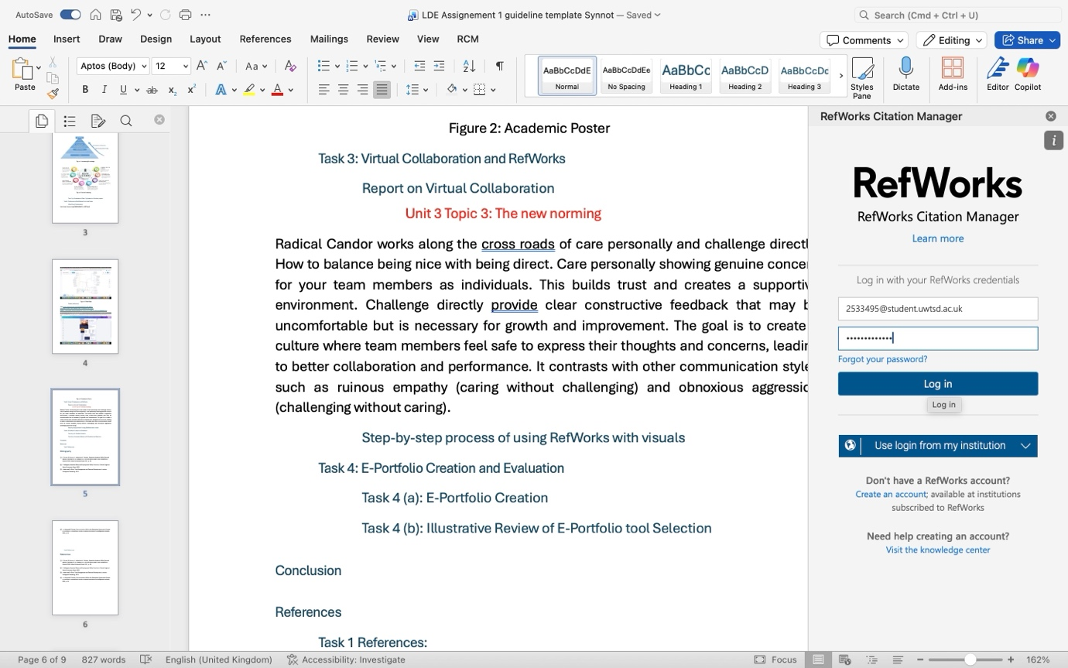
Figure 1: Log in to RefWorks
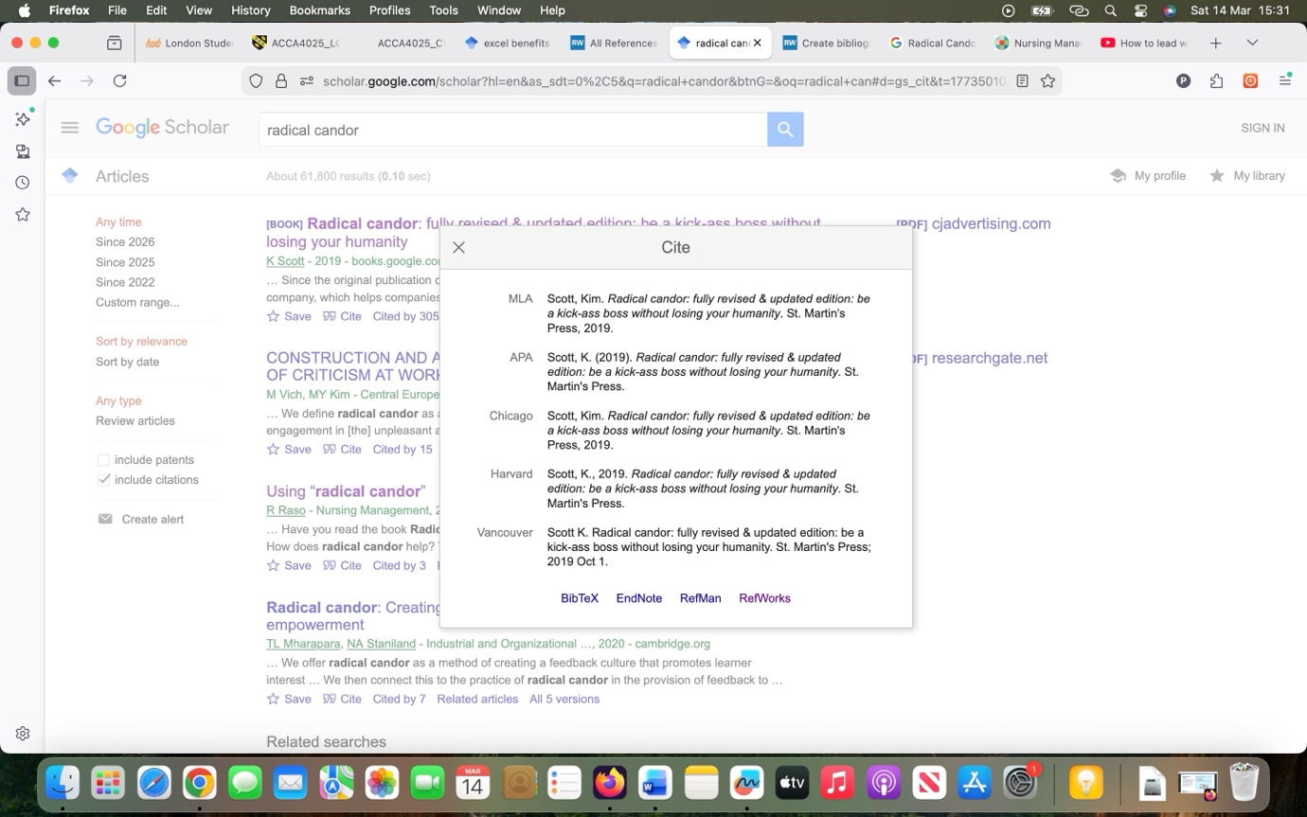
Figure 2: Cite to RefWorks
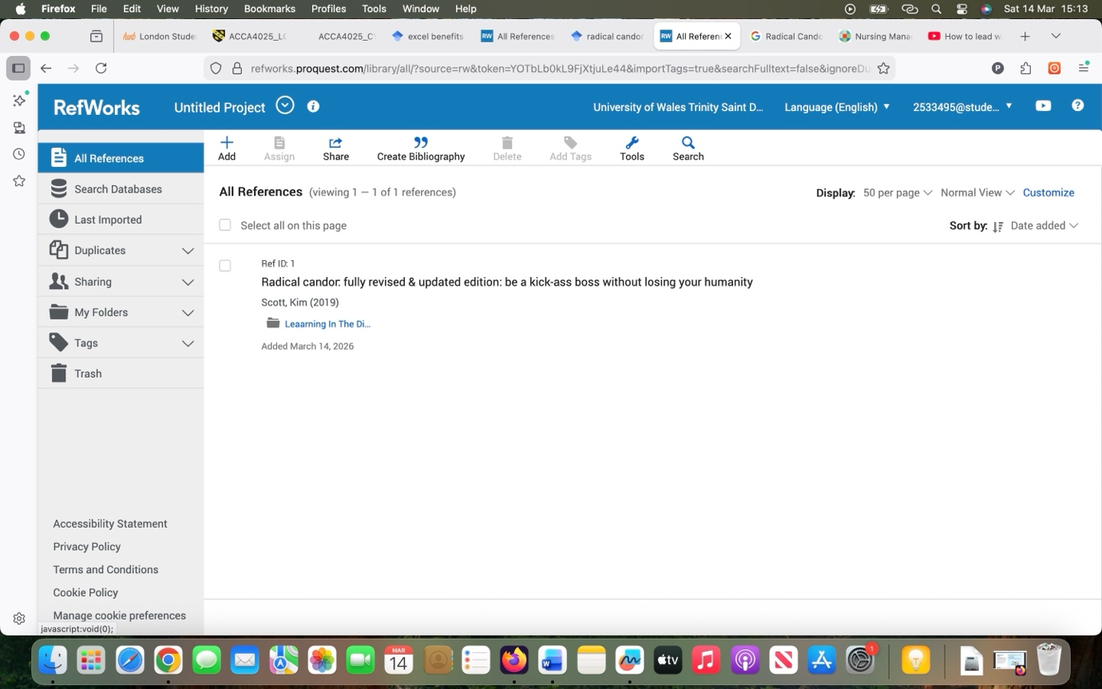
Figure 3: Citation added to RefWorks
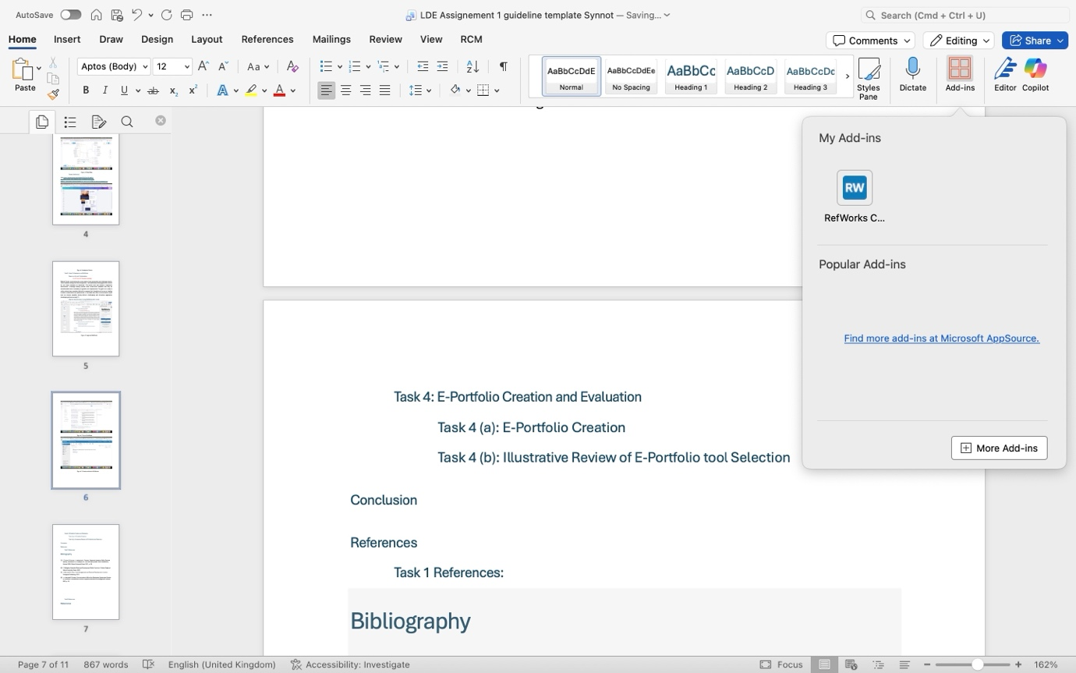
Figure 4: Load Add-Ins RefWorks
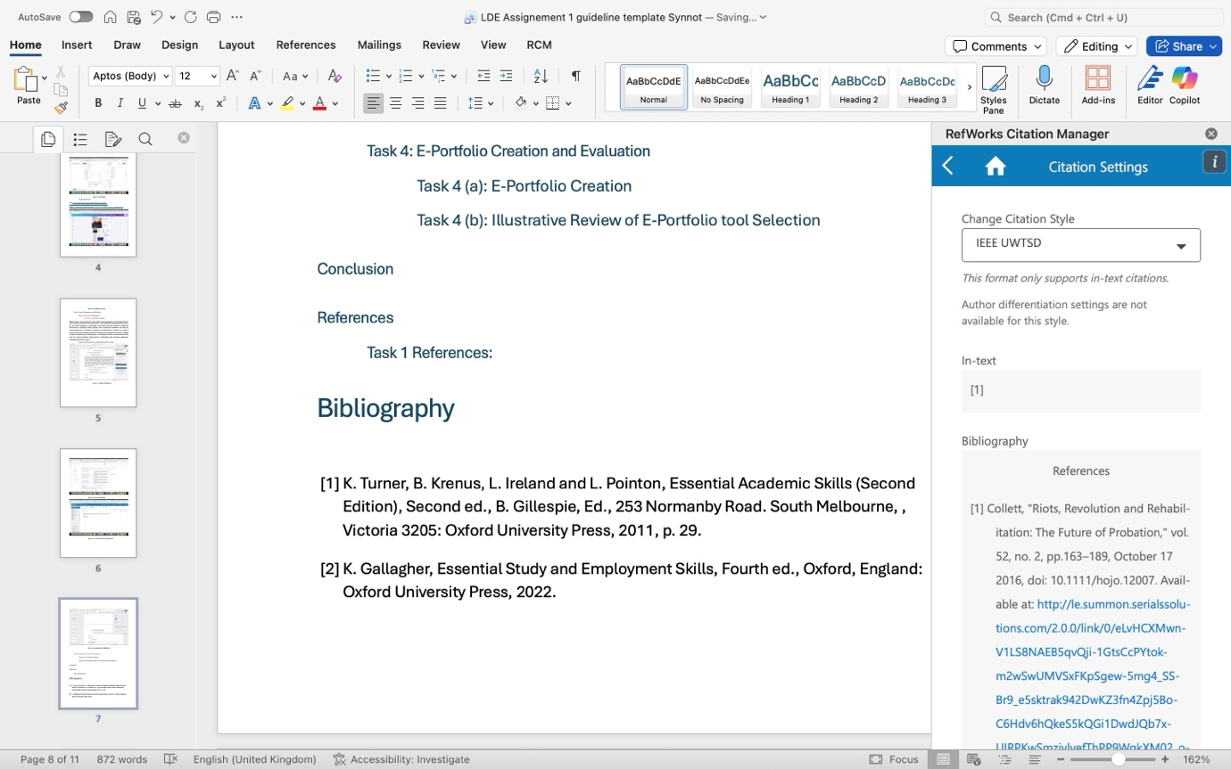
Figure 5: Change Citation setting to IEEE UWTSD
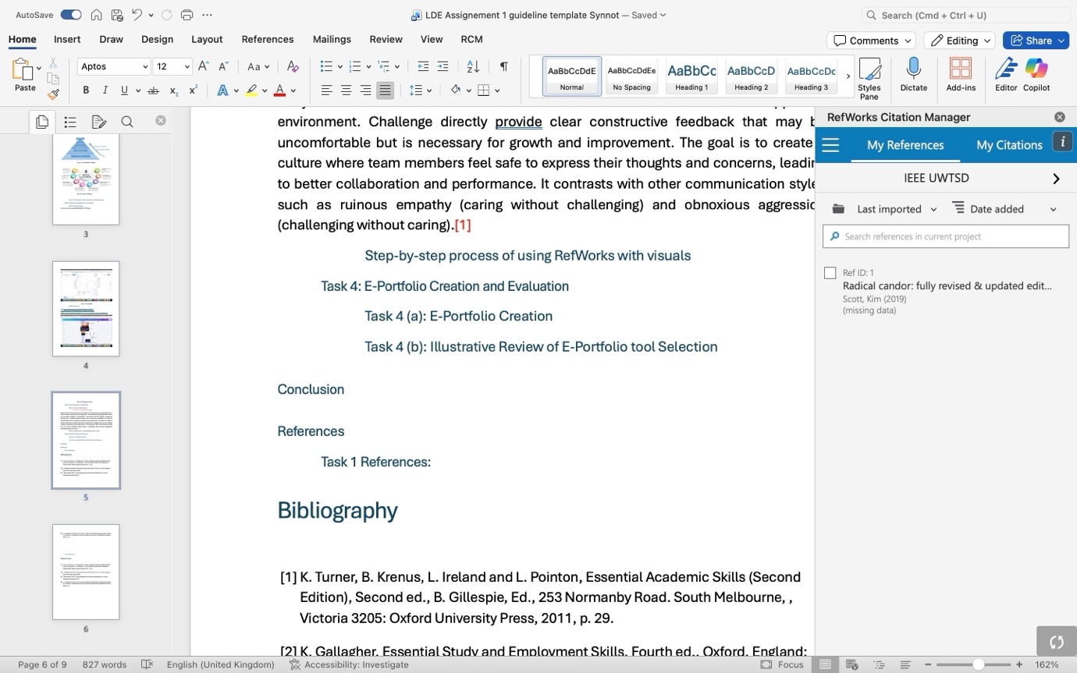
Figure 6: Select Citation
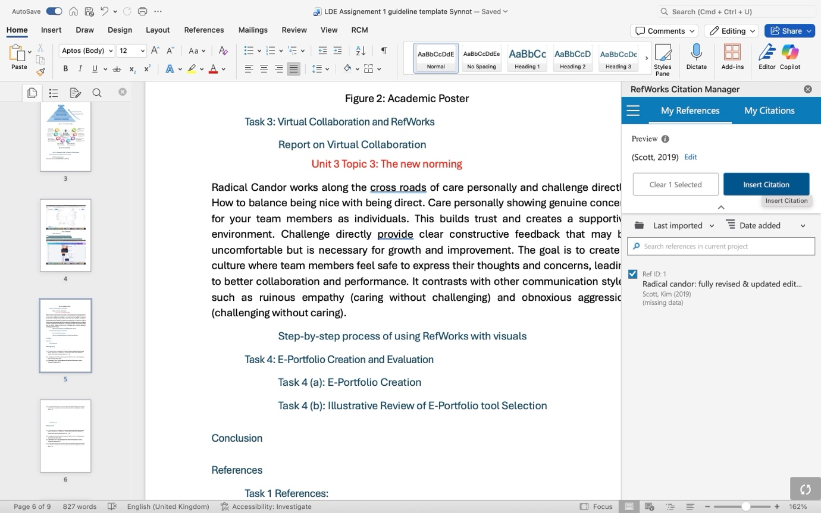
Figure 7: Insert Citation
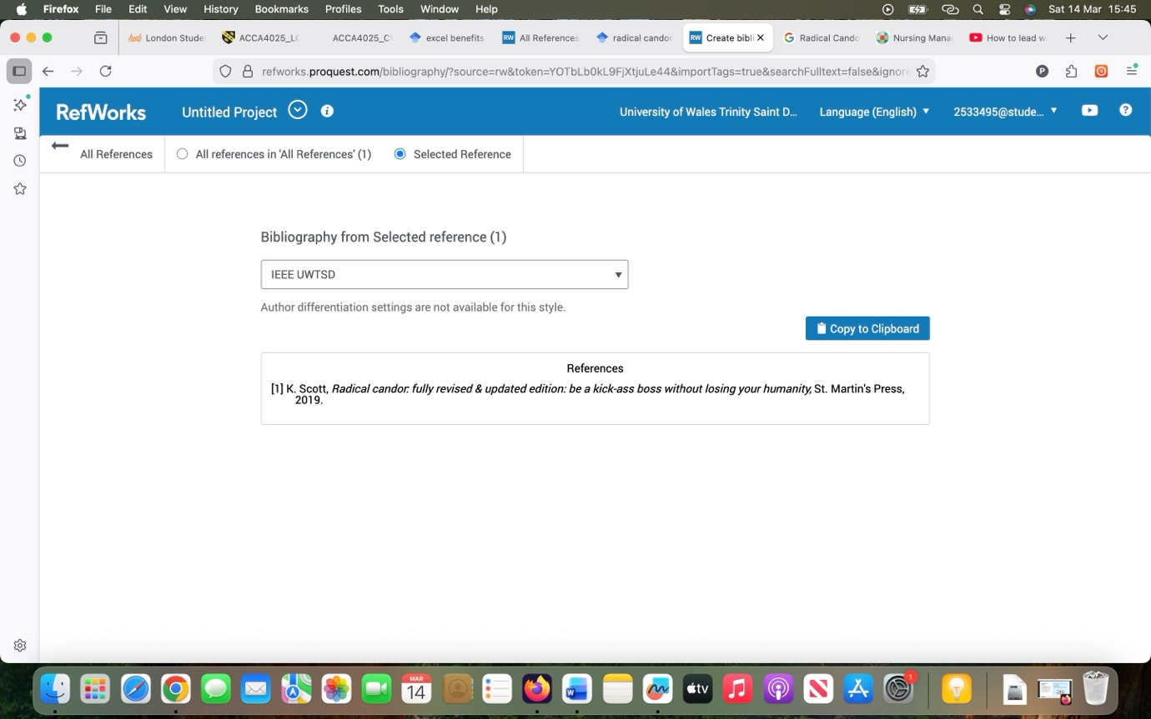
Figure 8: Create Bibliography & Copy
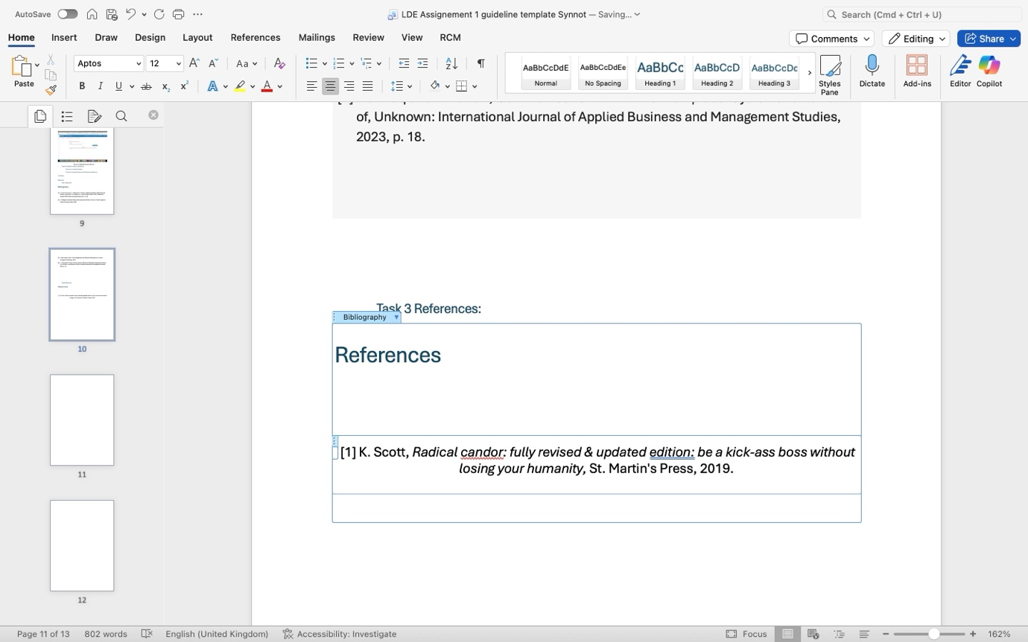
Figure 9: Paste References

Task 4: E-Portfolio Creation and Evaluation

Task 4 (a): E-Portfolio Creation

Task 4 (b): Illustrative Review of E-Portfolio tool Selection

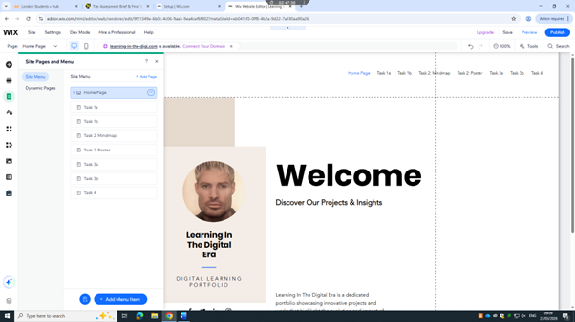
Figure 1: Eportfolio
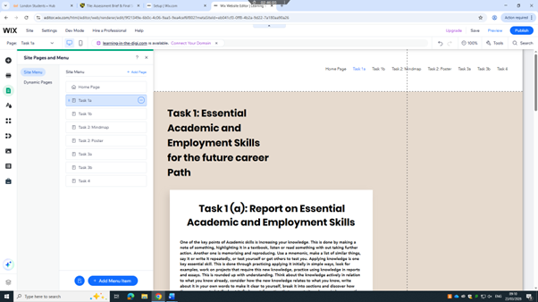
Figure 2: Eportfolio
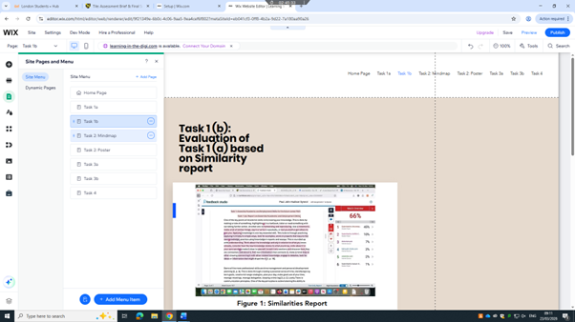
Figure 3: Eportfolio
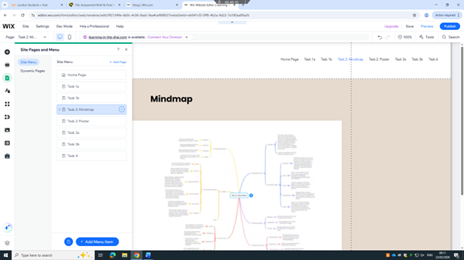
Figure 4: Eportfolio
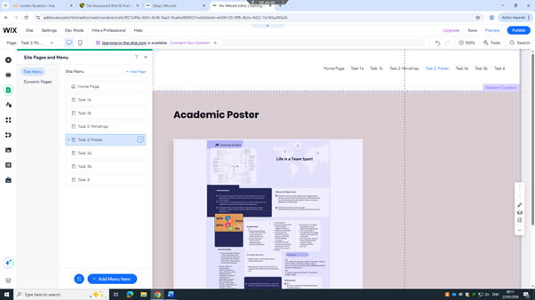
Figure 5: Eportfolio
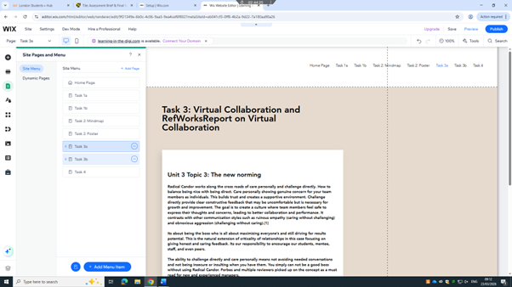
Figure 6: Eportfolio
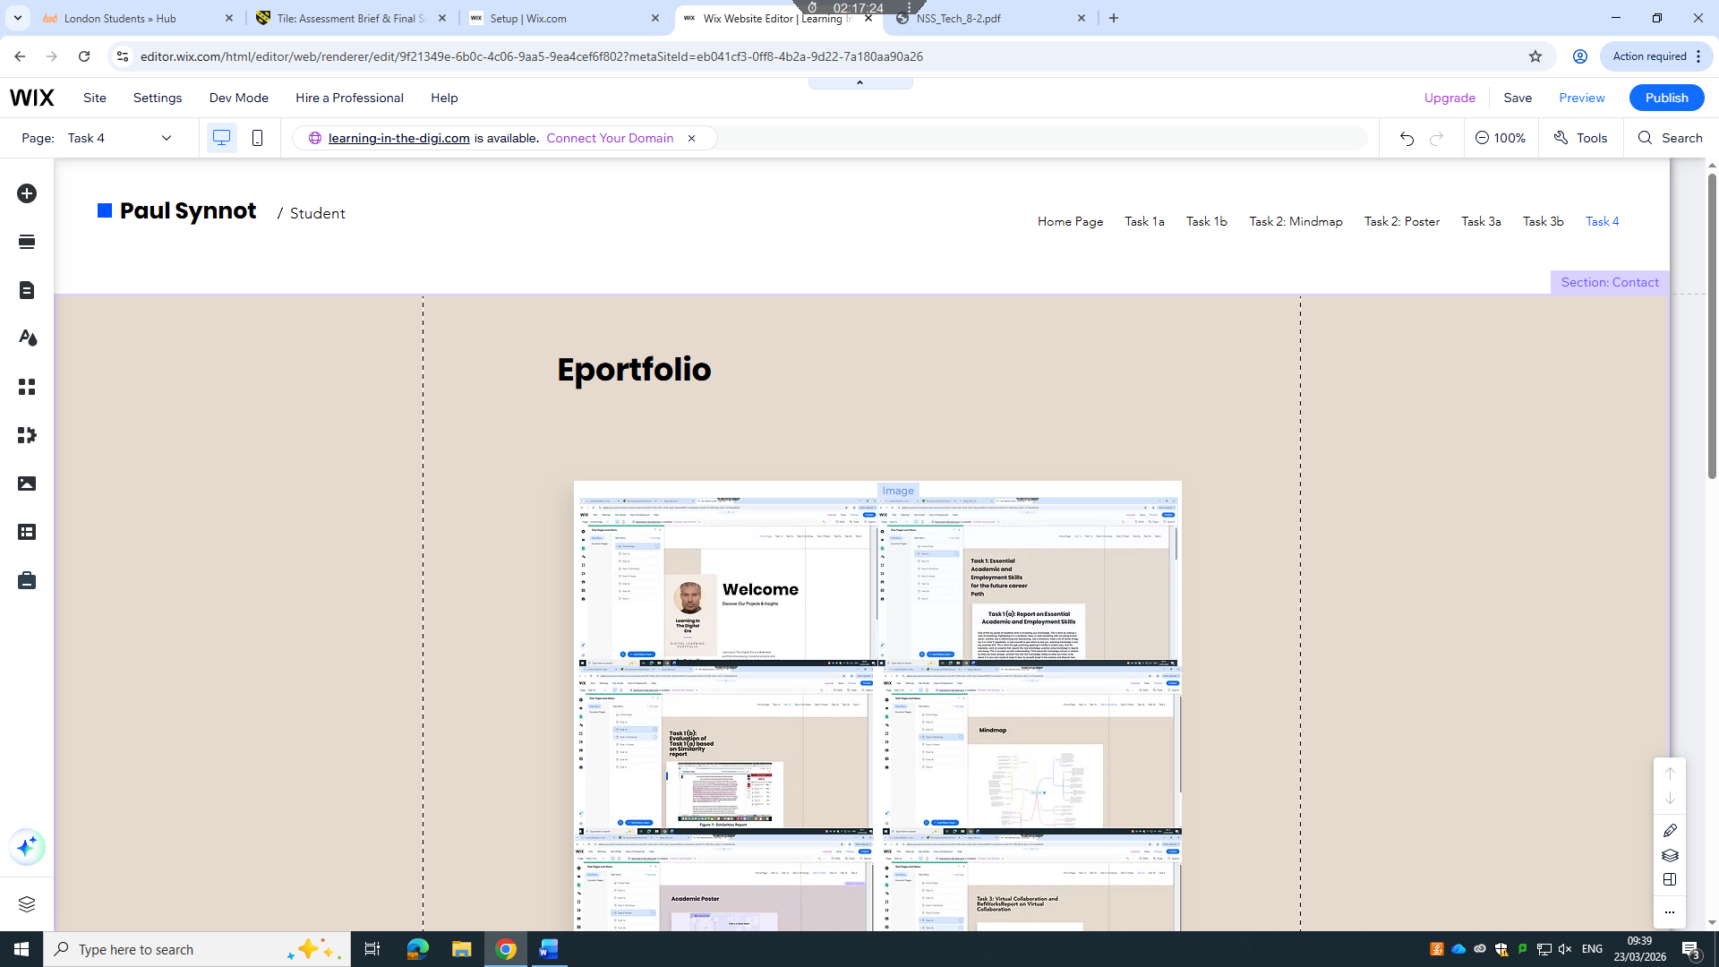
Figure 7: Eportfolio

I chose Wix to create my e-portfolio because it perfectly balances professional design with user friendly functionality. As a visual learner the drag and drop interface allowed me to customize every layout with out needing advanced coding skills. Wix offers sophisticated, mobile responsive templates that ensured my work looked polished on any device, which is essential for a strong first impression. [5]

Conclusion

References

Task 1 References:

Bibliography

[1] | K. Turner, B. Krenus, L. Ireland and L. Pointon, Essential Academic Skills (Second Edition), Second ed., B. Gillespie, Ed., 253 Normanby Road. South Melbourne, , Victoria 3205: Oxford University Press, 2011, p. 29.
[2] | K. Gallagher, Essential Study and Employment Skills, Fourth ed., Oxford, England: Oxford University Press, 2022.
[3] | J. Adair and M. Allen, Time Management and Personal Development, London: Thorogood Publishing, 2012.
[4] | I. u. Haq and R. Faizan, Communication Within the Workplace: Systematic Review of, Unknown: International Journal of Applied Business and Management Studies, 2023, p. 18.

Task 3 References:

References

References
[1] K. Scott, Radical candor: fully revised & updated edition: be a kick-ass boss without losing your humanity, St. Martin's Press, 2019.
[2] R. Raso, "Using “radical candor”," Nurs.Manage. vol. 5, 2018,

