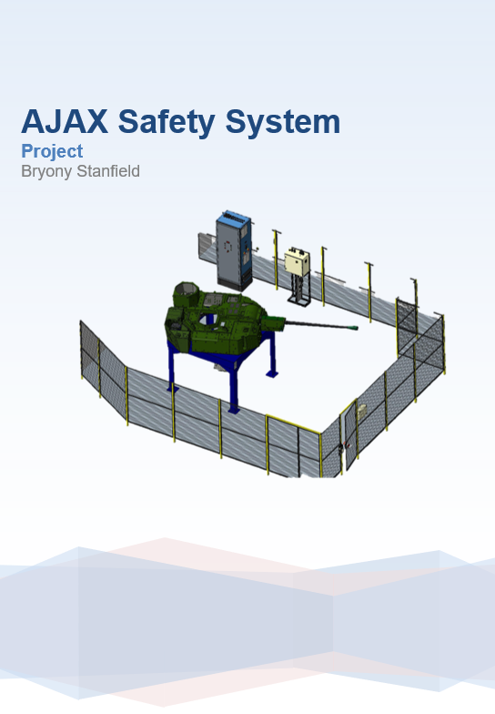
Contents
List of figures 3
Abstract 4
Introduction 5
Planning 6
Aims and Expectations. 12
Methods used during the project. 15
Research 19
Conclusion and Reflection 25
References 26

List of figures

Figure 1 Engineering Design Process 6
Figure 2 Gant Chart 8
Figure 3 Feasibility Study 9
Figure 4 PERT Chart 10
Figure 5 Plan of Action 11
Figure 6 Work breakdown structure 11
Figure 7 VIR 2 Enclosure View 1 15
Figure 8 VIR 2 Enclosure View 2 15
Figure 9 VIR 3Enclosure View 3 16
Figure 10 Turret Safety curtains 16
Figure 11 Light curtain placement 17
Figure 12 Barrel Elevation through curtains 17
Figure 13 Power Enclosure 18
Figure 14 Trapped door and key press 18
Figure 15 Light curtain/Presence sensing device 21
Figure 16 Trapped key system. 22
Figure 17Allen Bradley Beam Close up 23
Figure 18 Allen Bradley safety Pack 23
Figure 19 Trapped key design 24

Abstract

The Purpose of my project was to ensure that when the VIR2 rig is up and running in the test facility that it was safe. The project is based on the safety system of the turret, this includes light curtains, interlock doors and a plc system.
The time allocated for my project by the company was 36 weeks, I planned for the project to be complete in 33 weeks allowing me time for if something unexpected happened or if something needed more time than I anticipated.
The Main aim of this project is to ensure that when the turret is operational and if it were to go out of the defined limit it would power down safely. This was to ensure that the turret does not go out of the ‘working zone’ and does not cause harm to either operator or bystander.
Overall, I believe that my project on the VIR2 Safety system was a success.

Introduction

My name is Bryony Stanfield and I am an engineering Apprentice for General Dynamics Land Systems. General Dynamics is a leading contractor and complex systems integrator working in partnership with government, military and private companies around the world. The site in which I was based was Oakdale Land Systems, this is a site that deals with the control systems of the AFV.
“Providing best-in-class protection and survivability, reliability and mobility, and all-weather Intelligence, Surveillance, Target Acquisition and Recognition (ISTAR), the AJAX Family of Vehicles (FoV) enable sustained, expeditionary, full-spectrum and network-enabled operations with a reduced logistics footprint. Each AJAX variant has been ‘future-proofed’ to ensure it can be upgraded quickly and effectively throughout its service. With a surplus payload capacity and an open Electronic Architecture that is stable, secure and safe, the AJAX FoV have extensive potential to combat future threats and incorporate the latest technology.”
(AJAX - General Dynamics UK, 2021)

What the project is about?
The reason why the Ajax test rig is required to have a safety system is due to this particular variant of the fleet having a moving turret. There are two sections to this rig, the infrastructure of the Armored Fighting Vehicle and the turret, in separate sections. The main concern is the turret and the guarding system. When the turret is in operation on the rig, it can move 360° around the vehicle and can also move up and down, the concern was how to make this safe if there was an error with the system.
The Ajax safety system will consist of Light curtains and also a trapped key system, the reasons for having these safety systems on our rigs are to ensure that no harm or damage occurs to either the operator and/or products/machinery nearby.
The test rigs of the Ajax are all held in a test facility at the GDLS Oakdale site. This facility allows us to test and simulate different scenarios onto the vehicles software to see how it reacts for the real vehicle. The reason we perform the tests on the test rig rather than the production vehicle is to save on parts and time and we will have this rig as a permanent fixture for future uplifts on the vehicle.
I was given the task of designing, implementing and commissioning the electrical and electronic equipment as part of my Project. This project would require me to produce a system which includes electrical and electronic systems. I chose the project to be based around these two systems because I thought that going in-depth on a system of this nature will give me a better understanding of how these two systems can be integrated and how you are able to manipulate the software & hardware to do pretty much exactly what you want by way of programming and correct component selection.

Planning

Project Planning
Planning is an essential part of product design and manufacture within engineering. A thorough and well laid out plan allows companies to maximize efficiency through time management. When a plan is created prior to starting a project it also makes it easy to keep track of progress throughout.
The planning process does not just refer to what happens prior to a product being designed or being produced. The design process should be a full and thorough plan laid out with every detail for each step. It is important because most of the time people forget while doing a project what needs to be done and what they have achieved already.
When planning a project, you must know what you want to achieve and what you need to achieve and at when it needs to be achieved by. You need to set deadlines and have sectioned ideas of what needs to be done.
When doing this you need to make sure you add any details into what needs to be done just in case it gets missed out.

Design Process
The design process is a series of steps that are taken from the point a problem is defined to the point where the problem has been solved to a suitable standard. Design processes can vary from company to company, but the overall idea of the design process remains the same.
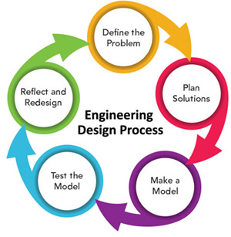
Figure 1 Engineering Design Process
(Anonymous, engineering design process - Bing, 2019)

Identify problem / Design brief – Before a design can be started there must first be a problem or idea. It is the idea or problem that allows a design brief to be made. The design brief outlines the problem without telling the designer how to do their job. The design brief is produced by a customer and supplied to the designer at the start of the design process.
Brainstorm ideas / research / possible solutions – Research the problem and speak to people associated. From this research, brainstorm ideas to come up with some suitable solution to the problem.
Product design specification – This is a more detailed design brief produced by the designer and supplied to the customer prior to the actual design process starting. It includes more detailed information of the specification of the product to be made without specifying exactly what it will be.
Decide on solution– From initial ideas select the most feasible solution that everyone involved is happy with.
Initial drawing / design – Produce sketches of the final idea.
Material, manufacturing methods, costing – Research materials and manufacturing methods along with costs involved to come to a suitable solution in line with the design brief.
Finalize design – Produce detailed drawings of the exact product to be manufactured and tested.
Manufacture – Make the product as specified in the designers drawing using the necessary techniques to produce the product in the most cost effective and efficient way possible.
Test / evaluate / re-design if necessary – Test the design, check it solves the problem and is capable of being satisfactory. If it isn’t for any reason the design should be evaluated and changed where necessary.
Present results – Once a suitable product has been produced it can be presented and see if there is any further work needed to be done and any comments.

Time management and planning tools which were implemented.
Gantt chart
The Gantt chart for my project was a visual guide on the amount of work needed to be completed, and if they were on time or not. This helped a lot in visualising where I was from week to week and to understand what was needed from each section. The Gant chart gave the information of what is being done, how long it will take for each task and what can be done in parallel with another task. It will also show deadline, what is been achieved and what is overdue.
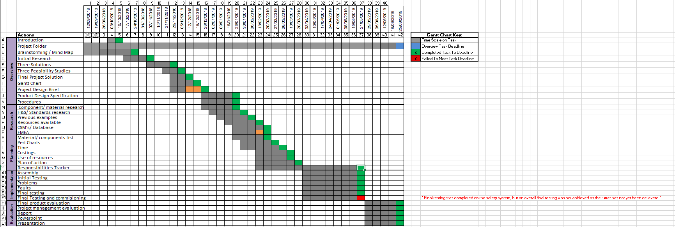
Figure 2 Gant Chart
Feasibility study
A feasibility study is an investigation that considers the entirety of a task's important elements including monetary, specialised, legitimate, and planning contemplations, to learn the probability of finishing the project/task effectively. Project managers use feasibility studies to perceive the upsides and downsides of undertaking a venture before they contribute a great deal of time and cash into the project.
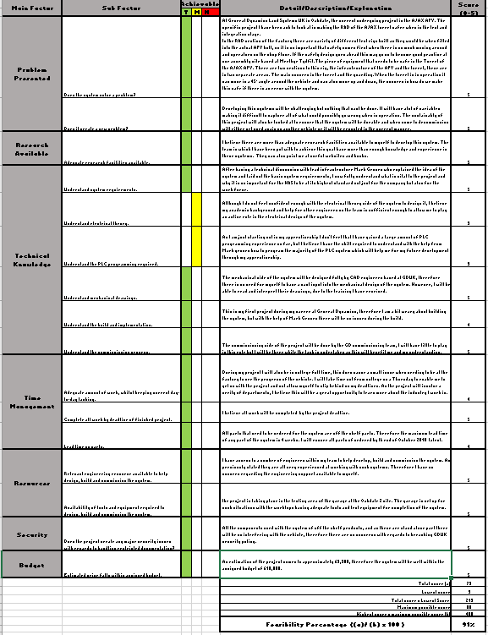
Figure 3 Feasibility Study

PERT Chart
A PERT chart is a visual tool that project managers use to outline and track the project and its associated tasks. The name PERT is an abbreviation for Project Evaluation and Review Technique.
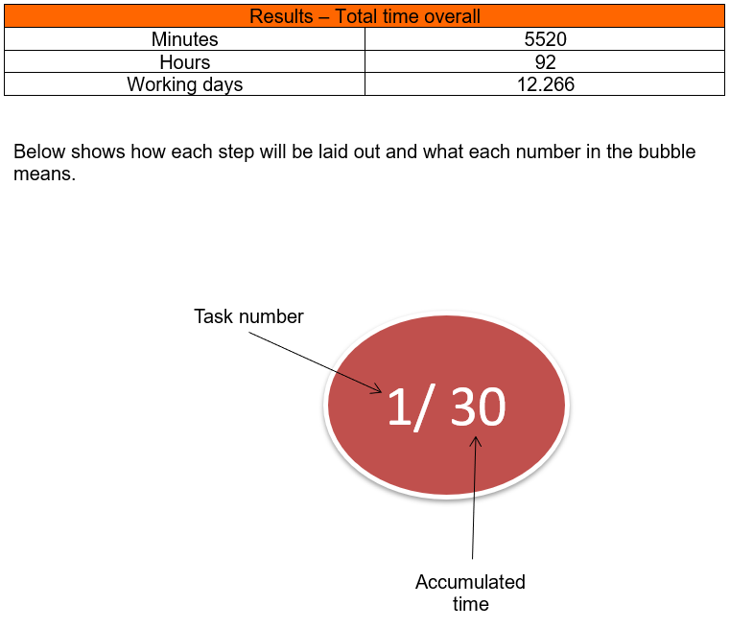

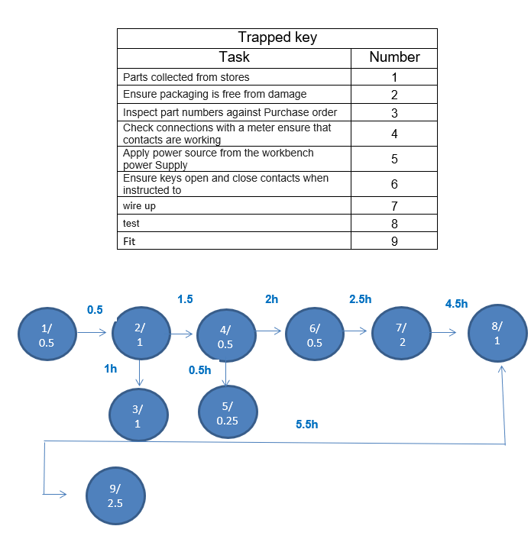

Figure 4 PERT Chart
Plan of action
A plan of action is a high-level step by step overview of each task to be undertaken in the project. The plan of action is usually broken down into milestones for the project team to have a clear vision on which task has been achieved and which ones are yet to be completed.
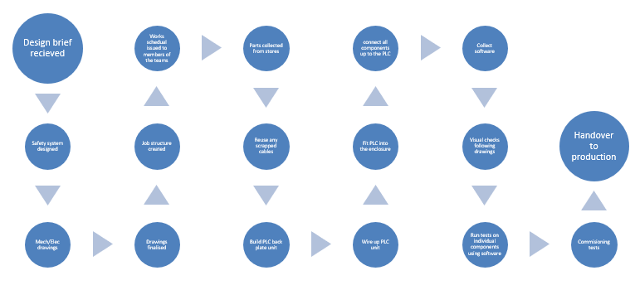
Figure 5 Plan of Action
Work breakdown structure
A work breakdown structure is a more detailed representation of the plan of action. The WBS is usually broken down into subsections which give a more comprehensive view of the task/milestone.
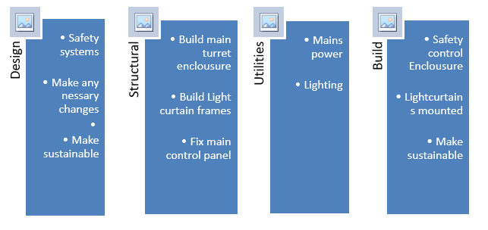
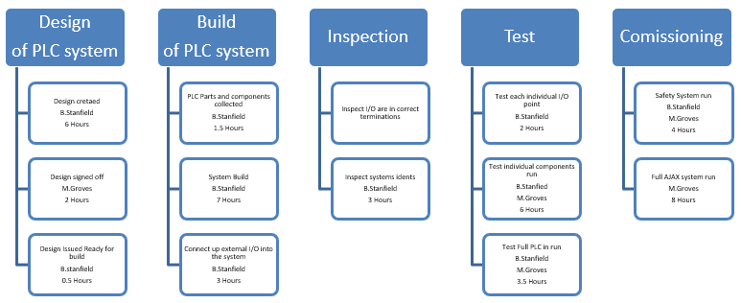
Figure 6 Work breakdown structure

Aims and Expectations.

This section of the project outlines the aims and expectations of which I wanted to achieve when completing this project. This was opportunity was for me to set out key points I wanted to achieve as well as the standard I wanted them completed at. I was also able to use this as a planning aid to ensure that each aim was hit and that we satisfied the customers’ requirements and constraints.
Expectations
Below are the expectations that were set out by our customer (The MOD) for their ‘Design Brief’. These expectations outline what the customer wanted us to achieve with the product and more specifically, concentrates on the safety of the system when it is under testing.
- The piece of equipment that needs to be safe under testing is the main Turret of the AJAX AFV. There are two sections to this rig, the infrastructure of the AFV and the turret, in a separate section. The main concern is the turret and the guarding. When the turret is in operation it has the ability to move freely in a 360° angle around the vehicle or test rig and the barrel will also, naturally, move up and down, the concern is how do we ensure that this is safe if there is an error with the system.
- Testing of new Software and Updates (Known as an Uplift) to be simulated and tested on the test rig, NOT on a live vehicle, as is normal protocol within General Dynamics. Our customer wishes for all future uplifts to be Uploaded and tested on the AJAX AFV Test Rig, ensuring that all systems communicate and operate with each other seamlessly before this uplift is applied to the entire vehicle, or at least, the updated turret is attached to the vehicle.
- The AJAX AFV rig is not only to be used as a Testing Rig but also to be able to run simulations of battle scenarios such as faults and errors so that Drivers and crew are able to be trained in-house before going out into open-world testing. This request will require far more advanced and pre-programmed software in order to run a completely separate simulation program on not only the turret, but also its relationship with the test rig. The timescale for this addition to the software was Summer 2019, this gave me a 5 month time frame to work to.

Constraints
As with any design brief or customer requirements, there are some limits that are to be applied to the entire project, some can be small details, others rather large and obvious. Below I have outlined the brief but substantial constraints that were to be applied to this project at ALL TIMES.
- Both the Customer and Ourselves both share the same level of security and privacy policies that fall in line with any United Kingdom Defense industry. Therefore, it is agreed that all Systems, Updates, Designs, Minutes and any internal communications are to ONLY be performed on the encrypted internal servers which cannot be accessed by any 3rd or Exterior Party. This promise instills trust between ourselves and the customer and protects us both from external data acquisition.
- Cost – The customer had set the cost for all aspects of the project to not exceed £10,000. This includes all labor, materials and components/systems not designed by ourselves. Naturally as with any customer order regardless of whom it may be, we maintained regular communication in the form of Progress Reviews (To be done on site preferably, however for some milestones we will be able to travel to the customer) and also digital/conference call communication with Project Managers and Engineers when between Progress Reviews. All aspects of the Research & Development for the project have their own associated Person’s, so getting answers from the correct personnel is not normally a problem, normally within 48 hours. This is very useful for such a sensitive project.
- Timings/Completion Date – As stated in the requirements section, the customer wished the Project to be completed by August/September 2019, this gave myself and the team around 5 months to complete the project. I scheduled in 5 to 6 Progress Reviews which would allow the customer to see clearly what had been achieved to date and would help to keep both parties in alignment for the entirety of the project (I.E. Any changes or additional specifications requested by the customer can be discussed in these official meetings) As mentioned above, regular communication via emails, calls and ‘open’ documents would aide progress and act as ‘mini’ reviews where small gremlins and problems can be resolved head on with the correct personnel concerned with a particular system, component or requirement.

Aims
- Presence sensing – Light curtains

The idea to have the presence sensor is that if the barrel were to break the light beam from the turret rotating too far past its set parameter or the software failing, these safety devices would cut the power directly to prevent any accidents involving humans or damaging any of the surroundings or the turret and barrel. The turret can move 360° horizontally & 45° vertically in either direction from horizontal. This I where I needed to make sure that the barrel wherever it may be, needed to be detected by the beams to cut the power (Fail safe). To fail safe the turret and barrel must maintain its place when the power is cut.
The systems which I used for the project were the Allen Bradley guard shield. This new design allowed each transceiver to be used as a transmitter or receiver via an innovative plug-in module. By inserting a plug-in module into the bottom of each transceiver, once powered up, the transceiver would learn its functionality from the plug-in module and begins operating as a transmitter or receiver. These curtain systems are equipped with an active protective field that provides sensing over the entire length of the transceiver.

- Trapped key Interlock systems

The Trapped key interlocking system ensures that the process is followed and cannot be circumvented or short cut. The transfer of a key ensures that wherever personnel find themselves, in either starting or shutting down operations, they can be assured that they are safe. There are three simple steps in designing a trapped key system, what is being isolated, how many access points are there and what type of access is required.
A key is used to start the process and remains trapped whilst the machine is running. The only way to remove the key is to isolate the hazard. This key is then used to gain access to the dangerous area and remains trapped in position. While the gate or door is opened, the key can only be removed when the gate or door has been shut. In this way the key is either trapped when the machine is running and access cannot be gained, or the key is trapped while access is gained and the machine cannot be started.

- Solenoid release unit

The solenoid release unit which is part of the main enclosure for the trapped keys are used for electrical isolation of machinery to improve safe access. It consists of a rotary power switch and a solenoid. The trapped key can be removed once an external signal is given to its internal solenoid locking mechanism. An indicator light on the solenoid release unit indicates when the trapped key can be removed; that is, when power is applied to the solenoid. The solenoid signal only needs to be present when key removal is necessary. The solenoid is rated for 100% duty cycle. Power to the solenoid can be removed after the trapped key is removed.
The positives outcomes of this project I was looking to achieve were;
- VIR2 fully functioning.
- VIR2 Safety System Working correct to specification.
- VIR2 Rig signed off by General dynamics Health and safety department.
- VIR2 Signed by MOD.
- VIR2 signed by trade compliance.

Methods used during the project.

During the entirety of the project there were various methods used to ensure that the project ran as smoothly as possible as well as adhering to the highest standards. As this was my first major project within the company, I also wanted to make a good first impression showing how important safety and time management were to me. Below I utilised CAD as my main method to illustrate the design.
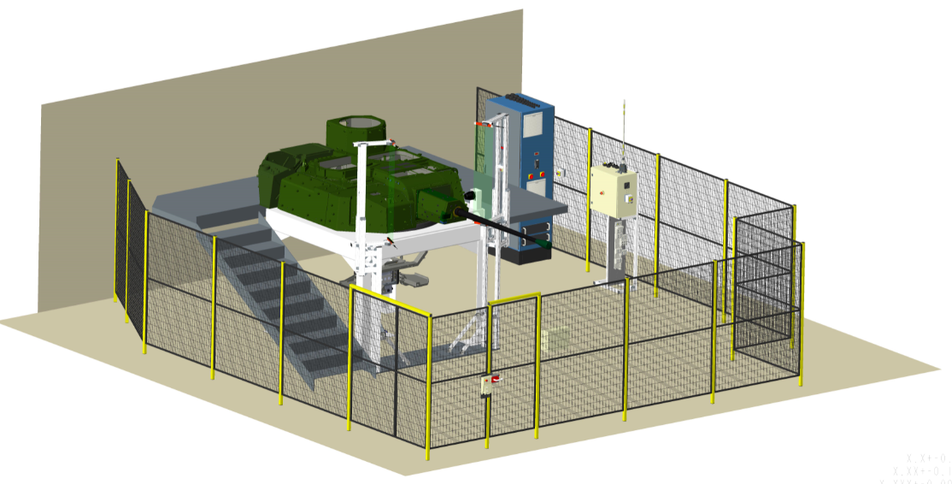

Figure 7 VIR 2 Enclosure View 1
In figure 2 this shows the whole of the enclosure containing the Turret and it electrical control enclosure. This Diagram was used to propose the layout of the VIR2 test rig.

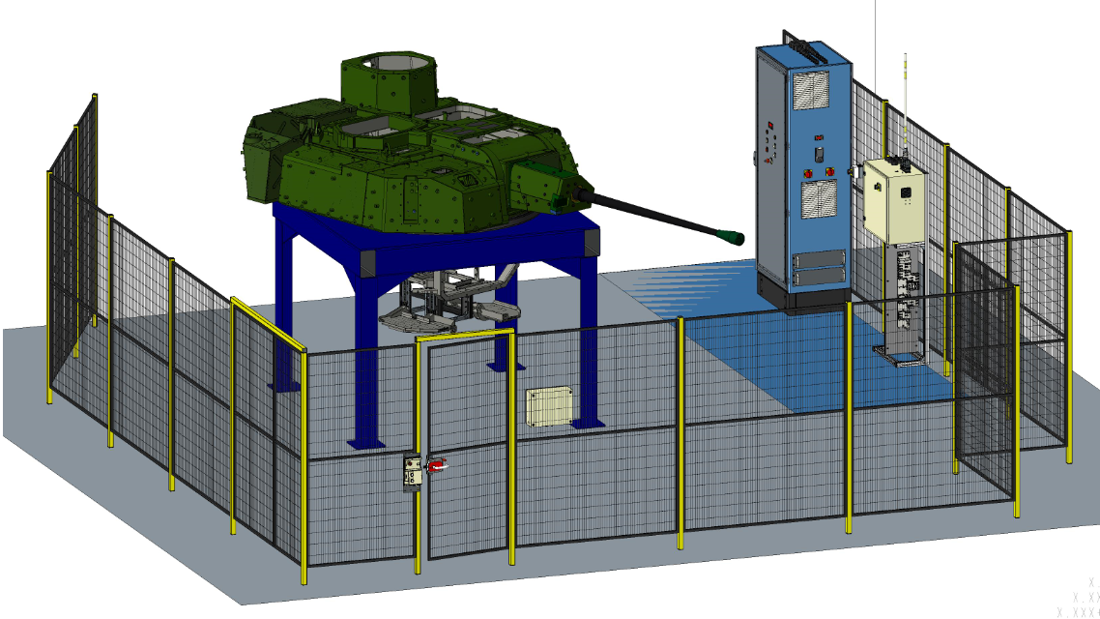

Figure 8 VIR 2 Enclosure View 2
Here in Figure 3 shows the enclosure with the Trapped key system. The trapped key system allows us to keep the enclosure controlled by allowing only the operators of the rig to be in control. This is achieved by the two operators having one key each either A or B, when they enter the rigs enclosure they will take one key each out of the control box situated at the entrance the key A is then inserted into the cream enclosure (shown in Figure 8) and B is placed into the control enclosure of the secondary part of the rig which cannot be shown for security purposes.

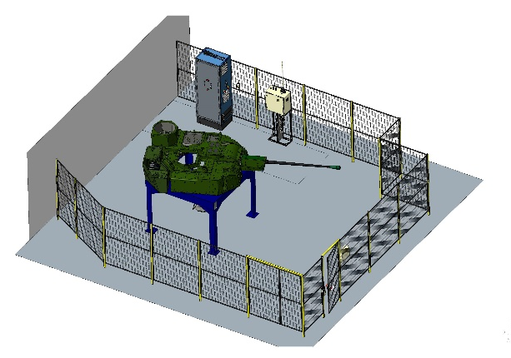

Figure 9 VIR 3Enclosure View 3
Figure 4 shows another view of the VIR2 without the safety light curtains but shows the main enclosure of the Turret and the power distribution.

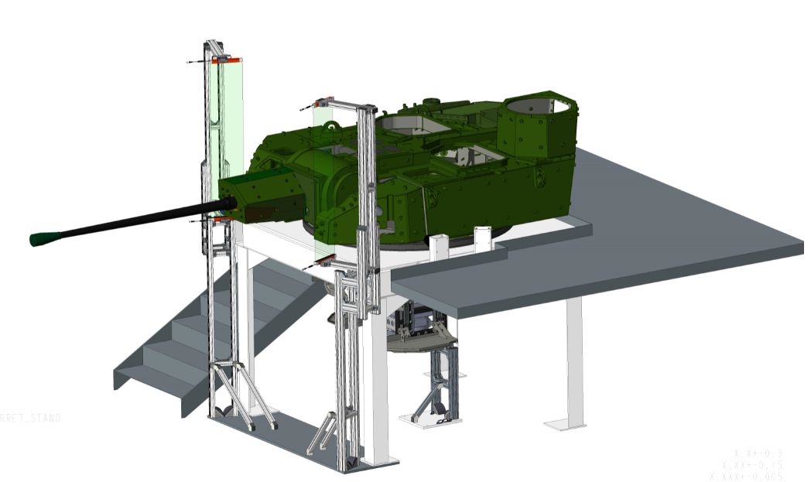

Figure 10 Turret Safety curtains
Figure 5 shows the concept of the Light curtains and how I planned in the project for them to be placed. Having the curtains in this position would allow myself and the users full reassurance that if the system was to fail that it would power down safely and ensure no harm done.
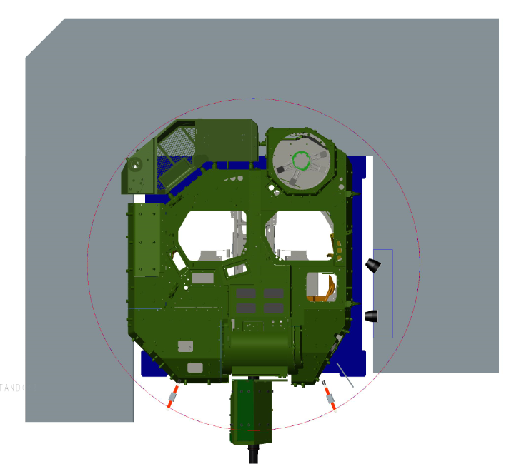
Figure 11 Light curtain placement
Figure 6 shows the light curtain placement from a bird’s eye view and also showing the diameter in which the turret turns.
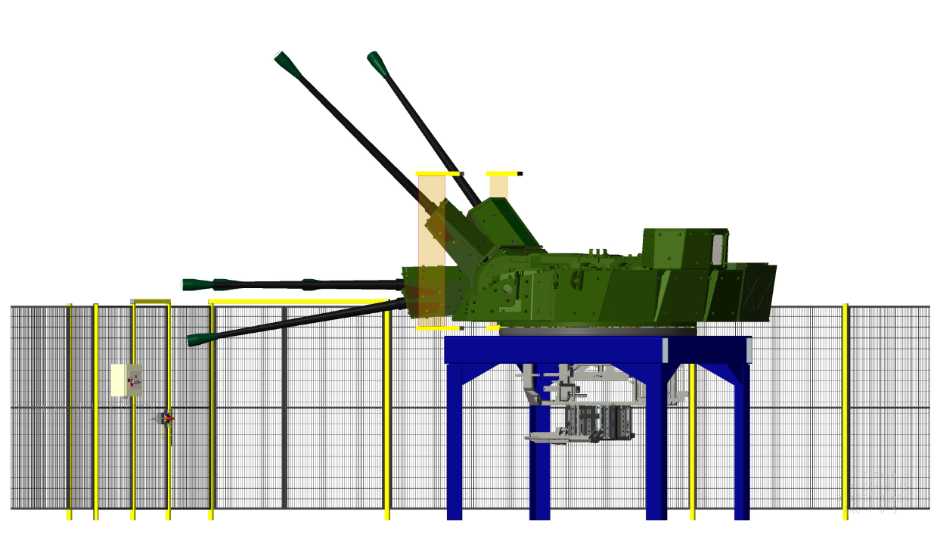
Figure 12 Barrel Elevation through curtains
Figure 7 shows the elevation gain of the Barrel. This is the main feature which we have to ensure that does not make any un-commanded movements.
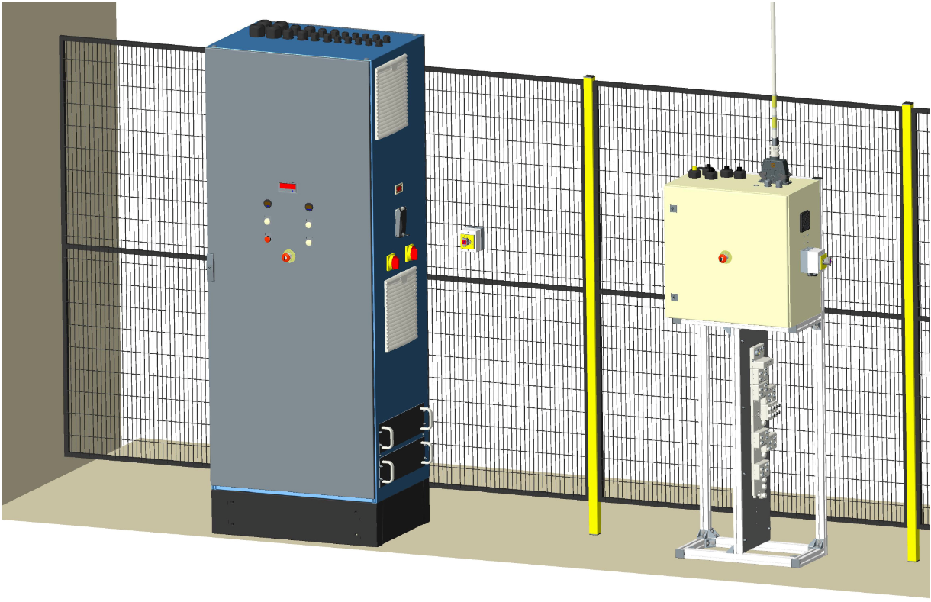
Figure 13 Power Enclosure
Figure 8 shows the power distribution enclosure along with the Trapped key and light curtain control enclosure. These two enclosures are both situated inside the Main VIR2 enclosure. The Tall cabinet is the main power distribution for both the turreted side of the enclosure as well as the hull. It ensures that power is maintained on both sides of the enclose and that if a failure were to occur that both systems would power down safely and ensure that the system is not left in a volatile state.

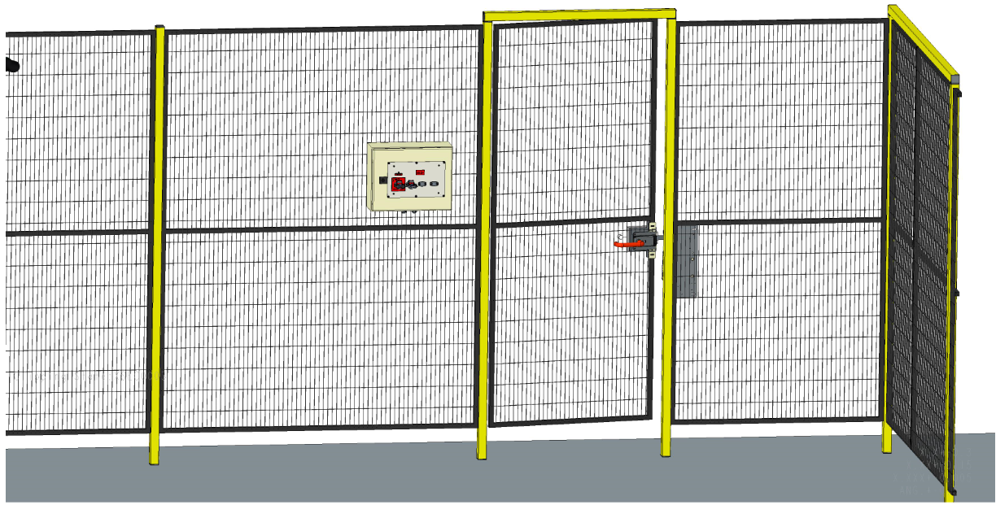
Figure 14 Trapped door and key press
Figure 9 shows the trapped door along with its control enclosure which shows the key press which holds the keys when in its safe position.

Research

The Research for my project covered a wide range of information, from Company information, AFV information to the products I would be using. Doing this research gave myself a greater understanding of what the company does and the range of vehicles that they supply to the MOD.
Having joined the company and being put on such as safety critical project, I wanted to make sure that I had a greater understanding of the range of vehicles General dynamics had to offer along with the Ammunition that they were going to use, to understand the gun system they were having to replicate in a safe environment.
General Dynamics have a Family of Armoured fighting Vehicles which are the Ajax family with six different variants all serving their own individual purpose. The Six Variants are;
- Ajax (turreted)
- Ares (Armoured Personnel Carrier)
- Argus (engineer carrier)
- Athena (command and control)
- Atlas (recovery and support)
- Apollo (repair)

AJAX Weapon Systems
“The primary armament is the CTAI 40 mm CTAS (Cased Telescoped Armament System) integrated into a revolutionary user-defined turret, along with a 7.62mm coaxial machine gun. The Primary Sight can be replaced with a fully stabilised Remote-Weapon system and its digital fire control system enables AJAX to fire on the move.
CT40 can conduct ‘smart fires’ which means they can fire; air burst rounds (13,000 sq ft coverage), point detonating rounds (can defeat 8.3” reinforced concrete) and armour piercing rounds (can penetrate 140 mm hardened steel armour).”
(Georgina Coupe, www.forces.net, 2021)
As an engineer in today’s world, safety is key. Being able to research safety systems and see the different types available on the market is outstanding. To be involved in such a critical feature has make me understand the importance of my role within General dynamics and by ensuring that we are making the work place a safer place following the guidance of the HSE.
“Before you start using any machine you need to think about what risks may occur and how these can be managed. You should therefore do the following:
- Check that the machine is complete, with all safeguards fitted, and free from defects. The term 'safeguarding' includes guards, interlocks, two-hand controls, light guards, pressure-sensitive mats etc. By law, the supplier must provide the right safeguards and inform buyers of any risks ('residual risks') that users need to be aware of and manage because they could not be designed out.
- Produce a safe system of work for using and maintaining the machine. Maintenance may require the inspection of critical features where deterioration would cause a risk. Also look at the residual risks identified by the manufacturer in the information/ instructions provided with the machine and make sure they are included in the safe system of work.
- Ensure every static machine has been installed properly and is stable (usually fixed down)
- Choose the right machine for the job and do not put machines where customers or visitors may be exposed to risk”.
(Anonymous, hse.gov.uk, 2018)
There were a few contributing factors for this safety system being implemented, these ranged from other industry experiences to some close near misses. During 2018/2019 accidents which involved moving machinery were responsible for “4% of all accidents resulting in injury reported to RIDDOR.”
(Claims, 2019)

Product research

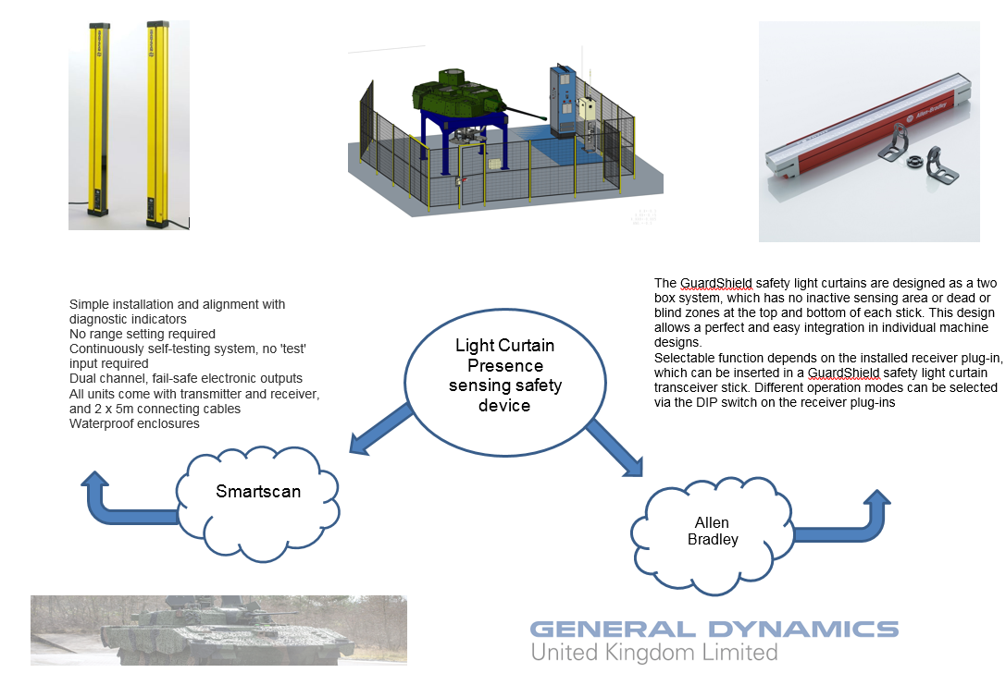

Figure 15 Light curtain/Presence sensing device
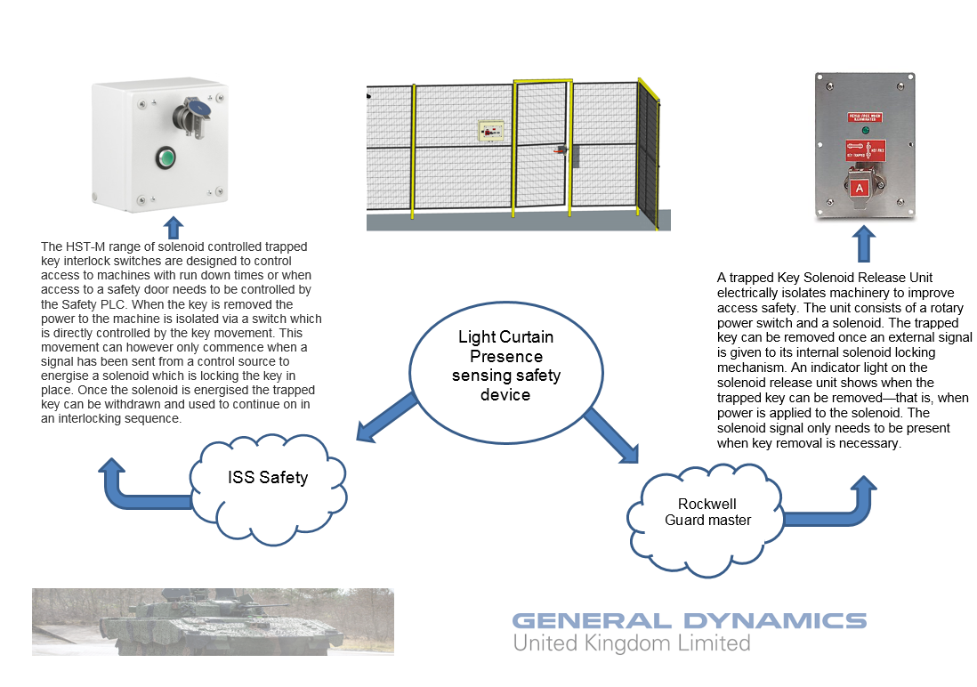
Figure 16 Trapped key system.
Allen Bradley Light curtains
Presence Sensing Devices are one of the most common safeguards for automatic feed part revolution clutch presses. They are designed to automatically stop the machine stroke if the sensing field is interrupted. Proper use of presence sensing devices provides protection not only for operators but also for other employees in the area. They also minimize operator resistance to these types of safety devices due to their non-restrictive design. Presence sensing devices are commonly referred to as light curtains. There are many requirements that must be met before light curtains can be installed as point-of-operation safeguards.
The idea to have the presence sensor is that if the barrel were to break the light beam from the turret rotating too far past its set parameter or the software failing, these safety devices will cut the power direct to prevent any accidents involving humans or damaging any of the surroundings or the turret and barrel. Where marked red on the CAD drawing below is where I wanted the Presence sensor (light curtain) to be located. “The turret can move 45° up and down”. This I where I needed to make sure that the barrel, wherever it may be, needed to be detected by the beams to cut the power (Fail safe). To fail safe the turret and barrel must maintain its position when the power is cut.
(Anonymous, General Dynamics Barrel movement, 2015)

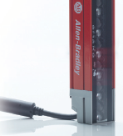

Figure 17Allen Bradley Beam Close up
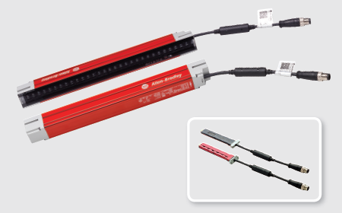

Figure 18 Allen Bradley safety Pack

Trapped key Interlock systems
Trapped key interlocking ensures that a process is followed and cannot be circumvented or short cut. The transfer of a key ensures that wherever personnel find themselves, in either starting or shutting down operations, they can be assured that they are safe.
There are three simple steps in designing a trapped key system, what is being isolated, how many access points are there and what type of access is required. A key is used to start the process and remains trapped whilst the machine is running. The only way to remove the key is to isolate the hazard. This key is then used to gain access to the dangerous area and remains trapped in position while the gate or door is opened. the key can only be removed when the gate or door has been shut. In this way the key is either trapped when the machine is running and access cannot be gained, or the key is trapped while access is gained, and the machine cannot be started.

Solenoid release unit
The solenoid release unit is used for electrical isolation of machinery to improve safe access. It consists of a rotary power switch and a solenoid. The trapped key can be removed once an external signal is given to its internal solenoid locking mechanism. An indicator light on the solenoid release unit indicates when the trapped key can be removed; that is, when power is applied to the solenoid. The solenoid signal only needs to be present when key removal is necessary. The solenoid is rated for 100% duty cycle. Power to the solenoid can be removed after the trapped key is removed. Rotating the trapped key causes the isolating power switch to change state; the normally open contacts open, and the normally closed contacts (if applicable) will close. The trapped key can then be used in the next sequence of the operation.

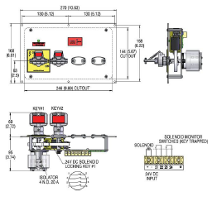
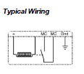

Figure 19 Trapped key design

Conclusion and Reflection

The safety system of the VIR2 Is now complete and successful. We did everything possible to ensure that the product works by simulating it ourselves using test props supplied from Allan Bradley themselves. The project came in just under what was allocated by the company for the AIT (Assembly, integration and test) section. The budget given for my part of the project alone was £6,000 the approximation I gave after adding up parts was just under £5,000. My section of the project fell well within the deadline set, completing the whole project within the 36 week time frame.
Any recommendations to be made such as upgrades/ improvements
Infrastructure
- Rig Power Control; Link so that Hull Power Cabinet controls both Hull and Turret PSU towers. Control to be driven from Hull, providing a more representative DIP BMS control from one location.
- Safety Interlocked door: Reprogram interlock behaviour to act as handle driven E-Stop.
- Keep the software of the Light curtains up to date and check on a monthly basis for any updates. Keeping these devices up to date will ensure that they will perform to the best of their capabilities. The reason I stress for these to be kept up to date if because they are a safety system, any glitch with the software could cause catastrophic failure or even death.
Facilities
- Physical barrier (ribbon / chain) to be installed between old Turret / Hull cells. Barrier put in place when preparing rig for movement.
- Assess potential for moving safety fence at rear right of turret (facing forward) to provision safe walkway from Hull cell, around rear of turret to steps – removing need to walk through barrel movement area.
- Reassess tape markings upon floor to indicate keep out zones.
- Regular VIR2 access / egress through CoTag controlled door. Only VIR2 trained operators to have CoTag access.

Overall, I believe that the project was a great success. I am happy with the way my project had been completed and as a joint decision with my line manager they also describe it as a great success. For future report writing, I would like to create a more advanced and comprehensive report consisting of more information that could include test results, test procedures, safe systems of work and also the implementation and build. What I have learnt and will take forward from this project and report writing, that communication between departments is key when managing a project. I found that during this project some things were lost in translation via emails, etc. I feel that this report does not reflect on my best skill set, as this was not captured due to the nature of this report. If I were to plan and re-write this report, I would ensure that the implementation of the project was captured to give the reader/customer an in-depth relation to the project throughout its initial stages and to show it maturing over time.

References

(Anonymous, hse.gov.uk, 2018)
Hse.gov.uk. 2021. Why is machinery safety important?. [online] Available at: <https://www.hse.gov.uk/toolbox/machinery/safety.htm>

(Harry Lye, www army-technology.com, 2021)
Lye, H., 2021. Industry blames CT40 Cannon for armored vehicle delays. [online] Army-technology.com. Available at: <https://www.army-technology.com/features/industry-blames-ct40-cannon-for-armoured-vehicle-delays/>

(Georgina Coupe, www.forces.net, 2021)
Coupe, G., 2021. All The Gen On The AJAX Military Vehicle. [online] Forces Network. Available at: <https://www.forces.net/services/army/all-gen-ajax-military-vehicle>

(AJAX - General Dynamics UK, 2021)
General Dynamics UK. 2021. AJAX - General Dynamics UK. [online] Available at: <https://generaldynamics.uk.com/systems/land-systems/ajax/>

(Anonymous, engineering design process - Bing, 2019)
Bing.com. 2019. Engineering design process - Bing. [Online] <https://www.blendspace.com/lessons/TVHU0WwqWCqh8Q/engineering-design-process>

(Harry Lye, www army-technology.com, 2019)
Lye, H., 2019. Industry blames CT40 Cannon for armored vehicle delays. [online] Army-technology.com. Available at: <https://www.army-technology.com/features/industry-blames-ct40-cannon-for-armoured-vehicle-delays/>

(Claims, 2019)
Claims, F., 2019. Moving Machinery Accidents – Friends Legal - Workplace Injury Claims. [online] Friends Legal - Workplace Injury Claims. Available at: <https://workplace-injury-claims.co.uk/work-accidents/moving-machinery/>

(Anonymous, General Dynamics Barrel movement, 2015)
Anonymous, 2015. General Dynamics Barrel movement. [Report] GD*****46

