

Programme: MSc Public Health and Social Care in Practice

Student Name: Rizwana Mahmood
Student ID number: 2215431
Module: Community Care and Management of Longer-term Conditions
Module Code: LCHS7003
Lecturer: Dr Aishat Bakre
Assignment Title: Component 1
Epilepsy: A Booklet for Health and Care Professionals in the UK
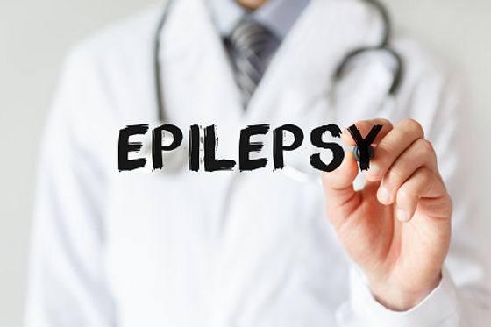
(Prokerala, 2021)

Table of Contents:

What is Epilepsy?

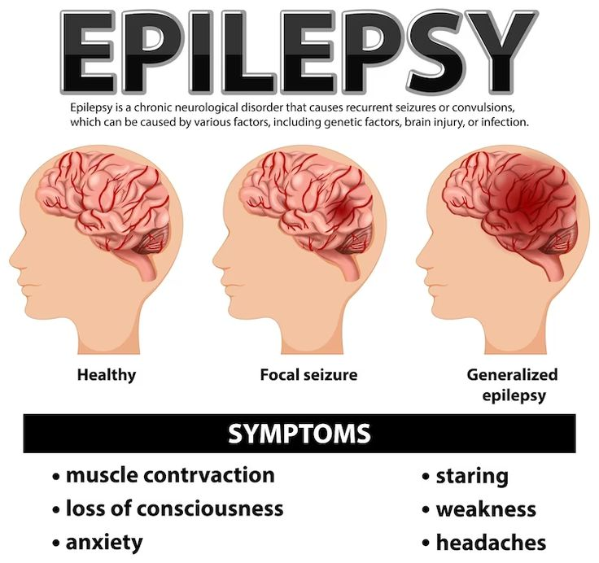
(Singh Kuldeep, 2025)

Epilepsy is a long-term, non-communicable neurological condition in which abnormal electrical activity in the brain gives a lasting tendency to repeated, unprovoked seizures (Epilepsy Action, 2019; Pelham, 2025). It ranks third among neurological conditions in older adults, and as new cases rise after 50 and the over-65s become the fastest-growing age group worldwide, many more people will be living with it in later life (Romigi et al., 2022). The International League Against Epilepsy (ILAE) diagnoses it after two unprovoked seizures more than 24 hours apart, after a single unprovoked seizure with a high chance of recurrence (at least 60% over ten years), or when an epilepsy syndrome is identified (Fisher et al., 2014). Seizures are grouped by where they begin (focal, generalised or unknown) and then by awareness and movement, while epilepsy itself is classified by seizure type, epilepsy type and syndrome, with the cause and related conditions noted at each level (Fisher et al., 2017; Scheffer et al., 2017). With no single diagnostic test, diagnosis relies chiefly on account of the event, and since fainting and other conditions can look like seizures, National Institute for Health and Care Excellence (NICE,2022) advises specialist assessment within two weeks of a suspected seizure (Thijs et al., 2019).
This booklet aims to equip practice nurses, GPs, community nurses and social care staff who are not epilepsy specialists to support children and adults with epilepsy and their families in a person-centred way, by explaining how the condition affects physical health, mood and daily life, outlining NHS treatment, weighing up the care models and policies behind long-term condition care, and offering practical recommendations that look beyond seizure control to safety, mental health, independence, work and carer support.

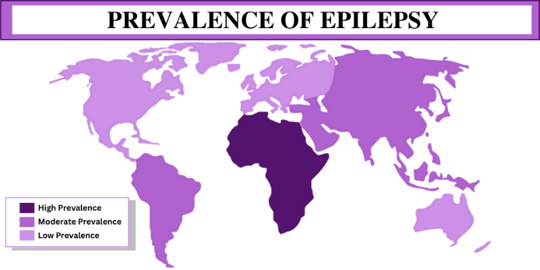
(Epilepsy day, 2023)

Worldwide Burden and Prevalence

Understanding of epilepsy has come a long way, from ancient Mesopotamian descriptions and Greek ideas of divine possession to Hughlings Jackson’s 1875 demonstration that seizures come from abnormal electrical discharges in the brain (Slater, 2026; Dallas, 2025). It is now recognised as one of the most common serious neurological conditions (Thijs et al., 2019), with about 6.4 per 1,000 people living with active epilepsy, 7.6 per 1,000 affected at some point in life, and around 68 new cases per 100,000 each year (Fiest et al., 2017). Roughly three people die from it each day, through sudden unexpected death in epilepsy (SUDEP), status epilepticus, injury or suicide, and UK deaths, about 1,200 annually, are climbing even as general mortality falls (Wigglesworth et al., 2023). People with learning disabilities are at greater risk (around 5% against under 1%), and an estimated 20-30% of people in the UK are wrongly diagnosed, suggesting pathways are unclear for non-epileptic attack disorder (NEAD) and other causes of seizures (NHS England, 2020). Each year in England, about 100,000 hospital attendances follow a seizure, with 40,000 admissions making up 1.4% of emergency medical admissions (NHS England Digital, 2012). The 2013 national audit of 4,544 emergency visits found that 18% of people with epilepsy took no antiepileptic drugs, only 75% of first-seizure witnesses were asked what happened, 58% saw a senior doctor, 27% were advised on managing future seizures and 55% were referred to a specialist (Dixon et al., 2015). Research investment is limited too, at about £18 million in 2022, or roughly £28.57 per person affected (NICE, 2022).
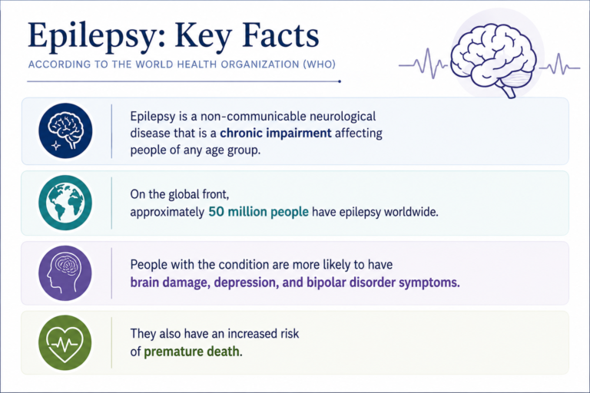
(Social Security Disability for Epilepsy in Cape Coral, FL, 2020)

Global Prevalence/Burden

In 2022, the 75th World Health Assembly and World Health Organisation (WHO) made epilepsy a priority for non-communicable disease control and adopted a global action plan on epilepsy and other neurological disorders for 2022-31 (Yang et al., 2024). Epilepsy affects around 50 million people worldwide, with about 5 million new cases each year, and nearly 80% live in low- and middle-income countries, where new diagnoses are far more common (up to 139 per 100,000 a year, against 49 in wealthier nations) because of infections, road injuries and birth complications (WHO, 2024). Up to 70% of people could be seizure-free with the right diagnosis and treatment, yet about three quarters in low-income countries receive no care, and their risk of early death is up to three times higher (Sen, Newton and Gift Ngwende, 2025). WHO-led projects in Ghana, Mozambique, Myanmar and Viet Nam are bringing treatment within reach of 6.5 million more people (WHO, 2024). In the UK, about 1,000 people die of epilepsy-related causes each year, half from SUDEP, and people with epilepsy die on average eight years earlier, with those in deprived areas three times more likely to die from it, even though over 60% could be seizure-free with proper treatment (Epilepsy Action, 2023).

Aetiology

Epilepsy develops when the brain becomes more likely to produce seizures without a trigger. Clinicians start by establishing that an episode was genuinely epileptic, then search for the underlying cause, which could be structural, genetic, infectious, metabolic, immune-related or neurodegenerative, sometimes in combination (Birbeck, 2025). Brain scarring, tumours, developmental differences, vascular abnormalities, stroke, inflammation and injury are common structural causes, and head injury is among the few that are preventable. Because advances in MRI, antibody testing and genetic sequencing keep improving, people whose cause remains unknown should have their case revisited periodically (Balestrini et al., 2021).
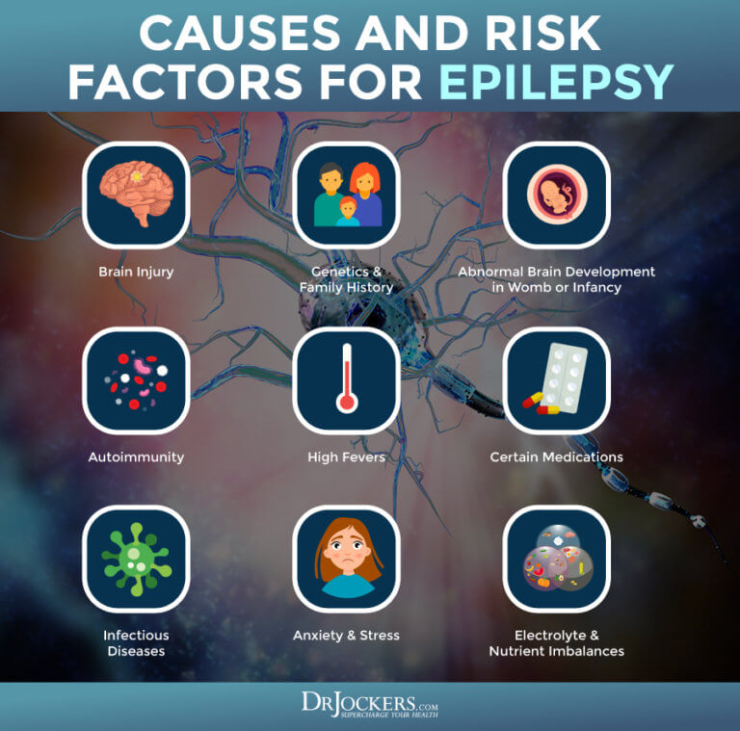
(Jockers, 2021)

Causes and Risk Factors

Some risk factors for epilepsy cannot be changed, such as premature birth, congenital brain malformation, family history and conditions like tuberous sclerosis, ADHD, autism and learning disability (Gavvala and Schuele, 2016; Krishnamurthy, 2016; Dixon et al., 2015). In later life, brain infection, tumours and neurosurgery matter more, with stroke behind up to half of cases with a known cause and dementia behind 10-20% in older people (CSK, 2025; Salema, 2018). Others can be prevented or managed, including head injury, diabetes, high blood pressure and atrial fibrillation. The same split applies to SUDEP: people can reduce risk by taking medication consistently, avoiding heavy drinking and drug use, controlling night-time and tonic-clonic seizures, and not sleeping or living alone without support (SIGN, 2015). Risks that cannot be changed include previous brain injury, infection, stroke or metastatic cancer and abnormal neurological examination findings (NICE, 2025).

Impact on the individual

Epilepsy affects far more than seizures: it shapes physical health, mental health and everyday life, and these effects feed each other.

Physical Impact

Epilepsy affects physical, cognitive, psychological and social wellbeing, with unpredictable seizures causing fear and loss of independence, and medication side effects can lower quality of life further (Siebenbrodt et al., 2023). Around 50 million people live with it worldwide, and while seizures differ greatly from one person to the next, the medication side effects, work challenges, stigma and ever-present worry about the next seizure pile up in ways outsiders rarely see (Ghosh et al., 2021). A seizure can leave someone with bruises, broken bones and pain that lingers if it isn’t properly looked after. The exhaustion that follows, both from the seizure and from recovering, can make it hard to stay active, and over time that can wear down heart health, strength and fitness (Hammond, 2026).

Psychological Impact

Epilepsy brings a range of psychological difficulties. Never knowing when a seizure might breed ongoing anxiety, and depression is much more common than in the wider population, linked to stigma, worries about the future, daily limitations, the brain changes behind epilepsy and, at times, medication. Combined, these pressures lower quality of life, satisfaction with life and the capacity to sustain relationships and work towards personal goals (Okunneye, 2025).
It becomes a concern when the feelings last and get in the way of daily living. Anti-seizure medications can sometimes influence mood, but side effects are rarer than people often assume, and support is available (Epilepsy Society, 2022). People with epilepsy are far more likely to experience depression than the general population, which may reflect stigma, worries about the future, and the everyday burden of living with the condition, such as avoiding triggers. It may also be tied to the neurological processes that cause epilepsy itself, and in some cases, depression can be a side effect of anti-epileptic medication (Bølling-Ladegaard et al., 2022; Schmitz, 2006). Left untreated, depression can lead to suicide, and people with epilepsy are around three times more likely to die this way than the general population, so spotting and supporting it early is vital (Mula and Sander, 2015).

Social Impact

Epilepsy can strain relationships, as unpredictable seizures and stigma lead families to worry and friends to withdraw, causing isolation. It also creates barriers in education and work, from missed school and learning difficulties to discrimination and limited job prospects (Okunneye, 2025; Karakis et al., 2023). According to the Office for National Statistics (ONS), more than half of working-age people with epilepsy in the UK are economically inactive, meaning they are not working and not seeking work, and two thirds are out of employment, a rate well above that for most other disabilities. Disabled employees also earn almost 20% less on average (Kountcheva, 2023). It also touches relationships, as people with epilepsy are less likely to marry and, when discriminated against, more likely to divorce (Kaur et al., 2019). One in five lives alone, raising the risk of injury during unwitnessed seizures and isolation. Good social support, by contrast, is linked to lower stigma and a stronger sense of control. Inequalities in access to treatment and surgery add to the burden, so better data and public awareness are needed to reduce them (Mula and Sander, 2016).

Critical View

Clinics commonly define success by seizure frequency, but quality-of-life research shows that, although seizure-free matters, it is not the only result patients care about. Brief appointments can leave emotional difficulties unnoticed, so every review should include routine checks for low mood and anxiety, along with fast access to psychological support (Reijneveld et al., 2024).

Impact on families and carers

Epilepsy touches the whole family, and those providing care often shoulder a heavy burden that goes unseen. Parents, partners and relatives may constantly worry about when the next seizure will strike, particularly overnight, which can mean broken sleep, reluctance to leave the person alone and fear of SUDEP (Epilepsy Action, 2026). Some reduce their hours or stop working altogether, cutting household income. Siblings can receive less attention, and families may become isolated when others misunderstand epilepsy or keep their distance, a form of stigma that reaches families too (WHO, 2024). Carers also handle medication, seizure plans, appointments and communication with schools, employers and social care, frequently with no training or recognition.
In England, the Care Act 2014 entitles carers to an assessment of their own needs, but services usually concentrate on the person with epilepsy, so carer’s needs often go unnoticed. Professionals should ask carers about their own health, sleep, finances and wellbeing, offer an assessment, and point them towards carers’ services and peer support.

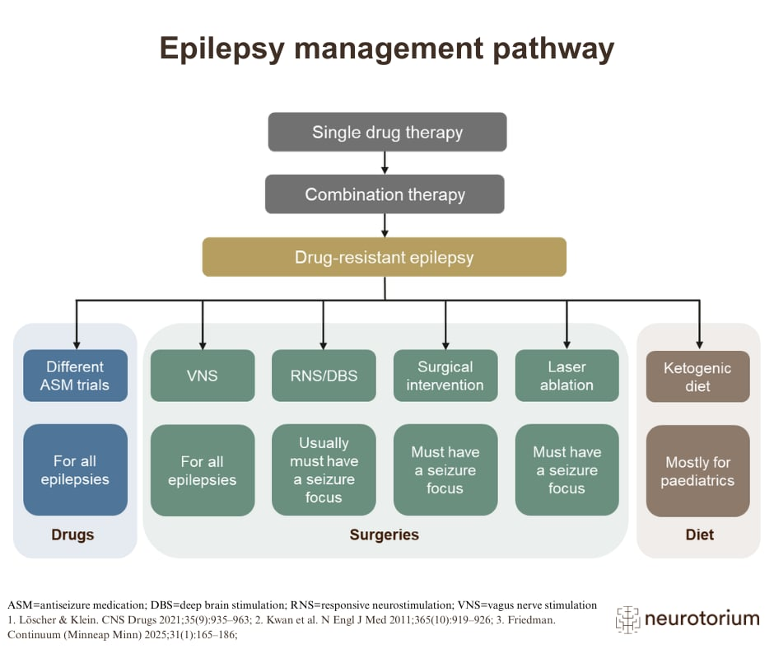
(neurotorium, 2025)

Evidence Based NHS Treatments

The goal of epilepsy treatment is to stop seizures using the smallest effective dose of antiepileptic drugs, begun at a low dose and increased gradually until seizures are controlled or side effects appear, with the drug chosen to suit the person’s seizure type, age, sex, health and circumstances, such as work or pregnancy plans (BNF, 2023). NICE recommends starting medication once a specialist has made the diagnosis after repeated seizures, or after a single seizure if more are likely. Medication controls seizures in up to 70% of people. For those it doesn’t help, options such as epilepsy surgery, vagus nerve stimulation (VNS), a specialist diet or Epicranial Application of Stimulation Electrodes for Epilepsy (EASEE) may be offered alongside medication, usually after several drugs have failed (Epilepsy Society, 2020).

A single drug is tried first, with a slow switch if it doesn’t work and combinations reserved for last, and withdrawal happens one drug at a time, and only after two years without seizures (NICE, 2022). Focal seizures usually start with lamotrigine or levetiracetam, tonic-clonic seizures with those two or valproate, absence seizures with ethosuximide, myoclonic seizures with levetiracetam or valproate, and atonic or tonic seizures with lamotrigine or valproate, while Dravet and Lennox-Gastaut syndromes need specialist care and the wrong drug can make some seizures worse (BNF, 2023). Women planning a pregnancy should continue their medication, seek specialist advice early and take folic acid, and anyone who finds they are pregnant should carry on and see a doctor urgently (Dr Colin Tidy, 2018).

Low mood or suicidal thoughts should be reported, a fever with a rash can signal a serious allergic reaction that means stopping the drug, and some medicines, such as carbamazepine and phenytoin, are best kept to a single brand (BNF, 2023). Cluster seizures, seizures lasting over five minutes and status epilepticus call for urgent benzodiazepine treatment as set out in the person’s emergency plan (CSK, 2025), and failure of two drugs should lead to specialist epilepsy centre referral (NICE, 2022). After a seizure, people must stop driving and notify the Driver and Vehicle Standards Agency (DVLA) and usually need a year without seizures before driving again (Government Digital Service, 2012).

Models for better outcomes

Improved epilepsy outcomes rely on well-organised, long-term care as much as on the right medication. Wagner’s Chronic Care Model (1998) and the House of Care, its UK adaptation (Coulter, Roberts and Dixon, 2013), both promote partnership between knowledgeable, involved patients and proactive, prepared professionals.

The Chronic Care Model
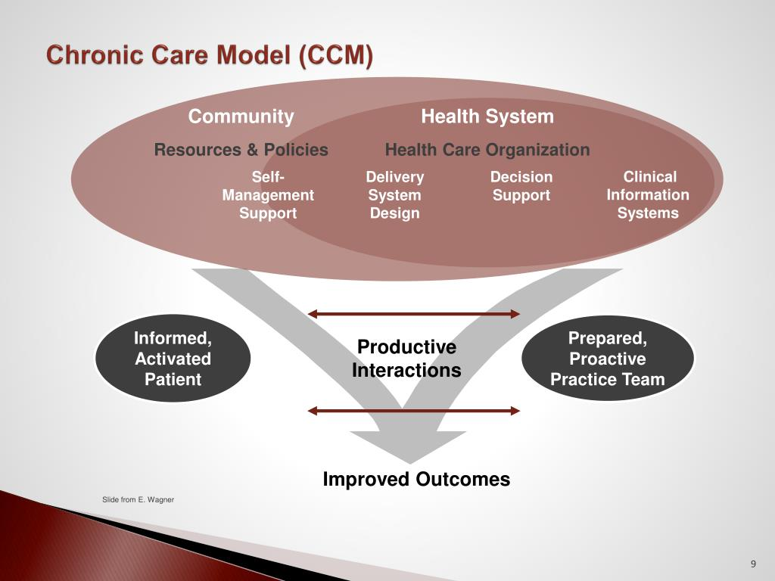
(Bertha, 2014)

Wagner’s Chronic Care Model (1998) strengthens long-term condition care through six elements: self-management support, delivery system design, decision support, clinical information systems, health system organisation and community resources (Melo, 2025). For epilepsy, this translates into education on adherence, sleep and safety, nurse-led clinics with planned annual reviews, NICE NG217 as the guide, epilepsy registers, and links to charities and employment support (CSK, 2025). Primary care professionals contribute throughout: they refer after a first seizure so a specialist can confirm and classify the diagnosis, prescribe antiseizure medication following specialist assessment where required, review people regularly, and equip them and their families or carers with advice on seizure first aid, driving, safety, contraception and pre-pregnancy counselling (NICE, 2022). Because the model covers the whole pathway, matches NICE NG217 and improves self-management and care processes, it suits lifelong condition (Bandura, 1977; Coleman et al., 2019). Its drawbacks are its US primary care origins, a stronger effect on confidence than on seizure control, little attention to stigma and mental health, and a reliance on staffing and resources that neurology and the NHS often lack.

House of Care Model
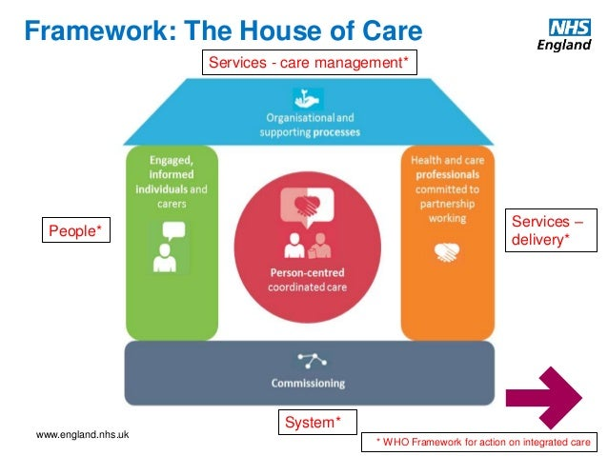
(Quality, 2016)

The House of Care, created for the NHS by Coulter, Roberts and Dixon (2013), reworks this model as a house with collaborative care planning at its centre. Informed, engaged individuals and professionals committed to partnership form the walls, organisational processes such as registers, recall and shared records form the roof, and responsive commissioning forms the foundation. In epilepsy, people complete a seizure diary and mood questionnaire before review, then agree a written yearly plan covering medication, pregnancy, safety, driving, work and emergencies, supported by trained staff, joined-up services and commissioned specialist nurses (NICE, 2022). It suits epilepsy because quality of life rests on mood, side effects and social support, but it has been tested mainly in diabetes, needs funding and consultation time, can turn into a box-ticking exercise, and may disadvantage people with learning disabilities or low health literacy (Dixon and Roberts, 2013).
Overall, the Chronic Care Model sets out what a good epilepsy service should include, while the House of Care shows how to deliver and fund it locally. Both struggle with a gap between design and delivery, so better outcomes depend on sufficient specialist capacity, routine mental health support and genuine involvement of people with epilepsy and their carers.

National and Local Policy Agendas

Policy gives epilepsy services a sound framework, but putting it into practice has been uneven. The NHS Long Term Plan (2019) backs personalised care, integration, prevention and fairer access, yet epilepsy is not a named priority and so attracts little ring-fenced funding or national targets. Integrated care systems (ICSs) could join up epilepsy pathways, but locally the condition competes with higher-profile priorities and often relies on a committed champion. NICE NG217 is advisory rather than mandatory, and the hospital audit and Getting it Right First Time (GIRFT) neurology review reveal wide variation, long waits, patchy access to specialist nurses and weak primary-specialist links, all constrained by workforce shortages (Neuro Advisory group, 2021).
Medicines and Healthcare products Regulatory Agency (MHRA) measures show a good policy response to risk, although compliance and communication with women have been inconsistent (MHRA, 2021). Rights under the Equality Act and Care Act have not become real change, as two-thirds of working-age people are unemployed, carers’ needs often go unassessed, and people in deprived areas face greater risk of epilepsy and of dying from it (Hassiotis and Shankar, 2024). At local level, commissioners could fund specialist nurses, nurse-led clinics, registers, annual reviews and joined-up neurology and mental health pathways, but poor recording and postcode variation remain (NHS England, 2019).
Without a national strategy, strong accountability or clear responsibility, and with pathways prioritised over employment, stigma and carer support, a wide gap persists between policy intent and lived experience (Dallas, 2025; NHS, 2023). Progress would come from a named ICS-led local pathway, more specialist nurses, routine mood screening, better data, stronger transition services, partnerships with employers and schools, routine carer’s assessments and co-production with people with epilepsy and their families (England, 2025; GIRFT, 2022).

Recommendations for Person-Centred Epilepsy Care

Person-centred epilepsy care looks beyond seizure control to what matters to each person, including safety, independence, work, relationships and mood. Each person should have a written plan, reviewed yearly, covering medication, emergencies, SUDEP risk, driving, work, education and mental health, prepared with a seizure diary and mood questionnaire and adapted for learning disabilities or low health literacy. Mood should be checked routinely with quick access to psychological support, and carers offered assessments, respite and peer support (NICE, 2020). This needs more epilepsy specialist nurses, shared records and registers, tertiary referral after two failed drugs and planned transition from children to adult services (NICE, 2022). For self-management, newly diagnosed people should receive structured education on adherence, sleep, triggers, first aid and safety, with peer support, carer training, open SUDEP discussion and an emergency plan for all (NICE, 2022). End-of-life care should start early with advance care planning and a named care coordinator (NICE, 2019), continuing antiseizure medication alongside bereavement support for families, including after SUDEP. Services work best when co-produced with people with epilepsy and carers, with trained staff and a named local lead (Essam, Gp and Chapman, 2019), though workforce shortages, fragmented commissioning and poor data mean proper resourcing is essential.

References

Ahmed, A., Rahman, A.-H., Williams, S., Toufiq, M., Jamileh, E., Chaudhry, S., Ahmed, K. and Ahmed, M. (2024) ‘Seizures and epilepsy: An overview for UK medical students’, Cureus, 16(10). Available at: https://doi.org/10.7759/cureus.70654.
Balestrini, S., Arzimanoglou, A., Blümcke, I., Scheffer, I.E., Wiebe, S., Zelano, J. and Walker, M.C. (2021) ‘The aetiologies of epilepsy’, Epileptic Disorders, 23(1), pp. 1–16. Available at: https://doi.org/10.1684/epd.2021.1255.
Bandura, A. (1977) ‘Self-efficacy: Toward a unifying theory of behavioral change’, Psychological Review, 84(2), pp. 191–215. Available at: https://doi.org/https://doi.org/10.1037/0033-295X.84.2.191.
Bell, G.S., Neligan, A. and Sander, J.W. (2014) ‘An unknown quantity—The worldwide prevalence of epilepsy’, Epilepsia, 55(7), pp. 958–962. Available at: https://doi.org/10.1111/epi.12605.
Bertha (2014) Leading through healthcare transformation - SlideServe, SlideServe. Available at: https://www.slideserve.com/bertha/leading-through-healthcare-transformation (Accessed: 18 October 2026).
Birbeck, P.D.G. (2025) Epilepsy - neurobiology and aetiology - neurotorium, Neurotorium. Available at: https://neurotorium.org/slidedeck/epilepsy-neurobiology-and-aetiology/ (Accessed: 22 October 2026).
Bloomer, A. (2026) Welcome to zscaler directory authentication, Learningdisabilitytoday.co.uk. Available at: https://www.learningdisabilitytoday.co.uk/news/latest-leder-report-shows-small-drop-in-avoidable-deaths-among-people-with-learning-disabilities/ (Accessed: 19 October 2026).
BNF (2023) Epilepsy, NICE. Available at: https://bnf.nice.org.uk/treatment-summaries/epilepsy/ (Accessed: 18 October 2026).
Bodenheimer, T., Wagner, E.H. and Grumbach, K. (2002) 'Improving primary care for patients with chronic illness', JAMA, 288(14), pp. 1775–1779.
Bølling-Ladegaard, E., Dreier, J.W., Kessing, L.V., Budtz-Jørgensen, E., Lolk, K. and Christensen, J. (2022) ‘Directionality of the association between epilepsy and depression: A nationwide, register-based cohort study’, Neurology, 100(9), p. 10.1212/WNL.0000000000201542. Available at: https://doi.org/10.1212/wnl.0000000000201542.
Boylan, L.S., Flint, L.A., Labovitz, D.L., Jackson, S.C., Starner, K. and Devinsky, O. (2004) ‘Depression but not seizure frequency predicts quality of life in treatment-resistant epilepsy’, Neurology, 62(2), pp. 258–61. Available at: https://doi.org/10.1212/01.wnl.0000103282.62353.85.
Broicher, S. and Hennric Jokeit (2011) ‘On clinical diagnostics of social cognition in patients with Epilepsies’, Epileptologie [Preprint]. Available at: https://www.epi.ch/wp-content/uploads/epileptologie/Artikel-Broicher_4_11.pdf (Accessed: 18 October 2026).
Caplan, R. and Austin, J.K. (2000) ‘Behavioral aspects of epilepsy in children with mental retardation’, Mental Retardation and Developmental Disabilities Research Reviews, 6(4), pp. 293–299. Available at: https://doi.org/10.1002/1098-2779(2000)6:4.
Care Act 2014, c. 23. Available at: https://www.legislation.gov.uk/ukpga/2014/23 (Accessed: 10 October 2026).
CKS is only available in the UK (2025) NICE. Available at: https://cks.nice.org.uk/topics/epilepsy/background-information/risk-factors/ (Accessed: 17 October 2026).
Coleman, K., Austin, B.T., Brach, C. and Wagner, E.H. (2019) ‘Evidence on the chronic care model in the new millennium’, Health Affairs, 28(1), pp. 75–85. Available at: https://doi.org/10.1377/hlthaff.28.1.75.
Dallas, R. (2025) Epilepsy facts and figures | Epilepsy Research Institute, Epilepsy-institute.org.uk. Available at: https://epilepsy-institute.org.uk/hub/resources/epilepsy-facts-figures/ (Accessed: 17 October 2026).
Department for Education (2015) Supporting pupils at school with medical conditions: statutory guidance for governing bodies of maintained schools and proprietors of academies in England. London: Department for Education.
Department of Health and Social Care (2025) Fit for the future: 10 Year Health Plan for England. London: Department of Health and Social Care. Available at: https://www.gov.uk/government/publications/10-year-health-plan-for-england-fit-for-the-future (Accessed: 10 October 2026).
Devinsky, O., Vezzani, A., O’Brien, T.J., Jette, N., Scheffer, I.E., de Curtis, M. and Perucca, P. (2018) ‘Epilepsy’, Nature Reviews Disease Primers, 4(1). Available at: https://doi.org/10.1038/nrdp.2018.24.
Dixon, A. and Roberts, S. (2013) Delivering better services for people with long-term conditions, The King’s Fund. Available at: https://www.kingsfund.org.uk/insight-and-analysis/reports/better-services-people-long-term-conditions (Accessed: 19 October 2026).
Dixon, P.A., Kirkham, J.J., Marson, A.G. and Pearson, M.G. (2015) ‘National Audit of Seizure Management in hospitals (NASH): Results of the national audit of adult epilepsy in the UK’, BMJ Open, 5(3), p. e007325. Available at: https://doi.org/10.1136/bmjopen-2014-007325.
Dr Colin Tidy (2018) Treatments for epilepsy, Patient.info. Available at: https://patient.info/brain-nerves/epilepsy-and-seizures/treatments-for-epilepsy (Accessed: 22 October 2026).
England, N. (2024) Response to regulation 28 report to prevent future deaths – Chloe Ann Tapp. London: NHS England. Available at: https://www.judiciary.uk/wp-content/uploads/2024/03/2024-0111-Response-from-NHS-England.pdf (Accessed: 20 October 2026).
England, N. (2025) NHS England » epilepsy, England.nhs.uk. Available at: https://www.england.nhs.uk/get-involved/cyp/epilepsy/ (Accessed: 19 October 2026).
Epilepsy Action (2019) What is epilepsy?, Epilepsy.org.uk. Available at: https://www.epilepsy.org.uk/info/what-is-epilepsy (Accessed: 18 October 2026).
Epilepsy Action (2023) Epilepsy facts and terminology, Epilepsy Action. Available at: https://www.epilepsy.org.uk/press/epilepsy-facts-and-terminology (Accessed: 17 October 2026).
Epilepsy Action (2026) Epilepsy facts and terminology. Available at: https://www.epilepsy.org.uk/press/epilepsy-facts-and-terminology (Accessed: 10 October 2026).
Epilepsy management pathway - neurotorium (2025) Neurotorium. Available at: https://neurotorium.org/image/epilepsy-management-pathway/ (Accessed: 21 October 2026).
Epilepsy Society (2020) Epilepsy treatment | Epilepsy Society, Epilepsysociety.org.uk. Available at: https://epilepsysociety.org.uk/understanding-epilepsy/treatment (Accessed: 22 October 2026).
Epilepsy Society (2022) Mental health | epilepsy society, epilepsysociety.org.uk. Available at: https://epilepsysociety.org.uk/living-epilepsy/mental-health-epilepsy (Accessed: 22 October 2026).
Equality Act 2010, c. 15. Available at: https://www.legislation.gov.uk/ukpga/2010/15 (Accessed: 10 October 2026).
Essam, M., Gp and Chapman, S. (2019) Implementing the comprehensive model of personalised care. Available at: https://napc.co.uk/wp-content/uploads/2019/10/NAPC19-Implementing-the-comprehensive-model-of-personalised-care.pdf (Accessed: 20 October 2026).
Fisher, R.S. et al. (2014) 'ILAE official report: a practical clinical definition of epilepsy', Epilepsia, 55(4), pp. 475–482.
Fisher, R.S. et al. (2017) 'Instruction manual for the ILAE 2017 operational classification of seizure types', Epilepsia, 58(4), pp. 531–542.
Gavvala, J.R. and Schuele, S.U. (2016) ‘New-onset seizure in adults and adolescents’, JAMA, 316(24), p. 2657. Available at: https://doi.org/10.1001/jama.2016.18625.
Government Digital Service (2012) Epilepsy and driving, GOV.UK. Available at: https://www.gov.uk/epilepsy-and-driving (Accessed: 21 October 2026).
Government Digital Service (2012) Epilepsy and driving, GOV.UK. Available at: https://www.gov.uk/epilepsy-and-driving (Accessed: 21 October 2026).
Guerrant, J., Anderson, W.W., Fischer, A., Weinstein, M.R., Jaros, R.M. and Deskins, A. (no date) ‘Psychological observations.’, Personality in epilepsy. Charles C Thomas Publisher, pp. 66–92. Available at: https://psycnet.apa.org/record/2013-29679-005 (Accessed: 18 October 2026).
Hammond, S. (2026) How does epilepsy affect your daily life?, Biology Insights. Available at: https://biologyinsights.com/how-does-epilepsy-affect-your-daily-life/ (Accessed: 22 October 2026).
Hassiotis, A. and Shankar, R. (2024) ‘Inequalities in epilepsy in the UK: Action is needed now’, The Lancet Public Health, 9(8), pp. e536-e537. Available at: https://doi.org/10.1016/s2468-2667(24)00164-6.
Health and Care Act (2022) Health and care act 2022, Legislation.gov.uk. Available at: https://www.legislation.gov.uk/ukpga/2022/31/contents (Accessed: 19 October 2026).
Health and Care Act 2022, c. 31. Available at: https://www.legislation.gov.uk/ukpga/2022/31 (Accessed: 10 October 2026).
House of Commons (2026) Sudden Unexpected Death in Epilepsy. Hansard, 22 April. Available at: https://hansard.parliament.uk/commons/2026-04-22/debates/A1A0076A-0BB5-4620-8C39-C05A39C98EEF/SuddenUnexpectedDeathInEpilepsy (Accessed: 10 October 2026).
Joint strategic needs assessment: A springboard for action (2026) Local.gov.uk. Local Government Association. Available at: https://www.local.gov.uk/publications/joint-strategic-needs-assessment-springboard-action (Accessed: 20 October 2026).
Karakis, I., Boualam, N., Moura, L.M. and Howard, D.H. (2023) ‘Quality of life and functional limitations in persons with epilepsy’, Epilepsy Research, 190, p. 107084. Available at: https://doi.org/10.1016/j.eplepsyres.2023.107084.
Karakis, I., Boualam, N., Moura, L.M. and Howard, D.H. (2023) ‘Quality of life and functional limitations in persons with epilepsy’, Epilepsy Research, 190, p. 107084. Available at: https://doi.org/10.1016/j.eplepsyres.2023.107084.
Keezer, M.R., Sisodiya, S.M. and Sander, J.W. (2016) 'Comorbidities of epilepsy: current concepts and future perspectives', The Lancet Neurology, 15(1), pp. 106–115.
Kerr, M., Linehan, C., Thompson, R., Mula, M., Gil‐Nagal, A., Zuberi, S.M. and Glynn, M. (2014) ‘A white paper on the medical and social needs of people with epilepsy and intellectual disability: The task force on intellectual disabilities and epilepsy of the international league against epilepsy’, Epilepsia, 55(12), pp. 1902–1906. Available at: https://doi.org/10.1111/epi.12848.
Kountcheva, K. (2023) High rate of economic inactivity in epilepsy - epilepsy action, Epilepsy Action. Available at: https://www.epilepsy.org.uk/news/high-rate-of-economic-inactivity-in-epilepsy (Accessed: 21 October 2026).
Krishnamurthy, K.B. (2016) ‘Epilepsy’, Annals of Internal Medicine, 164(3), pp. ITC17-ITC32. Available at: https://doi.org/10.7326/aitc201602020.
Lin, J.J., Mula, M. and Hermann, B.P. (2012) ‘Uncovering the neurobehavioural comorbidities of epilepsy over the lifespan’, The Lancet, 380(9848), pp. 1180–1192. Available at: https://doi.org/10.1016/s0140-6736(12)61455-x.
Melo, D. (2025) (1998) Chronic disease management what will it take to improve care for chronic illness, Scribd. Available at: https://www.scribd.com/document/532192955/1998-Chronic-Disease-Management-What-Will-it-Take-to-Improve-Care-for-Chronic-Illness (Accessed: 22 October 2026).
MHRA (2021) Antiepileptic drugs in pregnancy: Updated advice following comprehensive safety review, GOV.UK. Available at: https://www.gov.uk/drug-safety-update/antiepileptic-drugs-in-pregnancy-updated-advice-following-comprehensive-safety-review (Accessed: 19 October 2026).
Mula, M. and Sander, J.W. (2015) ‘Suicide and epilepsy: Do antiepileptic drugs increase the risk?’, Expert Opinion on Drug Safety, 14(4), pp. 553–558. Available at: https://doi.org/10.1517/14740338.2015.1010506.
Mula, M. and Sander, J.W. (2016) ‘Psychosocial aspects of epilepsy: A wider approach’, BJPsych Open, 2(4), pp. 270–274. Available at: https://doi.org/10.1192/bjpo.bp.115.002345.
National Institute for Health and Care Excellence (2019) End of life care for adults: service delivery (NICE guideline NG142). Available at: https://www.nice.org.uk/guidance/ng142 (Accessed: 10 October 2026).
National Institute for Health and Care Excellence (2022) Epilepsies in children, young people and adults (NICE guideline NG217). Available at: https://www.nice.org.uk/guidance/ng217 (Accessed: 10 October 2026).
Neuro Advisory group (2021) Neurology - getting it right first time - GIRFT report published, National Neurosciences Advisory Group. Available at: https://www.nnag.org.uk/news/neurology (Accessed: 19 October 2026).
Neurology - getting it right first time - GIRFT (2022). Available at: https://gettingitrightfirsttime.co.uk/medical_specialties/neurology/ (Accessed: 19 October 2026).
NHS (2023) NHS England » National bundle of care for children and young people with epilepsy, www.england.nhs.uk. Available at: https://www.england.nhs.uk/long-read/national-bundle-of-care-for-children-and-young-people-with-epilepsy/ (Accessed: 20 October 2026).
NHS England (2019) Universal personalised care: Implementing the comprehensive model, England.nhs.uk. Available at: https://www.england.nhs.uk/publication/universal-personalised-care-implementing-the-comprehensive-model/ (Accessed: 19 October 2026).
NHS England (2019a) NHS Long Term Plan. Available at: https://www.longtermplan.nhs.uk (Accessed: 10 October 2026).
NHS England (2019b) Universal personalised care: implementing the comprehensive model. Available at: https://www.england.nhs.uk/personalisedcare/ (Accessed: 10 October 2026).
NHS England (2020) RightCare: Epilepsy toolkit optimising a system for people living with epilepsy. Available at: https://www.england.nhs.uk/rightcare/wp-content/uploads/sites/40/2020/03/rightcare-epilepsy-toolkit-v2.pdf (Accessed: 21 October 2026).
NHS England (2021) Comprehensive model of personalised care, NHS England. Available at: https://www.england.nhs.uk/personalisedcare/comprehensive-model-of-personalised-care/ (Accessed: 19 October 2026).
NHS England (n.d.) National bundle of care for children and young people with epilepsy. Available at: https://www.england.nhs.uk/long-read/national-bundle-of-care-for-children-and-young-people-with-epilepsy/ (Accessed: 10 October 2026).
NHS England Digital (2012) NHS England Digital. Available at: https://digital.nhs.uk/data-and-information/publications/statistical/hospital-admitted-patient-care-activity/hes-on-epilepsy (Accessed: 17 October 2026).
NHS, Q. (2016) Quality and outcomes framework (QOF) - 2015-16, NHS Digital. Available at: https://digital.nhs.uk/data-and-information/publications/statistical/quality-and-outcomes-framework-achievement-prevalence-and-exceptions-data/quality-and-outcomes-framework-qof-2015-16 (Accessed: 18 October 2026).
NICE (2022) Overview | epilepsies in children, young people and adults | guidance | NICE, www.nice.org.uk. Available at: https://www.nice.org.uk/guidance/ng217 (Accessed: 17 October 2026).
NICE (2025) CKS is only available in the UK, NICE. Available at: https://cks.nice.org.uk/topics/epilepsy/ (Accessed: 21 October 2026).
Okunneye, A. (2025) Psychosocial challenges faced by individuals with epilepsy - Klarity Health Library, Klarity Health Library. Available at: https://my.klarity.health/psychosocial-challenges-faced-by-individuals-with-epilepsy/ (Accessed: 22 October 2026).
Org, S. (2024) Optimal clinical care pathway for adults: Epilepsy National Neurosciences Advisory Group (nnag) sudep action. Available at: https://static1.squarespace.com/static/5f1021faf6248b39f4c64f5d/t/65b93b444f7ec97848080ab9/1706638165509/12+NNAG+Epilepsy+pathway+v8.pdf (Accessed: 18 October 2026).
Pelham, C. (2025) What is epilepsy? | Epilepsy Society, Epilepsysociety.org.uk. Available at: https://epilepsysociety.org.uk/understanding-epilepsy/what-is-epilepsy (Accessed: 18 October 2026).
Prokerala (2021) 3-Yr-old treated of a rare paediatric epilepsy in Gurugram, prokerala. Prokerala. Available at: https://www.prokerala.com/news/photos/3-yr-old-treated-of-a-rare-paediatric-epilepsy-in-gurugram-3066989.html (Accessed: 18 October 2026).
Rare and complex epilepsies - find our more on epilepsies (no date) EpiCARE. Available at: https://epi-care.eu/about-epilepsies/ (Accessed: 17 October 2026).
Rob (2026) Commons debate highlights need to tackle failures in risk care, SUDEP Action. Available at: https://sudep.org/commons-debate-highlights-need-to-tackle-failures-in-risk-care/ (Accessed: 19 October 2026).
Romigi, A., Costa, C., Sen, A. and Giorgi, F.S. (2022) ‘Editorial: Epilepsy in older adults: From physiopathology to improvements in diagnosis and management’, Frontiers in Neurology, 13. Available at: https://doi.org/10.3389/fneur.2022.1063299.
Salema, L. (2018) Deaths associated with neurological conditions. Available at: https://assets.publishing.service.gov.uk/media/5a941945e5274a5b87c2fe47/Deaths_associated_with_neurological_conditions_data_analysis_report.pdf (Accessed: 18 October 2026).
Scheffer, I.E. et al. (2017) 'ILAE classification of the epilepsies: position paper of the ILAE Commission for Classification and Terminology', Epilepsia, 58(4), pp. 512–521.
Schmitz, B. (2006) ‘Effects of Antiepileptic Drugs on Mood and Behavior’, Epilepsia, 47(s2), pp. 28–33. Available at: https://doi.org/10.1111/j.1528-1167.2006.00684.x.
Seizures | right decisions (2018) Scot.nhs.uk. Available at: https://www.rightdecisions.scot.nhs.uk/shared-content/palliative-care/palliative-care/seizures/ (Accessed: 20 October 2026).
Sen, A., Newton, C.R. and Gift Ngwende (2025) ‘Epilepsy in low- to middle-income countries’, Current Opinion in Neurology [Preprint]. Available at: https://doi.org/10.1097/wco.0000000000001350.
SIGN (2015) SIGN 143 • diagnosis and management of epilepsy in adults a national clinical guideline evidence. Available at: https://www.sign.ac.uk/media/1079/sign143_2018.pdf (Accessed: 17 October 2026).
Slater, M. (2026) ‘4,000 Years in the making: Epilepsy history as modern medicine’, Journal of Child Neurology, 41(4), pp. 459–462. Available at: https://doi.org/10.1177/08830738261415698.
Sudden unexpected death in epilepsy (SUDEP) - hansard - UK parliament (2026) Parliament.uk. Available at: https://hansard.parliament.uk/commons/2026-04-22/debates/A1A0076A-0BB5-4620-8C39-C05A39C98EEF/SuddenUnexpectedDeathInEpilepsy (Accessed: 19 October 2026).
The King's Fund (2025) Truly fit for the future? The 10 Year Health Plan explained. Available at: https://www.kingsfund.org.uk/insight-and-analysis/long-reads/ten-year-health-plan-explained (Accessed: 10 October 2026).
Thijs, R. D, Surges, R., O’Brien, T.J. and Sander, J.W. (2019) ‘Epilepsy in adults’, The Lancet, 393(10172), pp. 689–701. Available at: https://doi.org/10.1016/s0140-6736(18)32596-0.
Thijs, R.D., Surges, R., O'Brien, T.J. and Sander, J.W. (2019) 'Epilepsy in adults', The Lancet, 393(10172), pp. 689–701.
van Vliet, E.A. and Marchi, N. (2022) ‘Epilepsia: Vol 63, no 6’, Wiley Online Library [Preprint]. Available at: https://doi.org/10.1111/epi.v63.6.
Wagner, E.H. (1998) 'Chronic disease management: what will it take to improve care for chronic illness?', Effective Clinical Practice, 1(1), pp. 2–4.
WHO (2024) Epilepsy, World Health Organization. Available at: https://www.who.int/news-room/fact-sheets/detail/epilepsy (Accessed: 17 October 2026).
Wigglesworth, S., Neligan, A., Dickson, J., Pullen, A., Yelland, E., Anjuman, T. and Reuber, M. (2023) ‘The incidence and prevalence of epilepsy in the United Kingdom 2013-2018: A retrospective cohort study of UK Primary Care Data.’, Seizure, 105(37–42). Available at: https://doi.org/10.1016/j.seizure.2023.01.003.
World Health Organization (2024) Epilepsy. Available at: https://www.who.int/news-room/fact-sheets/detail/epilepsy (Accessed: 10 October 2026).
Zeman, A., Kapur, N. and Jones-Gotman, M. (2012) Epilepsy and Memory. Oxford University Press. Available at: https://books.google.com/books?id=cwJREAAAQBAJ (Accessed: 18 October 2026).

