
Program Name: MBA International Business
Student Name: Sahil Thakarshibhai Lakhani
Student id: 2433103
Topic:
A Post-Pandemic Consumer Adoption of Online Shopping in the Retail sector: A Comparative Case Study of Amazon India and Amazon UK
Supervisor Name : Dr Charles Oham

AI uses Acknowledgement
I confirm that I did not use of any artificial intelligence (AI) instruments to prepare or write this research work. The information, analysis, and written work were created solely by me with reliance on the academic sources and my own knowledge to avoid duplication and false authorship and comply with the academic integrity requirements.
Table of Contents
1. Introduction 6
1.1 Background and Relevance of the Research Topic 6
1.2 Problem Statement 6
1.3 Research Aim, Objectives, and Questions 7
1.4 Research Significance 8
2. Literature review 9
2.1 Post-pandemic consumer online shopping behaviour in the retail sector 9
2.2 Key factors influencing consumer adoption in the online retail industry in the UK and India 9
2.3 Differences in consumer behaviour within the online retail industry between the UK and India 9
2.4 Recommendations for Increasing Online Shopping Adoption in UK and India 10
2.6 Theoretical Framework 10
2.7 Conceptual Framework 11
2.8 Literature Gap 12
3. Methodology 13
3.1 Research Philosophy 13
3.2 Research Approach 13
3.3 Research Design 13
3.4 Research Strategy 13
3.5 Data Collection Method 13
3.6 Inclusion and Exclusion Criteria 14
3.7 Data Analysis Method 14
3.8 Ethical Consideration 14
4. Expected findings 16
4.1 Post-Pandemic Online Shopping Behaviour 16
4.2 Factors Influencing Consumer Adoption 16
4.3 Differences Between Amazon UK and Amazon India 16
5. Limitations 17
5.1 Limited Use of Secondary Data 17
5.2 Limited Time Scope of Literature 17
5.3 Availability of Specific Market Data 17
6. Timeframe 18
6.1 Timeline 18
(Source: Self-Created) 19
7. Conclusion 20
7.1 Conclusion 20
7.2 Anticipated Outcomes 20
8. References 21

List of Figures
Figure 1: Global Retail E-Commerce Market Size 5
Figure 2: Technology Acceptance Model 9
Figure 3: Theory of Planned Behaviour (TPB) 10
Figure 4: Conceptual Framework 10

List of Tables
Table 1: Inclusion and Exclusion Criteria 14
Table 2: Gantt Chart 18

1. Introduction

1.1 Background and Relevance of the Research Topic
Online shopping involves the acquisition of products or services by consumers via digital platform and websites or mobile applications. The online shopping offers value with convenience, increased selection of products, competitive prices and time-saving shopping experiences. The development of online shopping in the global retail industry has increased rapidly, especially after the COVID-19 pandemic (Sayyida et al., 2021). The big online retailers like Amazon have increased their services, logistics, and delivery speed to satisfy the growing online demand. In 2024, Amazon declared an annual income of $638 billion globally, an indication of further increase in online customers and digital retailing (Amazon Annual Report, 2024).
It is essential to understand the post-pandemic online shopping behaviour in the retail industry. There are variations in the consumer adoption patterns of both developed and emerging markets, such as in the UK and India.

1.2 Problem Statement
Despite a fast growth in e-commerce, there are still concerns regarding the reasons why a large number of consumers still shop online after the pandemic.
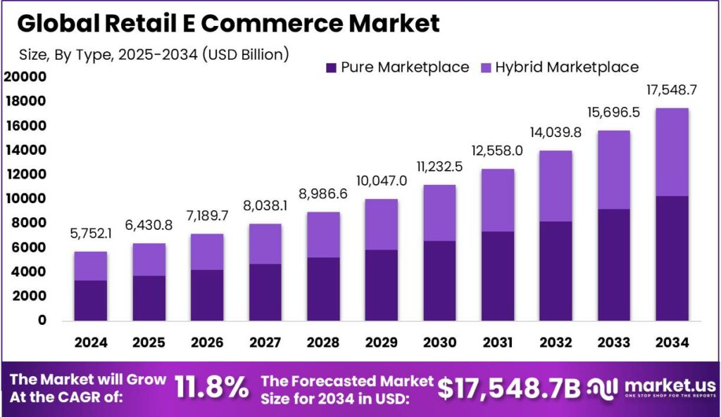
Figure 1: “Global Retail E-Commerce Market Size”
(Source: Market.us, 2025)
Global online retail is expected to make up about 21 % of all retail purchases in 2025, which is quite high even after the pandemic lockdowns (Market.us, 2025). However, limited research examines how consumer behaviour towards online shopping has changed following the pandemic, especially in various international markets. The comparative analysis of Amazon UK and Amazon India will be useful to determine the main aspects of convenience, speed of delivery, use of technology, and consumer trust that lead to further adoption of online retail platforms.

1.3 Research Aim, Objectives, and Questions
1.3.1 Aim
This research aims to examine post-pandemic consumer adoption of online shopping by comparing influencing factors in Amazon UK and Amazon India retail markets.
1.3.2 Objectives
- To assess the way consumer adoption of online shopping increased in India and the UK after COVID-19
- To conduct a comparative analysis of consumer adoption of online shopping between Amazon UK and Amazon India post-pandemic
- To examine challenges faced by consumers post-pandemic while shopping online from Amazon UK and Amazon India
- To provide recommendations to retailers like Amazon to influence customers towards online shopping in India and the UK
1.3.3 Questions
- How did consumer online shopping adoption change in UK and India post-COVID?
- What differences exist in consumer adoption between Amazon UK and Amazon India?
- What challenges do consumers face when shopping online on Amazon platforms?
- What strategies can retailers use to increase online shopping adoption?
1.3.4 Hypothesis
- H1: Consumer adoption of online shopping accelerated in Amazon India in comparison to Amazon UK post-pandemic
- H2: Consumers display more stable online shopping patterns post-pandemic towards Amazon India than Amazon UK

1.4 Research Significance
The study will shed some light on the post-pandemic behaviour and adoption of online shopping in the retail sector. It will contribute to the perception of dissimilarities between Amazon UK and Amazon India, and business owners should learn how to enhance digital retail.

2. Literature review

2.1 Post-pandemic consumer online shopping behaviour in the retail sector
The trends of consumer behaviour in the retail sector in the post-pandemic period are mixed in terms of online and physical shopping outlets. Diaz-Gutierrez et al. (2024), using a quasi-longitudinal survey and Structural Equation Modelling, revealed that a quarter of consumers amplified online shopping and more than three-quarters were planning on using online shopping after the pandemic. However, in their qualitative interview of 50 retail stores, Kadam and Bhatt (2021) found that most Indian consumers used local stores because they were more convenient and reliable.

2.2 Key factors influencing consumer adoption in the online retail industry in the UK and India
Key factors influencing consumer adoption in the online retail industry differ between developed and emerging markets. Schulze (2021) reported a quantitative survey of 152 UK consumers that identified that approximately 71% of consumers increased the rate of online shopping primarily because of convenience and ease of access on the internet. However, based on the PLS-SEM analysis of 327 respondents, Kaur et al. (2023) state that performance expectancy, price value, and habit and hedonic motivation are the factors to determine adoption, which explains 70.7% of the behavioural variations.

2.3 Differences in consumer behaviour within the online retail industry between the UK and India
Consumer behaviour in the online retail market is different in the post-pandemic market. In their survey-based behavioural analysis, Khanna et al. (2023) studied the situation in India and noted that after COVID-19, a significant percentage of consumers started moving towards online shopping because of convenience and safety issues. However, in the study by Rahmanov et al. (2021), which is analytical research with a survey of 417 individuals and a Google trend analysis, the authors believe that consumers grew more price-sensitive and particular, and concentrated on product value and brand loyalty in the UK.

2.4 Recommendations for Increasing Online Shopping Adoption in UK and India
Consumer adoption in post-COVID-19 markets is at variance with the market, depending on digital retail strategies. Nanda et al. (2021) claim a mixed-method study with strategy event data and interviews of UK retail managers suggests that digitalisation and multi-channel retail strategies led to online shopping adoption and transformed the retail structure of high streets. However, Khaled et al. (2021) conducted a survey of 700 consumers in the city of Delhi-NCR and found variables like product variety, digital payment, and free home delivery to have a behavioural effect, and SOP regulations did not have a significant effect in India.

2.6 Theoretical Framework
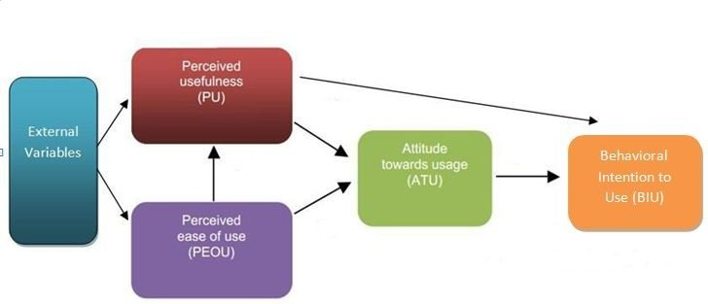
Figure 2: “Technology Acceptance Model”
(Source: Nikou et al., 2014)
The research will be grounded on the “Technology Acceptance Model (TAM)” to examine the factors that may affect the adoption of online shopping by consumers after the pandemic. According to Hossain et al. (2023), the model will be useful in explaining how the perceived usefulness and perceived ease of use influence the willingness of consumers to keep buying via Amazon platforms. It will also aid in the comprehension of how convenience, a digital presence, and a better platform experience will promote the use of online retail services by customers in the UK and India markets (Schorr, 2023).
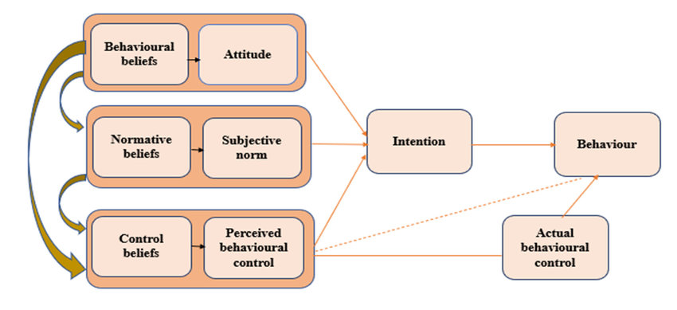
Figure 3: “Theory of Planned Behaviour (TPB)”
(Source: Omotayo et al., 2020)
The other theory that will be relevant will be the “Theory of Planned Behaviour (TPB)”. The target population will use this theory to examine how the attitudes of consumers, subjective norms, and perceived behavioural control will determine the intentions of customers to adopt and use online shopping platforms in the UK and India (Haris et al., 2021).

2.7 Conceptual Framework
Conceptual Framework for Post-Pandemic Online Shopping Adoption

Technology Acceptance Model (TAM)
• Perceived Usefulness
• Perceived Ease of Use

Consumer Online Shopping Behaviour
• Convenience Perception
• Trust in Platform
• Delivery Experience
Consumer Adoption of Online Shopping
• Adoption Frequency
• Purchase Intention
• Continued Platform Usage

Theory of Planned Behaviour (TPB)
• Attitude
• Subjective Norms
• Perceived Behavioural Control

Figure 4: Conceptual Framework
(Source: Self-Created)

2.8 Literature Gap
The existing literature mainly deals with online shopping behaviour after the pandemic or digital retail transformation in general, without giving a comparative analysis of different national retail markets. As an illustration, the study by Diaz-Gutierrez et al. (2024) and Rahmanov et al. (2021) analyses behavioural changes towards digital consumption, whereas Nanda et al. (2021) concentrate on the approach to digitalisation in retail. However, there is scant literature in making comparisons of consumer adoption drivers between developed and emerging retail markets, especially between the UK and India, and that leaves a gap that the research seeks to fill.

3. Methodology

3.1 Research Philosophy
The research philosophy the proposed study will consider is interpretivism research to gain knowledge about consumer behaviour and perceptions on online shopping following the COVID-19 pandemic. The interpretivism research philosophy will enable the researcher to interpret the available knowledge and findings of previous research pertaining to Amazon UK and Amazon India. The philosophy will aid in clarifying the effect of attitude, trust, and technological perceptions of consumers in online shopping adoption (Ali et al., 2021).

3.2 Research Approach
This study will effectively use the inductive research approach to investigate the trends in the literature of post-pandemic online shopping behaviour. The research approach will enable the themes to come out of the analysed literature and reports (Kumar and Ujire, 2024). It will contribute to the explanation of consumer adoption variations between Amazon UK and Amazon India and allow addressing the research questions successfully.

3.3 Research Design
The respective study will be adhered to secondary research design for the matter of explain the data available in the body of literature on consumer online shopping behaviour. The design will be aimed at perceptual understanding, motivation, and behavioural factors that can drive online shopping adoption (Anand et al., 2023).

3.4 Research Strategy
In this research, the secondary research strategy will be used, in which published academic literature, industry reports, and statistical data will be analysed. These sources will provide support on the trends of online shopping after the pandemic (Jensen et al., 2022).

3.5 Data Collection Method
The research will use a secondary data collection method to study online shopping adoption among the retail sector consumers after the pandemic. The sources of secondary data will consist of 24 peer-reviewed academic articles published in the years between 2021 and 2025 and databases such as Google Scholar, ProQuest, ScienceDirect, and Wiley Online Library. Also, the analysis of industry reports and statistical data provided by sources such as Statista, the World Bank, and the Amazon Annual Report 2024 will be conducted. This method will facilitate the research purpose and address the research questions well.

3.6 Inclusion and Exclusion Criteria
Inclusion Criteria | Exclusion Criteria
Peer-reviewed articles on online shopping adoption. | Articles not related to online retail behaviour.
Studies published between 2021 and 2025. | Studies published before 2021.
Research focused on the UK and India retail markets. | Studies focused on unrelated countries or sectors.
Academic sources from recognised databases. | Blogs, non-academic websites, or unreliable sources.
Industry reports and credible statistical databases. | Unverified data or non-credible reports.
Table 1: Inclusion and Exclusion Criteria
(Source: Self-Created)

3.7 Data Analysis Method
In this study, the thematic data analysis method will be used to analyze the collected secondary data. The analysis method will entail the identification, review, and interpretation of major themes associated with the post-pandemic online shopping behaviour (Hoang et al., 2023). Consumer trust, convenience, use of technology, and the experience of delivery are some of the themes that will be researched. This analysis will facilitate the sorting of the results of academic articles and industry reports, which will allow one to compare consumer adoption patterns in Amazon UK and Amazon India and justify the research objectives and questions.

3.8 Ethical Consideration
This study will follow ethical research principles while using secondary data sources. All data will be gathered through reliable scholarly databases and reports that are publicly available. It will be adequately cited and referenced to prevent any instances of plagiarism or lack of academic integrity. The study will not engage human subjects, and hence, no problem of consent or personal information will be present. Information will be utilized academically, and the information will be published in an honest and transparent manner.

4. Expected findings

4.1 Post-Pandemic Online Shopping Behaviour
The purpose of this study is to determine the observable modifications in the consumer online shopping behaviour following the COVID-19 pandemic. The study will entail a comparative analysis of UK and Indian customers of Amazon in order to determine how the trend of online shopping has been changing in these two markets. The consumers who continued with online shopping after the restrictions were lifted in the pandemic period are assumed to persist in the behaviour (Adibfar et al., 2022).

4.2 Factors Influencing Consumer Adoption
It is anticipated that the research will establish a number of main factors involved in the adoption of online shopping platforms like Amazon by the consumer. Such aspects will probably consist of perceived usefulness, ease of use, trust in the platform, and delivery efficiency. The research will use a comparative approach of analysing the influence of technological acceptance and consumer perceptions on the adoption of online shopping by conducting a comparative analysis of UK and Indian Amazon users. According to the Theory of Planned Behaviour and Technology Acceptance Model, the intention to continue online shopping is likely to be promoted by a positive attitude of the consumer and straightforward use of the platform.

5. Limitations

5.1 Limited Use of Secondary Data
The proposed research will be based exclusively on secondary data gathered through the existing academic articles, industry reports, and statistical databases. The study, therefore, will not involve any primary data to be collected directly among consumers. This could restrict the capacity to record real-time consumer attitudes, experience, and behaviour change regarding the adoption of online shopping after the pandemic.

5.2 Limited Time Scope of Literature
Published sources covering 2021 through 2025 will primarily be of interest to the study, so that recent post-pandemic consumer behaviour can be analysed. Although this will assist in making the research important, it will restrict the inclusion of previous research that may give a wider historical view of the online shopping trends before the pandemic.

5.3 Availability of Specific Market Data
The other limitation can be the availability of specific data that compares Amazon UK and Amazon India. Some reports on the industry may include the data on the e-commerce market in general, and not just on Amazon. This can limit the level of comparison between the two markets.

6. Timeframe

6.1 Timeline
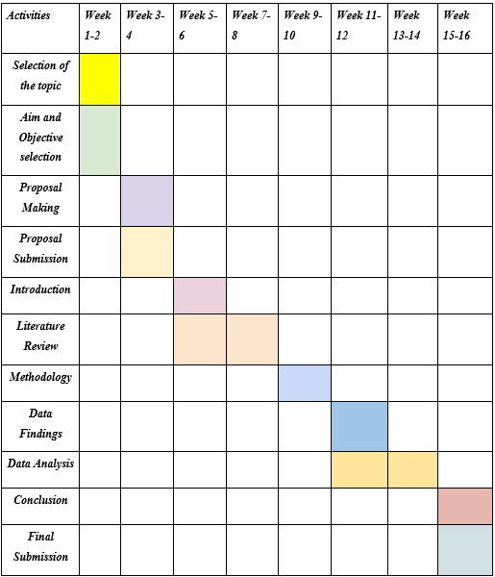
Table 2: “Gantt Chart”

(Source: Self-Created)

7. Conclusion

7.1 Conclusion
The research proposal studied the acceptance of online shopping by consumers in the retail sector after the pandemic through a comparison of Amazon UK and Amazon India. It looks at the progression of consumer behaviour after the COVID-19 pandemic and the determinants that have an important impact on the utilization of online shopping. The analysis will be based on available academic sources, industry reports, and statistical data to determine the adoption trends, consumer behaviour comparisons between developed and emerging markets, and obstacles affecting the online consumers. The theoretical basis of the study is the Technology Acceptance Model (TAM) and the Theory of Planned Behaviour (TPB), which offers a model to comprehend consumer adoption behaviour. The results are relevant to the existing knowledge of the post-pandemic digital retail life and provide suggestions to help retailers to increase digitalization and customer experience in various market conditions.

7.2 Anticipated Outcomes
The research will bring knowledge about variables affecting the adoption of online shopping after the pandemic in the UK and India. The results will guide retailers like Amazon to develop improved digital strategies, boost consumer confidence, and propel further development of online stores.

8. References
Adibfar, A., Gulhare, S., Srinivasan, S. and Costin, A. (2022) Analysis and modeling of changes in online shopping behavior due to Covid-19 pandemic: A Florida case study. Transport Policy, 126, pp.162-176. https://pmc.ncbi.nlm.nih.gov/articles/PMC9414037/pdf/main.pdf
Ali, M., Shah, A.A. and Shah, S.A.A. (2021) Positivism and interpretivism. Qlantic Journal of Social Sciences, 2(1), pp.20-26. https://qjss.com.pk/index.php/qjss/article/download/19/17
Amazon Annual Report. (2024) Annual Report 2024. [online] Available at: https://s2.q4cdn.com/299287126/files/doc_financials/2025/ar/Amazon-2024-Annual-Report.pdf [Accessed 7th March 2026]
Anand, B., Chakravarty, H., Athalye, M.S.G., Varalaxmi, P. and Mishra, A.K. (2023) Understanding consumer behaviour in the digital age: a study of online shopping habits. Shodha Prabha (UGC Care J.), 48(3), pp.84-93. https://www.academia.edu/download/108187784/UNDERSTANDING_CONSUMER_BEHAVIOUR_IN_THE_DIGITAL_AGE.pdf
Diaz-Gutierrez, J.M., Mohammadi-Mavi, H. and Ranjbari, A. (2024) COVID-19 impacts on online and in-store shopping behaviors: Why they happened and whether they will last post pandemic. Transportation Research Record, 2678(12), pp.580-598. https://doi.org/10.1177/03611981231155169
Haris, J., Rahim, S.A., Haris, M. and Zahari, M.S. (2021) Using the theory of planned behaviour to predict purchase intention towards using Taobao. International Journal of Academic Research in Business and Social Sciences, 11(2), pp.952-959. https://kwpublications.com/papers_submitted/15920/using-the-theory-of-planned-behaviour-to-predict-purchase-intention-towards-using-taobao.pdf
Hoang, D., Kousi, S. and Martinez, L.F. (2023) Online customer engagement in the post-pandemic scenario: a hybrid thematic analysis of the luxury fashion industry: D. Hoang. Electronic Commerce Research, 23(3), pp.1401-1428.https://link.springer.com/content/pdf/10.1007/s10660-022-09635-8.pdf
Hossain, M.I., Hussain, M.I. and Akther, A. (2023) E-commerce platforms in developing economies: unveiling behavioral intentions through technology acceptance model (TAM). Open Journal of Business and Management, 11(06), pp.2988-3020. https://doi.org/10.4236/ojbm.2023.116165
Jensen, E.A., Wong, P. and Reed, M.S. (2022) How research data deliver non-academic impacts: A secondary analysis of UK Research Excellence Framework impact case studies. PloS one, 17(3), p.e0264914. https://journals.plos.org/plosone/article/file?id=10.1371/journal.pone.0264914&type=printable
Kadam, S.H. and Bhatt, B.K. (2021) Consumer Behaviour Towards Retailing In India: Post Pandemic. Turkish Online Journal of Qualitative Inquiry, 12(9).https://www.researchgate.net/profile/Seema-Kadam-5/publication/390673462_Consumer_Behaviour_Towards_Retailing_In_India_Post_Pandemic/links/67f8ae6bdf0e3f544f4084c8/Consumer-Behaviour-Towards-Retailing-In-India-Post-Pandemic.pdf
Kaur, K., Keong, C.S., Singh, J., Sandhu, S.K., bin S Senathirajah, A.R. and Haque, R. (2023) Examining factors influencing fashion apparel purchases in omni-channel retailing: a post-covid-19 study. Transnational Marketing Journal, 11(1), pp.44-58. http://transnationalmarket.com/menu-script/index.php/transnational/article/download/260/297
Khaled, A.S., Alshaketheep, K.I., Tabash, M.I., Khan, M.A. and Al-Omari, M.A. (2021) Impact of COVID-19 on unorganized Indian retail markets. Innovative Marketing, 17(3), p.99. http://dx.doi.org/10.21511/im.17(3).2021.08
Khanna, P., Sehgal, R., Dubey, A.M. and Malviya, M. (2023) Change in buying behaviour of Indian consumers post-COVID-19 crisis: A new normal. In Managing and Strategising Global Business in Crisis (pp. 51-64). Routledge India. https://files.znu.edu.ua/files/Bibliobooks/Inshi75/0055912.pdf#page=72
Kumar, S. and Ujire, D.K. (2024) Inductive and deductive approaches to qualitative research. International Journal of Multidisciplinary Educational Research, 13(1), pp.58-63. http://ijmer.s3.amazonaws.com/pdf/volume13/volume13-issue1(4)/9.pdf
Market.us. (2025) Retail E-Commerce Market size | CAGR of 11.8%. [online] Available at: https://market.us/report/retail-e-commerce-market/. [Accessed 7th March 2026]
Nanda, A., Xu, Y. and Zhang, F. (2021) How would the COVID-19 pandemic reshape retail real estate and high streets through acceleration of E-commerce and digitalization?. Journal of Urban Management, 10(2), pp.110-124. https://doi.org/10.1016/j.jum.2021.04.001
Nikou, S.A. and Economides, A.A. (2014, July) Acceptance of mobile-based assessment from the perspective of self-determination theory of motivation. In 2014 IEEE 14th international conference on Advanced Learning Technologies (pp. 454-458). IEEE.https://www.researchgate.net/profile/Anastasios-Economides/publication/265397137_Acceptance_of_Mobile-Based_Assessment_from_the_Perspective_of_Self-Determination_Theory_of_Motivation/links/5e15fd09299bf10bc39c281f/Acceptance-of-Mobile-Based-Assessment-from-the-Perspective-of-Self-Determination-Theory-of-Motivation.pdf
Omotayo, A.O., Omotoso, A.B., Daud, A.S., Ogunniyi, A.I. and Olagunju, K.O. (2020) What drives households’ payment for waste disposal and recycling behaviours? Empirical evidence from South Africa’s General Household Survey. International Journal of Environmental Research and Public Health, 17(19), p.7188. https://doi.org/10.3390/ijerph17197188
Rahmanov, F., Mursalov, M. and Rosokhata, A.S. (2021) Consumer behavior in digital era: Impact of COVID-19. https://doi.org/10.21272/mmi.2021.2-20
Sayyida, S., Hartini, S., Gunawan, S. and Husin, S.N. (2021) The impact of the COVID-19 pandemic on retail consumer behavior. Aptisi Transactions on Management (ATM), 5(1), pp.79-88. https://doi.org/10.33050/atm.v5i1.1497
Schorr, A. (2023, February) The technology acceptance model (TAM) and its importance for digitalization research: A review. In International Symposium on Technikpsychologie (TecPsy) (pp. 55-65).https://sciendo.com/2/v2/download/book/9788366675896.pdf#page=57
Schulze, J. (2021) Online and offline shopping in the UK: The impact of COVID-19 on consumer buying behaviour and the digitalization process. PhD diss, Bournemouth University. https://www.researchgate.net/profile/Jennifer-Schulze-2/publication/355717269_Online_and_Offline_Shopping_in_the_UK_The_Impact_of_COVID-19_on_Consumer_Buying_Behaviour_and_the_Digitalization_Process/links/617aeea2a767a03c14c6c4b4/Online-and-Offline-Shopping-in-the-UK-The-Impact-of-COVID-19-on-Consumer-Buying-Behaviour-and-the-Digitalization-Process.pdf

