Reflection on technical reading and case study about network programmability
NETWORK PROGRAMMABILITY – ACCB5029
06/11/25
2317483@student.uwtsd.ac.uk
Daniel Leone (2317483)

Table of Contents
1. Reflective statement: Cisco Certified DevNet Associate course 2
1.1 Introduction 2
1.2 Chapter 2: The DevNet Developer Environment 2
1.2.1 DevNet Learning Labs 2
1.2.2 DevNet Sandbox 2
1.2.3 DevNet Exchanges 2
1.2.4 Developer Support and Community 2
1.3 Chapter 3: Software Development and Design 3
1.3.1 Software Development Lifecycle (SDLC) 3
1.3.2 Testing and Quality Assurance 4
1.3.3 Software Design Patterns 4
1.3.4 Version Control Systems (VCS) 4
1.3.5 Clean Code and Modularity 5
1.4 Chapter 4: Understanding and Using API’s 5
1.4.1 API Design and Communication Models 5
1.4.2 Rate Limiting and Error Handling 5
1.4.3 Webhooks and Event-Driven Automation 6
1.4.4 Troubleshooting API Integrations 6
1.5 Conclusion 6
2. Case Study: Implementing network programmability, DevOps practices, and automation to enhance an Organisations’ operations 7
2.1 Introduction 7
2.2 Analysis of Challenges 7
2.2.1 Slow and Inefficient Device Provisioning 7
2.2.2 Configuration Drift and Operational Inconsistency 7
2.3 Addressing Challenges through Network Programmability and DevOps 8
2.3.1 Automating Provisioning with Network Programmability 8
2.3.2 Integrating DevOps for Collaborative and Reliable Network Operations 9
2.4 Broader Industry Implications and Reflection 10
2.4.1 Advantages of Network Automation and DevOps Adoption 10
2.4.2 Challenges and Considerations 10
2.4.3 Emerging trends 11
2.5 Conclusion 11
3. References 12

1. Reflective statement: Cisco Certified DevNet Associate course

1.1 Introduction
The objective of this reflective statement is to detail the author's understanding of the main technical concepts covered in Chapters 2, 3, and 4 of the Cisco Certified DevNet Associate course. The reflection aims to highlight the essential technologies, programming techniques, and network automation tools that form the modern skill set of DevNet developers. These chapters lay the foundation for development environments, software design, and API based automation.

1.2 Chapter 2: The DevNet Developer Environment
Chapter 2 explores the Cisco DevNet ecosystem. The platform provides developers and network engineers with the resources and tools to learn, build, and test software-based network solutions.

1.2.1 DevNet Learning Labs
DevNet Learning Labs provides a vast number of online resources for developers in application development and automation. This includes; developer support, API documentation, and education. Step-by-step tutorials cover essential technologies such as Python programming, REST APIs, model driven programmability, and Cisco platform integration. These labs enable hands on experimentation with networking automation concepts in a guided environment.

1.2.2 DevNet Sandbox
The DevNet Sandbox provides preconfigured virtual environment where developers can safely test their code. It removes the need for local setup or production access, giving developers a risk-free space to experiment with software and APIs.

1.2.3 DevNet Exchanges
DevNet Exchanges serve as collaborative repositories that connect developers and organisations. The exchanges are divided into 3 key areas:
- Automation Exchange - Practical use cases and workflows for automating network configurations and policies.
- Code Exchange - A GitHub integrated repository containing verified code samples, tools, and scripts to accelerate development.
- Ecosystem Exchange - Vast library of apps and solutions created by partners, demonstrating Cisco's industry wide compatibility.

1.2.4 Developer Support and Community
The DevNet developer environment provides support through a comprehensive knowledge base, community forums, Webex Teams spaces, and a ticketing system (available to registered members of the Solution Partner Program) which offers one to one assistance. Its focus on community driven contributions promotes shared learning and collaborative troubleshooting and solutions for API integrations and platform specific development.

1.3 Chapter 3: Software Development and Design
Chapter 3 explores software engineering principles relevant to automation of network operations. The chapter provides a detailed breakdown of the software development lifecycle, design patterns, version control systems, coding best practices (Clean Code), and testing methodologies.

1.3.1 Software Development Lifecycle (SDLC)
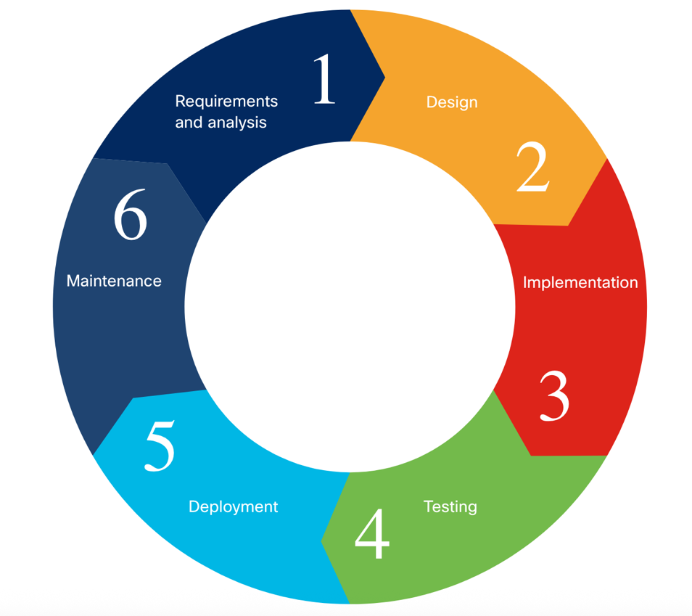
The SDLC defines a structured framework for developing reliable and maintainable software, guiding the process from initial concept to final delivery. The phases include requirements and analysis, design, implementation, testing, deployment, and maintenance. Each phase builds upon the previous one to ensure that technical solutions remain aligned with the business goals.
Figure 1: Software Development Lifecycle (SDLC) [19]
Three different SDLC models are outlined below:

- Waterfall - A sequential model with clear documentation, best for predictable projects but less adaptable to change.
- Agile - Focusses on collaboration, adaptability, and iterative delivery through ‘sprints’ (quick iterations) and ongoing feedback.
- Lean - Puts efficiency first by eliminating waste and concentrating on high value tasks.

1.3.2 Testing and Quality Assurance
Testing verifies that software functions as intended, covering both functional (unit, integration) and non-functional (e.g. usability, performance, security) aspects. In the Agile model, Test-Driven Development (TDD) is employed, with tests written before the code. Regular code reviews and automated testing further help maintain quality and standards, and increases testing efficiency.

1.3.3 Software Design Patterns
Standardised, Reusable templates known as design patterns are used to address common software issues. The foundational patterns are divided into following three groups:

- Creational - Handle object creation
- Structural - Define how objects are composed
- Behavioural - Manage communication between objects

1.3.4 Version Control Systems (VCS)
Types of version control systems include:

- Local
- Centralized
- Distributed

Version control systems facilitate accountability during collaboration, by monitoring and controlling any changes to the source code. Git and other distributed version control systems let users clone the entire repository, work separately, and then merge any changes.
Git concepts include:

- Working Directory: Local files that are being edited at the moment.
- Staging Area: Modifications chosen for commitment.
- Repository: Holds metadata and versions of committed code.

While merging incorporates finished work back into the primary branch, branching allows for various streams of development.

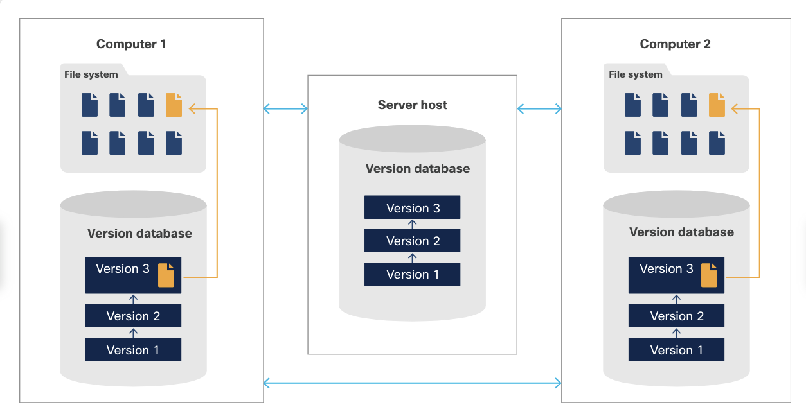
Figure 2: Distributed Version Control System (DVCS) [19]

1.3.5 Clean Code and Modularity
The term ‘Clean Code’ can be described as code that is easy to read, consistent, and maintainable. It encapsulates best practices such as the need for developers to consistently employ logical structure, appropriate indentation, and meaningful naming convention. Classes and functions are crucial to facilitate code reuse, encapsulation, and modularity. This further simplifies the code, reducing the likelihood of bugs and streamlines testing.

1.4 Chapter 4: Understanding and Using API’s
Chapter 4 explains how Application Programming Interfaces (APIs) facilitate communication between systems. They are essential to network automation since they enable services, applications, and devices to exchange data securely and efficiently.

1.4.1 API Design and Communication Models
Different architectural styles, including RPC, SOAP, and REST, can be used to develop APIs.
They can operate synchronously or asynchronously:

- Synchronous APIs - The client sends a request and waits for a direct response. Ideal when immediate feedback is required.
- Asynchronous APIs - The client continues other tasks while the server processes the request. Results are sent later through callbacks or webhooks.

1.4.2 Rate Limiting and Error Handling
To prevent server overload, rate limiting limits the quantity of API calls that can be made in a given time frame. Rate limit information, such as the number of requests left and the reset times, are often included in response headers. In order to detect problems as soon as possible, effective error handling requires examining HTTP status codes and API documentation.

1.4.3 Webhooks and Event-Driven Automation
Webhooks are HTTP call backs that are triggered by particular events. Continuous polling is no longer necessary because they push real time updates from one system to another. To function correctly, Applications need to register a webhook endpoint that can receive and process notifications.

1.4.4 Troubleshooting API Integrations
API troubleshooting involves validating endpoints, authentication credentials, and request formats. Unresponsiveness could be a sign of improper parameters or connectivity problems. Errors can typically be found and fixed by examining a server’s response logs.

1.5 Conclusion
Chapters 2-4 of the Cisco DevNet course demonstrate how networking has evolved into a programmable field. Developers are able to create secure, scalable, and automated solutions for modern network environments by utilising structured software development techniques, and API integration.

2. Case Study: Implementing network programmability, DevOps practices, and automation to enhance an Organisations’ operations

2.1 Introduction
CinePing is a hypothetical growing cinema chain currently operating 50 venues across the UK. Each cinema relies on network infrastructure supporting core operations such as point-of-sale (POS) terminals, ticketing kiosks, digital signage, CCTV systems, guest Wi-Fi, and back-end servers managing E-ticketing and operational data. The performance, security, and reliability of the networks are essential for daily operations, customer satisfaction, and revenue generation. The objective of this case study is to analyse CinePing’s network challenges, and propose solutions through the use of Network programmability, and DevOps principles. Furthermore, the author will reflect on the implications of these implementations within the wider leisure and entertainment industry.

2.2 Analysis of Challenges
CinePing currently experiences significant operational challenges due to their legacy approach to configuring network equipment. Each site’s setup currently requires engineers to manually perform configurations through a command line interface (CLI) [1, pp. 12,397]. This often leading to inconsistencies, and human error. The resulting issues can be particularly disruptive during periods of high demand, such as film premieres, when any downtime can be detrimental to customer experience and revenue potential.

2.2.1 Slow and Inefficient Device Provisioning
Manual device configuration requires around an hour of time to set up and deploy each device. For a typical site with 15–20 devices, this process can require up to 20 hours of time.
Moreover, Kief Morris [2, p. 29] lists the following drawbacks in this type of approach:
- Errors are common, resulting in outages.
- Ensuring uniform configuration across devices is difficult.
- Configuration reproduction depends on backups, which could not be readily transferable between devices.
- Someone with a strong understanding of a specific device is required to make even minor adjustments.

2.2.2 Configuration Drift and Operational Inconsistency
Without standardised, automated deployment, CinePing’s network configurations differ between sites. This ‘configuration drift’ occurs when changes are made manually without being recorded centrally. The result is fragile infrastructure where troubleshooting can often require re-learning each site’s unique configurations. Engineers cannot assume uniform security policies, VLAN mappings, or SSIDs etc., making fault resolution slow, and even breeds anxiety in the belief that a configuration change can cause something else to break. Morris describes this type of situation as a ‘Snowflake Server’ [2, pp. 7-9].

2.3 Addressing Challenges through Network Programmability and DevOps

2.3.1 Automating Provisioning with Network Programmability
To address its networking challenges, CinePing can adopt network programmability. This revolves around utilising software designed for machine-to-machine communication through programmable interfaces, known as application programming interfaces (APIs) [1, pp. 13-14]. Using a high-level programming language such as Python, engineers can develop automation scripts with the purpose of configuring network equipment automatically [3, p. 30] [4, pp. 16-19] [4, pp. 44-45].

Furthermore, Python offers libraries such as Netmiko and NAPALM which enable communication and automation of network devices [5, p. 33] [1, pp. 29-39, 612-613], These tools can interact with devices through APIs that rely on YANG data models, which define the structure of configuration and operational data in a consistent readable format. This enables scripts to retrieve configuration data from text based data files like YAML or JSON, validate the data, and apply the configuration to multiple devices automatically [1, pp. 323-328] [1, p. 353] [1, pp. 446-447] [6, p. 26].

To clarify the relationship between APIs, Python, YANG, and configuration files, ChatGPT [7] offers the following simplified overview:

“
- API – The interface that lets scripts talk to network devices.
- Python – The programming language used to write those scripts.
- Libraries (e.g. Netmiko, NAPALM) – Help Python communicate with devices through APIs.
- YANG – Defines the structure and rules for network data, so devices and scripts understand it the same way.
- YAML / JSON – Simple text files that store configuration data following the YANG structure, which scripts can read and apply. “

Central to CinePing’s network automation strategy would be the standardisation of Virtual Local Area Networks (VLANs) [1, p. 13] [1, p. 27]. VLANs logically segment the network into separate domains, allowing traffic to be isolated based on function or device type [8]. The following VLAN schema illustrates how this segmentation can be applied to CinePing networks:

VLAN | Devices | Purpose
10 | POS terminals | Secure and reliable sales transactions
20 | Ticket kiosks | Maintain consistent communication with ticketing servers
30 | Digital signage | Ensure smooth multimedia delivery
40 | Guest Wi-Fi | Isolate public traffic from internal systems
50 | CCTV cameras | Transmit surveillance data on a dedicated network segment

By automating VLAN creation and policy assignment, CinePing can deploy uniform configurations to all of its sites from a central location. Automation will not only reduce provisioning time, from hours per device to minutes per site, but also eliminate manual variability that can lead to configuration drift. New cinemas can be brought online quickly, and network updates can be deployed nationwide without service disruption.
Furthermore, this example demonstrates how establishing a consistent, automated deployment can deliver broader benefits beyond time savings [9] [10]:

- Improved network security: Sensitive transaction and surveillance data remain isolated from guest or public traffic, reducing the risk of interception or unauthorized access.
- Enhanced performance: VLAN segmentation reduces broadcast traffic and optimizes bandwidth, ensuring smoother operation for latency sensitive services like POS and signage video streams.
- Simplifies documentation and troubleshooting: A consistent VLAN design across all sites makes it easier for network administrators to identify, monitor, and resolve issues quickly.
- Supports scalable growth: Standardised VLAN design allows new sites or devices to be integrated seamlessly without reconfiguring the entire network.

2.3.2 Integrating DevOps for Collaborative and Reliable Network Operations
To support an API driven workflow, it would be beneficial for CinePing to adopt DevOps principles. At the core of this approach is the use of version control systems such as Git. All automation scripts and configurations can be stored in a central repository, enabling collaboration. Furthermore, Version control allows CinePing’s engineers to maintain a traceable history of all changes [2, pp. 15-16] [11].

A key component of this approach is the Continuous Integration / Continuous Delivery (CI/CD) pipeline. Continuous Integration automatically tests configuration changes whenever they are added to the repository, verifying syntax, and security compliance in a virtualised lab environment. Continuous Delivery then promotes validated configurations into production environments in a controlled manner. If tests fail, the pipeline halts deployment, preventing errors from propagating across multiple sites. Integrated rollback functions can restore previous configurations promptly [2, pp. 182-189] [12] [13].
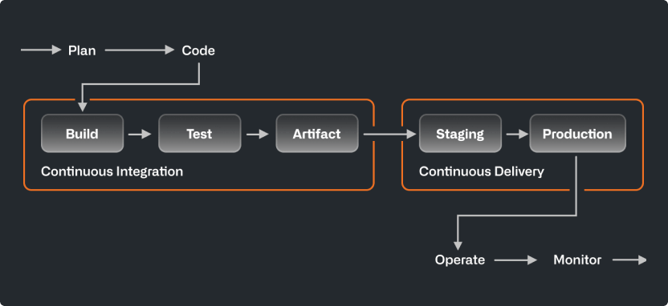
Figure 3 ,”Example of a CI/CD pipeline” [12]

2.4 Broader Industry Implications and Reflection

2.4.1 Advantages of Network Automation and DevOps Adoption
The transition to programmable, automated network management reflects a wider shift across industries dependent on network infrastructure. For cinema operators, reliability is essential: POS terminals, digital displays, and Wi-Fi directly affect customer satisfaction and operational continuity [14]. Implementing automation and DevOps practices offers several advantages [15] [16, p. 110]:

- Cost efficiency: Automation reduces labour hours spent on manual configuration and troubleshooting.
- Scalability: New venues and services can be deployed rapidly using established, reliable configurations.
- Consistency: Uniform policies across all sites minimise configuration drift and simplify support.
- Improved security and compliance: Centralised control ensures that VLANs, firewalls, and Wi-Fi policies adhere to corporate standards.
- Enhanced customer experience: Reliable networks maintain smooth ticketing, concessions, and connectivity services.

2.4.2 Challenges and Considerations
Implementing Automation and DevOps practices may introduce new challenges. The initial investment in automation tools and staff training can be significant. Moreover, the required cultural change can be challenging [16, p. 110].

Automation can create a single point of failure, meaning that a single coding or configuration error could affect multiple sites simultaneously, making rigorous testing, change control, and gradual rollouts essential to maintain stability and trust [17].

DevOps principles require teams to embrace collaborative efforts across development, and network management. With CinePing, this change would involve shifting from reactive, task focused work, to an approach which shares responsibilities, focuses on proactive problem solving, and continuous improvement [16, p. 101].

2.4.3 Emerging trends
Emerging technologies such as Zero-Touch Provisioning (ZTP) and AIOps (Artificial Intelligence for IT Operations) will further extend automation’s potential.

- ZTP enables network devices to configure themselves automatically when first connected to the network [1, p. 751].
- AIOps applies machine learning to detect anomalies, predict failures, and automatically take remedial action [18].

By embracing these emerging technologies, businesses like CinePing can continue to evolve their network operations to be more intelligent, adaptive, and resilient. Automation combined with predictive analytics will not only further streamline routine tasks but has the potential to anticipate issues such as POS or Wi-Fi interruptions, before they impact day to day operations.

2.5 Conclusion
CinePing’s current reliance on manual network configuration exposes the business to inefficiency, inconsistency, and operational risk. By embracing network programmability, automation, and DevOps principles, CinePing can address these challenges and transform how its networks are managed.

Automation scripts written in Python, validated against YANG models, and deployed via APIs provide a consistent, efficient, and reliable configuration process across all cinema sites. Coupled with DevOps practices such as version control and CI/CD pipelines, every network change can be tested, documented, and safely deployed, shifting network management from a reactive, manual process to a proactive, software-driven approach.

Beyond reducing operational effort, this transformation allows engineering teams to focus on strategic initiatives that support business growth. While investment in tools, staff training, and careful governance is necessary, the adoption of network programmability and DevOps practices is fundamental for network dependant businesses. In a highly competitive economy, businesses that embrace these capabilities gain the advantage needed to remain competitive and deliver consistent customer experiences.

3. References

[1] | M. Oswalt, C. Adell, S. S. Lowe and J. Edelman, Network Programmability & Automation - Skills for the Next-Generation Network Engineer, O'Reilly Media, 2018.
[2] | K. Morris, Infrastructure As Code : Managing Servers in the Cloud, O'Reilly Media, 2016.
[3] | K. Abuelenain, J. Doyle, A. Karneliuk and V. Jain, Network Programmability and Automation Fundamentals, Cisco Press, 2021.
[4] | K. Millie, Network programmability and Automation with python: The Ultimate Guide to Network Programmability with Python, Idependantly Published, 2024.
[5] | E. Chou, Mastering Python Networking : Utilize Python Packages and Frameworks for Network Automation, Monitoring, Cloud, and Management, Packt Publishing, 2023.
[6] | D. Barroso, 12 April 2024. [Online]. Available: https://napalm.readthedocs.io/_/downloads/en/latest/pdf/. [Accessed November 2025].
[7] | C. Private Communication, “ChatGPT,” [Online]. Available: chatgpt.com. [Accessed 2025 November 2].
[8] | Lenovo, “What is VLAN?,” [Online]. Available: https://www.lenovo.com/us/en/glossary/what-is-vlan/. [Accessed 1 November 2025].
[9] | UniFi, “Using VLANs for Network Security and Performance,” [Online]. Available: https://help.ui.com/hc/en-us/articles/26136851868695-Using-VLANs-for-Network-Security-and-Performance. [Accessed 4 November 2025].
[10] | Cisco, “What Is Network Design?,” [Online]. Available: https://www.cisco.com/site/us/en/learn/topics/networking/what-is-network-design.html. [Accessed 4 November 2025].
[11] | GitHub, “Git Guide, What is Git?,” [Online]. Available: https://github.com/git-guides. [Accessed 4 November 2025].
[12] | GitHub, “What is CI/CD?,” 7 November 2024. [Online]. Available: https://github.com/resources/articles/ci-cd. [Accessed 4 November 2025].
[13] | S. J. Gami, C. R. Katru and N. S. Kevin, “Enhancing Software Reliability: The Role of Automated Continuous Integration and Continuous Delivery,” International Journal of Computer Applications, vol. 187, pp. 57-58, 2025.
[14] | CSL, “IoT Security Strategies for Retail Store Networks,” 15 October 2025. [Online]. Available: https://www.csl-group.com/white-papers/iot-security-strategies-for-retail-store-networks/?utm_source=chatgpt.com. [Accessed 5 November 2025].
[15] | C. R. China, “What is network automation?,” IBM, [Online]. Available: https://www.ibm.com/think/topics/network-automation. [Accessed 4 November 2025].
[16] | R. Manchana, “The DevOps Automation Imperative: Enhancing Software Lifecycle Efficiency and Collaboration,” European Journal of Advances in Engineering and Technology, 2021.
[17] | A. BINSAHAQ, T. R. SHELTAMI and K. SALAH, “A Survey on Autonomic Provisioning and Management of QoS in SDN Networks,” IEEE Access, vol. 7, 2019.
[18] | IBM, “What is AIOps?,” [Online]. Available: https://www.ibm.com/think/topics/aiops. [Accessed 5 November 2025].
[19] | C. Academy, “DevNet Associate - Network Programmability Module,” [Online]. Available: https://www.netacad.com/launch?id=4a04bf0f-321f-4ac8-8226-3cea34fd28c1&tab=curriculum&view=db33e037-812e-57c6-914e-bd4a53752381. [Accessed October 2025].

