


MANAGING ENTERPRISE IN THE 21ST CENTURY
Car & Caviar Business Plan
Name: Dehelean George
ID: 2124303

Executive summary
The current report signifies the identification of an active business plan regarding a stratified structure of business in the UK market. The overview of the business is provided in order to understand the attributes needed to initiate the business within the organisation. The external environment analysis of the market conditions of the UK signees and the positioning of the business venture within the market. The significance of the business design and the objectives of the business are aligned toward the maintenance of the venture's profitability.

Table of Contents
1. Introduction 3
2. Business Description 4
3. Business Objectives 5
4. Business Structure 6
5. Business Description 7
6. Market analysis and Trends 8
6.1 PESTEL 8
6.2 SWOT 9
7. Operations plan 9
8. Planning Human Resource 9
9.Social Responsibility and Sustainability – within the Business Model 10
10. Risk of starting a new venture 10
11. Risk mitigation strategies 10
12. Development Milestone and Exit Plan 11
13. Financial Plan 12
14. Conclusion 12
References 13
Appendices 15
Appendix 1- P&L Account 15
Appendix 2- Cash flow statement 15
Appendix 3- Balance Sheet 16

1. Introduction
The approach to a new venture in the 21st century needs an extensive dynamic approach toward work and the implementation of technology in order to provide extensive and satisfying services. The development of a new venture needs to focus intricately on the product, ambience and services provided by the organisation in order to attract consumers (Ostgaard and Birley, 2018). The initiation of a new venture should possess a high solution providing capacity in order to meet the demands of the consumers and ease their lives. The present report signifies one such approach regarding garages. The name of the venture is Car & Caviar, a destination garage. The concept of the venture is to provide food and beverage services in the form of a restaurant to the customers of the garage.
The business venture Car & Caviar signifies the development of restaurants at the garages in order to provide entertainment and food services.
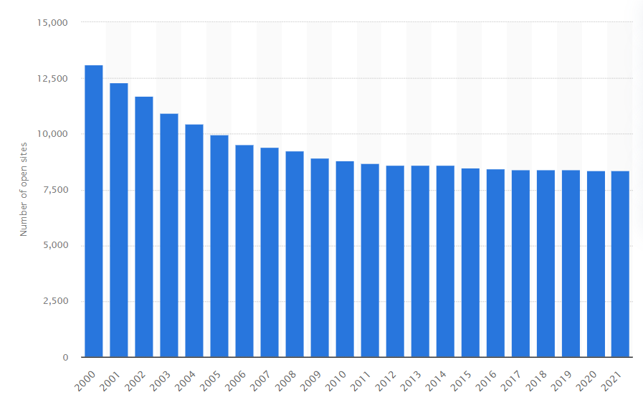
Figure 1: Car service and petrol station sites in the UK
(Source: Sönnichsen, 2018)
The profitability of the aspect signifies the fact that the solution-providing aspect is fulfilled by the business and the profitability of the venture owner is enhanced. The practice within the UK is expected to be a fruitful venture as the number of vehicle repair workshops in 2020 is estimated to be around 8378 (Sönnichsen, 2018). The objectives of the business are to provide extensive priority garage services. Secondly the organisation aims to develop a niche cooking regime of fast food that provides healthy food. The marketing of the organisation will be based over the quality segmentation and conversion of non-productive time to useful outcomes.

2. Business Description
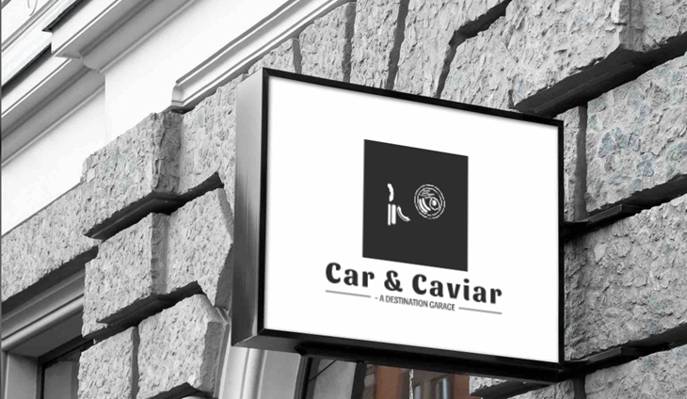
Figure 2: Branding of Car & Caviar
“Waiting time”, is the time that is totally wasted time on part of a customer when they reach a garage for car wash and maintenance. Sometimes the waiting time elongates to more than 5 to 6 hours and the customer cannot move to other places because of the submission of the car. The concept of the business utilises the waiting time at a garage for the consumer by providing them with food and beverage facilities along with little entertainment (Kumar and Reddy, 2016).
3. Mission and Vision
The mission of the organisation is the providence of highly accessible quality meals to its consumers, to ensure saving quality time while waiting for productive work. The vision of the organisation has been directed towards the innovation in business style in order to break general narrative of unhealthy fast-food regimes. The business also ensures effective cooking technique implementation in engrossing business cultures.

3. Business Objectives
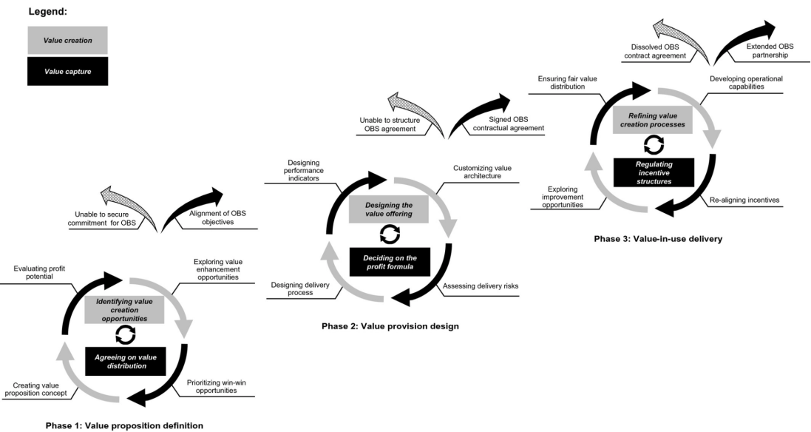
Figure 3: Value creation and value capture alignment for Car & Caviar
(Source: Sjödin et al., 2020)
The objectives of the business have been directed toward the development of customer satisfaction, building reputation, and increment of sales, revenue generation and market penetration. The above-mentioned objectives signify the initiation of the venture Car & Caviar, from initiation to profit development.
Customer satisfaction: Since the organisation is a service-providing organisation it is important to attain a customer-centric plan for business advancement (Suchánek and Králová, 2018). The providence of consumer satisfaction is based on the ethical approach of the business to create a self-reputation.
Building Reputation: The concept of reputation building initiates with the providence of high-quality services in order to maintain effective procedures. The approach of reputation building for Car and Caviar can be signified by the expansion of the business based on the quality of services and products (Brammer and Pavelin, 2021).
Increment of sales: The aspect of sales increment is attributed to implementing marketing strategies within the business. The process of forecasting the business concept along with enhancing service and product knowledge dispersion enhances the increment of sales.
Revenue generation: Revenue generation is directly related to the increment of sales. The attributes of proper investment in different sections of the process help in the process of maintaining the quality of products and services. This implicates the revenue generation aspect within a business.
Market Penetration: The implementation of competitive advantage signifies the market penetration aspect within the competitors of the market. The aspect of market penetration is based on the attribute of enhancing the business strategies within the organisation and focusing on the capital generation for running the business (Groth, 2021).

4. Business Structure
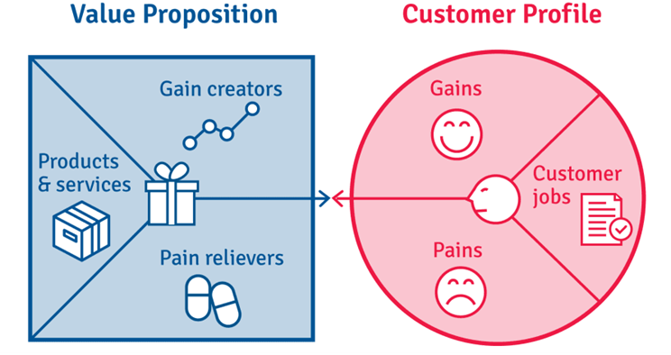
Figure 4: Business Design
(Source: Self-Developed)
The design of the business is signified within the organisation based on gains and pains and customer jobs.
The pains signify the situational analysis of the need for a new venture. The primary pain denotes the waiting time in the case of services provided within the garage. The waiting time provides the consumer with a dilemma in the providence of perfect time applicable issues. On the other hand, the providence of Car & Caviar restaurant may act upon the perception that fast food restaurants proving junk and unhealthy foods.
The Gain of the aspect signifies the fact of attaining a wholesome meal while the waiting time of the organisation is impacted evidently. Apart from that, a restaurant helps individuals to socialise over the aspect of car services, food and beverages.
The customer job section within the design implements the execution of jobs essential to the consumers by the application of the business concept. The significance of the aspect signifies the satisfaction of the employees in the actual completion of garage works along with food beverage and entertainment.

5. Business Description
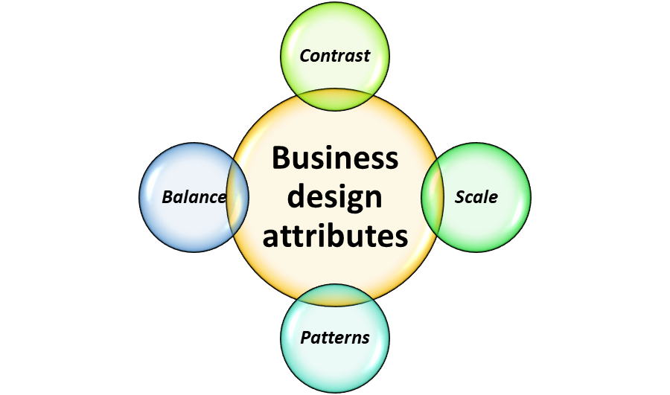
Figure 5: Business Design Attributes
(Source: Self-Developed)
The potential of the business design can be described over the application of the internal value proposal based on the reach of the business. The contribution of the business upon the owner and consumer sides is huge and enables providence of solution towards the consumers and profitability to the venture owner. The aspect of business design is implicated with the help of balance, scale, contrast, pattern, movement, and emphasis.
Balance: The balance signifies the intricate balance between the providence of the actual and the subordinate services to the consumers. The primary service denotes the providence of car services within the garage and the secondary services denote the restaurant services at the spot (Parkman and Malkewitz, 2021). This balance implicates the flow of customers towards the growth of the business.
Scale: The scale of the business design implicates the high impact and the low impact attributes of the organisation. Car & Caviar signifies that the services provided to the consumers are of high impact and the products are of low impact. The scale of the business will target consumer centrism at the highest level and the maintenance of service ethics at the lowest (Mishra, 2016).
Contrast: The contrast signifies the improper matching of the attributes within the business. The combination of car services and reliable fast food is hard to find obscure within major organisations. The providence of unique contrast will help in the development of USP within the process (Kramoliš, Staňková and Richtr, 2019).
Patterns: The development of schemes within the business intricate toward the maintenance of integrated schemes for the consumers combining the specific services around the car maintenance and food and beverage packages (Kramoliš, Staňková and Richtr, 2019).
Movement: The concept of movement within the design aspect signifies the use of monitoring the service providence within the organisation along with the maintenance of consumer centrism. The approach of the prospect helps in designing marketing prospects of the services based on the inventory count and the demand for the services.
Emphasis: The emphasis on the business design signifies the focus on the targeting of consumers to avail of the services within the UK market. The individual owning a vehicle within the UK is the prime contrast of the project (Möller et al., 2021).

6. Market analysis and Trends
The marketing condition of a business can be well demonstrated by the identification of the political, economic, social, technological, ecological, and legal attributes.

6.1 PESTEL
Political: The political attributes relate to the changes in policies, laws and taxes at bureaucratic levels within the country. The present condition of the UK market signifies the growth of the business potential within the UK in the post-Brexit condition (Burns and Carter, 2018). The government policies are stable and are not subject to major changes and low tax rates for new ventures.
Economical: Although the economic condition of the country has been heavily affected by the pandemic, the growth rates are drastic and have the potential to grow back to a large economy. Apart from that present-day organisations have been indenting towards large consumption of energy. Energy costs within the UK are huge within the UK (Hill, 2018).
Social: The Social attributes of the UK comprise the cultural changes from place to place and the social awareness of the people towards sustainable business approaches. The social attributes of the business in the UK are also based on the demography of the country.
Technological: The adoption of new technology within the UK is phenomenal towards venture growth. The application of automation-based technology makes work easier and easy to handle.
Ecological: The implementation of sustainability within the business venture and the awareness of people towards the use of clean energy is an integral part of new ventures within the UK. Furthermore, the prime approach of the government to being a carbon-neutral country.
Legal: The cost of compliance within the UK in the case of venture development is crucial for the implementation of new ventures within the country (International Monetary Fund, 2017).

6.2 SWOT
Strengths  - Change in business design  - Sustainability implementation | Weakness  - Totally new business model  - Decrease in the number of garages in the UK
Opportunity  - Chances to develop a digitized conglomerate business structure.  - Ability to involve a large number of stakeholders within the model. | Threats  - Lack of investment for the business  - Non-favourability in food structure
Table 1: SWOT Analysis
It has been identified that the new business technique and the innovative style of business proves positive for the organisations. On the other hand, the possibility of funding insecurity is obvious with decrease in the number of garages in the UK. The potential opportunities involve development of digitized conglomerate business style, which helps in combining two businesses together. The business also holds the threat for the non-favourability of healthy fast food as one of the intricate threats for the process.

7. Operations plan
The planning of the operation is based on the attainment of fresh supplies from the local vendors and providing familiar food to the people of the UK. The prospect signifies focusing on the maintenance of the quality of food to maintain regular consumer growth. The availability of fresh ingredients enables the production of fast food and exquisite dishes in order to maintain an organisational reputation. On the other hand, the providence of professional services within the restaurant and the maintenance of cleanliness enable the prospect of a better consumer base and better sales value.

8. Planning Human Resource
The planning of the human resource is integral towards the upliftment and the providence of professional services within the restaurant, Car & Caviar. The inclusion of the educated and experience holders will provide the organisation with the setting of a service standard amongst UK restaurants. The restaurant would require highly qualified and efficient chefs in order to provide boat fast food and exquisite dishes. The food cost and budgeting maintenance will require an efficient finance team along with an agile and adaptive marketing team. The technology-based approaches to marketing should be implemented over media platforms. Hence the HR department is efficient in the maintenance of the core team of the venture (Amit and Belcourt, 2019).

9. Social Responsibility and Sustainability – within the Business Model

Key Partners | Key activities | Values | Customer Relationship | Customer Segments
- Employees of the garage  - Suppliers of raw material  - Restaurant staffs | - Priority towards the regular consumers of the garage  - Fast chain section providing drive-through services | - Reduce waiting time in food delivery  - Consumer involvement with events and services | - Development of effective communication channels  - Encouraging feedback regarding the food and work services | - Targeting young and dynamic customers  - Implementing technology for fast and interactive services
Table 2: KPI of Car & Caviar

10. Risk of starting a new venture
The risks of starting a new restaurant business within the market of the UK signify the presence of potential risks that involve financial, compliance, cyber-security, and operational and reputational risks. The risks of financial prospects signify the loss of capital for the business. Car & Caviar possesses the risk based on the low sales count aspect. On the other hand, the issue of compliance is based on the change in laws and taxes by the government. The operational and cyber-security risk is based on the data collected by the organisation, from their consumer bases. It also implicates the potential for data threats towards the organisation.

11. Risk mitigation strategies
Risk Description  (List out the possible risks below) | Likelihood of the risk occurring | Impact of the risk | Severity  (Rating based on impact and likelihood)  1-5 (5 = mostly affected) | Mitigation | Contingent Action plan
Financial Losses | High | Medium | 3 | To highlight the scope and purpose of change management to employees | To have adaptive leadership management
Lack of employee motivation | High | High | 5 | To actively engage employees | To have mind refreshment activities
Training and Development | Low | Medium | 2 | To train about diversity and technology | To have a proper and effective recruitment procedure
Table 3: Risk Register

12. Development Milestone and Exit Plan
The primary milestone to be reached by the organisation is directed towards achieving a sales goal of 240,000 GBP within a time period of 3 years. It has been signified over the identification of the risk mitigation techniques and the potential of the research. The attainment of the target will help in the attaining 15% of the London market. The providence of service should be 12 hours per day based on the satisfaction of the consumers.
The exit plan is of the process is to grow and sell the venture or to liquidate the assets and the attributes of the business. This is signified as the smartest approach to intensify business exit.

13. Financial Plan
According to the proposed financial plan it has been identified that the product sale has been expected to increase with time. Every year the sale is doubled based on the application of the marketing strategies. The variable costs are maintained within 50,000 GBP in order to increase the profitability of the organisation (Refer to appendix 1). On the other hand, the fixed cost is directed towards the asset collection of the organisation. The cost maximizes 30,000 GBP to maintain the stability of the organisation (Refer to appendix 1).
The cash flow is predicted to increase with rise in the approach of the organisation to meet the agenda of increasing sales. It is by the end of the 3rd year the expected cash flow can be rendered to be 133,000 GBP (Refer to appendix 2).A major part of the cash flow is based on the recruitment process of the organisation signifying 12,000 GBP only for the recruitment process (Refer to appendix 2).This signifies the organisations’ dedication towards implementation of quality food.
The balance sheet of the organisation signifies the count of assets and liquidity of the organisation, signifying a gradual increase in the valuation and the profitability of car and caviar. The outcome by the end of the 3rd year is observed to be 195,000 GBP (Refer to appendix 3). The asset count has risen for the organisation from 154,000 GBP in 2nd year to 195,000 GBP in the third year (Refer to appendix 3). The increase signifies the potential of the organisation in meeting the objectives.

14. Conclusion
The business plan for Car & Caviar consists of multiple aspects for the enhancement of products and services. The demands of the business within the 21st century include the including of specified business attributes, business design, and business plan along with risk identification and management attributes. Hence this signifies the potential of the business plan for Car & Caviar in explicit all responses.

References
Amit, R. and Belcourt, M. (2019) ‘Human resources management processes: a value-creating source of competitive advantage’, European Management Journal, 17(2), pp. 174–181. doi: 10.1016/s0263-2373(98)00076-0.
Brammer, S. and Pavelin, S. (2021) ‘Building a Good Reputation’, European Management Journal, 22(6), pp. 704–713. doi: 10.1016/j.emj.2004.09.033.
Burns, C. and Carter, N. (2018) ‘Brexit and UK Environmental Policy and Politics’, Revue française de civilisationbritannique, 23(3). doi: 10.4000/rfcb.2385.
Groth, J. C. (2021) ‘Managing Action Inhibitors to Increase Sales’, Marketing Intelligence & Planning, 12(4), pp. 4–9. doi: 10.1108/02634509410060686.
Hill, J. (2018) Understanding the Social Factors That Contribute to Diabetes: A Means to Informing Health Care and Social Policies for the Chronically Ill | The Permanente Journal, The Permanente Journal. Available at: https://doi.org/10.7812%2FTPP%2F12-099 (Accessed: 9 August 2022).
International Monetary Fund (2017) The Demand for International Reserves Under Fixed and Floating Exchange Rates. 1st edn. UK: International Monetary Fund, pp. 1–68.
Kramoliš, J., Staňková, P. and Richtr, M. (2019) ‘The importance of design in business practices of czech companies’, E+M Ekonomie a Management, 18(2), pp. 151–164. doi: 10.15240/tul/001/2015-2-011.
Kumar, S. S. K. and Reddy, B. S. (2016) ‘Role of Private Garage Mechanics in Influencing Car Purchase’, Asian Social Science, 9(10). doi: 10.5539/ass.v9n10p169.
Mishra, A. (2016) ‘Attribute-based design perceptions and consumer-brand relationship: Role of user expertise’, Journal of Business Research, 69(12), pp. 5983–5992. doi: 10.1016/j.jbusres.2016.05.012.
Möller, F. et al. (2021) ‘Designing business model taxonomies – synthesis and guidance from information systems research’, Electronic Markets. doi: 10.1007/s12525-021-00507-x.
Ostgaard, T. A. and Birley, S. (2018) ‘New venture growth and personal networks’, Journal of Business Research, 36(1), pp. 37–50. doi: 10.1016/0148-2963(95)00161-1.
Parkman, I. and Malkewitz, K. (2021) ‘“Good Design is Good Business”: An Empirical Conceptualization of Design Management Using the Balanced Score Card’, Design Management Journal, 16(1), pp. 66–77. doi: 10.1111/dmj.12069.
Sjödin, D. et al. (2020) ‘Value Creation and Value Capture Alignment in Business Model Innovation: A Process View on Outcome‐Based Business Models’, Journal of Product Innovation Management, 37(2), pp. 158–183. doi: 10.1111/jpim.12516.
Sönnichsen, N. (2018) UK: number of petrol stations 2000-2018 | Statista, Statista. Statista. Available at: https://www.statista.com/statistics/312331/number-of-petrol-stations-in-the-united-kingdom-uk/ (Accessed: 9 August 2022).
Suchánek, P. and Králová, M. (2018) ‘Customer satisfaction and different evaluation of it by companies’, Economic Research-EkonomskaIstraživanja, 31(1), pp. 1330–1350. doi: 10.1080/1331677x.2018.1484786.

Appendices

Appendix 1- P&L Account
 | Year 1 (£) | Year 2 (£) | Year 3 (£)
Revenue (Sales):
Product Sale | 30,000.00 | 50,000.00 | 50,000.00
Service Sale | 10,000.00 | 25,000.00 | 40,000.00
Other Income | 5,000.00 | 15,000.00 | 15,000.00
Total Sales | 45,000.00 | 90,000.00 | 105,000.00
Variable Cost:
Electricity | 9,700.00 | 12,000.00 | 15,000.00
Food Ingredients | 9,000.00 | 10,000.00 | 11,000.00
Recruitment | 1,000.00 | 12,000.00 | 12,000.00
Web maintenance cost | 300.00 | 350.00 | 400.00
Transportation cost | 5,000.00 | 7,000.00 | 10,000.00
Marketing cost | 5,000.00 | 4,000.00 | 2,000.00
Total Variable Cost | 30,000.00 | 45,350.00 | 50,400.00
Fixed Cost:
Licence fees | 4,000.00 | 4,500.00 | 5,000.00
Insurance | 3,000.00 | 4,000.00 | 4,400.00
Salary | 12,000.00 | 15,000.00 | 20,000.00
Utilities | 1,000.00 | 1,500.00 | 1,500.00
Total Fixed Cost | 20,000.00 | 25,000.00 | 30,900.00
EBIT (Earnings Before Interest and Tax) | - 5,000.00 | 19,650.00 | 23,700.00
Less: Interest and Tax | - | 3,930.00 | 4,740.00
Net Profit After Tax | -5,000.00 | 15,720.00 | 18,960.00
Table 3: P&L Account

Appendix 2- Cash flow statement
 | Year 1 (£) | Year 2 (£) | Year 3 (£)
Receipts:
Sales | 45,000.00 | 90,000.00 | 105,000.00
Account Receivables | 2,250.00 | 4,000.00 | 8,000.00
Other Receipts | 10,000.00 | 25,000.00 | 20,000.00
Total Receipts | 57,250.00 | 119,000.00 | 133,000.00
Payments:
Electricity | 9,700.00 | 12,000.00 | 15,000.00
Food Ingredients | 9,000.00 | 10,000.00 | 11,000.00
Recruitment | 1,000.00 | 12,000.00 | 12,000.00
Web maintenance cost | 300.00 | 350.00 | 400.00
Transportation cost | 5,000.00 | 7,000.00 | 10,000.00
Machinery purchase and application development | 10,000.00 | 15,000.00 | 20,000.00
Interest of loan | 10,000.00 | 20,000.00 | 20,000.00
Marketing cost | 5,000.00 | 4,000.00 | 2,000.00
Total Payments | 50,000.00 | 80,350.00 | 90,400.00
Net Cash in Hand | 7,250.00 | 38,650.00 | 42,600.00
Opening Balance | - | 7,250.00 | 38,650.00
Closing Balance | 7,250.00 | 45,900.00 | 81,250.00
Table 4: Cash flow statement

Appendix 3- Balance Sheet
 | Year 1 (£) | Year 2 (£) | Year 3 (£)
Equity & Liabilities:
Shareholder's fund | - | 50,000.00 | 70,000.00
Current Liabilities:
Account Payables | 30,000.00 | 50,000.00 | 90,000.00
Notes Payables | 15,000.00 | 20,000.00 | 25,000.00
Accrued Expenses | 1,000.00 | 4,800.00 | 10,000.00
Non-current Liabilities:
Long-term Debt (Loan) | 50,000.00 | 30,000.00 | -
Total Equity and Liabilities: | 96,000.00 | 154,800.00 | 195,000.00
Assets:
Fixed Assets:
Land and buildings | 30,000.00 | 35,000.00 | 40,000.00
Machinery | 10,000.00 | 15,000.00 | 20,000.00
Current Assets:
Cash and Cash Equivalents | 7,250.00 | 45,900.00 | 81,250.00
Account Receivables | 25,000.00 | 35,000.00 | 20,000.00
Inventory | 5,750.00 | 3,900.00 | 4,000.00
Non-current Assets:
Investments | 18,000.00 | 20,000.00 | 29,750.00
Total Assets: | 96,000.00 | 154,800.00 | 195,000.00
Table 5: Balance Sheet

