

Student Name: Leelu Oghad Khistariya
Student ID: 2532036
Master of Business Administration (MBA)
Lecturer Name : Balendran Kandasamy
LCMB7003 - Strategic Management

Chosen Company: “Netflix”

STRATEGIC MANAGEMENT ANALYSIS OF NETFLIX’S GLOBAL STREAMING BUSINESS: EVALUATING ITS STRATEGIC POSITION AND COMPETITIVE ADVANTAGE

USE OF GENERATIVE AI IN ASSESSMENT
RESEARCH | For this assessment, you can use Generative AI to support you in research, including searching for bibliography, using tools to summarise, compare and  interrogate materials. | Yes ☒  No ☐
STRUCTURE | For this assessment, you can use Generative AI to support you in structuring your submission, including creating a draft argument structure, identifying parts  and headings, etc. | Yes ☐  No ☒
PROOFREADING | For this assessment, you can use Generative AI to check your own text/creation for grammatical and syntactical mistakes, including rephrasing of your  own work within specific standards. | Yes ☒  No ☐
WRITING | For this assessment, you can use Generative AI to create text for submission. | Yes ☐  No ☒
CREATIVE | For this assessment, you can use Generative AI to create creative materials, such as images. | Yes ☒  No ☐
PROGRAMING | For this assessment, you can use Generative AI to create and check code. | Yes ☐  No ☒
NONE | For this assessment, you are not allowed to use any type of Generative AI support. This includes research support, structure support, writing/proofreading  support and creative support. | ☐

Generative AI Acknowledgement
I have used Generative AI and digital tools when preparing this assignment according to assessment guidelines.
In Research: Generative AI used as a tool to support research, including identification of, and summarising, relevant academic and organisational materials, comparison and interrogation of those materials. The research activities included evaluation of a variety of material and information on Netflix, such as annual reports, shareholder letters, sustainability, environmental and social governance materials, inclusion and diversity reports, accessibility projects, corporate governance materials, company profile, and culture materials. I have independently assessed the sources relevant to the assignment, and they have been referenced appropriately throughout the assignment. Generative AI was used as a research-support tool, and not a replacement for my analysis and judgement.
In Proofreading: All my own work was proofread using the app, Grammarly (https://www.grammarly.com/ ) and I also formatted my grammar, spelling, punctuation, sentence structure, and syntactical accuracy using it. I consulted the suggestions given by the tool and accepted the final decisions about the wording and presentation of my work.
In Creative materials: Visual or creative materials which were created and designed using creative tools (Canva: https://www.canva.com ) were incorporated into the assignment when applicable. It was mainly used for presenting the questions and assignments as pictures and communicating the information visually.
I have done my own research, analysis, interpretation, arguments, conclusions, reference and themed presentation of this assignment. I have checked and edited the work to make sure that it is accurate to my understanding and work and meets assessment requirements and academic honesty.

Table of Contents
1. Organisational Context and Overview: Netflix 7
2. External and Internal Analysis of Netflix 8
2.1 External Environment Analysis 8
2.1.1 Political and Legal Pressures 8
2.1.2 Economic and Competitive Conditions 8
2.1.3 Social and Consumer Trends 9
2.1.4 Technological and Environmental Factors 9
2.2 Internal Environment Analysis 10
2.2.1 Financial, Content, and Platform Resources 10
2.2.2 Rarity, Imitability, and Organisational Capacity 11
2.3 SWOT Analysis and Strategic Synthesis 12
3. Comprehensive and Holistic View of Netflix 13
3.1 Corporate Social Responsibility Strategy 13
3.2 Balanced Scorecard 15
3.2.1 Financial Perspective 15
3.2.2 Customer Perspective 16
3.2.3 Internal Business Processes 17
3.2.4 Learning and Growth Perspective 17
4. Strategic Choices and Implementation 18
4.1 Available Business-Level Choices 18
4.2 Recommended Strategy 18
4.3 Porter’s Five Forces Validation 18
4.4 Ansoff and SAFe Evaluation 19
4.5 Performance and Competitive Advantage 20
4.6 Implementation Challenges and Mitigation 21
4.7 Conclusion 21
5. Reflective Account Using Gibbs’ Reflective Cycle 22
5.1 Description and Initial Feelings 22
5.2 Evaluation of the Research Process 22
5.3 Analysis of Learning 23
5.4 Conclusion and Action Plan 23
Reference list 25

1. Organisational Context and Overview: Netflix
Netflix Inc. is chosen as a strategic analysis case in the global subscription video-on-demand and digital entertainment business in general. Since Netflix is one business segment and generates primarily membership fees for its global streaming business, with advertising, live experiences, and other revenue streams being secondary, this report concentrates on its streaming business. Netflix was established on 29th August 1997 and started providing service on 14th April 1998, originally as a DVD rental company, and later as a streaming-based entertainment service (Netflix 2025a). It is currently available in numerous categories and languages, enabling members to enjoy its content in a flexible way, spanning their internet-connected devices (Netflix, 2026b).
The business of Netflix is perhaps as close to its mission statement of “entertaining the world”. Instead of having a traditional vision statement, Netflix's strategic direction can be seen in the way it states that it wants to expand across the world to provide better member experiences with content, technology and user interface development, and different pricing models, such as ads-based subscription (Netflix, 2026c; Netflix, 2026a). This is a combination of subscription streaming, advertising-supported, original content, licensed content, and platform convenience, which is how Netflix is monetising its business.
Netflix's position in the market is still solid. The revenue for the company in 2025 was US$45.2 billion, which is a 16% increase from the previous year, and the operating margin was 29.5%, and in 2025, the company had the advertising revenue of more than US$1.5 billion, and in Q4 2025, the company crossed 325 million paid memberships (Netflix, 2026d). The industry is also gaining traction, with the global video streaming market for instance expected to grow to US$416.8 billion by 2030, at a 21.5% CAGR from 2025 to 2030, according to the report by Grand View Research (2025).
But that's a highly competitive landscape for Netflix. It's not just Disney+, Amazon Prime Video, YouTube, Apple TV+, Max, Hulu and other streaming services that it competes with, it's also linear television, gaming, social media, user-generated video and piracy. Hence, Netflix's value proposition is based on the fact that it is global, offers a wide selection of content in multiple languages, creates original content, is flexible in how it is accessed, has various price tiers, and has a powerful entertainment brand. At present, its strategic position is solid, but it will be based on customer retention, content cost management, growth of advertising revenue and embracing regional viewing habits.

2. External and Internal Analysis of Netflix

2.1 External Environment Analysis

2.1.1 Political and Legal Pressures
The connection between access to streams and cultural investment, stream catalogue and visibility of contents is becoming more common in the regulation of streaming. The European Commission states that on-demand catalogues must have at least 30% European works and that they must be adequately promoted (European Commission, 2020). These commitments will benefit local producers, but will limit Netflix's ability to use global demand signals as a basis for determining where to spend its content budget. To qualify for C$25 million or more in local revenue, Canada has instituted qualifying unaffiliated streaming services that must pay five per cent of their relevant revenues (CRTC, 2024). But Netflix has a proven local production infrastructure that can help transform compliance into something that could be a regional TV show that extends into international markets. Regulation is a cost threat and entry barrier of smaller competitors, in turn.

2.1.2 Economic and Competitive Conditions
The biggest economic risk is still the affordability of subscription, as entertainment spending is discretionary and easily curtailed. There were four paid streaming services reported for use on average per American household, and 39 per cent of American households had recently cancelled one of their streaming services (Deloitte, 2025). Netflix could increase prices due to its strong catalogue and brand but doing so could reduce perceived value. The advertising-supported video model provides a huge opportunity since it is lower cost, and opens up a new revenue stream. This suggests that there is some meaningful substitution between the revenue models as many consumers opt to view free ads over transactional options, with evidence found across the board (McKenzie et al. 2025). However, the advertising exposure is cyclical as budgets can shrink very quickly when the economy slows down.
The battle isn't just between Disney+, Prime Video and Max, but also YouTube, gaming, social sites, piracy and “real” TV. Overall, American television viewing in December 2025 was 47.5 percent streaming and a platform record nine percent viewing was on Netflix (Nielsen, 2026). So the market leader is not immune to substitution risk because the consumer is free to reallocate his or her attention without a high cost. Netflix's resilience after being forced to implement password controls and advertising demonstrates management agility but for future growth, it will be more difficult to act in newer companies (Financial Times, 2024). Live programming, games and advertising may enhance engagement, but each activity brings in different capabilities and existing competitors.

2.1.3 Social and Consumer Trends
The connection with the global market increases Netflix's potential market, but less than expected in the lower income economies due to the lack of affordability. Despite the fact that 2.2 billion had not yet accessed the internet, and there were still quality gaps, six billion people used the internet in 2025 (ITU, 2025). Connectivity growth could be turned into paying demand through regional payment partnerships and/or mobile-only offers. Navigability and ‘binge-watching' were found to predict both subscription and continuation intentions in the research (Menon, 2022) that involved 576 Indian users. Netflix should therefore maintain simplicity of the interface and not get too addictive about consumption.
The impact of electronic word-of-mouth on attitudes towards streaming content and intentions to subscribe among younger Indian consumers (Gupta, 2023). This means that local social conversation can help to extend smaller productions, thereby decreasing the need for costly global franchises. But, when content causes controversy and goes against the expectations of the region, the damage can be as rapid as the spread of the content. Habit is related to continuous viewing, but future engagement decreases when viewing is binge-like, due to regret (Bastos et al. 2024). However, Netflix will need to navigate between wellbeing issues, regulatory attention, and potential customer fatigue. Customer satisfaction is a key to retaining customers for the long-term, not just to extend viewing hours.

2.1.4 Technological and Environmental Factors
However, piracy continues to be a structural issue as it provides access to a variety of services at a low cost in a multitude of content libraries. A study of 283 British respondents suggests that risk perceptions may impact illegal streaming practices (Shah et al. 2024). While Netflix can't stop piracy, low prices and timely regional releases can mitigate consumer incentives. Seger et al. (2023) showed that a seven-week intervention was able to decrease streaming emissions with information, shorter viewing time, and lower resolution settings. This evidence indicates that Netflix has the power to drive consumption effects on a transparent basis by providing information and using an "energy efficient" default setting.
Netflix's Scope One and Two emissions have been cut in half for 2023 as compared to 2022, due in part to a decrease in production activity (Netflix, 2024). This reduction should not be seen as proof of ‘structural decarbonisation' as such, however. Comparable progress is needed for credibility when production volume returns, as content creation produces a significant amount of emissions across the value-chain. Investments in efficiency reduce operating costs and thus present a strategic interest beyond mere reputation management to ensure compliance with regulations.
PESTEL factor | Priority opportunity | Priority threat
Political and legal | Local obligations can strengthen regional production ecosystems | Levies, quotas, censorship, and reporting reduce strategic flexibility
Economic | Advertising tiers widen access and diversify revenue | Inflation and subscription fatigue increase cancellation sensitivity
Social | Local stories and online discussion support international discovery | Cultural disputes and unhealthy viewing concerns damage trust
Technological | Personalisation and efficient delivery improve customer experience | Piracy, cyber risks, and rapid imitation weaken differentiation
Environmental | Efficient production and streaming can strengthen legitimacy | Production recovery may reverse reported emissions progress

2.2 Internal Environment Analysis

2.2.1 Financial, Content, and Platform Resources
Netflix revenue in 2025 is US$45.2B, its operating margin is 29.5 percent. Yet, to meet content commitments, about US$24.0 billion of content requires a certain degree of inflexibility for titles that don't perform (Netflix, 2026a). Size of financial investment, therefore, is a good thing, but it turns the creative uncertainty into concrete economic risk with a big commitment. The predictability of content success is still very uncertain, and it's more about portfolio discipline than just raising the annual production budget. There are about 18,000 servers in 6,000 locations total in 175 countries in the Open Connect network (Netflix, 2022). This infrastructure shortens the distance to be covered, congestions of the network and reliance on general internet routes. The more it is used in the world, the more valuable it becomes, and its past partnerships and deployment experience is hard to replicate quickly.
It has been demonstrated in the literature that the dynamic popularity, multiple quality versions, recommendation effects and heterogeneous demand patterns are key factors to take into account in the design of advanced caching (Choi et al. 2024). Netflix manages these technological needs and integrates them into a global delivery system very well. But it will take a long time for the competitors to replicate the experience of optimizing and building local network relationships, as Netflix does. The emotional information can enhance the relevance in the affective recommender research; however, data limitations and untrustworthy emotion detection are important constraints (Wang and Zhao, 2022). Personalisation thus facilitates differentiation; however, an algorithm cannot be successful enough and appropriately in place of weak and/or culturally inappropriate content.
Multi-behaviour recommender models can fill the gaps in the immediate user interactions with longer user preferences (Zhao et al. 2023). While Netflix has a lot of behavioural data, its privacy laws limit the usefulness of it for advertising and recommendations. Governance is the key to maintaining user trust over time for data scale to create advantage.

2.2.2 Rarity, Imitability, and Organisational Capacity
In 2026, Netflix's advertising tier reached over 250 million MAUs across the world each month (Netflix, 2026b), providing advertisers with significant reach. But it's a good audience and fairly scarce, except that YouTube and Amazon have better ad infrastructures. Netflix's still-developing ad tech, then, is less a competitive advantage than it is a potential one. As a whole, its worldwide brand, local commissioning links, recommendation information and content delivery system are more effective. Single resources are still replicable, but the temporal linkage of these resources is still not easily replicated and has high coordination costs.
Evidence shows moving films into subscription libraries can increase viewing substantially while reducing transactional sales, illustrating revenue cannibalisation risks (Baek et al. 2024). Netflix has to look at content placement from contribution, retention, ad value and life cycle perspectives. Studies reveal an inverted relationship between the diversification of business models and performance: at a certain point, too many business models will lead to increased coordination costs (Sohl et al. 2022). Netflix's associated add-ons might enhance involvement, but unassisted growth might water down its amusement features. Good organisational discipline is still essential to turn precious resources into lasting strategic results. Experimenting is therefore a must for the organisation, along with clear exit criteria and accountability for not working out for long-term projects.
Resource or capability | Valuable | Rare | Difficult to imitate | Organised | Strategic implication
Global brand and audience | Yes | Yes | Moderately | Yes | Strong temporary advantage
Open Connect infrastructure | Yes | Yes | Yes | Yes | Potential sustained advantage
Recommendation data and systems | Yes | Moderately | Moderately | Yes | Temporary technological advantage
Global-local content network | Yes | Yes | Yes | Yes | Potential sustained advantage
Advertising capability | Yes | No | No | Developing | Competitive parity
Games and live experiences | Uncertain | No | No | Developing | Possible disadvantage without focus

2.3 SWOT Analysis and Strategic Synthesis
Strengths | Weaknesses
Global brand, audience scale, profitable core operations, and strong distribution infrastructure | Heavy content commitments, uncertain title economics, and dependence upon one principal business segment
Personalisation, local commissioning relationships, and flexible subscription pricing | Advertising capability remains less mature than leading digital advertising platforms
Opportunities |  | Threats
Advertising growth, affordable mobile plans, local-language exports, live programming, and improved recommendation technology |  | Churn, piracy, regulation, cultural disputes, economic weakness, and aggressive attention-based competition
Sustainability innovation can reduce costs while improving stakeholder legitimacy |  | Diversification complexity may weaken execution and undermine established customer experience
The SWOT suggests that Netflix should not diversify its entertainment offerings, but rather expand its offerings in a more focused fashion. The demands of advertising and live programming are similar to those of streaming, in that they share audiences, content and platform infrastructure. Care needs to be taken when operating games and physical activities as they have different operating systems. Customer retention will be the key challenge of the strategy as switching costs have been lowered for most platform benefits. In the churn research, the most common determinants are found to be satisfaction, service quality, value, switching barriers and tariff features (Ribeiro et al. 2024). Netflix should, therefore, look at initiatives on a retention adjusted return basis, rather than look at viewings, subscribers acquired or advertising reach alone. The best strategic answer is local content investment, disciplined pricing, efficient distribution, and transparent data governance. Do not continue extensions that fail to add value to the customer or can be shared with the core platform.

3. Comprehensive and Holistic View of Netflix

3.1 Corporate Social Responsibility Strategy
Its climate programme aims to reduce its emissions by around 50% by 2030, and offset any remaining emissions using verified natural climate solutions (Netflix, n.d.). Reductions however cannot be addressed with carbon matching alone. Inclusion plan is related to the broader creative decisions and the quality of decision making within the organisation. Of the Netflix employees that were reported, 49.6 percent were women, while 51.4 percent of leadership was female (Netflix, 2023a).
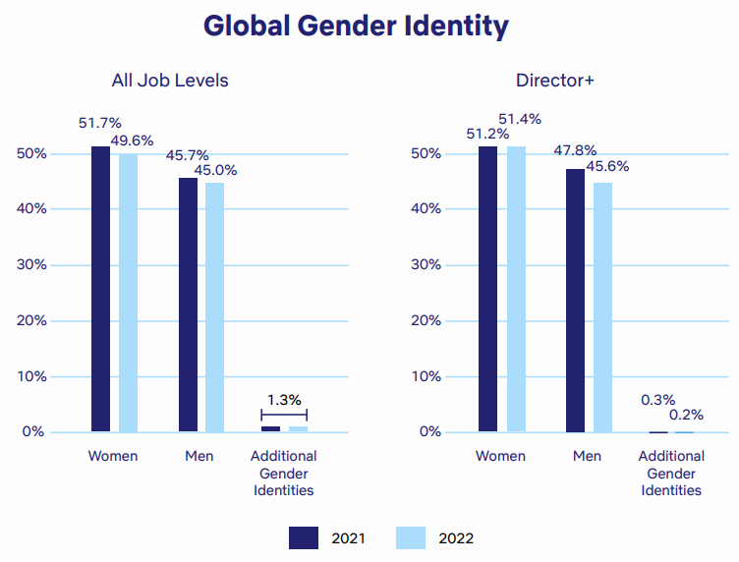
Figure 1: Global Gender Identity Representation Today
(Source: Netflix, 2022)
Those are general overall numbers but can mask variations in the data for a region, for an occupation, and by seniority. Improved disclosure should be between key markets on promotion, retention, compensation and career paths. The company has already invested $100 million over five years in promoting underrepresented creators and other groups, including Netflix (2023b). However, funding will be temporary unless there are permanent changes in commissioning and career pathways. When customers see that firms provide actual social value, research shows that it is linked to customer loyalty (Nguyen et al. 2022). Another research study revealed that responsibility impacts loyalty through the lenses of trust, satisfaction and perceived organisational credibility (Tran, 2022). Hence, the management should consider the level of responsibility based on the outcomes of the stakeholder, not in terms of any publicity generated, or programme cost. Almost one-third of its members use accessibility features and the total hours of audio described content are over 13,000 hours in 34 languages (Netflix, 2026a). Particularly future reporting should take place on the number of hours available as well as on the gaps in terms of whether people are completing or happy with the programme and whether it is easy to access. Around 415 TWh, or 1.5 per cent of global electricity consumption, was used by data centres in 2024 (International Energy Agency, 2025).
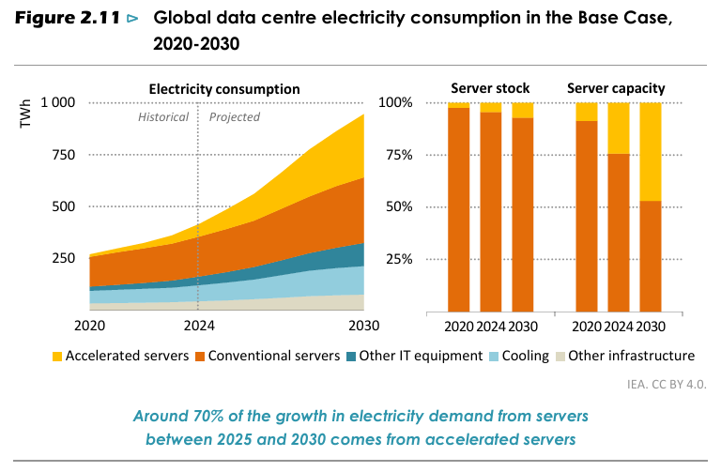
Figure 2: Global data centre electricity consumption in the Base Case, 2020-2030
(Source: Iea, 2025)
Netflix isn't responsible for all networks and devices used for streaming. But material impacts can be lessened if there is effective encoding, renewal of procurement, production standards, and open supplier requirements.

3.2 Balanced Scorecard

3.2.1 Financial Perspective
This financial goal should be a balance between good business growth and good business returns from content and advertising strategies. In second quarter 2026, Netflix's revenue amounted to 12.6 billion dollars, with an operating margin of 33% (Netflix, 2026b). The revenue growth should be kept in the double digits on an annual basis and the margins need to be in the vicinity of 30%. Indicators that are relevant are revenue growth, advertising contribution, content return, Free cash flow and retention adjusted profitability.
Technology investments should be correlated with measurable strategic outcomes, not individual activities (Fabac, 2022). There should be a requirement on Netflix to review portfolios after release to see if it is worth the price of keeping, advertising and catalogue value. The targets need to be flexible as there is uncertainty in creative performance which can't be eliminated by the budgeting process.

3.2.2 Customer Perspective
The objective of the customer should reinforce the perceived value, trust, access and satisfaction in various markets. Functional and experiential quality are found to create satisfaction and repurchase intentions in online service environments (Ananda et al. 2023). Netflix should focus on decreasing voluntary churn, better recommendation satisfaction and higher completion rates of new subscribers. Clear communication of the plan, easy-to-use interfaces, local payment systems, and robust content discovery should all be part of initiatives. UK data shows that young people are more likely to start with online platforms to access subscription video while demand for these services has stalled in the UK (Ofcom, 2025).
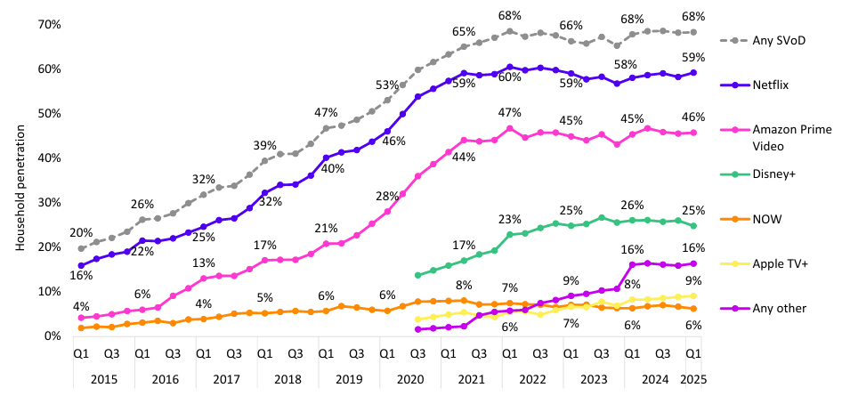
Figure 3: SVoD penetration of UK households, by provider: Q1 2015 to Q1 2025
(Source: Ofcom, 2025)
Recommendations for Netflix include watching monthly active use, reasons for canceling, customer effort, cross-border use, and accessibility satisfaction (Pekpazar et al. 2023). The targets of customers vary from market to market due to the fact that affordability, competition, regulation, and viewing habits are still unequal.

3.2.3 Internal Business Processes
The internal goal should enhance the discipline, quality and recommendation of the commission, production efficiency and execution of ads. There are a variety of data performance frameworks focusing on the quality, value, data governance and operational reliability of data (Pierce, 2022). Netflix should aim to make faster decisions, reduce the number of delayed releases, improve the ad delivery, and increase the diversity of recommendations. Governance should consider the algorithms and their bias toward using well-known titles and reduce discovery opportunities.
Streaming interfaces have been studied, and better perceived diversity and discovery of content can be achieved by using social recommendation (Kim et al. 2023). Similar research in the field of provider fairness also shows the need for algorithmic goals for diversity and catalogue coverage (Karakolis et al. 2022). Netflix should explore explainable recommendations, increased visibility of catalogue and intentional editorial manipulation for various audiences.

3.2.4 Learning and Growth Perspective
The learning objective should be designed to foster creativity, advertising skills and competencies, responsible use of AI and international leadership skills. While digital HR practices can positively affect innovative performance, poorly managed technology can also foster employee disengagement (Hu and Lan, 2024). Netflix should record key competencies that are retained, moved within the organization, completed, the quality of experimentation and employee confidence. More robust succession planning and measurable skills development in advertising and live programming should be targeted.
Organisational learning is used to build resilience when individuals turn their learning to better practices and innovation (Awad and Martín-Rojas, 2024). After big films, ads, tech experiments and live events, Netflix needs to create a structured review process. Lessons need to be uploaded to searchable systems and future investment criteria, instead of being a part of individual teams.

4. Strategic Choices and Implementation

4.1 Available Business-Level Choices
Netflix could opt for cost leadership, Focused differentiation, Wide entertainment diversification or Broad differentiation. Pure cost leadership seems inappropriate as content quality, brand reputation and personalisation influence customers' readiness to subscribe. Competition can come in various forms of the larger competitor with streaming via commerce, hardware, advertisement or telecommunication activities. Therefore, Netflix has the least powerful structure to continue to compete on price in each of the markets.
There is still a broad differentiation that is feasible due to Netflix's global reach, local production, convenience and recommendation technology. Selected audiences, languages, formats and advertising-supported plans would enhance this benefit with focused differentiation. There is potential for new revenue through increased game, venue, merchandise and unrelated experience diversification. But the complexity of organisations can become a hindrance to investment discipline, and divert leadership from the profitable streaming platform.

4.2 Recommended Strategy
It is recommendable to differentiate content, using local-global content, to personalise content, using trusted content, to adjust prices and to show selective live content. Netflix should invest in original, local content that has an international appeal, with a disciplined approach to a content portfolio. Advertising and live events shouldn't detract from the ease of access to the subscription platform.
According to a performance-ranking study, balanced evaluation is possible for strategic units in several objectives and stakeholder interests (Şenel et al. 2022). Netflix should prioritize content categories by these factors: retention, reach, advertising value, cultural relevance and the content's lifetime contribution. While financial returns will always be important, it is important that viewing hours are not the sole factor in commissioning. This method of portfolios would aid in the protection of experimentation, and would also be able to help pinpoint underperformance earlier.

4.3 Porter’s Five Forces Validation
There is a very high level of competitive rivalry as the audience splits up between streaming, social media, games, broadcasting and piracy. The power of the buyer is also strong as there are few restrictions on terminating the service and competition is plentiful. This pressure effects price rises, especially given household budgets are still tight, and reduces the tendency for price rises. Direct Comparability is limited through focused differentiation, which provides unique stories, events, accessibility and personalised discovery.
Supplier power is variable, as a well-known creator and sports rights can fetch big dollar values. Netflix, though, can offset such pressure by investing in talent and making diverse production partnerships. It is hard to enter at the global level due to the need for a significant investment in content creation, distribution, brand reputation, and recommendations. These forces are proponents of differentiation but require very tight control of limited premium rights. The amount spent on original content in Europe stands at 25.1 billion euros in 2024, of which about one-third is being produced by European streamers (European Audiovisual Observatory, 2025).
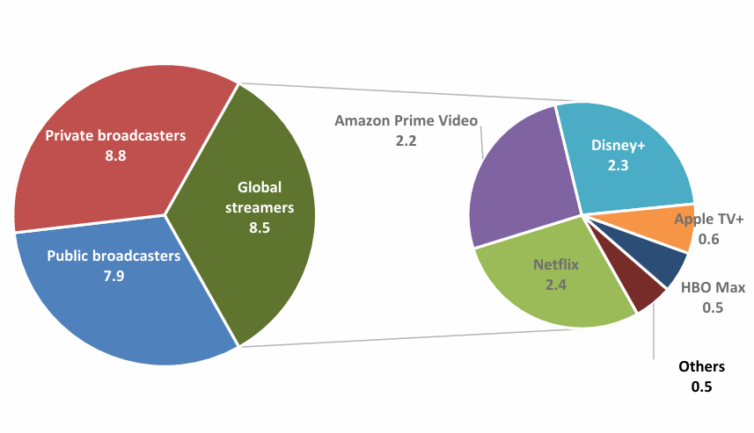
Figure 4: Breakdown of spending* on European original content (EUR bn, 2024)
(Source: Coe, 2025)
This investment marks a step to the right direction, as local production no longer is a collateral matter but a core competitive requirement. Netflix should not do the same kind of uniform increase in their spending, as budget levels are easer to mimic than learning. The benefit should be gained from selecting, producing, distributing and exporting local stories more effectively.

4.4 Ansoff and SAFe Evaluation
These are the market penetration opportunities that should be pursued first for the purposes of retention, advertising conversion and value of accounts, according to Ansoff's Matrix. Product development should be geared toward supporting selective live events, improving recommendations, and providing easy viewing features. Partnerships, mobile plans, and local payments should be used for the development of markets in underpenetrated economies. Operational links and customer demand are not yet certain, so diversification is not a priority for unrelated diversification.
Dynamic capability research indicates that successful transformation is dependent on change management relating technology, people, and strategic goals (Al-Moaid and Almarhdi, 2024). The proposal is appropriate as it tackles issues of churn, rivalry, affordability and cultural fragmentation. It's okay and it can work in tandem to allow for margins to be protected, combined with growth for shareholders and creative partners. It's possible due to Netflix already having worldwide distribution, data, brand and production relationships.
Personalised next-best-action systems can enhance decisions by learning from the interactions between multiple parties and fluctuating conditions (Cao and Zhu, 2022). Netflix might use this logic for customer offers, advertising frequency, content promotion, and preventing customers from canceling. However, automated actions must be consented, tested for privacy, fair and subject to human verification. These enable trust to be maintained and short term optimisation to not affect the long term relationship with the customer.

4.5 Performance and Competitive Advantage
Lower churn, better advertising yields, more catalogue usage and better production allocation, can provide focused differentiation to enhance performance. The satisfaction of recommender systems can vary based on the content, relevance, and format of the explanations (Zhang et al. 2022). Netflix should offer brief and comprehensible explanation for recommendations, while not revealing any sensitive behavioral profiles (Acharya et al. 2023). Clear revelation can enhance trust and assist customers to find local or international programmes they are not familiar with.
Fair recommendation research emphasizes the importance of taking into account users, creators, and other affected stakeholders (Dinnissen and Bauer, 2022). Netflix has a balance to strike between being relevant to customers and providing platforms to build exposure for smaller productions and regional creators. This balance provides for more catalogue worth and decreases reliance on a limited number of high-cost franchises. This makes the system more difficult to duplicate as it involves not just technical competence, but creative relationships and organisational processes.

4.6 Implementation Challenges and Mitigation
Implementation presents financial, organisational, ethical and operational risks which need to be carefully staged. Too frequent or inappropriate interruptions in viewing could undermine the quality of viewing.Too many ads or inappropriate ads could impact viewing quality. When Netflix's revenue outlook failed to outpace already high investor expectations, it was a sign of concern, said Reuters (2025). Managers should accordingly set achievable milestones and not offer lure of quick profits on business development.
Live programming brings with it the risks of rights inflation, technical problems, unpredictable demand and reputation risk. The use of limited rights portfolios, shared commercial partnerships, rehearsed capacity testing and clear exit criteria should be used by Netflix. Content localisation can also result in censorship issues or unevened brand standards in different jurisdictions. Regional governance committees should be made integrated of local knowledge, legal check, creativity and accountability to the centre.
The proxy statement stipulates that the executives own a significant share of the company, such as six times the executives' pay for Netflix (2026c). Such a governance structure sets up leadership to create long term value for shareholders, but ownership is not enough to guarantee and ensure responsible leadership. The content of the activities, the risk associated to the algorithms, the capacity of the employees, the emissions and customer trust should be reviewed by board oversight quarterly. Executive incentives should include both financial and actual customer, process, and responsibility outcomes.

4.7 Conclusion
Netflix needs to embrace smart differentiation through local-global content, trusted personalisation, affordable prices and limited live programming. It's a plan that leverages the strengths that already exist, while minimizing the cost of the coordination that unrelated diversification might generate. Measurable objectives are necessary, investment in stages, responsible technology and robust regional management are essential for a balanced implementation. This will take a long time to achieve, and it will require disciplined learning – not spending money or grabbing the audience's attention for a short time.

5. Reflective Account Using Gibbs’ Reflective Cycle

5.1 Description and Initial Feelings
I started the task by identifying the strategic unit to which Netflix will focus on the world’s streaming business. This boundary helped to minimize the impact of non-relevant activities on the analysis, and ensured information selection was uniform throughout the project. Then I checked out company disclosures, academic research, regulatory information and reputable industry information.
But the amount of information created led to uncertainty in terms of relevance, comparison and sourcing quality. Multiple reports omitted the need to include company stories and limitations/stakeholder issues in a similar fashion. I also discovered that strategic frameworks might motivate description when utilized separately as checklists. So, instead of focusing exclusively on the categories of the framework, I gathered evidence around decisions, tensions and implications.

5.2 Evaluation of the Research Process
The best thing was the mixture of up to the minute corporate information and separate academic and institutional evidence. Structured writing has been shown to enhance engagement and learning through structured journal writing research (Zafeer et al. 2023). I applied this to writing my notes on the reasons for why each source supported, challenged or qualified an emerging judgement. This approach helped to minimise unsupported claims, and identified inconsistencies between the claims made and strategic risk.
Emphasis in the source-screening process was given to recent peer-reviewed research, official reporting, and publically available statistics. When learners engage in active interpretation of the information, feedback based on analytics can enhance reflective performance (Suraworachet et al. 2023). I continually checked each portion for evidence of evaluation and determined if the evidence was present. This checking enhanced alignment, but also took a lot of time and structural revisions.
Several restrictions were noted due to the lack of profitability and churn rate per segment of the market and algorithmic outcomes at the title level. The adjustments in measures also occurred in the company disclosures and thus made a comparison with the previous reporting periods difficult. To overcome these weaknesses, I eliminated false precision, and split the evidence from reasoned inference. Some recommendations are, however, tentative, as information is not available on internal costs, customers and staff.

5.3 Analysis of Learning
The task helped me to understand the interplay between external pressures, resources and implementation decisions. Reflective writing aids deeper learning for students who consider and reflect on their assumptions and relate theory to practice (Sudirman et al. 2024). I knew that frameworks could offer questions that were helpful, but not the critical questions. They are based on the quality of the evidence, how evidence is compared, prioritised and explained.
At the beginning, I considered Corporate Responsibility as an ethical issue, instead of a performance issue. These were found to have an impact on customer value and organizational resilience through the processes of accessibility, inclusion, emissions, governance and trust. This change enabled me to relate the concept of CSR and the recommended strategy with the balanced scorecard. It was also shown how the financial and non-financial elements must be interpreted with great care in an integrated way.
I also found out that there are feasibility, ownership, targets, and implementation safeguards found in recommendations. When expectations and assessment purposes are not clear, the summative reflection research shows that students' understanding is not even (Ross et al. 2024). The Gibbs' stages helped to make the description of the activity clearer and to help evaluate the effectiveness of the activity. This was the place where the problems of research were translated into concrete enhancements which could be addressed in future studies.

5.4 Conclusion and Action Plan
Overall, the completed process instilled me with confidence in choosing evidence to support my own claims and countering corporate claims. It also revealed the lack of planning in early stages such as reading too much before formulating analytical questions. Future work will start with a requirement map that will connect all the criteria with evidence and expected judgements. I will keep a source matrix which will show credibility, method, relevance, limitations, and intended-use.
I will also develop tentative arguments prior to reading, and revise them after reading and finding more convincing evidence. For each of the major recommendations, an evidence test, counter argument, feasibility check and measurable implementation outcome will be provided. This process should make it easier to avoid having descriptive writing and enhance clear strategic thinking. It will also ensure coherence in the case of multiple frameworks tackling the same organisational issues.
Last, but not least, I will set aside time for sentence control, referencing consistency and final count of words. In my future reflection I will provide evidence that feedback worked NOT just to make my personal feelings more positive, but changed the decisions that I made. Such actions should lead to a clearer analysis and more balanced judgement and proffessional recommendations. They also help them to learn independently in a complex and uncertain management situation.

Reference list
Acharya, N., Sassenberg, A.-M. and Soar, J. (2023) ‘Consumers’ behavioural intentions to reuse recommender systems: Assessing the effects of trust propensity, trusting beliefs and perceived usefulness’, Journal of Theoretical and Applied Electronic Commerce Research, 18(1), pp. 55–78. Available at: https://doi.org/10.3390/jtaer18010004
Al-Moaid, N.A.A. and Almarhdi, S.G. (2024) ‘Developing dynamic capabilities for successful digital transformation projects: The mediating role of change management’, Journal of Innovation and Entrepreneurship, 13, article 85. Available at: https://doi.org/10.1186/s13731-024-00446-9
Ananda, A.S., Hanny, H., Hernández-García, Á. and Prasetya, P. (2023) ‘“Stimuli are all around”—The influence of offline and online servicescapes in customer satisfaction and repurchase intention’, Journal of Theoretical and Applied Electronic Commerce Research, 18(1), pp. 524–547. Available at: https://doi.org/10.3390/jtaer18010027
Awad, J.A.R. and Martín-Rojas, R. (2024) ‘Digital transformation influence on organisational resilience through organisational learning and innovation’, Journal of Innovation and Entrepreneurship, 13, article 69. Available at: https://doi.org/10.1186/s13731-024-00405-4
Baek, H., Jang, M. and Kim, S. (2024) ‘Strategies to mitigate the cannibalization effect between subscription video-on-demand and transactional video-on-demand’, Digital Business, 4(1), article 100073. Available at: https://doi.org/10.1016/j.digbus.2024.100073
Bastos, M., Naranjo-Zolotov, M. and Aparício, M. (2024) ‘Binge-watching uncovered: Examining the interplay of perceived usefulness, habit, and regret in continuous viewing’, Heliyon, 10(6), article e27848. Available at: https://doi.org/10.1016/j.heliyon.2024.e27848
Canadian Radio-television and Telecommunications Commission (CRTC) (2024) Broadcasting Regulatory Policy CRTC 2024-121: The Path Forward—Supporting Canadian and Indigenous Content through Base Contributions. Available at: https://crtc.gc.ca/eng/archive/2024/2024-121.htm (Accessed: 24 July 2026).
Cao, L. and Zhu, C. (2022) ‘Personalized next-best action recommendation with multi-party interaction learning for automated decision-making’, PLOS ONE, 17(2), article e0263010. Available at: https://doi.org/10.1371/journal.pone.0263010
Choi, M., Xiang, T., Lim, H., Kim, Y., Ahn, M., Oh, S. and Kim, H. (2024) ‘Caching, transcoding, delivery and learning for advanced video streaming services’, ICT Express, 10(4), pp. 774–785. Available at: https://doi.org/10.1016/j.icte.2024.05.012
Deloitte (2025) 2025 Digital Media Trends: Social Platforms Are Becoming a Dominant Force in Media and Entertainment. Available at: https://www.deloitte.com/us/en/insights/industry/technology/digital-media-trends-consumption-habits-survey/2025.html (Accessed: 24 July 2026).
Dinnissen, K. and Bauer, C. (2022) ‘Fairness in music recommender systems: A stakeholder-centered mini review’, Frontiers in Big Data, 5, article 913608. Available at: https://doi.org/10.3389/fdata.2022.913608
European Audiovisual Observatory (2025) Investments in original European content 2014–2024: Data September 2025. Strasbourg: Council of Europe. Available at: https://rm.coe.int/investments-in-original-european-content-2014-2024-data-september-2025/4880282a02 (Accessed: 4 August 2026).
European Audiovisual Observatory (2025) One third of spending on European original content is made by global streamers. Available at: https://www.obs.coe.int/en/web/observatoire/-/one-third-of-spending-on-european-original-content-is-made-by-global-streamers (Accessed: 4 August 2026).
European Commission (2020) Commission Releases Guidelines on Video-Sharing Platforms and Guidelines on European Works. Available at: https://digital-strategy.ec.europa.eu/en/library/commission-releases-guidelines-video-sharing-platforms-and-guidelines-european-works (Accessed: 24 July 2026).
Fabac, R. (2022) ‘Digital balanced scorecard system as a supporting strategy for digital transformation’, Sustainability, 14(15), article 9690. Available at: https://doi.org/10.3390/su14159690
Financial Times (2024) ‘How Netflix won the streaming wars’, 17 September. Available at: https://www.ft.com/content/465a2d0d-8973-4d8d-827d-8729737e6606 (Accessed: 24 July 2026).
Grand View Research (2025) Video Streaming Market Size & Share, Industry Report, 2030. Available at: https://www.grandviewresearch.com/industry-analysis/video-streaming-market
Gupta, S. (2023) ‘The impact of e-WOM on users’ attitudes toward over-the-top streaming video content and its subscription intention: Young Indians’ perspective’, International Journal of Professional Business Review, 8(2), article e01046. Available at: https://doi.org/10.26668/businessreview/2023.v8i2.1046
Hu, D. and Lan, Y. (2024) ‘The dual path effect mechanism study of digital-HRM on employee innovative performance and cyberloafing’, PLOS ONE, 19(8), article e0307195. Available at: https://doi.org/10.1371/journal.pone.0307195
International Energy Agency (2025) Energy and AI. Paris: International Energy Agency. Available at: https://www.iea.org/reports/energy-and-ai (Accessed: 4 August 2026).
International Energy Agency (2025) Energy and AI. Paris: International Energy Agency. Available at: https://iea.blob.core.windows.net/assets/de9dea13-b07d-42c5-a398-d1b3ae17d866/EnergyandAI.pdf (Accessed: 4 August 2026).
International Telecommunication Union (ITU) (2025) Measuring Digital Development: Facts and Figures 2025. Available at: https://www.itu.int/itu-d/reports/statistics/facts-figures-2025/ (Accessed: 24 July 2026).
Karakolis, E., Kokkinakos, P. and Askounis, D. (2022) ‘Provider fairness for diversity and coverage in multi-stakeholder recommender systems’, Applied Sciences, 12(10), article 4984. Available at: https://doi.org/10.3390/app12104984
Kim, S., Huh, I. and Lee, S. (2023) ‘No movie to watch: A design strategy for enhancing content diversity through social recommendation in the subscription-video-on-demand service’, Applied Sciences, 13(1), article 279. Available at: https://doi.org/10.3390/app13010279
McKenzie, J., Crosby, P., Collins, A. and Chmura, T. (2025) ‘No such thing as a free movie? Cross-country evidence on the potential impact of AVOD streaming services’, Journal of Cultural Economics, 49, pp. 407–433. Available at: https://doi.org/10.1007/s10824-024-09505-1
Menon, D. (2022) ‘Purchase and continuation intentions of over-the-top video-streaming platform subscriptions: A uses and gratification theory perspective’, Telematics and Informatics Reports, 5, article 100006. Available at: https://doi.org/10.1016/j.teler.2022.100006
Netflix (2023a) 2022 Inclusion Report Update. Available at: https://about.netflix.com/en/news/2022-inclusion-report-update (Accessed: 4 August 2026).
Netflix (2023b) Making Progress: Our Latest Film and Series Diversity Study and Netflix Fund for Creative Equity Updates. Available at: https://about.netflix.com/en/news/making-progress-our-latest-film-and-series-diversity-study-and-netflix-fund (Accessed: 4 August 2026).
Netflix (2026a) Our Latest Steps to Make Content More Accessible. Available at: https://about.netflix.com/en/news/our-latest-steps-in-making-content-more-accessible (Accessed: 4 August 2026).
Netflix (2026b) Q2 2026 Shareholder Letter. Available at: https://s22.q4cdn.com/959853165/files/doc_financials/2026/q2/FINAL-Q2-26-Shareholder-Letter.pdf (Accessed: 4 August 2026).
Netflix (2026c) 2026 Proxy Statement. Available at: https://www.sec.gov/Archives/edgar/data/1065280/000119312526159286/d20613ddef14a.htm (Accessed: 4 August 2026).
Netflix (n.d.) Sustainability. Available at: https://about.netflix.com/en/sustainability (Accessed: 4 August 2026).
Netflix Inc. (2025a) Form 10-K Annual Report 2024. Available at: https://www.sec.gov/Archives/edgar/data/1065280/000106528025000044/nflx-20241231.htm
Netflix Inc. (2026a) Form 10-K Annual Report 2025. Available at: https://www.sec.gov/Archives/edgar/data/1065280/000106528026000034/nflx-20251231.htm
Netflix Inc. (2026b) Company Profile. Available at: https://ir.netflix.net/ir-overview/profile/default.aspx
Netflix Inc. (2026c) Netflix Culture Memo. Available at: https://jobs.netflix.com/culture
Netflix Inc. (2026d) Q4 2025 Shareholder Letter. Available at: https://s22.q4cdn.com/959853165/files/doc_financials/2025/q4/FINAL-Q4-25-Shareholder-Letter.pdf
Netflix, Inc. (2022) Open Connect: Celebrating a Decade of Smooth and Efficient Streaming. Available at: https://about.netflix.com/en/news/open-connect-celebrating-a-decade-of-smooth-and-efficient-streaming (Accessed: 24 July 2026).
Netflix, Inc. (2023) 2022 Environmental, Social & Governance Report. Los Gatos, CA: Netflix, Inc. Available at: https://s22.q4cdn.com/959853165/files/doc_downloads/2023/06/29/Netflix_2022-ESG-Report-FINAL.pdf (Accessed: 4 August 2026).
Netflix, Inc. (2024) Our Sustainability Progress: Three Years In. Available at: https://about.netflix.com/en/news/netflix-sustainability-progress-three-years-in (Accessed: 24 July 2026).
Netflix, Inc. (2026a) 2025 Annual Report. Available at: https://s22.q4cdn.com/959853165/files/doc_financials/2025/ar/99482238-46b2-4d0d-b292-40e6781bdf03.pdf (Accessed: 24 July 2026).
Netflix, Inc. (2026b) Netflix Upfront 2026: Get Closer. Available at: https://about.netflix.com/en/news/netflix-upfront-2026-get-closer (Accessed: 24 July 2026).
Nguyen, D.T., Bach, K.V., Bui, K.L., Tran, N.M. and Le, H.N. (2022) ‘The relationship between corporate social responsibility and customer loyalty: Evidence from Vietnam’, International Journal of Customer Relationship Marketing and Management, 13(1), pp. 1–16. Available at: https://doi.org/10.4018/IJCRMM.304909
Nielsen (2026) Streaming Shatters Multiple Records in December 2025 with 47.5% of TV Viewing. Available at: https://www.nielsen.com/news-center/2026/streaming-shatters-multiple-records-in-december-2025-with-47-5-of-tv-viewing-according-to-nielsens-the-gauge/ (Accessed: 24 July 2026).
Ofcom (2025) Media Nations 2025. Available at: https://www.ofcom.org.uk/media-use-and-attitudes/media-habits-adults/media-nations-2025 (Accessed: 4 August 2026).
Ofcom (2025) Media Nations 2025: UK Report. London: Office of Communications. Available at: https://www.ofcom.org.uk/siteassets/resources/documents/research-and-data/multi-sector/media-nations/2025/media-nations-2025-uk-report.pdf?v=401287 (Accessed: 4 August 2026).
Pekpazar, A., Coşkun, M.C. and Altın Gümüşsoy, C. (2023) ‘Conceptualization and survey instrument development for over-the-top platforms’ usability’, Journal of Theoretical and Applied Electronic Commerce Research, 18(4), pp. 1764–1796. Available at: https://doi.org/10.3390/jtaer18040089
Pierce, E. (2022) ‘A balanced scorecard for maximizing data performance’, Frontiers in Big Data, 5, article 821103. Available at: https://doi.org/10.3389/fdata.2022.821103
Reuters (2025) ‘Netflix shares fall as weak dollar-driven forecast fails to impress’, 18 July. Available at: https://www.reuters.com/business/finance/netflix-shares-fall-weak-dollar-driven-forecast-fails-impress-2025-07-18/ (Accessed: 4 August 2026).
Ribeiro, H., Barbosa, B., Moreira, A.C. and Rodrigues, R.G. (2024) ‘Determinants of churn in telecommunication services: A systematic literature review’, Management Review Quarterly, 74, pp. 1327–1364. Available at: https://doi.org/10.1007/s11301-023-00335-7
Ross, M., Bohlmann, J. and Marren, A. (2024) ‘Reflective writing as summative assessment in higher education: A systematic review’, Journal of Perspectives in Applied Academic Practice, 12(1), pp. 54–67. Available at: https://doi.org/10.56433/jpaap.v12i1.577
Seger, B.T., Burkhardt, J., Straub, F., Scherz, S. and Nieding, G. (2023) ‘Reducing the individual carbon impact of video streaming: A seven-week intervention using information, goal setting, and feedback’, Journal of Consumer Policy, 46, pp. 137–153. Available at: https://doi.org/10.1007/s10603-023-09536-9
Şenel, U.T., Rouyendegh, B.D. and Demir, S. (2022) ‘A multi-attribute approach to ranking departments based on performance: A balanced scorecard pilot study’, Complex & Intelligent Systems, 8, pp. 4177–4185. Available at: https://doi.org/10.1007/s40747-022-00710-z
Shah, R., Cemiloglu, D., Yucel, C., Ali, R. and Katos, V. (2024) ‘Is cyber hygiene a remedy to IPTV infringement? A study of online-streaming behaviours and cyber-security practices’, International Journal of Information Security, 23(3), pp. 1913–1926. Available at: https://doi.org/10.1007/s10207-024-00824-0
Sohl, T., McCann, B.T. and Vroom, G. (2022) ‘Business model diversification: Demand relatedness, entry sequencing, and curvilinearity in the diversification-performance relationship’, Long Range Planning, 55(6), article 102215. Available at: https://doi.org/10.1016/j.lrp.2022.102215
Sudirman, A., Gemilang, A.V., Kristanto, T.M.A., Robiasih, R.H., Hikmah, I., Nugroho, A.D., Karjono, J.C.S., Lestari, T., Widyarini, T.L., Prastanti, A.D., Susanto, M.R. and Rais, B. (2024) ‘Reinforcing reflective practice through reflective writing in higher education: A systematic review’, International Journal of Learning, Teaching and Educational Research, 23(5), pp. 454–474. Available at: https://doi.org/10.26803/ijlter.23.5.24
Suraworachet, W., Zhou, Q. and Cukurova, M. (2023) ‘Impact of combining human and analytics feedback on students’ engagement with, and performance in, reflective writing tasks’, International Journal of Educational Technology in Higher Education, 20, article 1. Available at: https://doi.org/10.1186/s41239-022-00368-0
Tran, N.T. (2022) ‘Impact of corporate social responsibility on customer loyalty: Evidence from the Vietnamese jewellery industry’, Cogent Business & Management, 9(1), article 2025675. Available at: https://doi.org/10.1080/23311975.2022.2025675
Wang, D. and Zhao, X. (2022) ‘Affective video recommender systems: A survey’, Frontiers in Neuroscience, 16, article 984404. Available at: https://doi.org/10.3389/fnins.2022.984404
Zafeer, H.M.I., Li, Y. and Maqbool, S. (2023) ‘An approach to progress learning outcomes: International graduate students’ engagement in reflective practice and reflective journal writing during pandemic’, Sustainability, 15(3), article 1898. Available at: https://doi.org/10.3390/su15031898
Zhang, Z., Chen, L., Jiang, T., Li, Y. and Li, L. (2022) ‘Effects of feature-based explanation and its output modality on user satisfaction with service recommender systems’, Frontiers in Big Data, 5, article 897381. Available at: https://doi.org/10.3389/fdata.2022.897381
Zhao, Y., Wang, S., Wang, Y. and Liu, H. (2023) ‘MbSRS: A multi-behavior streaming recommender system’, Information Sciences, 631, pp. 145–163. Available at: https://doi.org/10.1016/j.ins.2023.01.101

