Internet of Things, Smart City Security & Cloud-Based Services Security Issues
Module: Network Security (M7X01701)
Computer Networks & Cybersecurity
Student Number P147535
Lecturer: Dr. Carlene Campbell
Abstract—This paper is divided into two parts, the first part is a research analysis that examines the security issues, importance and limitation of two important topics in the field of Information Technology (IT); Cloud-Based services and Internet of Things (IoT) and smart cities. In the second part, the author will be performing a real-life penetration testing scenario to the live website (https://tevelcyber.com/) while providing a professional report underlining all the vulnerabilities found or exploited with a viable solution to mitigate those threats. Cloud services are IT-based services offered to clients on a network system for a specific period with the capacity to upscale or downscale the service's specifications. The benefits of the service include its flexible and resilient nature, scalability, functionality, and outsourcing of minor organisational operations. It is a novel organisational framework that can be adopted by businesses without investing in it upfront. Despite the many benefits of the cloud services, however, businesses are skeptical about adopting it as a result of the privacy protection challenges and threats that the service is vulnerable to. One core challenge that affects the development of the cloud service is data security. Handling confidential information to another firm is quite worrying, so providers must be cautious and understand the risks involved in information breaches in this new setting. In this paper, the security challenges associated with cloud services are discussed in detail. IoT works together with cloud services and blends with intelligent technological tools and systems, and these systems are sensitive to the occurrence of events in their environs and threshold and capable of responding while integrated into a network system. Various individuals, organisations, and industries have integrated IoT in their set up. Whether in residences, official buildings, law enforcement departments, medical care, agriculture, logistics, educational or environments; IoT and metropolitan states have been universally instigated to ensure all aspects and sectors operate effectively and efficiently.

Index Terms—Network Security, Internet of Things (IoT), Penetration testing (Ethical Hacking), Cybersecurity, Cybercrime, Artificial Intelligence (AI), Denial of Service (DoS), Risk Assessment Framework (RAF), Web Application Firewall (WAF), Open Web Application Security Project (OWASP), Transport Layer Security (TLS), Secure Socket Layer (SSL), Certification Authority (CA), Structured Query Language (SQL) injection (SQLi), Cross-Site Scripting (XSS), XML External Entity (XXE), Strict Transport Security (HSTS), Secure Shell (SSH), File Transfer Protocol (FTP), Intrusion Detection Systems (IDS), Intrusion Prevention Systems (IPS), Network Behaviour Analysis system (NBA), Hypertext Transfer Protocol Secure (HTTPS), Hypertext Preprocessor (PHP).

INTRODUCTION
Information Technology keeps changing every aspect of human life, from simple online purchase to a self-driven taxi or live online heart surgery. Everything is changing fast, thanks to the large growth of the internet, IoT, cloud services, technological advancement, high-speed connection and more. All these come with huge price and great pressure, a pressure that IT experts trying to absorb in the fight against cybercrimes [1]. In the current climate, every individual or organisation are required some degree of network security to fight these growing cyber threats. Cloud computing is the computational framework that conveys processes between software and hardware through the centralisation of data storage, processing, and bandwidth. The cloud model delivers services through web browsers or light-weight desktop machines over the Internet [2]. This model eliminates the traditional needs of remote servers in non-cloud computing while drastically slashing costs [3]. A variety of attacks are potential plagues to cloud-based services. Identify theft is one of the commonest. Others are session Hijacking issues, Temporary Denial of Service (TDOS) attacks, and flashing attacks [4]. This paper intends to examine the problems facing cloud services, highlighting the gap between current cloud security measures and the existing cloud service threats.
As computers, hackers are increasingly becoming more sophisticated due to the avalanche of knowledge in the public domain and the resultant benefits of a single successful hack. The issues facing clue services are equally growing at sporadic rates, with new vulnerabilities surfacing nearly daily, putting individuals and businesses at extremely significant risk. Security and privacy are the two major challenges facing cloud services and IoT. The goal and objective of the IoT are to ensure the digital space is reformed. The notion of the IoT is to integrate zillions of smart tools that would leave room for conversing and interacting with each other at any given period or location.

Network Security

Penetration Testing
Penetration testing is simulated cyber-attack performed by an ethical hacker to uncover and exploit any number of vulnerabilities within computer systems such as web applications, protocols, interfaces (APIs), web servers, etc. Many types of penetration testing exist such as External testing, Internal testing, Black-Box testing, Grey-Box testing and White-Box testing, each of these tests is designed to serve a specific purpose. Penetration testing is often governed by a detailed penetration testing framework as part of the wider Risk Assessment Framework (RAF), every penetration tester or ethical hacker must adhere and follow the guides and steps to ensure the integrity of data and assets. As per this scenario given, the author will be performing a black-box penetration test for Tevel Corps website, in this context, the primary aim of this penetration testing would be enhancing the Web Application Firewall (WAF) and providing a professional report with proposed solutions and designs to mitigate the threats uncovered [5][6].

Black-Box Penetration testing
Penetration testing tasks are often categorised into different spectrums, all based on the level of knowledge and the access granted. This variation goes from Black-Box Penetration testing where the Ethical hacker is given minimum information about the targeted system to Grey-Box Penetration testing and finally to White-Box where a higher level of information and access is been granted. In Black-Box penetration testing, the pen tester or consultant must have good knowledge about automated scanning tools and methodologies to perform a manual penetration testing. Also, being able to re-create a network map of the targeted system based on the information captured. In general, this type of penetration testing depends mainly on dynamic analysis of programs and systems within the target network and the ability to gather enough information to perform the task [7][8][9].

Cloud-Based Service Security Issues
Organisations globally are keying into the plethora of ease and profit that cloud computing brings into their businesses. With the widespread adoption comes new challenges that outdo present-day security measures partially and sometimes downright [10]. Cloud computing creates threats that are taken by providers as shared responsibility. Here are the primary issues of security:
Server and Application Access
Traditional data centres have data centres on the scene; in cloud computing, access by the administrator is through the web. This lack of total control increases the propensity sporadically for breaches in security to occur since access control is beyond the administrator's sole reach [10]. The need to rigorously monitor and manage all administrative access in of uttermost importance. This can be enhanced by creating a seamless exchange of security policies between the vendor and the user.
Data Transmission
Massive amounts of data transmission take place in cloud computing. These involve communication between the vendors and the users, the user to user transmission, and user to third party transmission. Data transmission requires that the sending and receiving ends are tidied through encryption to guarantee safety. The questionable strength of most encryptions can create vulnerability and leave a space for attackers to find a place between traffic that is being exchanged on both poles. This is usually referred to as man-in-the-middle attack [11]. This nature of the attack is one of the commonest when discussing the breach of data transmission. This nature of attack can be minimised by auditing and limiting access to information utilising access controls. Creating access levels and authentication management can also be useful in managing breaches that result from data transmission.

Virtual Machine Security
One of the merits of cloud computing is virtual computing. The versatility of virtual machines makes reversion to previous instances possible. It also has the functionality to pause and restart easily, so different situations running on the same virtual machine are run concurrently and isolated. This dynamism of virtualisation capability is also responsible for enormous security threats that virtual machine faces. There are three outcomes of an attack that are unfavourable to users. In the first instance, the guest is compromised; the second instance will have multiple guests compromised; the third is having the host compromised [11]. System admin can unroll guests to the system state before the attack, but if the host is compromised, attackers can have borderless access to computer hardware and unlimited freedom. Local attacks are just one class of VM attacks. Another attack is with the hacker initiating communication between a compromised VM to communicate with another VM on the same localhost. This is in direct violation of the isolation principle of VMs. The hypervisor is another class of attack with the potential of giving attackers access to the hardware and the operating system on which the VM is operating. Denial of Service (DoS) is mostly useful in attacking VMs since it has the potency to consume resources from all VMs on the host.
Network Security
Networks are often subservient to DNS attacks, sniffer attacks, and reused IP addresses. At the births of cloud computing, DDoS attacks were complicated to generate. But with the proliferation of IoT devices, the viability of DDoS attacks has increased sporadically in that if enough traffic is initiated to cloud computing, it can cause it to go down entirely or experience difficulties. Shared cloud computing resources between users can lead to network vulnerabilities, that may happen when one user is compromised. Employee negligence and mistakes can also result in a security compromise.
Data Loss and Inadequate Data Backups
Another security issue is that of loss in data and inadequate backups. It is the port that opens many businesses and organisations to ransomware, a specific type of cloud security threat. The ransomware virus operates by locking away an individual or company data in encrypted files, so much access is only possible after the owner has paid a ransom [12]. Since the ransomware virus only affects the computer, it infests, a reliable data backup centre can help prevent data loss and compromise.
Outdated Protocols, Firewalls, and Virus-protection
Vulnerabilities in systems, especially in networks that possess infrastructures and multiple third-party platforms, are not uncommon. Hackers permeate cloud services through well-known system vulnerabilities such as improper patching and outdated protocols lacking in now supports. Cracks in firewalls and antiquated virus protection also open cloud computing to attacks.

Internet of Things and Smart City Security Issues
Smart cities are created due to the blending of smart markets that interact and converse with each other as a result of their connectivity. Smart cities are an assimilation of smart hubs that communicate with each other due to their connection. This circle includes smart organisations, control network channels, residences, logistics, and hospitality companies' waste control. They have a strong reliance on the data that is retrieved from the smart markets within the network channel framework [13]. Instigation is done via a service system called cloud computational services, which supports every management system's interaction. An extended number of different nodes with connections with each other within a singular post and have the aim of sharing data, interacting, and responding effectively during communications can be called cloud computing. Mentioned below are the highlights of current threats and issues that affect the IoT security.
Intruder Model: A systematic model that poses a threat and invades and intercepts data that is being streamed amongst IoT nodes. DY invader system is highly and can outperform the NSA oftentimes.
Denial of Service Attack (DoS): This can make the information that has been integrated in the IoT framework to be unavailable to persons interested in using it. Often, nodes in the IoT are lacking a high capacity to store data, and computing is not done accurately, which impacts the framework, thus making the threats cause severe havoc.
Physical Attacks: Due to the nature of a mesh, which is distributive, attacks carried out on the hardware systems that are joined to the IoT systems to have them destroyed.
Privacy: A big threat to IoT based network channels is Privacy Invasion. Securing the Privacy of data is quite challenging. There are various threats and attacks carried out on the security of data currently and they include Digging up information, Analysing traffic, Surveying data passively and spying.
Inadequate Patching & Testing: Outdated resources and gadgets may have dangerous bugs that allow invaders to intrude and intercept the Privacy of information. The bugs leave the systems vulnerable, thus allowing attacks to be launched on users' secured data. Nonetheless, even if a host ensures upgrading an IoT-based device, it is important to ensure that the devices and resources are updated constantly and the patch as well to ensure Privacy protection and ward off the activities of attackers [14].
Lack of Standards: Presently, the IoT network has no recognised or noted standards and policies that can be accessed. There is not a single acknowledged or perceived basic description amongst various high-profile and technology inclined firms. There are different intricacies inherent in the setup of the IoT with the availability of varying standards that shadows every bit and piece of the network. As a result, it poses a challenge prospectively as the inconsistencies of the standards are pronounced, thereby counteracting the interactions and connections between IoT based computer systems.

Recommendations
Cloud-based services can also be used to tackle the challenges encountered with certification/authenticity and identification of an object [15]. This cloud-based service would help programmers of the IoT based technologies to concentrate on their core competencies and ensure privacy protection is incorporated within the IoT network, not minding the core competencies of the computer systems.
Authorisation & Authentication: one way to resolve the issue with authentication and Authorisation is to implement an original certification authorised body globally, however, some constraints may be experienced such as the feasibility of issuing certification to every individual object attached to the IoT is low since the amount of the objects totally are majorly high in number. Thus, it is recommended that certification is replaced and in the same vein, Authorisation should be replaced as it is essential for the IoT network.
Lightweight Cryptosystems and Security Protocols: The challenge encountered while using Cryptosystems that are light-weighted and protection protocols could be tackled implementing cryptosystems that use symmetric key because overt source key cryptosystems typically offer increased protected components although there is which undergoes increased overheads during computation. This causes them to be used minimally or completely left out several times. Thus, the decline in overheads while computing for overt symmetric-key cryptosystems and complex protection systems would continue to be a core problem for privacy protection in IoT based systems [16].
Software Vulnerability and Backdoor Analysis: The issues with backdoor description and the loops in software applications that can be taken advantage of by invaders is a challenge [17] and can be tackled by implementing a very functional and efficient method such as the Dynamic evaluation which serves as a support for experts into software developing and sampling to detect the core weaknesses and loops of the product prior to launching it. The dynamic evaluation could be made highly functional by implementing the emulation procedure, which can emulate the attitudes of systems in a server that has increased computational abilities thereby supporting the process of the dynamic evaluation to outwit the constraints of resources. Furthermore, to ensure backdoors are eradicated, the dynamic evaluation method stated previously above-mentioned proves to be an effective intervention. On the other hand, this issue does not have many technicalities to navigate. Therefore, the policies and administration have essential parts to play. Various multiple level evaluations currently exist which are very useful to help in eradicating backdoors utilisation, which includes the detection of backdoors with an engineered system that is reversed.

Most common cyber threats and attacks including some of OWASP top ten (2019/20)
In this critical and vital network security field, every private consultant or penetration tester must be updated and well-aware of all types of cyber-attacks that organisations networks and assets still facing. There are various types of cyber-attacks, different in terms of nature, complexity, execution and how destructive and damaging they can be. Therefore, the diversity of these sophisticated and persistent attacks can be challenging for any organisation network security team.

Man-in-the-middle attack (MiTM)
A Man-in-the-Middle attack (MiTM) is another highly common Cyber-security threats that many individuals and organisations still falling victims of, this attack allow the hacker to intercept the communication between two endpoints and appear as the legitimate user for both parties and become a valid host. When this type of attacks is successfully mounted, the attacker can passively send and receive critical data between the two ends. This hijacking and eavesdropping to seize and exploit real-time data between client and server. Many tools (non-proxy and proxy) such as Ettercap, Bettercap, Dsniff, PacketCreator, etc. have been developed to take advantage of Transport Layer Security (TLS) weaknesses and loopholes, authentication misconfiguration and bypassing a trusted Certification Authority (CA). Not only that, but this attacking technique has also become a key step in the development of web applications and widely used for Web vulnerabilities assessment [23][24] [25].

Denial of Service& Distributed Denial of Service
Denial of Service (DoS) attack is still one of the destructive Cyber-security threats that network security’s organisations still facing, it is highly effective and can cost businesses time and money losses while resources are inaccessible. This type of attacks strikes a targeted computer, server or network with a high volume of illegitimate requests to flood the network and overwhelmed its processing capabilities. This process renders the victim email-server, website, or application, etc. inaccessible, unable to respond to legitimate users or cause system crash using different methods such as “Smurf “or SYN floods attacks. DoS attack has evolved through the years to become Distributed DoS (DDoS) attack, more lethal and aggressive than its predecessor. In DDoS attacks, the hacker uses exploited botnets and Zombies to mount their distribution attacks via a single or multiple controller(s). In recent years, a new danger has emerged where hackers start exploiting a huge number of IoT (up to 400 000) devices to mount a larger DDoS attack such as “Mirai-Style” DDoS. In 2016 this “Mirai” DDoS attack has cost a larger group of highly regarded businesses such as Amazon, Netflix, Spotify, Twitter, PayPal, and others a loss of $110 million in a single day [25][26][27].

SQL Injection
Structured Query Language (SQL) attack remain as one of the top ten OWASP lists that target mainly application security, this is a code-built attack designed to inject the malicious arbitrary language into the web application to gain complete control of its database. Either SQL injections (SQLi) In-band or Out-of-band can cause great damage to organisations web application back-end where critical data can be compromised, tampered with, or deleted. Most of these SQLi exist primarily due to SQL misconfiguration statement that leads to compromise authentication and finally exploiting the database itself. Hackers so far have proven that this programming language is a weak one, therefore many web developers start to pay great attention into hardening their line of defence against this type of attacks and adopting alternative methods to host their databases [28][29][30].

Broken Authentication and session management
Broken authentication is still considered as the second top critical cyber-threat according to OWASP top 10 attacks; therefore, many modern organisations and web application developers start to design a robust system based on secure user authentication and session management mechanism. The appropriate security measures and authentication methods must be applied and regularly tested for any flaws and vulnerabilities to stop or reduce this kind of attacks. Many of these weaknesses such as session-id exposure, weak login details, system misconfiguration (session timeout) and data not encrypted still permit attackers to bypass authentication security and gain unauthorised access to critical data. However, the human factor side and some simple actions such as login out properly, clearing the cookies regularly and using strong credentials could play an important role in combating these attacks [24][31] [32].

XML External Entities (XXE)
XML External Entity (XXE) attack also known as XXE injection, is widely abused web vulnerability that enables attackers unauthorised manipulation and interference with applications processors and back-end services through XML parsers. They are often used to perform Denial of Service attack via XML Bombes, to enable remote and local access to content services, to perform unauthorised web application requests, Servers Side Request Forgery (SSRF) and port scanning, etc [19][33].
Different organisations and web application developers have been using different approaches to help mitigate and reduce the risks of falling victim of XXE threats, some of these widely adopted approaches are:
- Securing XML parsers by neutralising almost the entire External Entities (not 100%).
- Ensuring access restriction to XML features by designing web servers to perform permission request to restrict access to certain XML directories and libraries.
- Deploying different alternative coding language such as Java, Python, C#, etc. to disable the entire XML features.

Cross-Site Scripting (XSS)
Cross-site Scripting also known as XSS attack is another web application attack specifically designed to target the application layer in client-side, this XSS vulnerability found in the client web browser is often exploited using embedded scripts injection. This threat is mainly the direct result of security flaws within the client-side web scripting methods such as JavaScript and HTML. Many experts in this filed believes that XSS flaws could be detected and fixed easily. However, XSS threat still considered as one of the most common software issues that web developers still facing [34]. The main danger starts when the malicious code gets executed in the victim’s web application, this will allow the attacker to take control of the victim’s web browser or account and manipulate or steal sensitive data after bypassing the security controls. Many types of XSS attacks such as “Reflective XSS”, “Persistent XSS”, “Dom XSS”, etc. can often lead to the execution of malicious activities such as:
- Stealing browser history, cookies, and clipboard content.
- Enable web browser remote control.
- Hijack individuals account.
- Manipulate sensitive data.
- Successfully exploit intranet applications [34][35][36].

Penetration testing plan
In the second part of this research paper, the author was instructed to demonstrate all the knowledge and skills learned throughout the network security module by performing a real-life black box penetration test on live website (https://tevelcyber.com/). This test shall be performed while adhering to rules and guidelines set by Tevelcyber Corps Limited. As a good practice, the penetration test consultant should outline and define some key elements and stages such as contingency planning, penetration testing framework adopted and most importantly endorsed a mutual agreement between the two parties before taking any actions. In this section, the author will demonstrate the process of conducting this penetration test, the tools and protocols involved in each attack. At the end of this process, the author will provide a comprehensive report of all vulnerabilities found or exploited and framework the recommendation solutions to help mitigate the potential threats.

Contingency Policy
As part of any penetration test planning the security consultant or “Ethical Hacker” should formulate a detailed contingency plan or “Incident Response Planning” to help the organisation mitigate the security threats if and when the asset is compromised, this should provide the management and the incident response team with swift and clear actions to manage the risks and vulnerabilities within the assets, it should also include a reliable procedure and planning to mitigate those security risks and recover from a loss. When it comes to network security, any organisation must implement a sound Security Threat, Risk and Vulnerability Assessment (TRVA) policy. In terms of planning structure, a well-designed structure of this contingency plan could help the organisation avoid a full crisis impact and minimise the loss as much as possible [16][39].
Every contingency planning consists of various steps that outline comprehensive planning for the organisation to adhere to. The first step is developing a statement policy, the approved policy shall deliver the foundation and executive guidelines to generate a contingency policy. With the help of Business Impact Analysis (BIA), a systematic approach to improving the organisation ethics and mechanisms used should also be established. It is also key that all preventive countermeasures should be considered to reduce the impact of system failure and reduce the cost. When it comes to system failure, every organisation strive to recover quickly with the least loss as possible, this can only be achieved if organisations pay great attention in developing efficient planning of strategic management, increasing physical testing and developing an effective training programme for the staff to raise awareness and enhance security practices while maintaining this contingency plan and updating regularly [37] [38].

Penetration Testing Framework
As a common practice, most organisations create their penetration testing framework to suit their assets infrastructure and business needs, it is often done through adopting and adapting one the Risk Assessment Framework (RAF) umbrellas such as NIST, ITIL, ISO27001, etc. each of these major RAF provides a detailed procedure of conducting penetration testing as a form of vulnerability assessment. Most penetration tests are often conducted using one of the following penetration testing frameworks [40][41]:
- As part of one of the major Risk Assessment Frameworks (NIST, ISO, ITIL, etc.).
- Open Source Testing Methodology Manual (OSSTMM).
- Open Web Application Security Project (OWASP).
- Penetration Testing Execution Standards (PTES).

Instead of being more pragmatic, the author will be adopting a more focus framework called “Kill Chain”. This approach can easily adapt to any organisation requirement and fit well with the regulation; it is more of an attacking-minded strategy (slightly aggressive).

Implementation
At the core of this research paper, the author is required to demonstrate how a professional penetration testing consultant should conduct a thorough penetration test to expose Tevel Cyber website vulnerabilities while respecting the data integrity of this organisation. Taken in consideration that the author is not professionally certified, and the website is life, every single mounted attack will be carefully executed to protect the organisation asset. Finally, when it comes to the tools available for the author (open source only), the overall quality of this penetration test is likely to be moderate and more academic rather than a professional one.

Nmap / Zenmap Scan
Nmap scanning tool and Zenmap the graphical version are considered as powerful and efficient tools by many experts and professionals in the cybersecurity field, this open-source tool is designed to perform a variety of scans such as stealth to remain undetected by IDS/IPS or NBA system. At this stage, the penetration tester needs to use a variety of tools to confirm and complement the data gathered and never rely on one, even the most expensive professional tools. In this scan, the system uses a combination of TCP/UDP packets to identify the open ports, the protocols used on each port, the operating system, the public key type and bits used, the signature algorithm, the key algorithm, the encryption key and algorithm, the DNS host server details and it’s backup, etc. all these valuable data could be used to start planning different types of attacks to exploit the system or compromised the data traffic captured [42][43]. As shown below (figures 1-6) the author has performed a stealth scan to the target website after running Anonsurf to stay anonymous and mask the public IP and the local DNS.

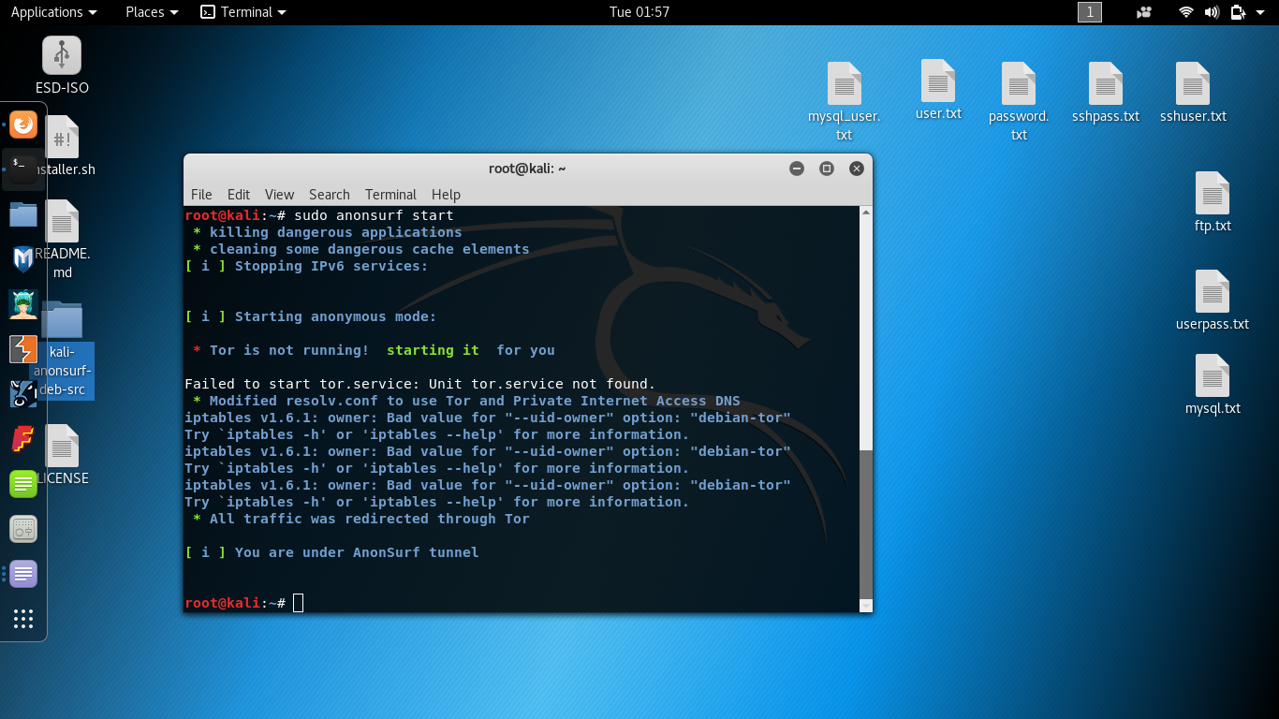
Figure 1 - Running Anonsurf to stay anonymous
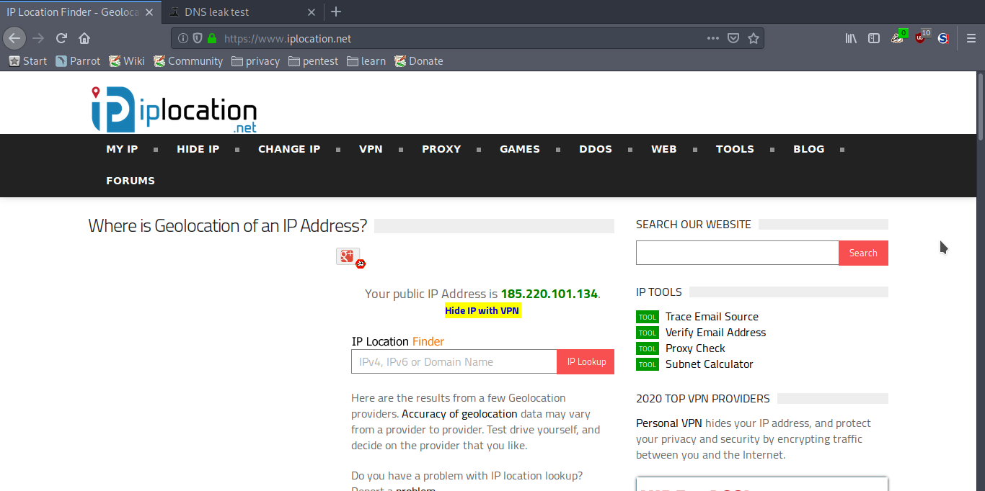
Figure 2 - The public IP location check (Anonymous)
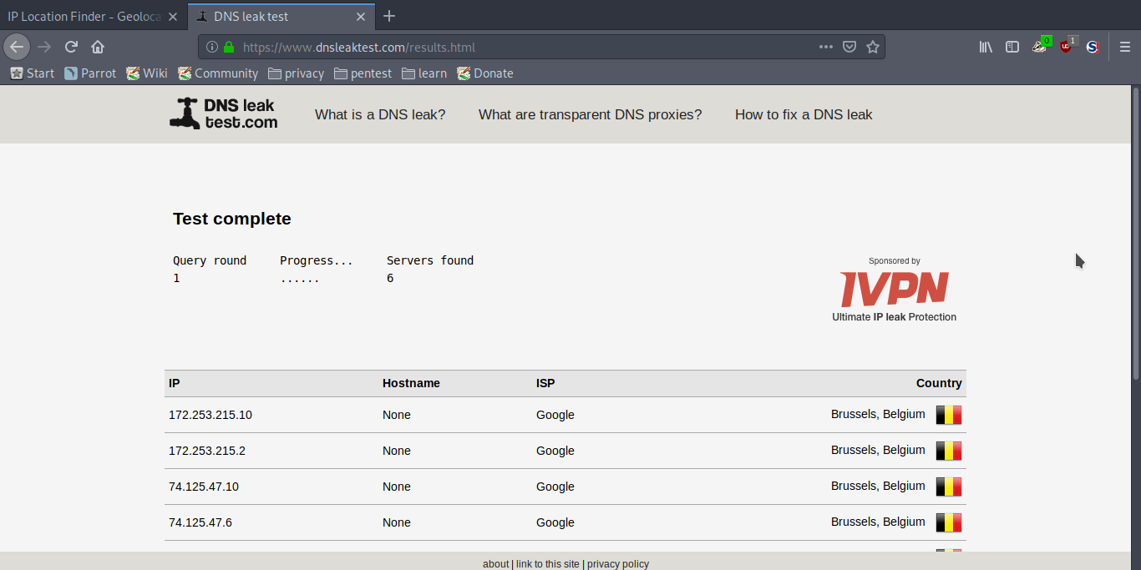
Figure 3 - The DNS leak check (Anonymous)
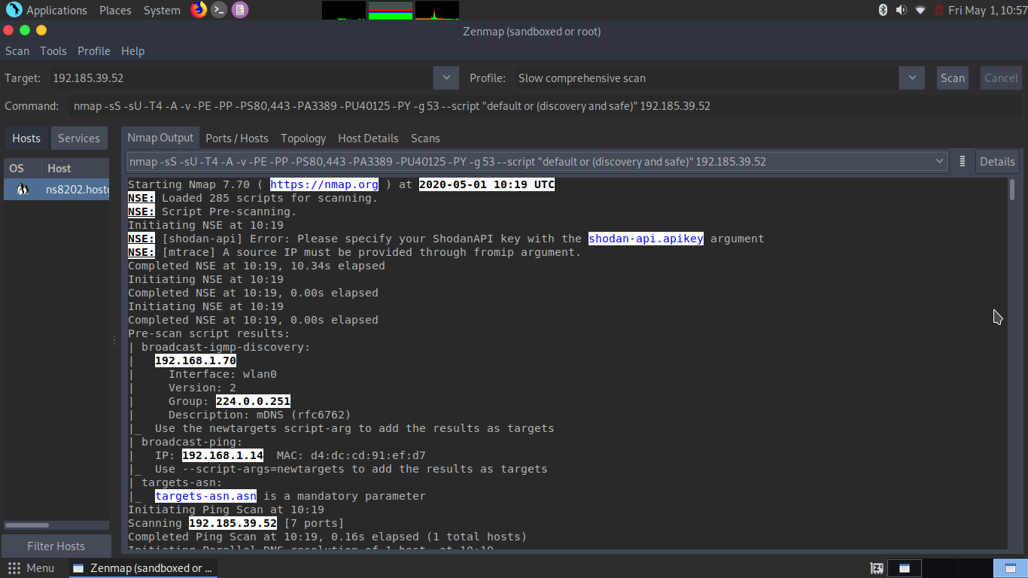
Figure 4 - Zenmap report-pg1
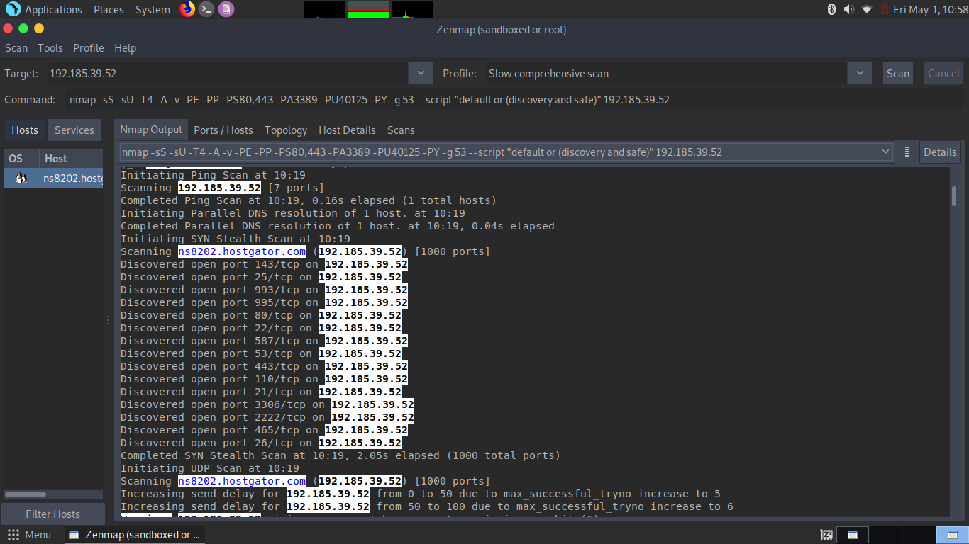
Figure 5 - Zenmap report-pg2
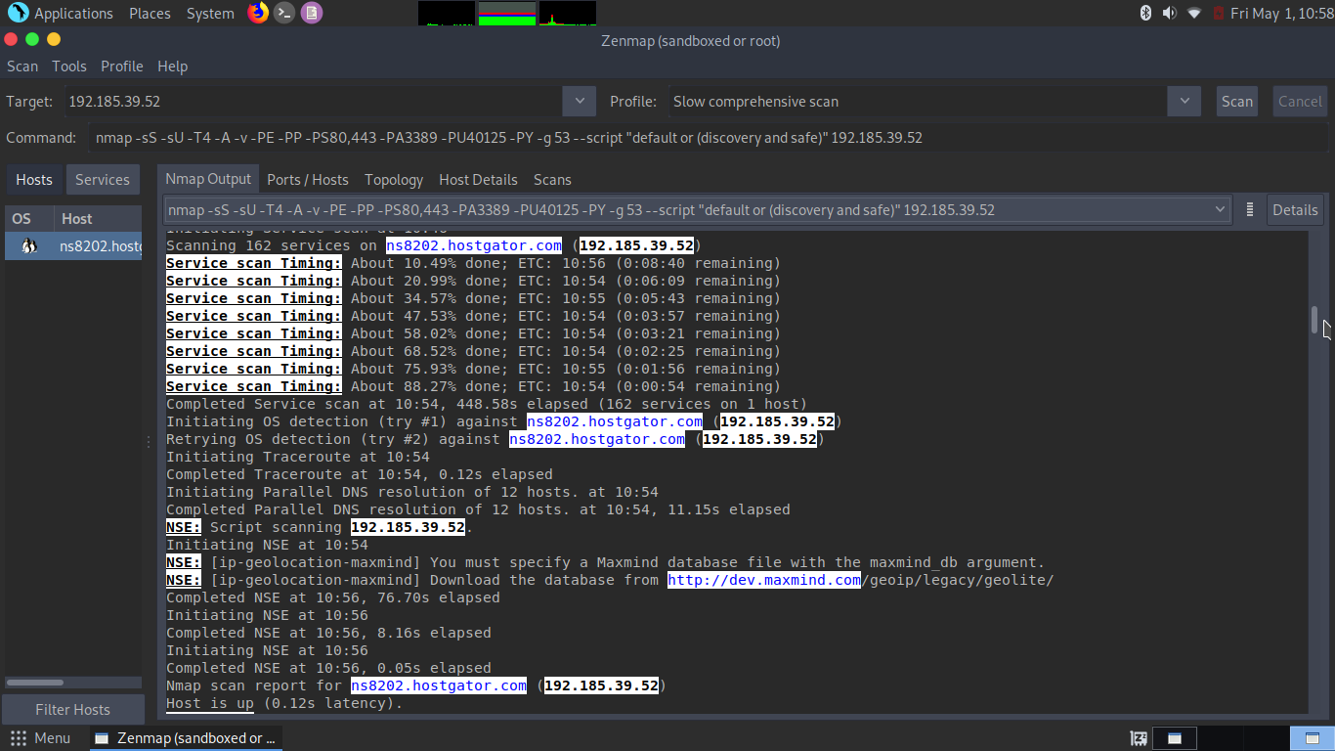
Figure 6 - Zenmap report-pg3
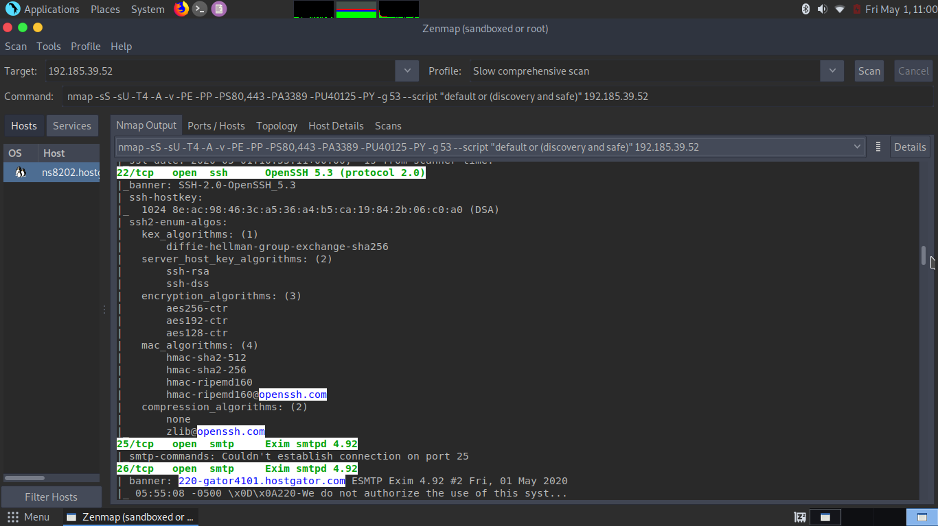
Figure 7 - Zenmap report-pg4
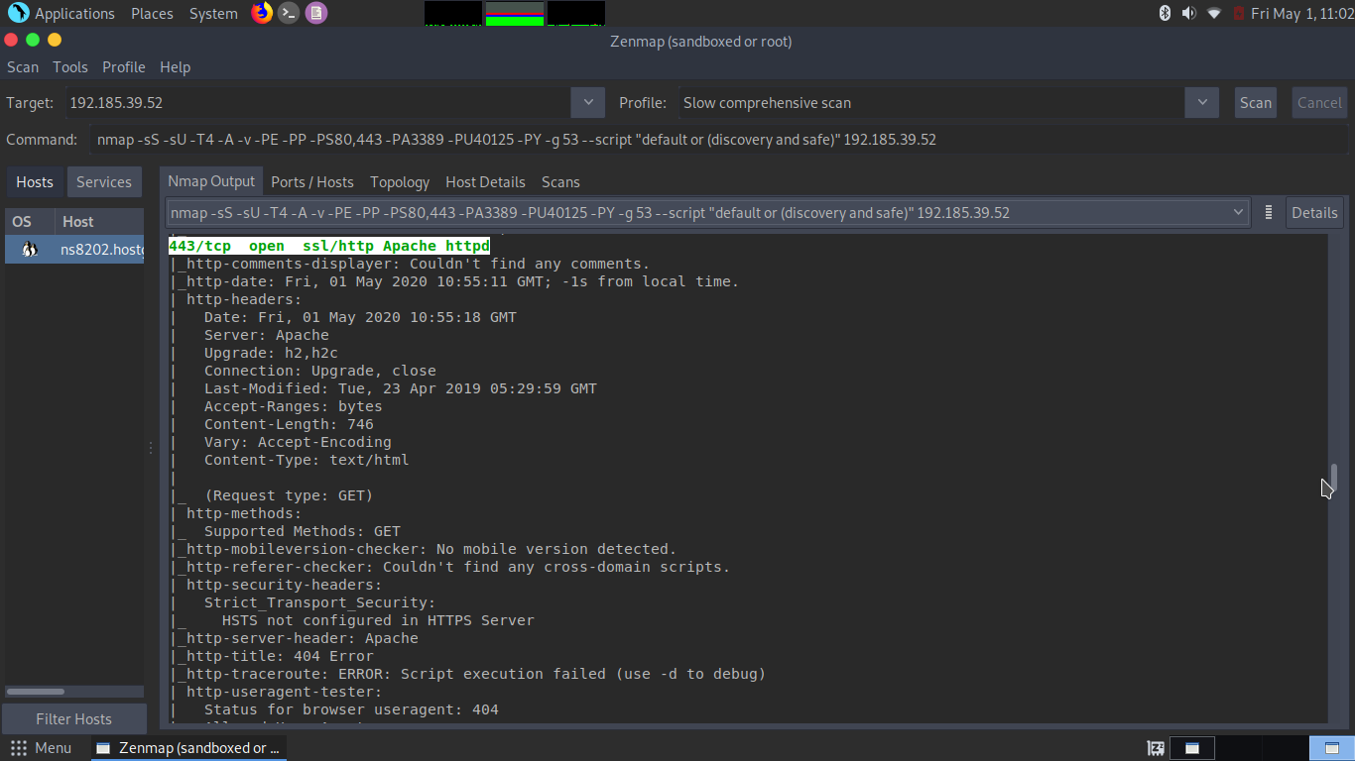Figure 8 - Zenmap report-pg5
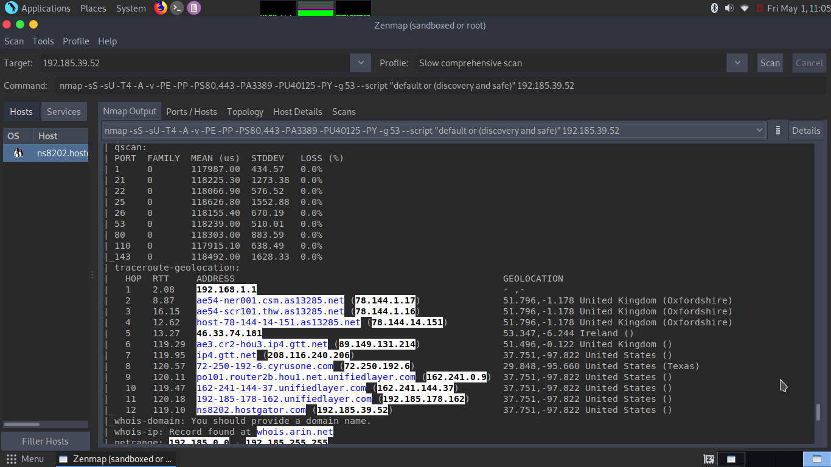
Figure 9 – Zenmap- host traceroute details
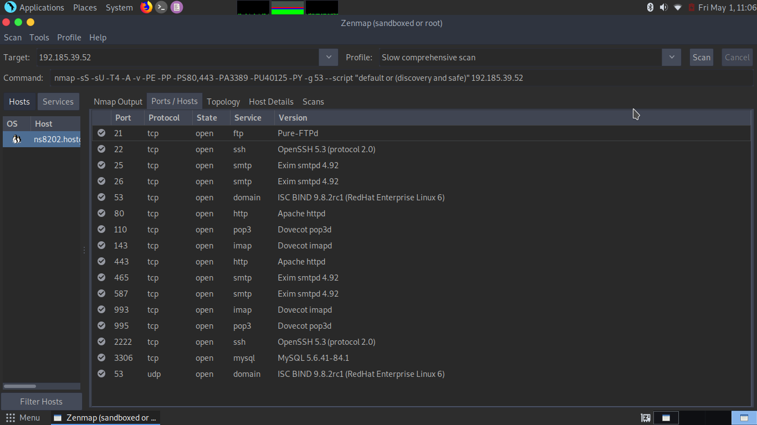
Figure 10 - Zenmap ports/host details
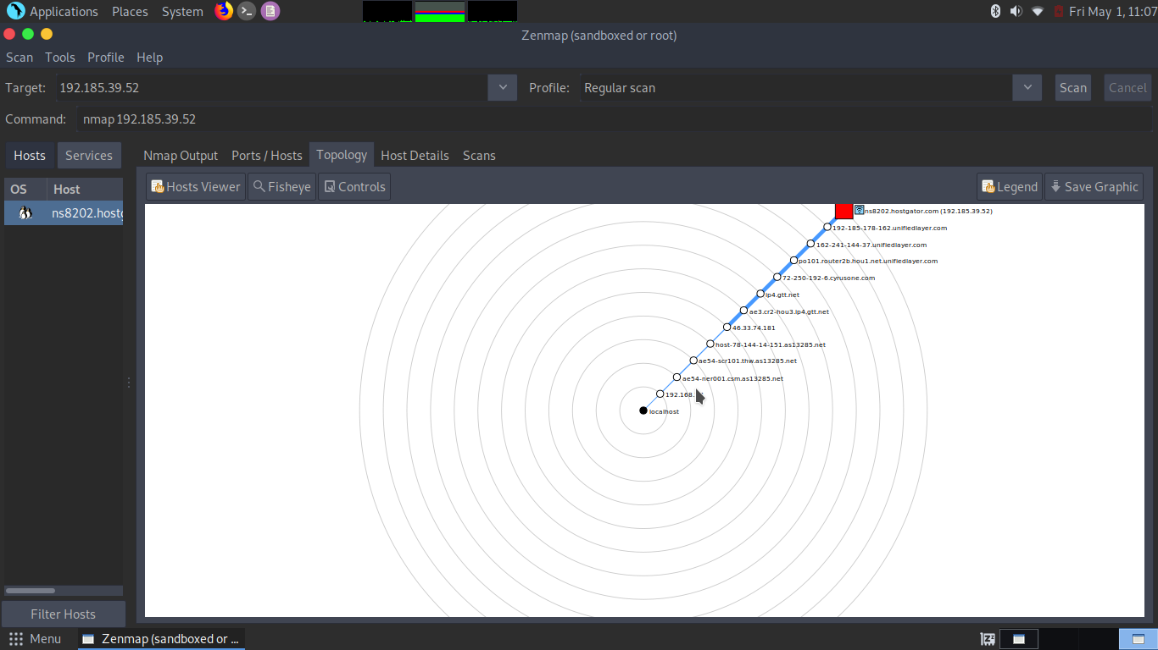
Figure 11 – Zenmap- host topology
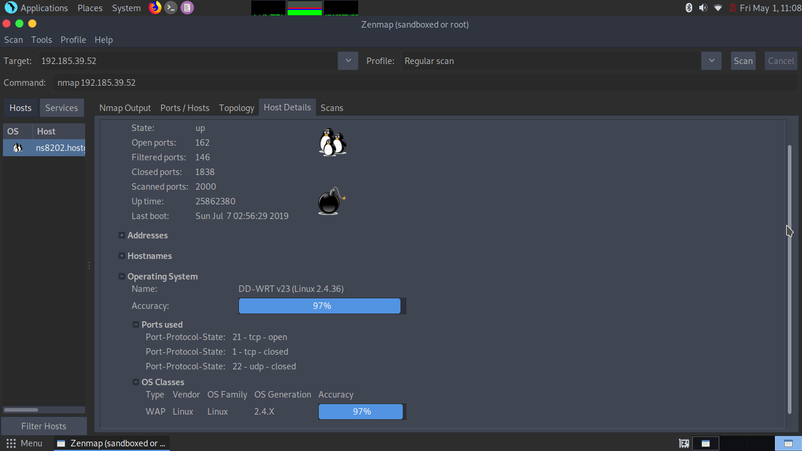
Figure 12 - Zenmap- host Operating System (Linux 2.4.36)
Maltego Scan

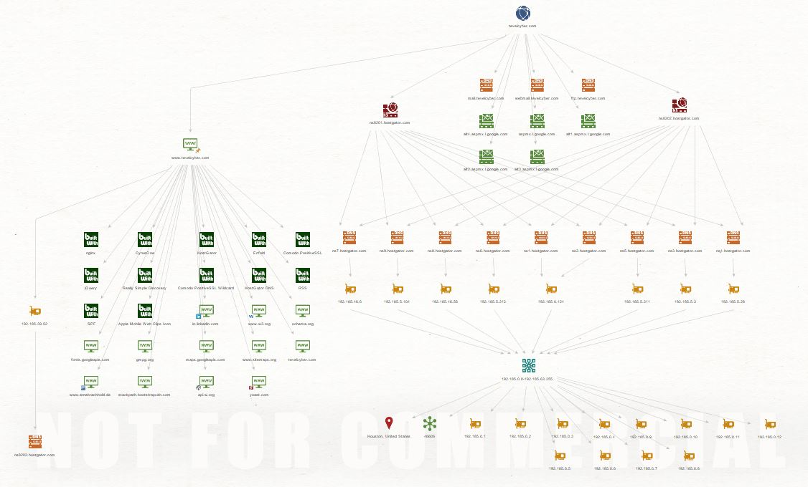
Figure 13- Maltego - Tevelcyver data-mining topology
This powerful open-source tool was used to perform a more profound scanning and data mining about the target website, this tool generates an efficient visual illustration about the website technical structure and the topology of sub-services, server technology, running services, subdomains, Name Server, MX Server, tracking codes, Netblocks AS numbers and more. All these data will allow the penetration tester to build a complete picture of Tevelcyber Corps organisation. As illustrated in figures below (figures 13 – 16) the author has successfully managed to discover a great deal of data about the target organisation.
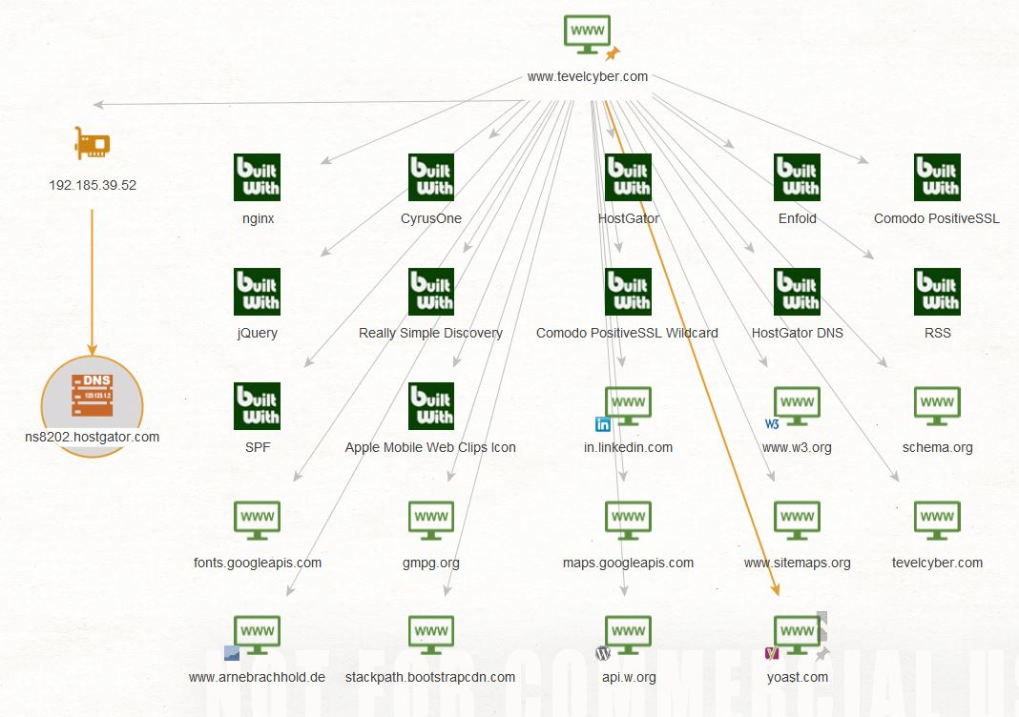
Figure 14 - Maltego- linked available services (LinkedIn, Gmail, etc.)

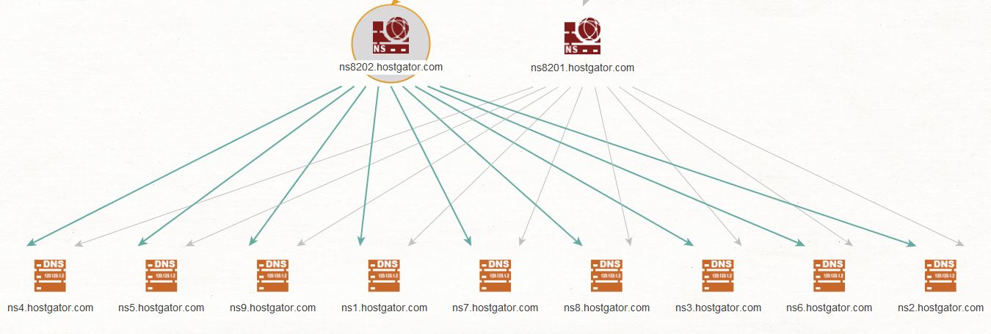
Figure 15 - Maltego- NS services

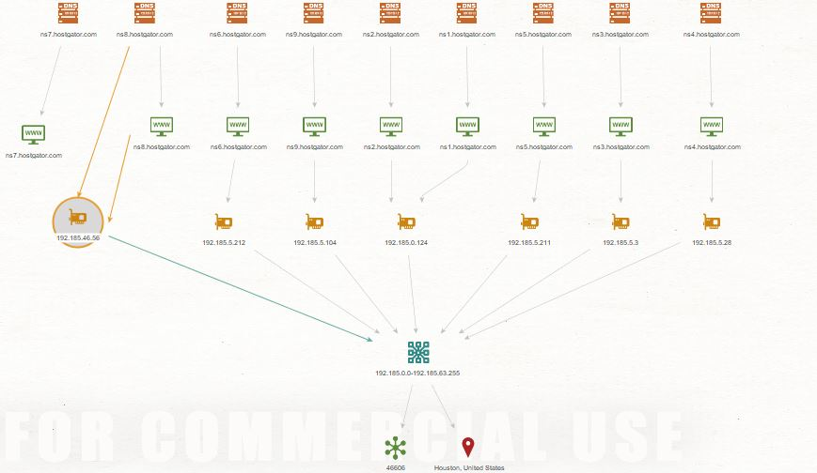
Figure 16 - Maltego- Netblocks and AS numbers (routing)
Online scanning tools
The author has also used some efficient online scanning tools such as Shodan, Censys and Qualys SSL lab, these automated tools are often used by organisations to perform a security and vulnerability analysis about their website to provide an overview of possible weaknesses and exploit over the web interface.

Shodan Scan
The following figures demonstrate some of the vulnerabilities discovered using Shodan tool.

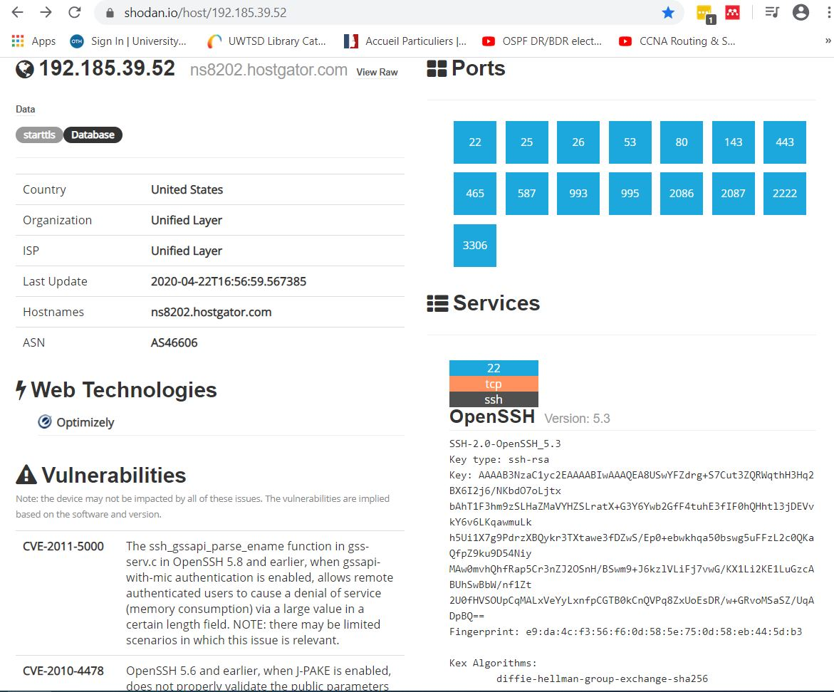
Figure 17 - Shodan Scan
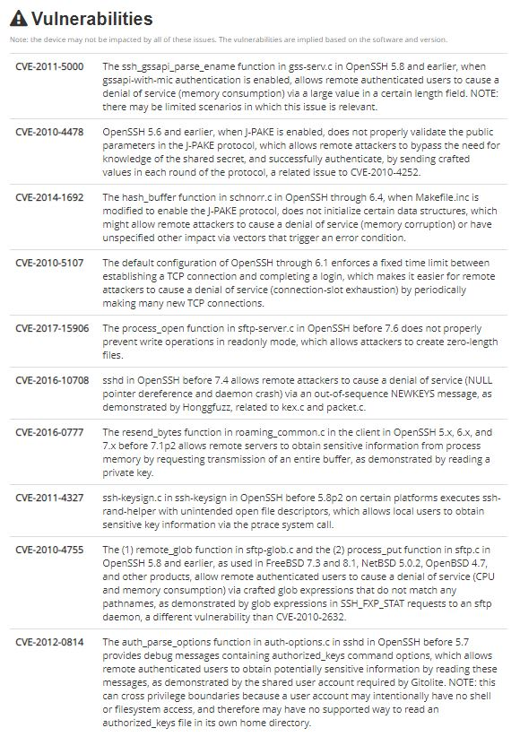
Figure 18 - Vulnerabilities found using Shodan Scan

Censys Scan
Censys scanning tools can provide more details about the autonomous system used, the cypher suite, the certificate chain and protocol on each open port discovered. All these details can be used by the penetration tester to evaluate the website overall security. The following figures (19-21) illustrate some of this gathered information.

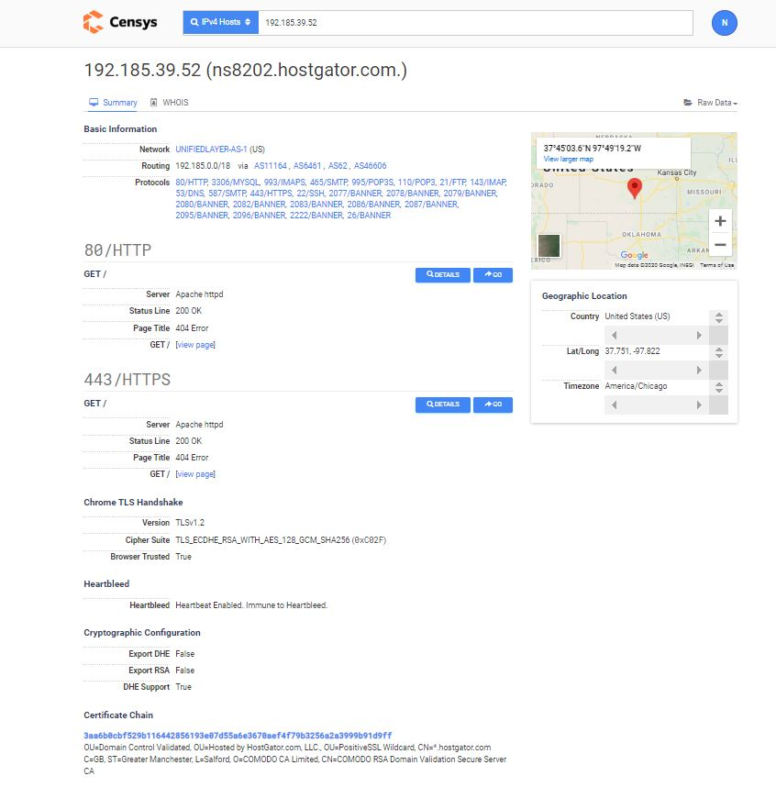
Figure 19 - Censys Scan - (HTTP/HTTPS) TLS data
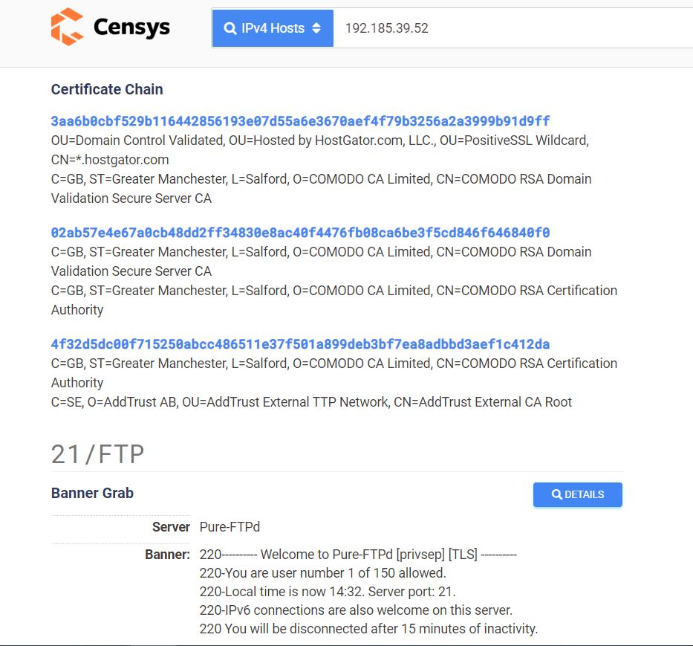
Figure 20 - Censys Scan - Certificate chain details
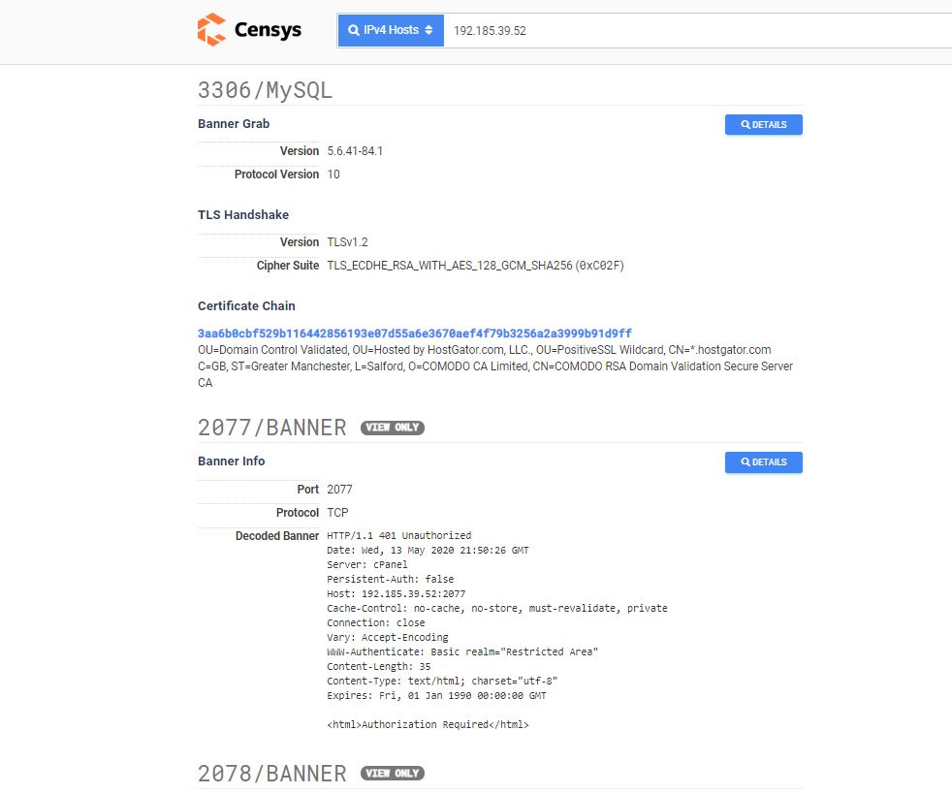
Figure 21- Censys Scan - MySQL data
Qualys SSL Labs
Qualys SSL Labs is also classified among the best online website security analysis for websites security, evaluation and vulnerability detection, this tool focus more on the Transport Layer Security (TLS) analysis of the target web and provide a reliable analysis about the most common web attacks that can be exploited. Please see below some screenshots from the Tevelcyber.com Qualys report.
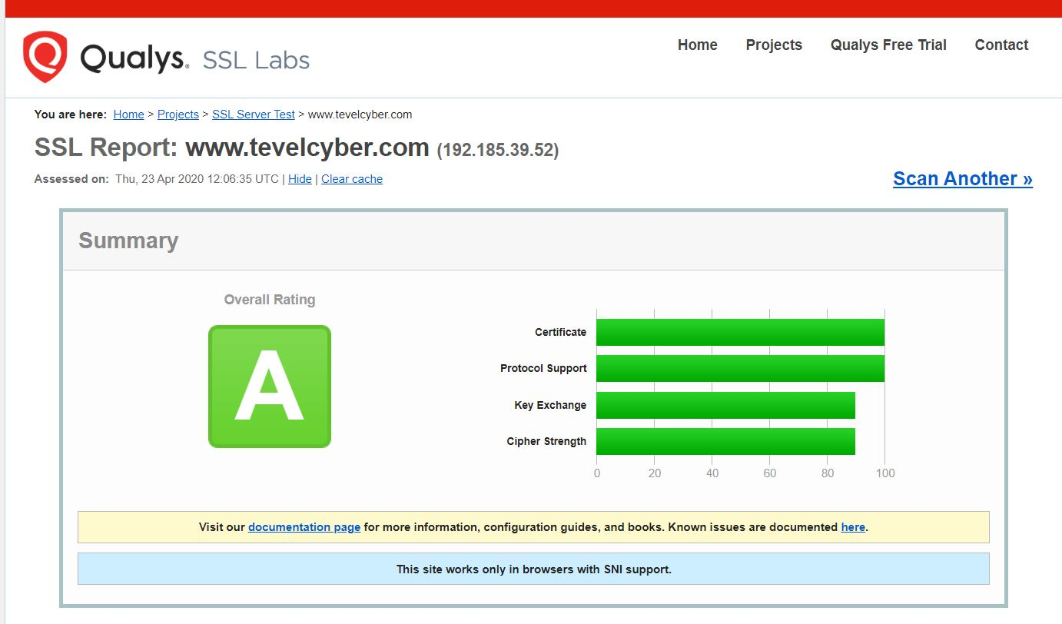
Figure 22 – Qualys- The overall rating of the website security (A)
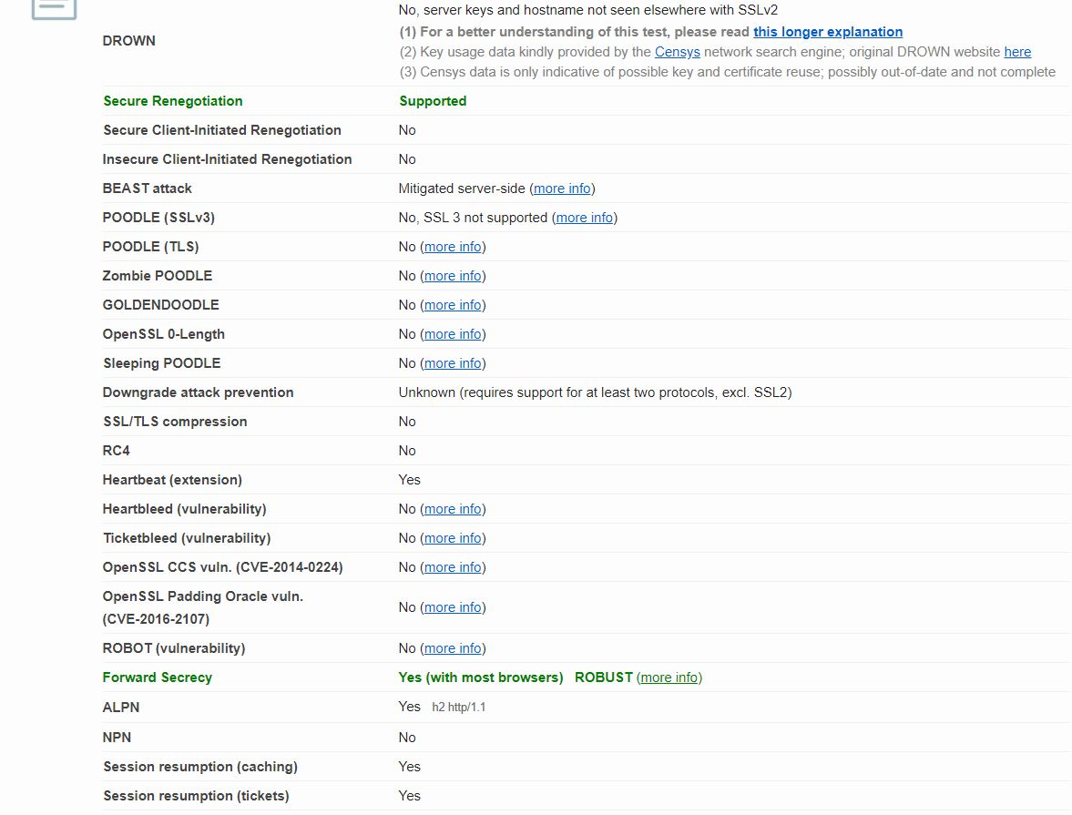
Figure 23 - Qualys - Most common web attacks vulnerabilities
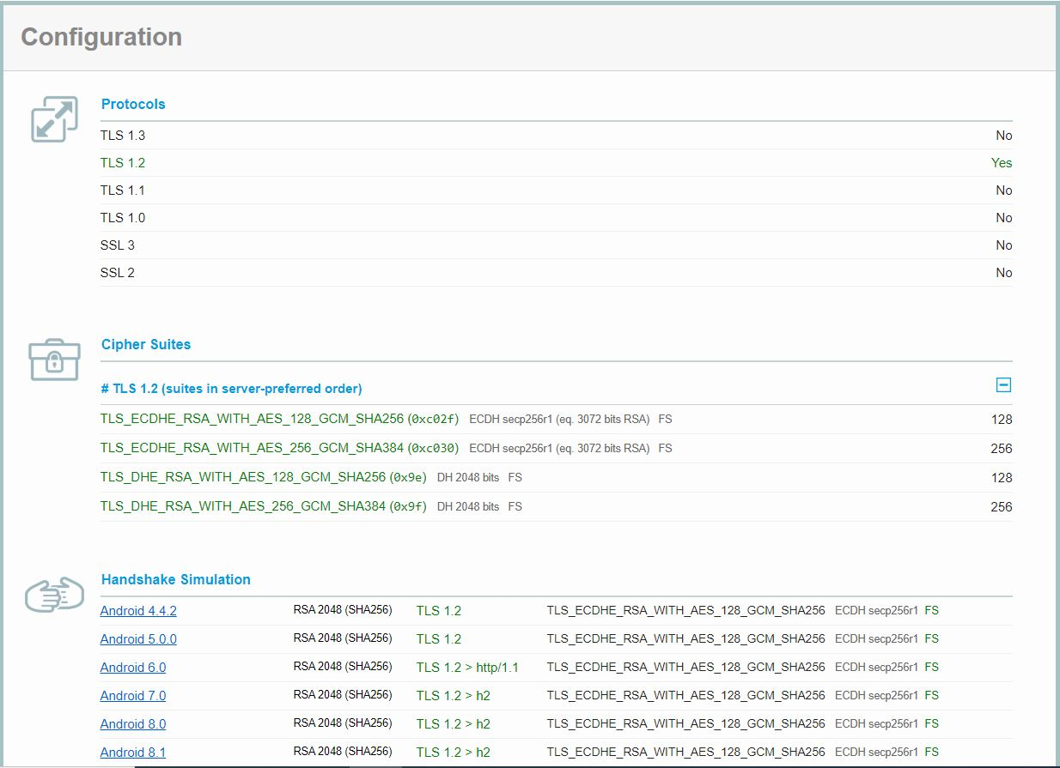
Figure 24- Qualys- Protocols supported, cypher suites and system.
Nikto web vulnerability scan
The author has also used this open-source web vulnerability scanner to check if the Tevelcyber.com can be exploited through, protocols used, versions supported, detected PHP login, cookies, SQL injection, headers, XSS protection header, Transport Security Layer, cyphers used and more. Please see figures (25-26) below showing some the vulnerabilities found on Tevelcyber.com website using Nikto.
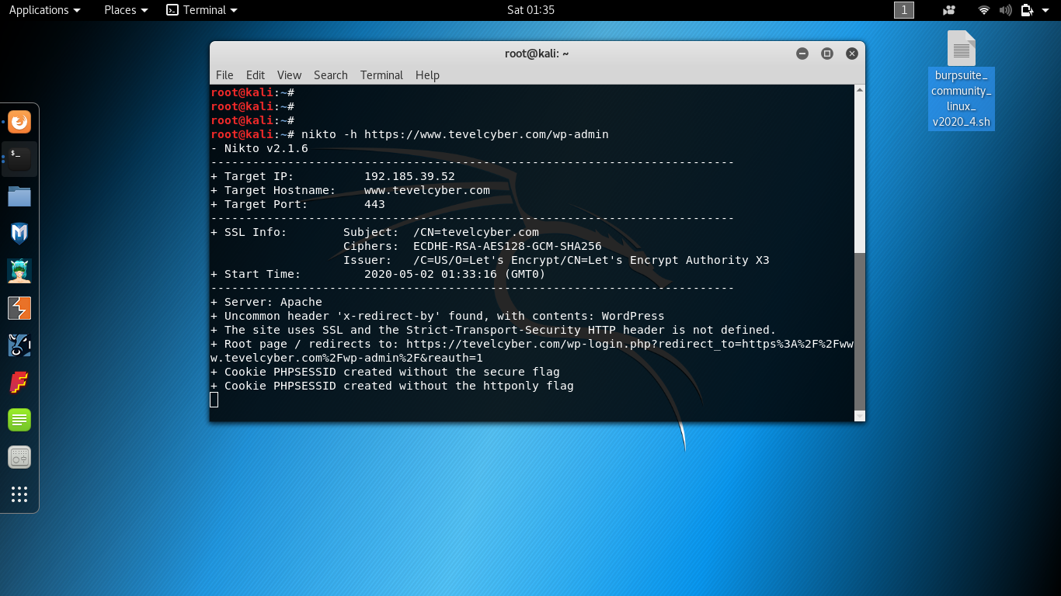
Figure 25 - Nikto scan
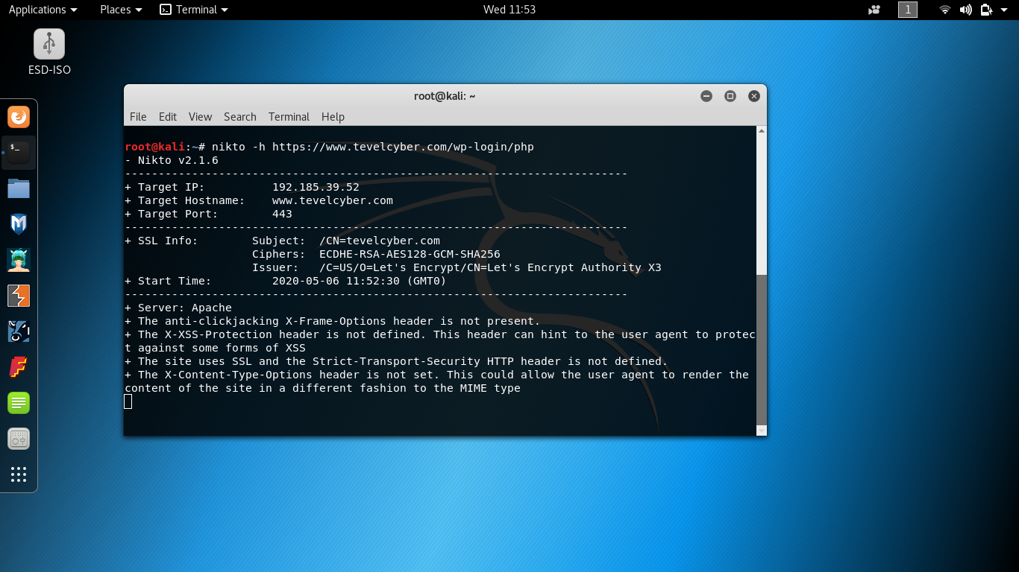
Figure 26 - Vulnerabilities detected using Nikto
D-TECT Scan

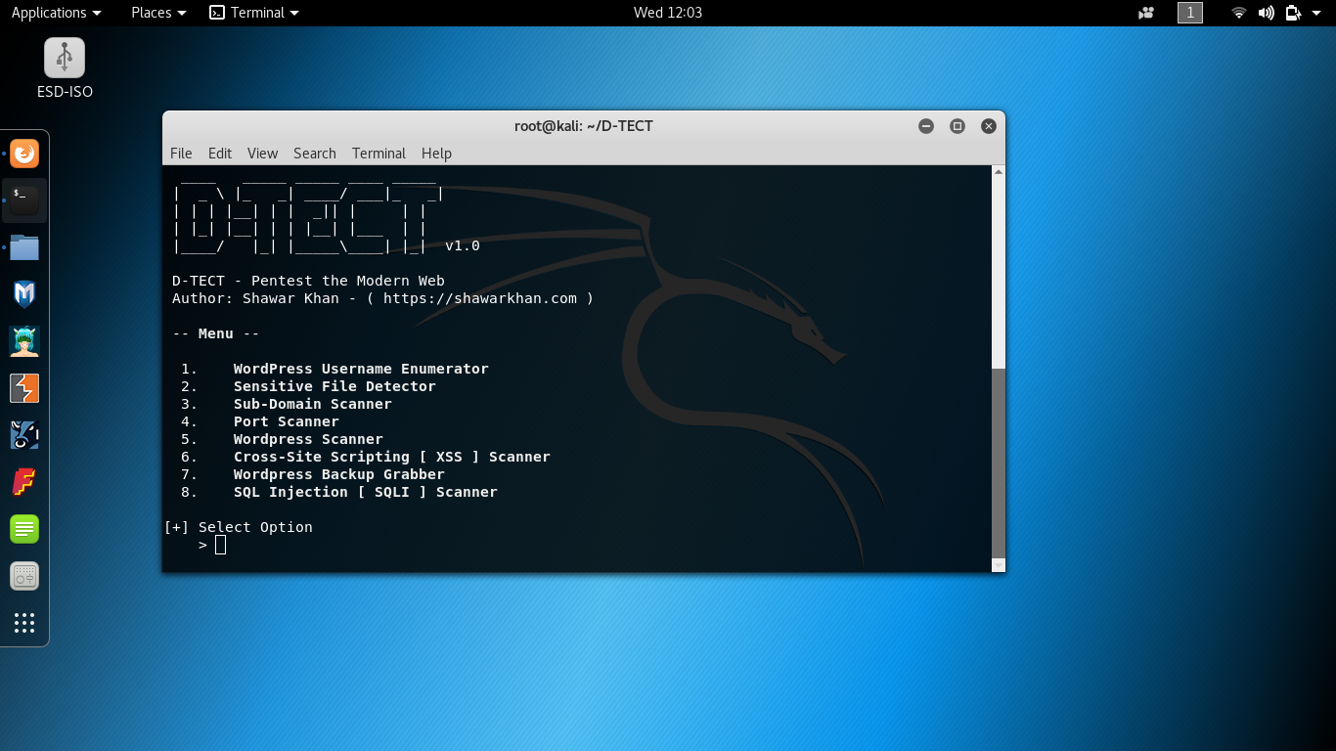
Figure 27 - D-TECT scanning tool
These multifunction scanning tools were deployed to run multiple scans to check if the target website is vulnerable to Cross-Site Scripting (XSS), SQL injection, WordPress login Brute force. Also, to run more comprehensive scans for sensitive files, sub-domains, and WordPress data. This powerful easy to use tool has helped the author to uncover some new information and confirms some previous ones as illustrated in the following figures (28 – 32).

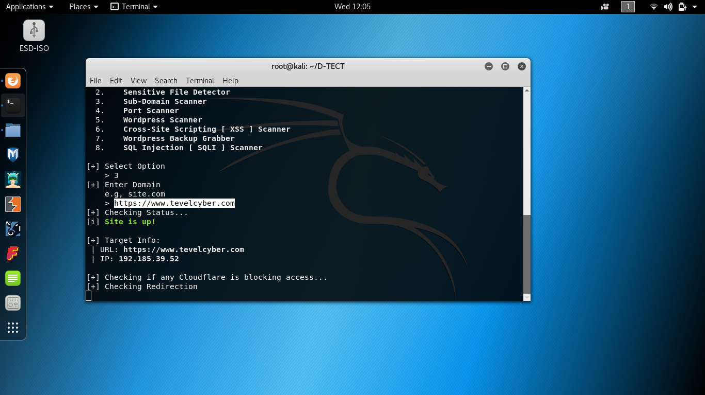
Figure 28 - D-TECT Scan menu
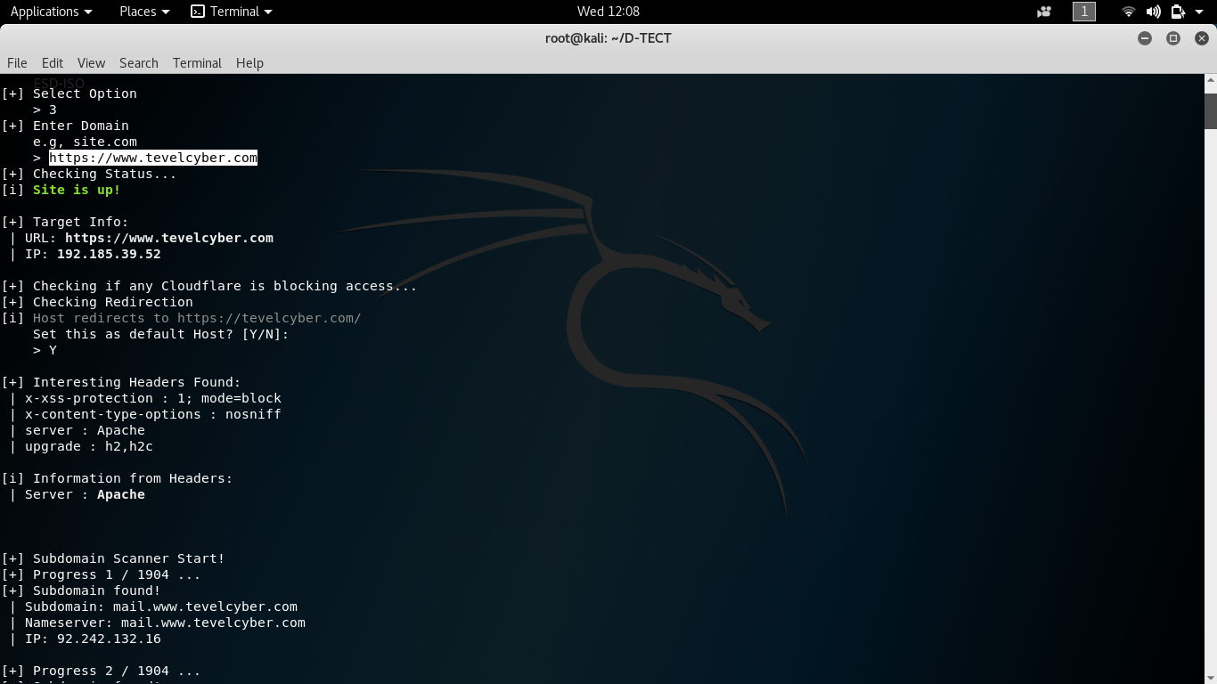
Figure 29 - D-TECT Scan - XSS
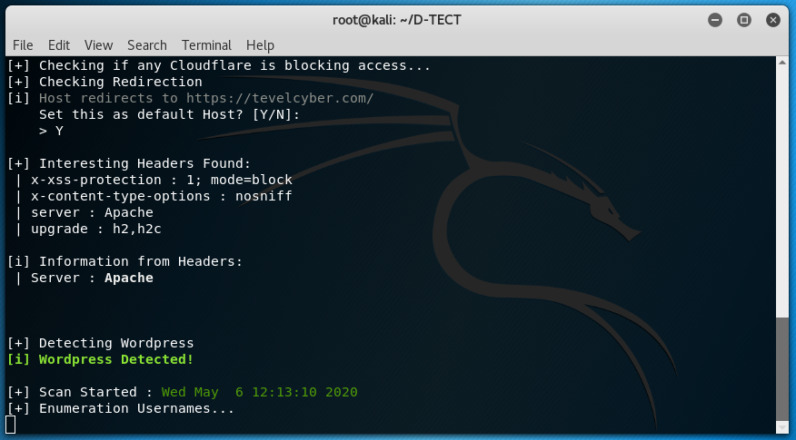
Figure 30 - D-TECT Scan - WordPress Emulator
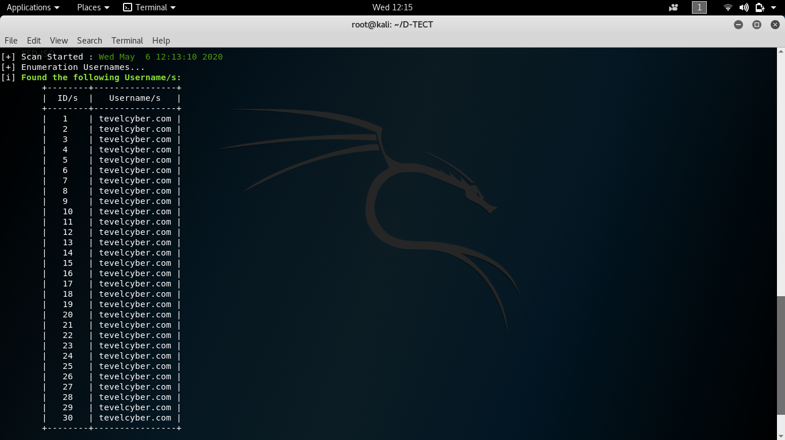
Figure 31 - D-TECT Scan - WordPress usernames (Strongly hashed)
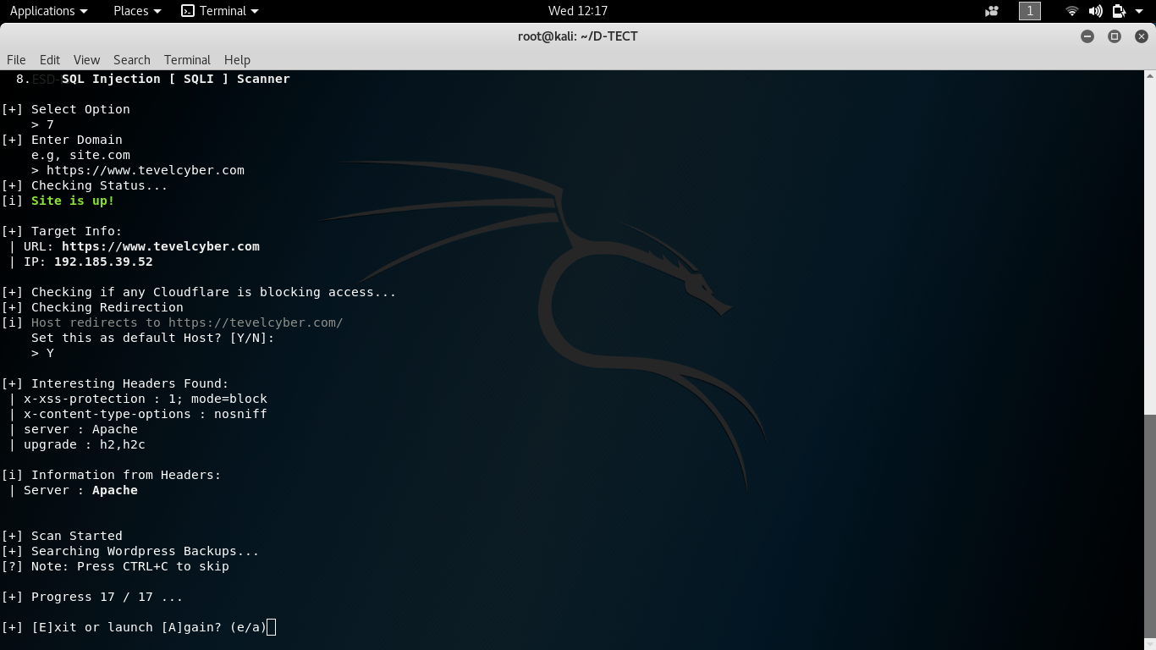
Figure 32 - D-TECT Scan -SQL injection (undetected)
Vega web security scanner
This is an open-source web security testing platform, widely used by penetration testers. Also, capable of detecting and validating SQL injection on websites, Cross-Site Scripting (XSS) vulnerabilities and probes for TLS/SSL security settings. The following figures (33 – 35) shows some of the vulnerabilities discovered within the PUT-profile function of the HTTP server that could give the attacker the opportunity to overwrite on the pre-existing resources of the server.

Figure 33 - Vega Scan
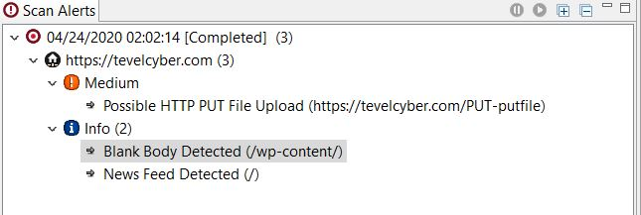
Figure 34 - Vega Scan alerts
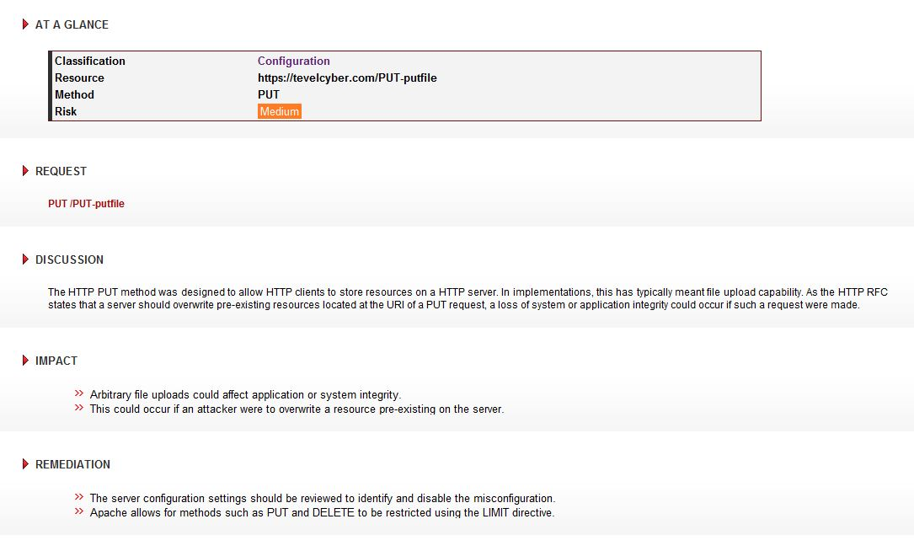
Figure 35 - Vega Scan - Vulnerabilities detected
Burp-Suite project
Burp-Suite Project tools is a cutting-edge Cybersecurity tool widely used, taught, and certified by great numbers of web security organisation worldwide, it is available in three versions: Enterprise, Professional and Community. This tool is widely used by web developers to evaluate the overall security of their web design. This toolkit has been designed for simplicity and efficiency. The following figures (36-39) illustrate how the Crawling function was set to scan Tevelcyber.com and the vulnerability discovered on the wp-admin_login.
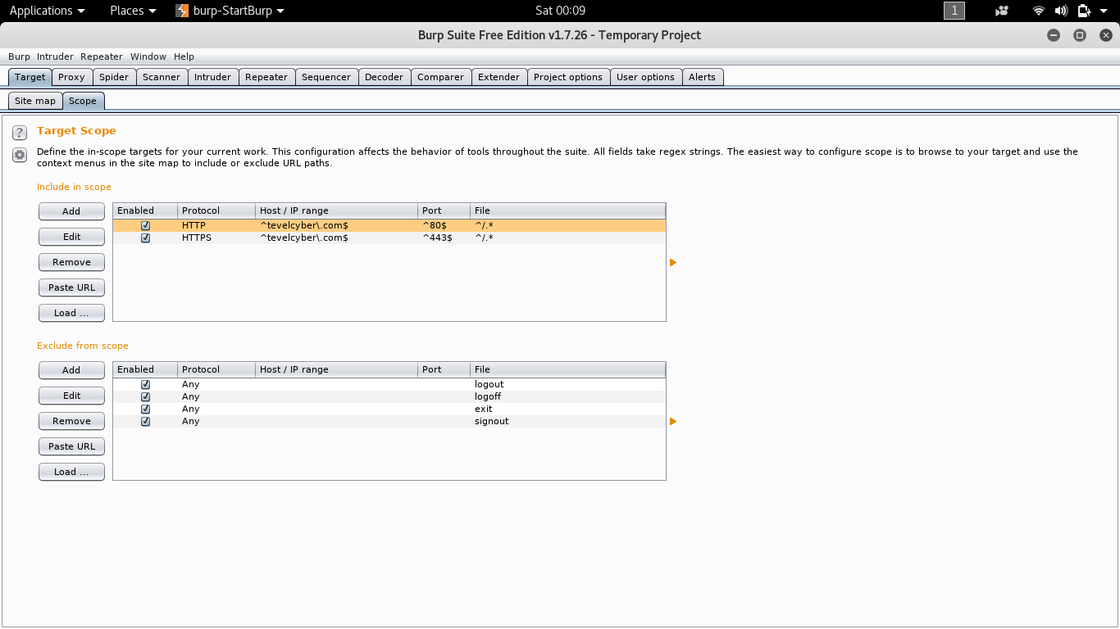
Figure 36 - Burp-Suite - setting-up the target
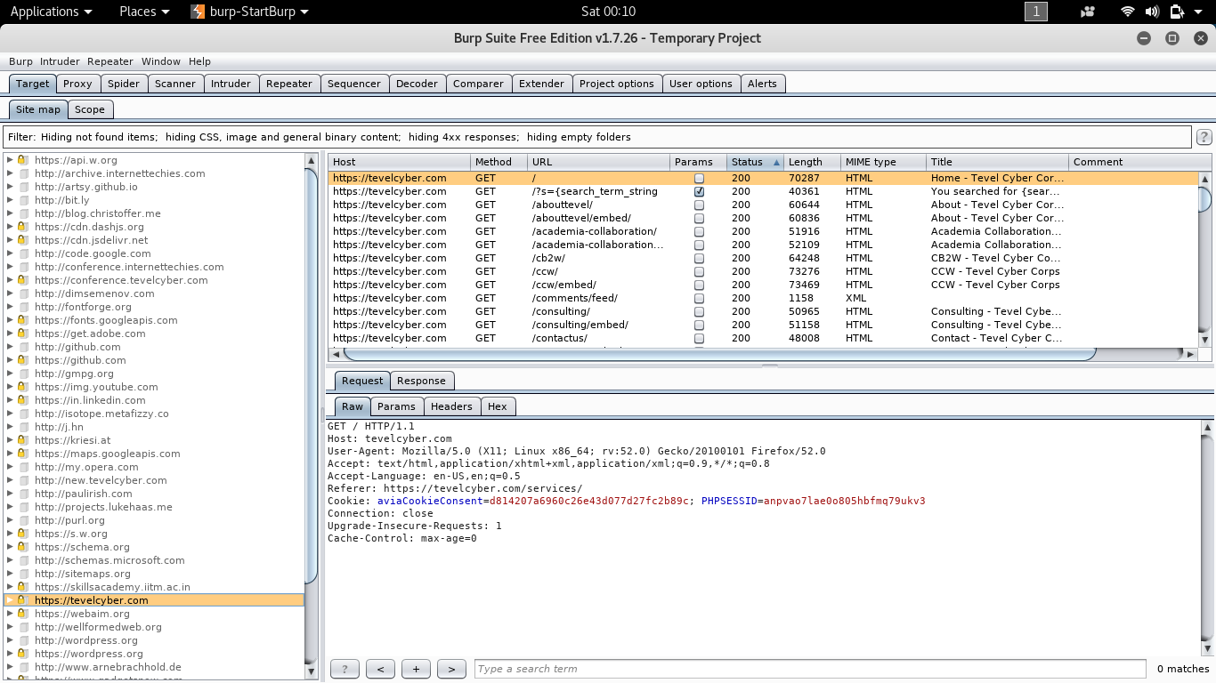
Figure 37 - Burp-Suite scan
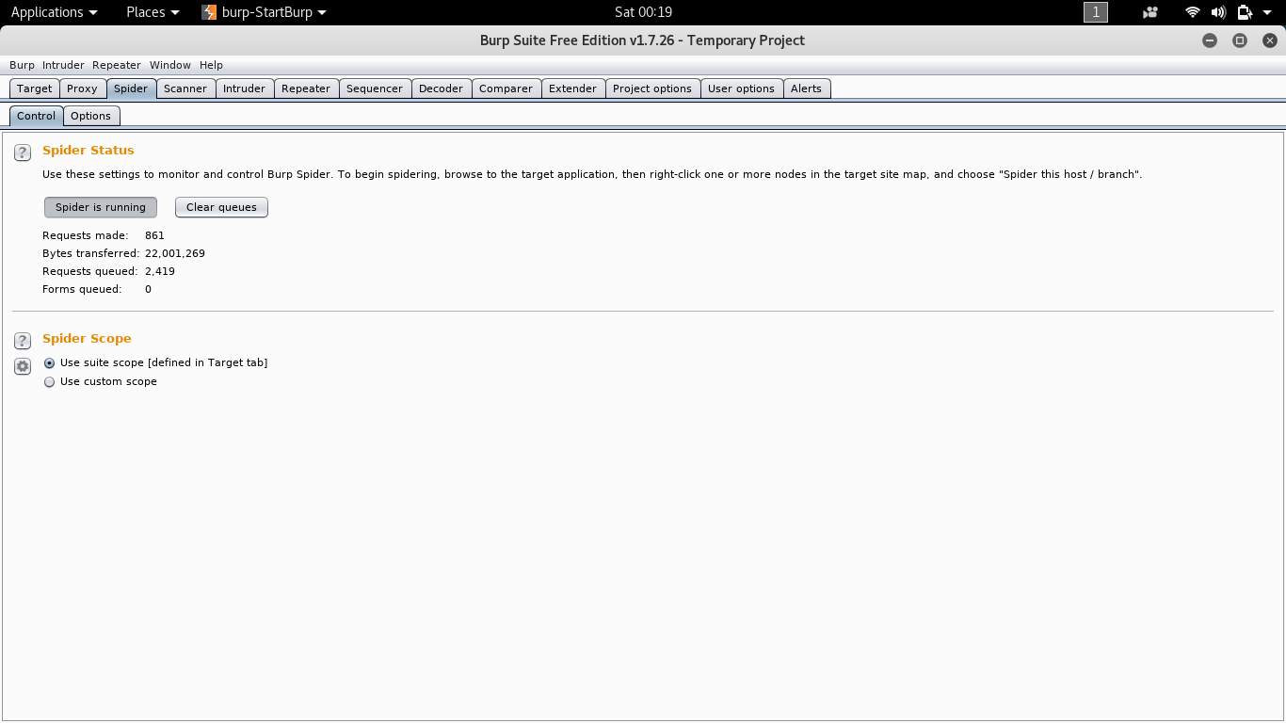
Figure 38 - Burp-Suite - Spider control function
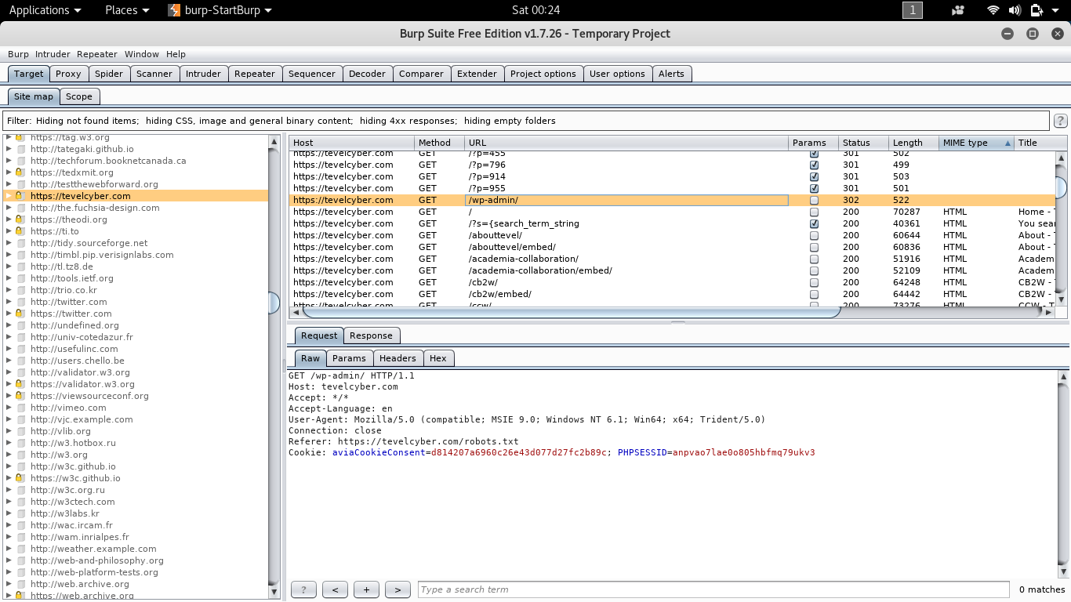
Figure 39 - Burp-Suite - wp-admin vulnerability
Grabber web application scanner
This tool was designed mainly to scan small and personnel website. However, the author has taken the opportunity of having this function pre-installed to run this simple scan to check if any new loopholes can be detected withing SQL, PHP, XSS and backup files. The next figure (40) shows a negative result of this quick scan.
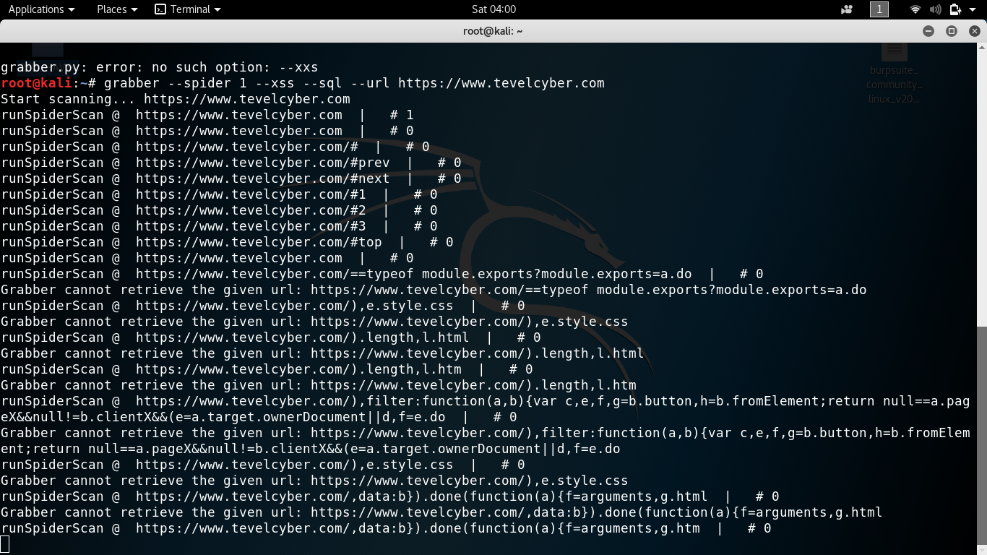
Figure 40 - Grabber Scan
WP-Scan
This is a black box open-source WordPress vulnerability scanner that focuses mainly on detecting loopholes in WordPress remote installation, it is also used to determine WP login details using Brute force method, WordPress version, WordPress-seo, backup config, and performing WP password attack using Brute force. The following figures (41-44) illustrate this WP-Scan/ exploit results (unsuccessful).

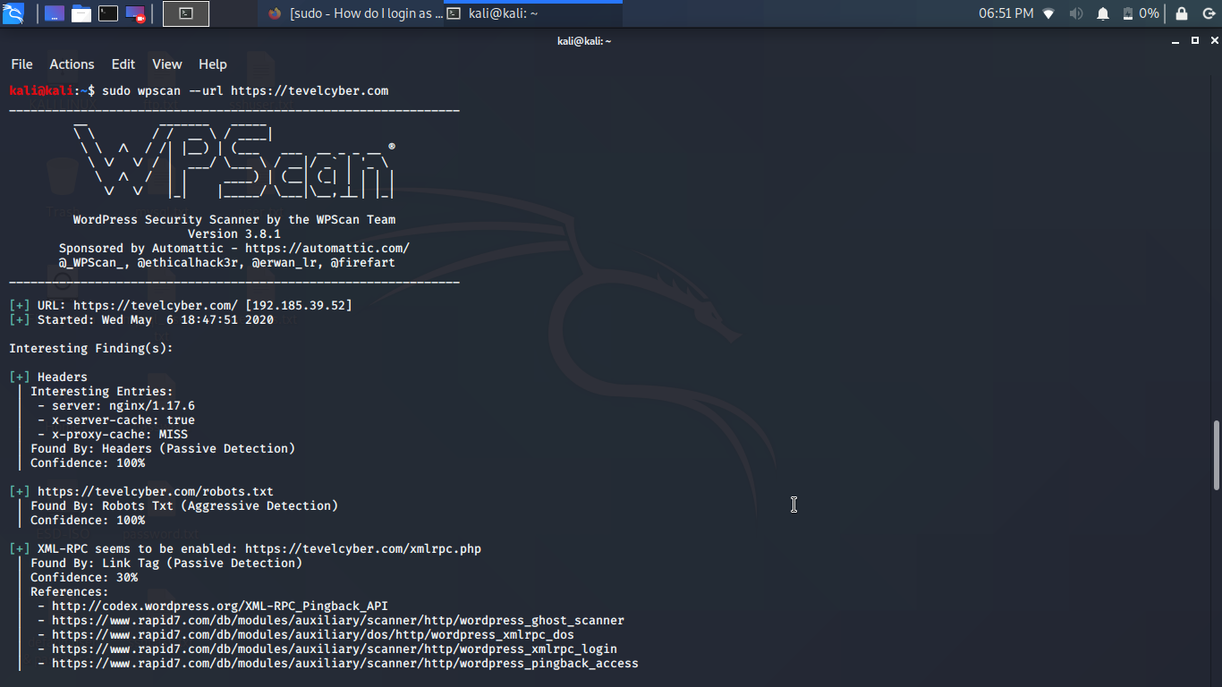
Figure 41- WP-Scan
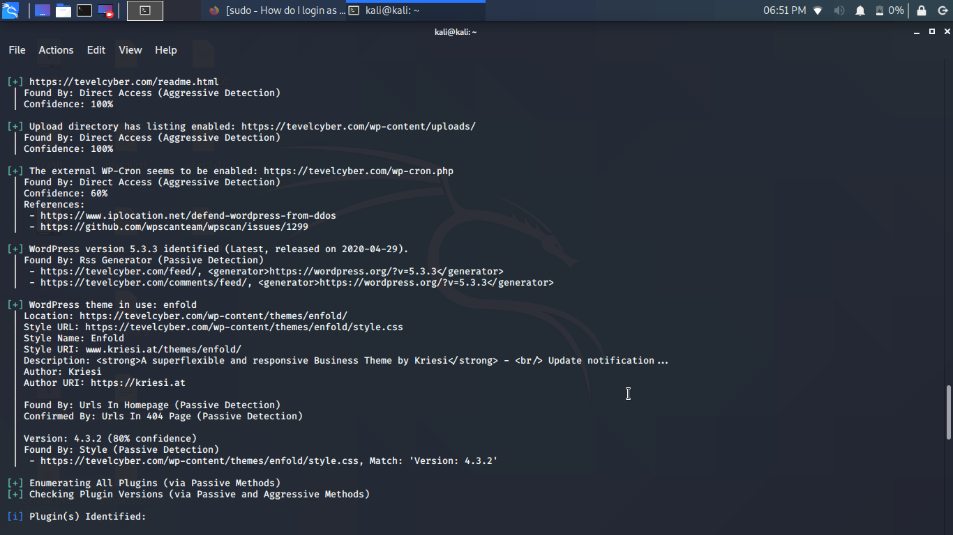
Figure 42 - WP Scan - WP version / Plugin emulator
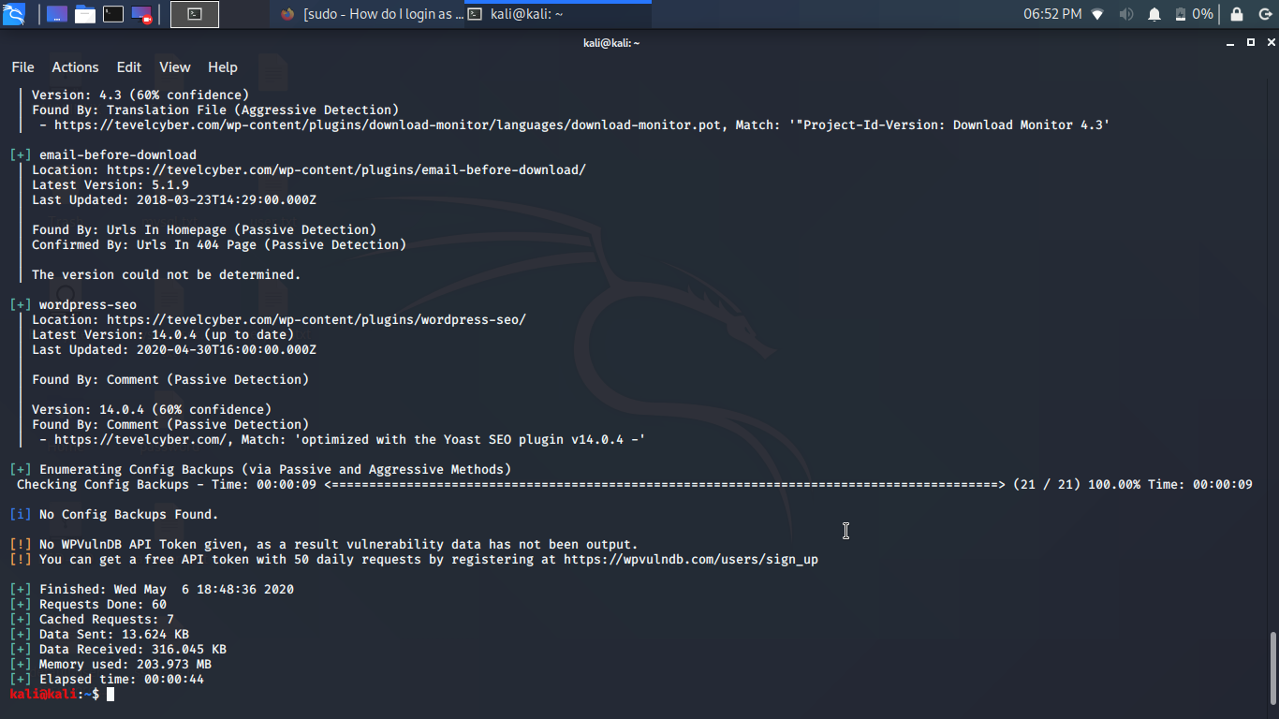
Figure 43 – WP-Scan - WordPress-seo detection
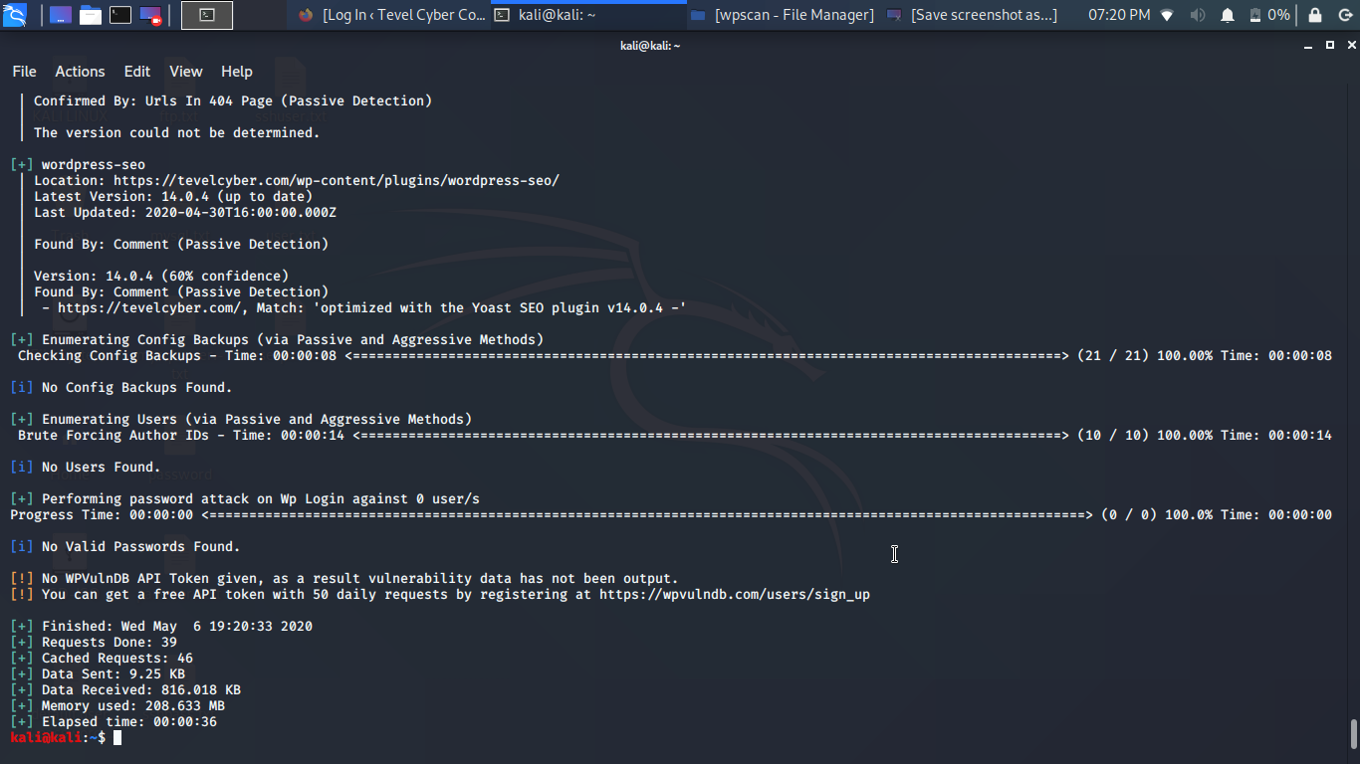
Figure 44 - WP-Scan - WordPress password attack

SQLMAP
This pre-installed open-source tools in Kali Linux was used to perform an active attack, it relies on sending a simple GET requests to the web server using the HTTP protocol. The following figures (45-48) shows that the author has failed to run any successful SQL injection on the target website.

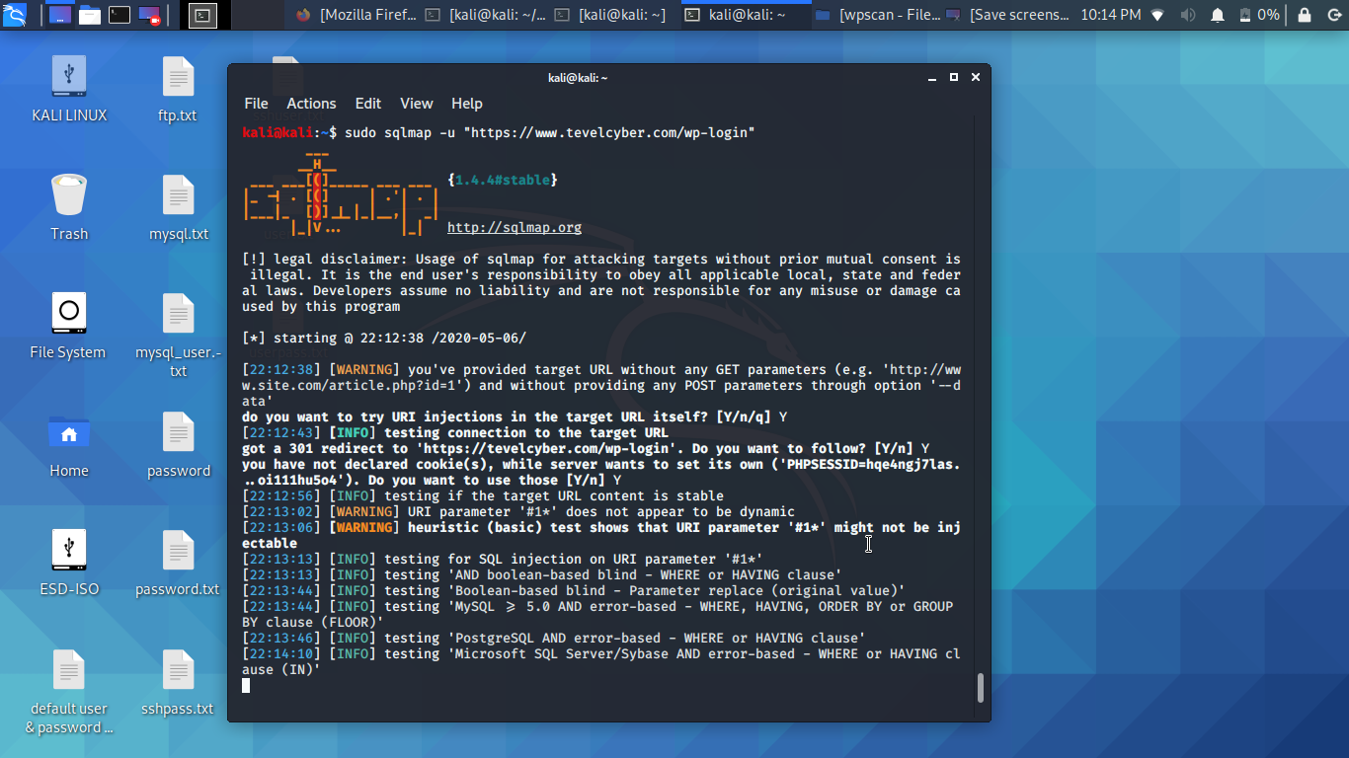
Figure 45 - SQLMAP - SQL Injection
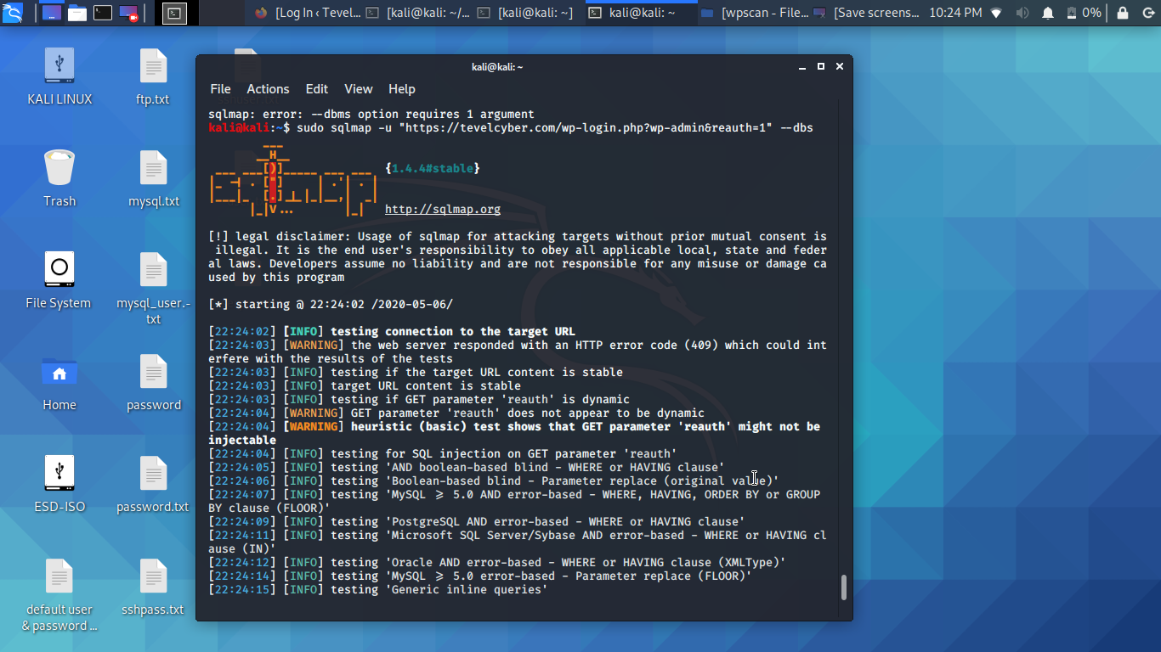
Figure 46 - SQL Injection - WP-login
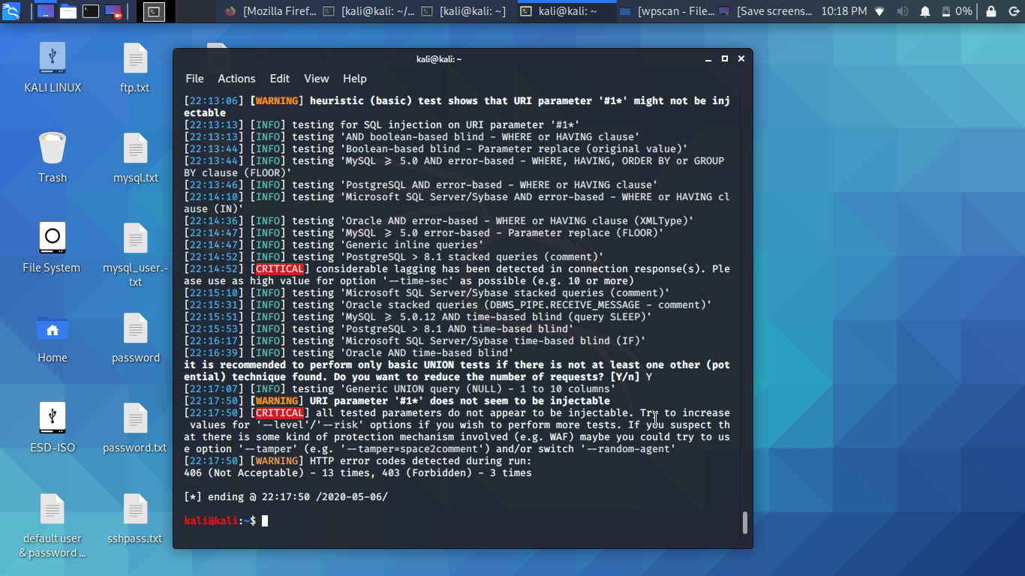
Figure 47 - SQLMAP - failure to inject Tevelcyber website
(MySQL server)

OWASP Zed Attack Proxy (ZAP)
OWASP ZAP is a powerful aggressive tool used for website security analysis, this open-source software appears to be complex when first time used. However, the quality of the results produced shows its value among professional penetration testers. The following figures (48-51) shows that five vulnerabilities have been detected (3-SQLi, 1-XSS, 1-Java Script).
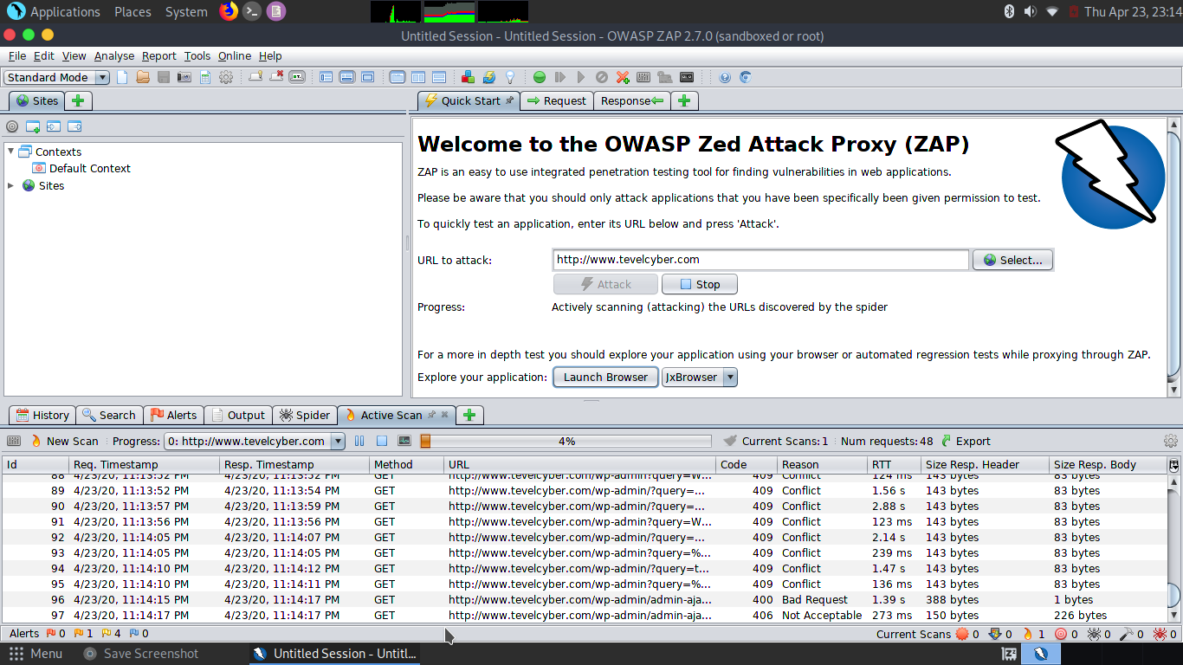
Figure 48 - OWASP Zap Scan
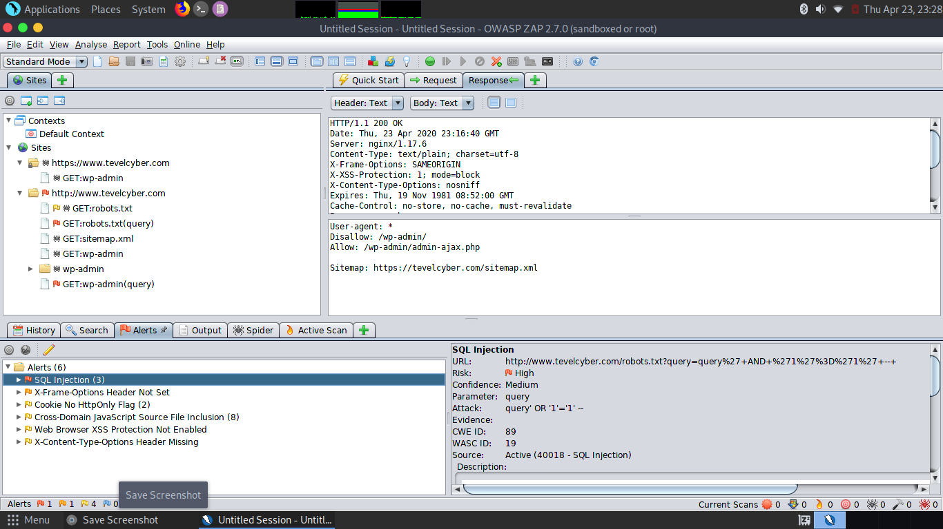
Figure 49 - OWASP Zap SQL injection vulnerabilities
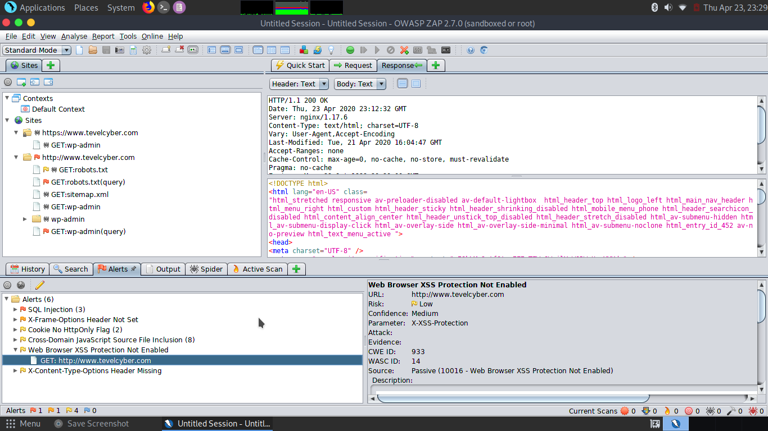
Figure 50 - OWASP Zap XSS vulnerability
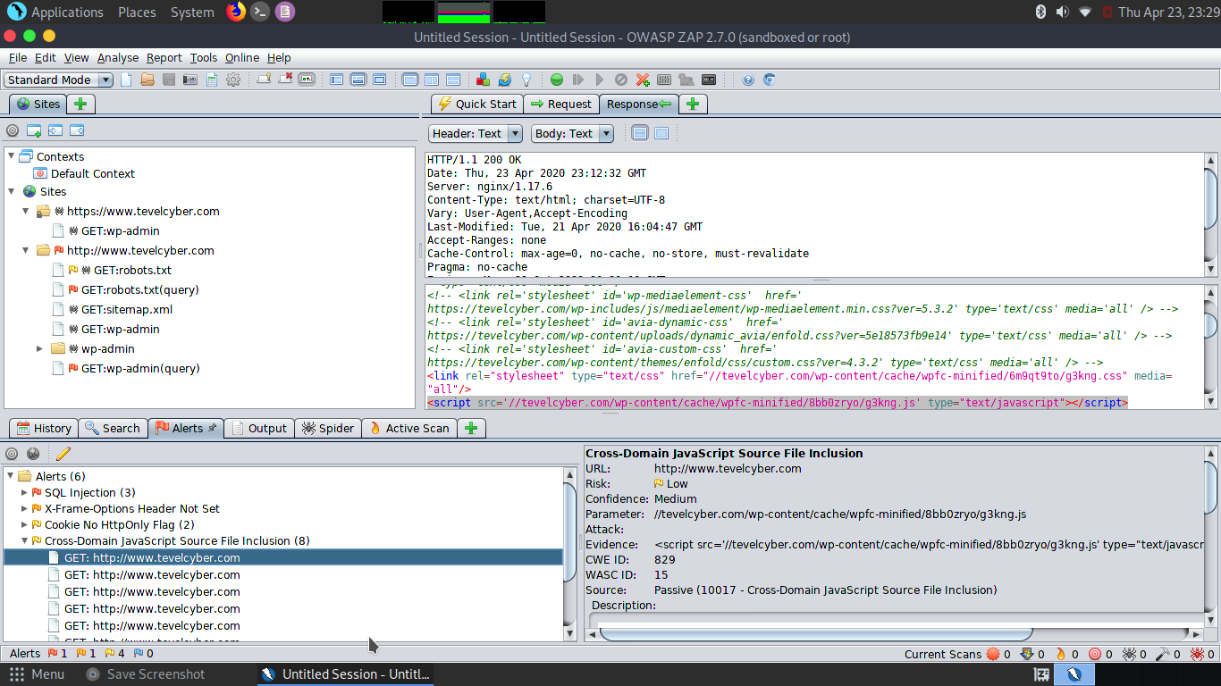
Figure 51 - OWASP Zap Java Script Vulnerability
Metasploit MSF console (msfconsole)
The author has also used Metasploit MSF console to mount Brute force password attacks on FTP login, SSH login, MySQL login using one of the latest username/password words list for each function. The following figures (52-59) illustrate how these attacks have been mounted and that all the attempts have failed to login successfully.
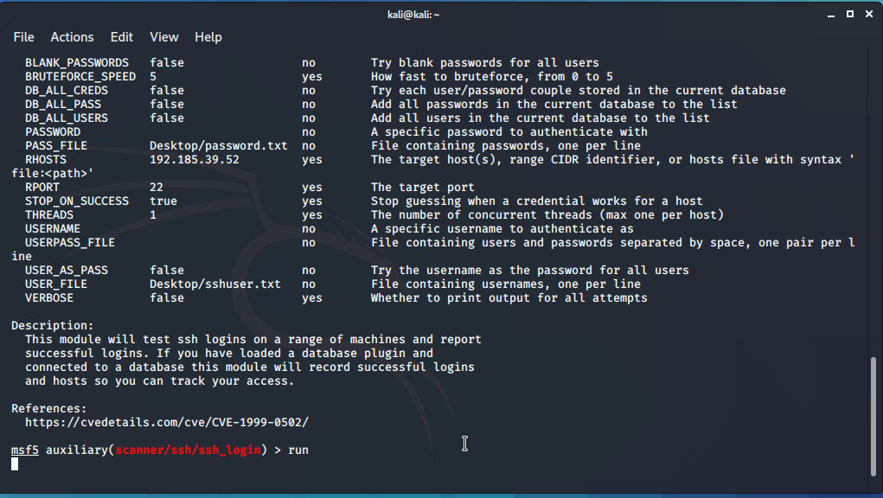
Figure 52 - msfconsole - SSH_login
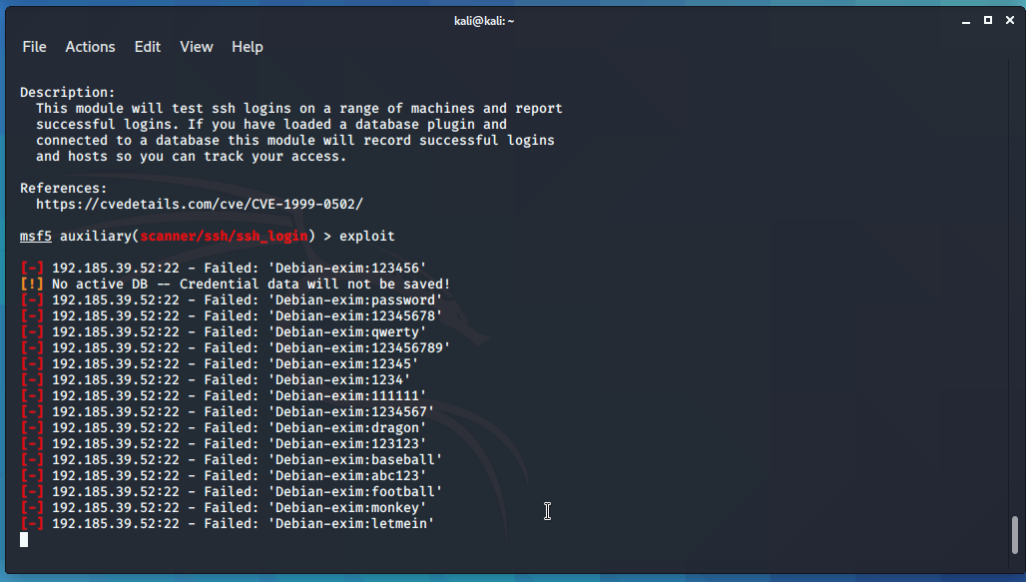
Figure 53 - msfconsole - SSH_login failed
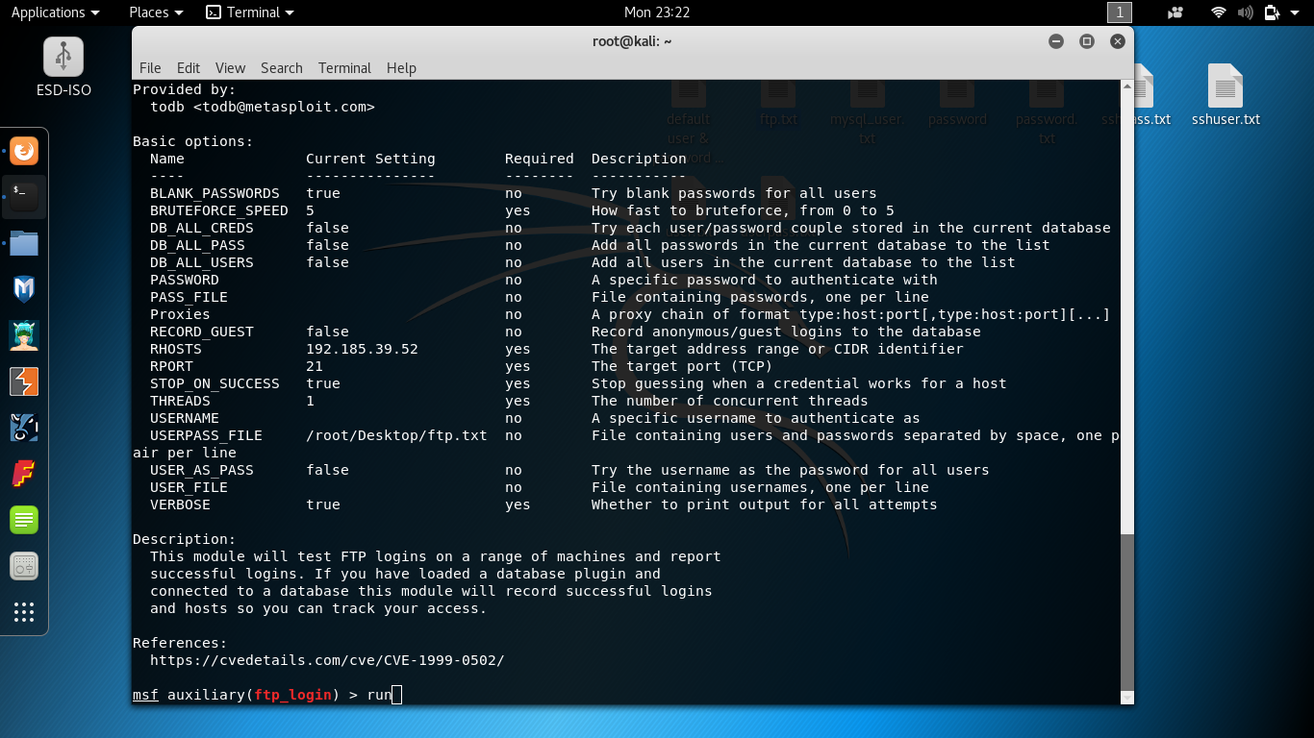
Figure 54 - msfconsole - FTP_login
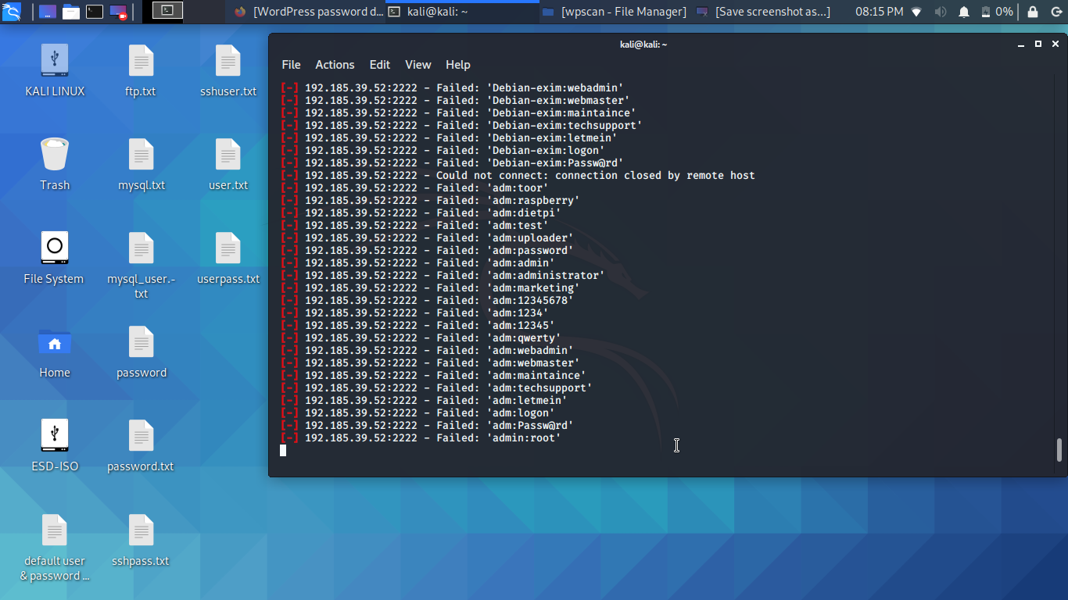
Figure 55 - msfconsole - FTP_login failed
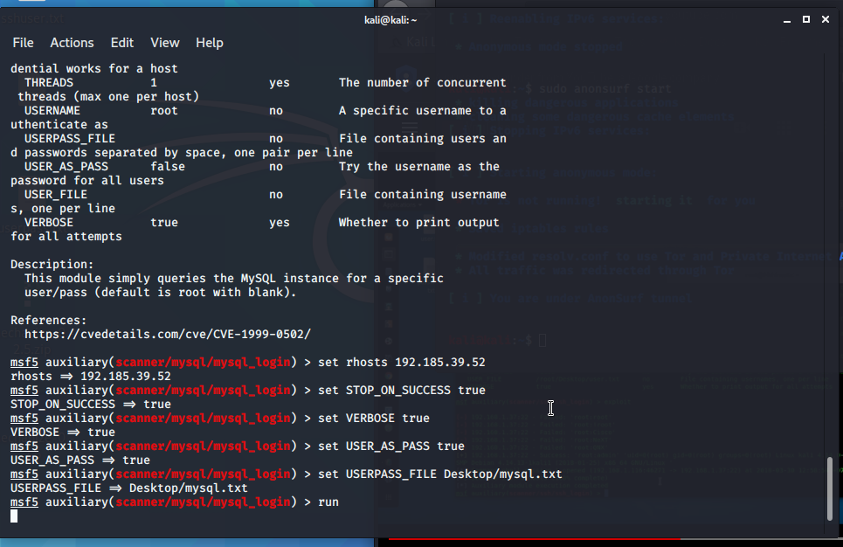
Figure 56 - msfconsole - MySQL_login
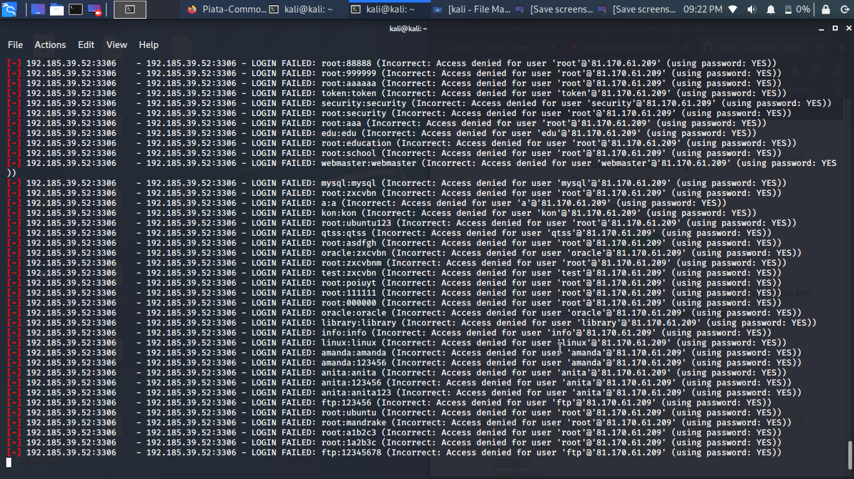
Figure 57 - msfconsole - MySQL_login failed
SSL_LABS using MSF console.
This quick Linux scan has successfully detected that the target website is vulnerable to downgrading attacks, Strict Transport Security (HSTS) attacks and forward secrecy attacks using most browsers.
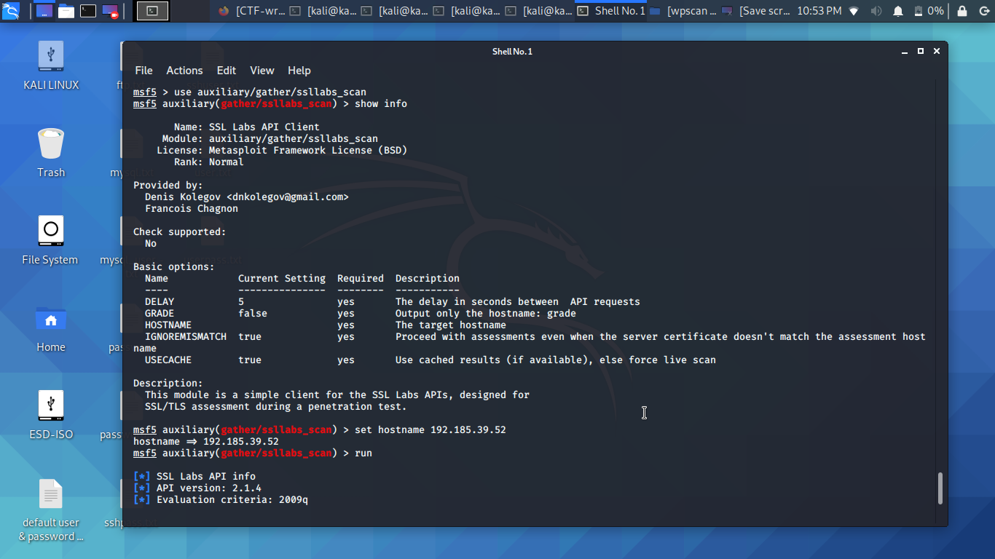
Figure 58 - SSL_LABS Scan
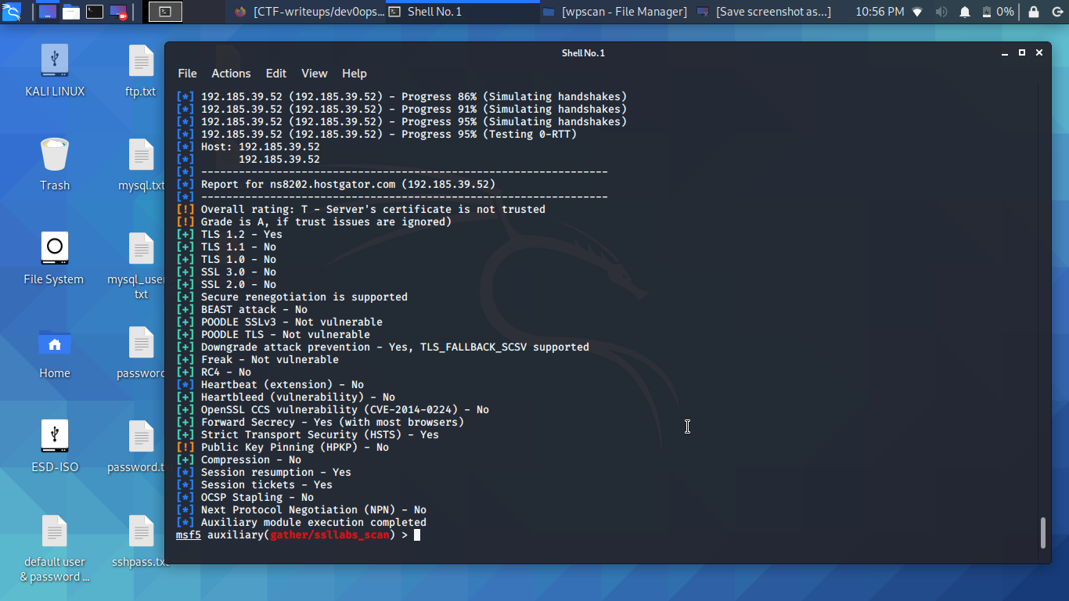
Figure 59 - SSL_LABS results

Evaluation of the Results
This ethical penetration test performed on Tevelcyber Corps live web application has been conducted within the scope and terms agreed, multiple penetration tests have been performed using different tools, different protocols and many services related to this web application. Most of these tools were implemented using Kali Linux, Parrot OS and online free web penetration testing tools. In terms of information gathering and vulnerabilities assessment, the author believes that those two objectives have been achieved successfully taken into consideration the limited tools available. However, the author was not able to exploit successfully all the vulnerabilities discovered throughout this penetration test mainly due to the high integrity of the security implemented by Tevelcyber. Throughout this experience the author has uncovered a great deal of information about the target company other services related to the live website, many exploits could have been executed through indirect links such as DNS services, google mail or routing. Taken in consideration that this is not agreed, and this test was conducted mainly for academic purpose, the author has completed this penetration test with no risk or damage to Tevelcyber assets using the following protocols:
- TCP/IP
- UDP
- SSL
- SSH
- ICMP
- FTP
- HTTP
- HTTPS
- SMTP

Conclusion
Hackers particularly have a wealth of things to gain from penetrating a cloud service since it exposes a lot of data from which massive information can be harnessed and used to their advantage. The array of attacks that cloud services face is hardly changing. With the increasing sophistication of security apparatus, threats are equally getting more sophisticated daily, at unequal and negatively advantageous rates. One-way providers can guarantee security is to prioritise testing vulnerabilities in their system by employing external security experts to eliminate potential bias. The institutionalisation of IoT technology in smart cities is very important as it is one technological domain that is growing and expanding continually. Challenges are faced on IoT-based networks, such as attacking the systems physically, service threat denials, invader model, data security breach, inaccurate examinations, and absence of standardised features in the network. To tackle the issues and barriers encountered, it is essential to combat these problems adequately, and the discovery made needs to be implemented with many precautions. There is also a need to come up with viable interventions. Interventions recommended to resolve these issues can also be used to resolve data security issues by implementing information gathering policy and systems that enable encryptions. Object identification, authorisation, certification, and backdoor evaluation, and so on are all solutions that can be employed. Finally, it is the author believes that regular penetration testing can reduce cyber-threats substantially as well as the prominent role of governments, education, and training of cyber professionals. However, the future of Cybersecurity can only count on innovative and smart solutions developed using Artificial Intelligence (AI) [38] [44].

References
[1] V. K. Gunjan, A. Kumar, and A. A. Rao, “Present and Future Paradigms of Cyber Crime and Security Majors-Growth and Rising Trends,” Proc. - 2014 4th Int. Conf. Artif. Intell. with Appl. Eng. Technol. ICAIET 2014, pp. 89–94, 2015.
[2] D. Wink, "Cloud Computing", Nurse Educator, vol. 37, no. 1, pp. 3-5, 2012. Available: 10.1097/nne.0b013e3182383371 [Accessed 11 June 2020].
[3] R. Moreno-Vozmediano, Montero and I. Llorente, "IaaS Cloud Architecture: From Virtualized Datacenters to Federated Cloud Infrastructures", Computer, vol. 45, no. 12, pp. 65-72, 2012. Available: 10.1109/mc.2012.76 [Accessed 11 June 2020].
[4] P. Cory, "Danish police proposal: Ban anonymous Internet use", Boing Boing, 2011. [Online]. Available: http://boingboing.net/2011/06/23/danish-police-propos.html. [Accessed: 11- Jun- 2020].

[5] Y. Wang and J. Yang, “Ethical hacking and network defense: Choose your best network vulnerability scanning tool,” in Proceedings - 31st IEEE International Conference on Advanced Information Networking and Applications Workshops, WAINA 2017, 2017.
[6] Ethical Hacking and the legal System, “Ethical Hacking and the Legal System,” no. July, pp. 3–27, 2013.
[7] G. Deepa, P. S. Thilagam, A. Praseed, and A. R. Pais, “DetLogic: A black-box approach for detecting logic vulnerabilities in web applications,” J. Netw. Comput. Appl., vol. 109, no. September 2017, pp. 89–109, 2018.
[8] J. Hang, K. Han, H. Chen, and Y. Li, “Ensemble adversarial black-box attacks against deep learning systems,” Pattern Recognit., vol. 101, p. 107184, 2020.
[9] A. Cabana, C. Charrier, and A. Louis, “Mono and multi-modal biometric systems assessment by a common black box testing framework,” Futur. Gener. Comput. Syst., vol. 101, pp. 293–303, 2019.
[10] N. Mathkunti, "Cloud Computing: Security Issues", International Journal of Computer and Communication Engineering, vol. 3, no. 4, pp. 259-263, 2014. Available: 10.7763/ijcce.2014.v3.332 [Accessed 11 June 2020].
[11] R. Sharma, and R. Trivedi, "Literature review: Cloud Computing –Security Issues, Solution and Technologies", International Journal of Engineering Research, vol. 3, no. 4, pp. 221-225, 2014. Available: 10.17950/ijer/v3s4/408 [Accessed 11 June 2020].
[12] "A study on issues of Cloud Security issues through Ransomewares.", International Journal of Recent Trends in Engineering and Research, vol. 3, no. 11, pp. 301-308, 2017. Available: 10.23883/ijrter.2017.3530.cto51 [Accessed 11 June 2020].
[13] A. Singh, "SMART CITY With IOT and BIG Data", SSRN Electronic Journal, 2019. Available: 10.2139/ssrn.3405839 [Accessed 11 June 2020].
[14] G. Alandjani, "Features and Potential Security Challenges for IoT Enabled Devices in Smart City Environment", International Journal of Advanced Computer Science and Applications, vol. 9, no. 8, 2018. Available: 10.14569/ijacsa.2018.090830 [Accessed 11 June 2020].
[15] A. Giannakoulias, "Cloud computing security: protecting cloud-based smart city applications", Journal of Smart Cities, vol. 2, no. 1, 2016. Available: 10.18063/jsc.2016.01.007 [Accessed 11 June 2020].
[16] C. Badii, P. Bellini, A. Difino and P. Nesi, "Smart City IoT Platform Respecting GDPR Privacy and Security Aspects", IEEE Access, vol. 8, pp. 23601-23623, 2020. Available: 10.1109/access.2020.2968741 [Accessed 11 June 2020].
[17] "IOT Based Application for Smart City Implementation", International Journal of Modern Trends in Engineering & Research, vol. 3, no. 9, pp. 146-149, 2016. Available: 10.21884/ijmter.2016.3057.cdtxa [Accessed 11 June 2020].
[18] A. Singh and K. Chatterjee, “Cloud security issues and challenges: A survey,” J. Netw. Comput. Appl., vol. 79, no. August 2016, pp. 88–115, 2017.
[19] R. Kumar and R. Goyal, “On cloud security requirements, threats, vulnerabilities and countermeasures: A survey,” Comput. Sci. Rev., vol. 33, pp. 1–48, 2019.
[20] J. B. Hong, A. Nhlabatsi, D. S. Kim, A. Hussein, N. Fetais, and K. M. Khan, “Systematic identification of threats in the cloud: A Survey,” Comput. Networks, vol. 150, pp. 46–69, 2019.
[21] S. Parikli, D. Dave, R. Patel, and N. Doshi, “Security and privacy issues in cloud, fog and edge computing,” Procedia Comput. Sci., vol. 160, pp. 734–739, 2019.
[22] N. Subramanian and A. Jeyaraj, “Recent security challenges in cloud computing,” Comput. Electr. Eng., vol. 71, no. July, pp. 28–42, 2018.
[23] O. Eisen, “Catching the fraudulent Man-in-the-Middle,” Netw. Secur., vol. 2012, no. 6, pp. 18–20, 2012.
[24] G. Varshney, M. Misra, and P. Atrey, “Secure authentication scheme to thwart RT MITM, CR MITM and malicious browser extension based phishing attacks,” J. Inf. Secur. Appl., vol. 42, pp. 1–17, 2018.
[25] F. Aliyu, T. Sheltami, and E. M. Shakshuki, “A detection and prevention technique for man in the middle attack in fog computing,” Procedia Comput. Sci., vol. 141, pp. 24–31, 2018.
[26] S. Karapoola, P. K. Vairam, S. Raman, and V. Kamakoti, “Net-Police: A network patrolling service for effective mitigation of volumetric DDoS attacks,” Comput. Commun., vol. 150, no. May 2019, pp. 438–454, 2020.
[27] S. Hosseini and M. Azizi, “The hybrid technique for DDoS detection with supervised learning algorithms,” Comput. Networks, vol. 158, pp. 35–45, 2019.
[28] P. R. McWhirter, K. Kifayat, Q. Shi, and B. Askwith, “SQL Injection Attack classification through the feature extraction of SQL query strings using a Gap-Weighted String Subsequence Kernel,” J. Inf. Secur. Appl., vol. 40, pp. 199–216, 2018.
[29] D. Kar, S. Panigrahi, and S. Sundararajan, “SQLiGoT: Detecting SQL injection attacks using graph of tokens and SVM,” Comput. Secur., vol. 60, pp. 206–225, 2016.
[30] Y. S. Jang and J. Y. Choi, “Detecting SQL injection attacks using query result size,” Comput. Secur., vol. 44, pp. 104–118, 2014.
[31] J. Pauli, “Web Application Exploitation with Broken Authentication and Path Traversal,” in The Basics of Web Hacking, Elsevier, 2013, pp. 87–103.
[32] S. Iqbal et al., “On cloud security attacks: A taxonomy and intrusion detection and prevention as a service,” J. Netw. Comput. Appl., vol. 74, pp. 98–120, 2016.
[33] T. Ten, M. Critical, W. Application, and S. Risks, “Important Notice Request for Comments RC Release Candidate 2 Copyright and License,” 2017.
[34] G. E. Rodríguez, J. G. Torres, P. Flores, and D. E. Benavides, “Cross-site scripting (XSS) attacks and mitigation: A survey,” Comput. Networks, vol. 166, 2020.
[35] Y. Zhou and P. Wang, “An ensemble learning approach for XSS attack detection with domain knowledge and threat intelligence,” Comput. Secur., vol. 82, pp. 261–269, 2019.
[36] A. W. Marashdih and Z. F. Zaaba, “Cross Site Scripting: Removing Approaches in Web Application,” Procedia Comput. Sci., vol. 124, pp. 647–655, 2017.
[37] IMPERVA, “Protect Your Applications Against All OWASP Top 10 Risks Content,” 2018.
[38] Sucuri, “The Top 10 OWASP 2019,” pp. 1–18, 2019.
[39] D. Achmadi, Y. Suryanto, and K. Ramli, “On Developing Information Security Management System (ISMS) Framework for ISO 27001-based Data Center,” 2018 Int. Work. Big Data Inf. Secur. IWBIS 2018, pp. 149–157, 2018.
[40] N. V. Patil, C. Rama Krishna, K. Kumar, and S. Behal, “E-Had: A distributed and collaborative detection framework for early detection of DDoS attacks,” J. King Saud Univ. - Comput. Inf. Sci., no. xxxx, 2019.
[41] M. Beltrán, “Identifying, authenticating and authorizing smart objects and end users to cloud services in Internet of Things,” Comput. Secur., vol. 77, pp. 595–611, 2018.
[42] H. Berger and A. Jones, “Cyber security & ethical hacking for SMEs,” ACM Int. Conf. Proceeding Ser., vol. Part F1305, 2016.
[43] O. B. Lawal, A. Ibitola, and O. B. Longe, “Analysis and Evaluation of Network-Based Intrusion Detectionork Using Snort Freeware,” African J. Comput. ICT African J. Comput. ICT Ref. Format O.B. Lawal, vol. 6, no. 2, pp. 169–184, 2013.
[44] T. S. Sethi and M. Kantardzic, “Data driven exploratory attacks on black box classifiers in adversarial domains,” Neurocomputing, vol. 289, pp. 129–143, 2018.

