

Lecturer’s name: Rula Alousi Group 1 students:
1. Adela Dan (1919043)
- Adrian Alin Ciubotaru (1919032)
- Alexandru Festila (1920398)
- Ana Stefaniu (1921012)
- Costel Porumba (1920946)



- Introduction
- background of the organisation
- the challenge(s) before the introduction of modern technology
- insights to the modern technology introduced
- the impact of the technology introduced
- lessons that can be drawn from the case study
- conclusion
- references

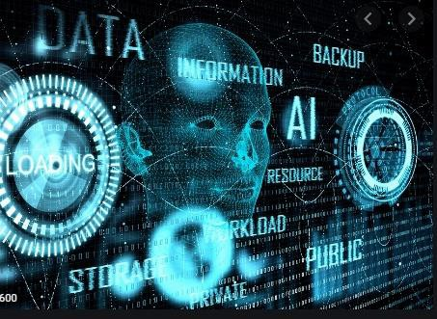
- Digital skills are defined as a range of abilities to use digital devices, communication applications, and networks to access and manage information (Grand-Clement, 2017).
- It is really important in today’s era that employees possess digital skills so that they can easily be able to analyze the needs and demands of consumers and can also increase the satisfaction level of customers by making use of internet (Morgan, 2016)

  - There are various basic and essential digital skills such as device handling and information, communicating, transacting.

  - All these skills are really necessary for workers so that they can be able to achieve their set target as well as mission(Grand-Clement, 2017).

  - It will also assist the firm in growing and increasing their managerial efficiency. Digital skills are really important as it will assist in enhancing the quality of services that is being provided by firm (Maund, Schriek and Tinkler, 2017).




- Travelodge Hotels Limited is a private company operating in the hotels and hospitality industry throughout the United Kingdom, Ireland and Spain.

- Known simply as Travelodge, it is the UK's largest independent hotel brand with over 570 hotels across the UK (Grand-Clement, 2017).

  - The hospitality organisation is been involved in making use of the various digital technology so that they can attract large range of consumers (Maund, Schriek and Tinkler, 2017).

  - Travelodge has taken the digital software from Monscierge. It is the global software company who has been providing solutions to hospitality firm.

  - They are making sure that communication is been enhanced between the guest and hotel so that better relationship can be made between them (Grand-Clement, 2017).

  - The hotel has installed sensory systems inside. They have installed the built in sensors so that light and air conditioning can be controlled with the help of tablets and computers (Maund, Schriek and Tinkler, 2017).

  - Social media and customer care are also been related. Travelodge has been engaged in promoting their business through it. This has assisted them in growing.





- Digital technology is really important for hospitality industry so that they can increase their business as well as managerial performance (Maund, Schriek and Tinkler, 2017).

- There were various challenges which have been faced by Travelodge before introduction of digital technology.

- In order to overcome this firm has been involved in doing formulating various strategies and taking different initiatives so that they can grow.

- Digital technology is really important for hospitality industry so that they can increase their business as well as managerial performance (Grand-Clement, 2017).

- There were various challenges which have been faced by Travelodge before introduction of digital technology.

- In order to overcome this firm has been involved in doing various strategies and taking different initiatives so that they can grow.


  - Handling employee pushback
  - Develop a Company-Wide Digital Transformation Strategy
  - Finding the Expertise to Lead Digitization Initiatives (Maund, Schriek and Tinkler, 2017)
  - Changing of organisational structure
  - Training and leaning related to digitalisation
  - Doing all the work manually

- Finding the Expertise to Lead Digitization Initiatives:

- It has been analysed that Travelodge has also faced this challenge of finding digitalized expert who can change the current system (Morgan, 2016).

- High skilled worker is been required so that changes can be successfully implemented.

- It has also been analysed that this expert also needs to be really supportive so that accurate guidance can be provided to employees.




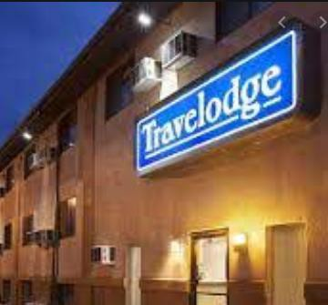
  - Information and communication technology
  - Management information system
  - Networking technology
  - Social media marketing
  - Development of new app (Morgan, 2016)

- Social media marketing:

- It is one of the most important digital technology which has been used by Travelodge (Grand-Clement, 2017).

- This technology has assisted the hospitality firm in reaching out large range of consumers.

- It has been analysed that company has been involved in promoting by making use of social media channels like Facebook, Twitter, Instagram (Maund, Schriek and Tinkler, 2017).

  - Networking technology:

  - Travelodge has also been involved in making use of various type of networking technology (Correa, 2016).

  - In this the firm is also engaged in making use of LAN. In this computer devices and low voltage devices are connected to each other. They are connected in small distance. It is really easy and helpful to share information by making use of this technology.

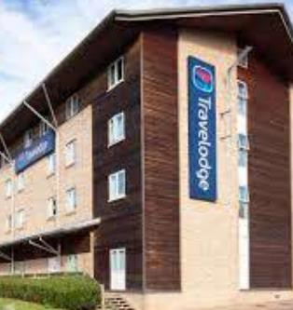




  - Travelodge has been involved in making use of various digital technology such as management information system, social media marketing, networking technology.

  - This digital technology has huge impact on growth of organisation and it has also assisted the firm in being more productive.

- Information and communication technology:

- The technology has assisted the firm in doing effective communication with workers so that firm can grow and achieve their set target (Maund, Schriek and Tinkler, 2017).

- This information management system allows management to control the flow of information all around the organisation.


  - It has also been analysed that Travelodge is also been engaged in making use of social media tools so that they can communicate easily with their consumers as well as employees.

  - It has also been analysed that they have also been involved in getting feedback from consumers through social media websites.



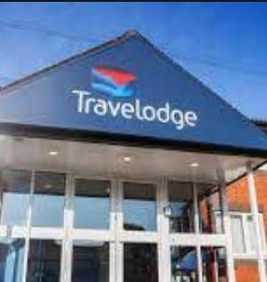
- There are various lessons that has been learnt from the report. It has also been analysed that Travelodge was facing so many challenges before implementation of digital tools and technology.
- They were involved in doing manual work which includes so many paper work.
- This has created confusion as it was quiet hectic for staff members to handle all the papers.(Cruz,and Díaz, 2016).

- So in order to overcome from this issue, hospitality organisation has thought of doing a digital transformation.

- It has also been determined that by this way Travelodge has increased their productivity and also been able to expand their business.

- This was the way they have achieved competitive advantage.

- From the case study it has also been evaluated and learnt that in order to grow and be more effective going digital is the only solution.



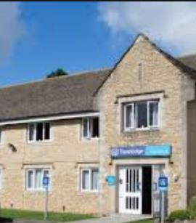
  - From the above study it has been summarised that that Travelodge has their own website in which consumers can be involved in writing feedback related to services which has been provided by them (Morgan, 2016).

  - It has also been analysed that hospitality firm is has also been involved in making use of digital technology which has supported them in growing.

- This has assisted them in attracting large range of consumers and also consumer’s satisfaction has been increased by making use of it (Grand-Clement, 2017).

- It has also been noted from the report that company has also faced various challenges before the implementation of digital technology. They have been involved in facing problem related to increase in work load as all the work has to be done manually (Morgan, 2016).



  - Correa, T., 2016. Digital skills and social media use: how Internet skills are related to different types of Facebook use among ‘digital natives’. Information, communication & society, 19(8), pp.1095-1107.
  - Cruz, F.J.F. and Díaz, M.J.F., 2016. Generation z's teachers and their digital skills. Comunicar. Media Education Research Journal, 24(1).
  - Grand-Clement, S., 2017. Digital Learning: Education and Skills in the Digital Age. RAND Europe.
  - Maund, A. Schriek, M. and Tinkler, P. (2017). Certificate in Higher Education: Skills for the Workplace Student Yearbook. Sage Publications
  - Morgan, P. (2016). The Business Student’s Guide to Study and Employability. Sage Publications



- Van Laar, E. and et.al., 2017. The relation between 21st-century skills and digital skills: A systematic literature review. Computers in human behavior, 72, pp.577-588.
- Iordache, C., Mariën, I. and Baelden, D., 2017. Developing digital skills and competences: A quick-scan analysis of 13 digital literacy models. Italian Journal of Sociology of Education, 9(1).

