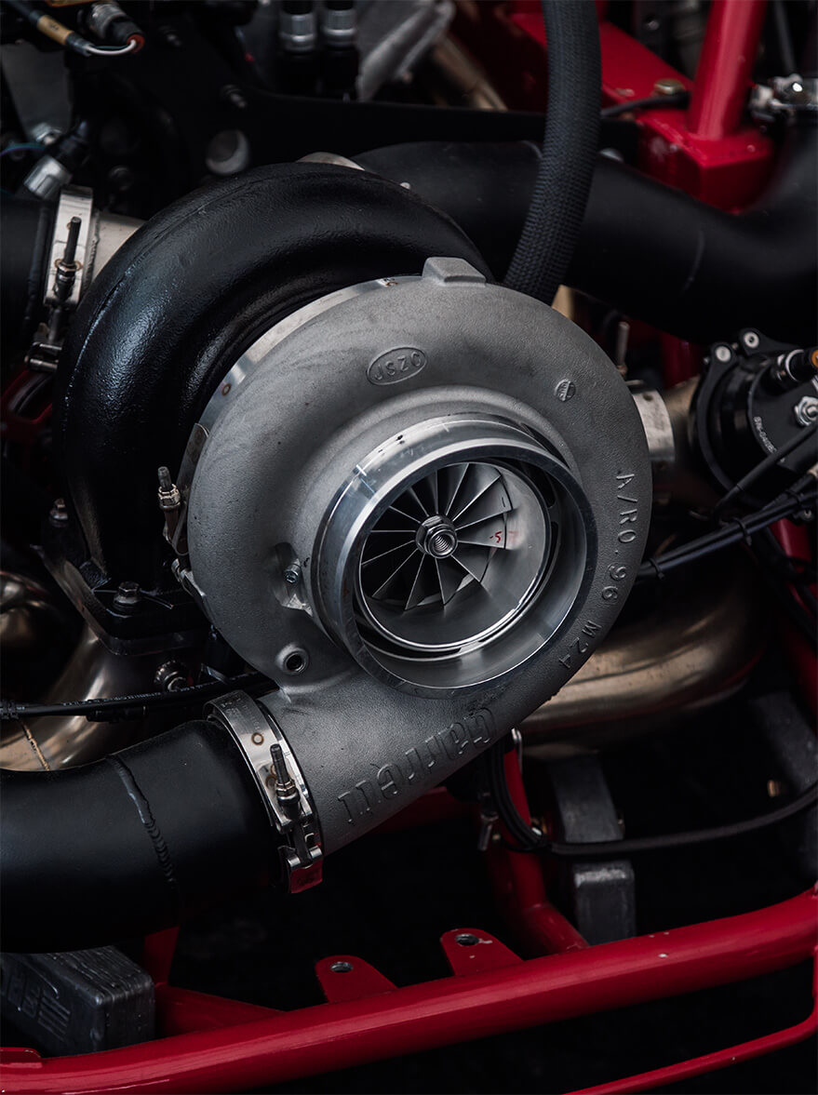
Image 1 https://www.garrettmotion.com/wp-content/uploads/2018/06/competition.jpg
Turbo Charger Analysis
POWERtrain design and efficiency
João Moura

2019
Table of Contents
1.0 Introduction 2
2.0 Background Research 3
2.1 Turbochargers 3
2.1.1 Operational Considerations 4
3.0 Air Flow – Turbocharged Engines 6
4.0 Methodology – Turbo disassembly 7
5.0 Turbocharger Design 12
5.1 Turbonetics compressor map 14
5.2 Intercooler Efficiency 15
5.3 Intercooler size 16
6.0 Modifications 17
7.0 Conclusion 18
References 19

1.0 Introduction

Even though turbochargers have been around for over 100 years, the breakthrough happened in 1925 when Alfred Buchi achieved a power increase of over 40% using exhaust gases to drive the turbine.
During the following years and the second world war, the progress of turbo charging was slow, and it was only after the war that some major applications were implemented. The first cars using turbochargers were the Chevy Monza and the Oldsmobile in the 1960’s. Due to reliability issues and premature engine detonation, it can be said that turbo technology was not very well accepted by the public. The 70’s saw a major breakthrough when turbochargers were first used in Formula 1, thus accelerating the development of turbocharging in commercial cars. BMW and Mercedes Benz were the first two manufacturers to successfully utilise turbochargers driven by exhaust gases in their vehicles. The following years and an oil crisis pushed this technology to be used in diesel vehicles, helping with power output, emissions and economy. Nowadays, turbochargers are used in almost every vehicle in order to maximise engine efficiency and reduce green house gas emissions around the globe. (Technik, 2019)


Image 1 Alfred Buchi https://en.turbolader.net/images/Geschichte/Portr_14271-003-A-PL.jpg

2.0 Background Research

2.1 Turbochargers
For an engine to produce power it requires two things, air and fuel. The more oxygen an engine can ingest, the more fuel can be delivered to create stronger combustions. In a naturally aspirated engine, the amount of air going into the combustion chamber is dictated by the displacement of the engine, the bigger the engine the more air can be pulled in. So, power and torque will always be limited to a degree in relation to the volumetric capacity of the engine. (Explained, 2011)
Turbocharged engines on the other hand can compress the air before it goes into the combustion chamber allowing a larger volume of air to be pushed into the cylinders, thus having more oxygen available to react with the fuel injected and ultimately producing more power.
A turbocharger is essentially a compressor wheel and a turbine wheel mounted on a shaft. The turbine is driven by exhaust gases that achieve tremendous velocity and make the turbine turn extremely quickly, which in turn, spins the compressor wheel that compresses the air and sends it to the cylinders. (Turbo, 2016)
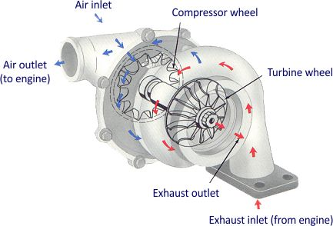
Image 2 Turbocharger http://www.troublecodes.net/wp-content/uploads/2015/11/turbocharger.jpg

2.1.1 Operational Considerations

Turbochargers produce a lot of pressure. This pressure must be managed, otherwise it would destroy the engine itself. Any pressurised cylinder must have a pressure relief valve. When a certain amount of pressure is achieved, or the maximum pressure is surpassed, a relief valve opens letting the compressed air out, maintaining safe levels of pressure within the system.
In turbocharger systems this valve is called the waste gate.
Waste gates simply open when a certain level of pressure is achieved, thus diverting air away from the turbine, which in turn saves the turbo from excessive stress and overpressure to be sent into the cylinders. Waste gates can be mounted on the turbo itself or externally, usually on the exhaust manifold.
In the past, wastegates were operated mechanically with the aid of mechanical valves. Nowadays so-called boost control valves, like the infamous N75 used by the VW group, are solenoid operated valves which receive inputs from the ECU to better control the levels of pressure in the system.
In addition to waste gates, when off throttle, the intake manifold is still pressurised and the use of blow off valves or divert valves is used to either recirculate the air back to the air intake or blow off to the atmosphere, which in the later causes the so well known ‘turbo noise’ when changing gears or when taking the foot off the throttle. (Motorsport, 2019)
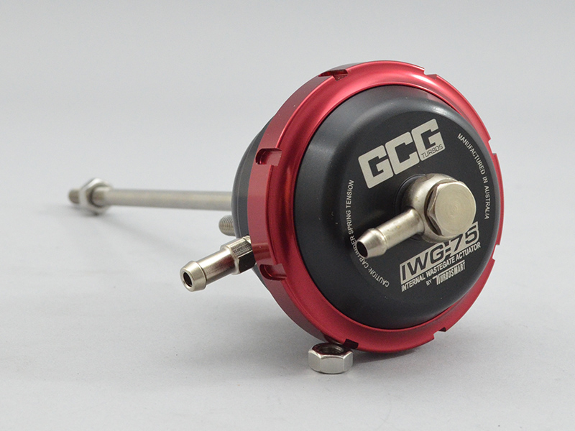
Image 3 – Wastegate https://gcg.com.au/images/stories/virtuemart/product/gcg-dualport.jpg

Another and very important factor to take into consideration is the fact that any gas when compressed, its temperature raises significantly. In this case, when the compressor wheels compress the air coming from the atmosphere, its temperature raises and thus there is a drop in oxygen density which in turn equates to less power. For this reason, it is crucial the addition of an intercooler to the system. An intercooler is basically a radiator. Hot air passes through the intercooler air channels and cools down, regaining its density and creating more power when mixed with fuel.
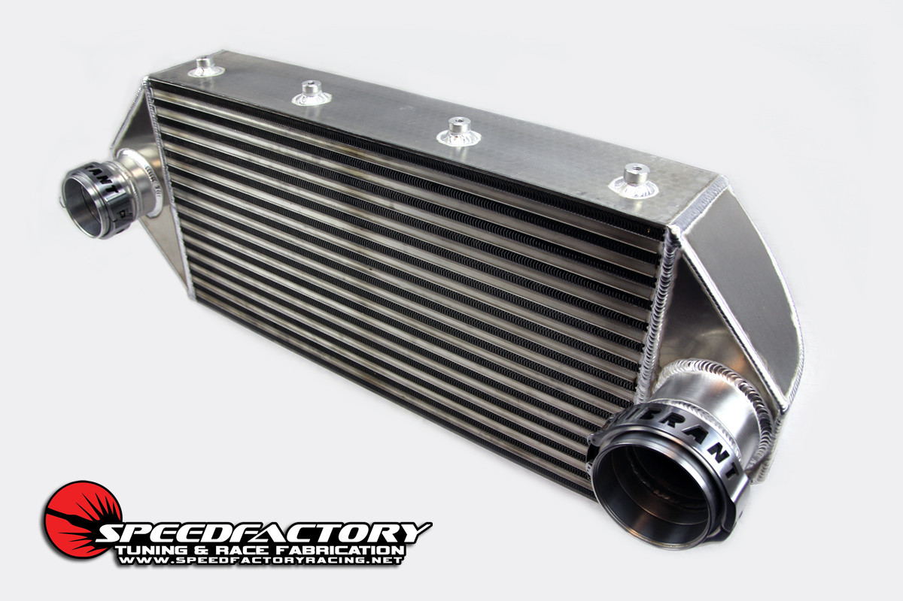
Image 4 - Intercoolerhttps://smhttp-ssl-51231.nexcesscdn.net/media/catalog/category/4.5INCHDBD.jpg

3.0 Air Flow – Turbocharged Engines

The air flow starts its journey at the air filter, more precisely at the air intake. The engine is running and thus creating vacuum. Air is pulled through the intake passing the air filter which blocks any debris that could cause potential arm to the engine. At this point the turbo is also ‘on’ because the engine is on, expelling exhaust gases and spinning the turbine. The air continues down the intake manifold passing by the intake temperature sensor and MAF sensor which reads the air temperature and the mass of the air coming in. The air now reaches the compressor wheel where it is compressed and sent to the intercooler to be cooled down. After passing through the intercooler, it now reaches the throttle body and then the intake manifold and into the cylinders to be mixed up with fuel, creating combustion. At this point exhaust valves open and the gases are expelled through the exhaust manifold passing by the turbine and spinning it and only then follow the final path down the exhaust and O2 sensor and tail pipe to be expelled to the atmosphere. (Dynamics, 2019)

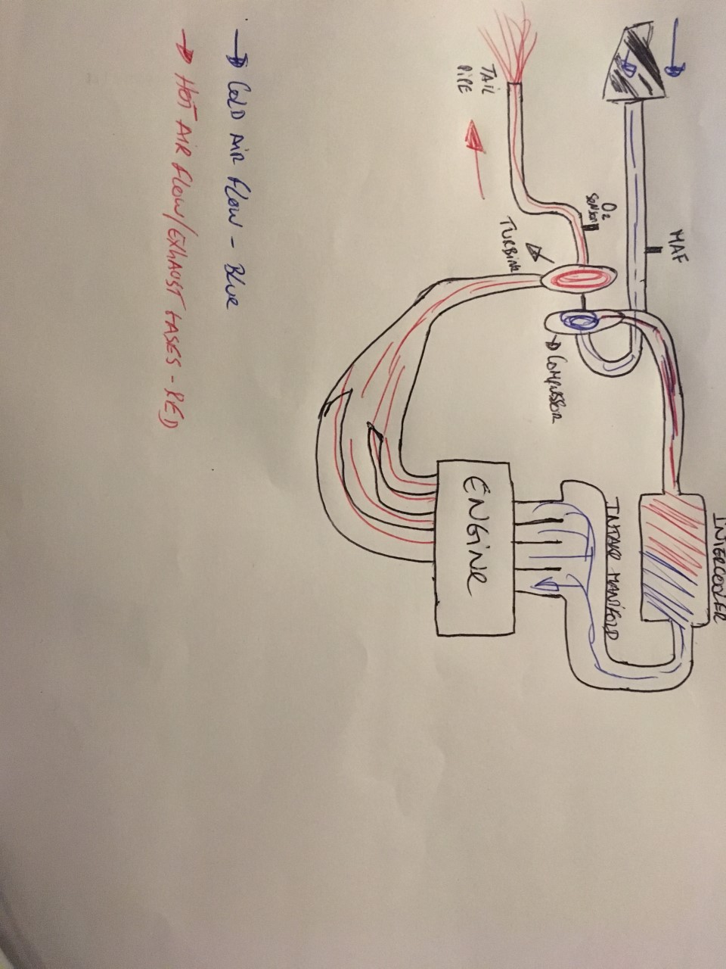
Diagram 1 – Air flow

4.0 Methodology – Turbo disassembly

The following procedures will be in great part the same for every turbocharger, with only particular steps to be added regarding your specific turbo. (Heco94, 2019)
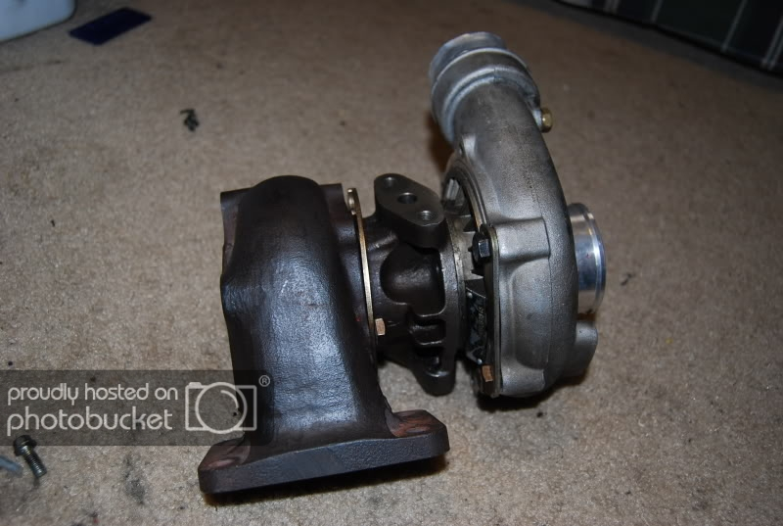
Image 5 - Turbocharger

1 – Start by removing the two 14 mm bolts to remove the compressor housing
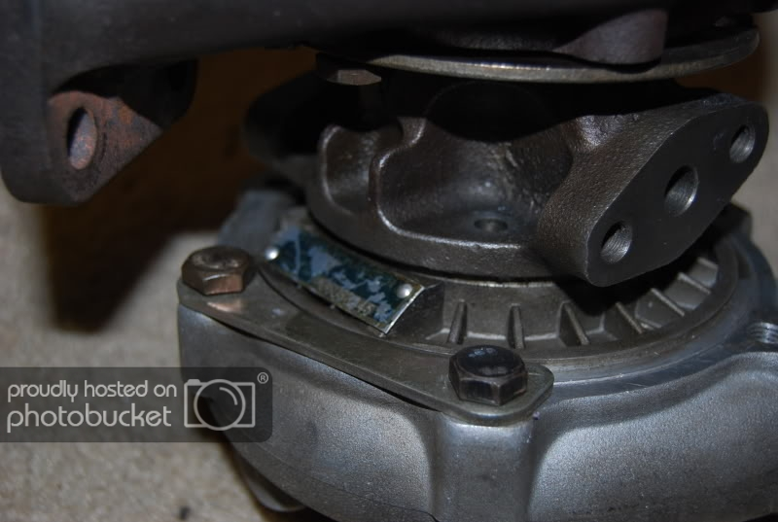
Image 6 - compressor housing

2 – Remove the compressor housing to expose the compressor
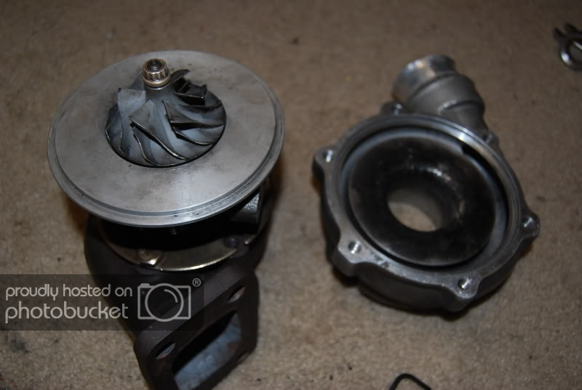
Image 7 – compressor
3 – Using a socket wrench on the turbine side, secure the turbo shaft. Then use the close end of a 10mm spanner to remove the nut that secures the compressor in place. Note that the bolt is reverse threaded
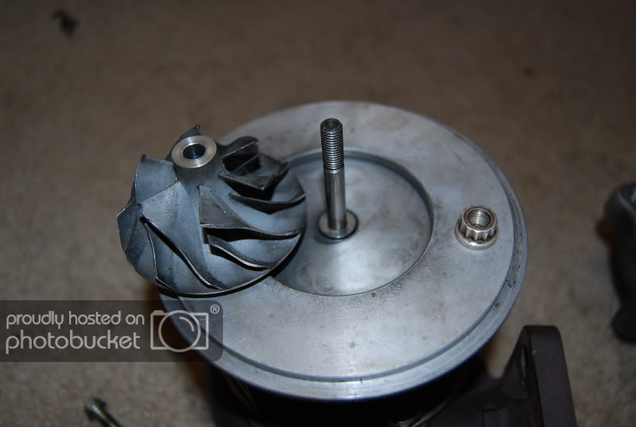
Image 8 – compressor wheel

4 – Remove the four 8mm bolts that secure the compressor plate in place
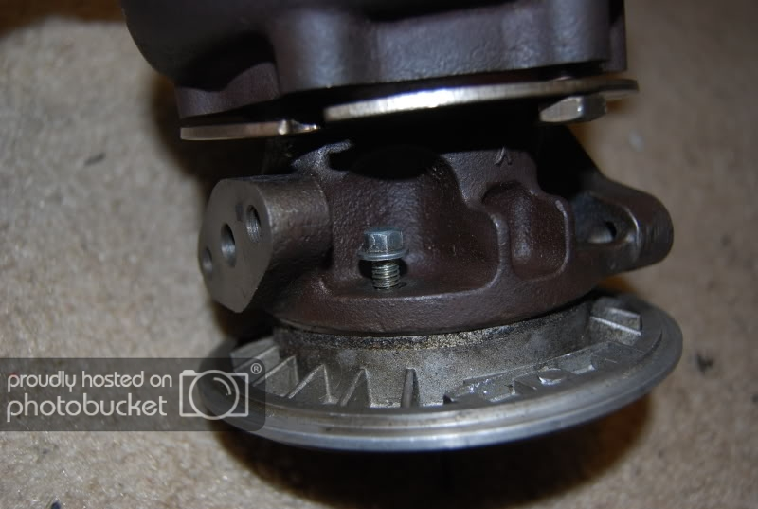
Image 9 – Compressor plate
5 – After removing the compressor plate, the centre piece of the turbo and oil channels are exposed.
Remove the C clip
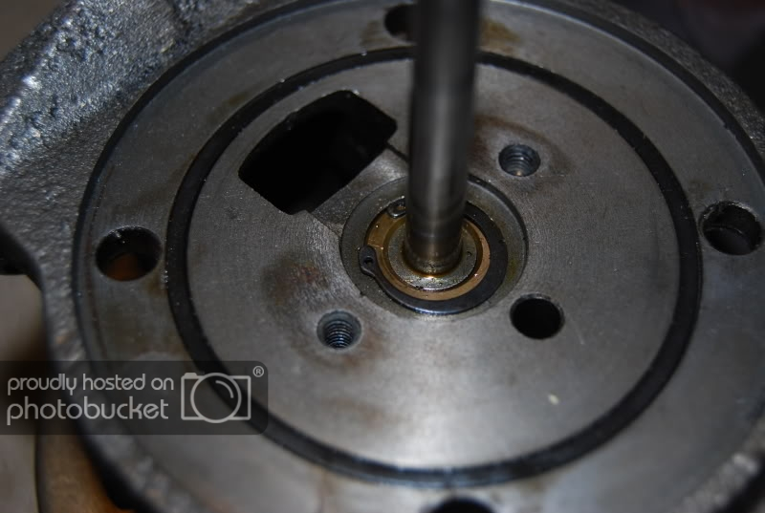
Image 10 – Core

6 – Remove the turbine clamps – 14mm bolts
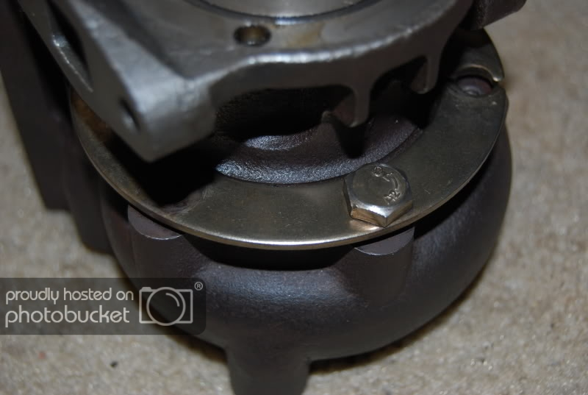
Image 11 – Turbine clamps
7 – Pry the core off. Use a small screw driver.
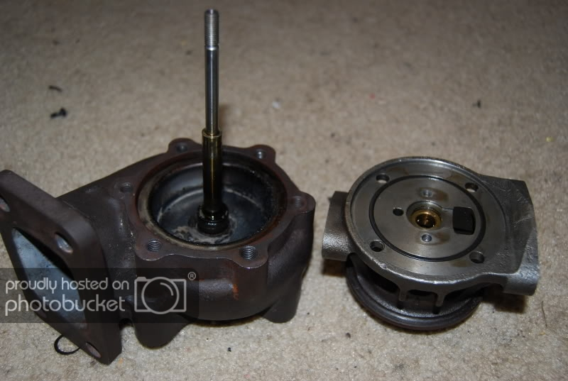
Image 12 – Turbo core

8 – Pull the turbine and shaft assembly up
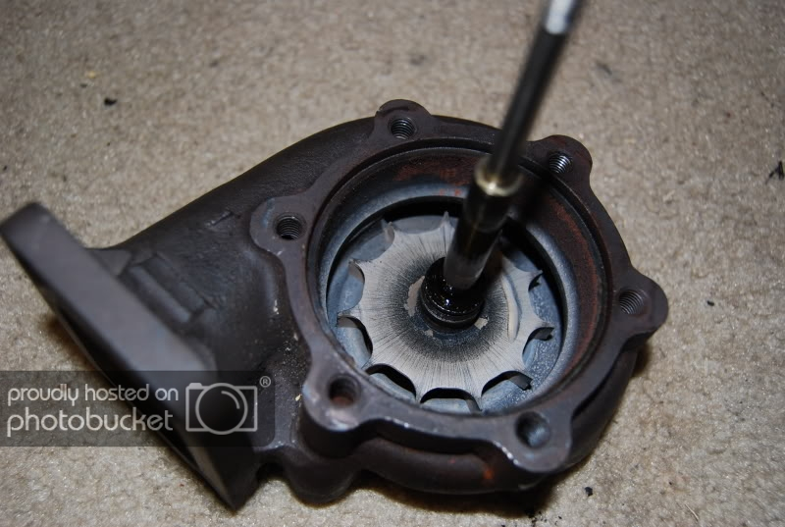
Image 13 – Turbine and turbo shaft

9 – Finally, the turbine comes apart from the housing.
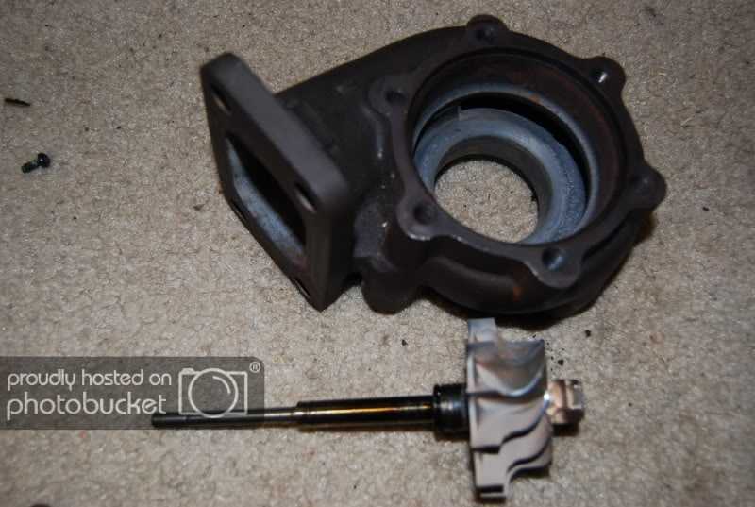
Image 14 – Turbine

5.0 Turbocharger Design

This chapter will be dedicated to the process followed to find a suitable turbocharger for a particular engine application as well as the necessary calculations to support the chosen turbocharger and intercooler.
Engine Specifications in naturally aspirated form
Layout: V8
Bore: 95 mm (0.095m)
Stroke: 80mm (0.08m)
Max engine speed: 9500rpm
Volumetric efficiency: 85%
Aimed boost pressure: 12psi
The first step is to calculate the engine capacity using the following formula:
V_{c} = π r² h
V_{c} = [ π 0.0475 ² 0.08 ] x 8 cylinders
V_{c} = 0.00453 m³
The volumetric flow rate can now be calculated using the formula below:
$$V=\frac{v×η_{v}×N}{2×60}$$

$$V= \frac{0.00453 x 0.85 x 9500}{2x60}$$
V = 0.305 m³/s

Now that the volumetric flow rate of the engine in naturally aspirated form has been calculated, the pressure ratio (difference between pressures of N/A engine vs turbocharged engine) must be taken into consideration. The pressure ratio formula is as it follows:
$$PR=\frac{14.7+boost pressure}{14.7}$$
Required boost pressure: 12psi
$$PR=\frac{14.7+12}{14.7}$$
PR = 1.82
The volumetric flow rate for the turbocharged engine can now be calculated
$$V=1.82 x 0.305$$$V=0.554$ m³/s
Multiplying the results by 2119 will give us the result in Cfm
V = 1173.88 cfm
Multiplying the value in cfm by 0.07 will give us the result in lb/min
V = 82.17 lb/min

5.1 Turbonetics compressor map

Now that the volumetric flow rate for our turbocharged engine has been calculated it can now be decided what sort of compressor to use by interpreting the compressor maps.
The compressor chosen is the compressor #4.
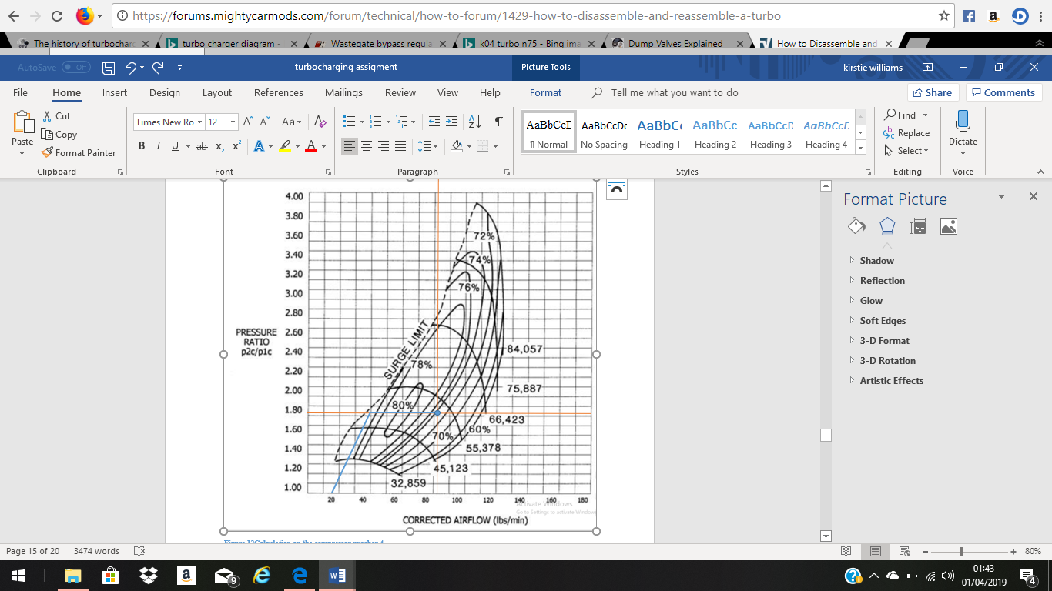
Image 15 - Turbo map #4
With a volumetric flow rate of 82.17 lb/min at a pressure ratio of 1.82, the compressor #4 is the only one capable to support the requirements needed to efficiently operate the chosen engine.
By looking at this particular compressor map it can be said that the maximum efficiency of the compressor will be in the region of 74% at the volumetric rate of 82.17 lb/min at 50000rpm.

5.2 Intercooler Efficiency

In order to calculate by how much fitting a 60% efficient intercooler would lower charge temperatures, first the compressor outlet temperature must be calculated, followed by the intercooler outlet temperature.
Compressor outlet temperature (actual temperature rise):
$$\text{ATR}=\frac{\left(PR^{0.28}×T_{in}\right)-T_{in}}{η_{c}}$$
$T_{in}$ = exterior temperature 27 C + 273 K = 300 K
$η_{c}$ = 74%
$$\text{ATR}=\frac{\left({1.82}^{0.28}×300\right)-300}{0.74}$$
ATR = 74 K
Intercooler outlet temperature:
$$T_{io}= T_{co}-[ η_{i}(T_{co}- T_{a}]$$
$$T_{co}=compressor outlet temperature-374 K$$
$$T_{a}=ambient temperature-300 K$$
$$T_{io}=329.6 K degrees$$
By subtracting the intercooler outlet temperature by the compressor outlet temperature, the reduction in temperature can be found:
374 – 329.6 = 44.4 K

5.3 Intercooler size

The size of an intercooler is dependent on the amount of air the engine aspirates. In this application is 1173.88 cfm. Using the graph below we can determine the how large the frontal area must be.

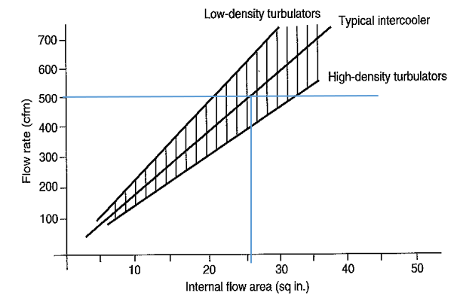
Image 15 - sq in vs cfm
For 500 cfm the frontal area is 26inches. In our case the flow rate is 1173.88.
$\frac{1173.88x26}{500}$ = 61.04 sq in
Since for a typical intercooler around 45% of the charge air face is available for entry into the tubes, the frontal area must be divided by 0.45 to obtain the real area needed for the intercooler to perform at its best on our application. (Monteiro, 2019)
$\frac{61.04}{0.45}$ = 135.5 sq in

6.0 Modifications

Most naturally aspirated engines can hold a certain amount of boost without the need to upgrade internal components. However, it is imperative that if we are talking about a high end, high revving application that the internals must be changed before attempting to install a turbo. This will guarantee to a certain degree, the longevity of the engine and also increase the amount of boost it can hold. Uprated connecting rods, pistons, rod bearings and rod bolts. In extreme cases forged cylinder sleeves are also needed.
it will also be needed an intercooler for our application, bigger injectors to supply more fuel. A high capacity fuel pump, to provide the system with more fuel. A high capacity MAF sensor to read the increased amount of air coming into the engine and a bigger air intake and a bigger intake manifold to also support the larger amount of air sucked by the engine. A custom exhaust manifold and a larger exhaust to support the increased exhaust gases and reduce back pressure. Maybe colder spark plugs to support ignition timing. A stand-alone ECU would also be needed, so a new engine map can be written in the ECU.

7.0 Conclusion

This report contains specific information about turbochargers and a specific application of a turbocharge to a naturally aspirated engine. It can be concluded that a turbocharge can increase the power output on and engine significantly but there are many things to take into consideration when doing such modifications. It was also shown and explained how an intercooler is vital to maintain turbo and engine efficiency.
The selection of a turbocharge for your specific application largely depends on the capacity of your engine and even though there are turbo system that can be bought off shelf, is it wise to understand and know how to read turbo maps in order to select the right turbo for a specific application, whereas is road use of motorsport, high end torque or low end torque.
In summary, engine specification must be taken into account to calculate the volumetric flow rate so a turbo can be selected. Then, the temperature raise must be calculated in order to choose a specific intercooler to cool down the air after it has been compressed by the compressor wheel.
Depending on how much boost the engine will be running, a list of possible modification was also added to this report.
Nowadays engineers have understood the benefits of turbocharging any type of engine, small or large capacity. A decline in exhaust gases and an increase in engine efficiency is largely due to the implementation of turbochargers. The technological advances in terms of engine control system have also allowed for better and more responsive turbos to be developed. It is a technology that we take for granted, but it took just over 100 years to be truly efficient.

References
Dynamics, T., 2019. Turbo Dynamics. [Online]
Available at: https://www.turbodynamics.co.uk/technical/understanding-turbochargers/
Explained, E., 2011. youtube. [Online]
Available at: https://www.youtube.com/watch?v=zenMEj0cAC4
Heco94, 2019. Mighty Car Mods. [Online]
Available at: https://forums.mightycarmods.com/forum/technical/how-to-forum/1429-how-to-disassemble-and-reassemble-a-turbo
Monteiro, P., 2019. Powertrain design and efficiency Intercoolers. [Online].
Motorsport, B., 2019. Balance motorsport. [Online]
Available at: https://balancemotorsport.co.uk/dump-valves
Technik, T., 2019. Turbo Lader. [Online]
Available at: :https://en.turbolader.net/Technology/History.aspx
Turbo, B., 2016. Youtube. [Online]
Available at: https://www.youtube.com/watch?v=jt2UTL4AhpU

