Marriott Placement Learning Log

Rohan Dubrey (1905715)

Week 5:

Wednesday 12th February 2020 (14:300-23:00hrs) Thursday 13th January 2020 (14:30-21:00) Friday 14th January 2020 (08:00-16:00hrs) Saturday 15th February 2020 (14:30-23:30hrs)

Department: Front Office

Work Undertaken:

- Maintenance cost saving measures.
- Fire alarm system and procedures
- Checking of sewage system
- Maintenance Plant room checks
- Sprinkler system repairs monitored
- Topping up of essence for steam room
- Room clearance for new carpet
- Performing concierge duties
- Training on Customer Service
- Completing VIP list on GXP
- Hotel inspection visual checks
- Fire door checks
- Fire sprinkler engine room inspection
- Handling guest complaint
- Transcendent work request
- Inputting traces and alerts in Opera
- Mobile check in
- Updating guest profile
- Assign mobile key
- Allocating Marriott Bonvoy Membership points or free breakfast
- Concierge duties
- Authorisation of credit cards (hold)
- Accepting full payments (deposited)
- Preparing codes on reservation cards
- Printing next day reports.

Self-Appraisal

Clearly, the interaction and involvement of the maintenance team is of extreme importance within the hotel industry. Being able to work within this department and experiencing the hotel from a different angle, has given me the advantage to hold an erudite discussion. Nevertheless, the lack of engineering knowledge has seen hotel management students refusing to work in this department. However, working in this department has equipped me with skills to be a more productive hotel manager in the future.

Strengths:

Remaining calm under pressure and acting professional throughout have been paramount again this week within my strengths. Having to stand over twenty five minutes listening to a guest complaint, allowed me to portray graduate attribute achieved, showing empathy and listening skills.

Again, this week has been an improvement on my learning, with ongoing training within Opera PMS. Confidence has been gained in authorisations and deposits payments from guests on the main reception. Also, being able to make group pre-check-ins has allowed me to be faster when checking in guests. This has allowed me to be more productive within the team.

Weaknesses:

The main challenge this week came from learning to do group bookings merging from excel to Opera PMS. Having to stop throughout training to check-in guests and deal with guests’ queries, meant the process had was to keep restarting. However, after being relieved from the reception desk, further training in the back office allowed for the training to be completed.

Lost Opportunities:

The ability to manually cut a room key through vision line, has been seen as a lost opportunity for me this week. Prior training scheduled had to be rescheduled for a later date. However, being able to cut a duplicate key through Opera PMS, has given me the confidence that I will be able to grasp the training quickly when done.

.

Plans for next week:

- Completing solo tasks confidently.

- Turning up for shifts promptly and in proper attire, completing a variety of shifts accumulating to over 30 hours per week.
- Seeing how all departments link with finance.

Appendixes

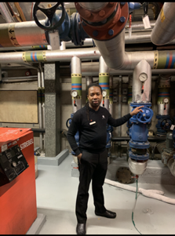
Maintenance Plant Room (14.2.2020)

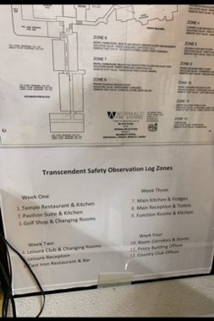
Transcendent Sheet (14.2.2020)

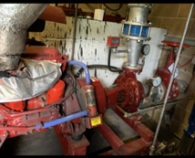
Sprinkler System Engine Room (14.2.2020)

