BMSW5102
Christopher Davis
1712446
BA Management-skills for the workplace
Developing relationships and Workplace achievement: Part 2.

Contents
Task 1 2
Task 2 5
Task 3 7
References 10

Task 1
Critically evaluate development vehicles available to an organisation appropriate to the development needs of the individual.
In the following report the researcher will be critically evaluating development vehicles available to an organisation and the development needs of the individual. The researcher will also look at the benefits of these to both the employer and the employee. The report will then conclude with the researcher developing a Personal Development Plan to meet the development needs and expectations of the individual. The researcher is aware that there are numerous ways to engage and develop their employees and this can be done through motivation, engagement, training and performance management however for the purpose of this report the researcher is going to be focussing on motivation and training.
“Employers want to select the best people but also those that have made positive decisions to work for the company” (Horn, 2009)
What is motivation?
“Motivation is the term used to describe those processes, both instinctive and rational, by which people seek to satisfy the basic drives, perceived needs and personal goals, which trigger human behaviour. (Cole,1995,page 119)
Research shows that motivation is psychological and to truly motivate your employees you need to understand their wants and needs. Many of the things that can motivate individuals are instincts. Desires and needs and arousal levels. “Motivation is the word derived from the word ’motive’ which means needs, desires, wants or drives within the individuals. It is the process of stimulating people to actions to accomplish the goals. In the work goal context, the psychological factors stimulating the people’s behaviour can be desire for money, success, recognition and job satisfaction.” (Managementstudyguide.com, 2019)
There are two main types of motivation and these can be Extrinsic and Intrinsic this means that Extrinsic is affected by external factors and are often rewarded with success whilst Intrinsic arises from the individual and are purely done for personal satisfaction. Motivation can help shape an employee’s behavior and actions in the workplace and there can be many different factors that will motivate the employee to succeed and perform well within the organization. By motivating your employees, you are ensuring that they remain focused and continue to perform well whilst keeping them interested in their job and given task. Motivation can be the reason an individual does something or sets themselves a goal to achieve. Motivation can also be the reason many people act or perform the way they do throughout their everyday life. Over the years there have been many motivation theorists including Maslow’s Theory, Herzberg’s Motivation Hygiene Theory, McClelland’s Need Theory, McGregor’s Participation Theory Urwick’s Theory Z, Argyris’s Theory, Vroom’s Expectancy Theory, Porter and Lawler’s Expectancy Theory.
From the researcher’s perspective Maslow’s Theory is probably the most well-known.
“Human needs arrange themselves in heirachies of pro potency that is to say the appearance of one need usually rests on the prior satisfaction of another more pre potent need.Also no need or drive can be treated as if it were isolated or discrete; every drive is related to the state of satisfaction or dis satisfaction of other drives.”(Maslow, 2013,page 6)

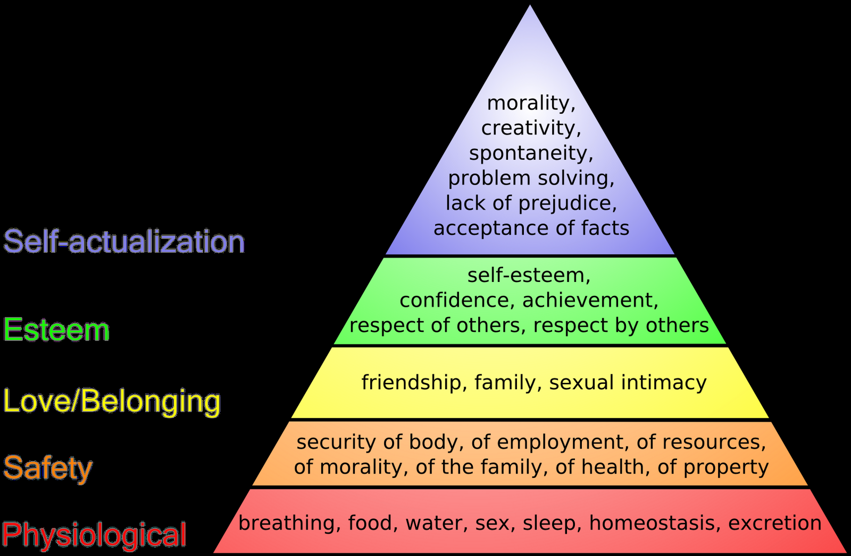
(3.bp.blogspot.com, 2019)
What is training?
” Training can be formal or informal and can take place on or off the job. It is an intervention aimed at increasing an individual’s skills and knowledge in the workplace.” (Cole, 2011, page 482)
It is important to train your employees as you are ensuring that they have the necessary skills, attitudes and behaviors needed to carry out their roles. This can also motivate your employees more as you are showing your commitment to them through taking the time and financial costs of improving and developing on an employee’s job skills and knowledge. Training is identified as a must when employees are no longer performing or reaching their potential as they don’t have enough knowledge/training to allow them to complete a task. Depending on the size of the organization and nature of the training this can be easily done at times in-house, however for the more tailored training and development there may be a need to send your employees off site to a qualified assessor/trainer to deliver the necessary training.

“In order to achieve effective training, a series of steps might be followed. In the 1970s, Boydell (1970) introduced ‘systematic training in 10 steps’ this being later adapted into the more commonly known training cycle (Buckley and Caple 1995, 2009).” (FutureLearn, 2019)

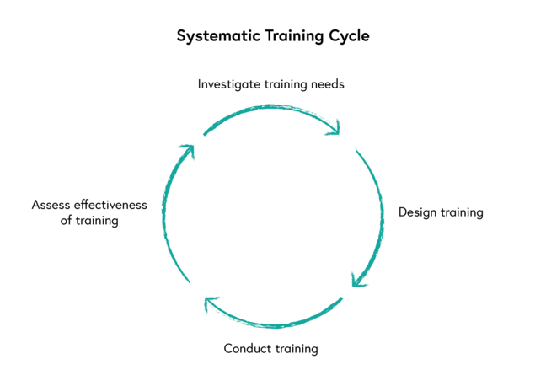(FutureLearn,2019)
Training and motivation can be interlinked as Peter Morgan Says, “Short training courses are a very common source of information if an organisation is struggling to know how, for example, to motivate its people or undertake a particular process.” (Morgan, 2017)

Task 2
Critically assess the potential benefits to the organisation and the individual of personally developing individuals in the workplace.
“Trust is the highest form of human motivation. It brings out the very best in people. But it takes time and patience, and it doesn’t preclude the necessity to train and develop people so that their competency can rise to the level of that trust.” (Covey, 2004)
It is important for an organisation to understand what motivates their employees because motivated staff are more likely to be happy in their job role and will be more productive and perform better in their employed roles. Google believe that to motivate their staff they need” To create the most happiest workplace in the world.” (Linkedin.com, 2019)
Motivated staff are also more likely to want to climb the corporate ladder and succeed and reach targets given, they will be eager to learn and develop their skills as they are being made to feel wanted and important, this will result in higher performing employees.. There are many benefits to an organisation if the employees are motivated. To positively influence motivation in the organization they need to ensure that all employees are given the correct training and tools to carry out their roles in a safe and positive environment, these small changes will make an employee feel appreciated and comfortable with any tasks they are given as they know they are trained correctly and given the correct clothing, footwear and tools to complete their tasks whilst protecting themselves from unnecessary accidents within the workplace. The motivation can also be influenced via rewards both financial and non-financial and through positive employee relations. “Disney believes that the best examples of things that motivate others always involve surprise and delight” (bradt, 2019) This can be easily done by giving bonuses or extras when employees complete given tasks. good working conditions will also help motivate you as an individual an all employees will be grateful of the opportunity of flexitime, sick and maternity pay, childcare vouchers, holidays and time in lieu and the opportunity to do overtime and be compensated for it. Depending on the size and nature of your organisation employees could be motivated with the extra benefits which could range from company car, private health care, employee discount, private pension and in some cases a subsidised canteen or bus to transport employees to work all of these benefits are offered to permanent and temporary staff at Amazon Warehouse U.K (amazon.jobs, 2019)
“Training is a program that helps employees learn specific knowledge or skills to improve performance in their current roles.” (AllenComm, 2019)
As an organization you can offer your employees on the job training or off the job training. On the job training is cost effective, convenient and quick however there is the disadvantage of the training being wrong as the employee giving the training session may not be suitably qualified. Off the job training is normally a more costly option but you are guaranteeing the employee is receiving the training without any distractions they may experience with their on the job training. The training given off site is also not specific to your company as they are just delivering an overall training package making it harder to transfer what they have learned. If an employee is well trained, then everyone can benefit from the employee to the employer and even the customers as they will receive an excellent customer experience. An employer will benefit from training its staff as there will be less mistakes which will mean a lot of less complaints as customers will be happier and more likely to return so this will also increase the organizations profit and improve its reputation. Other benefits will also include enhanced performance and efficiency and from a Health& Safety angle there will be less accidents. The employee will also benefit as there are more confident carryout tasks as their skills are improved. The employees will also have improved morale making them feel happy and important in their roles.
Training is important to all major organisations and small businesses alike. One company’s training programme who benefits both employer and employee is Aldi who offer an apprenticeship programme who will train their staff to a manager position within 3 years. (Aldirecruitment.co.uk, 2019)
When offering training to employees it is also important to monitor and evaluate the costs and the benefits of this training for financial and non - financial reasons. Tesco provides tools to monitor and evaluate their training by setting opjectives in PDP and activity plans. (Tesco-careers.com, 2019)

Task 3
Develop a plan to meet the identified development needs and expectations of an individual.
“From identifying employee training needs, to spotting your company’s rising stars, employee appraisals have many important uses. Whether staff are performing well or poorly, employee appraisals present an ideal opportunity for HR to identify the next stage in their development. Many organisations use personal development plans (PDPs) within staff appraisals, to direct and record staff development. You can use PDPs to set development goals that the employee should try to reach before their next appraisal.” (BrightHR, 2019)
“We believe our programmes will provide you with a foundation of experience, skills, knowledge and behaviours that you’ll need to be successful with us. And, if it’s relevant to your development and the graduate programme you’re on, we’ll give you the financial support, study leave and your own personal development plan to gain a professional qualification.” (Virgin Media Careers, 2019)
After completing an appraisal on a member of the Customer Service Team and talking to their colleagues and observing them in their day to day job role the manager needed to develop a PDP for the employee.
“A personal Development Plan (PDP) is a set of techniques used in the workplace to manage your learning and development” (Horn,2009, page 69)
The appraisal highlighted the employees desire to climb the ranks and work towards becoming the Customer Services Manager. The PDP was designed with input from both the employer and employee and between them they have set 6 objectives the employee needs to be fully trained and confident in being promoted to Manager Status. The objectives were set with varying timescales and priorities and the employer will be keeping themselves aware of the task and review dates to ensure all objectives are achievable.
The employee will be shadowing the current Customer Services manager on an arranged schedule and will be enrolled on the next Customer Care training course which is run in the head office in Leicester. The priority has been highlighted as high as it is very important that she attends the training as soon as possible so over the next 12 months she will be already trained in the employer’s programme including all policies and procedures for the Customer Services Department. The employer will need to improve on their time management and organizational skills as over the next 12 months there is going to be a lot of learning and courses needed attending to gain the promotion. There is going to be an ongoing review of this objective as there are different timelines for all the training needs. The employer has decided that this employee is a rising star in the company and is worth training and developing to the highest standard, it is also believed that by investing in her gaining a formal qualification in Level 4 Skills for the workplace that the business will benefit from their qualifications and what they can bring to the organisation. The review for this is 12 months as the course is run in a local university via 2 mornings a week for the next year.
“Personal Development is an often used but rarely explained term, it is about investing in yourself so that you can manage yourself effectively. Personal Development allows you to be pro-active rather than wait for good things to happen.” (Coaching Positive Performance, 2019)

Objectives | Measures | Priority | Support & Development  Internal/External | Review Date | Comments
Improve on Customer Service. | Attend a training course on Customer care. | High | Internal &External | 1 Month | Liaise with Head Office for next training dates.  Shadow the current Customer Services Manager.
Time Management/  Organizational  Skills. | Schedule weekly meetings  Generate diary  Manage all relevant training days in a timely manner. | Medium | Internal | Ongoing | To organize and structure the Customer Service procedures and policies.  Ensure that all training is attended.  Becoming competent setting timescales etc
Gain a Formal Qualification | Enroll on level 4 Sills in the workplace. | Medium | External | 12 months | Ensure flexible working pattern to accommodate studies and assignment deadlines.
Become First Aid Trained & Fire Marshall Training | Enrol on a course with St. Johns Ambulance | Low | External | 3 months | Attend 3-day FA course and 4hours marshal training.
Complete ECDL  Course | Research online packages.  Attend ECDL.  Familiarize with Microsoft Office | Medium | Internal | Ongoing | Complete the course and gain the qualification.  Provide a laptop with Microsoft package.
Become a Manager | Complete all above objectives.  Gain promotion. | Medium | Internal | 12 months. | Ensure fully supported over the next 12 months to ensure the employee is qualified and confident to become a manager.

On completion of this PDP the employee will feel like a highly valued member of staff and will be grateful for the investments given and feel a sense of confidence and belief that they are now capable of applying to be the Customer Services Manager. It is also important to apply the SMART technique when writing a PDP so you are ensuring the objectives are achievable from the start.
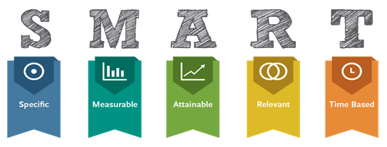(Yourdost-blog-images.s3-ap-southeast-1.amazonaws.com, 2019

References
3.bp.blogspot.com. (2019). [online] Available at: http://3.bp.blogspot.com/-nGu0o8MU46M/Ta1XYp0P5rI/AAAAAAAAABE/QfmVOXvHlps/s1600/maslow.png [Accessed 1 Dec. 2019].
Aldirecruitment.co.uk. (2019). Aldi Recruitment - Stores Apprentices. [online] Available at: https://www.aldirecruitment.co.uk/apprentice/our-apprentice-programmes/stores-apprentices/ [Accessed 6 Dec. 2019].
AllenComm. (2019). What is Employee Training & Development? | AllenComm. [online] Available at: https://www.allencomm.com/what-is-employee-training-development/ [Accessed 6 Dec. 2019].
amazon.jobs. (2019). Fulfilment / Warehouse Associate. [online] Available at: https://www.amazon.jobs/en-gb/job_categories/fulfillment-warehouse-associate [Accessed 3 Dec. 2019].
bradt, g. (2019). Disney's Best Ever Example Of Motivating Employees. [online] Forbes.com. Available at: https://www.forbes.com/sites/georgebradt/2015/05/20/disneys-best-ever-example-of-motivating-employees/ [Accessed 3 Dec. 2019].
BrightHR. (2019). Why Employee Appraisals are Important | BrightHR. [online] Available at: https://www.brighthr.com/articles/culture-and-performance/appraisals/why-are-employee-appraisals-important [Accessed 4 Dec. 2019].
Coaching Positive Performance. (2019). 6 Core benefits of personal development. Take charge of your life.. [online] Available at: https://www.coachingpositiveperformance.com/6-core-benefits-personal-development/ [Accessed 3 Dec. 2019].
Cole, G. (1995). Organisational behaviour continuum. London: Thomson,p.119.
Cole, G. (2011). Management. Andover, UK: South-Western Cengage Learning, p.482.
Covey, S. (2004). The seven habits of highly effective people. London: Simon and Schuster, p.178.
FutureLearn. (2019). Introducing the training cycle. [online] Available at: https://www.futurelearn.com/courses/7093exq-01/1/steps/421580 [Accessed 1 Dec. 2019].
Horn, R. (2009). The business skills handbook. London: CIPD, p.69.
Horn, R. (2009). The business skills handbook. London: CIPD, p.94.
http://yourdost-blog-images.s3-ap-southeast-1.amazonaws.com/wp-content/uploads/2016/07/29123148/SMART-TEchnique.png{Accessed 7 Dec. 2019}.
Linkedin.com. (2019). Employee Motivation: The Google Way!. [online] Available at: https://www.linkedin.com/pulse/employee-motivation-google-way-sampurna-majumder [Accessed 3 Dec. 2019].
Managementstudyguide.com. (2019). What is Motivation. [online] Available at: https://www.managementstudyguide.com/what_is_motivation.htm [Accessed 1 Dec. 2019].
Maslow, A. (2013). Theory of human motivation. [USA]: Black Curtain Press, p.6.
Morgan, P. (2017). The business student's guide to study and employability. london: sage publications ltd, p.308.
Tesco-careers.com. (2019). Home | Tesco Careers. [online] Available at: https://www.tesco-careers.com/ [Accessed 6 Dec. 2019].
Virgin Media Careers. (2019). Training | Virgin Media Careers. [online] Available at: https://careers.virginmedia.com/early-careers/graduates-interns/training/ [Accessed 6 Dec. 2019].

