UWTSD, BABM,LCBB4004,Assessment 1
Lecturer: Tushara Balendran
Student: Tonka Nikolova, 1914038, Term 2, Group 1

Critical analysis and marketing process evaluation of Nescafe

Content
Introduction…………………………………………………………………………………………………………………………………3
Marketing and marketing process…………………………………………………………………………………………………3
1.Situational analysis of NESCAFE…………………………………………………………………………………………….4
PESTLE analysis………………………………………………………………………………………………………………4
SWOT analysis……………………………………………………………………………………………………………….7
2, Segmentation, targeting, positioning of NESCAFE………………………………………………………………….11
3. Marketing mix of NESCAFE…………………………………………………………………………………………………….13
Conclusion and recommendation…………………………………………………………………………………………………..19
Reference list………………………………………………………………………………………………………………………………..21

Introduction:
In this essay I will emphasize processes and stages of marketing, including the role of the marketing mix by connecting them with the company of my choice-NESCAFE. Nescafe is brand, created by Nescafe and has a long and interesting history, having proven himself in time as a brand and excellent reputation since its inception. Seven years it took the chemist Dr. Max Mergenthaler to develop the final product at the be orders of Brazilian businessmen. His work was rewarded and on April 1, 1938 Nescafe appears on the market. This famous brand comes to the market to meet the growing demand for a cup of coffee to be consumed out of home. As I will look at the company from a marketing perspective I will start with a definition of Marketing. “Marketing is the activity, set of institutions, and processes for creating, communicating, delivering, and exchanging offerings that have value for customers, clients, partners, and society at large.”(How to market your business, Dave Patten, 2008, p.1) Marketing is process of produce and selling gods and services and has been described as knowing where to go, while selling is the act getting there.(https://www.britannica.com/topic/marketing/)
The marketing process and its importance consists of analysing the factors influencing the development of the business, the opportunities, the objectives, their implementation and, in a nutshell, it can be presented in the following 5 steps the marketing process and its importance consists of analysing the factors influencing the development of the business, the opportunities, the objectives, their implementation and, in a nutshell, it can be presented in the following 5 steps(Dreamstime.com, 2020) (Fig 1).
• Situational analysis.
• Objectives
• Strategies
• Implementation
• Control
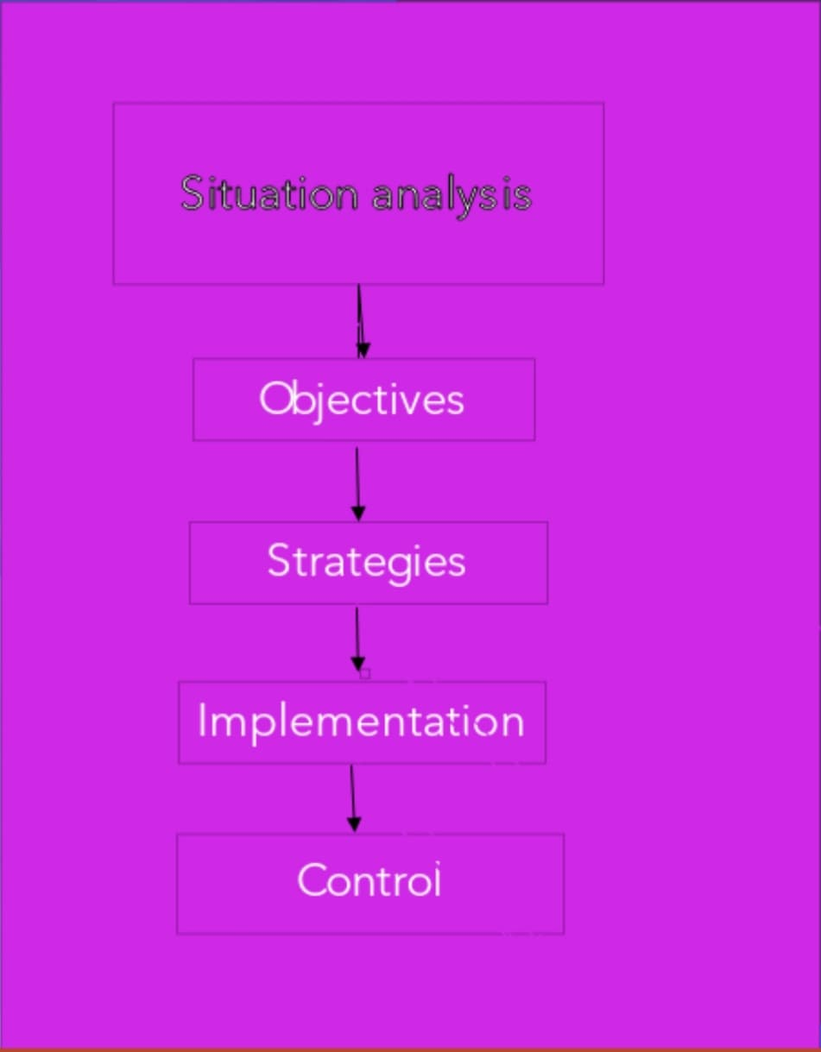
(Fig.1, Source: Tonka Nikolova)
First will start with mission statement of NESCAFE which is to bring NESCAFE to people around the globe, providing a "1 NOW 1 NESCAFE" to satisfy every aspect of needs. Nescafe provides good taste, aromatic smells of coffee to people, providing "1 Nescafe with 1 unique moment "so that everyone can enjoy. Wherever you are, you will be able to find Nescafe around, whether in shopping complexes, supermarkets/hypermarkets or even grocery stalls (http://www.antya.com/detail/Nestle-com/48318).
Situation Analysis
Situational analysis is an important tool for identifying external and internal factors influencing the organization to achieve its objectives and includes many analytical approaches: The SWOT, PESTLE and Porter Five Forces Analysis A Marketing Strategy is designed to advise businesses in how to convey the value of their goods to the needs of potential customers the situation analysis is a first step in the marketing process and is a crucial step in maintaining a long-term partnership with customers. (www.definitions.net,n.d.) Applying it in practice in this case, I will focus on PESTLE and SWOT analysis of the chosen company.
- PESTLE analysis covers political, economic, social, and technological, legal and environment factors influencing favorable and unfavorable over the business development of Nescafe. His type of analysis is of utmost importance for each company as it gives a clear picture of market dynamics and allows to improve the business.
• Political Factors: „Nescafe is having the largest global coffee footprint with its presence in more than 180 countries “(Team, n.d.). Therefore, is understandable that it is strongly influenced by the political factors. Changes in policies of any of these countries will affect the brand. As the corporate tax cut made by India's government from 30 per cent to 22 per cent will act as a great bonus for Nescafe. The tax rate reduction would lead to more cash in hand which can be used to boost demand by giving the customers extra discounts.
• Economic factors: Coffee production in Brazil is projected to rise leading to increased supply but the same is not anticipated. Coffee prices are expected to increase as farmers are only supplying a small amount at the low price that is now prevailing on the market and hosting the rest and waiting for the rising prices. That would have an impact on the brand as its costs increase. However, the demand for coffee is still growing in spite of this. India, largely a tea drinking country, has experienced a 40 percent increase in coffee demand over the last decade, with instant coffee being the most preferred among the millennials. Nescafe captures market share of the Indian market at 51 per cent, followed by its rival companies Bru. In South Africa, the situation is completely different. Nescafe's other rivals such as Frisco and Ricoffy are regularly lowering their price to get on the market. The business has invested 1.2 billion rupees in South Africa's instant coffee production plant because it believes there's demand in SA's coffee industry.
• Social factors: Nescafe introduced the same logo for the first time in 75 years, in all the countries where it sells. The company uses a new slogan "Everything begins with a Nescafe." The slogan was designed to bear in mind customers of the new generation. Company claimed they needed a more united and stronger framework for the brand to exist in a more globalised and interconnected environment that could convey the brand's unique personality in different countries. It had rejuvenated the brand, making it more contemporary. It provides expertise beyond coffee, with its advertisements such as "making every moment count" and badlolifekiraftar. It provides the young people with an positive outlook on life. It has a broad variety of items to suit any individual's taste. It has wide product selection from pure soluble coffees to 3 in 1 mix and ready to drink coffee. Nescafe celebrate the International Coffee Day every year by organising social events for the people.
• Technological Factors: Nescafe has its own special hub of research and development in China. It has links with agricultural universities with the aim of supporting the industrial sector. Nescafe-a smart coffee machine that makes hot and cold coffee-has established the brand with first of its kind E. It must be paired with Nescafe E linked mug device via Bluetooth. There have been numerous social media campaigns like 'Good Morning World' which have asked people to share their video on digital channels with their morning coffee mug. As the biggest engaging site, the campaign managed to reach 15 million users on Facebook. Through e-commerce too the brand is expanding. Nearly all the items can be found on various e-commerce websites such as Flipkart , Amazon, Big Basket making it more convenient for people.
• Legal factors: The company recently filed a complaint against various third parties in Delhi high court for the unlawful manufacture , distribution and selling of Nescafe instant coffee imitation. Since of these counterfeit goods, the interests of the company and the public health were at stake. Together with India's Food Safety and Standards Authority (FSSAI), the Ministry of Health and Family Welfare is taking charge of the matter. Nescafe's scam giving free coffee machines for testers was around the corner. The company has reported to the Malaysian Communications Commission and Multimedia Commission for the same.
• Environmental Factors: Brand has the Nescafe Program, the main sustainability programmed.
‘We are the biggest consumers of green coffee with a responsible sourcing. They teach farmers techniques of specialty coffee growing with minimal water use. Energy saving methods are being used in the UK to use less energy to roast more coffee. Farmers are advised to minimize the use of pesticides and prevent disease'. Impact of COVID-19 affects differently the geography, the sales channel, and the type of product. It also depends on the period of outbreak, the perimeter of restrictions, and the behavior of the buyer. For some products, Covid 19 has had a favorable impact on increasing sales growth, for example Purina Petcare/Nestle, coffee products and Nestle Health Science have increased their growth according to Netsle web site (Nestlé Global. (n.d.) the markets have undergone a major change. Out-of-home sales notes negative growth, as opposed to home consumption, where growth has increased At the same time, online sales increased significantly (29.4%). The period is still difficult - but the company is adaptable and resilient due to the variety of its products and global operating business.
Geographies: In North America and Europe, the market increased in March , but in China there was a decline in sales for the quarantine quarter.
Product categories: Essential products saw increased demand.” (Nestlé Global, 2020):
- SWOT: As a strategic tool SWOT is a respectable instrument for summarizing data from environmental analysis but it cannot be used on its own. SWOT can identify many issues but prioritizing between all of them can be an issue (tiduko.com, 2017). Now I will examine SWOT analysis of NESCAFE.
Strengths
Nescafe is a product of Nestle, which is famous worldwide and has a huge market share on the global scene, and that allows for their further progress and development. What’s more, the brand covers various market segments because of its wide range of products, for example, they offer their famous Nescafe coffee as well as cereal, dairy, etc., some of which have a variety of different tastes. The brand is number one in the UK, also among the leading companies on the coffee market in some other countries and therefore, it has its own loyal clientele. Moreover, the company provides excellent quality at a good price, which attracts new customers and retains the existing.

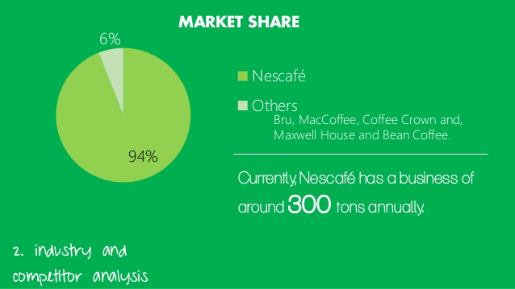
Source:( http://www.docstoc.com/docs/12163694/Nestle-Marketing-Mix-and-SWOT)

Weaknesses
However strong a brand is, Nescafe also has its weaknesses. The growing need for customers to lead healthy lifestyles leads to an increased demand for products with more health benefits. Caffeine, which is normally a part of the experience, is a strong stimulant and it has a physical and psychological impact on people when they drink too much; which may contribute to a decline in coffee intake as people become more aware of their health issues. Also, oversaturation on the market can have a reverse psychological effect on people by making them want to buy less of their products, as the American psychologist Barry Schwartz says in his book The Paradox of Choice: Why More is Less, “Learning to choose is hard. Learning to choose well is harder. And learning to choose well in a world of unlimited possibilities is harder still, perhaps too hard.” (Schwartz, 2004).
Opportunity
As successful as it is, Nescafe always has opportunities lined up. Even if people’s health concerns contribute to their weaknesses, it could be turned around. This is a great chance for the company to introduce to the market a new product to fit more people’s needs; for example, they have produced a sugar free option for coffee lovers with diabetes, and decaf for those who want to enjoy their favourite beverage without the stimulant, the brand could also develop a more organic product that offers more health benefits as well. What’s more, the company could open their own Nescafe coffee shop where they can sell their own products and offer more tastes and alternatives to their clients, especially if they follow more trends and implement more specific flavours, such as green tea for example. Another good idea is possibly the partnership with restaurants, to offer their goods, that way the distribution will become even wider and would be able to reach more clients.
Threat
The bigger the brand, the higher the stakes; Nescafe could face threats from other well-known brands such as Starbucks. The coffee market is already mature, and the brand has to be very competitive in order to succeed.
I continue to follow steps of marketing process and next is objectives: In business terms, the objective is a set of steps that a company will have to undertake in order to achieve its goal. As we look into Nestle, they have a big responsibility to fulfil their set objectives, some of which are less water usage and more recycling.
Strategies: A strategy is a plan for the future, A plan is a collection of actions, designed to achieve long term’s goals: (Simplicable, n.d.).
OBJECTIVES- business objectives describe what the company expects to achieve at different time intervals, such as one year or five years (Azcentral.com, 2012).
MARKETING IMPLEMENTATION- This is the process that transforms marketing plans into tangible actions to achieve a marketing objective. Marketing planning provides the structure for the implementation to occur, in the sense that planning refers to the abstract terms of marketing activities and the implementation works out the specifics.
MARKETING CONTROL- involves gathering information on marketing performance and comparing the achieved performance against planned or budgeted performance, using predetermined standards and yardsticks. It provides feedback; it regulates; and it exercises a restraining influence or a redirecting influence (Essays, Research Papers and Articles on Business Management, 2019).
Segmentation, targeting, positioning in the Marketing strategy of Nescafe – A mix of Geographic , demographic and psychographic segmentation strategies are used by Nescafe in order to make one type of coffee beans available in another part of the globe and revolutionize the coffee culture. (https://www.facebook.com/marketing91, 2017)
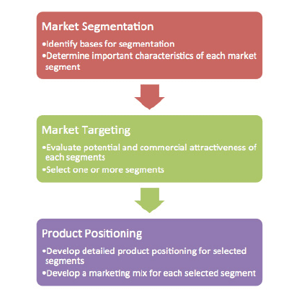
Source( https://www.smartinsights.com/digital-marketing-strategy/customer-segmentation-targeting/segmentation-targeting-and-positioning/)
MARKET SEGMENTATION STRATEGIES OF NESCAFE COFFEE is based on four areas:
Nescafe has four main strategies of market segmentation.
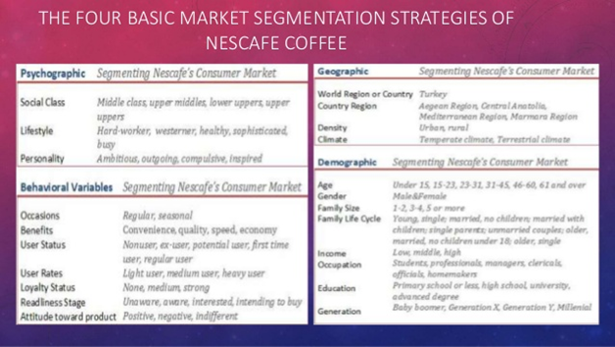
Source: https://www.slideshare.net/
Target market refers to a group of consumers, who would most likely purchase products and utilize services. Marketing always starts from identifying these customers so the company producer can manufacture the stock in accordance with their clientele’s needs and preferences, as well as benefit from a marketing mix in order to convince more people to buy the products. Target market can be divided on a demographic, psychographic and geographic bases. Nescafe’s target market is comprised of people who value the quality of their coffee and make it at home. Most often these people are either students or working professionals from 25 to 32 years old.
Demographic factors
Age is one of the main factors when it comes to the target market, as the company knows their limits with caffeine, which isn’t recommended for adolescents and people in risky health groups. Nescafe used to focus primarily on people who need a cup of coffee in the morning but nowadays they target more people who need to optimize their work – people below the age of 35. Coffee drinkers don’t have to classify in terms of gender as the beverage is consumed by all. People in education take advantage of the drink so as to be able to maximize their productivity. Nescafe targets people who have an average income or more, that’s why their products are made affordable.
Brand positioning comprises the targeted demographic’s reasoning as to why they should buy a certain brand and not another one. It is the niche that all brand activity should come back to in order for all the sectors to conduct the work in accordance with the company’s aim, which is guided by ‘all the points of contact with the consumer.’ (Managementstudyguide.com, 2019). Market positioning is not an easy process to make since the brand has to look through their clients’ eyes and see how their product is perceived so that the company can then present their stock in the most favourable way. Periodically brand positioning could vary when the company is trying to adjust their product in the public’s perception. The best strategy that fits with the Nescafe coffee is the Transformational positioning / Lifestyle positioning.
Marketing mix
Marketing mix is an important technique in marketing. By researching the market, the organizations identify the most suitable marketing mix. The marketing mix should consist of the right product sold at the right price in the right place by using the attractive promotional technique (Team, n.d.)
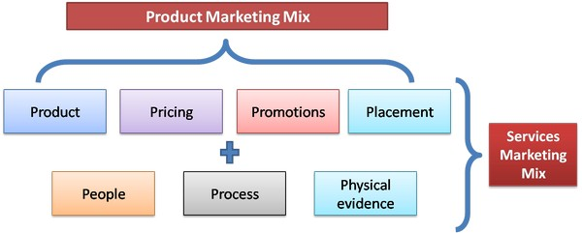
Source: https://www.marketing91.com/importance-marketing-mix/

The Products- NESCAFE provide a wide range of coffee products for coffee lovers. Varieties of coffee product in the market: The company using family branding strategy.” Nestle is the parent company of Nescafe and it is one of the most successful companies in the world and is well known for offering a variety of products, one of them being Nescafe” (Marketing91, 2017)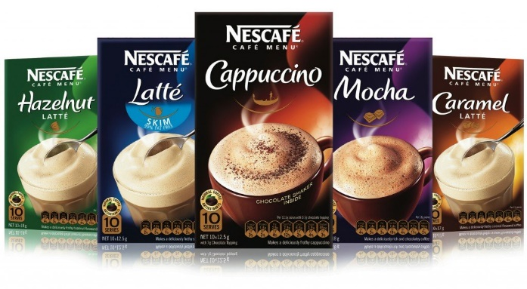
Source: https://www.amazon.co.uk/NESCAFE
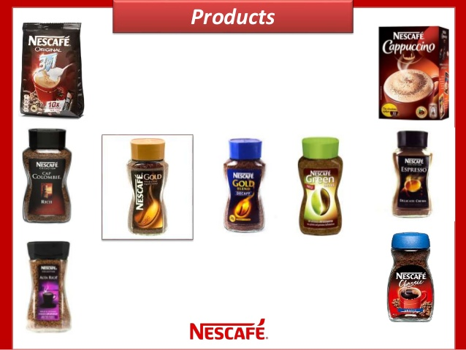
Source: https://www.amazon.co.uk/NESCAFE

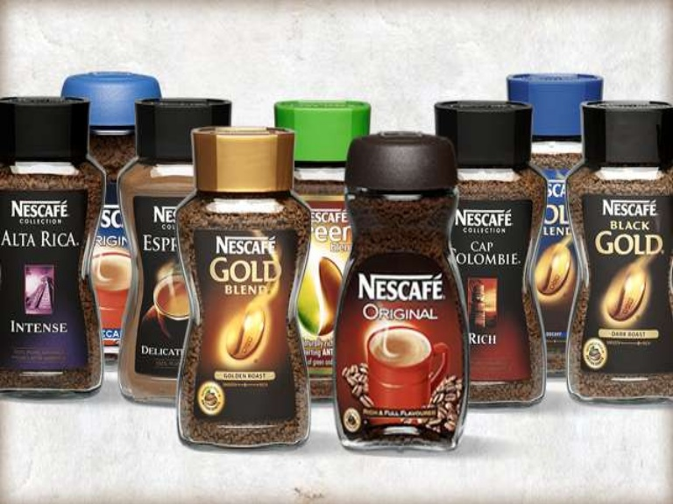
Source: https://www.amazon.co.uk/NESCAFE

EVERYDAY COFFE: Nescafe classic- leading coffee, Nescafe 3 in 1, Nescafe Alta Rica, Nescafe Cap Colombia, Nescafe Espresso

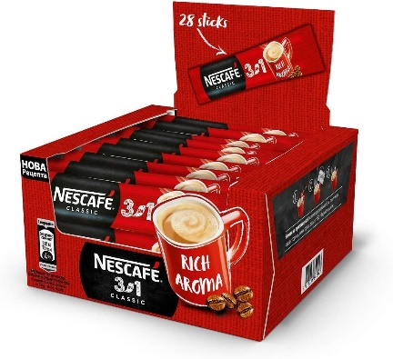

Source: https://www.amazon.co.uk/NESCAFE-ORIGINAL-SACHETS-sachet-WHOLESALE/
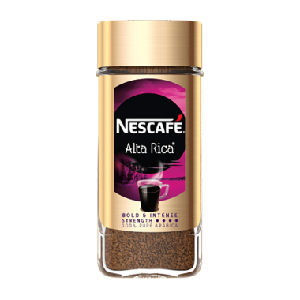
Source:https://www. nescafe.com/tr/kahvelerimiz/nescafe-alta-rica

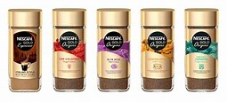
Source: https://www.amazon.co.uk/NESCAFE-ORIGINAL-SACHETS-sachet-WHOLESALE/
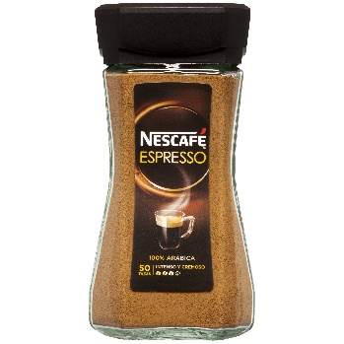
Source; https://www.amazon.com/Nescafé-HAZC048490-Nescafe-Collection-Espresso/dp/B004AVB6FI

PREMIUM COFFEE:
Nescafe Gold, Nescafe Green Blend, Nescafe Cappuccino, Decaff coffee, Nescafe classic Decaff,
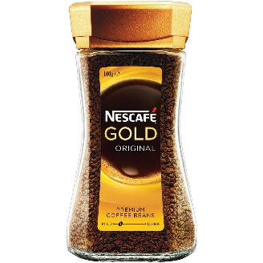
Source: https://www.woolworths.com.au/shop/productdetails/34978/nescafe-gold-instant-coffee-original-roast
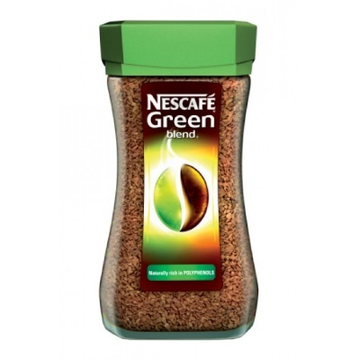
Source: http://www.chocolate-brands.com/index.php?route=product/product&product_id=254
PRICE:
The next important stage of marketing mix is Price. Before setting a price, marketers must be aware of the value of their product, which includes quality, distribution, etc. (Acutt, 2016). Price is very important for the overall profit of the company. It has to be competitive but also in the right position for the company’s benefit. The pricing can be flexible but only for institutional businesses, otherwise the prices are fixed. This is due to their strong market position and unfeather leadership.
PLACE
Nescafe has two channels of distribution: direct and indirect. The brand use Dual Distribution, it is difficult for clients to buy directly from Nestle. Tats why they have different sites in different languages those sites is made only for the country in which language it is written (Unknown, 2016).
Distribution Channel 1: Nestle/ Nescafé, Supermarket, Consumer.
Distribution Channel 2: Nestle/ Nescafé; Wholesale; Consumer; Retailer
Nescafe makes part of the selective distribution. They manage the guidelines of the
retailers that deliver to the consumer.
It applies to the region in which
the ready-made product is to be delivered. There has to be a proper place to keep
types of food ready where the buyers are available. Apart from the venue, the distribution and arrangement of the commodity also has its own significance in attracting potential users. Place has a very important role to make the product available. The company distributes its products by intermediaries(supermarket, superstore)- indirect channel of distribution.

If there are unhappy customers from Nescafe products they can do complain in special link, providing from the company, where are telephone number and email (ComplaintPoint.co.uk, 2019)
Promotion:
Promotion is made in order to attract more people towards the likes of a brand, and it is the last step to undertake of the marketing mix. For Nescafe it is easy to boost their image and sales at different times because it’s already a well-known brand and implementing promotional strategies is not new to them. There are various promotional options but some of the most common ones include sales promotion, advertisement, buzz marketing, in store promotional activities, and packaging.
Advertisement:
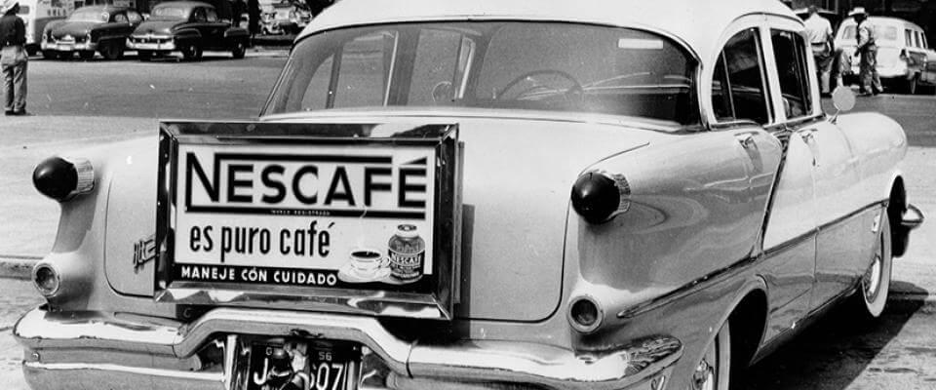An old advert from 1950s.
Source: (https://www.nestleprofessional.co.uk/news/case-studies/brief-nescafe-history)

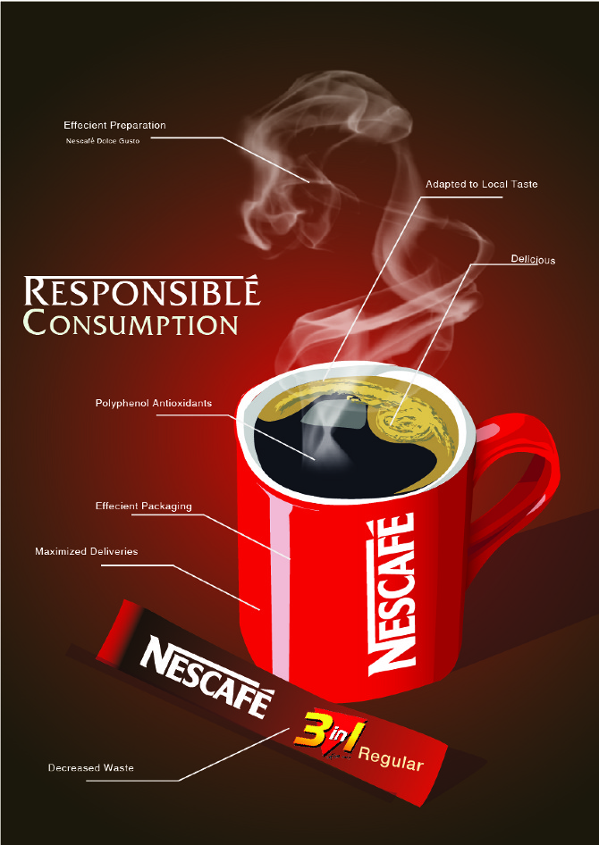Nescafe now.
Source: http://cargocollective.com/seanteh/Nescafe-Advertisement

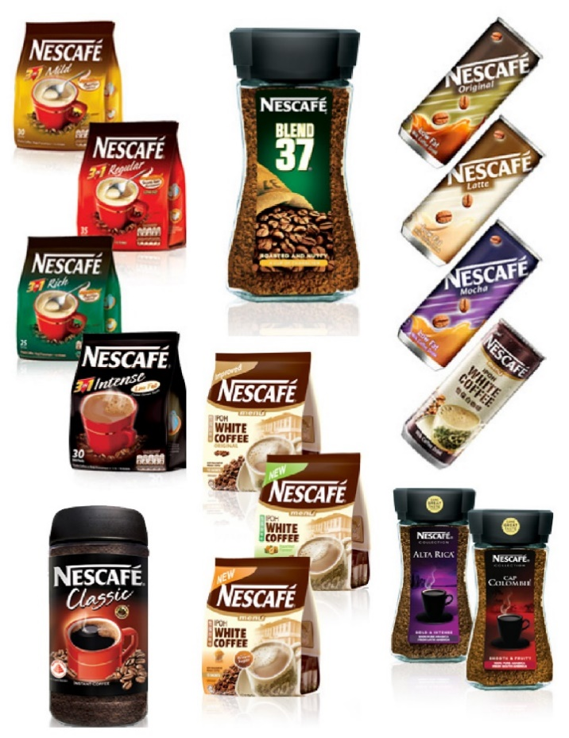
Nescafe products are packed attractively. This is the tool to attract the customers for buying that product. So Nescafe used different packaging for attracting the customers. Example: (free range)
_ It is packaged in Yellow and black so as to give an appealing look.
-Contained in foil to increase its life;
-Also available in re-useable airtight plastic jars;
-It is available in 200,400-gram packs;
Its 200 grams pack is designed as a SKU to capture small shoppers shelves

Advertisement:
Advertisement is the one of the tool to encourage the audience. Television advertising and online media advertising are the two important advertisement used by Nescafe. The main aim of the advertisement is give awareness about the product to the public. Nescafe used different advertisement in social media, online advertisement, television etc.

Facebook:
(facebook)
Twitter:
(Twitter)
YouTube:
(youtube)

In store promotional activities:
In store promotional activities are those activities done in the store for promoting the product. Nescafe used different in-store promotional activities. They are Poster (brodericks):

Billboard (global advertisie):
Attractive offers:
Nescafe provides attractive offers to customers for promoting the product. Buy a 200g Nescafe gold and get 1 travel mug for free. (theodmgroup)

Conclusion and recommendation:
According to the comprehensive study carried out so far, we should have already had a full imagine of Nescafe business operating. The prosperity of their products based in the great synchronization of 4Ps.Company appeals consumers by strong brand name and reputation, wide range of variety products and packaging and advertising. Nowadays, it is too difficult to survive the business due to high competition. Nescafe's promotional efforts include all types of promotional resources such as internet ads, television, radio, social media, etc. With the promotional campaign, they are seeking to raise their brand name to a higher level and will become the world's biggest coffee maker in years to come. Nescafe has built a strong brand by using aggressive marketing strategies, but despite the excellent results and brilliant marketing tactics, Nescafe is in its mature stage. What I can recommend to the company in this stage using Ansoff Matrix (Corporate Finance Institute, 2000):
1.To keep a competitive advantage in the market company can focused of product development. Nescafe should create new product that better match the needs of the existing market .For example may be biscuits with different NESCAFE taste, or as I mentioned in opportunity(SWOT)Nescafe can develop new sugar free option small packaging for coffee lovers, and decaf in small packages for clients, loves beverage without stimulant. Idea with hot chocolate is very good , but they have this product already;
2.Market Penetration – Existing market, existing products. That what can do Nescafe is to decreasing prices to attract new customers and increasing promotion and distributions of their products.

References:

Acutt, M. (2016). Price - Marketing Mix Pricing Strategy. [online] The Marketing Mix. Available at: https://marketingmix.co.uk/price/[Accessed 02 Aug. 2020].
Unknown (2016). Nestle Nescafe Coffee: Marketing channels of Nescafe. [online] Nestle Nescafe Coffee. Available at: https://nestle-nescafe.blogspot.com/2016/12/marketing-channels-of-nescafe.html [Accessed 02 Aug. 2020].
ComplaintPoint.co.uk. (2019). Nescafe complaints email & Phone number | The Complaint Point. [online] Available at: http://thecomplaintpoint.co.uk/nescafe-complaints-email-phone-number#:~:text=Nescafe%20provide%20a%20range%20of%20complaint%20handling%20options [Accessed 02 Aug. 2020].
Corporate Finance Institute. (2000). Ansoff Matrix - Overview, Strategies and Practical Examples. [online] Available at: https://corporatefinanceinstitute.com/resources/knowledge/strategy/ansoff-matrix /[Accessed 02 Aug. 2020].
Marketing91 (2017). Marketing Strategy of Nescafe - Nescafe Marketing Strategy. [online] Marketing91. Available at: https://www.marketing91.com/marketing-strategy-nescafe /[Accessed 02 Aug. 2020].
Marketing91. (2015). Marketing mix of Nescafe - Nescafe marketing mix. [online] Available at: https://www.marketing91.com/marketing-mix-nescafe/#:~:text=Nestle%20is%20the%20parent%20company%20of%20Nescafe%20and [Accessed 02 Aug. 2020].
Vevey. (2019). Nestlé announces the global launch of a new range of Starbucks products to enjoy at home. Nestle. Available at: https://www.nestle.com/media/pressreleases/allpressreleases/global-launch-new-starbucks-products
www.nescafe.com. (n.d.). About Us | Nescafe Global. [online] Available at: https://www.nescafe.com/about-us [Accessed 02 Aug. 2020].
Azcentral.com. (2012). Marketing Aims and Objectives. [online] Available at: https://yourbusiness.azcentral.com/marketing-aims-objectives-3135.html [Accessed 04 Aug. 2020].
Essays, Research Papers and Articles on Business Management. (2019). Marketing Control: Meaning, Scope, Importance, Process, Techniques. [online] Available at: https://www.businessmanagementideas.com/marketing-management/marketing-control/20955 [Accessed 04 Aug. 2020].
Nestlé Global. (n.d.). Nestlé reports three-month sales for 2020, provides COVID-19 update. [online] Available at: https://www.nestle.com/media/pressreleases/allpressreleases/three-month-sales-2020 [Accessed 02 Aug. 2020].
Branding China: Nespresso strategy in China. (2020). [Blog]. Retrieved from https://daxueconsulting.com/nespresso-strategy-in-china/ [Accessed 04 Aug. 2020].
Team, M.S. (n.d.). Nescafe Marketing Mix (4Ps) | Nescafe Marketing Strategy. [online] MBA Skool-Study.Learn.Share. Available at: https://www.mbaskool.com/marketing-mix/products/16754-nescafe.html#:~:text=Nescafe%20Marketing%20Mix%20%284Ps%29%20Strategy%201%20Product%3A%20Nescafe [Accessed 04 Aug. 2020].

