Author: Liliya Hristova
Student ID: 1816238
Date: 05.01.2020
Professor’s name: Dr. Kenny Tang
Program study (LCBB4005)

Global Business Environment
  - Volvo and the automobile industry

Introduction to Electric vehicle Industry
The global automobile industry has seen unprecedented changes in the last decade, spearheaded by the emergence of the electric-vehicle (EV) which is disrupting not just individual auto companies but the entire traditional supply chain that includes suppliers, logistics providers but also altering the very nature of world trade and even the dynamics of many national economies. In just a space of 4 years, the global market for EVs has grown from 300,000 units sold in 2014 to 2.1million units sold in 2018, there an increase of 63 % on a year-on-year basis as shown in figure 1 (McKinsey 2019a). BY 2030, the market is forecast to reach 21million units in global sales or a 950% increase (Deloitte 2018).
Figure 1: The global market for EVs 2014-2018
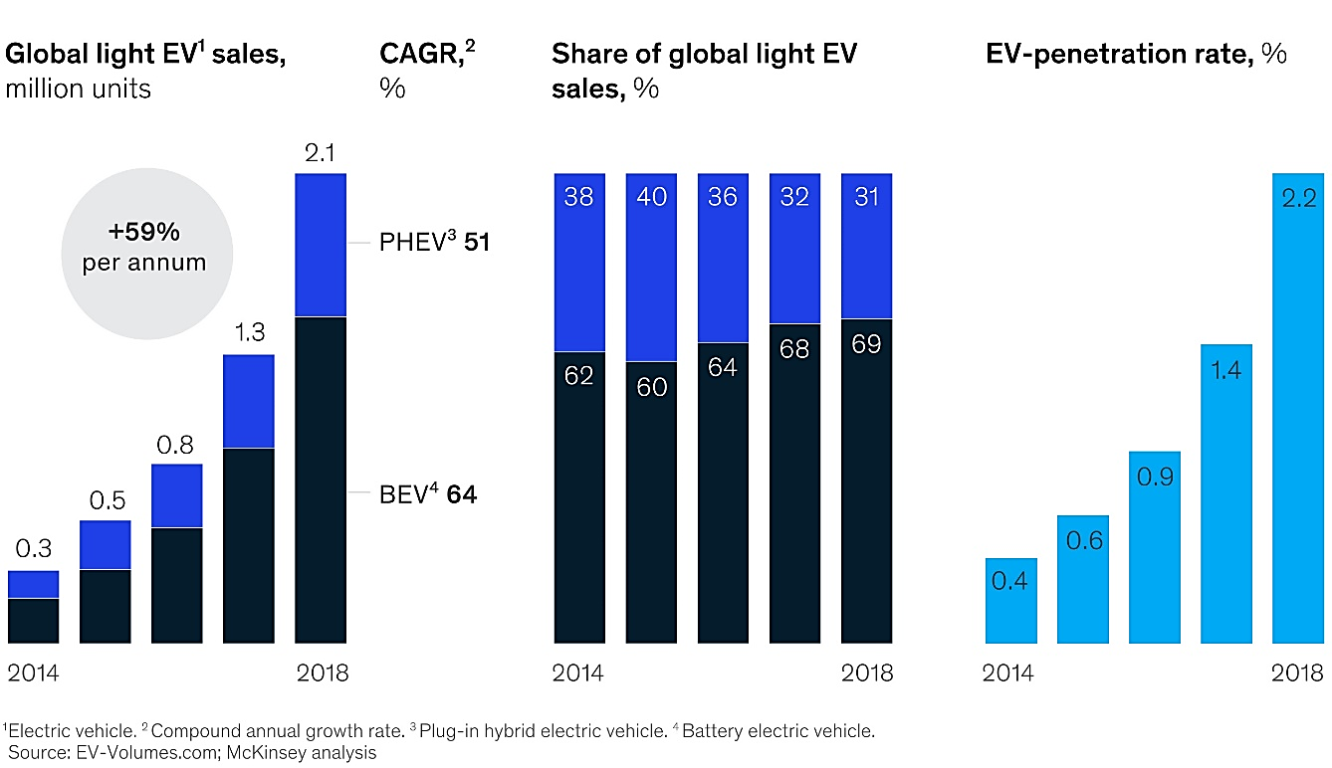 Source: McKinsey 2019a
This report examines the business environment of the automobile industry looking at the growth of the EV market and other major changes that are driving the microeconomic and macroeconomic foundations of the industry and the impact on firm strategy, and industry structure.

PART 1- External forces
The business environment of a firm consists of external factors of a political, economic, social, technological, legal, and environmental nature that impinge on business activity as well as internal factors from its immediate or operational environment that affect the day-to-day operations including suppliers, competitors, customers etc. (Worthington and Britton 2014; Johnson et al 2017).
The figure below illustrates the two levels making up the business environment;
Figure 2: The two levels of the business environment
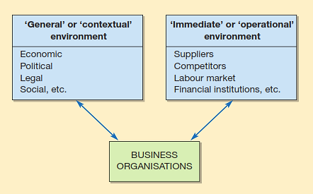
Source: Worthington and Britton 2014

In the following section, the report looks at the key socio-political, economic, and environmental factors that are predominantly pushing EV adoption across the EU and other major markets.

A. PESTEL for EV industry

Social

Carbon footprint
There are three main factors to motivates the early EV adopting by consumers. The first one if the Carbon footprint reduction, this are environmental conscious customers who are motivated to pay even premium price for low or zero emissions vehicle.

Cost saving
The second reason is cost saving, Usually the ICE cars are cheaper than the EV. But in some countries where the government subsidies the customers, the EV cars are cheaper than the ICE. There are benefits such as exemption from taxes, VAT, annual circulation, road charges, tax from registration.

Driving and usage benefits
And the third reason is the Driving and benefit usage, which means the government do incentives and subsidy, such as parking permits, availability to use the bus line, etc., encourage more EVs sales

Political

Government stimulus
The biggest driver behind the push towards the production of electric cars is government stimulus, in form of subsidies, tax breaks, investment in EV infrastructure and the tightening of CO2 emissions via emissions reduction caps that have pressured and encouraged car manufacturers to invest more in producing EVs (see environmental section).

Brexit impact
Another key political factor likely to shape the car manufacturing industry is Brexit. According to the SMMT (Society of Motor Manufacturers and Traders), Brexit especially a ‘hard Brexit’ will have devastating consequences on the competitiveness of the UK’s and EU’s integrated supply chain, bringing an end to the single market, tariff-free trade, customs agreements, EU labour and preferential access to the sectors biggest market (2018). Brexit uncertainty has already led to a decline of 31% in the value of UK automotive investment in 2017. If it happens, it will retard EV technology development for the UK and EU.

Economic
While the governments tax breaks and other economic incentives have driven demand for EVs among consumers, research shows that economic factors among still influence EV adoption. In Norway (the EUs biggest market for EVs) for instance, early adoption and uptake for EVs was highest among consumer segments that are primarily high income and highly educated (McKinsey 2014). While TCO (total cost of ownership) for EVs still plays a determinant role in driving demand, for now, the premium cost of EVs is a stumbling block — the average price of every two of three top-sells of EV models is over $80,000 and in the US, only households earning over $300,000 (3% of US population) are most likely to buy electric car that are battery-powered (CB Insights 2018). However, the biggest economic incentive for the adoption of sustainable transport is it could save the companies and the governments, and individuals up to $70trillion by 2050 as demand for fossil fuels declines (CB Insights).

Environmental
As part of its environmental efforts, the EU set very ambitious CO2 reduction caps of 95g CO2/km by 2020 for light vehicles, along with China (the world’s biggest EV market) setting 2020 targets of 117g CO2/km and the US at 121g CO2/km by 2020 (McKinsey 20014). Such measures have both pressured and encouraged car manufacturers in these markets to invest more in producing EVs, leading to market growth as shown in figure 3 (see appendix)

Other external macro factors
Other social, technological and legal factors affecting the automobile industry include the rise of ride hailing and sharing apps, new developments in artificial intelligence and autonomous vehicles, declining levels of car ownership especially among millennial consumers (Harris 2017; Waters 2018) and the increasing regulatory/legal hurdles driving zero emissions developments including clean air levies and bans on diesel/petrol cars across the UK/EU (Hook et al 2018; Laville 2019).

B. Porters five forces & conclusion
threat of entries/ barriers is low to medium now, and medium to high the next 5 to 10 years

Completive rivalry is highly competitive

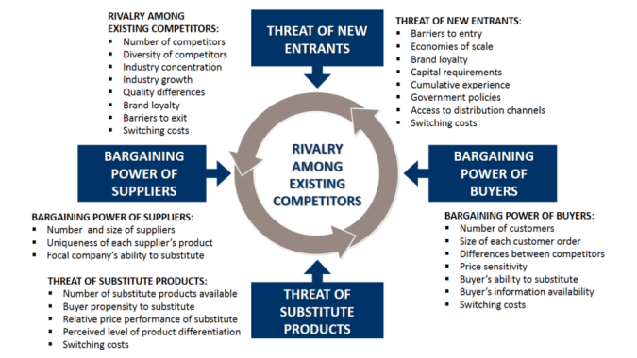
Buyers power is high
significant bargaining power, so the power of suppliers is high
the treat of substitutes is high for alternative transports(public), and low to EVs .

https://www.business-to-you.com/porters-five-forces/

Competitive rivalry
The level of profitability in an industry, as well as the determinant of industry attractiveness is the intensity of rivalry which can often be so intense prices are even pushed below cost, leading to industrywide losses (Grant 2016). The global automobile industry in general is highly competitive and this intensity is set to follow the EV sector with an influx of entrants from traditional OEMS like Toyota, Volkswagen joined by over 50 electric vehicle startups worldwide, making the sector highly competitive (CB insights 2019).

Threat of entry/barriers to entry
Threat of entry is the ease with which new entrants can enter/exit an industry, often determined by barriers to entry that are created either by external factors such as government regulation or incumbents. Barriers to entry include branding, capital requirements, product differentiation, economies of scale, access to distribution etc (Grant 2016; Johnson et al 2017). While incumbents are using financial muscle, technical expertise and existing production infrastructure as barriers of entry against tech upstarts, the market is predicted to get overcrowded with over 50 EV startups worldwide already operating, which means the threat of entries/barriers are low to medium now, and medium to high the next 5 to 10 years. Chinese EV startups alone including BAIC and NIO raised over $8B in funding in just 2018 (CB Insights 2019).

Threat of substitutes
The price that customers are willing to pay is in part determined by availability of substitutes, leading to price sensitivity/insensitivity. While ICE cars are not true substitutes of EVs due to their negative environmental performance, other forms of public transportation including buses, trains, autonomous vehicles, bicycles and ride sharing apps all form credible substitutes to EV ownership that is high, as long as their environmental performance can match or even beat that of EVs, which mean the treat of substitutes is high for alternative transports(public), and low to EVs .

Power of buyers
Buyers of EVs are still price sensitive due to ICE cars still being cheap but also because access to substitutes including public transport like trains, buses, ride sharing apps or bicycles makes it easy to switch, thus giving buyers more power over EV OEMs. Buyer power is predicted to increase even further over the next decade due to excess capacity arising out EV production outstripping demand as shown in figure below (Deloitte 2018). Analysts have forecasted global over-supply of 14million electric cars by 2030 (CB Insights 2019). So the power of buyers is high.
Figure 4: Electric vehicles: Market demand v industry supply
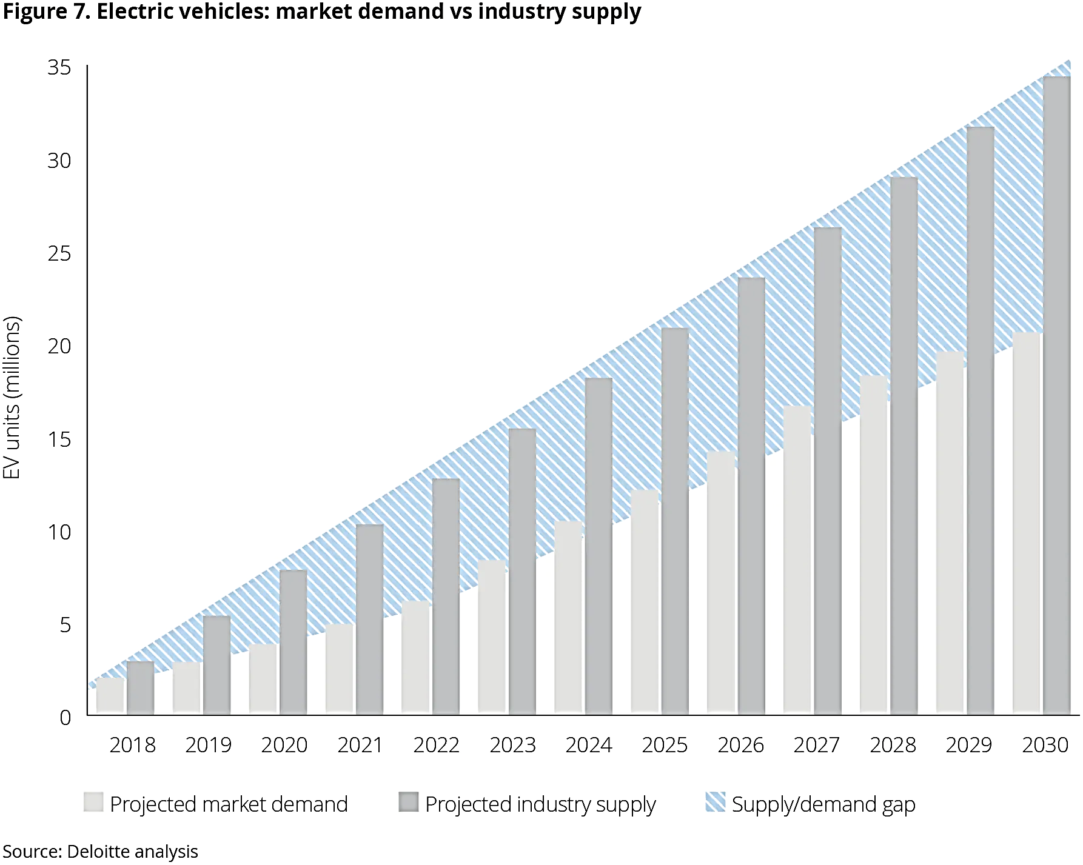Source: Deloitte 2018

Power of suppliers
Other than Tesla which manufactures its own small-format Li-ion-based batteries, almost all other OEM car manufacturers outsource production of the main component of EV cars – the battery pack, to battery suppliers. Because the battery makes up a third of the cost of EVs, its suppliers have significant bargaining power, so the power of suppliers is high over OEMs in the short run (Deloitte 2018).
While Porters five forces shows that the EV market is likely to become as competitive as the general auto industry, the framework has been criticised for making assumptions that all the forces apply equally to all manufacturers within an industry. Stonehouse and Snowdon (2007) for instance argued that the strengths of the five forces may impact individual firms differently depending on firm size and brand power.
The EV industries is becoming more and more attractive it has a big poenitentia of growth for existing car producers and for new startups. The government in many countries are supporting the EVs producers to produce EVs, and also its investing in infrastructures for charging stations and encourage the customers to purchase them by government stimuli and subsidies.

C. Organisation changes - evaluate the changes driving move towards EVs and the reasons for these organizational changes
To support EV growth, the automobile industry structure, technology, and supply chain is being overhauled with new manufacturing techniques, capabilities, strategies and business models.

Production strategy changes
Different OEMS are pursuing different competitive strategies as firms position themselves to gain a competitive advantage. This primarily because EV production is following one of two production strategies – the conversion route (using existing ICE vehicle production techniques but replacing its engine) or the purpose-built course (from scratch with an EV powertrain).
Various OEMs such as BMW and Jaguar Land Rover are for instance pursuing the conversion route, using their existing infrastructure to produce ICE cars, hybrids, plug-in hybrids, or fully electric from the same platform. The advantages of this strategy is the flexibility it affords them, scaling production up or down depending on demand, an advantage that acts as a barrier of entry against tech companies and startups. This is more so given that demand for EVs is progressing at various rates in different markets (CB Insights 2019).
Others such as Tesla, GM, and Volkswagen have invested in modular EV platforms that produce everything including battery packs and motors as they strategize for operational dominance. If batteries become commoditized as predicted by some analysts (Deloitte 2018), then strategies of some OEMs may become sources of sustained competitive advantage.

Infrastructural changes
Another change that’s taking place is increased investment in the supporting infrastructure of electric vehicles such as charging infrastructure, and aftersales maintenance and repair infrastructure. An estimated $6trillion in investments are needed to build the essential electric car’s infrastructures, such as power network and charging stations (CB Insights 2019). While most of it is currently undertaken by governments worldwide, the costs are too significant to be borne by the public sector alone, leaving a gap in the market for OEMs and start-ups who can viably enter this space commercially in the coming years (McKinsey 2014).

Conclusion
As EV adoption continues to gain momentum, underpinned by a combination of powerful macro PESTLE factors as well as internal organizational level changes that are taking place, the competitive environment is also intensifying as incumbent OEMs fight it out with start-ups worldwide for market dominance. While factors such as high costs, and lack of infrastructure are still limiting EV adoption, the transformation of the automobile industry and its supply chain is set to continue with the EV sector leading. The macro influences driving EV production coupled with variations in OEM strategies means that at some point, the market will reach excess capacity when supply exceeds demand, a situation that might bring industry consolidation and ultimately market equilibrium.
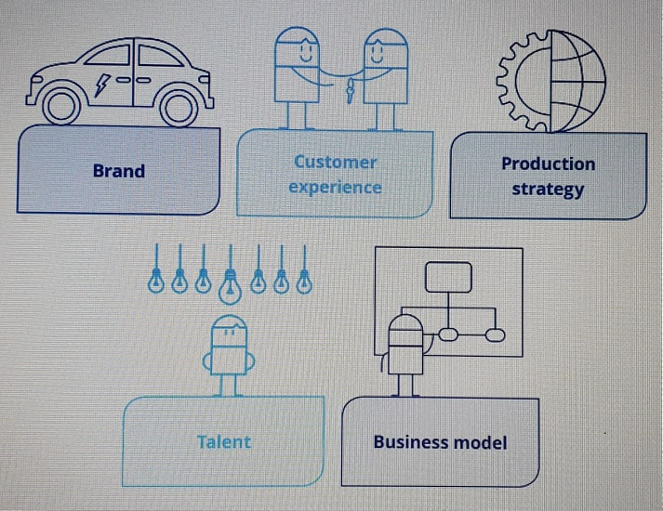
https://www2.deloitte.com/content/dam/Deloitte/uk/Documents/manufacturing/deloitte-uk-battery-electric-vehicles.pdf
One of the best ways to for existing OEMs is their brand and existing customers base. Another way to encourage sales for the companies is to be environmental sustainability (Deloitte, 2018) The customer experience is a key factor in the car industry and will continue to be important part not only during the sale but aftersales as well. The big competition between the EV producers to deliver the newest and the best technology will impact the manufactures in their sales (Deloitte, 2018). Furthermore, the complexity and the experience of the existing car manufactures is a high barrier for the new entrants in the EV industry. The production strategy is impact mainly by the electric and electronic parts and the battery. The battery is the most expensive part of the car’s components. Many manufacturers need to consider the supply of batteries and the end of life, reusing and recycling or disposing (Deloitte, 2018) the batteries. The talent investment of people who are expertise and many electric mechanical engineering will be required. And the last factor is the business model which means building and expanding the in flexibility, effectiveness, cost and convenience. The key point for the success will be innovation and customer focus models. (Deloitte, 2018)

PART 2 – New opportunities

A. Porters generic value chain & conclusion (adapted to electric vehicles)
As the EV trend continues to disrupt the global automobile industry and its supply chain, its creating new opportunities and gaps in the markets across the value chain, for entrepreneurs and organizations who can take advantage. Analysts have noted that supporting the forecasted growth and demand that the production and marketing of electric cars may present will require changes to everything from technology, manufacturing techniques, systems, business models, as well as the aftersales supporting (McCrea 2018).
In order to understand the scale of opportunity, it is vital to first examine how the production and marketing of electric vehicles will change the value chain as shown in figure below;
Figure 5: The EV Potter’s value chain
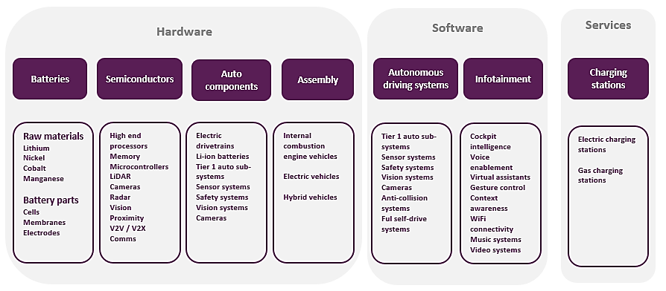Source: Global Data
As the figure above shows, the value chain helps put together how the various value adding activities within the automobile industry will be altered as firms transform various inputs into finished products and services that will form the bedrock of the new industry supply chain. The value chain can conceptually help in understanding the role of various resources in giving competitive advantage to individual firms by identifying where value is presently added and where there is potential to create future value. As a product moves along the value chain, firms can identify activities where they can add value, which is essential in creating sustainable competitive advantage (Porter 1985; Johnson et al 2017).

B. New business opportunities
Battery Management

Artificial intelligence (AI)
Charging station
Power networks,
Electric utilities, software,
Smart grid technology,
Semiconductor industry, solar powered charging station panels,
Battery pack life cycle producers, etc.

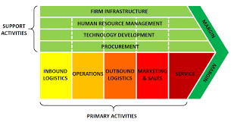
https://www.business-to-you.com/value-chain/
Batteries leasing and charging

The new EV value chain will bring about new business opportunities for entrepreneurs and business executives both in the auto industry and outside. As earlier stated, an estimated $6trillion in needed investments, just to build the essential infrastructure electric cars need worldwide, outside production of the cars themselves. Such infrastructure includes charging stations, utilities and power networks, software, mobility-as-a-service business models, aftersales support and maintenance, EV dealer networks, component recycling services, and the control for critical battery raw materials such as lithium, cobalt, graphite, nickel and copper (McKinsey 2014; Fessler 2018).
One of the biggest opportunities for auto entrepreneurs and business executives is partnerships with electric utilities. Fessler (2019) for instance argues that American utility companies, which have been struggling from low demand for electricity (and growing at an annual average of just 1%), stand to gain a lot from EV adoption.
Demand for electricity in the US has been stagnant and continues to decline primarily because since the turn of the century, many manufacturers of consumer products ranging from refrigerators to motors have continued to improve the energy efficiency of their gadgets. While this has been good news for consumers electricity bills that have been getting lower, utilities lost out. So, EV adoption brings with it business opportunities for utilities and auto firms to partner across a wide range of products and services including charging infrastructure, smart grid technology, software and other sources of revenue (Deloitte 2019).
Other sectors that could be good investment and profitability opportunities from increased EV adoption include the semiconductor industry, primarily because a typical electrical vehicle uses 2-3 times the $ value of semiconductor elements, compared to an ICE vehicle (Shaffer 2017).
Another business opportunity lies in solar powered charging stations and panels, EV battery life cycle management. Battery pack life cycle management will especially present business opportunities, primarily because the life cycle of a typical EV lithium ion battery is limited to just 7 years of use, before it needs to be swapped out. Such batteries cannot be thrown away due to their environmental toxicity as well as the valuable raw materials that go into making them (Simlett 2019).
Due to the costly nature of recycling EV batteries as well the fact that expired EV batteries retain 50-70% of their performance, opportunities are there for businesses to integrate used batteries into the circular economy of "use, reuse, recycle”. This involves reconfiguring EV batteries for alternative use in less demanding applications, such as e-bus power packs, backups for large buildings and supply stabilization for solar and wind power generators, hence giving them second, third and even fourth ‘lives’ (Simlett 2019).

C. Discontinued businesses


Declining demand for Gasoline and diesel fuel
Producers of ICE car components,
Maintenance
Tail pipe producers
Liquid fuel components
Internal combustion engine (ICE)

https://www.business-to-you.com/value-chain/

However, while some businesses look forward to the arrival of EVs, many legacy firms within the current auto value chain need to worry – a lot. Many business models will have to be discontinued. Other than the fact that 55% of the new car sales and 33% of the worldwide fleet is anticipated to be electric, ICE vehicles have as many 2,000 moving parts compared to EVs 20 moving parts, dramatically reducing a lot of components that will be needed. Some of the businesses that could see demand decline dramatically and may not be profitable include oil companies. As things stand, ICE vehicles account for 20% of the global oil demands. Its estimated that demand for oil could decrease by as much as 15% by 2035 if EV adoption goes mainstream after 2025, setting off a vicious cycle that will lead to further oil divestment (Shaffer 2017).
Many component producers of combustion engines, gearbox, transmission will also see decline in demand for these products with those who adapt some traditional components such as units, steering systems, brakes, and, air-conditioning may survive.
Other losers will include lenders, dealer networks, and maintenance businesses primarily because adoption of electric vehicles will mean reduce maintenance costs for consumers, a fact arising out of fewer moving components in EVs and their increased longevity (Shaffer 2017).

Conclusion
It is inevitable that such a transformation as one being witnessed in the automobile industry will bring about winners and losers, a fact even oil companies are aware of given empirical evidence that shows they are some of the biggest investors in the sustainable energy sector. Outside the production and marketing of EVs, some of the biggest opportunities for future profitability will involve charging stations, utilities and power networks, software, mobility-as-a-service business models, aftersales support and maintenance, EV dealer networks, battery life cycle management services and the semiconductor industry. But perhaps the biggest loser is likely to be the oil companies.

Part 3 – Conclusion
In 2011, only 50,000 electric vehicles were sold globally yet by 2018, 2.1million EVs had been sold worldwide, with Deloitte predicting global sales of battery electric cars to reach 21-35million by 2030 (Deloitte 2018). The drive towards EVs technology is underpinned by a combination of powerful macro PESTLE factors as well as organizational level changes that are taking place including R&D, powertrains and charging infrastructure.
Battery prices have traditionally made up the biggest cost of EVs, thus accounting for their high prices. In 2015, more than 57% of the total cost is made up by the battery for a mid-size EV sedan in the US, but by 2019, around 33%, and by 2025, battery cost is expected to only be 20% of the total cars cost. Once EVs reach price with ICE cars in terms of upfront cost, it could signal the end of ICE vehicles whose total cost of ownership (TCO) is much higher than EVs (McKinsey 2014).
According to the CB Insights (2019) report, EVs are estimated to cost less than half the cost it takes to operate their fossil fuel powered substitutes – with a University of Michigan study estimating the cost at $485 for an EV compared to $1,117 for an average US gas-powered car. Therefore 66% of prospective EV buyers admit that long-term cost savings have a big bearing on their purchasing decision, one of the reasons driving mass production of electric cars.
In conclusion the two frame works, Potter’s five forces and Potter’s value chain help to identify the strength and weaknesses and how the company/ manufacturer to use them in their advantage so they can continue to be competitive, to create higher barriers for the new entrants and to improve their own infrastructure and process of production of EV.

References
- Deloitte (2018) “New market, new entrants, new challenges: Battery electric vehicles” [Online] at https://www2.deloitte.com/content/dam/Deloitte/uk/Documents/manufacturing/deloitte-uk-battery-electric-vehicles.pdf
- Deloitte (2019) “2020 Power and Utilities Industry Outlook: Exploring clean energy trends in the power sector” [Online] at https://www2.deloitte.com/us/en/pages/energy-and-resources/articles/power-and-utilities-industry-outlook.html
- CB Insights (2019) “The Race For The Electric Car” [Online] at https://www.cbinsights.com/research/report/electric-car-race/#15
- Fessler, David (2018) “How the Switch to EVs Is Causing Problems for Carmakers” Profit Trends [Online] at https://profittrends.com/energy-investing/electric-vehicles/electric-vehicles-disrupting-the-automotive-supply-chain/
- Fessler, David (2019) “Energy Demand From EVs Will Save Suffering Utilities” Profit Trends [Online] at https://profittrends.com/energy-investing/electric-vehicles/energy-demand-from-evs-will-save-suffering-utilities/
- Global Data (2019) “Electric Vehicles in Utilities - Thematic Research” [Online] at https://www.power-technology.com/comment/energy-suppliers-are-asking-what-can-ev-schemes-do-for-us/
- Grant, M. Robert (2016) “Contemporary Strategy Analysis: Text and cases edition” 9th ed., John Wiley.
- Harris, John (2017) “Owning a car will soon be a thing of the past” The Guardian [online] at https://www.theguardian.com/commentisfree/2017/oct/23/owning-car-thing-of-the-past-cities-utopian-vision
- Hook, L., Pickard, J., & Raval, A. (2018) “UK stops short of 2040 ban on petrol and diesel vehicles” Financial Times [Online] at https://www.ft.com/content/30f7e328-8372-11e8-96dd-fa565ec55929
- Johnson, G., Scholes, K., Regner, P., Angwin, D., and Whittington, R. (2017) “Exploring strategy: Text and cases” 11th ed., Pearson Education.
- Laville, Sandra (2019) “Bristol council votes to ban diesel cars in first for a UK city” The Guardian [Online] at https://www.theguardian.com/environment/2019/nov/05/bristol-becomes-first-uk-city-ban-diesel-cars
- McCrea, Bridget (2019) “5 Ways Electric Vehicles are Impacting the Auto Supply Chain” Source Today [Online] at https://www.sourcetoday.com/supply-chain/5-ways-electric-vehicles-are-impacting-auto-supply-chain
- McKinsey (2014) “Electric vehicles in Europe: Gearing up for a new phase” [Online] at https://www.mckinsey.com/featured-insights/europe/electric-vehicles-in-europe-gearing-up-for-a-new-phase
- McKinsey (2019a) “Expanding electric-vehicle adoption despite early growing pains” [Online] at https://www.mckinsey.com/industries/automotive-and-assembly/our-insights/expanding-electric-vehicle-adoption-despite-early-growing-pains
- Porter, Michael. (1985) “Competitive strategy” New York; Free Press.
- Shaffer, Leslie (2017) “JPMorgan thinks the electric vehicle revolution will create a lot of losers” CNBC [Online] at https://www.cnbc.com/2017/08/22/jpmorgan-thinks-the-electric-vehicle-revolution-will-create-a-lot-of-losers.html
- SMTTP (2018) “Automotive priorities for the Brexit transition March 2018” [Online] at https://www.smmt.co.uk/wp-content/uploads/sites/2/SMMT-Brexit-Position-Paper-UK-Automotive-Priorities-for-the-Brexit-Transition.pdf
- Simlett, John (2019) “Batteries are about life cycle, not just life” Auto News [Online] at https://www.autonews.com/commentary/batteries-are-about-life-cycle-not-just-life
- Stonehouse, G., and Snowdon, B. (2007) “Competitive Advantage Revisited: Michael Porter on Strategy and Competitiveness” Journal of Management Inquiry, 16(3), pp.256–273
- Waters, Richard (2018) “Driverless cars reach commercial milestone on long road to future” Financial Times [Online] at https://www.ft.com/content/b001ad00-dd83-11e8-9f04-38d397e6661c
- Worthington, I., and Britton, C. (2014) “The Business Environment” 7th ed., Pearson Education.

Appendix
Figure 3: Light EV sales by region, thousand units (% share of EV market)
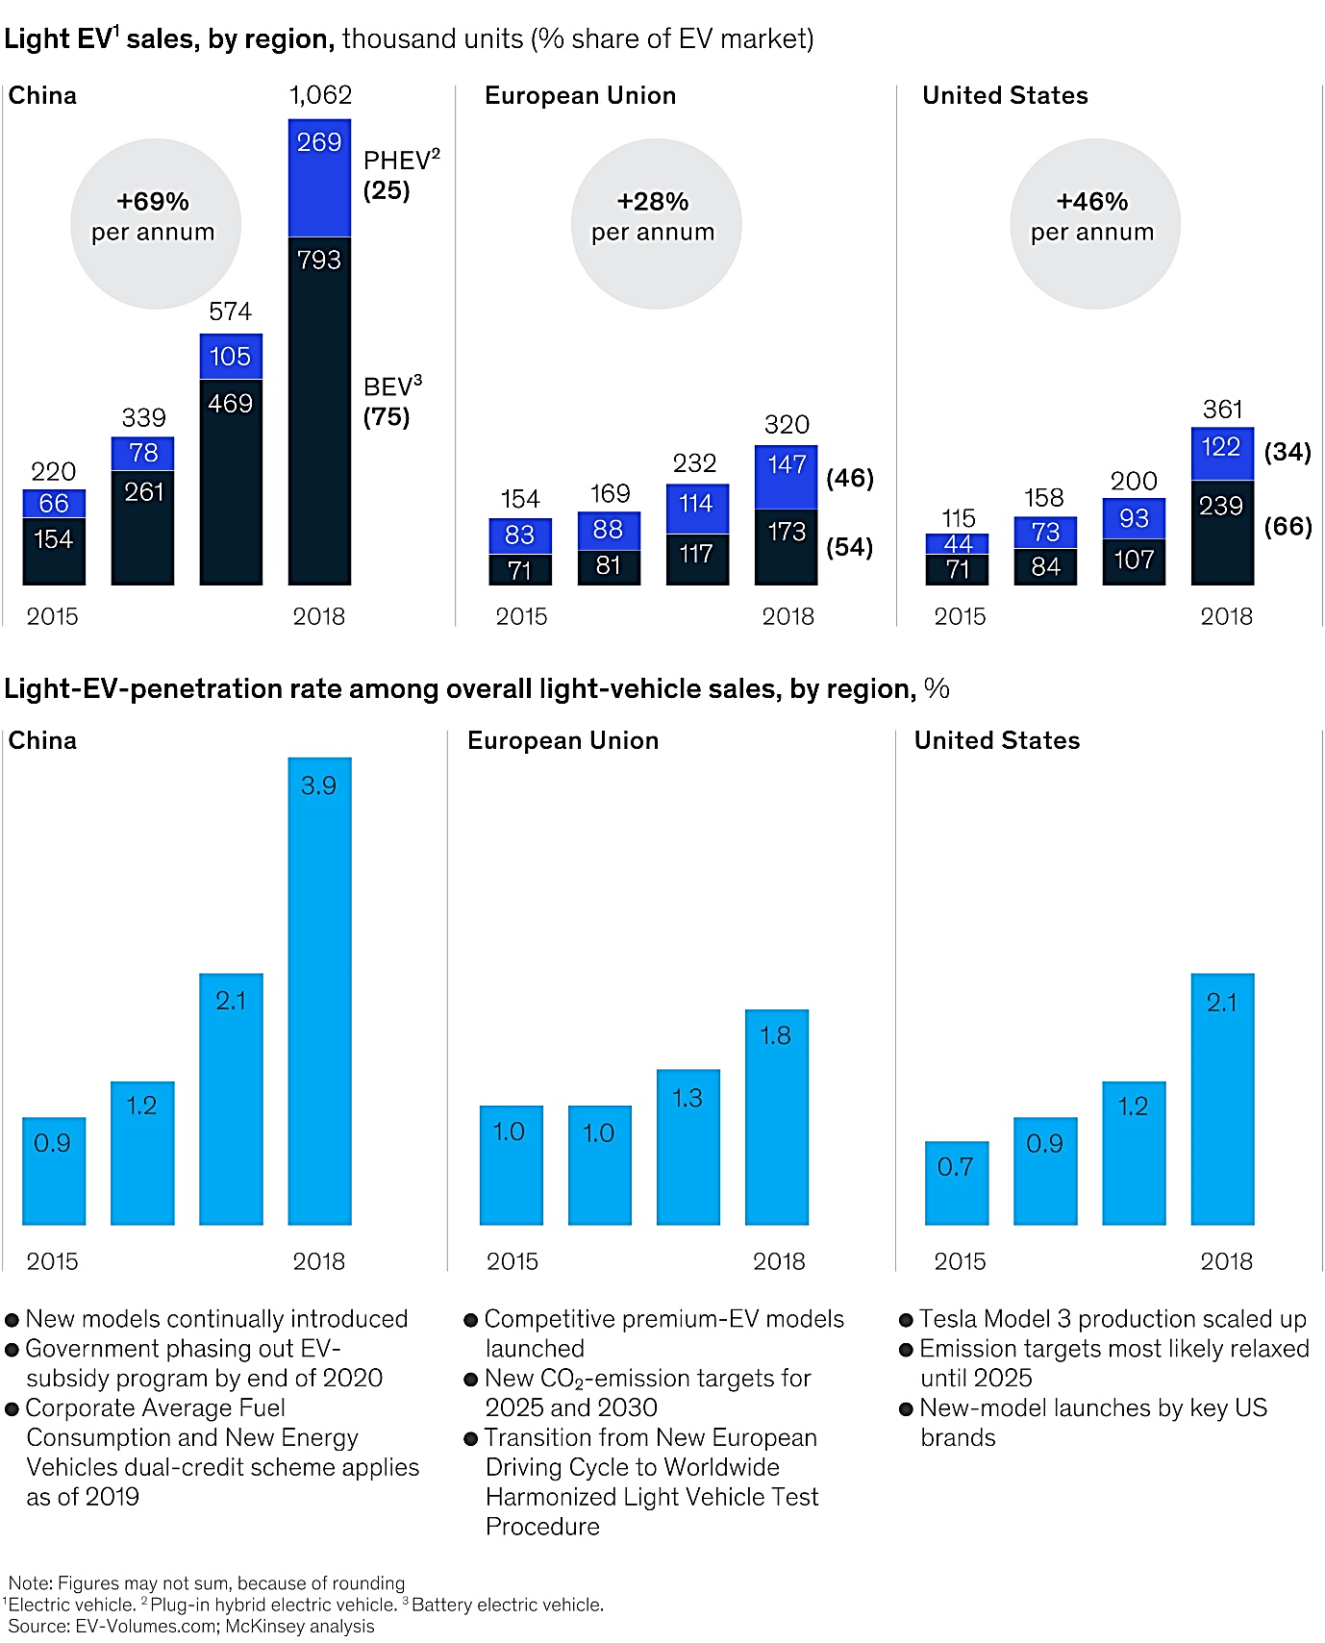Source: McKinsey 2014

