
A DBA RESEARCH PORTFOLIO
ON

EXPLAINABLE ARTIFICIAL INTELLIGENCE MODELS FOR ENHANCING FINANCIAL FRAUD DETECTION IN BANKING.
A portfolio demonstrating research strategy, preparation, and growth of Doctoral research.

28th JULY 2026
STUDENT: BINA SUBEDI (2512009)
LECTURER: DR. STEPHEN MALONE
ADVANCING TO DOCTORAL STAGE (LCDB7012)



Contents
1. Personal Reflections: Beginning the journey 1
1.1 Project Title, Aims, Objectives and Research questions 2
1.1.1 Project Title 2
1.1.2 Project Aim 2
1.1.3 Project Objectives 2
1.4 Project Research Questions 3
2.Purpose of this Portfolio 3
3. Overview of the Portfolio 4
4. Research Narrative 6
4.1 Inciting Incident- the back story 6
4.2 Rising Action 6
4.3 Crisis- Challenges, Validity, Reliability 7
4.4 Climax- Personal Reflection 7
4.5 Denouement- resolving contradiction 7
4.6 Next Steps 8
5. Portfolio Items- Description, Evaluation and Analysis 8
5.1 Item 1: Wallace & Wray Critical Reading (Wallace and Wray, 2011) 8
5.3 Item 3: Critical Analysis of Five Relevant Articles 9
5.4 Item 4: Four-Quadrant Blueprint Mapping 11
6. Paradigmatic Reflection: Kuhn, Alternatives and Pragmatic Position 13
6.1 Locating the Field in Kuhn's Cycle 13
6.2 My paradigmatic Position 14
6.2.1 Ontology 14
6.2.2 Epistemology 14
6.2.3 Methodological 15
6.3 Conceptual Framework 16
6.4 Key Literature Themes 17
6.5 Evolution of Scope 17
7. Conclusion: Refined Research Topic, Title and Plan 18
7.1 Refined Title 18
7.2 Refined Objectives 18
7.3 Research Plan 19
8. Reflective Summary of the portfolio journey 19
References 21
Appendix 24
Appendix A: Mike Wallace and Alison Wray synopsis template (Wallace and Wray, 2011) 24
Appendix B: A ‘What, Why and How’ Framework for Crafting the Research (Bryman and Bell, 2011). 29
Appendix C: Critical Analysis of Five Relevant Articles 31
Appendix D: The Four-Quadrant Blueprint Mapping 36
Appendix E: Reflective Learning Log and Group Search-Term Activity. 38
Appendix F: Further Realia (For Completion) 45
F1: Research Diary Extract 45
F2: Video illustrating perspective 47
F3: The duck-rabbit illustration 48
F4: Examples from the research methods module 50

List of Tables
Table 1: Six stages of research story. 5
Table 2: Critical Analysis of five relevant articles. 10
Table 3: Future Research Plan 19

List of Figures
Figure 1: Conceptual Framework of the study. 16

List of Appendix Figures
Appendix Figure F1: The duck-rabbit illustration (Jastrow, 1900), as used by Kuhn (1962) to illustrate paradigm-dependent perception……………………………………………………….48
Appendix Figure F2: Paradigm comparison table used in the research-methods module………50

1. Personal Reflections: Beginning the journey
I didn't have a specific subject when I started the May 12 Advancing to Doctoral Research session. My wide interest in AI and fraud was influenced by my banking and audit work in Nepal, but it became clear how unfocused that interest was when I was asked to define a doctorate question. I assumed that breadth indicated doctoral rigour, so my first reaction was to broaden the scope. I didn't realise that a specific, well-founded inquiry is more resilient than a broad, ambiguous one until after the June paradigm session and interaction with Guba and Lincoln's (1994) opposing paradigms.
Early talks with banking practitioners indicated conflicts between banking and corporate audit viewpoints before I could describe them academically, providing a significant advantage. What slowed development was my technical predisposition. Coming from a culture where predicted accuracy is paramount in model evaluation, I first saw explainability as secondary. Cil and Yildiz's (2025) work on "explaining the explanation" undermined this assumption, revealing my alignment with the accuracy-first paradigm attacked in Section 6.1.
I discovered that paradigm selection is not a preparatory formality, but rather the foundation for all following queries. Module sessions, lecturer input on an early draft, and peer exchanges, especially the 2 June search-term exercise, demonstrated how "topics" may disguise underlying beliefs. I anticipate that this discomfort will persist, and I have described it frankly rather than retrospectively softening the story.
The most notable difference was the restriction of the focus from banking and corporate audits to banking alone. My initial dual-sector aim believed fraud tendencies were comparable enough for a unified XAI strategy. Early research soon debunked this claim: banking and audit fraud have distinct methods, data structures, and regulatory settings. Attempts to create an integrated framework resulted in unfocused models, an issue exacerbated by supervisory feedback.
Banking datasets, AML/KYC requirements, and transactional anomalies provide organised and accessible data for XAI. Corporate-audit fraud depends on qualitative judgement and document analysis, while XAI is less established. Readings from Kuhn (1962), Crotty (1998), and Creswell (2009) emphasised the importance of methodological consistency above breadth.
Applying SHAP, LIME, and counterfactuals across both industries revealed that banking aligned with numerical data, but audit fraud needed interpretative, document-heavy analysis. The methodological mismatch rendered a dual-sector investigation unfeasible.
Limiting the scope to banks provided clarity. It improved methodological alignment, focused objectives, and positioned XAI where its explanatory value is relevant. What worked well was enhanced coherence; what didn't were initial attempts at extreme width and the time invested in audit literature that turned out to be ineffective.
Authors such as Bell, Harley and Bryman (2022), Maxwell (2013), Denscombe (2014), and Denzin and Lincoln (2011) emphasised the significance of reflexivity, feasibility, and paradigm clarity. Narrowing the study allowed for more detailed banking-focused questions and targets (Section 6.2), rather than retreating from research.

1.1 Project Title, Aims, Objectives and Research questions

1.1.1 Project Title
Explainable Artificial Intelligence (XAI) Models for Enhancing Financial Fraud Detection in Banking.

1.1.2 Project Aim
The aim of this project is to develop and rigorously evaluate enhanced explainable artificial intelligence (XAI) models that enhance the prediction performance and interpretability of financial fraud detection systems in banking contexts.

1.1.3 Project Objectives
- This study seeks to present a thorough evaluation of the existing challenges that limit efficient fraud detection inside financial institutions practices.
- To critically analyse the inadequacies of existing fraud detection methods used in the financial and audit arenas.
- To conduct a comparison of XAI models with traditional AI-based fraud detection systems, evaluating predicted performance and interpretability. To assess the performance and explainability of XAI models compared to traditional AI models.
Instead of a collection of disparate goals, these objectives constitute a logical, tiered development. According to Černevičienė and Kabašinskas (2024), despite extensive AI deployment, financial fraud continues to be costly and persistent. The accountability requirements of banking and audit work make opaque black-box models more unworkable. Objective 2 focuses on a key research gap in AI-based fraud detection studies, which emphasise predicted accuracy measures above interpretability, organisational uptake, and audit-specific applicability (Cil and Yildiz, 2025). Objective 3 compares explainability approaches like SHAP and LIME to conventional models, evaluating their technical performance and practitioner acceptability.
This mixed-methods, audit-focused review of XAI combines comparative model testing with primary practitioner observations from Nepalese banking and audit experts. A UK sample is also included for contextual comparison, where possible. This convergence of technical evaluation and practitioner-centered inquiry is under-addressed in the present literature (Aljunaid et al., 2025; Awosika et al., 2024; Zhou et al., 2023), positioning the project to provide a unique and practice-relevant contribution.

1.4 Project Research Questions
- What are the current limitations of AI-based fraud detection systems in banking?
- How can XAI techniques improve transparency and strengthen decision justification in fraud detection contexts?
- Which XAI models provide the most effective balance between forecasting accuracy and interpretability?
- How can XAI outputs support auditors, risk managers, and compliance officers in their decision‑making processes?
- What comprehensive framework can integrate XAI into real-world fraud detection workflows?

2.Purpose of this Portfolio
This portfolio chronicles the evolution of my DBA research plan, from a broad professional interest to a specific goal, objectives, and methodological approach. Experience in banking and audit practice, along with reading and debate, revealed a major issue: AI models that excel at identifying sophisticated fraud are frequently inaccessible to auditors, compliance teams, and risk managers. The conflict between accuracy and interpretability influences the portfolio's concentration.
Kuhn's concept of paradigm creation offers a helpful, if incomplete, framework. The current paradigm for fraud detection is based on accuracy-driven, black-box models. However, there is a growing desire for explainability as anomalies accumulate. I use this cautiously, knowing that Kuhn's paradigm, built for scientific revolutions, does not completely represent the gradual, socio-technical growth typical of banking practice. My strategy thus permits both interpretations: explainable AI may enhance the current paradigm or progressively transform how auditors justify algorithmic judgement. This dual potential appears throughout the portfolio and is discussed in the conclusion.
The first six elements follow the module's narrative arc: inciting incident, escalating action, crisis, climax, denouement, and future actions. They mirror the actual course of the study plan: initial difficulty, reaction, setback, evidence-based turning point, resolution, and continuing concerns.
Fraud detection was chosen over wider AI in banking because it provides the most demanding context for explainability. Both false positives and false negatives have serious operational, regulatory, and reputational implications. Auditors confront unique challenges: they must evaluate controls based on AI systems that they did not create or run, but professional standards demand them to defend their findings. This friction, which was felt immediately in practice, prompted an emphasis on explainability as a research challenge rather than considering fraud detection as a technical performance issue. This theme appears throughout the portfolio.

3. Overview of the Portfolio
This portfolio is structured as a research story, with six stages: inciting incident, rising action, crisis, climax, denouement, and next steps. Each portfolio item listed below is linked to the stage(s) it represents and the module objective(s) it supports. The relevant appendix has full evidence tables for each item, which the main text discusses, analyses, and examines.

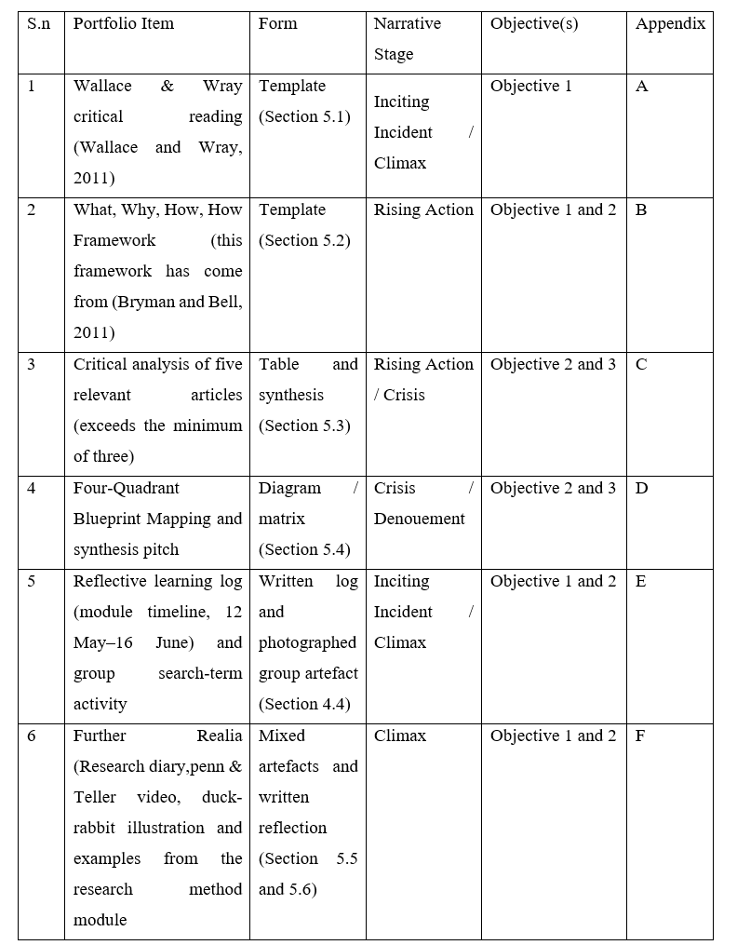
Table 1: Six stages of research story.
Source(s): Authors' Work.
Six linked elements are attached in the appendix. Item 1 outlines the study's personal reflection, Item 2 outlines the research design, Item 3 engages with literature to support Objectives 2 and 3, Item 4 synthesises problem, context, theory, and access into a deliverable research statement, and Item 5 provides a dated, session-by-session log tracing the paradigmatic and methodological reasoning behind it. Section 3 has detailed discussions of each issue, with cross-references provided. An additional set of suggested 'realia' such as research-diary excerpts, pictures, and video links depicting perspective and research method modules is provided as an optional Item 6 in Appendix F, to be completed using true personal material rather than imagined content.
Since then, the Penn & Teller (Saturday Night Live, 2013) viewpoint video, the duck-rabbit example and Kuhn's Aristotle tale, and a synopsis of the module's paradigm-comparison table have been included to Appendix F items (F1–F4). All these continue to serve as stand-ins for the personal journal excerpts, process photos, and additional module content.

4. Research Narrative

4.1 Inciting Incident- the back story
My previous work 'Systematic Literature Review on fraud detection techniques' sparked an interest in modern AI models and the contrast between explainable and conventional systems, which served as the foundation for this study. Financial fraud is a significant expense for businesses, but current AI models lack transparency for audit and regulatory reasons (Item 4, Appendix D, Quadrant 1). Professional experience in Nepal's banking and audit sectors demonstrated practitioners' difficulties in explaining highlighted situations, which lowered trust in AI outcomes. Research supports accountability and compliance issues in financial environments (Černevičienė and Kabašinskas, 2024).

4.2 Rising Action
The study uses a mixed-methods methodology that combines secondary technological and literature reviews with primary qualitative information gathering, as described in Item 2 (Appendix B). Primary data will be collected through five to six semi-structured interviews with Nepalese bank managers, auditors, and financial analysts. A UK survey will also be conducted to examine regulatory disparities in explainability and confidence. The secondary data analysis will include peer-reviewed sources from Scopus, Web of Science, IEEE Xplore, EBSCO Host, Emerald Insight, ProQuest, Taylor & Francis Online, ScienceDirect, and SpringerLink. This strategy tackles limitations of technical benchmarking (Zhou et al., 2023; Aljunaid et al., 2025) and organisational impediments to XAI adoption (Cil and Yildiz, 2025) by combining practitioner experience with technical evaluation (Item 4, Appendix D).

4.3 Crisis- Challenges, Validity, Reliability
Three major planning difficulties have surfaced at this point. Due to restricted access to transaction-level fraud data, banks do not share raw fraud-flag records. As a result, previous research have relied on synthetic or federated datasets (Aljunaid et al., 2025; Awosika et al., 2024). This limitation also focuses my technological design towards public benchmarks. The lack of a consistent operational definition of explainability, along with varying SHAP, LIME, and hybrid outputs, poses validity concerns unless explanation-adequacy criteria are established beforehand (Černevičienė & Kabašinskas, 2024). Third, Nepal-based recruiting may result in a self-selected sample, necessitating meticulous documentation for reliable qualitative analysis.

4.4 Climax- Personal Reflection
I kept a reflective notebook (Item 5, Appendix E) to track my comprehension of research theories and techniques. On May 12, at the first doctoral session, I chose fraud detection as my topic, drawing on philosophical approaches from Guba and Lincoln (1994), Rossman and Rallis (2016), and Creswell (2009). Subsequent sessions improved my literature search method and analytical approach. By June 9, I had embraced a pragmatic approach, as supported by Morgan (2007). Reading Černevičienė and Kabašinskas (2024) altered my attention from technical XAI comparison to banking sector significance, as demonstrated in Item 4's plan prioritising governance over model mechanics.

4.5 Denouement- resolving contradiction
Two major tensions form the portfolio and must be fully addressed in the final plan. The first is paradigmatic: technical XAI research such as Zhou et al. (2023), Aljunaid et al. (2025), and Awosika et al. (2024) highlight quantifiable model attributes, whereas my interview strand takes an interpretivist perspective of trust, adequacy, and usefulness as socially placed. A pragmatic approach connects these elements by viewing them as complimentary. The second factor is context: most work focuses on major, developed-economy institutions, while my primary access is in Nepal. I approach Nepal-based fieldwork as a contextual contribution, supported when practicable by a UK comparative sample.

4.6 Next Steps
This portfolio generates three immediate actions, each of which is related to previous methodological and validity issues. Before conducting interviews, submit an institutional ethics application that includes participant information and permission procedures as indicated in Quadrant 4 of Item 4 (Appendix D). The technical strand needs picking appropriate public fraud-detection datasets, as access to genuine transaction-level data is difficult. Relying on benchmark datasets, although restricting ecological validity, corresponds with Aljunaid et al. (2025) and Awosika et al. (2024). Third, explanation adequacy must be operationalised before to fieldwork to prevent validity issues. Two unresolved problems remain: UK sample feasibility and reconciling SHAP-LIME divergences identified by Černevičienė and Kabašinskas (2024).

5. Portfolio Items- Description, Evaluation and Analysis

5.1 Item 1: Wallace & Wray Critical Reading (Wallace and Wray, 2011)
Description: The three systematic studies of Černevičienė and Kabašinskas (2024), Tuge and Msweli (2026), and Weber, Carl and Hinz (2024) focus on Explainable AI in financial decision-making, but differ in scope and disciplinary perspective. The authors give the greatest coverage, synthesising 138 papers spanning several financial sectors and finding leading XAI approaches such as SHAP. Most applications are orientated in credit scoring instead of auditing. Tuge and Msweli (2026) confine their attention to banks, emphasising organisational, sociotechnical, and legal impediments to XAI implementation. Weber, Carl, and Hinz (2024) use an interdisciplinary approach, evaluating 60 publications in Finance, Information Systems, and Computer Science to demonstrate how explainability promotes confidence, regulatory compliance, and practical implementation. Together, the three sources depict the technological, organisational, and regulatory components of XAI in finance.
Evaluation: Analytical strength and persuasiveness differ between the three pieces. Černevičienė and Kabašinskas (2024) provide accurate descriptive insights, but their comprehensive analysis does not test XAI performance in audit-specific circumstances. Their modest assertions are appealing since they are descriptive rather than causative. Tuge and Msweli (2026), on the other hand, give a more practical account by framing explainability as a sociotechnical problem backed up by data from organisational procedures and regulatory expectations; this triangulation strengthens their results above merely technical assessments. Weber, Carl, and Hinz (2024) are compelling because of their multidisciplinary synthesis, which reinforces the idea that explainability is vital beyond model performance. Although their dataset is smaller, combining three literatures improves conceptual robustness and identifies gaps particularly in privacy and AML that previous assessments do not address. The papers complement each other via breadth (Source 1), organisational depth (Source 2), and conceptual integration (Source 3).
Analysis: Taken together, the three evaluations transform my understanding of XAI in fraud detection from a restricted technological worry to a multifaceted challenge encompassing organisational communication, regulatory compliance, and stakeholder trust. Černevičienė and Kabašinskas (2024) identify a research gap in audit-focused XAI applications, which directly supports Objective 1. Tuge and Msweli (2026) emphasise the need of a practitioner-facing, mixed-methods design with a pragmatic approach. They demonstrate that explainability failures are caused by sociotechnical misalignment, not model design alone. Weber, Carl, and Hinz (2024) go on to show that explainability is essential for governance, trust, and regulatory compliance, which strengthens the case for including organisational and regulatory views in the conceptual framework. Together, these findings support a research design that tackles technical, organisational, and regulatory limitations in banking fraud detection, as well as providing a consistent framework for the study's objectives and methodological decisions.

5.3 Item 3: Critical Analysis of Five Relevant Articles
Five peer-reviewed publications (2023-2025) were critically evaluated against the research topic, method/data, major results, and relevance to this study, exceeding the module's requirement of three sources. The entire comparison table may be found in Appendix C.

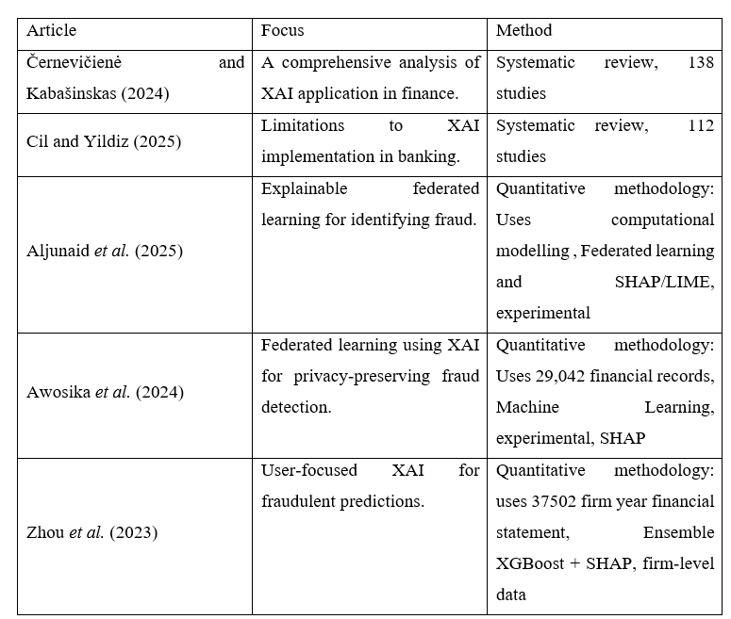
Table 2: Critical Analysis of five relevant articles.
Source(s): Authors' Work.
Evaluation. The five essays are methodologically aligned and thematically complimentary, with a focus on quantitative, model-centered, and positivist approaches. Three empirical investigations (Aljunaid et al., 2025; Awosika et al., 2024; Zhou et al., 2023) show that high prediction accuracy and SHAP/LIME-based interpretability are not mutually incompatible, which is directly related to Objective 3. Two review studies (Černevičienė and Kabašinskas, 2024; Cil and Yildiz, 2025) indicate that real-world XAI implementation in banking is mostly hindered by organisational, cultural, and standardisation constraints, rather than technological viability.
Analysis. These five sources support the project's change from a technical research issue to one that considers practitioner and organisational views, as outlined in Sections 3.2 and 3.5. The articles do not explicitly address corporate auditing practices or use original data from Nepal or South Asia. These omissions highlight the unique empirical and contextual gap that the current study is intended to fill.

5.4 Item 4: Four-Quadrant Blueprint Mapping
The study's practical challenge, empirical context, theoretical lens, and access conditions were mapped into four quadrants and synthesised into a succinct four-sentence research pitch to effectively express the project's reasoning to both practitioner and academic audiences. Appendix D has the whole blueprint and synthesis pitch.
Evaluation. The exercise helped distinguish between the general problem of black-box AI's impact on trust and regulatory compliance in fraud detection and the study's specific empirical setting (banking and audit practitioners in Nepal, with potential UK comparisons). Earlier framings have blended them together, hiding the unique contribution made by the Nepal environment. Including Technology Acceptance Theory, XAI, and fraud detection theory in Quadrant 3 emphasises the project's focus on organisational adoption, trust, and decision-making, rather than just comparing technological models.
Analysis. This item serves as the portfolio's underlying structure. The deliverable research statement combines Item 1's practice-level trigger, Item 2's design rationale, and Item 3's evidence foundation. This item is closely related to the Denouement debate in Section 3.5 and the final synthesis in Section 6, which outlines the project's conceptual and methodological direction.
5.5 Reflective Log
Description: Includes a dated, session-by-session record covering the module from May 12 to July 21, as well as the shared group search-term activity beginning on June 2. Appendix E provides a narrative summary of the log and the group activity artefact.
Evaluation: The log's fundamental virtue is that it is dated and chronological rather than rebuilt following the fact, which lends it more evidentiary weight than one retrospective comment would have. For example, the pragmatist viewpoint was reached on a precise date (9 June) after specific preceding meetings, rather than being proclaimed retrospectively as if it had always been the goal. Its key disadvantage is that it continues to rely on recollection and self-report rather than an exact contemporaneous record, implying some retrospective smoothing, notably in how cleanly the 12 May ambiguity is resolved by 16 June.
Analysis: The log enables Section 4 to be written as a true story rather than a rationally reconstructed one, and it directly supports Objective 1 by demonstrating, rather than simply saying, how the practice problem and paradigm choice evolved together. The group search-term artefact in Appendix E also demonstrates the search-strategy considerations supporting Item 3.
5.6 Further Realia
Description: The log enables Section 4 to be written as a true story rather than a rationally reconstructed one, and it directly supports Objective 1 by demonstrating, rather than simply saying, how the practice problem and paradigm choice evolved together. I have attached reflecting journal images and a sample of a functional Excel sheet to illustrate data storage and organization in F1. The group search-term artefact in Appendix E also demonstrates the search-strategy considerations supporting Item 3. All three remain placeholders in Appendix F, requiring true personal information, and are not represented as comprehensive proof here. F2 (the Penn & Teller video) and F3 (the duck-rabbit example, together with Kuhn's Aristotle narrative) are complete and detailed in detail in Appendix F.
Evaluation: F1 displays an excerpt from the reflective journal, which was written both during the lecture sessions and separately investigating the topic, recording the continual process of critical thought and analysis and excelsheet allows for critical evaluation and identification of gaps in the literature. F2 and F3 work well as illustrative artefacts because they were utilised in the module to teach the Kuhnian cycle, rather than being chosen retroactively to support my point. Using examples from the teaching process adds authenticity that self-selected examples may not have. However, their application to our research, especially fraud detection AI, was not obvious and required active interpretation. The following discussion in F2 and F3 is meant to emphasise the importance of the objects and to make the relationship between them and the project's conceptual issues obvious.
Analysis: F2 and F3 directly contribute to Section 6.1's Kuhnian analysis. F2 is a simplified analogue of the normal‑science-crisis-paradigm‑shift model, while F3 functions as a defence against presuming that the current accuracy-first paradigm in fraud-detection AI is merely "behind" an imagined explainability-first successor. Their usefulness comes in their ability to highlight the conceptual processes covered in the section, rather than presenting sector-specific data. F1would improve the Crisis and Climax stages indicated in Sections 3.3-3.4 by providing dated, first-hand artefacts that the current text-only story cannot adequately recreate. Their ultimate inclusion would therefore improve the empirical foundation of the portfolio's developmental narrative.

6. Paradigmatic Reflection: Kuhn, Alternatives and Pragmatic Position

6.1 Locating the Field in Kuhn's Cycle
According to Kuhn's (1962) model of scientific development: normal science, anomaly, crisis, and occasional paradigm shift (McLeod, 2020), AI-based fraud detection is now experiencing normal science under pressure rather than a paradigm rupture. Accuracy, Area under the curve (AUC), and recall on unbalanced fraud classes remain the leading metrics for model quality (Zhou et al., 2023). Even newer architectures such as federated deep learning (Awosika et al., 2024) are assessed within this accuracy-first frame.
Explainability is a growing collection of anomalies within this paradigm. The accuracy-centered strategy has limitations due to regulatory demands for defensible judgements, auditors' requirement to justify flagged transactions, and persisting confidence deficiencies in black-box systems (Černevičienė & Kabašinskas, 2024). Cil and Yildiz (2025) "explaining the explanation" dilemma, where adding SHAP does not alleviate socio-technical trust concerns, suggests a Kuhnian crisis. The paradigm's own tools cannot resolve the anomalies it causes.
However, the field has not seen a complete paradigm change. According to a Lakatosian perspective, XAI approaches like SHAP and LIME serve as a safeguard against trust and accountability issues, rather than replacing the basic evaluation criterion. A partly this viewpoint is also appropriate, as XAI approaches may be gradually examined and perhaps falsified against interpretability and fidelity requirements. According to Feyerabend (1975) theory of methodological pluralism, researchers now utilise a variety of approaches, including computational benchmarking, socio-technical analysis, and practitioner-focused qualitative investigation.
This perception directly influences the study's contribution. Rather than resolving a paradigm crisis, the study provides evidence for early anomaly buildup. The mixed-methods audit assesses if existing XAI "patches" (SHAP, LIME) are sufficient from a practitioner viewpoint, or if anomalies found in Section 3 require a deeper rethinking of evaluating criteria. The methodological approach, which combines quantitative model comparison with qualitative practitioner interviews, coincides with a Feyerabend-influenced reading and provides a consistent and justified methodology.

6.2 My paradigmatic Position
Building on the reflective process described in Section 3.4, this section outlines the ontological, epistemological, and methodological commitments that stem from the pragmatic paradigm used in this study, in accordance with Morgan (2007) call to organise research choices around human experience, action, and methodology rather than fixed metaphysical positions (also Guba and Lincoln, 1994, on paradigms as systems of beliefs structured by these three questions).

6.2.1 Ontology
My ontology is pluralist, which means I do not believe in a singular, mind-independent reality for what makes XAI successful. Following Guba and Lincoln's (1994) definition of ontology as a belief about what may be known, I see XAI's utility as multifaceted and role-dependent. Banking practitioners interpret the same explanation through their organisational responsibilities: bank managers focus on operational risk reduction, internal auditors on evidence-based audit conclusions, compliance officers on regulatory defensibility, and data analysts on predictive performance. The study employs a pluralist ontology that accepts different and context-shaped realities, rather than assuming a single universal definition of XAI effectiveness..

6.2.2 Epistemology
My epistemology is pragmatic, not entirely constructivist. Using a constructivist approach can provide detailed descriptions of practitioner meaning-making, but it may restrict the study's potential to yield practice-relevant findings. A pragmatic epistemology recognises both technical evidence and practitioner interpretation as acceptable knowledge sources, evaluating assertions based on their utility in enhancing fraud detection practice. This is consistent with the viewpoint taken on June 9th and with Morgan (2007) argument that research should be orientated around action rather than fixed metaphysical convictions.
The study uses a practical, multi-source approach, including a systematic literature review, thematic analysis, practitioner interviews, and a possible UK audit survey. According to Rossman and Rallis (2016), knowledge is co-constructed. For instance, while research suggests SHAP enhances transparency, interviews reveal auditors struggle to comprehend SHAP outcomes without proper training. Combining these approaches yields information that is both rigorous and practical.
This epistemological perspective, which aligns with Creswell's belief that techniques should follow research goals, includes several types of data to develop findings that might substantially enhance banking practice.

6.2.3 Methodological
The study uses a pragmatic mixed-methods approach to identify the most effective options for increasing the transparency, interpretability, and efficacy of XAI-enabled fraud detection. Qualitative interviews with banking practitioners illustrate how XAI is understood, trusted, and utilised in practice. Quantitative components, including published model findings and a hypothetical UK auditor survey, uncover trends and enable cross-context comparison. Together, these threads present a more complete picture of XAI than any could alone.
This literature study examines the present level of knowledge, analyses the constraints of black-box models, compares modern XAI methodologies, and determines the prevailing AI paradigm. Restricting the review to post-2020 papers highlights the fast progress of XAI and current legislative advancements in trustworthy AI. Thematic analysis synthesises recurring patterns across research rather than just summarising them.
Semi-structured interviews with managers, auditors, compliance officers, and data analysts reveal practitioner perspectives of XAI. An optional UK auditor survey assesses if lessons from Nepal may be applied to a different regulatory environment. These approaches contribute to an evidence-based framework for using XAI to detect financial fraud, fulfilling both academic and practical needs for DBAs.

6.3 Conceptual Framework
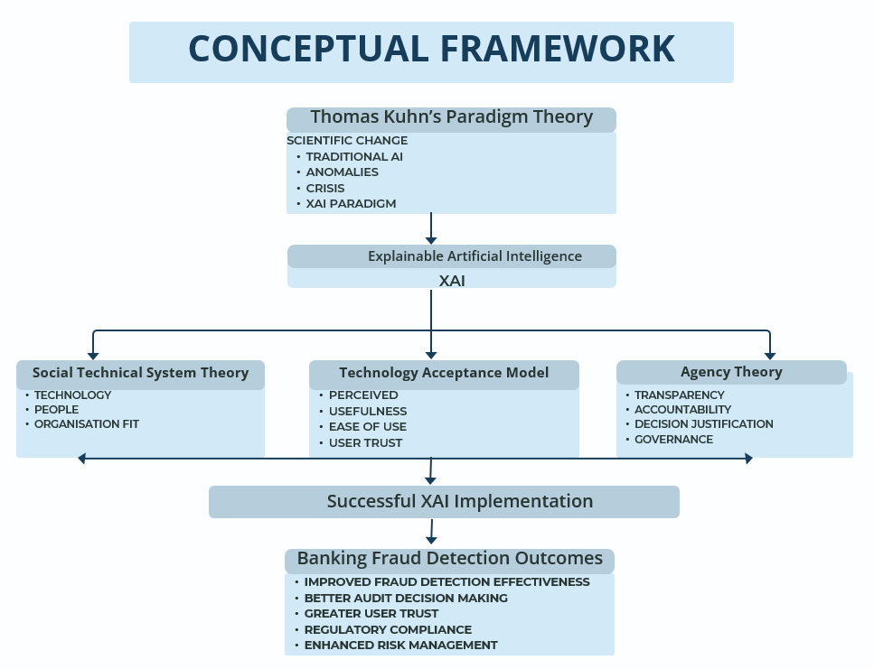
Figure 1: Conceptual Framework of the study.
Source(s): Authors' Work.
The conceptual framework combines four theoretical strands, each highlighting a different aspect of how Explainable AI can transform fraud detection practices in banking.
1. Kuhn's paradigm theory (Kuhn, 1962) illustrates how scientific and professional knowledge changes over time, offering insight into the field's present shift from accuracy-centered modelling to explainability.
2. Socio-Technical Systems Theory (Trist & Bamforth, 1951) emphasises the interconnectedness of technology tools and organisational functions, explaining why auditors, compliance officers, managers, and analysts may interpret the same XAI approach differently.
3. Technology adoption Model (Davis, 1989) describes practitioner adoption of new systems, which helps account for differences in how banking professionals adopt or reject XAI technologies.
4. Agency Theory (Jensen & Meckling, 1976) focuses on accountability, decision justification, and the requirement for defensible explanations when using AI-generated outputs by auditors and compliance officers.
These theories offer a multi-layered explanation of how XAI might alter fraud detection practices. Kuhn explains the field's trajectory and emerging anomalies, Socio-Technical Systems Theory explains role-specific differences in how XAI is used, TAM clarifies why practitioners adopt XAI tools, and Agency Theory explains why certain roles, particularly auditors and compliance officers, require explanations to justify decisions retrospectively. This integrated paradigm therefore facilitates a comprehensive comprehension of XAI's organisational, behavioural, and epistemic consequences for banking fraud detection.

6.4 Key Literature Themes
So far, the literature study has identified five significant themes that run throughout the field:
- Financial fraud in banking.
- Traditional AI models used for fraud detection.
- Limitations of black-box AI.
- XAI techniques such as SHAP, LIME and counterfactual explanations.
- Human trust and decision support.

6.5 Evolution of Scope
The research has gradually refined its emphasis as the portfolio has grown, driven by a better understanding of the function of paradigm selection and its consequences for methodological coherence. After conducting a thorough literature analysis (Item 3), the study focused on the banking sector rather than broad banking and corporate audits. This change improves the project's conceptual clarity, viability, and prospective academic value.
Although corporate auditing is no longer treated as a separate empirical topic, the audit perspective remains important. Internal auditors continue to be one of the four practitioner groups studied (as described in the ontological stance above). Their ideas are now reviewed as part of the larger constellation of professional jobs inside banking, rather than in a parallel corporate audit context. The study repositions audit practice in the context of AI-driven fraud detection, retaining its relevance.

7. Conclusion: Refined Research Topic, Title and Plan

7.1 Refined Title
The working title evolved in two unique stages throughout the process of putting up this portfolio. Item 1 and 4 clarified that the audit viewpoint is the project's unique contribution, with banking practice serving as the major empirical context. Following the comprehensive paradigmatic and methodological examination, the scope was refined to focus just on the banking industry. Internal auditors are still a crucial element of the study, but they are now considered a single professional job inside banks rather than a distinct corporate audit sector.
The resultant, more specifically tailored working title is:‘Explainable Artificial Intelligence (XAI) for Financial Fraud Detection: A Mixed-Methods Evaluation of Interpretability and Practitioner Trust Across Banking Sector, with Evidence from Nepal.’

7.2 Refined Objectives
- To critically examine current fraud detection problems in banking, focusing on responsibility, audit trail requirements, and organisational circumstances that impact detection quality.
- To assess the constraints of standard and black-box AI models, focusing on the banking audit and contextualising these limitations of black-box AI.
- To rigorously compare the performance and explainability of XAI models (SHAP and LIME) with traditional techniques.
- To investigate banking and audit practitioners' perceptions of XAI explanation adequacy and trust through semi-structured interviews in Nepal and supplemented with a UK reference sample to assess cross-context variance in trust and interpretability expectations.
Objective 4 is an important addition to the original three-objective system. The Denouement analysis in Section 3.5 highlighted the need for a practitioner-centered purpose to prevent the research from becoming a technical benchmarking exercise, which is already covered in the literature examined in Item 3. The addition of a practitioner-focused aim means that the project tackles both the socio-technical and organisational elements of explainability, consistent with its larger mixed-methods, pragmatist approach.

7.3 Research Plan
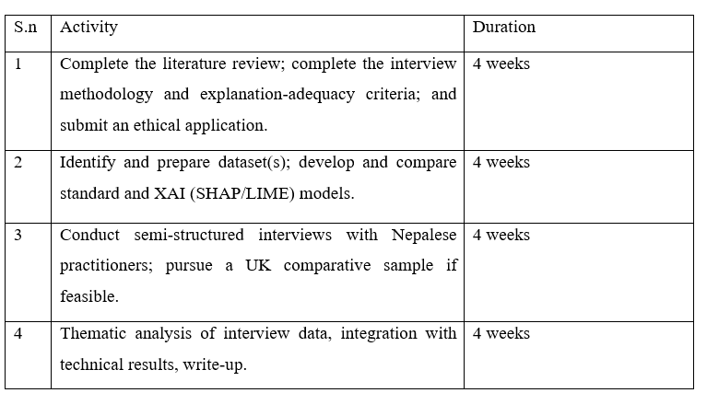
Table 3: Future Research Plan
Source(s): Authors' Work.

8. Reflective Summary of the portfolio journey
The portfolio demonstrates how the paradigmatic viewpoint affected the study's scope. The shift from a dual-sector design to a banking-specific project was not only pragmatic, but also based on ontological and epistemological reflection. Banking fraud is a unique real-world context that requires its own evidence base, interpretive criteria, and norms for explanation.
The second insight involves pragmatism. When used systematically, pragmatism reinforces methodological discipline by demanding both positivist and interpretivist norms to be satisfied. The final design represents dual accountability, with the SHAP/LIME comparison using positivist standards for quantitative evaluation and practitioner interviews using interpretivist criteria for role-specific meaning (Section 3). Each strand is assessed according to the criteria of its own epistemic tradition, rather than under a pragmatic canopy.
The Kuhnian analysis (Section 6) and the integrated literature review (Items 1 and 3) provide a third insight. These resources demonstrate that XAI's fundamental limits are socio-technical, not just technological. Effective explanations need trust, regulatory compliance, organisational acceptability, and role-specific interpretative demands. The study switched from a technique-comparison design to a mixed-methods, practitioner-inclusive strategy that considers the organisational realities of XAI implementation.
The research shifted from a broad dual-sector idea (12 May) to a targeted, pragmatic, banking-specific study with model comparison and interviews across four practitioner positions (16 June). The final topic fits academic requirements with a systematic evaluation of evidence (Items 1, 3, Appendix C), clear paradigmatic stance in respect to Kuhn (1962), Lakatos (2014) and Feyerabend (Section 6.1), and a defensible triangulated mixed-methods design (Section 6.2). Its professional relevance arises from practitioner access to Nepal's banking industry and alignment with the requirements of managers, auditors, compliance officers, and data analysts. The remaining difficulties, such as UK comparability and explanation sufficiency (Section 3), are carried forward to the next study phase rather than being resolved prematurely.

References
Abbott, A. (2004) Methods of Discovery: Heuristics for the Social Sciences. New York: W.W. Norton.
Aljunaid, S.K., Almheiri, S.J., Dawood, H. and Khan, M.A. (2025) ‘Secure and transparent banking: explainable AI-driven federated learning model for financial fraud detection’, Journal of Risk and Financial Management, 18(179), pp. 1–26. Available at: https://doi.org/10.3390/jrfm18040179.
Awosika, T., Shukla, R. M., and Pranggono, B. (2024) ‘Transparency and Privacy: The Role of Explainable AI and Federated Learning in Financial Fraud Detection’, IEEE Access, 12, pp. 64551–64560. Available at: https://doi.org/10.1109/ACCESS.2024.3394528
Bell, E., Harley, B. and Bryman, A. (2022) Business Research Methods. Oxford University Press.
Bryman, A. and Bell, E. (2011) Business Research Methods 3e. Oxford University Press.
Černevičienė, J. and Kabašinskas, A. (2024) ‘Explainable artificial intelligence (XAI) in finance: a systematic literature review’, The Artificial Intelligence Review, 57(216), pp. 1–45. Available at: https://doi.org/10.1007/s10462-024-10854-8
Charmaz, K. (2006) Constructing Grounded Theory: A Practical Guide through Qualitative Analysis. London: Sage.
Cil, A. E., and Yildiz, K. (2025) ‘A systematic literature review on applications of explainable artificial intelligence in the financial sector’, Internet of Things (Amsterdam. Online), 33(101696), pp. 224–226. Available at: https://doi.org/10.1016/j.iot.2025.101696
Creswell, J.W. (2009) Research Design: Qualitative, Quantitative, and Mixed Methods Approaches. CA: Sage.
Creswell, J.W. and Clark, V.L.P (2017) Designing and Conducting Mixed Methods Research. Sage Publications.
Crotty, M.J. (1998) The Foundations of Social Research: Meaning and Perspective in the Research Process. Sage.

Davis, F. D. (1989) ‘Perceived Usefulness, Perceived Ease of Use, and User Acceptance of Information Technology’, MIS Quarterly, 13(3), pp. 319–340. Available at: https://doi.org/10.2307/249008
Denscombe, M. (2017) EBOOK: The Good Research Guide: For Small-Scale Social Research Projects. McGraw-Hill Education (UK).
Denzin, N.K. and Lincoln, Y.S. (2011) The SAGE Handbook of Qualitative Research. Sage.
Feyerabend, P. (1975) Against Method. London: New Left Books.
Guba, E.G. and Lincoln, Y.S., 1994. Competing paradigms in qualitative research. Handbook of qualitative research, 2(163-194), p.105.
Jastrow, J. (1900) The mind's eye, Fact and fable in psychology, pp.275–295.
Jensen, M.C. and Meckling, W.H. (1976) ‘Theory of the firm: managerial behavior, agency costs and ownership structure’, Journal of Financial Economics, 3(4), pp. 305–360. Available at: https://doi.org/10.1016/ 0304-405X(76)90026-X.
Kuhn, T.S. (1962) The Structure of Scientific Revolutions. Chicago: University of Chicago Press.
Lakatos, I. (2014) Falsification and the methodology of scientific research programmes. Philosophy, science, and history (pp. 89-94). Routledge.
Lincoln, Y.S., Lynham, S.A. and Guba, E.G. (2011) Paradigmatic controversies, contradictions, and emerging confluences, revisited. The Sage handbook of qualitative research, 4(2), pp.97-128. Sage
Maxwell, J.A. (2013) Qualitative Research Design: An Interactive Approach. CA: Sage.
McLeod, S.A. (2020) ‘Thomas Kuhn - science as a paradigm’, Simply Psychology. Available at: www.simplypsychology.org/Kuhn-Paradigm.html
Morgan, D. L. (2007) ‘Paradigms Lost and Pragmatism Regained: Methodological Implications of Combining Qualitative and Quantitative Methods’, Journal of Mixed Methods Research, 1(1), pp. 48–76. Available at: https://doi.org/10.1177/2345678906292462

Patton, M. Q. (2002) ‘Two Decades of Developments in Qualitative Inquiry: A Personal, Experiential Perspective’, Qualitative Social Work : QSW : Research and Practice, 1(3), pp. 261–283. Available at https://doi.org/10.1177/1473325002001003636
Rossman, G.B. and Rallis, S.F. (2016) An Introduction to Qualitative Research: Learning in the Field. Sage Publications.
Saturday Night Live (2013) Penn and Teller: The Best Magicians in the World - SNL. 12 December. Available at: https://youtu.be/mwkmgqbYXdE (Accessed: 28 July 2026).
Trist, E.L. and Bamforth, K.W. (1951) ‘Some social and psychological consequences of the longwall method of coal-getting: An examination of the psychological situation and defences of a work group in relation to the social structure and technological content of the work system', Human Relations, 4(1), pp.3–38.
Tuge, N. B. and Msweli, N. T. (2026) ‘Explainable Artificial Intelligence in the Banking Sector: A Systematic Literature Review’, Applied Artificial Intelligence, 40(1), pp. 1–13. Available at: https://doi.org/10.1080/08839514.2026.2676353
Wallace, M. and Wray, A. (2011) Critical Reading and Writing for Postgraduates. Sage.
Weber, P., Carl, K. V., & Hinz, O. (2024) ‘Applications of Explainable Artificial Intelligence in Finance—a systematic review of Finance, Information Systems, and Computer Science literature’, Management Review Quarterly, 74(2), pp. 867–907. Available at: https://doi.org/10.1007/s11301-023-00320-0
Zhou, Y., Li, H., Xiao, Z., & Qiu, J. (2023) ‘A user-centered explainable artificial intelligence approach for financial fraud detection’, Finance Research Letters, 58(104309), pp. 1–10. Available at: https://doi.org/10.1016/j.frl.2023.104309

Appendix

Appendix A: Mike Wallace and Alison Wray synopsis template (Wallace and Wray, 2011)
Template: Critical Synopsis of a Text
Text (reference details)
Černevičienė, J. and Kabašinskas, A. (2024) ‘Explainable artificial intelligence (XAI) in finance: a systematic literature review’, The Artificial Intelligence Review, 57(216), pp. 1–45. Available at: https://doi.org/10.1007/s10462-024-10854-8
A. Why am I reading this?
I'm reading this article because it gives me a reliable, industry-wide overview of XAI in finance, identifies research gaps in fraud detection, and offers the conceptual framework for my research.
B. What are the authors trying to achieve in writing this?
By examining 138 research from 2005 to 2022, the authors hope to methodically outline the application of Explainable AI in the financial industry. They categorise XAI techniques, contrast how they are used to various financial tasks, and point out problems and gaps in the literature. Its objective is to assist researchers in identifying areas that require more research as well as practitioners in selecting appropriate XAI techniques.
C. What are the authors claiming that is relevant to my work?
The authors contend that because black box models compromise accountability, regulatory compliance, and confidence, explainable AI is crucial for high-risk financial jobs like fraud detection. They demonstrate that the most popular approaches for explaining fraud-related AI models include Shapley additive explanations (SHAP), feature significance methods, and hybrid XAI frameworks, but they also point out significant gaps, particularly the absence of explainability requirements and the paucity of research on audit-focused fraud detection. By highlighting the necessity of XAI in fraud detection as well as the existing lack of XAI applications in corporate audits, these assertions directly bolster your research.

D. How convincing are these claims, and why?
Because the authors' findings are supported by a systematic review of 138 peer-reviewed research, their conclusions have solid empirical support across a variety of financial disciplines. Consistent data demonstrating the pervasive use of opaque black box models and the predominance of SHAP, feature importance, and hybrid frameworks bolsters their claims on the significance of XAI in high-risk activities including fraud detection, credit scoring, and risk management. Their transparent methodology and unambiguous identification of unresolved gaps, especially the lack of explainability criteria and the paucity of research in audit-focused fraud detection, which clearly connect with and confirm the necessity for your research, further bolster the assertions.
E. In conclusion, what use can I make of this?
This article can serve as a sector-wide basis for comprehending the current state of XAI's use in financial fraud detection and identifying the main methodological and practical deficiencies. It explicitly supports the need of my research by demonstrating that explainability is crucial for trust, regulatory compliance, and decision making, and that fraud detection mostly depends on black box models. Most significantly, it draws attention to the dearth of XAI applications in corporate audits, providing you with a convincing argument for the uniqueness and value of my study.

Template: Critical Synopsis of a Text

Text (reference details)
Tuge, N. B. and Msweli, N. T. (2026) ‘Explainable Artificial Intelligence in the Banking Sector: A Systematic Literature Review’, Applied Artificial Intelligence, 40(1), pp. 1–13. Available at: https://doi.org/10.1080/08839514.2026.2676353
A. Why am I reading this?
This study enhances my research on Explainable AI models for detecting financial fraud in banking. It identifies socio-technical barriers, regulatory pressures, and XAI techniques that impact explainability integration in high-stakes financial systems.
B. What are the authors trying to achieve in writing this?
The researchers want to identify the challenges in implementing explainable AI in banking and provide a socio-technical framework to bridge the gap between XAI research and real-world financial practice.
C. What are the authors claiming that is relevant to my work?
Banks face challenges in implementing explainable AI due to technical limitations (e.g., accuracy-interpretability trade-off and unreliable post-hoc explanations), organisational barriers (e.g., cultural resistance, gaps in expertise, and lack of communication among data analysts and compliance and risk teams), and regulatory pressures, resulting in a persistent socio-technical implementation gap.
D. How convincing are these claims, and why?
The authors' claims on explainable AI models for financial fraud detection are credible due to a systematic review of 78 peer-reviewed studies, clear evidence of technical, organisational, and regulatory barriers, and alignment with established banking AI challenges.

E. In conclusion, what use can I make of this?
To strengthen the theoretical and practical foundation of a research, it emphasises the socio-technical, regulatory, and institutional gaps that explainable AI must address in banking. These insights can be directly applied to support my research problem, further develop conceptual framework, and demonstrate why XAI-based fraud detection models are essential and relevant.

Template: Critical Synopsis of a Text

Text (reference details)
Weber, P., Carl, K. V., & Hinz, O. (2024) ‘Applications of Explainable Artificial Intelligence in Finance—a systematic review of Finance, Information Systems, and Computer Science literature’, Management Review Quarterly, 74(2), pp. 867–907. Available at: https://doi.org/10.1007/s11301-023-00320-0
A. Why am I reading this?
Explainable AI models can enhance financial fraud detection in banking, improving transparency, trustworthiness, and operational effectiveness. This strengthens regulatory compliance and management decision-making.
B. What are the authors trying to achieve in writing this?
By methodically reviewing existing research, elucidating which XAI techniques and objectives have been implemented across financial industry domains, emphasising legal and pragmatic motivations for explainability, exposing gaps like the paucity of work on privacy and anti-money-laundering, and ultimately offering a structured foundation that directs future scholarly research and supports practitioners in implementing transparent, reliable AI systems in banking and finance, the authors hope to consolidate fragmented research on explainable AI in finance.

C. What are the authors claiming that is relevant to my work?
In line with my focus on utilising XAI to improve the efficacy and accountability of fraud detection systems in banking, the authors assert that explainable AI is crucial for financial fraud detection because it boosts model transparency, supports regulatory compliance, enhances trust among banking stakeholders, and enables practitioners to comprehend, validate, and act on AI-generated fraud signals.
D. How convincing are these claims, and why?
Because the claims are based on well-established industry pressures such as regulatory demands for model transparency, the documented risks of opaque fraud-detection systems, and empirical evidence demonstrating that XAI improves stakeholder trust and operational decision-making they are largely persuasive. The authors bolster these claims by synthesising 60 studies from the finance industry, showing consistent patterns that directly reinforce the relevance and credibility of explainability for improving fraud detection in banking.
E. In conclusion, what use can I make of this?
To bolster my research of explainable AI in banking by utilising its frameworks, evidence, and identified research gaps to bolster claims such as XAI is not only technically advantageous but also crucial for stakeholder trust, regulatory compliance, and the real-world application of fraud-detection models in actual banking settings.

Appendix B: A ‘What, Why and How’ Framework for Crafting the Research (Bryman and Bell, 2011).
What? | Why?
What puzzles/intrigues me? What do I want to know more about/understand better? What are my key research questions?  The growing use of artificial intelligence (AI) in financial fraud detection and the drawbacks of its explainability are the driving forces behind this study. Despite the great predicted accuracy of AI models, their "black-box" nature diminishes accountability, transparency, and trust, especially in corporate auditing and banking where decisions need to be justified. The study looks at whether Explainable Artificial Intelligence (XAI) may enhance the interpretability of AI-driven judgements as well as the effectiveness of fraud detection.  The following queries are addressed by the study:  - What are the current limitations of AI-based fraud detection systems in banking and corporate audits?  - How explainable AI techniques can improve transparency and strengthen decision justification in fraud detection contexts.  - Which XAI models provide the most effective balance between forecasting accuracy and interpretability?  - How can XAI outputs support auditors, risk managers, and compliance officers in their decision‑making processes?  - What comprehensive framework can integrate XAI into real-world fraud detection workflows? | Why will this be of enough interest to others to be published as a thesis, book, paper, guide to practitioners or policy makers? Can the research be justified as a ‘contribution to knowledge’?  Financial institutions continue to face significant challenges due to financial fraud, and growing regulatory demands call for transparent and responsible AI systems. Although AI-based fraud detection has advanced, little study has looked at how XAI helps with corporate audits and financial decision-making. In order to close this gap, this study assesses XAI from both a technical and user standpoint.  The study advances knowledge through:  - contrasting XAI with conventional AI models  - analysing practitioners' views of explainability and trust  - critically synthesising the most recent research on AI and XAI in fraud detection  - offering a workable framework for XAI implementation in banking and corporate audit settings.  Researchers, financial institutions, auditors, and legislators looking for reliable and comprehensible AI solutions will find value in the findings.
How — conceptually? | How — practically?
What models, concepts and theories can I draw on/develop to answer my research questions? How can these be brought together into a basic conceptual framework to guide my investigation?  The research incorporates ideas from artificial intelligence, explainable artificial intelligence, fraud detection, auditor decision-making, confidence in AI, and regulatory compliance. It compares traditional machine learning models to XAI approaches like SHAP and LIME to investigate the link between model explainability, user trust, and fraud detection efficacy.  The conceptual framework posits that enhanced explainability improves users' comprehension and trust, resulting in better fraud detection judgements and regulatory compliance. | What investigative styles and techniques shall I use to apply my conceptual framework (both to gather material and analyse it)? How shall I gain and maintain access to information sources?  This study uses a mixed-methods approach, integrating qualitative and secondary data analysis.  Primary data will be gathered through five to six semi-structured interviews with bank managers, auditors, and financial data analysts in Nepal to investigate perceptions of AI explainability, trust, and fraud detection applications. If feasible, a short survey of UK auditors might be performed to give comparative perspectives.  Secondary data will include peer-reviewed scientific publications that have been evaluated using thematic analysis to compare AI and XAI models in terms of performance, interpretability, and practical applicability. The review is based on current research, including Cil and Yildiz's (2025) Explainable AI in the Banking Sector: A Systematic Literature Review.  Interview and literature data will be thematically examined to uncover significant trends in explainability, trust, decision-making, and organisational adoption. Access to participants in Nepal has already been established through professional networks, and academic material will be obtained from databases such as Scopus, Web of Science, IEEE Xplore, ScienceDirect, and SpringerLink.

Appendix C: Critical Analysis of Five Relevant Articles
1. Černevičienė and Kabašinskas (2024)
Research questions: The study answers four key research questions: which financial AI applications use XAI, how XAI methods differ across tasks and domains, how new XAI techniques are developed and implemented, and what challenges, requirements, and unresolved issues arise when using XAI in financial settings.
Method: A thorough review of 138 peer-reviewed publications published between 2005 and 2022 addressed key aspects of XAI in finance.
Key Findings: The review reveals numerous key trends. Credit risk management is the most researched application field, with 44% of all assessed papers. SHAP, a feature-relevance strategy, is the most commonly employed explainability technique (45% of research), often in conjunction with black-box models like Random Forest, XGBoost, and neural networks. XAI algorithms are used for a variety of financial activities, including fraud detection, bankruptcy prediction, portfolio optimisation, forecasting, and risk management. Fraud detection is a key component of risk-related applications. Despite advances, the analysis identifies some outstanding obstacles, including the lack of defined explainability standards, ongoing accuracy-interpretability trade-offs, scaling limits, and difficulty aligning model explanations with practitioner intuition. These concerns collectively imply that XAI acceptance in finance is still unequal, and interpretability has not yet been fully incorporated into mainstream evaluation processes.
Relevance: This review is directly relevant to the current dissertation. This map depicts the present state of XAI in financial services, with a focus on credit risk, fraud detection, and model transparency. It emphasises the need to examine explainability and governance in fraud detection systems. The findings support the dissertation's focus on organisational responsibility, practitioner trust, and the limits of black-box AI in banking.
2. Cil and Yildiz (2025)
Research Questions:The review answers a number of fundamental research questions, including what obstacles stand in the way of successful XAI implementation in banking, how these obstacles can be overcome technically, organisationally, and through regulation, which XAI techniques are best suited for banking and what limitations they carry, how organisational dynamics influence XAI adoption, what governance frameworks are available for integrating XAI into banking, and how explanations can be customised to meet the needs of various stakeholders.
Method: A comprehensive analysis of 78 peer-reviewed publications and industry reports covering the most current advancements in XAI use in financial services, published between 2021 and 2025, was used to investigate these concerns.
Key Findings: A number of related discoveries are identified by the review. The accuracy–interpretability trade-off and the ongoing "explaining the explanation" issue, in which tools like SHAP and LIME provide outputs that practitioners still find difficult to understand, are technical issues that the profession is currently struggling with. Deeper organisational and cultural obstacles, such as reluctance to change, mismatch between technical teams and business units, and the lack of uniform assessment frameworks, exacerbate these technical problems. The review comes to the conclusion that multidisciplinary cooperation, context-sensitive explanation design, and human-centric governance structures that can enable accountability and decision justification are necessary for the effective deployment of XAI.
Relevance: This review directly relates to the dissertation. It primarily looks at the use of XAI in banking, including regulatory compliance, fraud detection, and model transparency. The study's emphasis on practitioner trust and explainability within fraud-detection mechanisms is supported conceptually by its insights into governance challenges, organisational alignment, and stakeholder-specific explanation needs, even though it does not specifically address corporate audits.
3. Aljunaid, Almheiri, Dawood and Khan (2025)
Research Question: The study looks into a number of related research questions, such as how financial institutions can improve fraud detection while protecting data privacy, how to reduce the opacity of black-box AI models, whether an integrated Explainable Federated Learning (XFL) approach can provide both high predictive performance and interpretability, and how XFL stacks up against current machine-learning, deep-learning, ensemble, and federated-learning models in terms of accuracy, privacy, scalability, and interpretability. These enquiries fit within the larger context of explainable fraud detection and privacy-preserving AI.
Methods: The study's methodology uses quantitative, computational modelling approach where Federated Learning across several universities provide cooperative model training without exchanging raw transaction data. Federated Averaging is used to aggregate model updates, while SHAP and LIME are used to introduce interpretability. Standard preprocessing, exploratory analysis, and validation processes enable the method.
Key Findings: The results show that the XFL model has a very low miss rate (0.05%) and an unusually high fraud-detection accuracy (99.95%). By offering clear, case-level explanations, SHAP and LIME successfully tackle the black-box issue. Federated Learning demonstrates its applicability for high-risk financial contexts by facilitating safe, privacy-preserving collaboration across institutions, lowering false positives, and supporting real-time detection.
Relevance: There is a clear connection to the current dissertation. In keeping with the project's emphasis on explainable AI for fraud detection, the study creates an explainable federated-learning model utilising SHAP and LIME. The dissertation fills a vacuum in the current XFL literature by extending these concepts into the areas of corporate audit practice and organisational governance, whereas the evaluated work focuses on banking-transaction data.
4. Awosika, Shukla and Pranggono (2024)
Research Questions: The study investigates how financial organisations can collectively detect fraudulent transactions without sharing confidential information, whether Federated Learning provides performance improvements over centralised models under severe class imbalance, how Explainable AI (XAI) can be incorporated into FL-based fraud-detection systems to enhance transparency and user trust, and whether integrating FL with a Deep Neural Network (DNN) yields a scalable, accurate, and privacy-preserving solution.
Methods: The authors use a quantitative experimental approach with a publicly accessible fraud dataset of 29,042 observations and 32 characteristics. The workflow involves data preparation, SMOTE-based class balancing, DNN training in a Federated Learning environment, and producing model explanations with SHAP.
Key Findings: Federated Learning significantly improves privacy-preserving fraud detection. The DNN-within-FL model obtained 93% accuracy, with steady gains in precision, recall, and F1 score. SMOTE significantly reduced the high class disparity found in fraud data. SHAP discovered key predictors of fraudulent activity and developed a web-based FL platform for real-time monitoring and updating.
Relevance: The study demonstrates how Explainable AI and Federated Learning may improve fraud detection while protecting data privacy. This study broadens the subject by including organisational and governance views and applying XAI to banking and corporate audit environments, providing a more context-specific and practitioner-centered approach.
5. Zhou, Li, Xiao and Qiu (2023)
Research Questions: The project aims to improve transparency of machine-learning-based fraud detection algorithms for external stakeholders, such as regulators, auditors, analysts, and investors. The study assesses SHAP's ability to provide stakeholder-specific and global explanations, whether incorporating a Shapley-value framework improves predictive accuracy and interpretability, and which financial-statement variables have the greatest impact on fraud predictions and how to communicate these insights in a user-centred manner.
Methods: The authors analysed 37,502 firm-year financial statements from Chinese listed businesses (2007-2020), including 432 verified fraud incidents, using the CSMAR database. An ensemble XGBoost model is created and analysed with SHAP.
Key Findings: The ensemble XGBoost model outperforms standalone XGBoost (AUC 0.58) and typical imbalance-handling techniques, with an AUC of 0.79. SHAP delivers local and global explanations that are relevant to stakeholder demands. Local explanations reveal that fraud-risk factors differ among organisations, but global explanations emphasise key elements like as prepayments and goodwill, which are consistent with existing accounting studies. Feature-interaction analysis shows that fraud risk arises from a mix of factors, rather than single signs. The authors highlight that SHAP explanations represent model-derived patterns, not causative mechanisms, and should be evaluated with expert assessment.
Relevance: The study creates a SHAP-based XAI framework that aligns with this project's focus on explainable fraud detection models. This paper illustrates how local and global explanations may improve transparency for regulators, auditors, analysts, and investors. It also provides a solid framework for utilising XAI in banking fraud analytics and corporate audits.

Appendix D: The Four-Quadrant Blueprint Mapping
Quadrant 1: The Practical Problem | Quadrant 2: The Specific Context
What is the broad, recurring real-world corporate/industry pain point?  Financial fraud remains a continuous issue for banks and corporations, resulting in huge financial losses, brand harm, and regulatory problems. Although artificial intelligence (AI) has improved fraud detection capabilities, many current AI models act as "black boxes," restricting the transparency and interpretability of their judgements. This lack of explainability undermines user trust, limits auditors' ability to defend fraud-related actions, and complicates regulatory compliance. As a result, there is an increasing demand for Explainable Artificial Intelligence (XAI) models that can detect fraud accurately while also providing transparent and interpretable decision assistance. | Where is this happening? (Bind by industry, sector, scale, or region)  The study is conducted in the banking and corporate auditing sectors, where AI-enabled fraud detection tools are increasingly used to detect financial abnormalities and enhance risk management. The empirical inquiry will largely focus on financial institutions and audit experts in Nepal, where the researcher has developed professional connections with participants. Where possible, the research will seek opinions from UK auditing experts to give comparative insights into the uptake and deployment of explainable AI in various regulatory and organisational contexts.
Quadrant 3: The Theoretical Lens | Quadrant 4: The Empirical Access
What established academic theory or model will guide your analysis?  The study draws on principles from Explainable Artificial Intelligence (XAI), Machine Learning-based Fraud Detection, and Technology Acceptance Theory, which highlights the relevance of transparency, trust, and perceived utility in technological system adoption. The analysis will leverage explainability methodologies such as SHAP (SHapley Additive Explanations) and LIME (Local Interpretable Model-agnostic Explanations) to assess how explainable models affect user comprehension, trust, and decision-making. These notions will serve as the theoretical underpinning for the creation of a framework that connects model explainability to fraud detection effectiveness and organisational decision support. | How will you secure permission to extract data or interview subjects?  Primary data will be gathered through semi-structured interviews with bank management, auditors, and financial data analysts. The researcher will have access to participants in Nepal through his or her current professional networks and organisational ties. Prior to participant recruiting, formal authorisation will be sought from appropriate organisations. Prior to data collection, all participants will be given an information sheet and asked to obtain informed permission in accordance with university procedures. If comparison data from the United Kingdom are included, participants will be recruited via professional networks and publicly available industry connections, subject to organisational consent and ethical clearance. Secondary data will be gathered from peer-reviewed journal publications available through university library databases, with no further organisational authorisation required.

The Master 4-Sentence Synthesis Pitch
Combining the four quadrants above produces the following single, cohesive script, to be delivered to peers during Phase 2 (Executive) and Phase 3 (Academic) of the Crucible:
Financial fraud is still a chronic issue in the banking and corporate auditing sectors, and while Artificial Intelligence (AI) has enhanced fraud detection skills, its lack of transparency and explainability hinders user confidence, accountability, and regulatory compliance. This study looks into how Explainable Artificial Intelligence (XAI) models can improve both the predictive performance and interpretability of fraud detection systems in banking and corporate auditing contexts, using empirical evidence primarily from professionals in Nepal and, where possible, the United Kingdom. The project, guided by Explainable AI, machine learning-based fraud detection, and technology acceptance theories, will look at how explainability approaches like SHAP and LIME affect auditors, bank managers, and compliance professionals' decision-making processes. Using a mixed-methods approach that includes semi-structured interviews and thematic analysis of recent peer-reviewed literature, the study aims to create a practical framework for incorporating XAI into financial fraud detection to support more transparent, trustworthy, and effective organisational decision-making.

Appendix E: Reflective Learning Log and Group Search-Term Activity.
The table below represents the shared result of the group activity on June 2nd, in which each applicant identified group- and individual-level search phrases for their particular subject. My individual phrases are presented in the right column versus common group terms on the left side; contrasting the two columns among applicants helped me refine the search technique employed in the literature review that underpins Item 3.
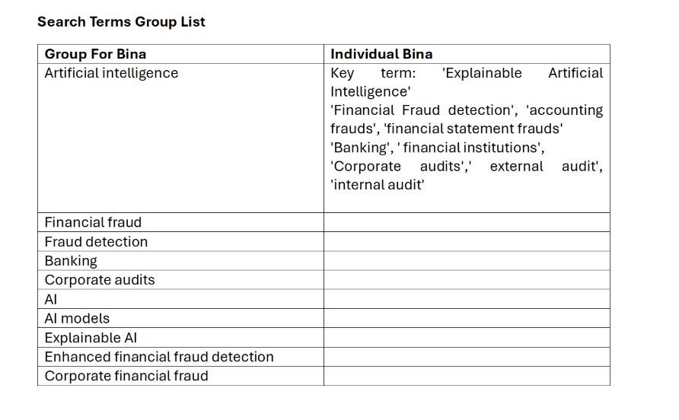
A brief, dated summary of the larger reflective journal kept throughout the module below:
The Advancing to Doctoral Stage LCDB 7012 module began on May 12, and we were required to explain our desired study domains, sectors, and prospective themes. Although the initial selection process created some doubt, I finally opted to expand on my past work by doing a more in-depth examination of financial fraud detection systems. During the first session, we also undertook a small brainstorming activity centred on the issue "Is it worth going to university?" (excerpt: "we did brainstorming about the topic 'Is it worth going to university?'").
Research Philosophy and Early Theoretical Foundations (19 May)
On May 19, the class discussed research philosophies and methodological techniques. We were asked to select a study topic and begin organising a methodical inquiry. Foundational readings included the following:
- Guba and Lincoln (1994) compare positivism, post-positivism, critical theory, and constructivism as research paradigms based on ontology, epistemology, and methodologies.
- According to Rossman and Rallis (2016), research is a value-laden, participatory learning process that draws on interpretivist and constructivist traditions.
- According to Creswell (2009), philosophical assumptions have a significant role in selecting quantitative, qualitative, or mixed-methods research designs.
In class, we were asked to understand all these Crotty, Creswell, Maxwell, Denscombe, Denzin, Guba and Lincoln and Cohen philosophical assumptions. According to Kuhn (1962), paradigms rather than accumulated knowledge influence scientific advancement. Until anomalies cause a crisis and replacement, paradigms determine acceptable issues, procedures, and norms. Due to conflicting paradigms' incompatible interpretations of reality, his historical study demonstrates that scientific change is non-linear, social, and characterised by incommensurability.
Bell, Bryman, and Harley (2019) advocate for a methodologically pluralist approach that blends interpretivist meaning-focused inquiry with positivist measurement. They promote quantitative, qualitative, and mixed-techniques designs to capture organisational complexity, emphasising adaptability, ethical integrity, and coherence between research topics and methods.
Crotty (1988) proposes a constructivist epistemology in which meaning is constructed by human interpretation. He describes four interconnected elements: epistemology, theoretical viewpoint, methodology, and methods and demonstrates how philosophical stances influence choices such as interviews, observation, and textual analysis to expose socially created meanings.
Creswell & Creswell (2022) take a pragmatic approach, claiming that design should follow the research challenge. The authors distinguish between quantitative, qualitative, and mixed methodologies techniques, emphasising the need of aligning questions, sampling, data collecting, analysis, and ethical reflexivity to ensure validity and trustworthiness.
Maxwell (2013) takes a realist-interpretivist qualitative approach, focusing on participants' meanings and causal processes. The author emphasises the need of iterative design, researcher reflexivity, and validity procedures including triangulation and respondent verification. Interviews, observations, and document analysis are used to provide believable, context-based explanations.
Denscombe (2017) presents a practical applied research paradigm for small‑scale investigations, highlighting clarity, feasibility, ethics, and methodical inquiry. He advocates for a variety of approaches, including surveys, case studies, experiments, ethnography, and grounded theory, and emphasises thorough sampling, analysis, and truthful reporting.
Denzin and Lincoln (2011) takes an interpretative symbolic-interactionist approach, perceiving social reality as shaped by meanings and interactions. His reflexive qualitative technique produces rich, contextual interpretation through triangulation of interviews, observations, records, and life experiences.
Cohen, Manion, and Morrison (2007) provide a comprehensive educational research paradigm that incorporates positivist, interpretivist, and critical views. The authors advocate using a mix of quantitative and qualitative approaches, such as surveys, experiments, interviews, and observation, to solve educational complexity.
These authors argue that research is a structured, philosophically informed, and methodologically diverse process that shapes knowledge through paradigms, interpretations, and practical design choices. It integrates epistemology, methodology, and methods to produce credible, context-grounded understanding.
I further developed my study idea as follows: Explainable Artificial Intelligence (XAI) Models for Enhancing Financial Fraud Detection in Banking and Corporate Audit.
My literature study emphasised the need of detecting fraud in financial institutions due to rising digitalisation, cybercrime, identity theft, fraudulent payments, and money laundering. Banks are using AI-based fraud detection systems, but they often function as opaque "black boxes," making it difficult for users to comprehend and justify choices (Černevičienė and Kabašinskas, 2024). In contrast, XAI includes tools and approaches that allow humans to comprehend how AI systems create outputs. Its significance rests in improving trust, safety, and regulatory compliance, especially in high-risk industries like banking.
According to Cil and Yildiz (2025), the most common model-agnostic explainability approaches in financial applications are SHAP and LIME. This includes:
- Explain the importance of the feature (for example, SHAP values).
- Rule-based learners use simplification as an explanation method.
- Local explanations, such as LIME, which explains model behaviour on an individual prediction basis.
Developing the WWHH Framework (26 May)
On May 26, we studied axiology and finished the WWHH template:
- What: Key questions on how XAI might improve fraud detection.
- Why: The issue has both academic and practical value.
- How (conceptually): The ideas and models that underpin the conceptual framework.
- How (practically): The methodological tactics necessary to implement the framework.
This prompted me to investigate the transition from standard AI to XAI. Although typical AI models attain great predicted accuracy, they have limited interpretability, low user confidence, regulatory issues, and poor auditability. These concerns are anomalies in Kuhn's paradigm cycle. Recent research confirms that transparency and explainability are key implementation issues in financial AI (Khan et al., 2025).
XAI is a novel paradigm that handles anomalies using SHAP, LIME, counterfactuals, feature significance analysis, and human-readable explanations. These strategies encourage trust, openness, regulatory alignment, and better human decision-making.
Key Search Terms and Identifying Research Gaps (2 June)
On June 2, a group exercise helped each participant discover essential search phrases for their topic. This test found both common and distinctive terms among people.
We also talked about the necessity of recognising research gaps such as topics that have yet to be addressed, are underexplored, or require further empirical support as well as recognising limitations in existing studies. Evolution of Fraud Detection Mechanisms; Further research revealed a historical trend in fraud detection:
- Traditional approaches involve rule-based systems, statistical analysis, and manual research.
- Machine learning phases include Random Forest, XGBoost, neural networks, deep learning, and black-box AI.
- The XAI phase involves transparency, interpretability, accountability, and human-centered AI.
According to Khan et al. (2025), the constraints of black-box AI have led to the development of XAI as a new paradigm.
Philosophical Positioning and Ontological Assumptions (9–16 June)
On June 9, I chose pragmatism as the ideal paradigm for my research, emphasising practical answers to real-world issues. I used a pluralist ontology, acknowledging that the perceived value of XAI differs by profession bank managers, internal auditors, compliance officers, and data analysts. Each group views XAI differently depending on their organisational duties.
On June 16, we discussed ontological, epistemological, and methodological assumptions. Drawing on Morgan (2007), I used a practical epistemology that included a systematic literature review, thematic analysis, practitioner interviews, and a fictional UK auditor survey. For example, while the literature suggests that SHAP increases transparency, interviews may indicate that auditors fail to comprehend SHAP findings without training. Using diverse evidence sources guarantees both academic rigour and practical usefulness.
Methodological Development and Mixed-Methods Design (23 June)
On June 23, we employed Kuhn's paradigm cycle to analyse mixed-methods research. My methodological decisions are motivated by the study goal rather than adherence to a specific approach. Combining qualitative and quantitative evidence is a pragmatic approach to enhancing XAI-enabled fraud detection inside an organization.
The study used a mixed-methods design.
- Qualitative research used semi-structured interviews with banking experts.
- Quantitative: published research and a possible UK auditor survey.
A thorough literature study (limited to post-2020 research owing to fast XAI development and increasing banking rules) highlights prevalent concepts, limits of black-box AI, and contemporary XAI methodologies. Thematic analysis identifies repeating trends throughout research. Bank management, internal auditors, and compliance officials all have unique perspectives. The suggested XAI implementation framework's validity is strengthened by the triangulation of evidence.
Critical Synthesis and Theoretical Alignment (7–14 July)
On July 7, we learnt how to critically analyse, contrast, and synthesise literature by finding conceptual disagreements and persistent gaps. Feedback stressed the need of explaining ontological, epistemological, and methodological assumptions, as well as explicitly demonstrating paradigm changes.
By 14 July, I had polished my philosophical viewpoint and recognised limitations:
- AI adoption may be more gradual than transformational.
- The findings from Nepal may not be widely applicable.
- Rapid technological progress may exceed available evidence.
I also discovered theories that corresponded with my study aims.
- Kuhn's Paradigm Theory describes transformations in scientific and professional understanding.
- Socio-Technical Systems Theory focuses on the interplay between technology and organisational functions.
- Technology Acceptance Model (TAM) explains how users embrace new solutions.
- Agency Theory emphasises accountability and justification in decision-making.
Together, these theories shed light on how XAI might transform fraud detection procedures.
Presentation Submission (21 July)
On July 21, I submitted the Task 2 presentation, which combined Kuhn's paradigm theory with the philosophical foundations ontology, epistemology, and methodology that support my planned study for Task 1.
Several hurdles emerged during the learning process, highlighting both conceptual and practical difficulties in building a cohesive doctorate research program. Early sessions demonstrated hesitation in choosing a valid topic and matching it with a proper philosophical viewpoint, especially when dealing with complicated paradigmatic arguments like ontology, epistemology, and methodology. As the course continued, the fast expansion of XAI technologies made it difficult to keep up with growing research, and contradictions between explainability methodologies (for example, SHAP vs. LIME) hindered efforts to define clear conceptual boundaries.
Additional obstacles occurred in finding actual research gaps, synthesising multiple theoretical views, and restricting the focus from broad organisational settings to the banking industry while maintaining relevance. Balancing qualitative and quantitative methodologies in a pragmatic paradigm needed careful reasoning. Additionally, limitations about data access, sample representativeness, and the generalisability of Nepal-based findings limited the study design. Collectively, these challenges demonstrate the iterative and frequently challenging nature of transferring from subject inquiry to a rigorous doctorate research structure.

Appendix F: Further Realia (For Completion)
The elements listed below are merely recommendations and placeholders; they should be changed with actual material of your own rather than imagined information, because the value of realia is precisely its authenticity.

F1: Research Diary Extract
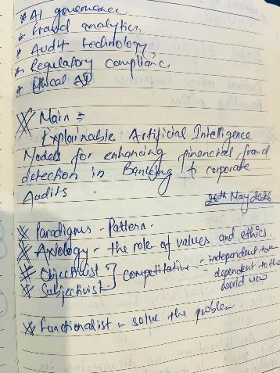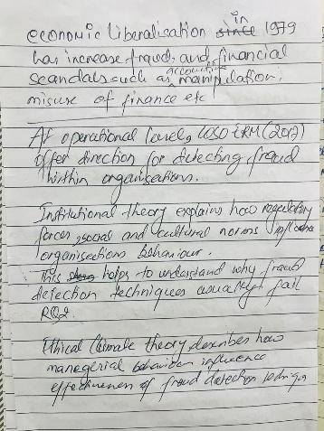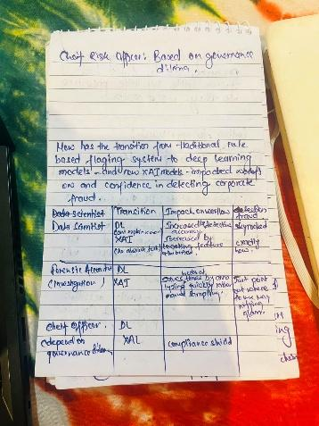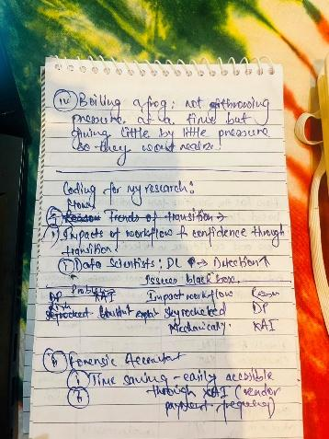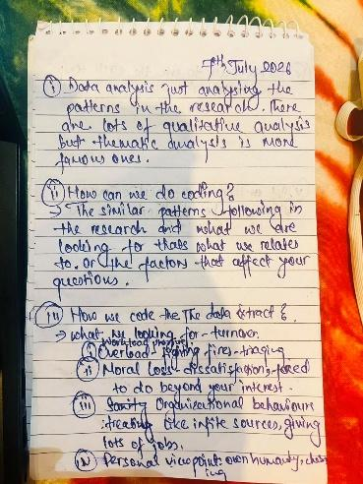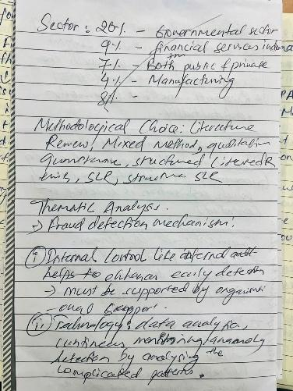
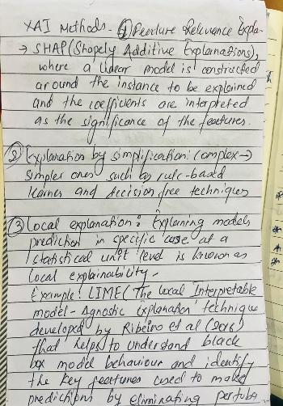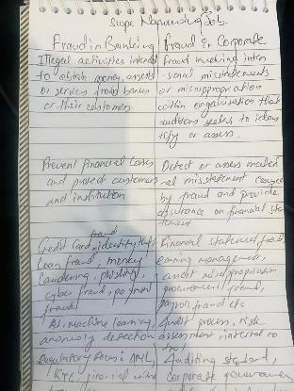
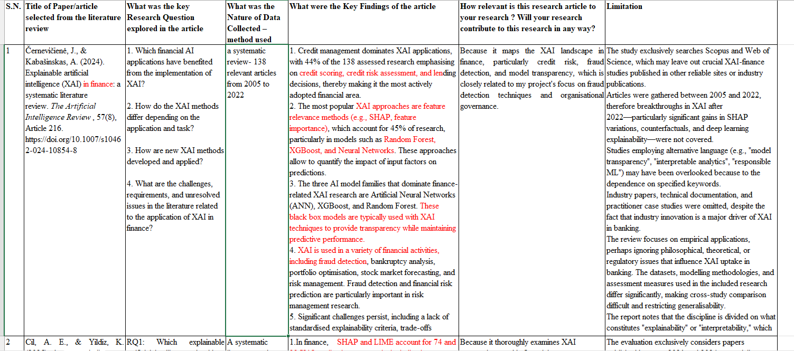



F2: Video illustrating perspective
Penn & Teller's magic trick performance was utilized in the research methodology module to demonstrate the transition from regular science to crisis to paradigm shift. Available at: https://youtu.be/3cp6pEzx3uw
The video depicts Penn and Teller doing a series of magic tricks, and the spectator generates assumptions about how each trick is performed based on what appears to be relevant evidence at the moment. At the final point, the lens pans out to reveal that Penn and Teller were upside down throughout the performance, thus the illusions were accomplished only by gravity. The evidence that the viewer initially believed to be significant turns out to be irrelevant, while other, overlooked details (like how much product was in their hair) turn out to be precisely what was required to justify the true explanation. The earlier hypotheses, which made sense given the assumptions in play at the time, turn out to have been completely off-base.
The video is a condensed, memorable imitation of Kuhn's (1962) normal-science/crisis/paradigm-shift cycle, which directly relates to Section 6.1. Normal science is the viewer's self-assured, empirically supported theories developed under an unquestioned premise (that the performers are the "right way up"); crisis is the point at which the trick cannot be explained within that premise; and paradigm shift is the revelation, which not only adds a new fact but also retroactively rearranges which earlier observations were considered evidence at all. The final point, which I find most helpful for my own work, serves as a reminder that when a field's presumptions change (for instance, from accuracy-first approach to explainability-first assessment of fraudulent models, discussed in Section 6.1), the restructuring involves not only new evidence but also which existing evidence is even acknowledged as relevant.

F3: The duck-rabbit illustration

Appendix Figure F1: The duck-rabbit illustration (Jastrow, 1900), as used by Kuhn (1962) to illustrate paradigm-dependent perception.
In the research-methods module, this picture was used to illustrate Kuhn's concept of paradigm shifts and how individuals might perceive the same object in various ways. An observer may perceive a rabbit, a duck, or, in theory, a form that has never been given a name. Kuhn treats science as, in this sense, subjective because each observer brings a prior framework that shapes what is seen, not just how it is interpreted later. He used precisely this kind of image to argue that paradigms are different ways of seeing rather than simply different amounts of knowledge.
Kuhn's intellectual biography was also connected to this in the module. By the standards of modern physics, Aristotle's writings on motion appeared to be full of fundamental errors, both logical and observational; in Kuhn's words, Aristotle appeared "like an idiot," but he was obviously not one. Kuhn began by asking how much mechanics Aristotle had actually learned in comparison to what remained for Galileo and Newton to discover. Kuhn came to the conclusion that one must comprehend the intellectual heritage in order to comprehend Aristotelian science. For Aristotle, "motion" implied movement in general, not only a change in a physical body's location, as a modern reader would naturally interpret the term. In general, the realisation is that comprehending scientific advancement necessitates comprehending the intellectual frameworks that scientists operate within rather than merely evaluating their findings in light of current norms; this is essentially the driving force behind Kuhn's (1962) entire argument, and it is the same point that the duck-rabbit image illustrates.
The relevance to this project is that it is a caution against treating the current accuracy-first paradigm in fraud-detection AI (Section 6.1) as simply 'behind' an explainability-first paradigm, in the way a modern physicist might once have dismissed Aristotle as simply behind Newton. Rather than treating earlier, purely predictive fraud models as straightforwardly inferior, I have tried to understand why accuracy was, and largely still is, the field's dominant criterion of a 'good' model, before arguing that explainability needs to be added or prioritised differently the duck-rabbit image is a useful discipline for remembering that a shift in evaluative criteria is a shift in framework, not simply an accumulation of missing facts.
Another point from the module session deserves particular mention since it reinforced the justification for including pragmatism into this study. Choosing a pragmatic perspective does not free the researcher from the demands of more philosophically severe stances; rather, it requires a commitment to satisfying the full methodological standards of both positivist and constructivist traditions, wherever they are used. Pragmatism does not grant an escape from disciplinary requirements, but rather demands the researcher to meet them concurrently.
The principle is represented in Section 6.2. The technical model-comparison strand is assessed based on quantifiable performance, whereas the practitioner-interview strand is evaluated using constructivist and interpretivist criteria for situated, role-dependent meaning. Neither strand is regarded permissively or loosely since the underlying paradigm is pragmatic; each is held to the epistemic lineage's acceptable norms.

F4: Examples from the research methods module
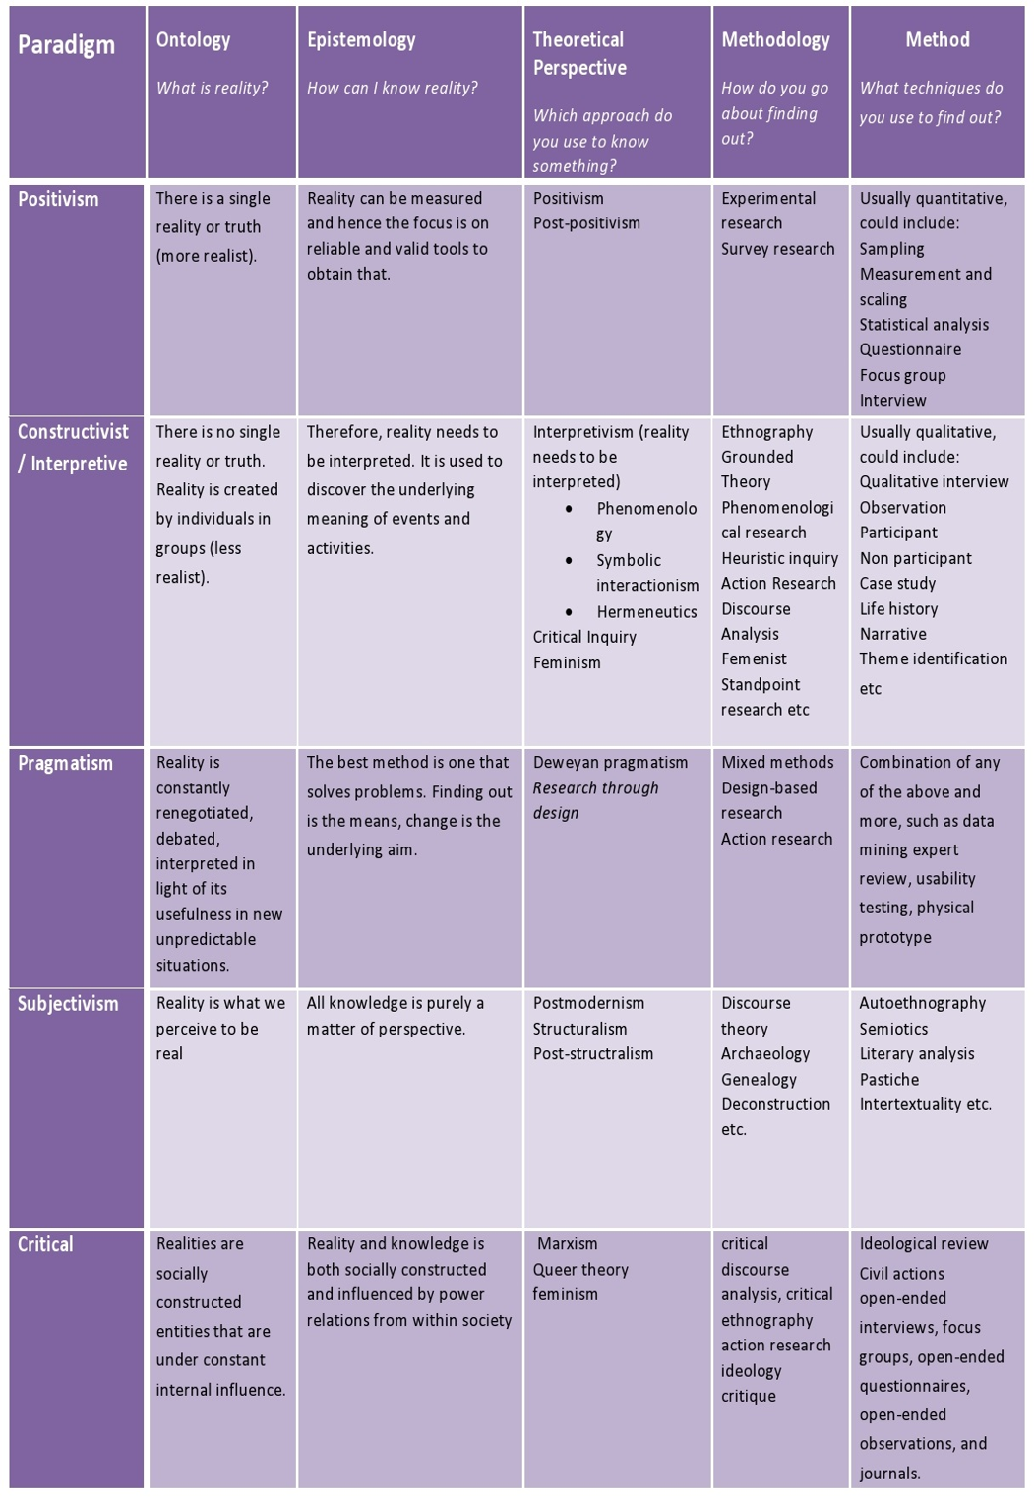
Appendix Figure F2: Paradigm comparison table used in the research-methods module.
A more comprehensive mini-literature review that was covered in the research-methods module is summarised in this table. According to Lincoln et al. (2011), "paradigm" in social research refers to the philosophical presumptions, or fundamental set of beliefs, that direct a researcher's actions and worldview; "worldview" is frequently used as a near-synonym, described as a means of understanding the complexities of the real world (Patton, 2002; Creswell and Clark, 2017; Rossman and Rallis, 2016). Axiology (beliefs about values in research), ontology (assumptions about the nature of reality), epistemology (assumptions about how knowledge is gained and the relationship between knower and known), methodology (a shared understanding of how best to gain knowledge), and rhetoric (the language of research) are the common elements that form each paradigm. Rather than being abstract positions to be adopted for their own sake, paradigms serve as heuristic "tools" for solving particular research problems (Abbott, 2004; Creswell, 2009; Lincoln et al., 2011).
Five paradigms are mapped against these components in the table itself. Positivism views reality as unique and quantifiable and uses survey or experimental research to produce objective, broadly applicable knowledge. Constructivism/interpretivism, which is closely related to Charmaz (2006) contention that the researcher and participants jointly produce the account of reality rather than the researcher merely discovering a pre-existing one, maintains that there can be no single truth, that the truth is generated by people and organisations, and that research should interpret meaning through techniques like grounded theory, phenomenology, or discourse analysis.
The row most pertinent to Section 6.2 is pragmatism, which views reality as continuously renegotiated and evaluates the optimal approach depending on whether it resolves the current issue, usually using mixed methods, design-based research, or action research. Although they are included for completeness, subjectivism (reality as purely perspectival, associated with contemporary and post-structured methods) is unlikely to endorse the practice-specific findings this investigation is required to generate, and the Critical paradigm (reality as shaped by power relations, allied with philosophical critique and critical ethnography) addresses a different type of research question than the technical and institutional focus of this project.

