Laser Doppler vibrometer -Brake Disc Modal Analysis
Structural Integrity and Material Evaluation (Peter Charlton)
Maulik Bhanushankar Dave (2106684)
Mr Maulik B Dave, Automotive Engineering, University of Wales Trinity Saint David, Swansea,



INDEX

1] ABSTRACT.......................................................................................................................................................3

2] APPARATUS....................................................................................................................................................3

3]INTRODUCTION.............................................................................................................................................6

4]LITERATUREREVIEW ….............................................................................................................................6

- Working Principle of Laser doppler vibrometer....................................................................7
- Application of LDV on automotive industry.............................................................................8

5]METHODOLOGY..............................................................................................................................................9
- 2D alignment and Laser signal……………………………………………………………………….9
- Component Scan and analysis…………………………………………………………………….10

6]Graphs..............................................................................................................................................................12

7] RESULTS AND DISCUSSIONS................................................................................................................14

8]CONCLUSIONS..............................................................................................................................................14

9]REFERENCES.................................................................................................................................................14

ABSTRACT - The purpose of this experimental study was to assess the viability of using a laser doppler vibrometer to analyse the vibration velocity and movement in a brake disc using data processing. Up until the scan is finished across all scan points, the brake disc is kept stationary and agitated at a fixed place by a solenoid actuator. Both the time and frequency domains were used to analyse the vibration data. The main difficulties in getting a displacement scan report are the multiple frequencies of higher vibrations that were obtained due to inaccurate solenoid excitation and variable amplitude as a result of improper mounting. While torsional surface vibrations are only detected in a narrow bandwidth, external vibrations play a major part in disturbing the environment.

APPARATUS
A Laser Doppler Vibrometer (LDV) setup is made up of a number of devices that operate on the idea of signal transmission and are managed by data gathering software.
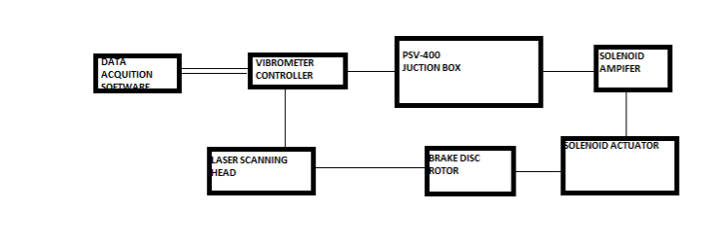
Fig1: Apparatus set up of Polytec LDV
Two concepts govern how a vibrometer controller system operates. It receives from the scanning head the vibration velocity and displacement at a fixed spot on the component's surface and directs the feedback to the acquisition software. The output is attached to the generator's PSV-400 junction box. outputs to coordinate the component's surface velocity movement and indentation timing. The controller receives an analogue input that represents the velocity output from the laser scanning head.

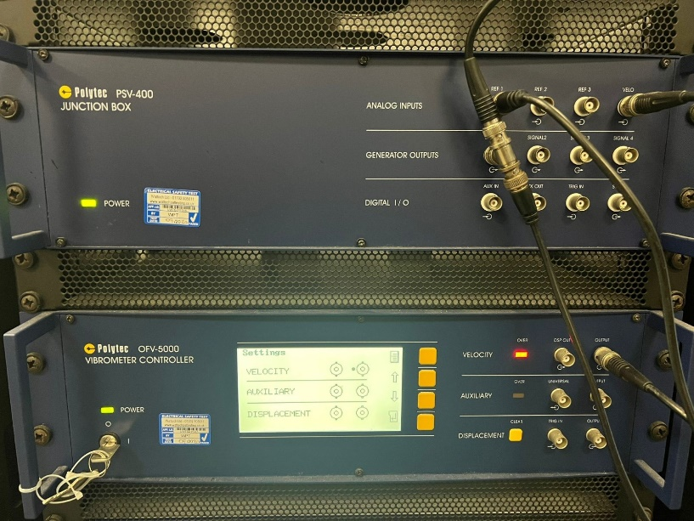
Fig 2: polytec ofv-5000 vibrometer controller
A solenoid actuator receives an analogue input from the junction box and applies an impact force to the component, which can be positioned depending on the component's nature or the desired outcomes. The resonant frequency is determined by the spot of indentation and is directly correlated with the amplified indentation of the solenoid actuator.

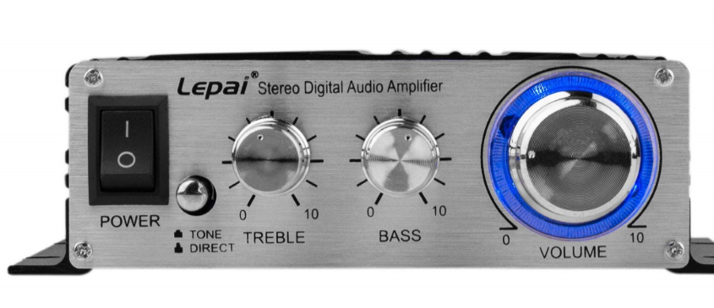
Fig 3: solenoid actuation frequency controller
A scanning head with a laser stream that will be reflected back from the component to the detector through a Bragg cell makes up a laser Doppler vibrometer. When the acquisition software produces an analogue signal for the hit by the solenoid actuator, it immediately stores the frequency shift of the reflected light.

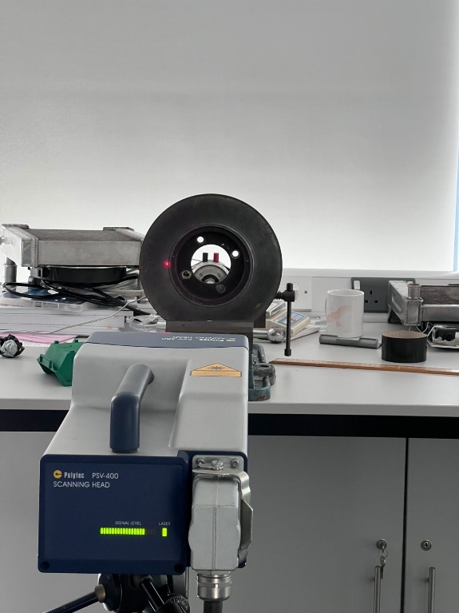

Fig 4: polytec PSV-400 scanning Head
Every finite second, a solenoid actuator produces a hit that is produced by the generator and can be directly set on PSV acquisition software, which transfers an analogue signal. A brake disc from an automobile was used as the test component for the experimental study. The brake disc is subjected to friction by the compression of the caliper assembly, where a powerful sliding indentation of the brake pads disturbs the frequency, causing vibration of the component. The material's behavior for the intended braking force applied by the driver as a matter of application is understood through an analysis of the brake rotor.

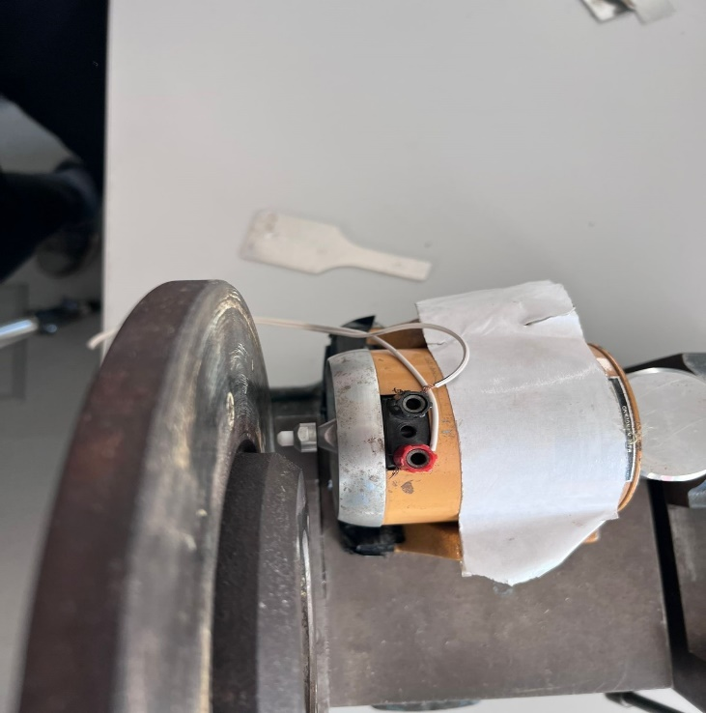

Fig 5: Solenoid Actuator and mounted brake disc

INTRODUCTION
Limiting vibration and vibration analysis of automotive components has grown in importance as a quality control job in recent years. When it comes to material performance, design, and regulatory relationships, brake rotors are frequently quite complicated. Automotive braking component design parameters and mechanical properties are frequently chosen to satisfy performance and scalability goals. This can be done by minimizing the vibrations caused by braking that are transmitted to the chassis and have a significant negative effect on driver comfort. Research into the behavior of vibration and noise transmission is essential because it is not possible to directly attach vibration reduction calipers or other dampening factors to the component. in order to achieve the best transition between various standards, from all angles.
Three scan heads make up the LDV, which can detect motions in the horizontal and vertical planes to clearly understand movements in three dimensions. With the LDV idea of operation, vibration velocity and displacement at a specific position are understood.
The brake disc's displacement and vibration velocity as a result of an external force with a fixed frequency stimulating it to resonate and acquire frequency at various contact points are experimentally examined in this article.

LITERATURE REVIEW
LDVs have been used for research reasons extensively in the literature, especially in the area of vibration analysis. They have been employed to gauge the vibrations of many different objects, such as wind turbines, buildings, and bridges. Studies of the vibration behavior of different materials, such as composites and metals, have also used LDVs.
Due to their high precision and accuracy, LDVs are useful tools for research and development across a variety of sectors. They have aided in the creation of more dependable and efficient products by assisting engineers and scientists in understanding the behavior of materials and structures under various conditions.

1 Working Principle of Laser doppler vibrometer.
An oscillating surface receives a laser stream from the LDV, which is then reflected off it. To maximize measurement effectiveness, a laser vibrometer can be fitted with a scanner that consists of a number of orthogonal reflectors (D.M. Chen, 2016). Through spinning mirrors under the direction of a controller, the vibrometer's laser light may continuously travel across a predetermined path on a material to measure its surface velocity.

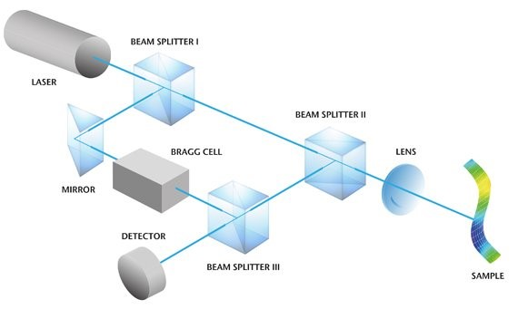
Fig 5: components of laser doppler vibrometer

The Doppler shift of the reflected laser beam frequency is used to calculate the frequency and amplitude of the vibrating target. The Doppler effect refers to the apparent discrepancy between the frequency at which sound or light waves depart a source and that at which they arrive at an observer due to relative motion between the observer and the wave source. The LDV is a continuous analogue voltage that varies in direct relation to the speed of the vibrating target. In LDV systems, helium-neon lasers are typically used.
As shown in Figure, beam splitter 1 divides the laser beam that is concentrated on the target, or the vibrating surface, into reference and test beams at an initial frequency of (fo).
The target beam receives frequency shift (fb) from the test beam as it passes through the Bragg cell. This beam is directed at a vibrating mass and has a frequency of (fo + fb) (Target). A Doppler change in the beam results from the target's velocity, which is vibrating.
A Laser Doppler Vibrometer operates on the Doppler Effect as its underlying concept. Equation 1 can be used to determine the speed of light in the laser beam, which can be used to determine the frequency of the light pulse displayed by the LDV.

Frequency = Speed of light in laser beam/ wavelength

2 Application of LDV on automotive industry
LDVs are used extensively in the automotive industry, particularly in the areas of testing, quality control, and research and development. Here are some instances of LDV usage in the automotive sector:
- Vibration testing: LDVs can be used to measure the vibration of different parts and systems inside a car, including the suspension, steering, engine, and transmission. This can assist engineers in identifying potential issues and creating solutions to enhance the vehicle's performance and dependability.
- Noise analysis: LDVs can be used to gauge how loud various components of the car, like the exhaust system, the tires, and the wind noise, are. This can aid engineers in creating vehicles that are quieter and less noisy.
- Testing for aerodynamics: LDVs can be used to measure the airflow around the vehicle, which is crucial for increasing fuel efficiency and lowering drag. This knowledge can be applied to the vehicle's design to lessen its environmental impact.
- Crash testing: LDVs can be used to assess the effects of a collision on the body, frame, and safety systems of the vehicle. The use of this information can increase vehicle security and lower the possibility of passenger injury.
- Quality assurance: Different parts and components, such as brakes, suspension, and steering systems, can be tested for consistency and quality using LDVs. This can help guarantee that each vehicle complies with the necessary requirements and specifications.
LDVs are useful tools for engineers in the automotive industry, assisting them to enhance the performance, safety, and environmental impact ofvehicles, and make sure that each one complies with the necessary requirements.

METHODOLOGY

  - 2D alignment and Laser signal.

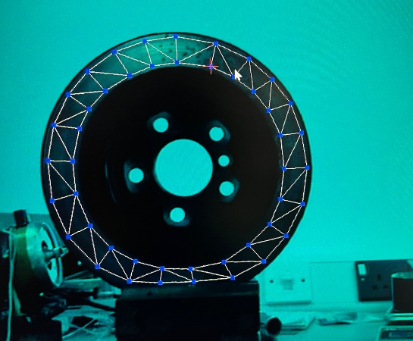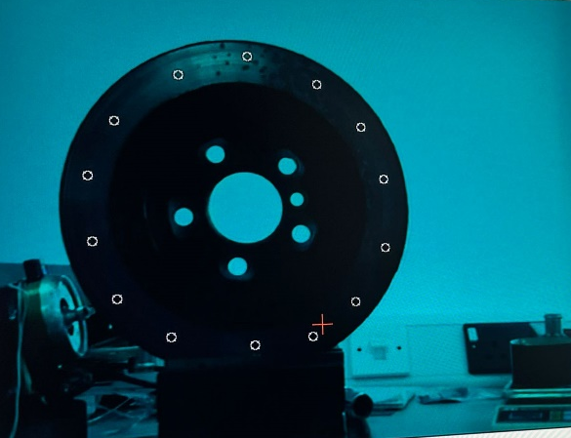
Fig 6:2D alignment
Within 1.2 meters, a brake disc is assembled on a fixed jack that is parallel to the scanning head. The 2D alignment function under setup is performed after starting the PSV data acquisition software. Figure: components of laser shows the eight different locations on the component where the scan points are defined. As shown in figure:2D alignment, the scan points are placed by navigating a toolbar that follows the path of the laser beam across the brake disc surface.

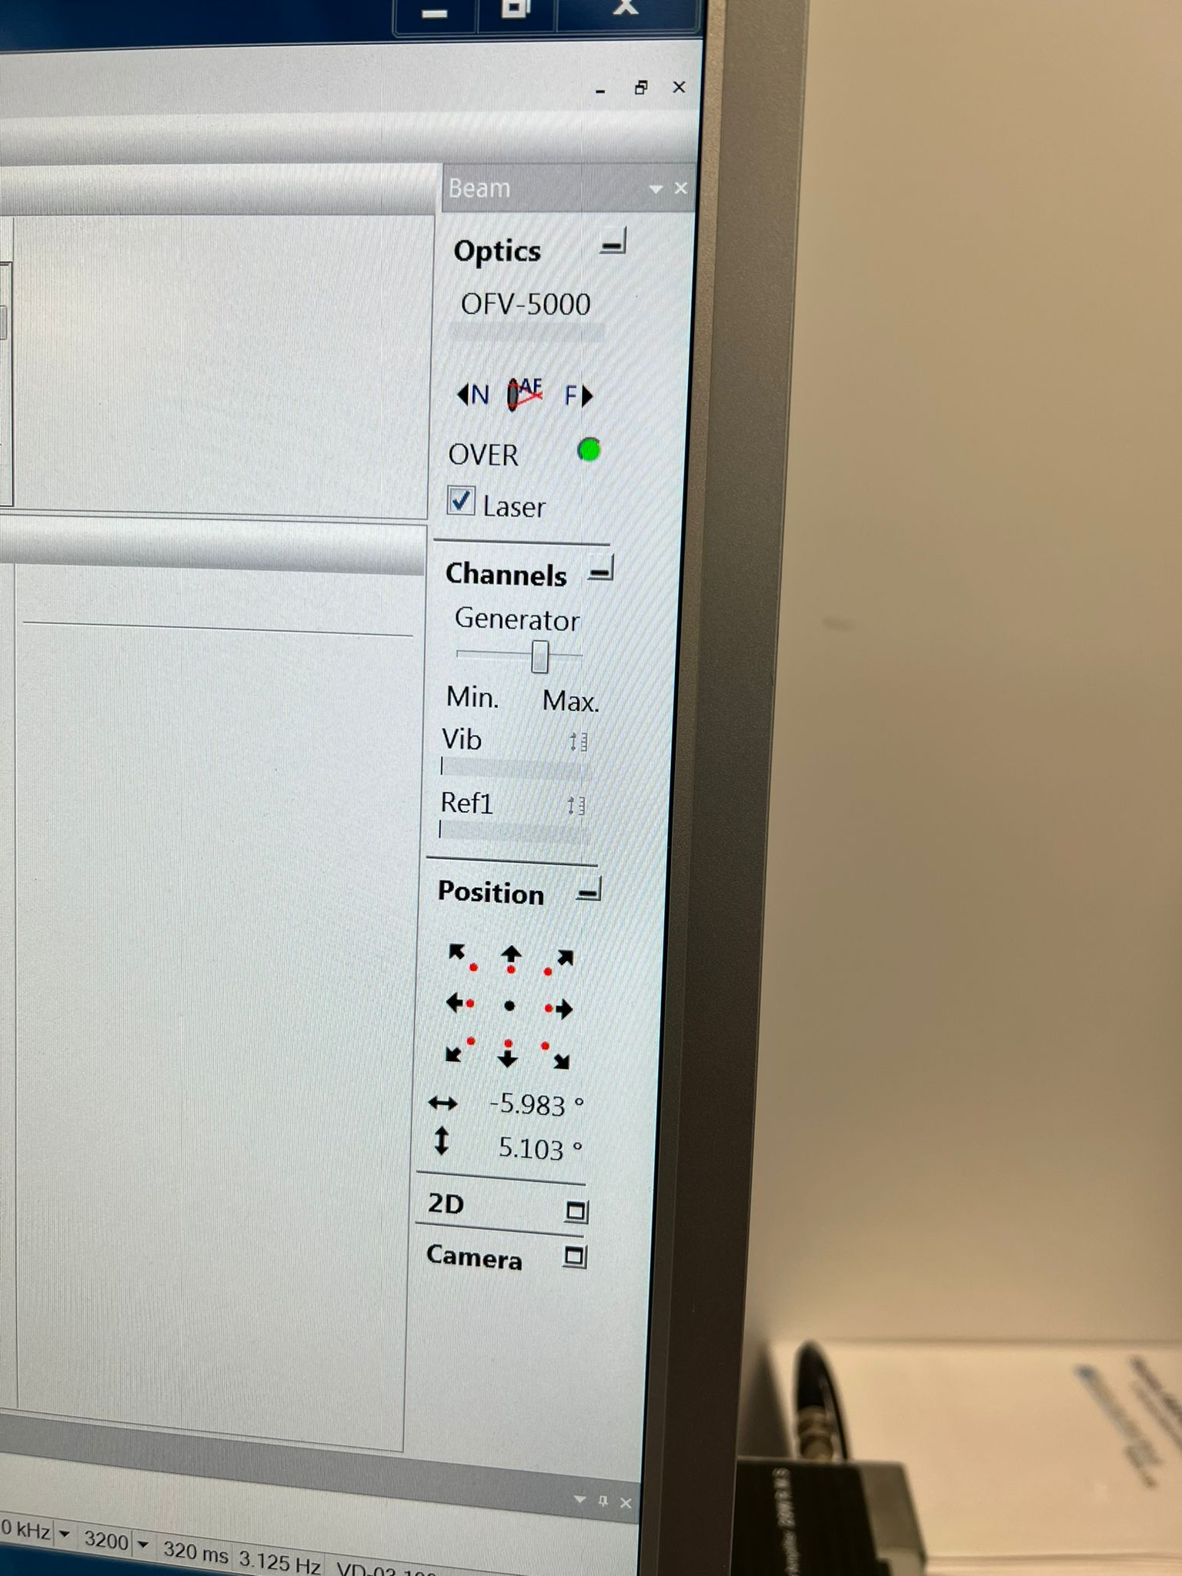
Fig 7: Toolbar used for 2D scan point
The auto focus toolbar is used to complete the 2D alignment directed by the laser once, as shown in figure: toolbar 2D scan point b, concluding that a signal is being obtained from the component's surface that has been excited. The scan points are set for experimentation after the signal level feedback is received.

Fig 8: Auto focus and signal feedback

2 Component Scan and analysis
A polygon surface profile is used, as shown in figure: auto focus and signal , because the scan necessitates a thorough analysis of data across the surface of the circular component in order to define scan points and determine the velocity displacement on the component surface. The scan points are constrained between the polygon shapes defined throughout the brake disc by the circular grid property defined with the density properties. The result is a finished scan grid, as shown in figure.
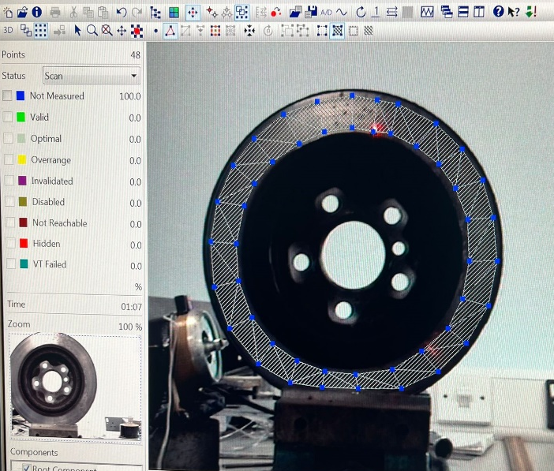

Fig 9: scan grid properties
Using a PSV data analysis program, the scan is started by saving the scan result to a filename. To gather information on the vibration velocity and displacement at the time of excitation, the scan is started through all previously identified points where the laser is positioned. Figures 1scan grid properties and halfway scan and automated laser show the results of the experiment's half and full scans, respectively, which are saved in the source file.
A live data stream of the vibration velocity against time is displayed in the FFT window during the scan, as shown in Graph 1, to help the user comprehend the significance of the excitation and signal decay. The solenoid actuator's placement, which must be done precisely so that the excitation stays the same, affects the vibration's velocity.
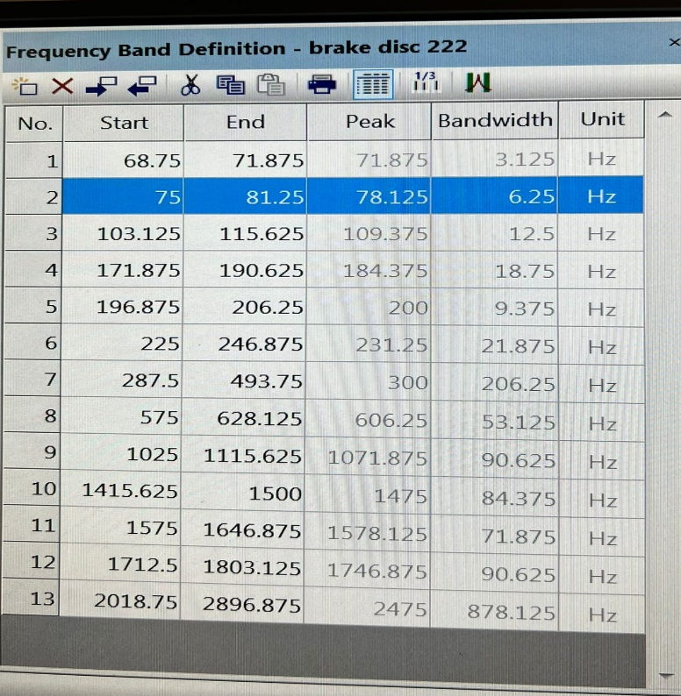

Table: 1 Frequency band table

This chart shows when the device starts scanning and when it ends. Additionally, it shows when the peak and bandwidth are.

Graphs

Graph 1 displays the vibration signal's spectrum as it was live-measured during the exercise. Six frequency bands of greater magnitude are extracted from the scanned data using the analysis tools.
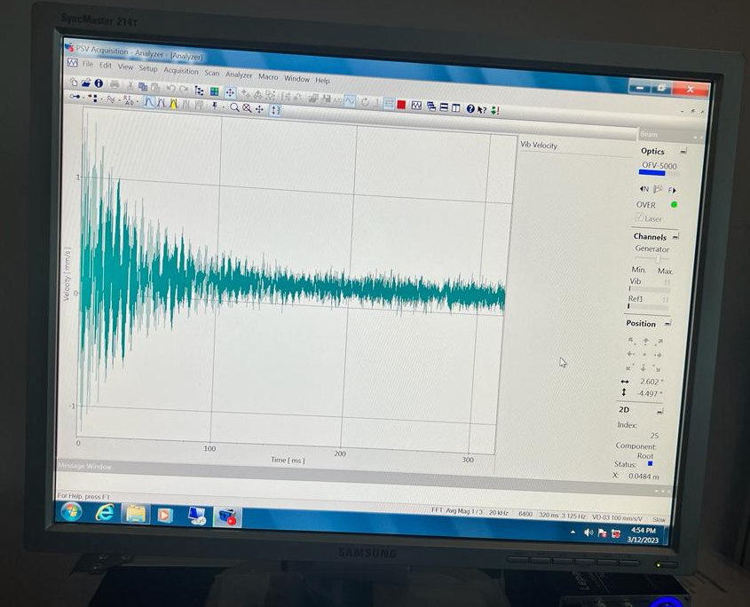

Graph 1: Live capture
The scaled results from the completed scan's vibration velocity frequency bands are shown in Graph 2.
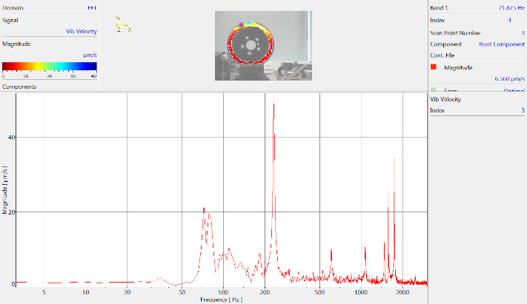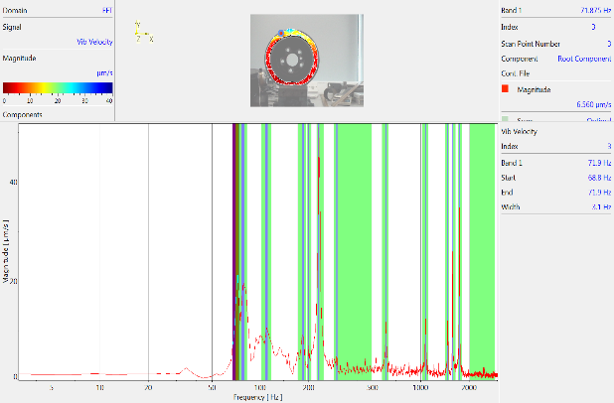

Graph 2: Frequency of the recorded data
On the frequency bands chosen on the recorded data, a 2-dimensional analysis of the vibration measurement across the scan spot picked up by the laser vibrometer is displayed. Table 1 provides descriptions of the relevant values' peak frequency and bandwidth. The rear assembly of the rotor was affected by the actuator, which caused the chosen peaks to have the values of 71.875,78.025,109.375,184.375,231.25,300,1071.875,1746.875, and 2475Hz, respectively, as shown in table 1.

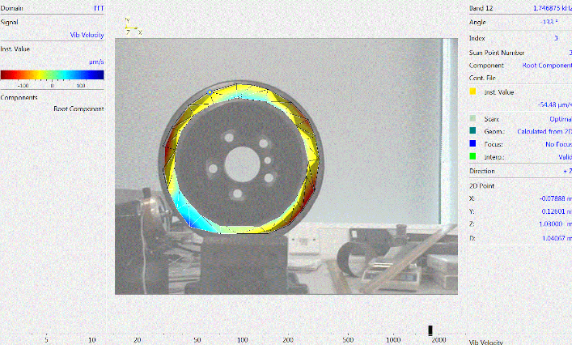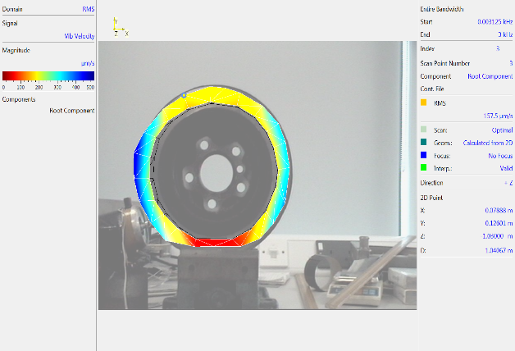

Fig 10: 2D Frequency picture
Different hues are represented by the surface's bending modes as a representation of the reflected laser beam's wavelength. It is evident from this that the solenoid actuator's indentation caused a significant effect that caused the material to vibrate at higher frequencies. In both 2D and 3D views of the analysis tools, the torsional modes of the modal analysis are shown as a transition between blue, yellow, and red.

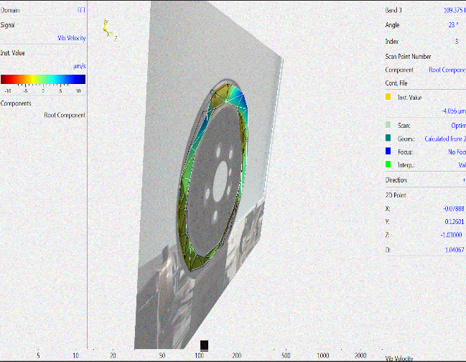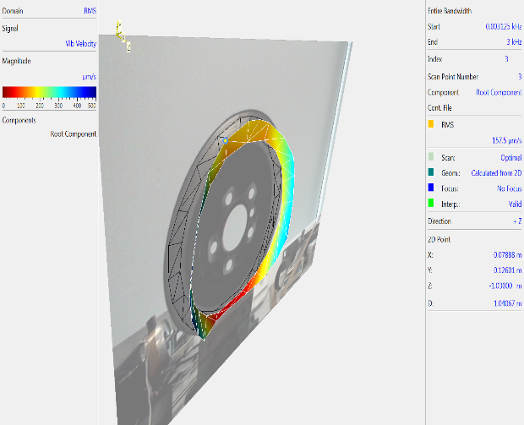

Fig11: 3D Frequency picture
Figure10 shows a three-dimensional vibration study of the chosen frequencies. Since the component's border experiences greater surface vibration, the component as a whole exhibit's torsion-oriented behaviors. This is because of the vertically mounted, limited rotor.

RESULTS AND DISCUSSIONS

Synchronized material behavior is taken into account in the computational analysis of a brake disc's dynamic behavior that is explained here. Following the scan of the brake disc's surface, a total of six distinct vibration frequencies are discovered. The opposing side of the scan excited the brake disc vertically. Figures 14 and 15 show, respectively, the use of data analysis tools to visualize the component's vibration in 2D and 3D. The frequency of1578.125 with a magnitude of vibration of over 200 micrometers per second produced the greatest peak of the chosen bandwidth.
Therefore, the component vibrated torsional on its horizontal axis in the direction of the mounting location. The behavior of the component at various frequencies is perfectly illustrated in a 3D graph. At 200 Hertz, component displacement is constant throughout the component.

CONCLUSIONS

It is obvious that the mounting of the component and actuator, which affects the vibrational frequencies, directly relates to the error percentage of the LDV setup. The shape, stiffness, and mass of the component are all factors in the modal analysis of the component. An approach where the design and development of the brake disc have a significant impact on the dependability of the steering mechanism and driver comfort is produced by a clear analysis of the vibrational displacement and behaviour of the material. The research comes to the conclusion that the testing environment for the material must be sealed off from outside interference. Only if the excitation energy is effectively transferred to the component through impact can efficiency of the results be attained. If the mounting of the setup is not reliable, it is more likely that inconsistent characteristics will be discovered through data.

REFERENCES

"Laser Doppler Vibrometer: Development of advanced measurement techniques for vibration analysis of structures and materials," by M.
Ruzzene and A. Marzani, Measurement, vol. 134, pp. 471-483, 2019.
Ewins, D., 2000. Modal Testing: Theory, Practice and Application, Second edition. Hertfordshire, UK: , Research Studies Press.
P. Castellini, 2002. "Vibration Measurements by Tracking Laser Doppler Vibrometer on Automotive Components". Shock and Vibration,, 9(Article ID 260478), p. 23.
Fairlie G, N. J., 2020. Damping Properties of Flax/Carbon Hybrid Epoxy/Fibre-Reinforced Composites for Automotive Semi-. Structural Applications, 10(64), p. 8.
"A Review on Laser Doppler Vibrometry: from classical to advanced techniques," by A. Marzani, M. Ruzzene, and G. Serra, Shock and Vibration, vol. 2017, Article ID 5068702, 20 pages, 2017.

FIGER 5 : (https://www.polytec.com/eu/vibrometry/technology/laser-doppler-vibrometry)

