

Task 1 – Reading Task Template
Upload your photo of your A3 in-class notes here:
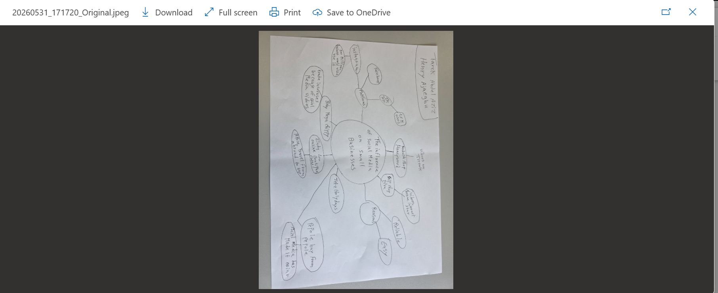

1. Answer these questions using the sentence starters below
a. What is the main idea of the text?
The main idea is how a viral chicken shop draws customers from hours away.
b. What are two key points?
One key point is the influence of social media on small businesses.
Another key point is how it feels when your business is at the centre of a viral trend.
c. What part of the text did you find most important? Why?
The most important part is how social media platforms has it easier than ever to be noticed by world.
d. Was anything unclear or difficult to understand?
It wasn’t too difficult.
e. How did your group help you understand the text better?
My group helped me by bringing ideas together.
3. One sentence reflection
Question: What did you find challenging about this task?
The hardest part was
Trying to compare ideas

