SJIE 6003 Inclusive Education: Policy and Practice. Case Study
Introduction
Question: ‘What support is available in a mainstream secondary school for a pupil with complex needs to enable them to develop physically, socially and emotionally. Furthermore, can the current curriculum be adapted sufficiently to meet their needs?’
The 1988 Education Reform Act saw the introduction of a National Curriculum which all children, in all schools, would follow. Since that time there has been a constant strive within the education system to get the balance right between providing what is appropriate for every pupil and adhering to what the law requires (Tutt, 2016). For this ethnographical case study and to be able to analyse and answer the question posed, the writer will present qualitative research to show how inclusive educational policies have been developed and then evaluate whether these are able to meet the needs of all children within an inclusive mainstream setting. The writer will examine whether the curriculum can be adapted to support pupils physical, social and emotional development especially from KS3 to KS4 and into the start of GCSE’s Qualitative research looks for meaning and understanding through the gathering of information in many areas including from observations, data and in this case, from the knowledge of a setting and its pupils (Merriam and Grenier, 2018).
The chosen learner for this case study (Pupil A) is a 14-year-old girl who was born prematurely and remained under paediatric care as her development was slow. At the age of two the child started having severe epileptic seizures and she has been under the care of a major children’s hospital ever since. In 2016 she was fitted with a Vagus Nerve Stimulator (VNS). The VNS device lies inside the body, near the collar bone and it is connected to the left vagus nerve in the neck. The VNS sends regular, electrical stimulations through the nerve to help calm the irregular brain activity that leads to seizures. Medication is also taken regularly. The child also has a visual cortical defect and she uses glasses for close work (THB, 2017). She lives in a happy, caring home with both parents and a younger sister. She also has a close relationship with several members of the wider family and enjoys days out and holidays in a family group. The author has chosen this child to study as, due to the complexity of their needs, they have made very little progress academically in secondary education, despite the interventions put in place.
However, they have grown and developed in many other ways which necessitates further investigation as to the purpose of education and the ability of the curriculum to be tailored to individual needs.
When the child first entered secondary education, initially she was very timid, emotional and hugely reliant on adult help for nearly all tasks. She would often break down in to tears and would become overwhelmed very quickly, especially with homework. Due to the severity of her needs and possible over protectiveness, she also lacked many of the skills that help to foster independence and she had difficulty reading social cues and expressions. With the support of her family, cohort, medical professionals, teachers and teaching assistants, she has blossomed into a lovely young lady who is an inspiration to others although there are still many basic skills that she encounters such as dressing, (putting clothes on and managing zips, buttons and shoelaces) and personal care (washing and controlling her long hair). Pupil A has very weak gross and fine motor skills which make, even basic tasks such as writing or using a pencil and ruler, extremely challenging. She has difficulty carrying a plate of food across a canteen and opening packets and cartons. Hand -eye coordination is also weak. A Statement of Educational Needs has been applied for but at the present time, the child is School Action Plus (SA+). This is where the school and the Additional Learning Needs Coordinator (ALNco) within the school, work together with external services, such as medical experts and Educational Psychologists, to provide detailed planning and wrap around support for the child (Dauncey, 2015).
She lacks confidence at times and can be very sensitive to situations, feeling deeply against any perceived violence, distress or cruelty. She can become unduly worried over relatively simple things such as having the wrong pair of shorts for PE lessons. She often misunderstands situations, not knowing when she is in trouble, whether something is her own fault or whether people are upset with her. The child’s working memory is poor and this makes it difficult for her to remember instructions or process large amounts of verbal information. Basic mathematic skills are an area of weakness. Her epilepsy is controlled but she continues to have multiple absence seizures daily which manifest themselves in several forms such as by her staring into space for several seconds, smacking her lips together, becoming suddenly motionless or by her speech curtailment, mid-way through a sentence. These absences are often so subtle that they can sometimes go unnoticed, but they impact on the child’s ability to learn, develop and retain information.
There are significant difficulties with processing information and comprehension which results in her making progress during a lesson one day only to forget this information the next day and she finds this very frustrating. The child has shared Teaching Assistant support in all lessons and is closely supported in her learning, especially in situations involving physical movement or working with equipment. She is significantly behind her peers in all aspects of the curriculum. She is also very sensitive to the comments of others but thrives on positive reassurance. Despite her difficulties, Pupil A is currently in year 9 and enjoys many extra-curricular activities including horse riding, guides, cookery and drama clubs and she also attends a local youth club. She loves animals, drawing and talking to adults and children alike. She is a delightful, caring young person who is happy, helpful and thoughtful with inquisitive nature but very immature for her age but, ultimately, she is kind and friendly and has a determination that is very endearing.
The child attends School A which is an English-medium mainstream mixed comprehensive school for pupils aged 11-18, situated in Wales. The school has approximately 900 pupils with 25 percent of these having Additional Learning Needs although only 1 percent has a statement of educational needs (School A, 2019). School A has an Equality Plan in place which takes guidance from The Equality Act 2010 to eliminate discrimination, harassment and victimisation. The plan is reviewed annually and one of the 5 outcomes it is judged against is whether children with additional needs have a suitably differentiated and adapted curriculum with the appropriate support and intervention in place (School A Equality Plan, 2018).
Methodology
The writer will use a combination of methods to enable them to analyse the question and investigate whether policy and practice can support pupil development within the constraints of the curriculum. Policy and practice will be investigated and links to theory will also be sought. Questionnaires have been completed by teaching professionals and the qualitative data provided in them will be gathered and categorised to evaluate the evidence collected regarding Child A. This information will enable the writer to build a picture of the child over her last 3 years and to review what is important for meeting her needs in the future. The descriptive data will allow evaluation to take place as to whether the support, currently in place, is equitable and to consider what further interventions can be arranged to nurture her physical, social and emotional development as she moves forward in her education.
As a Teaching Assistant, the writer knows the child well, as do the questionnaire respondents. Therefore, some of the information provided by them, may include opinion and this knowledge will be considered during analysis although, ultimately, all the participants in this study have the best interests of the child at heart so their honesty and openness in answering any questions are necessary to enable the writer to pursue their quest. The author of this independent and impartial case study has ensured ethical considerations have been considered and that the appropriate permissions are in place for their study of Pupil A (Appendix 1). The child’s parents and the other participants have been assured that the protection of their anonymity is paramount and that all data collected will be treated in the strictest confidence and following analysis all paperwork will be shredded and disposed of securely (Ethics Guidebook, 2017).
Findings
Firstly, the writer will analyse the information from the questionnaires (Appendix 2) completed by a small number of teaching professionals, targeted as they have all worked closely with Child A over the last 3 years and will continue to do so. Questionnaires have been completed by one of the child’s Teaching Assistants, her Form Tutor, Mathematics and English Teachers. The English teacher is also the school’s ALNco. One questionnaire was not returned.
Collation of the questionnaire data shows that the child has grown socially and emotionally during her time in secondary school. All participants agreed that the child has become more confident, is more organised and is less reliant on constant adult help. She can have more mature conversations than she once did and can instigate conversations on appropriate topics too. She has also developed empathy and often reassures younger pupils. Furthermore, although she still struggles emotionally herself due to her naivety and fear of failure, the instances are not as common as they once were, and she is able to move past an episode much quicker.
The child’s increased confidence in many areas may be partly due to a recognition of her preferred learning styles. The child is a visual learner and when resources have been used to support this, such as bead strings and counters in Mathematics, the child is able to have a greater understanding of concepts and this allows for more independent work. Appendix 3 is an example of a visual learning resource used in English for reading and comprehension tasks. It is a self-checking resource which is used for the practice and reinforcement of literacy skills for children with additional learning needs (LDA 2019).
These resources do not necessarily allow the child to progress academically though, as her memory problems and inability to work methodically means than the gap between her and her peers is widening significantly, especially in Mathematics.
Although more socially and emotionally developed, the child still struggles physically. She has poor fine and gross motor skills and has significant difficulty with dressing and undressing for PE and swimming lessons. Problems with working memory are a key feature of epilepsy and this is partly due to some of the medication used to treat it. Surgery, seizures and medication can lead to huge pieces of stored information in the brain, going missing. When epilepsy is diagnosed at an early age, automatic behaviours which as often learnt by repetition such as washing and dressing have not yet been learned and this leads to many future challenges for the person (Baxendale, 2014).
Everyone agrees that her physical development should be a focus area as the child moves forward although many of the problems she faces can not simply be overcome, some may improve with time, practice and repetition. Child A wants to do well and when teaching combines visual resources and calm verbalisation of the work to be produced, progress can be made in some areas. Her handwriting skills were practically non-existent when entering secondary school due to her previous reliance on digital literacy programs only. The child is ambidextrous with dominant left handedness. With patience, persuasion, modelling and guidance, her improved handwriting skills are one of her biggest accomplishments during the last 3 years (Appendix 4). Vygotsky’s Social Constructivism Theory talks of ‘scaffolding’, where the level of support offered by an adult is tailored to the needs of the child (Vygotsky, 1986). The adult acts as a guide, using verbal or physical cues to recall previous knowledge. This is particularly important when the child has had an absence seizure as following one, they often get confused as to what point they are at in their work or activity. Vygotsky also stresses the importance of social interaction in cognitive development which is a view supported by Piaget as he also believed that social interaction together with varied learning techniques such as linking different concepts and absorbing information from people and the wider world, all contribute to development (Good and Brophy, 1990).
The questionnaire feedback showed significant changes are needed for the transition period from KS3 to KS4. This would ensure the child receives an inclusive education where her social, physical and emotional development could be nurtured alongside her academic achievement.
The main concern is how the curriculum can be successfully modified or adapted to meet the needs of the individual child. Many GCSE or BTEC option choices will be too difficult for her and there are worries that the child will not be emotionally mature enough to cope with the demands of increased classwork and homework and the complexity of the curriculum even if she is placed in supported, lower ability classes. A multiagency review is due to take place shortly, regarding the transition and the opinions and views of all concerned, including the child and her parents, will be considered before proceeding further. Alternative options to be investigated are work placements, the reduction in options to allow for extra support lessons or to pursue alternative recognised qualifications such as ASDAN. They are an educational charity who can provide recognised, flexible and engaging programmes and qualifications to help young people develop skills for learning, work and life (ASDAN, 2019).
The areas where everyone agrees, concentration should be focussed is on is her life skills and physical development but experience of working in secondary education in this locality has shown that there is not a lot of opportunity for these skills to be developed. School staff work hard to give children the extra support they need, often giving up their own time before school and at break time to play memory games and develop social skills and after school to escort children to the local fitness gym or cookery club for extracurricular school sessions. Support for the child during these interventions are voluntary and in the current financial climate, where schools across the country struggle to balance their budgets, inevitably it is the much-needed, sometimes costly, extra resources that are the first to go even when this is detrimental to children.
Conclusion
Before the Constructivist theories of Piaget and Vygotsky were widely known, educational theorist John Dewey (2011) said that children learn best when environments are interactive and when the child is given the opportunities to become involved in their own learning. He believed that education should be part of life and not just preparation for it. Ofsted judge schools by a narrow range of academic results, and this has exacerbated the gulf between the reality of schools trying to meet an increasingly wide range of needs in mainstream schools and the fixation by various governments on standards, where schools are expected to increase academic results year of year. Somewhere in the middle are the children. Surely there is more to education than purely academic achievement.

Following Professor Graham Donaldson’s ‘Successful Futures’ Review in 2015, The New Curriculum for Wales was devised, aiming to give children the foundations they need for a changing world and to live life independently (WAG, 2018) but whether the curriculum will be able to deliver in a way that is broad, balanced and inclusive, is yet to be seen when it is introduced across Wales in 2022. The author believes that if funding that is available for a child in a Specialist school environment was the same as for the same child in a mainstream school then tailored support could be improved. Statistics reveal that funding per head for a child in a local mainstream secondary school for the 2018/19 year is £3958 whereas funding for the same child in a specialist school would be £19,036. (Statswales, 2018) Nearly 5 times more. The hope is that with new legislation following The Additional Learning Needs and Educational Tribunal (Wales) Act of 2018, the extension of security and entitlements to all learners will follow and not just that the financial support available is merely diluted. Legislation changes alone will never be enough.

References
ASDAN (2019) https://www.asdan.org.uk (Accessed: 19 February 2019).
Baxendale, S. (2014) https://www.epilepsysociety.org.uk/memory-aids-reminders-and-brain-training#.W8s1M0xFxhg (Accessed: 17 February 2019).
Dauncey, M. (2015) National Assembly for Wales Research paper Special Educational Needs (SEN)/ Additional Learning Needs (ALN) in Wales 15/025. Cardiff: Research Service Publication.
Dewey, J. (2011) Democracy and Education. Milton Keynes: Simon and Brown.
Ethics Guidebook (2017) The Research Ethics Guidebook. A resource for Social Scientists. [Online]. Available at: http://www.ethicsguidebook.ac.uk (Accessed: 15 February 2019).
Good, T, L., and Brophy, J, E. (1990) Education Psychology. A Realistic Approach. 4th Ed. New York: Longman.
LDA Learning (2019) Stile Literacy Programme for Literacy Comprehension.
Merriam, S.B. and Grenier, R. S. (2018) Qualitative Research and Case Study Applications in Education. Revised and Expanded from Case Study Research in Education. 2nd Ed. San Francisco: Jossey-Bass.
School A (2019) Current School Roll: Breakdown of Information.
School A (2018) Equality Plan.
Statswales (2018) School Funding Figures 2018/19 Available at: https://www.statswales.gov.wales (Accessed: 25 February 2019).
Teaching Health Board (2017) Paediatric Occupational Therapy and Physiotherapy Report for Pupil A.
Tutt, R. (2016) Rona Tutt’s Guide to SEND and Inclusion. London: SAGE.
Vygotsky, L. (1986) Thought and Language. Boston: MIT Press.
Welsh Assembly Government (2018) New school curriculum for Wales-overview. [Online] Available at: https//: www.beta.gov.wales/new-school-curriculum-overview. (Accessed: 22 February 2019).
Bibliography
Bruner, J, S. (1960) The Process of Education. Cambridge, Massachusetts: Harvard.
Careers Wales (2019) https://www.careerswales.com/en/your-career/features-1/option-choices-in-year-9/faqs-gcse-options/ (Accessed: 16 February 2019).
Cottrell, S. (2008) Study Skills Handbook. 3rd Ed. Basingstoke: Palgrave Macmillan.
Driver, S. (2016) ‘Teach how they learn’. SEN Magazine (Issue 67) April 2016.
Gathercole, S, E. and Alloway, T, P. (2008) Working memory and learning: A practical guide for teachers. London: Sage.
Gross, R. and McIlveen, R. (1999) Psychology: A New Introduction. London: Psychology Press.
Inger, D. (2014) Transparency, accountability and user engagement at the centre of new SEN reform. Institute of Wales: Click on Wales.
Ingham, R. (2015) Understanding and Supporting Learning. Smart Strategies™ Theory into Practice.
Morgan, J., Jones, C. and Booth-Coates, S. (2016) Achieving Outstanding Support in Your Secondary School. Abingdon: Routledge.
Shakespeare, T and Watson, N. (2002) ‘The social model of disability: an outdated ideology?’ Research in Social Science and Disability 2:9-28
Tutt, R. (2007) Every Child Included. London: Sage.
Yin R K (2009) Case study research: design and methods. 4th ed. London: Sag

Appendices
Appendix 1
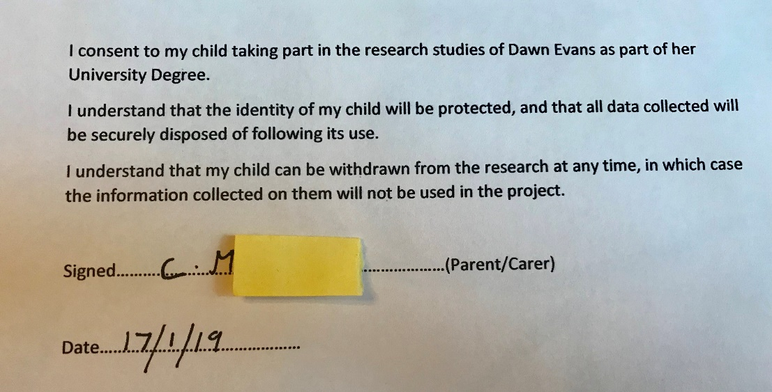

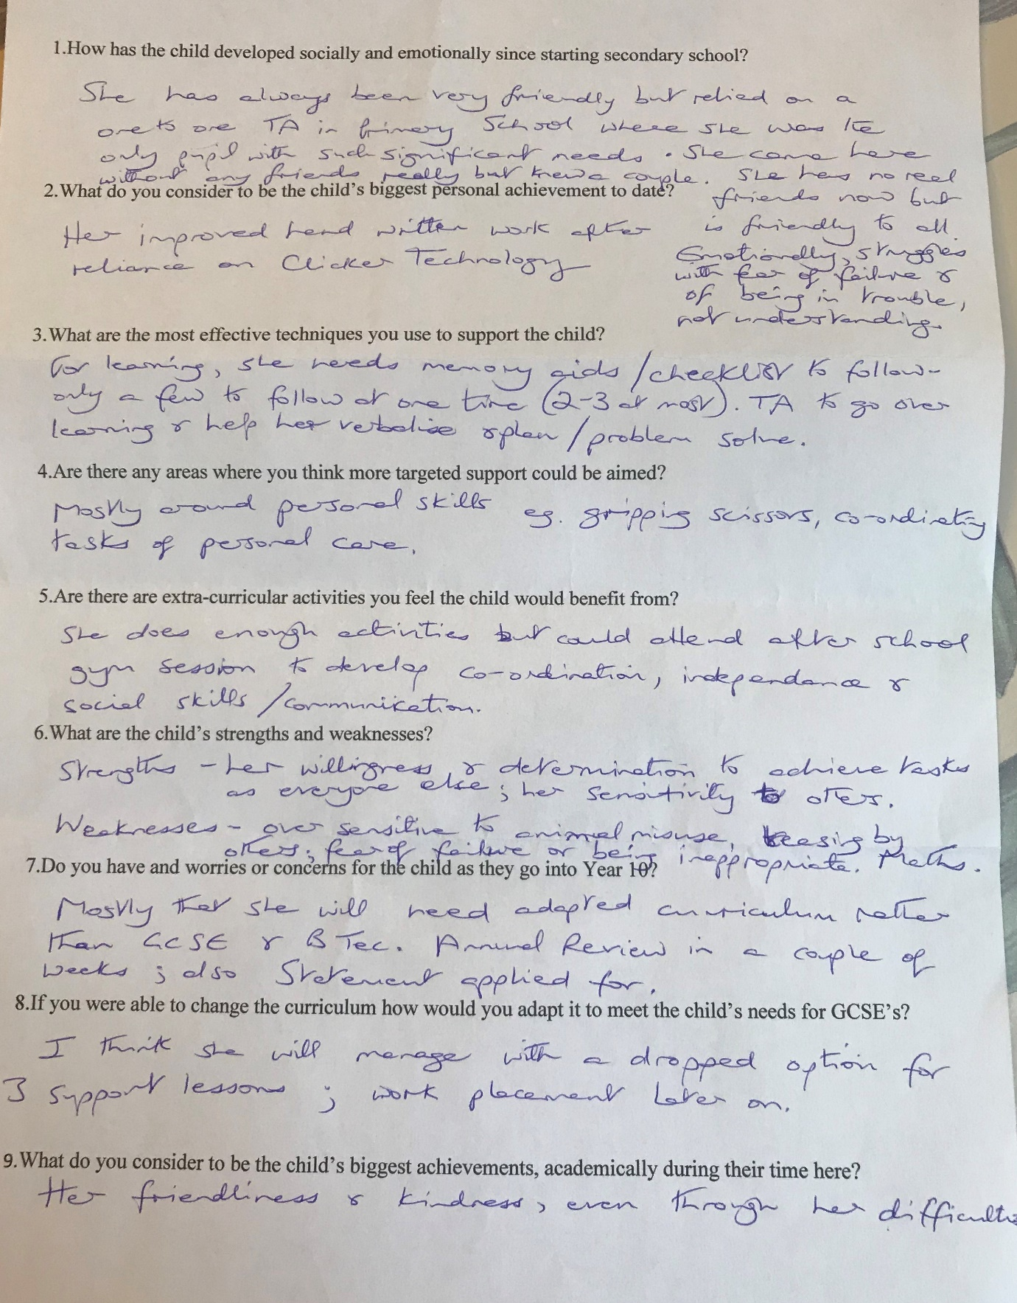
Appendix 2 (4 questionnaires)
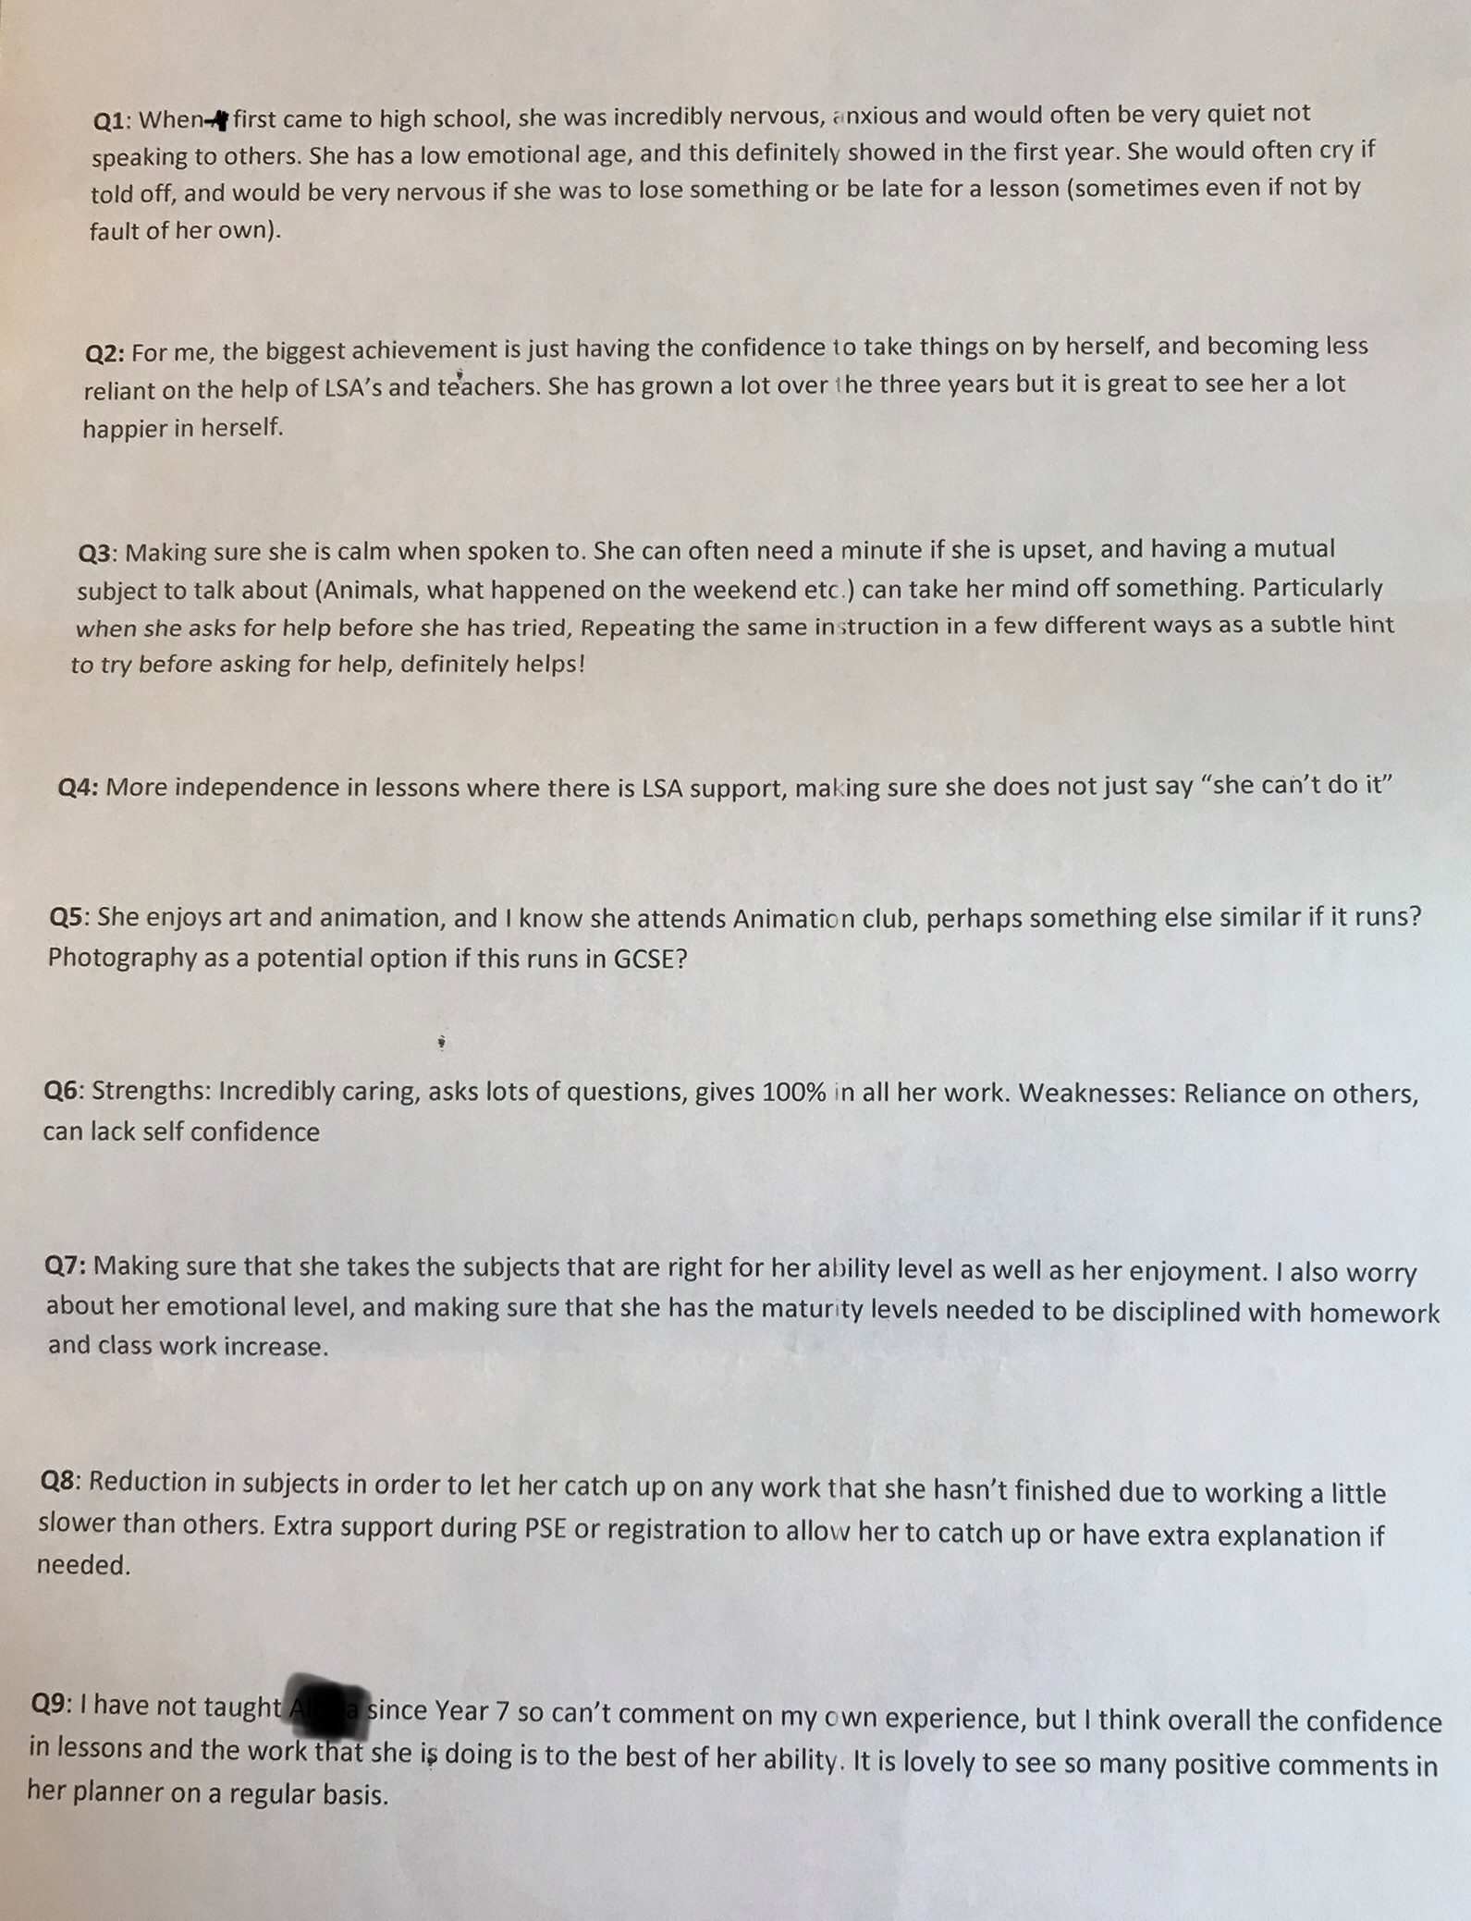

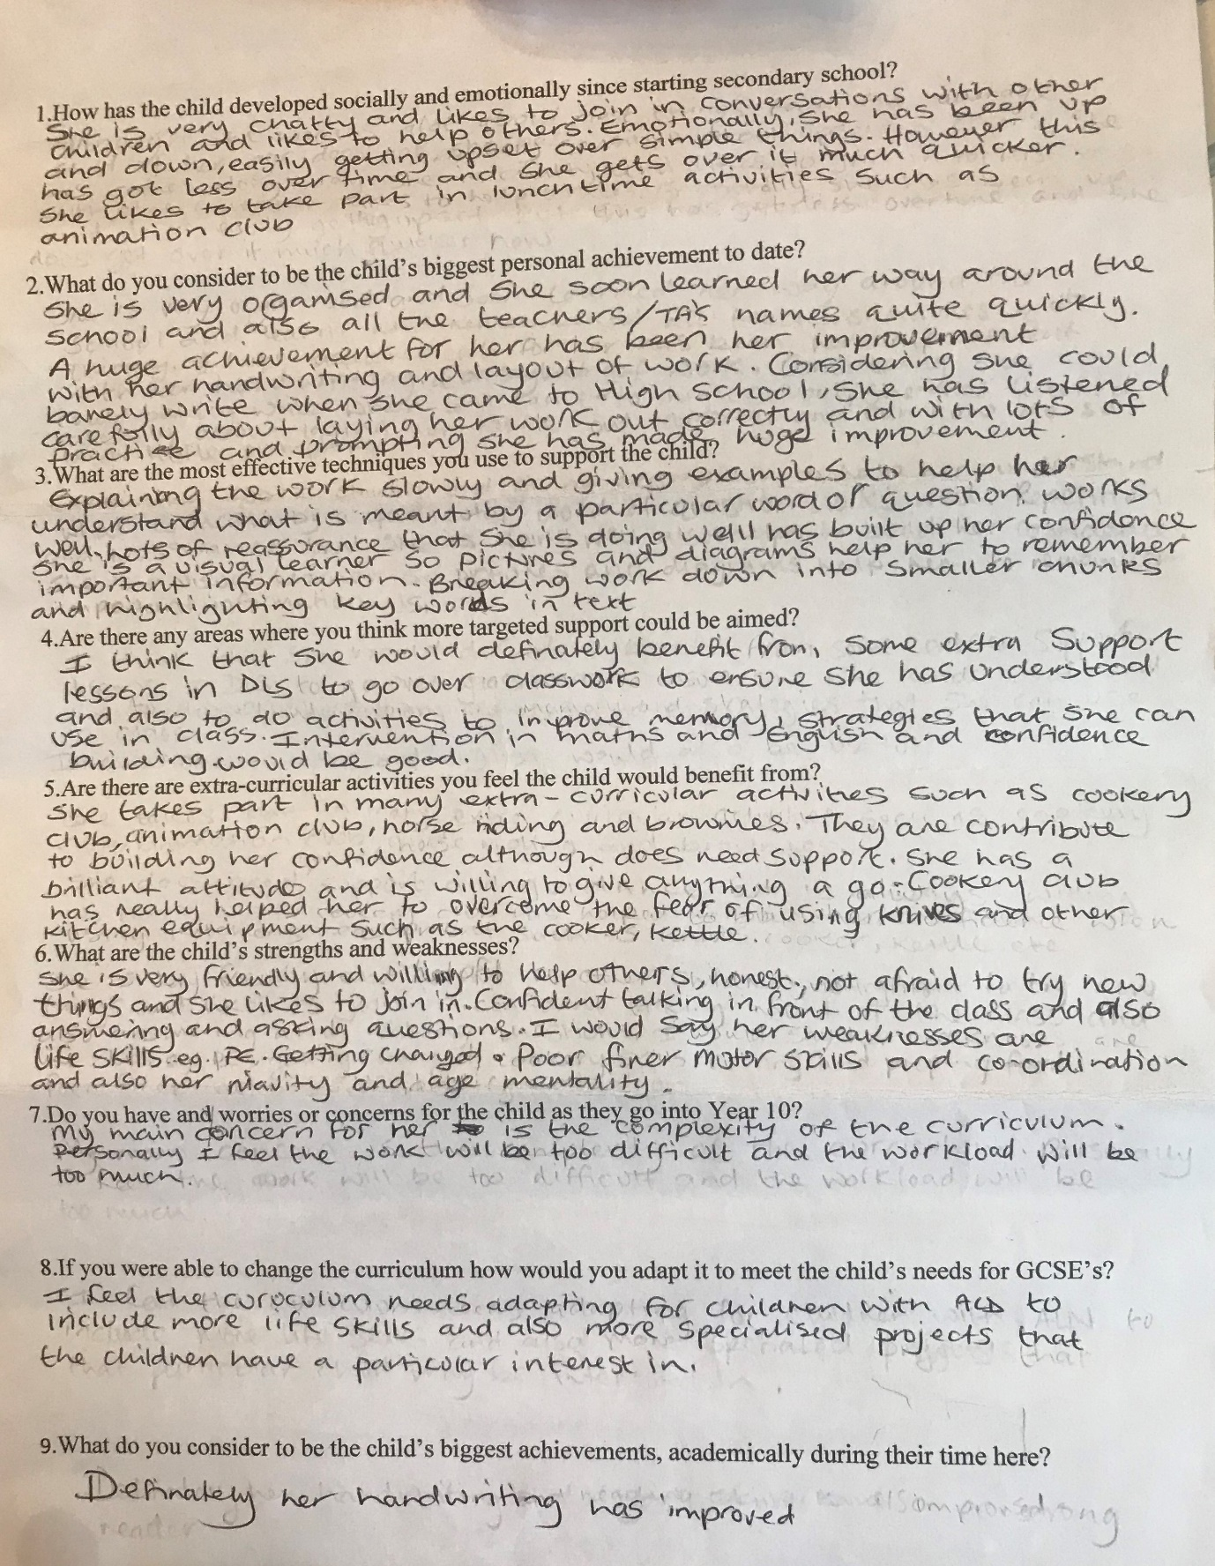

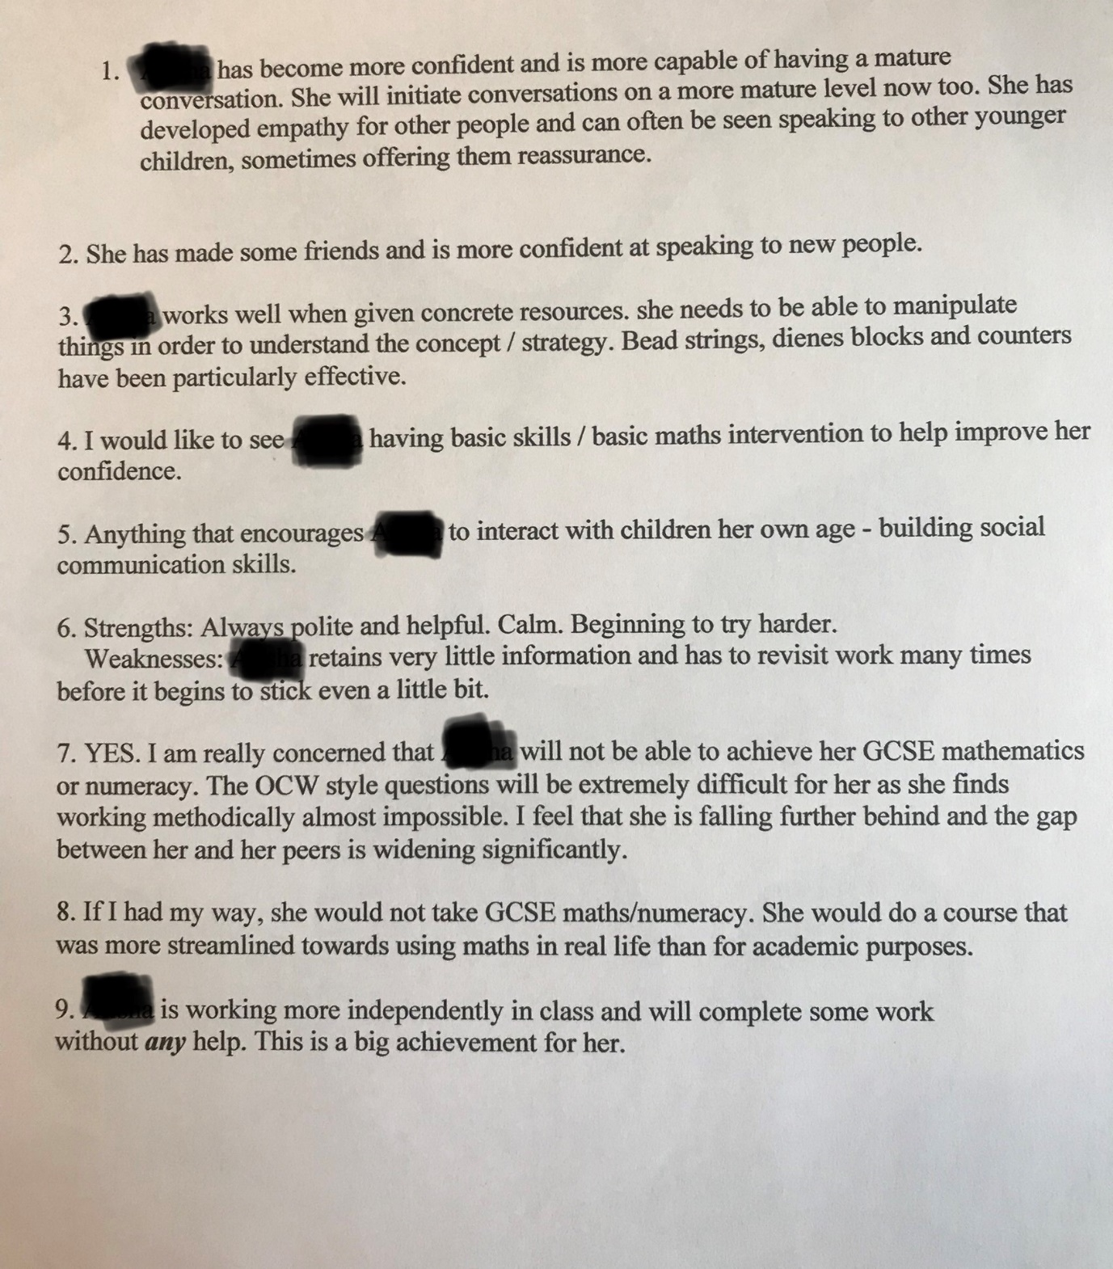

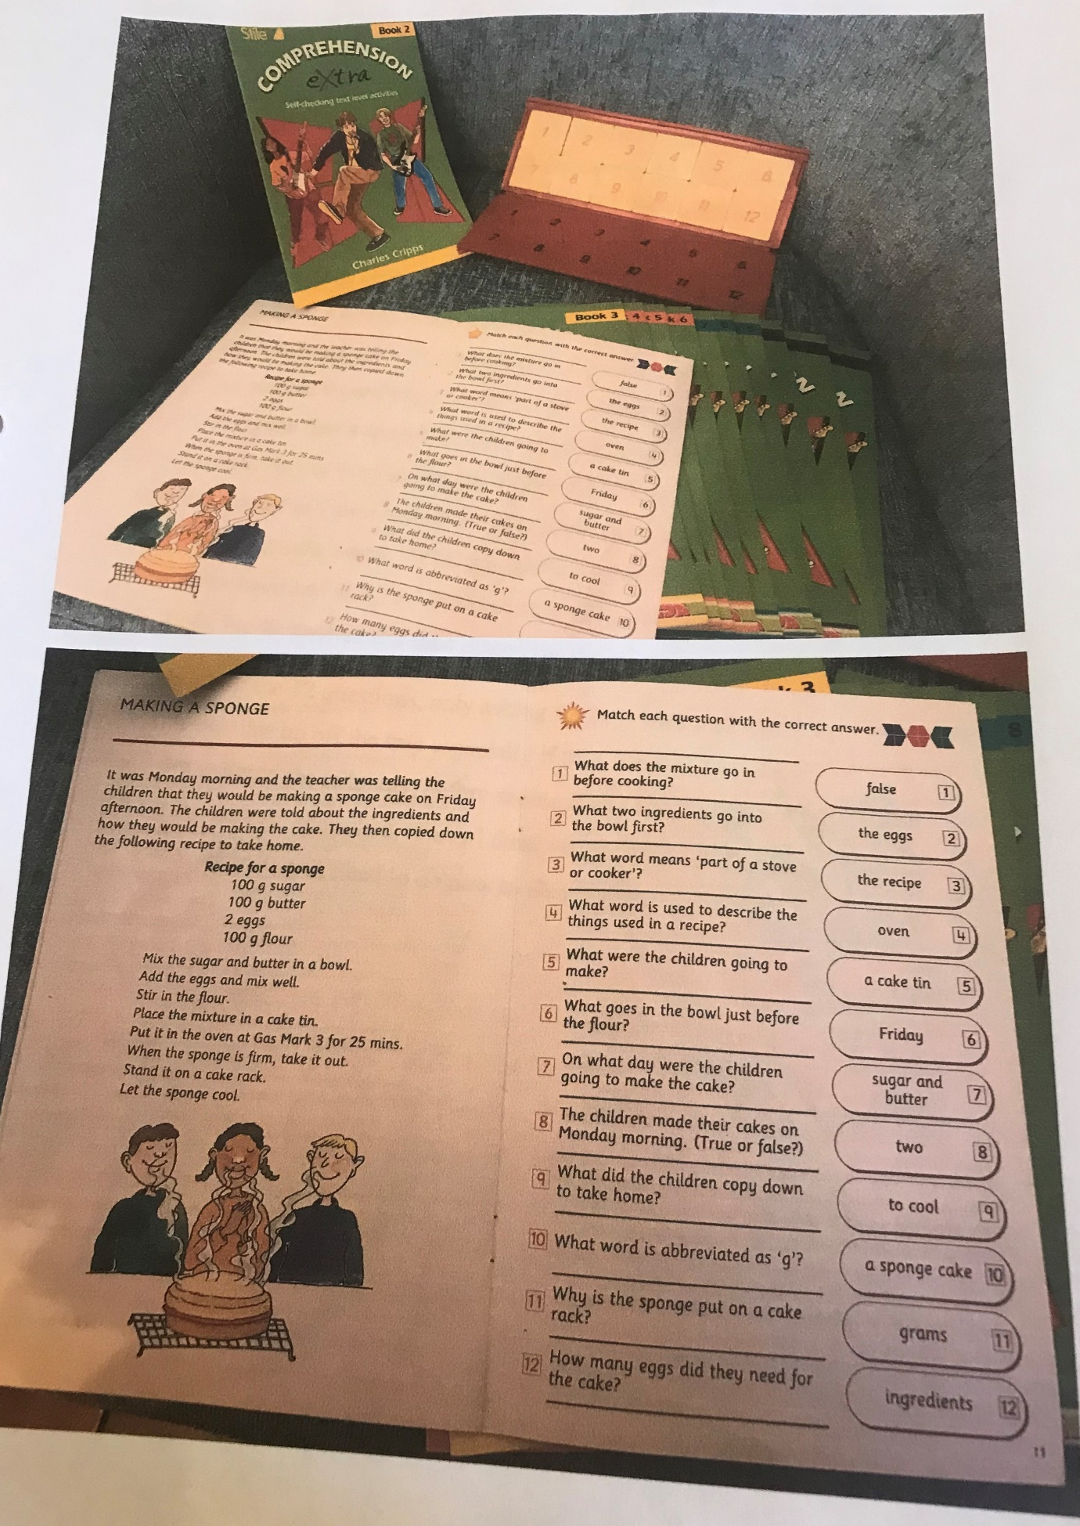
Appendix 3

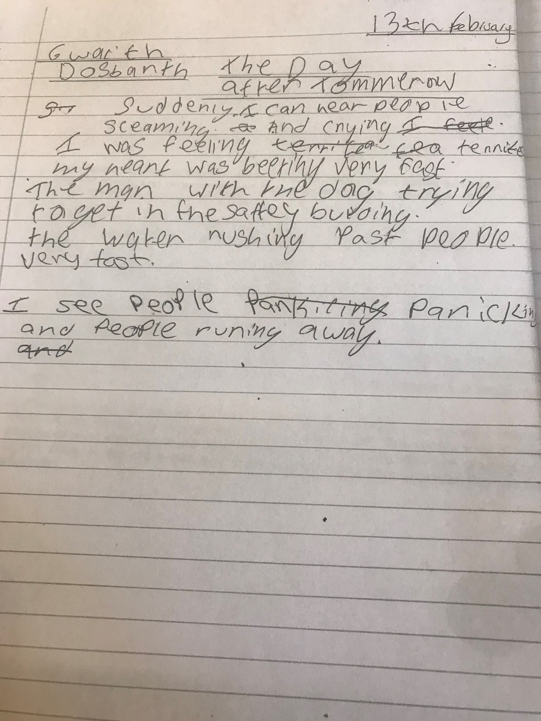
Appendix 4

