L5 - Changemakers: Creativity and Value Creation (ACCA5033)

Assignment 1

Stephen Ace

Student Number: 0650007

Creative Games Design

contents

https://space.pb.online/eportfoliochangemakers

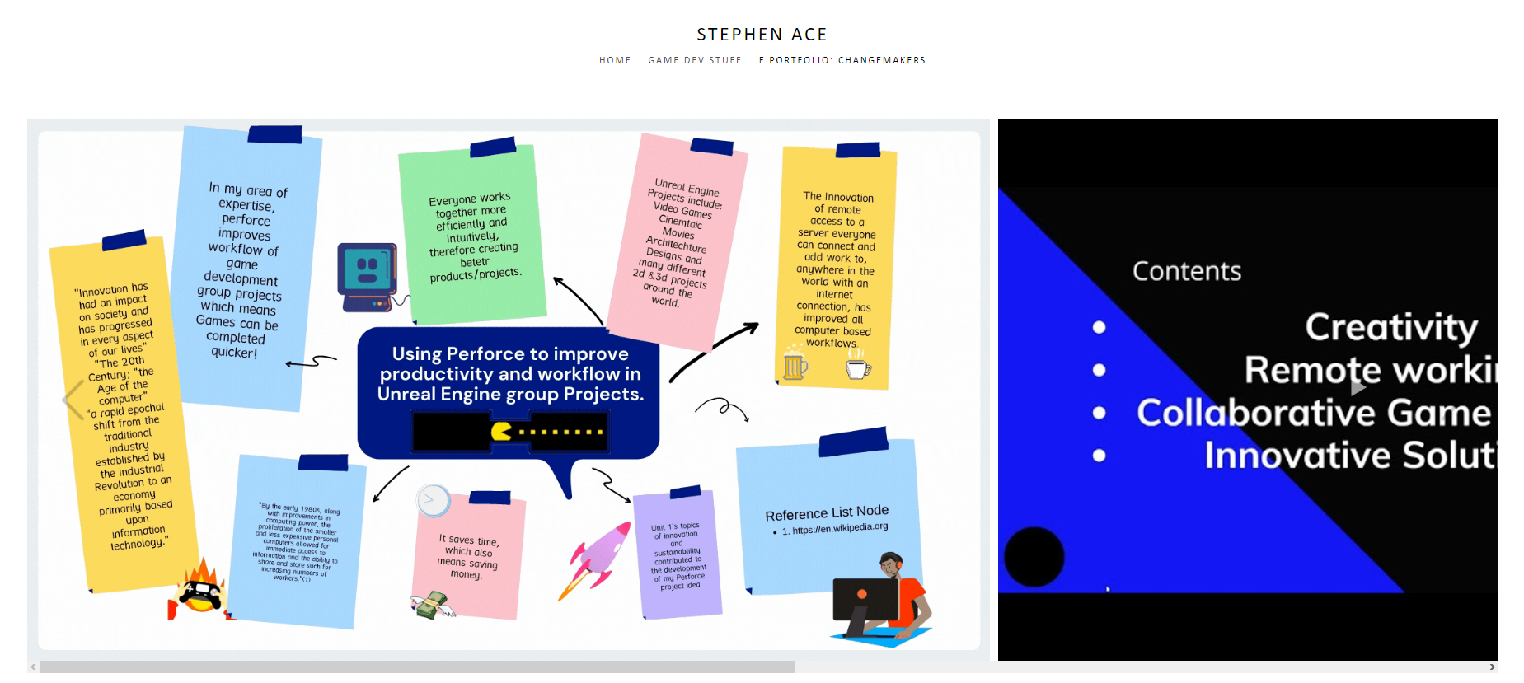

Task 1 - Mind Map

https://space.pb.online/eportfoliochangemakers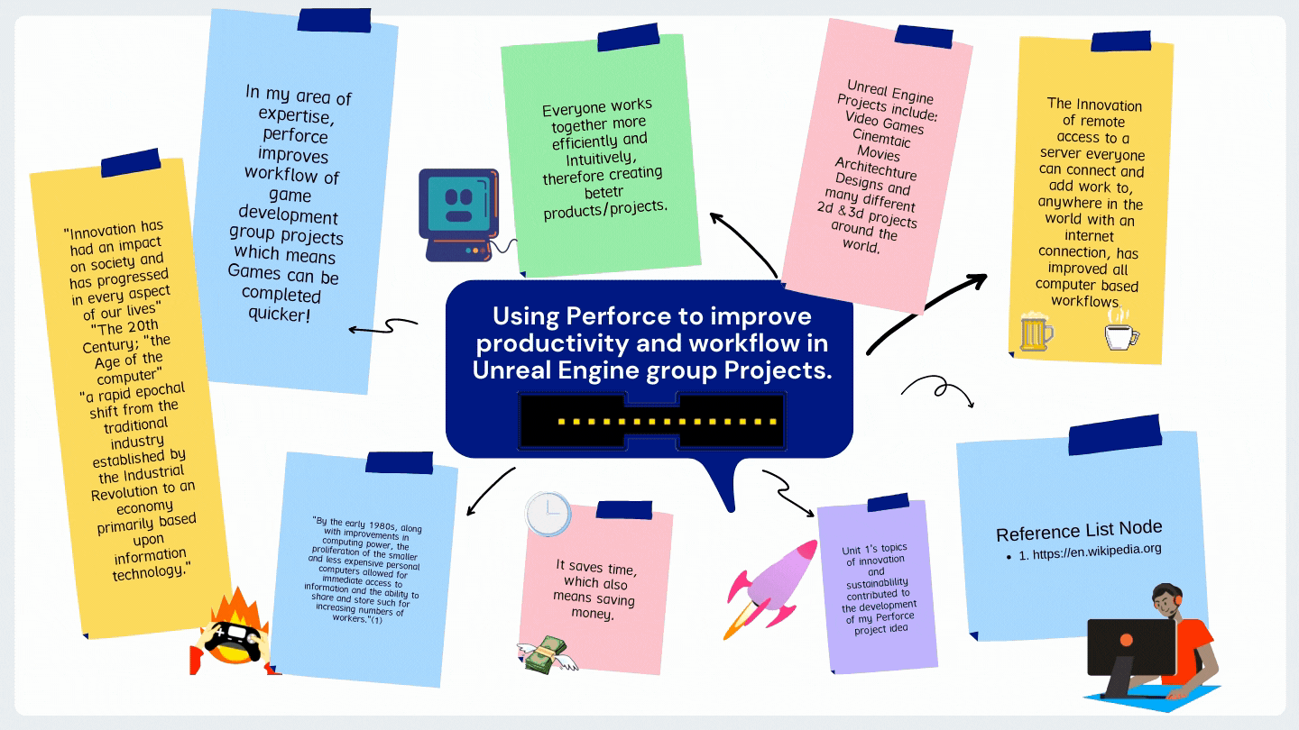

Task 2 - Image Based Video Presentation

https://space.pb.online/eportfoliochangemakers

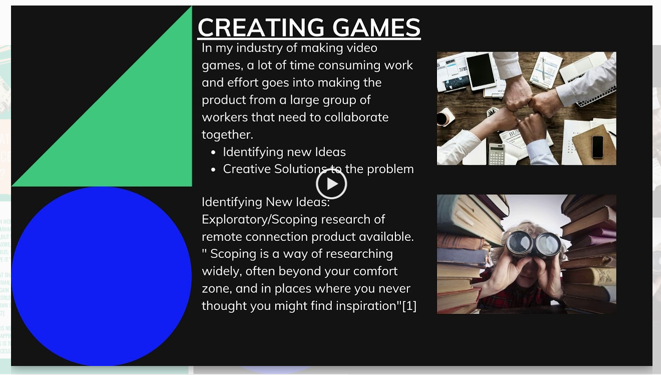

Task 3 - Image Based Video Presentation

https://space.pb.online/eportfoliochangemakers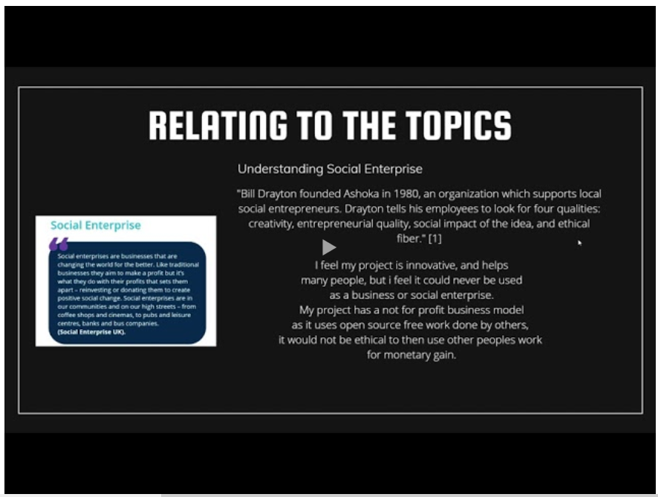

Task 4 - Image Based Video Presentation

https://space.pb.online/eportfoliochangemakers



