Name – Luke Hart
Student No. – 1807673
Module – Integrated Group Project
Module Code – ACBA6003
Submission Date – 24/04/2021

Contents Page.
Page 3 – Figures list.
Page 4 - Introduction and Foundations.
Page 5 – Frame.
Page 6 – Superstructure.
Page 7 – Superstructure Cont.
Page 8 – Superstructure Cont. & Partition Walls.
Page 9 – Roof
Page 10 – Roof Cont.
Page 11 - Floor and Ceiling Finishes
Page 12 – Wall Finishes and Construction Methods.
- Concrete Pile Foundations.
- Steel Frame
- Superstructure
Page 13 – Construction Methods Cont.
- Superstructure Cont.
- Roof Coverings.
Page 14 – Construction Methods Cont.
- Solar Panels
– Machinery Used.
Page 15 – Machinery Used Cont. & Conclusion.
Page 16 – Reference List.
Page 17 – Reference List Cont.
Page 18 – Reference List Cont.

Figures List
Figure 1. Pile foundations – east and west elevations. Page 5
Figure 2. Brickwork rear. Page 7
Figure 3. Curtain wall cladding face. Page 7
Figure 4. Side elevation. Page 8
Figure 5. Different roof coverings used. Page 10
Figure 6. Size difference between ground floor and first & second floors. Page 10

Part 4: Construction materials & methods.
- Identify the different materials and/or components used, considering material options.
- Identify the construction methods and machinery used.
- Justifications of selections.
4.1 Introduction
Having reviewed the requirements of the client to construct additional halls at the University of Wales Trinity Saint David, with the top two floors becoming accommodation and the ground floor to be used as multi functioning retail spaces, we have come up with a design which we think meets these requirements whilst also being sustainable, innovative and importantly cost effective.
4.2 Foundations
Having researched the proposed location for this project it was found that the site is on a former dockland in SA1 and is associated with having poor ground conditions, based on this knowledge we have decided to select concrete pile foundations for the structure. When further research was carried out by members of the team and historic data was accessed, it became evident that contamination within the specified location was present in the majority of previous case studies. The research seems to agree with the choice of foundations that we have made, this is explained in more detail back in the ‘Ground Investigation’ section in a previous chapter.
There were other methods of foundation/construction which we considered such as.
- Raft foundation
- Strip foundation
- Pad foundation
- Diaphragm walls
Having looked at the advantages and disadvantages of the above methods it was decided that these processes were either not viable at all or we did not deem their advantages to outweigh those of using concrete pile foundations.
(www.designingbuildings.co.uk, n.d.)
To implement concrete piled foundations it is necessary to eliminate the contaminated ground and reinstate before introducing the concrete piles. To finish this the piles will then be topped with a reinforced pile cap like shown in Figure 1 on the following page.
The benefits of using piled foundations are –
- They are not affected by groundwater
- Cost effective
- Installation speed
- Precast to specification
- Long lasting
Any deviation that has occurred whilst driving the piles into the ground will be corrected with the pile cap.

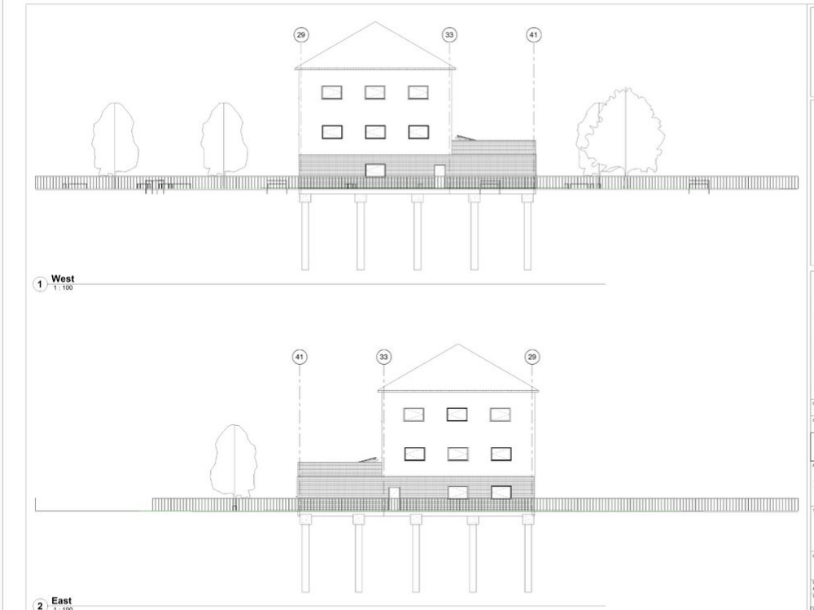
Figure 1. Pile foundations – east and west elevations.
4.3 Frame
There were two options that we considered for the material of the frame for this project but after carefully researching and comparing them together we come to a decision. The two materials which we took into consideration were;
A reinforced concrete frame.
or.
A steel frame.
Below I have shown the advantages of both frames.
Reinforced Concrete | Steel
Strength | Strength
Fire resistant | Durability
Affordability | Affordability
Can be precast | Versatility
Less skilled labour needed | Improved construction time
Availability | Sustainability

And below are the disadvantages.
Reinforced concrete | Steel
Long curing time | Thermal conductivity
Tensile strength less than compressive strength | Cannot mould in any direction
Lower safety than steel | Fire resistance lower than concrete
Cost of formwork can be high | Maintenance costs can be high

(Jalal, 2012)
For the design of the frame for this project we have decided to go with a steel frame, the reasoning behind this decision is because of the many advantages that I have shown above we deem it to be the most appropriate material.
Selecting to have a steel frame will also give us the opportunity to maximise space with the steel beams being able to span a much greater distance than a concrete frame would be able to, therefore reducing the number of vertical beams needed.
4.4 Superstructure
For the superstructure of the project, we have decided to differ the external cladding for the ground floor and the first and second floors – the reasoning for this is the different uses the floors have, with the first floor being used for retail and the top two floors being used for student accommodation.
For the ground floor we have decided to go with a traditional brickwork outer skin with an internal cavity blockwork infill between the steel frame. Another option which we contemplated for the external façade of the project was brickwork cladding, below I have shown some of the advantages and disadvantages of each of the options.
Advantages.
Traditional Brickwork | Brickwork Cladding
Considerably cheaper to supply and install | Reduces cost in structural frame
Lower maintenance | Install time
Sustainability | Reduces preliminaries costs
Durability | Expected higher quality

(Signia, 2016)
Disadvantages.
Traditional Brickwork | Brickwork Cladding
Time consuming construction | Difficult to repair
Can cause efflorescence when exposed | Can create issues with moisture if incorrectly installed
Quality can differ | Cost
Need skilled workers | Needs sealing to be protected

(Eco Outdoor, n.d.)
Having weighed up both the advantages and disadvantages of traditional brickwork and brickwork cladding we decided to choose the traditional brickwork method, this was decided mainly based on it being cheaper, less maintenance and more durable. This has been decided to be used on the two sides and the back of the property - shown in Figure 2, with the decision to use curtain wall cladding on the face of the retail spaces shown in Figure 3. Although using this will mean more maintenance – washing etc this is not really an issue as it is only on the face of the ground floor of this project, so it is easily accessible for this (Crucial Engineering, 2020). It will also help to increase the amount of natural light entering the retail spaces and allows passers-by to have a bit more of an insight as to what the retail store specialises in and may work to entice customers inside (www.soundcraft-doors.co.uk, n.d.).

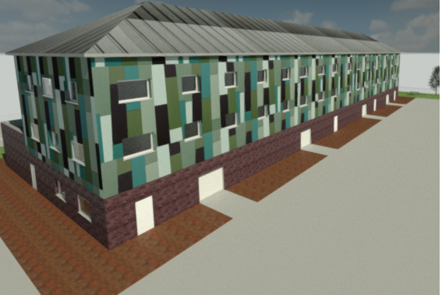
Figure 2. Brickwork rear

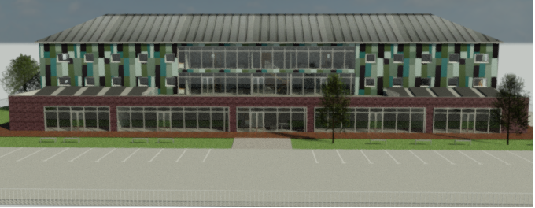
Figure 3. Curtain wall cladding face.
Then for the remaining two upper floors we have decided to again have a blockwork infill between the steel frame but this time with an external skin of blockwork and rainscreen cladding fixed to the outside of that. There were a few options which we could have chosen for the external of the upper two floors such as structural glazing, curtain walling and other types of cladding but deem the rainscreen cladding to be the most appropriate method to use for this project because of the ability to increase energy efficiency, low maintenance and its durability which makes it an ideal, cost effective material for student accommodation (Cupa Pizarras, 2019).
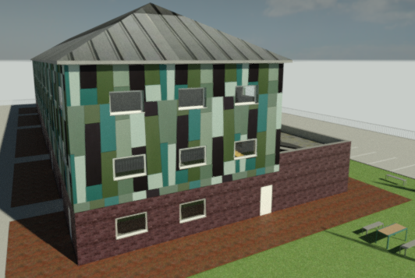
Figure 4. Side elevation.
For the internal floors of the project, we have decided on installing precast concrete planks. We had other options for the floors such as.
- Suspended timber floor
- Suspended concrete floor
- Ribbed upper floor
- Raised floor
- Floating floor
(TheengineeringEdu, n.d.)
But decided that installing concrete planks would be the most viable and suitable option because of the ability to suit both commercial and industrial constructions, it improves both thermal and sound insulation whilst being lightweight and easy to install increasing production time and the overall speed of the project (Longley Concrete Group, n.d.).
4.5 Partition walls
As a group the options that we considered for the partition walls of the project were;
- Timber stud partitions
- Brick / blockwork partitions
Having compared and evaluated the differences between the available construction methods of the partition walls we made the decision to choose timber stud partition walls for this project. We believe this method would be more suited to this project as it was noted that they could be more easily dismantled / adjusted to suit the needs / wants of the building in the future when in comparison to the other methods. The decision was also influenced by the many further advantages of the timber stud frame, which are;
- Reduced construction time
- It is cost effective
- Recyclable and renewable
- Energy efficiency
- Minimal waste
(Barros, 2018)
The insulation used inside of the timber stud walls constructed and the finish applied to either side of the walls will help ensure that the walls sound and fire resistance is at the correct standard (www.rockwool.com, n.d.).
4.6 Roof
There were a few options that we considered to be used for the roof covering on this project, such as.
- Flat roof
- Tiled
- Slate
- Standing seam metal roof
After reviewing the advantages and disadvantages off the above methods, we were able to decide and we deemed that the ‘standing seam metal roof’ would be the most suitable for the project.
We have made this decision based on the standings seam roof’s ability to balance sustainability with performance, whilst remaining easy to install and requiring next to no maintenance (Burtonroofing.co.uk, 2018) which makes it the perfect choice for the desired building’s needs. It also brings durability to the roofing structure while maintaining a modern look. Ensuring that this complies with ISO 14001, BES6001 and the BBA Certificate.
We have also decided to include solar panels on the roof of this structure, the reasoning for this is the many advantages that they will bring and the degree of sustainability they will enhance in the project.
- Cost savings
- Installation speed
- Low maintenance
- Enhanced safety performance
- Improved aesthetics
(Marley, n.d.)
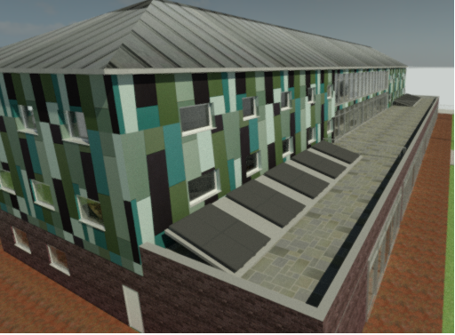
Figure 5. Different roof coverings used for main roof and flat roof.
It was also decided to construct the project with the footprint of the building being a greater size than the first and second floors of the accommodation like shown below in Figure 6.

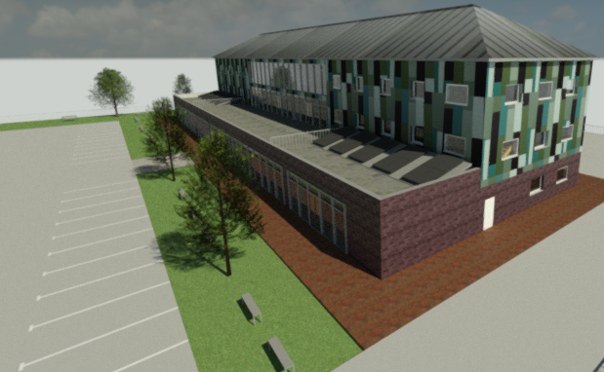
Figure 6. Size difference between ground floor and first & second floors.
Having the ability to do this gave us the opportunity to provide a communal area on the roof of the group floor retail spaces and to also introduce more solar panels to contribute to the sustainability of the building – see advantages on page 8.
For the flat roof it has been decided that it would be best to have a compact flat roof on a reinforced concrete deck with either paving slabs or interlocking paving stones on the surface, the decision was made on this because of the quality, cost efficiency, sustainability, safety and functionality brought to the project by the above system (www.foamglas.com, n.d.).
4.7 Floor finishes
We had a few options which we considered when it came to the floor finishes of the project, such as.
- Carpet
- Stone
- Wood
- Vinyl
- Ceramic tiles
For the floor finish of the ground floor, we have chosen to use ceramic tile flooring.
We made our decision based on the knowledge that the ground floor is going to be used as multi functioning retails spaces. Knowing that ceramic tiles are easy to install, cost effective, incredibly low maintenance and will remain to show a stylish finish, we believed that it would be the best option for the ground floor (O’Halloran, n.d.).
For the second and third floors of the project which are to become student accommodation we have decided to use carpet as the choice of floor finish. We have made this decision based on the ability of the finish being comfortable, warm, cost effective and it will also minimise noise transfer to the floor below (The Spruce, n.d.).
We have also chosen vinyl sheet flooring for the floor finishes in the bathrooms and kitchens of the student accommodation. We made this decision based on the benefits of the vinyl sheet flooring, such as.
- Completely waterproof as it is one continuous sheet
- Its durable
- Cost effective
- Easy to install
- No maintenance required
(Architypes, n.d.)
We believe the above benefits make it an ideal material for student accommodation.
4.8 Ceiling finishes
For the ceiling finishes on the project again we have differed the ground floor ceiling to the ceilings on floors one and two. For the ground floor we have decided to go for mineral fibre suspended ceiling tiles, we have made this decision because they are a good cost-effective method that can be used to improve the appearance. They are also fire and water resistant which means that they can be easily maintained without having to worry about things like mould etc (Dexune, 2012).
Then for the ceiling finishes of the first and second floor we have decided to go for a plasterboard finish. We made this decision based on the plasterboards ability to dampen acoustics, which is ideal for living accommodation, its fire resistant, cost effective, easy to install and is also easy to repair (Decorsystems.com, 2016)
4.9 Wall finishes
Plastered wall finishes throughout finished with coatings of paint.
4.10 Construction methods
Concrete pile foundation –
- Prior to starting construction of the pile foundations, it must be ensured that a strategy to protect the top of the pile head shattering is in place – considering the driving requirements.
- Ensure the pile has acquired its full strength.
- Lift the precast concrete pile into the assigned area.
- Drive the pile into the ground using the impact pile driving hammer – ensuring that the driver has adequate cushioning in order to not shatter the pile.
- Keep driving the pile into the ground until the required depth is reached.
(Engineering, Engineering and Foundation, 2019)
- Formwork is then constructed in an excavated area just outside of the piles to enable the pile cap to be poured.
- The piles need to be trimmed to roughly the same height – the pile cap has the ability to adapt to the slight difference if necessary.
- The reinforcement is then situated into the formwork and connected to the piles.
- The concrete is then able to be poured. Once this is set the formwork can be removed.
(Designingbuildings.co.uk, 2018)
Steel frame –
- Fabricated steel will arrive at site made to the measurements specified.
- The external frame may come in sections rather than individual pieces – if this is the case then it will be lifted into place as it comes and will be aligned before being bolted and connected to other sections.
- The steel columns are then lifted into place and bolted on the base plates.
- The steel beams are then lifted into place and bolted into the columns which are in place – working off scaffolding and ensuring that everything is aligned before tightening.
- Once the frame has been erected and secured it is possible to insert the remaining steels necessary.
(ProMoxBuzz, n.d.)
Superstructure –
- Ground floor – Brick and block cavity wall -
- It is necessary to use drill in ties to ensure that the blockwork infill is tied into the steel.
- The blockwork can then be built up ensuring that wall ties are positioned in the correct place to be able to tie in the outer brickwork skin. Vertically every 2 courses of blockwork (450mm) and horizontally no more than every 900mm.
- The insulation can then be fixed to the cavity side of the blockwork, sitting in between the wall ties and being fixed by retaining clips.
- The cavity wall can then continue to be built up to height, which is top of ground floor.

There is then curtain wall cladding for the face of the retail spaces on the ground floor.
- This system transfers the loads to the main structure so in this case the steel frame will be carrying the load.
- The brackets are secured to the structure of the building.
- The sliding joint fixing bracket is then slid over the connection and bolted on either side to secure.
- The above should comply with BS8539 and BS5080 (NHBC Standards 2021, n.d.).
(R Chudley and Greeno, 2016)
For the first and second floors it is virtually the same principles as above just with both skins being built out of blockwork and then the rainscreen cladding will be used on the upper two floors.

- First & second floor – Block infill with rainscreen cladding -
- Again, like above it is necessary to use drill in ties which will ensure the blockwork infill is tied to the steel frame.
- The inside skin can be built up to certain height, ensuring the wall ties are positioned in the correct place.
- The insulation is then fixed to the outer side of the internal skin as the building progresses and that is held in place by retaining clips.
- The outer skin which is also blockwork for the first and second floor can be built up using the ties in place on the inner skin to tie the two skins together.
- It is then necessary to fix a structural frame to the outer skin which will support the rainscreen cladding.
- The frame is made up of brackets which have bolted fixings so, the rainscreen cladding is bolted to the outer skin of blockwork using the brackets.
(R Chudley and Greeno, 2016)
Roof covering for main roof –
- The underlayment that is used must be self-adhering and water resistant.
- Once the underlayment is installed the standing seam panels must be fixed in a particular order.
- These are fixed to the underlayment with the help of clips
- The standing seam roof is installed by crimping together the seams which are next to each other, this will then form them into one join.
- This process will be repeated until all panels are joined.
(Managing and Rodriguez, n.d.)
Roof covering for flat roof –
- The bitumen is applied to the concrete surface with a roller before the foamglass slabs are bonded fully on top using more hot bitumen.
- Waterproof membrane is then applied to the top of these, preferably two layers with the second layer being torched.
- A layer of granulated rubber crumb is then applied to fulfil acoustic requirements and act as sound insulation.
- It is then necessary to apply a level layer of chippings before continuing to lay either paving slabs or interlocking paving stones.
(www.foamglas.com, n.d.).
Solar panels –
There are a few ways to install solar panels onto a standing seam metal roof but for this project we have chosen a method that means the installer does not need to drill holes into the roof.
- The solar panels can be attached easily using a system that will just clamp the panels onto the seams of the roof.
- Using this method ensures that no holes need to be drilled into the roof.
- Combining the metal roof with the solar panels will ensure that we construct a good eco-friendly building.
(Solar News, 2018)
When it comes to issuing the solar panels onto the flat roof it has been decided to do so using a ballasted racking system. The reasons for choosing this method are because it need no / fewer fasteners than the other methods which means less work, less penetration of the roof and less chance of the roof leaking.
This method is where the solar panels are held down using a considerable amount of weight to ensure that the panels do not move – this could be concrete blocks etc. The roof we are using will have very little slope on it so I believe that no fasteners will be required. The only issue with this method would be that it would have to be ensured that the load bearing capacity of the roof has been taken into consideration and checked before proceeding (www.thesolarnerd.com, n.d.).
4.11 Machinery used
Excavator –
Tasks included –
- Remove all contaminated ground on existing site.
- Landscaping.
Hydraulic impact pile hammer –
Tasks included –
- Attached to crane and used to drive all piles into ground to construct foundations.
Crane –
Tasks included –
- Moving of materials/machinery.
- Attach the hydraulic impact pile hammer.
- Assist with construction – moving steels / concrete planks etc into place.
Concrete lorries –
Tasks included –
- Delivering concrete as and when needed to the site – foundations/cap etc.
Telehandler –
Tasks included –
- Moving materials/waste.
- Small excavations.
- Rubble clearance.
- Backfilling.
Dumpers –
Tasks included –
- Assist in transporting excess waste/topsoil/materials in bulk.
Trailers –
Tasks included –
- Assist in the movement of materials and waste.
Hoists –
Tasks included –
- Used to assist the movement of loads up and down scaffold.
- Can be attached to the likes of the crane/telehandler to assist with moving materials.
Forklift –
Tasks included –
- Moving of materials.
Mobile elevating work platforms (MEWP’s) –
Tasks included –
- Providing temporary access whilst working at height – places which scaffold may not be accessible.
Whacker plate –
Tasks included –
- Compacting of ground, necessary before some work is carried out.
(Admin, 2015)
4.12 Conclusions
All the decisions made by the group regarding the construction of this project have been made on the combined knowledge and research of all members of the team to try and deliver a final completed building which uses sustainable materials throughout and has little environmental impact during construction and through its full life cycle. We have introduced the use of renewable energy through the likes of roofing solar panels which will fully contribute to the aim of reducing the carbon footprint.
4.13 Reference list.
Admin (2015). Type of Equipment used in construction. [online] Basic Civil Engineering. Available at: https://basiccivilengineering.com/2015/04/type-of-equipment-use-in-construction.html. [Accessed 3 Jan. 2021].
Architypes. (n.d.). 10 Reasons Vinyl Is the Best Flooring For Bathrooms. [online] Available at: https://architypes.net/flooring/vinyl/bathrooms/ [Accessed 3 Jan. 2021].
Barros (2018). Advantages and Disadvantages of Timber Frame Construction - Isabel Barros Architects - Blog. [online] Isabel Barros Architects - Blog. Available at: https://isabelbarrosarchitects.ie/blog/advantages-and-disadvantages-of-timber-frame-construction/. [Accessed 30 Dec. 2020].
Burtonroofing.co.uk. (2018). An introduction to steel standing seam roofing. [online] Available at: https://www.burtonroofing.co.uk/news/post/an-introduction-to-steel-standing-seam-roofing.html. [Accessed 30 Dec. 2020].
Crucial Engineering. (2020). Curtain Walling VS Cladding: Which is better? [online] Available at: https://crucialengineering.co.uk/curtain-walling-vs-cladding-which-is-better/. [Accessed 30 Dec. 2020].
Cupa Pizarras. (2019). What is a rainscreen cladding system and what are the advantages? [online] Available at: https://www.cupapizarras.com/uk/news/what-is-rainscreen-cladding-advantages/. [Accessed 2 Jan. 2021].
Decorsystems.com. (2016). The advantages of using plasterboard in construction | Decor Systems. [online] Available at: https://decorsystems.com.au/the-advantages-of-using-plasterboard-in-construction/. [Accessed 3 Jan. 2021].
Designingbuildings.co.uk. (2015). Raft foundation - Designing Buildings Wiki. [online] Available at: https://www.designingbuildings.co.uk/wiki/Raft_foundation. [Accessed 4 Jan. 2021].
Designingbuildings.co.uk. (2018). Pile cap. [online] Available at: https://www.designingbuildings.co.uk/wiki/Pile_cap [Accessed 4 Jan. 2021].
Dexune. (2012). Advantages of Mineral Fibre Ceiling Tiles. [online] Available at: https://dexune.wordpress.com/2012/09/06/advantages-of-mineral-fiber-ceiling-tiles/ [Accessed 4 Jan. 2021].
Eco Outdoor. (n.d.). Stone Cladding: The Pros and Cons. [online] Available at: https://www.ecooutdoor.com./learning-library/pros-cons-natural-stone-cladding/. [Accessed 30 Dec. 2020].
Engineering, P. in F., Engineering, G. and Foundation, P. (2019). Driven Precast Concrete Pile - Construction, Applications and Advantages. [online] The Constructor. Available at: https://theconstructor.org/geotechnical/driven-precast-concrete-piles/7092/. [Accessed 3 Jan. 2021].
Jalal (2012). Disadvantages of steel structures: [online] Engineering Intro. Available at: https://www.engineeringintro.com/introduction-to-steel/steel-structure/disadvantages-of-steel-structures/#:~:text=Disadvantages%20of%20steel%20structures%3A%201%20Maintenance%20cost%20of [Accessed 30 Dec. 2020].
Jamal, H. (n.d.). Types of Foundation and Methods of Construction of Foundations of Different Types. [online] www.aboutcivil.org. Available at: https://www.aboutcivil.org/foundation-types-construction-methods.html [Accessed 2 Jan. 2021].
Longley Concrete Group. (n.d.). Hollowcore Flooring | Precast Concrete Floors by Longley. [online] Available at: https://www.longley.uk.com/products/hollowcore/ [Accessed 2 Jan. 2021].
Managing, F.B.F.L.J.R. is a former writer with T.B. who covered large-scale construction H. is an engineer with experience and Rodriguez, overseeing large civil works construction R.T.B. editorial policies J. (n.d.). Advantages, Types and Cost of Standing Seam Metal Roofs. [online] The Balance Small Business. Available at: https://www.thebalancesmb.com/types-of-metal-roofing-standing-seam-roofing-844860. [Accessed 2 Mar. 2021].
Marley. (n.d.). What are the benefits of integrated solar roof panels? [online] Available at: https://www.marley.co.uk/blog/what-are-the-benefits-of-integrated-solar-roof-tiles [Accessed 2 Feb. 2021].
NHBC Standards 2021. (n.d.). 6.9.5 Support and fixings. [online] Available at: https://nhbc-standards.co.uk/6-superstructure-excluding-roofs/6-9-curtain-walling-and-cladding/6-9-5-support-and-fixings/ [Accessed 2 Mar. 2021]
O’Halloran, S. (n.d.). Top Ten Benefits of Ceramic Tile | DoItYourself.com. [online] www.doityourself.com. Available at: https://www.doityourself.com/stry/ceramicdecorating#:~:text=Top%20Ten%20Benefits%20of%20Ceramic%20Tile%201%20Ease [Accessed 3 Jan. 2021].
ProMoxBuzz. (n.d.). Method Statement for Structural Steel Erection. [online] Available at: https://promoxbuzz.blogspot.com/2016/01/method-statement-for-structural-steel.html [Accessed 18 Feb. 2021].
property.swansea.gov.uk. (n.d.). 2015/1584 | Application under Section 73 to vary the Outline Permission for the SA1 Waterfront Development to facilitate the implementation of the revised masterplan proposals for the “Swansea Waterfront Innovation Quarter” - principally varying Conditions 1 (review of phasing programme), 2 (land use masterplan), 3 (review of urban design framework), 5 (development capacity), 7 (scale, nature, distribution and design of Class A3 and commercial leisure uses), and other conditions to the Section 73 application 2008/0996 (granted 11 October. 2010) which previously varied the original outline planning permission 2002/1000 (granted 19 August 2003) | Land South Of Fabian Way And East Of River Tawe Swansea. [online] Available at: https://property.swansea.gov.uk/online-applications/applicationDetails.do?activeTab=documents&keyVal=ZZZZRMEVXB008 [Accessed 29 Mar. 2021].
R Chudley and Greeno, R. (2016). Building construction handbook. London: Routledge. [Accessed 29 Dec. 2020].
Signia. (2016). Traditional brickwork -vs- brick panel cladding. [online] Available at: https://signia-living.co.uk/news/traditional-brickwork-vs-brick-panel-cladding/. [Accessed 30 Dec. 2020].
Solar News. (2018). Can I Install Solar Panels on a Metal Roof in 2021? | EnergySage. [online] Available at: https://news.energysage.com/solar-metal-roofs-top-5-things-need-know/#:~:text=Solar%20metal%20roofs%20can%20host%20thin-film%20panels%20in [Accessed 18 Feb. 2021].
The Spruce. (n.d.). Discover the Seven Benefits of Carpet. [online] Available at: https://www.thespruce.com/benefits-of-carpet-2908867 [Accessed 3 Jan. 2021].
TheengineeringEdu. (n.d.). Types of Upper Floors: Concrete, Timber and More. [online] Available at: https://theengineeringedu.com/types-of-upper-floors/ [Accessed 2 Jan. 2021].
www.designingbuildings.co.uk. (n.d.). Building foundations. [online] Available at: https://www.designingbuildings.co.uk/wiki/Building_foundations#Diaphragm_walls [Accessed 23 Mar. 2021].
www.foamglas.com. (n.d.). Home. [online] Available at: https://www.foamglas.com [Accessed 25 Mar. 2021].
www.rockwool.com. (n.d.). Timber Stud Wall Insulation | ROCKWOOL UK. [online] Available at: https://www.rockwool.com/uk/products-and-applications/internal-wall-insulation/partition-wall-insulation/timber-stud-wall-insulation/ [Accessed 8 Apr. 2021].
www.soundcraft-doors.co.uk. (n.d.). The benefits of curtain walling for the building envelope? [online] Available at: https://www.soundcraft-doors.co.uk/blog/the-benefits-of-curtain-walling-for-the-building-envelope/. [Accessed 4 Jan. 2021].
www.thesolarnerd.com. (n.d.). Can solar panels be installed on a flat roof? [online] Available at: https://www.thesolarnerd.com/blog/can-solar-panels-be-installed-flat-roof/ [Accessed 29 Mar. 2021].

