Transition within the Early Years .
Human Development – ECEY4001
2307790
Lucy Howells

CONTENTS.

Introduction to Transitions. Pg3
The Needs of the Child.
The Role of the Adult.
Partnerships.
Interventions.
Proposed Outcomes.
Reference List.

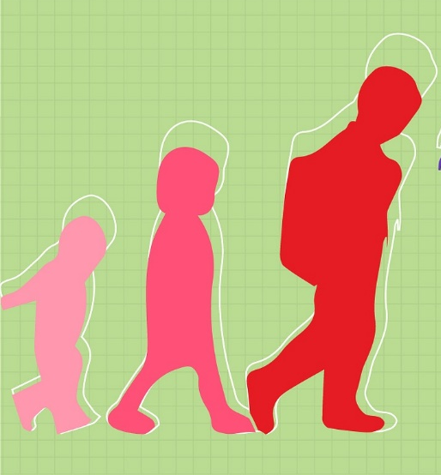

Introduction to Transition.
What is Transition?
A transition is a period of time when a significant experience or stage changes. As they grow older and develop, children inevitably go through a lot of different transitions and significant events, and these experiences can have a variety of effects on them. Certain changes or significant events may come as a surprise or be unexpected, but some are typical for most children and can usually be predicted or expected. Children will always need varying degrees of support to help them cope with these life transitions. Remembering that transition is a process rather than a singular occurrence is vital. As the child and family move into this new stage, it is important to anticipate and meet their needs. It is acknowledged that transitions are important for experiences and overall wellbeing. According to Birth to 5 Matters (2021), "transition" refers to the period of change from one stage to another. Trodd (2012) lends support to this, highlighting that transitions are a normal aspect of life rather than a singular occurrence. Any change that could interfere with a child's regular and predictable routines is considered a transition, according to Allingham (2012).
‘Getting transition right is vital for every child and is not a single event that merely happens. Transition should be viewed as a process rather than an event that involves children, practitioners and parents together. Transition has been described as an ongoing journey rather than a destination’. Early Years Matters – Transition – The journey.
Transition refers to the various phases of growth and development that young children go through in the context of early childhood education. Examples of these changes could include: children are being moved from their home to a new location, swapping year groups within a single institution, entering a new school, moving from one age group to the next, or going from preschool to school making changes in early learning environments and moving across them. It is possible for children to go through many transitions simultaneously. The unique needs of each child and family must be taken into account and addressed in a flexible and compassionate manner in all areas of the transition process (Welsh Gov, 2017). Welsh Gov (2017) highlights that practitioners should acknowledge that each child will adjust in their own way and that integrating is a slow process. They should also take into consideration the unique circumstances of each family in order to assist with smooth transitions. An inclusive system will be maintained, and different types of help will be given for each child since all families ought to feel accepted and unjudged.

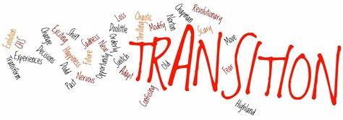

The Needs of the Child.
Effective practises, such as the establishment of caring connections, the connection between children's holistic needs and how those needs may be evaluated and met via efficient planning, observation, and evaluation, can be used to promote the development of children in the environment. According to Macleod-Brudenell and Kay (2008 p.68) “Children’s growth and development enables them to explore their environment, to make sense of their world, to achieve new skills, to change the way others perceive them, and, most importantly, it aids in their development of self.” This backs up the theory by Maslow’s Hierarchy of Needs (1943).
In his work "A Theory of Human Motivation," psychologist Abraham Maslow emphasised the need of addressing human survival's physiological demands above all else. These needs are universal to all people, regardless of status or environment. He maintained that the body and mind of a human cannot operate normally if such demands are not satisfied. His "hierarchy of needs" is well known today, frequently cited, and influenced the idea underlying our "living model."
(Maslow’s Hierarchy of Needs.)
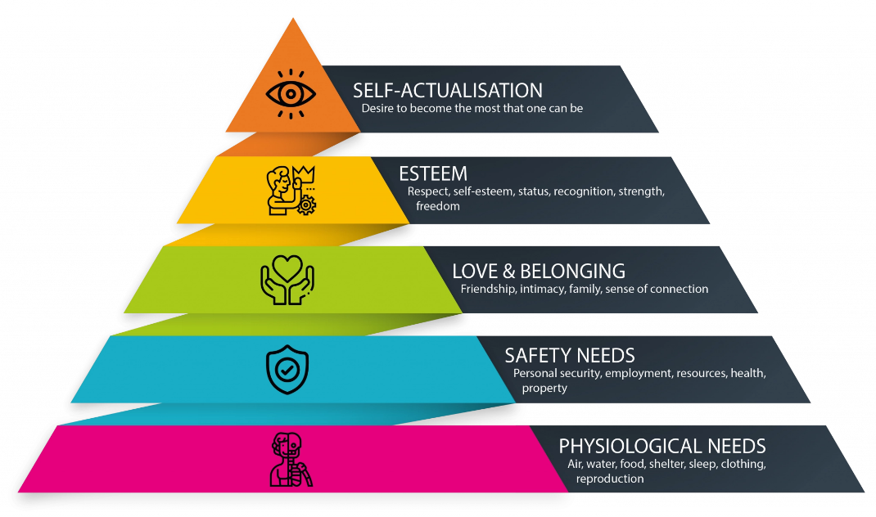(VisionOne, 2021)
The following example illustrates how classroom and school policy practises are impacted by Maslow's Hierarchy of Needs: In terms of their physical needs, this entails making sure children always have unlimited access to water and encourage them to pack a nutritious snack for playtime. It is essential for everyone’s safety to have a fun and secure play area for break and leisure time as well as within the classrooms. The social aspect of the theory includes the overall school culture as well as relationships with the community and parents and lastly, participating in school council, giving the child's voice, and promoting their health and well-being during circle time can help them develop a sense of self-worth.
Practitioners need to establish a system for the child that builds on routine, consistency, and familiarity when they transition from Nursery to Reception. It is possible to plan for and take into account each child's unique interests by paying attention to what they say and think and using pupil voice. The UNCRC's Article 12 on the voice of the child stipulates that the child's opinions and feelings must be taken into consideration (UNICEF, 2019). Spending quality time with children is essential for settings to understand how they learn, what they enjoy doing, what they might struggle with, and where they might need additional support to ensure their learning. All of this contributes to preparation for their future learning and development.
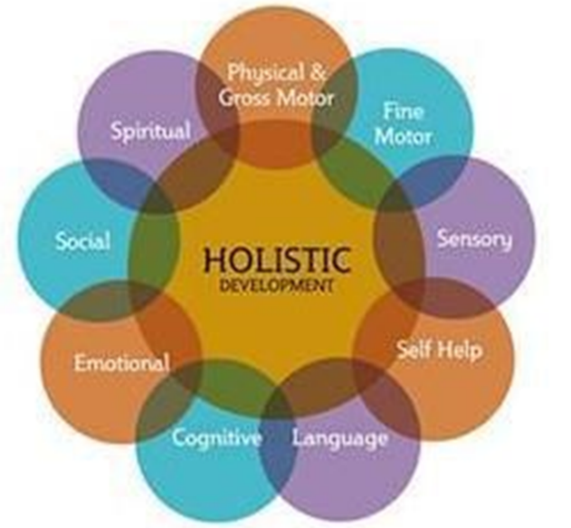

The Montessori Theory is a method of teaching developed by Maria Montessori where the key principles are Independence, Observation, Following the Child, Correcting the Child, Prepared Environment and Absorbent Mind.

The Role of the Adult.
The role of the adult in supporting children is especially important as this will likely be the childs first experience of education outside of the home. You should make this a positive, safe and inclusive experience for every child. (Education.Gov.uk) According to the Childrens Workforce Development Council, (2010) it is crucial to build trust with the child or young person and their family from the outset by clarifying issues and procedures surrounding confidentiality, consent and information sharing. Any child can make progress in their learning with the right help and support. Effective pedagogy consists of a variety of strategies combined together. Children learn through play, adult modelling, peer observation, guided learning, and direct instruction as perceived by Bandura's Social Learning Theory that states that people learn behaviour from their environment through observation, imitation, and modelling (Bandura, 1977).
With great care, practitioners create an environment that is conducive to excellent play. Every now and then, they give children the time and room they require to make their own play. Trodd (2013) describes that from time to time, practitioners join in to help the children learn more effectively and gently. In the Early Years, practitioners encourage collaborative tasks that help young learners acquire knowledge. For older children, more guided learning is required. An appropriately constructed indoor and outdoor learning environment is one of the most important pedagogical elements (cited GOV.UK - Department for Education – Development Matters 2023)
‘Wales needs a different kind of teacher who understands why and how to work with children (and how to work with their parents, who in turn support those children). (Donaldson, 2015)
‘The role of the adult is to form positive relationships based on trust and mutual respect’. (Welsh Government, 2022) This is backed up by Bowlby (cited in Pound, 2005), who suggests that children show a marked preference for closeness to a small number of adults and these attachments are a normal and universal part of human development.
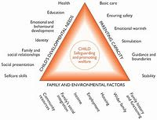

According to Hohmann (2007), there is an equilateral "triangle of care" with the child at the top and the parent and practitioner at each of the bottom vertices. This triangle should ideally consist of two-way relationships built upon trust between adults (parents and professionals) to support the child, with whom they share a positive and nurturing relationship. The three parties must develop a complex relationship under the direction of the practitioner and with the parent's full cooperation. In order to provide comfort, ensure that the child has a good experience, which helps them form a close relationship with the practitioner, the two adults gain confidence in each other.
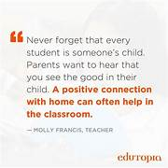
Regular close, honest, and trustworthy communication between parents and minders is necessary to maintain a caring triangle (Brooker, 2014).
Practitioners must consider the individual needs, interests, and development of each child in their care, and use this information to plan a challenging and enjoyable experience for each child in all areas of learning and development.

Partnerships.
In order to provide young children with a nurturing and stimulating environment, partnerships with parents, carers and other caretakers are necessary. The most important factor in helping some children to succeed regardless of background is involving parents and carers in the education of their children. Throughout the early years, if the child’s progress in any prime area gives cause for concern, practitioners must discuss this with the child’s parents or carers and agree how to support the child. Practitioners must consider whether a child may have a special educational need or disability which requires specialist support. They should link with and help families to access, relevant services from other agencies as appropriate according to the EYFS Framework - Department for Education (2023).
In our society, there are many different types of partnerships between individuals and groups. The most successful partnerships are those in which each partner is given the same amount of authority and respect. The foundation of a successful partnership must be the recognition of each individual's or organisation's contributions as greatly appreciated as those of the others. Teams from several disciplines, including education, health, and social care teams, may collaborate with families in early childhood settings to meet the unique needs of each child. The terms that have been agreed regarding to confidentiality and data sharing determine how partners collaborate; as a result, information is shared only with those who have a legitimate need to know.

As suggested by Early Years Matters (2023) collaborating as a team offers several benefits, including the ability for all families to share information about their child's growth or education and helping children with special needs receive individualised care. According to Bronfenbrenner's Ecological model (1977), a child's well-being can be positively impacted by links between the school and parents as well as the local community, which in turn positively influences the child's cognitive development. This is illustrated below, which not only highlights the importance of the child in this theory but also highlights the influence of the child's relationships as well as the potential involvement of external and environmental factors.
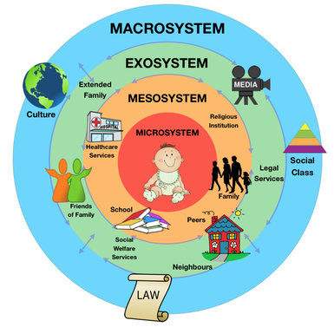

Interventions.

Early intervention is about improving outcomes for children and families. Effective early intervention works to prevent problems from occurring in the first place or tackle them head on before they get worse. Support measures like early intervention and assistance are meant to keep problems from getting worse or to keep the requirements of children from becoming worsened. They are therefore frequently referred to as early detection or proactive measures. The National Society of Protection of Cruelty to Childrens Early Help and Early Intervention (2023) document states that as an aspect of a "continuum of support," these programmes assist families that are either too high or too low to qualify for government-funded involvement. Early intervention courses and support are available to children and young people at any point in their lives, from the early years through adolescence. Services are available for individual parents, families, or education settings inclusively. Early family support is crucial, according to UK government safeguarding advice. The shape such services take, however, differs according on the local provider.
“In recent years, educational interventions are an essential part of school life. They let teachers and teaching assistants fill in any gaps in a student's learning or development. Appropriate interventions can be implemented to overcome any challenges in the child's learning process after the need has been identified” Hawthorne, H. (2021).
Lev Vygotsky (1896-1934) states that through the Zone of Proximal Development (ZPD), indicates the difference between what a student can do without guidance and what he can achieve with the encouragement and guidance of a skilled partner. Therefore the term ‘proximal’ related to those skills that the student is close to mastering. An example of this could be ‘reading buddies’ where good readers from an older age group read with average to low readers of a lower age group, give guidance to the reader and feedback to the practitioner. This means that learning is a social process as opposed to an independent journey of discovery (Aubrey and Riley, 2019, p.55-68). Peer tutoring interventions involve pupils working in pairs or small groups to provide each other with explicit teaching support. (Education Endowment Foundation, 2018).
Another intervention is the ELSA (Emotional Literacy Support Assistant) programme (2004) which was started in Southampton by educational psychologist Sheila Burton and has now expanded to include a network of practitioners across the UK. ELSAs are professionals with a specialisation in early childhood education, focused on intervention and support for children of all ages. In many cases, these practitioners already work as teaching assistants. After completing the required training, "ELSAs" are qualified to deal with young people one-on-one or in small groups. When children face significant challenges including attachment requirements, anxiety, or problems at home, the focus may shift to more focused intervention or encouragement of social skills or emotional literacy development. They often help children identify suitable outlets for their emotions, making them a key part of wellbeing support in any school setting. ELSAs have received further training in emotional wellness and literacy. They receive training, ongoing support, and supervision from educational psychologists, who also give them guidance. (ELSA Network, 2017). Claude Steiner (1979) was one of the first theorists to put forward the idea of emotional literacy. He identified five essential elements; knowing your feelings, empathy, managing your emotions, learning to repair emotional problems and developing emotional interactivity. Steiner's model prioritises understanding one's own emotions as well as being sensitive to others' feelings. (Penfold, 2022).

Proposed Outcomes.

The Welsh Government's 2020 New Curriculum for Wales outlines four purposes with the expectation that children will become:
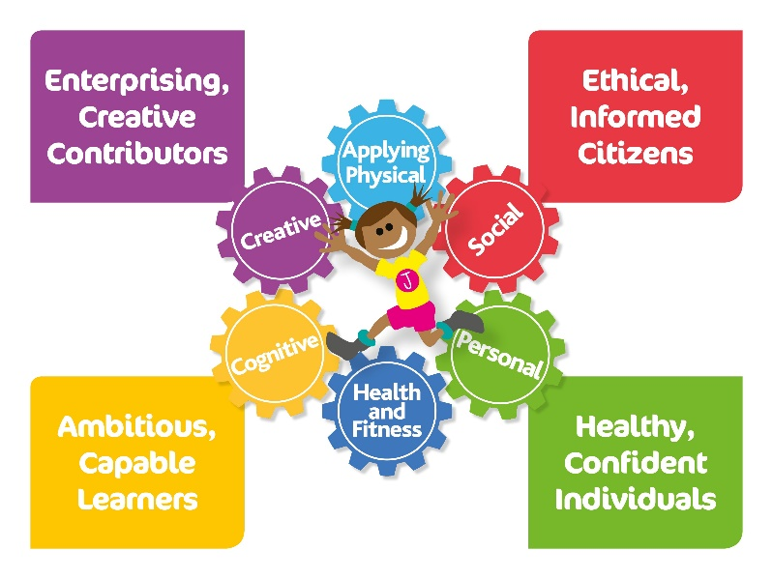

No one theory can explain all areas of child development. It is important in practice to acknowledge the contribution of all theories and to implement a number of principles that guid early years education (PACEY, 2016)

Reference List.

Allingham, S. (2012) Transitions in the early years : a practical guide to supporting children between early years settings and into Key Stage one. Luton: Andrews Uk
Aubrey, K. and Riley, A. (2019). Understanding and Using Educational Theories. 2nd ed. Los Angeles ; London ; New Delhi ; Singapore ; Washington Dc ; Melbourne: Sage
Available at: http://psychologydos.weebly.com/psych-journal/journal-8-urie-bronfenbrenners-ecological-systems-theory (Accessed:22/11/23)
Bronfenbrenner, U. (1977). Toward an experimental ecology of human development. American Psychologist, 32 (7), 513–531. https:// https://doi.org/10.1037/0003-066X.32.7.513 Abstract
Brooker, E. (2014). The Sage handbook of play and learning in early childhood. London: Sage Publications.
Early Years Matters (2007). Working in Partnership. [online] Early Years Matters. Available at: https://www.earlyyearsmatters.co.uk/eyfs/positive-relationships/working-in-partnership/.
Effective Interventions: Promoting Learning, Tackling Workload. (n.d.). Available at: https://www.nasuwt.org.uk/static/uploaded/68ddda7f-afca-420c-a18798ea9271695f.pdf (Accessed 25/11/23)
EEF(2018). Peer tutoring. Available at: (https//educationendowmentfoundation.org.uk/evidence-summaries/teaching-learning-toolkit/peer-tutoring/),accessed on 26/11/23
https://www.elsanetwork.org/author/sheilaburton/
https://www.elsanetwork.org/free_resource/elsa-leaflet/
GOV.UK - Department for Education – Development Matters 2023
Hawthorne, H. (2021). Interventions in Education | Importance, Types & Strategies. [online] The Hub | High Speed Training. Available at: https://www.highspeedtraining.co.uk/hub/effective-interventions-in-education/.
Langston.A - Facilitating children’s learning in the EYFS (2014) Open University Press
https://learning.nspcc.org.uk/safeguarding-child-protection/early-help-and-early-intervention
Penfold,S. Early Years Educator. (n.d.). What is emotional literacy? [online] Available at: https://www.earlyyearseducator.co.uk/features/article/emotional-literacy-what-is-emotional-literacy#:~:text=Claude%20Steiner%20(1979)%20was%20one [Accessed 23rd Nov 2023].
Pound, L. (2005)
Trodd, L. (2013) Transitions in the early years : working with children and families. London: Sage Publications.
Ulrike Hohmann (formerly Gelder) (2007) Rights, expertise and negotiations in care and education, Early Years, 27:1, 33-46, DOI: 10.1080/09575140601135114
Unicef (2019)

