

Institute of Inner-City Learning Birmingham Campus

BSc (Hons) Health and Social Care

Methods and Search Strategy Academic Poster

Student name: Sameena Iqbal
Student ID: 2315950

Behind the Mask: Exploring Social Camouflaging in Autistic Adults and its Psychological Impact.
01 Introduction and Research Aim  The methods chapter of the dissertation presents a systematic literature review which investigates social camouflaging through the mask of autistic adults. It is a structured secondary research method that synthesises existing evidence to identify patterns, gaps, and implications (Cheong et al., 2023).  Research Aim: This study aims to critically examine social camouflaging in autistic adults, focusing on its psychological impact on mental health, identity development, and well-being, while analysing the psychological and social factors that contribute to sustained masking behaviours. | 02 Search Strategy  The secondary research process requires researchers to establish a search strategy which combines particular keywords with Boolean operators and database selection and research limits in order to conduct complete literature searches while minimising research bias (Nussbaumer-Streit et al., 2020).  The research team conducted their study by implementing a structured search framework which explored Google Scholar and PubMed through multiple search combinations between "autism AND camouflaging" and "autistic masking AND mental health" and "autism AND identity AND masking" and "autistic burnout AND camouflaging". The focus is on peer-reviewed articles available since 2015 and published in English.
03 Searching for Information  The search process followed a clear staged approach: keyword searching, title screening, abstract screening, and full-text review which used PRISMA guidelines. The research process examined studies which fulfilled the necessary quality standards for research synthesis, while focusing on autism spectrum studies that investigated camouflaging behavior (Petrolini et al., 2023; Zhuang et al., 2023). | 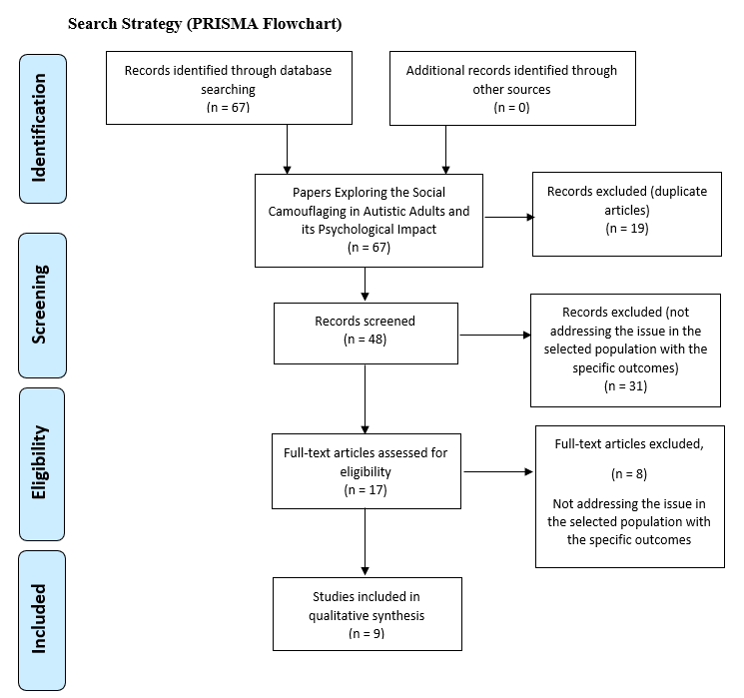  04 Prisma Flow Diagram
05 Research Validation and Analysis
The process of validating secondary research needs assessment of source credibility and source relevance and source reliability according to CRAAP criteria which includes Currency, Relevance, Authority, Accuracy and Purpose (Arnold et al., 2026). The researchers restricted their sources to peer-reviewed materials because they wanted to maintain academic standards. Thematic analysis served as the primary method which the researchers used to examine their secondary research data (McLeod, 2024). The researchers extracted data from the included studies and organised it into structured tables which they used to develop three main themes which included psychological burden together with anxiety and depression and burnout and the theme of identity and self-concept and the theme of social navigation pressures. The findings indicate that camouflaging is linked to increased levels of anxiety and depression (Hull et al. 2021; Oshima et al. 2024). According to Pritchard-Rowe et al. (2024), it may affect diagnostic accuracy and it is affected by cross-cultural variations in mental health results.
06 Inclusion Criteria  The review examined English-language peer-reviewed studies (from 2015 onwards) which focused on autistic adults who were 18 years and older and studied social camouflaging or masking together with its effects on mental health and well-being including both empirical studies and systematic reviews. | 07 Exclusion Criteria  The study excluded participants younger than 18 who did not show camouflaging or masking behaviors and whose research did not investigate psychological or identity-related results and who published their work through non-peer-reviewed or inaccessible opinion-based content.
08 Ethical Considerations
- The ethical guidelines for secondary research establish standards for researchers to use existing literature with integrity by properly attributing all sources and maintaining the scientific honesty of the original studies and their sensitive research subjects (Sony et al., 2025).

References
Arnold, W.M., Bitsika, V. and Sharpley, C.F. (2026). Camouflaging and autism: Conceptualisation and methodological issues. Autism. https://doi.org/10.1177/13623613261420085
Cheong, H., Lyons, A., Houghton, R. and Majumdar, A. (2023). Secondary Qualitative Research Methodology Using Online Data within the Context of Social Sciences. International Journal of Qualitative Methods, 22(1), pp.1–19.
Frost, D.M. and Meyer, I.H. (2023). Minority stress theory: Application, critique, and continued relevance. Current Opinion in Psychology, [online] 51, p.101579. https://doi.org/10.1016/j.copsyc.2023.101579
Hull, L., Levy, L., Lai, M.-C., Petrides, K.V., Baron-Cohen, S., Allison, C., Smith, P. and Mandy, W. (2021). Is social camouflaging associated with anxiety and depression in autistic adults? Molecular Autism, [online] 12(1). https://doi.org/10.1186/s13229-021-00421-1
McLeod, S. (2024). Thematic Analysis: A Step by Step Guide. ResearchGate. [online] https://doi.org/10.13140/RG.2.2.13084.71048
Nussbaumer-Streit, B., Klerings, I., Dobrescu, A.I., Persad, E., Stevens, A., Garritty, C., Kamel, C., Affengruber, L., King, V.J. and Gartlehner, G. (2020). Excluding non-English publications from evidence-syntheses did not change conclusions: a meta-epidemiological study. Journal of Clinical Epidemiology, [online] 118, pp.42–54. https://doi.org/10.1016/j.jclinepi.2019.10.011
Oshima, F., Takahashi, T., Tamura, M., Guan, S., Seto, M., Hull, L., Mandy, W., Tsuchiya, K. and Shimizu, E. (2024). The association between social camouflage and mental health among autistic people in Japan and the UK: a cross-cultural study. Molecular Autism, [online] 15(1). https://doi.org/10.1186/s13229-023-00579-w
Petrolini, V., Rodríguez-Armendariz, E. and Vicente, A. (2023). Autistic camouflaging across the spectrum. New Ideas in Psychology, [online] 68, p.100992. https://doi.org/10.1016/j.newideapsych.2022.100992
Pritchard-Rowe, E., de Lemos, C., Howard, K. and Gibson, J. (2024). Autistic adults’ perspectives and experiences of diagnostic assessments that include play across the lifespan. Autism, [online] 29(1), pp.64–75. https://doi.org/10.1177/13623613241257601
Sony, E., Ali, E., Engr Cletus and Okeke, G.N. (2025). Ethical Standards in Research: A Professional Imperative. ResearchGate, [online] pp.94–104. https://doi.org/10.5281/zenodo.14875237
Zhuang, S., Diana Weiting Tan, Reddrop, S., Dean, L., Maybery, M.T. and Magiati, I. (2023). Psychosocial factors associated with camouflaging in autistic people and their relationship with mental health and well-being: A mixed methods systematic review. Clinical Psychology Review, 105, pp.102335–102335. https://doi.org/10.1016/j.cpr.2023.102335

