

Work Based Learning – Submission 3 – Reflective Journal



Student name and ID: James Cullen (P151951).
Course: Construction Management.
Company name and address: Dwr Cymru Welsh Water, 1st Floor, Glien House, Glien Road, Johnstown, Carmarthen SA31 3RB.
Contact name and number: Dai Kirk (Dave.Kirk@dwrcymru.com, 07881907532).

As per the learning contract this interim submission will focus on the period between 07/12/19 – 24/01/20, encapsulating the Christmas shut down period, before which all operational workspaces needed to be temporarily closed down, backfilled and reinstated.
The timeframe provided sufficient scope for learning in relation to a number of aspects related to the project. These included the implementation of the full ’Control Point’ system for quality management of fusion welded joints on the newly installed water mains, whereby, “The pipes to be joined are cleaned, inserted into the electrofusion fitting and a voltage, of typically 40V, is applied for a fixed time depending on the size of the pipe and fitting being installed” (GPS 2015). Seen as a potential weakness and a source for leakage in the system DCWW felt the need for a robust procedure to oversee it. In the time period above, over 600 fusion welded joints were installed and reviewed with 21 being highlighted as non-compliant, all of which were cut out and re-done. Below shows a view of the Control Point Dashboard profiling the joint details and the action taken following its failure:

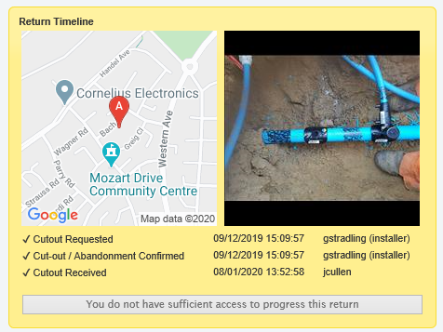

(Image 3: View of timeline of actions taken following 1 non-conformant joint installed at Bach Road, Sandfields, Port Talbot 19/12/19, Control Point, 2019)

In addition, the scheme took a hiatus between 20/12/19 and 06/01/20 for the festive period. This necessitated the need for all excavations on site to be backfilled (even at sites where the work was not yet complete) in line with DCWW’s Christmas Compliance bulletin:

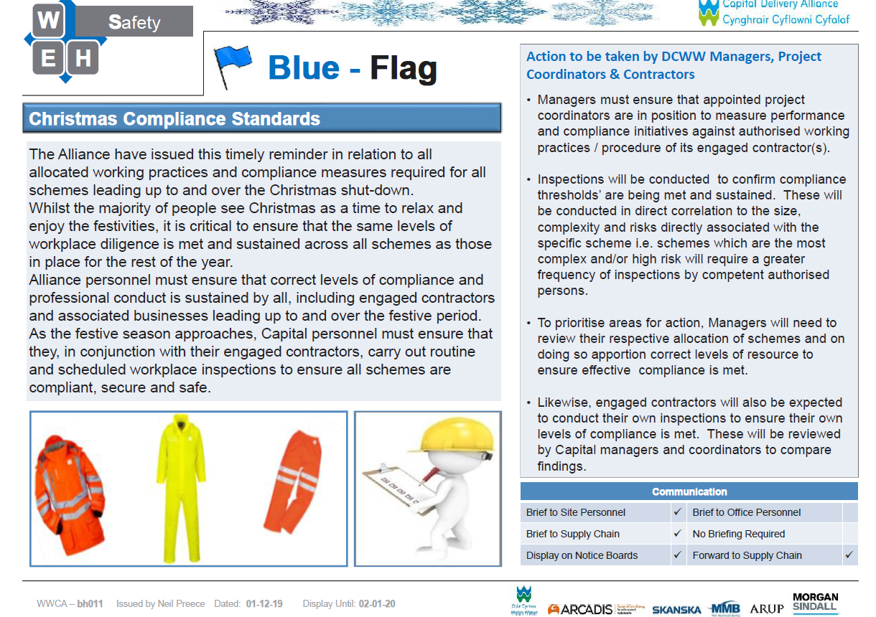

(Image 4: DCWW Christmas Compliance Standards H&S bulletin, Preece, 2019).

This process meant production on the scheme was reduced and extra cost was incurred, although it emphasized the level of resource DCWW dedicate to Health and Safety.
A highlight of this period of the undertaking was the completed shut down of the site to a high standard which complied with Welsh Water’s specifications. It provided a ‘snapshot’ of how the area is likely to look once the scheme is completed in its entirety. This was however a labour-intensive exercise and counterproductive to the programme which required planning and co-ordination to ensure that the work’s cost and duration were not overly affected. Monitoring and attention was also needed to ensure the quality of the backfilled and reinstated excavations. With no personnel on site over the shut down period, this was of high importance to keep members of the public safe.
The continued heavy workload was further exacerbated during the term with the Control Point system evolving into a more holistic system which demanded that each non-compliant joint cut out must be physically returned to the site office and reviewed by the project co-ordinator. Following this, every piece was logged, and the system updated prior to submission to Control Point in readiness for logistical testing.
Overall this period appears to have complied with the goals and aims set out with the learning contract and provide a sound basis for continuing to work on the project.

Reference List

- GPS (2015), Getting to Grips with Electrofusion Jointing, http://www.gpsuk.com/articles/3/79/getting-to-grips-with-electrofusion-jointing.html, accessed 16/02/20.
- Preece (2019), Christmas Compliance Standards H&S bulletin, DCWW, UK.

List of images

Front page top:
- Image 1: DCWW (2019) Dwr Cymru Welsh Water logo, https://www.dwrcymru.com/, accessed 10/11/19.
Front page bottom:
- Image 2: UWTSD (2019) University of Wales Trinity Saint Davids logo, https://www.uwtsd.ac.uk/courses/, accessed 10/11/19.
- Image 3: Control Point (2019), View of timeline of actions taken following 1 non-conformant joint installed at Bach Road, Sandfields, Port Talbot 19/12/19, Control Point Ltd, UK.
- Image 4: Preece (2019), Christmas Compliance Standards H&S bulletin, DCWW, UK.

