“Renewable Energy Entrepreneurship as a Pathway to Wealth Creation and Sustainable Growth for SMEs in Nigeria: An International Business Perspective.”
In partial completion of BA International Business Management in University of Wales, Trinity Saint Davids
By
Kelechi Ibeabuchi

Chapter 1: Introduction

1.1 Background to the Study

Overview of SMEs in Nigeria and their contribution to GDP and employment

Small and Medium Enterprises (SMEs) have long functioned as the structural backbone of Nigeria’s economy, operating as a central driver of economic growth, employment creation, and youth empowerment (XXXXXXXXX). Their importance extends beyond commercial activity, as they play a critical role in promoting social stability and inclusive development. Current estimates indicate that SMEs account for over 96% of all businesses in Nigeria and generate approximately 84% of national employment (XXXXXXXXX). Highlighting their indispensable contribution to the country’s economy.

Nigeria’s demographic trajectory further amplifies the significance of the SME sector. With a population exceeding 250 million in 2026, the country represents the largest consumer and labour market in Africa (XXXXXXXXXX). While this demographic scale offers considerable economic potential, it also creates substantial pressures related to job creation, income generation, and economic diversification. Within this context, SMEs provide a vital mechanism for absorbing labour, stimulating innovation, and facilitating grassroots economic participation. Data from the Small and Medium Enterprises Development Agency of Nigeria (SMEDAN) suggest that more than 40 million enterprises operate across the country (XXXXXXXX). These micro, small, and medium-sized categories are defined primarily by employment size and asset thresholds.

Micro-enterprises, typically employing between one and twenty workers, constitute the largest proportion of the sector and are often characterised by informal or semi-formal operational structures (XXXXXXX). Small enterprises generally employ between twenty-one and forty-nine individuals, while medium-sized enterprises engage between fifty and two hundred workers (XXXXXXXXX). From an asset perspective, medium enterprises commonly operate with capital bases ranging from ₦50 million to ₦500 million. This indicates their growing capacity to contribute to industrial output, productivity enhancement, and value chain development (XXXXXXXXXX).

In recent years, the SME landscape in Nigeria has undergone significant transformation driven by rapid population growth and accelerating technological change. Advances in digitalisation, artificial intelligence, and automation have reshaped the operational environment for businesses of all sizes (XXXXXXXXXX). Although the COVID-19 pandemic disrupted economic activity and exposed structural vulnerabilities, the SME sector demonstrated notable resilience. From 2021 onwards, many enterprises adapted through increased digital adoption, innovation in service delivery, and the exploration of new consumer markets. By 2023, SMEs continued to dominate Nigeria’s business ecosystem, reinforcing their central role in employment generation and entrepreneurial expansion (XXXXXXXXX0.

From both national and global perspectives, SME development is widely recognised as a determinant of sustainable economic competitiveness (XXXXXXXXX). International evidence consistently links a strong SME sector to GDP growth, economic diversification, and inclusive participation in formal markets. In Nigeria, SMEs contribute to widening the tax base, strengthening domestic production, encouraging entrepreneurship, and improving financial inclusion (XXXXXXXXX). These contributions position the sector as a critical instrument for long-term economic transformation.

However, the continued growth of SMEs depends on the presence of effective regulatory frameworks, improved access to finance, and coordinated stakeholder engagement. Government interventions through policy reforms, financial incentives, and institutional support remain essential in shaping the business environment within which SMEs operate (XXXXXXXXX). Strengthening these enabling mechanisms is therefore fundamental to consolidating Nigeria’s economic resilience and positioning the SME sector as a catalyst for sustained structural development (XXXXXXXX).

Description and case Study Nigeria
Nigeria, formally referred to as the Federal Republic of Nigeria, is situated in West Africa. It is bordered by Niger to the north, Chad to the northeast, Cameroon to the east, and the Gulf of Guinea to the south. With a population surpassing 200 million, Nigeria stands as the most populous country in Africa and boasts one of the continent's largest economies. The capital city is Abuja, while Lagos is the largest city, known for its dynamic commercial activities. Renowned for its extensive cultural diversity and deep historical roots, Nigeria is home to civilizations and traditions that extend back to ancient times.

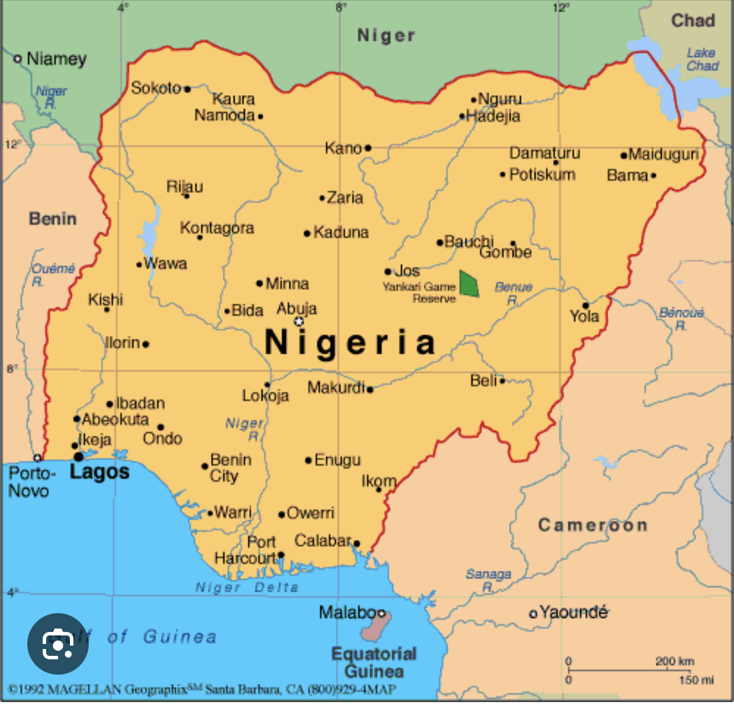

https://www.infoplease.com/atlas/africa/nigeria-map

After gaining independence from Britain, Nigeria went through a series of shifts between civilian and military governance until democracy was restored in 1999. Today, it is recognized as one of the major political and economic powers in Africa, often dubbed "the Giant of Africa" because of its vast population and rich cultural heritage. The country is home to over 250 ethnic groups and speaks more than 500 languages.

The mid-20th century saw the discovery of oil in the Niger Delta, which transformed Nigeria's economy, making it one of the leading oil producers in the world. While the nation grapples with ongoing environmental challenges and regional conflicts, it continues to play a significant role in African politics and peacekeeping efforts.

Nigeria’s electricity crisis and its impact on entrepreneurship
Nigeria’s persistent electricity deficit remains one of the most significant structural barriers to economic development and entrepreneurial activity. Small and Medium-Sized Enterprises (SMEs), which underpin employment and productivity, are particularly vulnerable to unreliable power supply (XXXXXXXXX). Chronic outages, voltage fluctuations, and limited generation capacity create an operating environment defined by elevated costs, operational inefficiencies, and constrained business expansion.

Over the past two decades, successive governments have pursued reforms aimed at improving electricity generation and distribution. A major turning point occurred in 2013 with the privatization of the power sector, designed to modernise infrastructure, enhance efficiency, and attract private investment (XXXXXXXXXX). The reform agenda also sought to diversify the national energy mix beyond hydropower and fossil fuels by encouraging renewable energy development. Despite these ambitions, progress has been hindered by regulatory uncertainty, governance challenges, limited transmission capacity, and persistent structural inefficiencies across the value chain (XXXXXXXXX).

The economic implications of inadequate electricity supply are substantial. Power shortages impose significant productivity losses at the national level while simultaneously increasing the cost of doing business (XXXXXXXXXXX). For SMEs, unreliable electricity often necessitates self-generation through petrol or diesel generators (XXXXXXXXX). This reliance substantially raises operating expenses, exposes firms to fuel price volatility and foreign exchange fluctuations, and ultimately erodes profit margins and competitiveness.

The consequences for entrepreneurship are far-reaching. High energy costs raise barriers to entry for new ventures and discourage investment in manufacturing and technology-driven sectors that depend on stable electricity (XXXXXXXXX). Entrepreneurs must frequently allocate scarce capital to alternative power solutions rather than productive investment, limiting firm growth and innovation (XXXXXXXXXX). In this context, energy insecurity becomes a critical constraint on job creation, business scalability, and economic diversification.

Nigeria possesses significant renewable energy potential, particularly in solar resources across its northern regions. While several large-scale solar initiatives have been launched and supported by international development partners, progress has been uneven and constrained by limitations in transmission infrastructure and grid integration (XXXXXXXX). As a result, improvements in electricity reliability have not matched the scale of investment committed to the sector.

Reliance on fossil-fuel generators also carries environmental and public health consequences, including increased greenhouse gas emissions and air pollution (XXXXXXXXX). These externalities intensify the broader socioeconomic costs of energy insecurity and highlight the urgency of transitioning toward sustainable energy solutions.

Addressing Nigeria’s electricity crisis therefore requires coordinated structural reform, sustained investment in transmission and distribution networks, regulatory clarity, and accelerated deployment of renewable energy technologies (XXXXXXXXXX). Without reliable and affordable electricity, entrepreneurial activity will remain constrained, limiting the capacity of SMEs to drive inclusive growth, industrialisation, and long-term economic transformation.

Emergence of Renewable Energy as a Business Opportunity
The global transition toward renewable energy has accelerated significantly in recent decades in response to climate change, environmental degradation, and the growing economic risks associated with continued dependence on fossil fuels (XXXXXXXXXX). Rising greenhouse gas emissions have intensified international commitments to decarbonisation, prompting governments, financial institutions, and private investors to prioritise clean energy development (XXXXXXXXXX). Many advanced economies have introduced ambitious policy frameworks to support this shift. For example, national commitments to net-zero emissions and expanded financial incentives for clean technology investment demonstrate a broader global consensus that sustainable energy systems are essential for long-term economic stability and resilience (XXXXXXXXXX).
For Small and Medium-Sized Enterprises (SMEs), renewable energy represents more than an environmental obligation; it is increasingly recognised as a strategic business opportunity (XXXXXXXXX). The adoption of solar, wind, and other renewable technologies can reduce long-term operating costs, protect businesses from fuel price volatility, and enhance corporate sustainability credentials (XXXXXXXXX). As consumers and investors become more environmentally conscious, firms that integrate renewable energy into their operations are better positioned to strengthen competitiveness, access new markets, and attract environmentally responsible investment.
In developing economies such as Nigeria, the importance of renewable energy is even more pronounced. Persistent electricity shortages and unreliable grid infrastructure have long constrained industrial growth, productivity, and entrepreneurship. Decentralised renewable energy solutions, particularly solar power, offer a practical pathway to address these challenges (XXXXXXXX). By enabling reliable and affordable energy access, renewable technologies can stimulate enterprise development, support business expansion, and improve overall economic productivity.
The renewable energy sector also generates opportunities across an extensive value chain. These opportunities include equipment manufacturing, system installation, maintenance services, financing solutions, and technological innovation (XXXXXXXXXXXX). Such diversification contributes to job creation, supports local skills development, and encourages domestic technological advancement (XXXXXXXXXX). Consequently, renewable energy can serve as both an economic catalyst and a foundation for sustainable industrial development.
The global sustainability agenda further reinforces the role of renewable energy in economic transformation. Clean energy is closely linked with broader development objectives, including economic growth, climate action, and social inclusion (XXXXXXXXX). Achieving these goals requires collaboration between governments, private investors, research institutions, and entrepreneurial ventures. While public policy establishes the regulatory and financial framework, entrepreneurial innovation drives market expansion, technology adoption, and the creation of scalable business models (XXXXXXXXXX).
Innovative approaches such as pay-as-you-go solar systems, mini-grids, and community-based energy enterprises illustrate how renewable energy can be both commercially viable and socially transformative (XXXXXXXXXXX). These models are particularly impactful in rural and underserved regions, where access to affordable and reliable electricity directly enhances productivity, income generation, and quality of life (XXXXXXXXXXX).
Despite these opportunities, the renewable energy sector continues to face structural barriers, including high upfront capital costs, regulatory uncertainty, limited technical expertise, and financing constraints in emerging markets (XXXXXXXXX). Overcoming these challenges will require targeted investment, capacity building, supportive regulatory frameworks, and transparent governance systems.
Overall, renewable energy represents a powerful convergence of environmental responsibility and economic opportunity. By aligning entrepreneurial innovation with clean energy development, nations can enhance energy security, promote inclusive economic growth, and progress toward a more sustainable and resilient economic future (XXXXXXXXXX).

Growing Global Investment in Green Entrepreneurship
By 2025, global investment in green entrepreneurship and clean energy transition has surpassed $2.3 trillion, marking one of the most significant capital reallocations in modern economic history (XXXXXXXXX). This unprecedented financial commitment reflects a structural shift toward a low-carbon economy, supported by government policies, regulatory reforms, and market-driven sustainability strategies (XXXXXXXXXX). This is aimed at reducing greenhouse gas emissions and limiting reliance on fossil fuels.
Multilateral institutions such as the World Bank and the United Nations have reinforced climate-aligned financing frameworks. This is to encourage both public and private sector investment in renewable energy infrastructure and green enterprise development (XXXXXXXXX). These record capital flows are accelerating the commercialization of clean technologies and strengthening the global competitiveness of sustainable industries.
The United States and the European Union collectively account for a substantial share of this investment surge. Policy instruments such as the EU’s Net-Zero Industry Act, alongside corporate net-zero commitments, supported by surveys indicating that 85% of business leaders prioritize sustainability(XXXXXXXXX). This has intensified momentum in green markets. In addition, grants and concessional financing have been extended to several African economies to stimulate renewable energy adoption and climate-resilient infrastructure (XXXXXXXXX).
Sector-specific allocations highlight the scale of transformation. Investment in solar photovoltaic (PV) technology exceeded $554 billion in 2024, demonstrating continued confidence in scalable renewable generation (XXXXXXXXXX). Electric vehicles and electrified transportation attracted approximately $890 billion, reflecting a 21% increase between 2024 and 2025 (XXXXXXXXX). Battery storage technologies, critical for grid stability and renewable integration, accounted for $74 billion in 2024 (XXXXXXXXX). These figures underscore a coordinated expansion across production, storage, and consumption segments of the energy value chain.
Beyond energy systems, capital has increasingly flowed into waste management innovation, plastic reduction initiatives, and circular economy solutions. In agriculture, advancements in artificial intelligence and precision technologies have strengthened food security while minimizing environmental degradation (XXXXXXXXXX). By 2024, approximately 90% of global energy transition financing had been directed toward climate-technology solutions, supported by enhanced research and development infrastructure and cross-sector collaboration (XXXXXXXXXX).
This large-scale financial mobilization has catalyzed the rise of green start-ups and sustainability-driven business models. Entrepreneurs are embedding environmental objectives into core operational strategies, transforming sustainability from a compliance requirement into a source of competitive advantage (XXXXXXXXXX). Regulatory reforms and market incentives have further reinforced long-term profitability and economic resilience within green sectors.
For emerging markets such as Nigeria, these global capital movements present strategic opportunities. Entrepreneurs who align with renewable energy and climate-technology trends can attract international investment, foster innovation, and integrate into global value chains (XXXXXXXXXXX). According to sustainability frameworks advanced by the World Bank, green industries possess the potential to generate trillions of dollars in economic value while simultaneously reducing environmental impact (XXXXXXXXXX).
In essence, the expansion of global green investment represents more than environmental reform. It signals a fundamental restructuring of international business priorities. Firms that strategically position themselves within this transition are likely to capture substantial market share, achieve long-term profitability, and contribute meaningfully to sustainable economic development (XXXXXXXXXXX).
1.2 Problem Statement

High energy costs reducing SME profitability

Dependence on diesel generators and financial losses

Limited access to sustainable and affordable energy solutions

Under-explored potential of renewable energy entrepreneurship

1.3 Research Aim

To examine how renewable energy entrepreneurship contributes to wealth creation and sustainable growth of SMEs in Nigeria from an international business perspective.

1.4 Research Objectives

To analyse energy challenges affecting SME profitability in Nigeria

To examine renewable energy as a high-growth entrepreneurial sector

To evaluate how renewable energy adoption improves SME profitability and competitiveness

To assess opportunities for international investment and business expansion

1.5 Research Questions

How do energy challenges affect SME profitability in Nigeria?

How does renewable energy entrepreneurship support SME wealth creation?

What opportunities exist for international investors in Nigeria’s renewable energy sector?

1.6 Significance of the Study

Academic contribution to international business and sustainability research

Practical relevance for entrepreneurs, investors and policymakers

1.7 Scope and Limitations of the Study

1.8 Structure of the Dissertation

Chapter 2: Literature Review

2.1 Introduction

2.2 SME and Economic Development in Nigeria

Nigeria, situated in West Africa, is the continent’s most populous nation and continues to experience rapid population growth, an expanding labour force, and increasing energy demand (XXXXXXXXX). These demographic and economic pressures place considerable strain on national infrastructure, employment creation, and the sustainable management of natural resources. Within this context, the integration of renewable energy development with Small and Medium-Sized Enterprises (SMEs) presents a strategic pathway for achieving long-term, sustainable economic transformation (XXXXXXXXXX). SMEs are widely acknowledged as key drivers of economic diversification, innovation and employment generation across developing economies (XXXXXXXXXX). Expanding their participation within the renewable energy sector has the potential to enhance productivity, encourage green entrepreneurship and strengthen economic resilience, while simultaneously addressing Nigeria’s persistent energy supply challenges.

SMEs play a critical role in stimulating market competition, technological advancement, and participation in global value chains. At both national and community levels, their activities strengthen local supply networks, encourage skills development, and generate inclusive employment opportunities (XXXXXXXXXX). Within the renewable energy sector, SMEs are uniquely positioned to accelerate the transition to a digitally enabled and environmentally sustainable economy through decentralised energy solutions, installation services, energy management systems, and climate-technology innovations (XXXXXXXXXX).

Globally, SMEs account for over 90% of businesses and contribute more than half of total employment, particularly in advanced economies. XXXXXXX have emphasized that For developing countries such as Nigeria, expanding SME participation in renewable energy aligns with broader economic diversification objectives. Promoting entrepreneurship in clean energy industries can reduce dependence on carbon-intensive sectors, strengthen technical capacity, and address persistent unemployment challenges.

The urgency of this transition is reinforced by demographic trends. Over the past decades, approximately 1.2 billion young people have entered the global labour force, intensifying competition for limited employment opportunities (XXXXXXXXXX). At the same time, projections suggest that the renewable energy sector could generate up to 420 million jobs globally by 2030. This contrast highlights both a challenge and an opportunity. This can be achieved through targeted policy support and investment in entrepreneurial ecosystems, the employment potential of renewable industries may remain underutilised.

Despite this opportunity, access to finance remains a major constraint for SME expansion in Nigeria’s renewable energy market (XXXXXXXXXX). While large corporations dominate key segments of the clean energy value chain, smaller enterprises frequently encounter capital shortages, limited credit access, and regulatory complexity (XXXXXXXXXX). In addition to financial barriers, scaling renewable energy businesses requires technical expertise, infrastructure support, and stable policy frameworks.

This dissertation therefore examines how targeted government interventions, private-sector collaboration, and institutional reforms can stimulate youth participation in renewable energy entrepreneurship in Nigeria. Encouraging young people to engage in clean energy ventures can address short-term employment challenges while strengthening long-term economic sustainability (XXXXXXXXXX). By embedding renewable energy within SME development strategies, Nigeria can promote inclusive growth, stimulate innovation, and advance toward a competitive low-carbon economy.

Renewable Energy Entrepreneurship and the Global SME Finance Gap: Implications for Nigeria
Access to finance remains one of the most significant constraints on the growth of renewable energy entrepreneurship, particularly within emerging markets. The 2025 MSME Finance Gap Report by the International Finance Corporation (IFC) and the World Bank estimates that across 119 developing economies, small and medium-sized enterprises face a combined financing gap of approximately $5.7 trillion (XXXXXXXX). This shortfall represents a substantial proportion of economic activity, equivalent to nearly 19% of GDP and over 20% of total private-sector credit in those markets.
The report further indicates that while roughly 40% of formal MSMEs have gained some level of financial access, an estimated $1.9 trillion has been directed toward renewable energy–related investments (XXXXXXXXXX). Between 2015 and 2019, credit flows to green and renewable enterprises increased steadily, reflecting growing recognition of clean energy as both a commercial opportunity and a development priority.
For Nigeria, these global financing trends have direct relevance. Expanding access to capital for SMEs is essential to unlocking investment in solar installations, energy-efficient technologies, and decentralized renewable systems. Financial innovation, including digital lending platforms, peer-to-peer financing, and crowdfunding, has emerged globally as alternative mechanisms for supporting early-stage ventures (XXXXXXXXXX). However, these instruments remain underdeveloped within Nigeria’s financial ecosystem.
Nigerian Entrepreneurship and green energy Investment
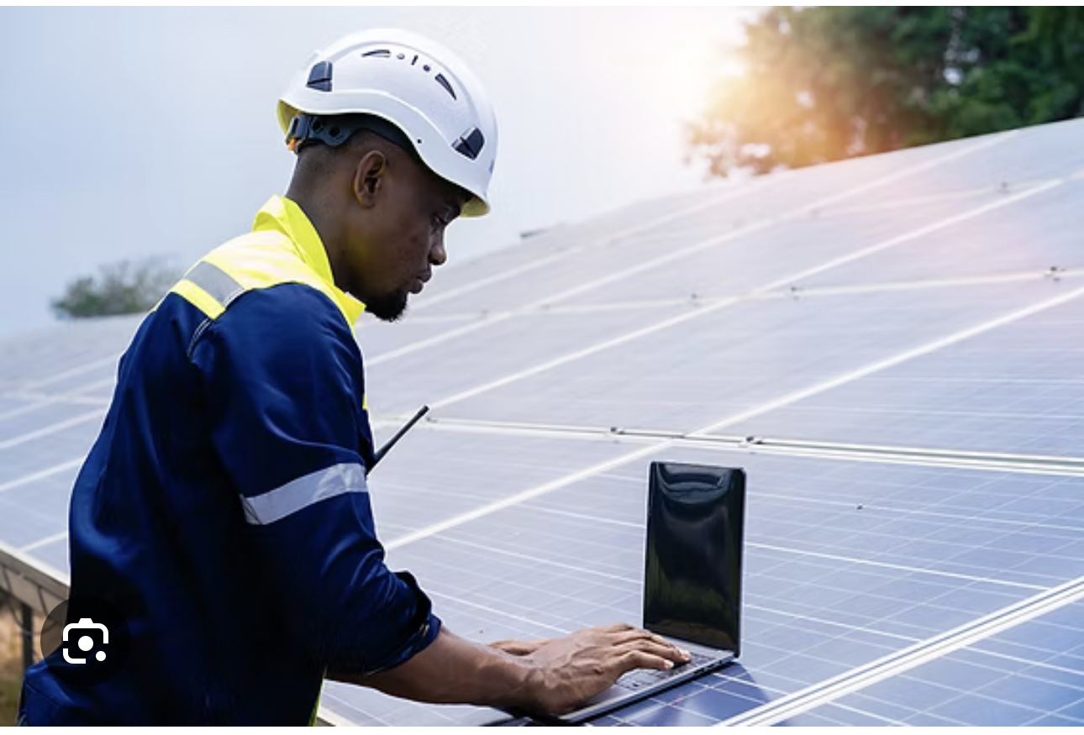

https://www.enee.io/post/the-future-of-energy-in-nigeria-new-financed-renewable-systems-and-their-impact-on-uptake-and-affor
Creating an enabling financing environment requires structural reform. Strengthening credit infrastructure through improved credit reporting systems, collateral registries, and risk-sharing mechanisms would enhance lender confidence and reduce borrowing constraints (XXXXXXXXXX). In advanced economies such as the United Kingdom and the United States, entrepreneurs benefit from mature digital finance ecosystems and regulatory frameworks that facilitate long-term capital access (XXXXXXXX). These systems reduce transaction costs, mitigate information asymmetry, and encourage private-sector participation in innovation financing.
Adapting similar models within Nigeria could stimulate private investment in renewable energy ventures while lowering perceived lending risks (XXXXXXXXXX). Meaningful public–private partnerships, coordinated financial sector reforms, and collaboration with international SME finance initiatives would be critical in this regard. Leveraging technology and data-driven credit assessment tools can further enhance transparency and broaden access to funding.
Ultimately, bridging the SME finance gap is central to scaling renewable energy entrepreneurship in Nigeria. By aligning financial sector development with clean energy priorities, the country can foster inclusive growth, support innovation, and strengthen its position within the evolving global green economy.
SME Finance and Barriers in Nigeria

International Business and Investment in Nigeria

Research Gap

Chapter 3: Research Methodology

(≈ 1,200–1,400 words)

3.1 Introduction

3.2 Research Philosophy

3.3 Research Approach

3.4 Research Design

Qualitative case study approach

3.5 Data Collection Methods

Interviews with SME owners and renewable energy entrepreneurs

Secondary data from reports and international organisations

3.6 Sampling Strategy

3.7 Data Analysis Techniques

Thematic analysis

3.8 Ethical Considerations

3.9 Reliability and Validity

3.10 Limitations of Methodology

Chapter 4: Findings and Analysis

(≈ 1,600–1,800 words)

4.1 Introduction

4.2 Profile of Participants / Data Sources

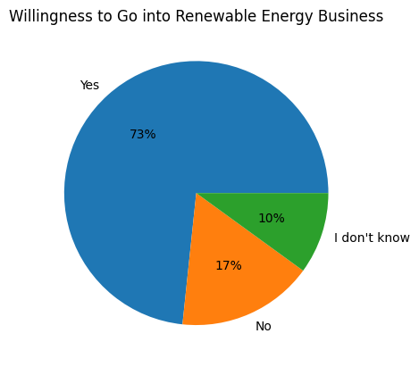

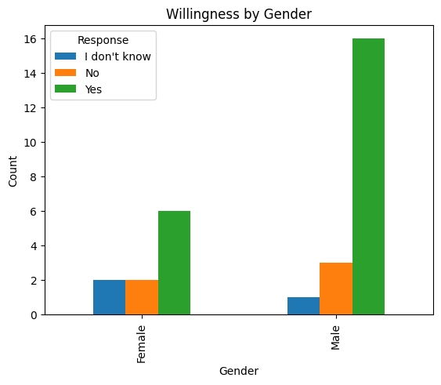
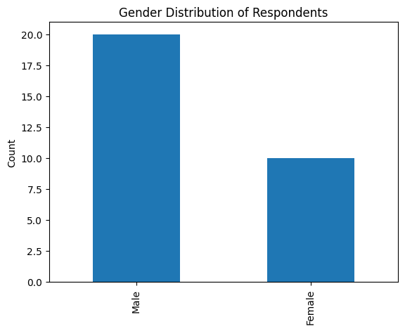

4.3 Energy Challenges Affecting SME Profitability

Generator costs

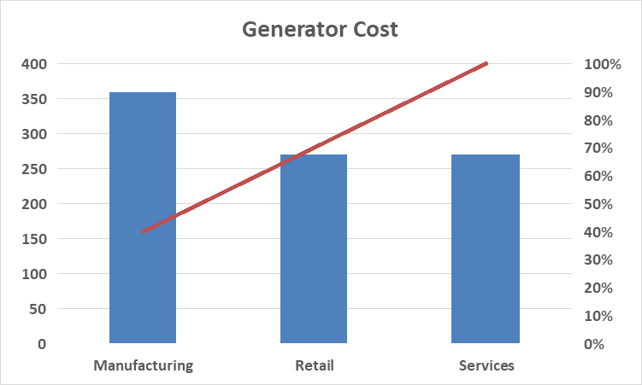

Business interruptions

Rising operational expenses

4.4 Renewable Energy as an Entrepreneurial Opportunity

New business models

Market demand growth
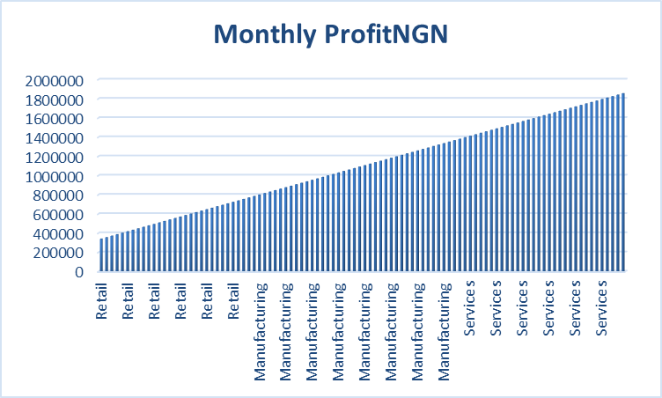

Job and income generation

4.5 Impact on SME Wealth Creation

Nigeria Power Demand vs supply
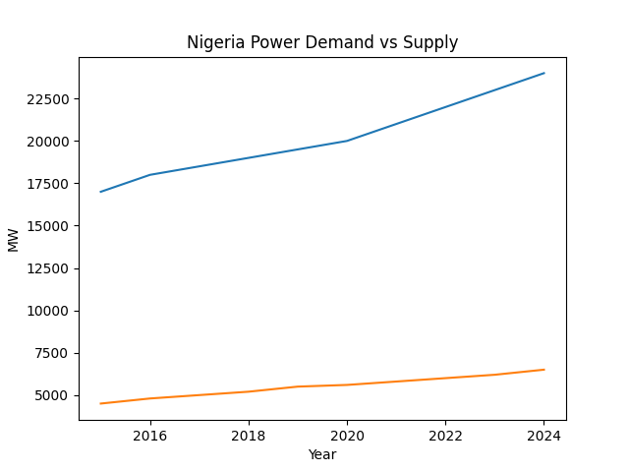

Solar capacity growth
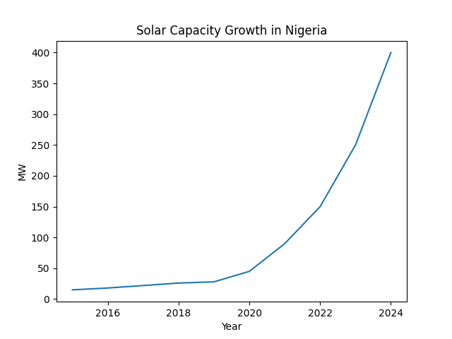

Improved competitiveness

4.6 Sustainability Outcomes

Environmental benefits

Social and economic benefits

4.7 International Business Opportunities

Foreign partnerships

Investment potential

Export and technology transfer opportunities

4.8 Summary of Key Findings

Chapter 5: Discussion

(≈ 1,200–1,400 words)

5.1 Introduction

5.2 Discussion of Findings vs Literature

5.3 Renewable Energy Entrepreneurship as a Wealth Creation Pathway

5.4 Implications for International Business Strategy

Investors

Multinational companies

Entrepreneurs

5.5 Theoretical Implications

5.6 Practical Implications

Chapter 6: Conclusion and Recommendations

(≈ 800–1,000 words)

6.1 Summary of Study

6.2 Conclusion

6.3 Recommendations

SMEs

Renewable energy entrepreneurs

Policymakers

International investors

6.4 Contribution to Knowledge

6.5 Limitations of Study

6.6 Suggestions for Future Research

References

Appendices

Interview questions

Consent forms

Data tables

