15/08/2026
Module Name: Creativity and Value Creation
Module Code: ACCA5033
Assignment Title: Project Management and Innovation
Student Name: Ahmed Remache
Student Id: 2334747
Lecturer’s Name: Fahad Ahmed

AI-POWERED STUDENT PERFORMANCE PREDICTION AND EARLY INTERVENTION SYSTEM

INTRODUCTION
Students underperforming is a significant institutional concern because early identification can potentially end the hope of delivering effective academic intervention. To minimize such a problem, the suggested AI-Powered Student Performance Prediction and Early Intervention System will analyze such indicators as attendance, assessment performance and engagement to group students according to their risk of academic performance. Instead of substituting academic judgement, the system offers an evidence based warning system that facilitates earlier intervention without disregarding constraints with prediction accuracy, quality of data and algorithmic bias. It is therefore a project through creativity and innovation to develop already existing educational data into action. The report is critical on its planning, design, implementation, risks and contribution to society.

II. TASK 1: PROJECT MANAGEMENT

A. Project Scope and Proposed Solution
The project addresses the specific problem of recognition of the students who are at the risk of underachievement in their academic performance late, which may restrict the effectiveness of subsequent interventions. The suggested solution is a prototype AI-Powered Student Performance Prediction and Early Intervention System which analyses attendance, assessment performance and engagement data to categorize possible academic risk and provide actionable alerts to authorised personnel. Data preprocessing, predictive modeling, risk classification, a staff dashboard, intervention recommendations, security controls and ethical safeguards [1] will be involved in the project. It will not entail automated disciplinary determinations, independent adjudication, replacement of academic determination and wholesale institutionalisation. This limit gives a feasible minimum viable product and reduces the risks of unwarranted automated decision-making [19].
Project objective: The prototype development and design of an AI-based system to anticipate potential underperformance in students and enable early and evidence-based intervention by the designated academic staff.
The key activities are the performance indicators analysis, development of an appropriate data structure, the development and testing of a predictive model, the classification of the risk level, an intervention dashboard, and privacy, security, and ethical controls.

B. Technologies and Resources
Area | Technology/Resource | Purpose
Programming | Python | Predictive model development
Data analysis | Pandas/NumPy | Data preparation and transformation
Machine learning | Scikit-learn | Model training and evaluation
Database | MySQL/MongoDB | Structured student information
Backend | Flask/FastAPI | Secure API services
Frontend | React | Interactive staff dashboard
Design | Microsoft Visio | Architecture and process diagrams
Project management | Microsoft Project | Gantt chart and scheduling
Version control | Git/GitHub | Version management
Testing | Postman/Jest | API and functional testing
Table 1: Technologies
Python is particularly well adapted with its current data-science ecosystem allowing preprocessing, model creation and testing to be run within a single environment. Nonetheless, it also means that reliance on numerous libraries and outside services hikes integration and maintenance needs. Microsoft Project will offer organized dependency and milestone management and Microsoft Visio will convert technical architecture into designs that are professionally communicable.

C. Timeline, Schedule and Constraints
The project will be designed in Microsoft Project in 14 steps: initiation, literature research, requirements analysis, data requirements, system design, data preparation, machine-learning development, backend development, dashboard development, integration, testing, evaluation, documentation and final submission [2]. Dependencies will make sure that data preparation is done after requirements definition and testing is done after system integration [21]. The major milestones will consist of the approval of requirements, completion of the prototype, completion of testing and submission.
The key constraints of it are the limited academic schedule, building resources, availability, and quality of suitable datasets, data-protection requirements, computing power, model quality, technical capability and potential scope creep. Therefore, the project will focus on a minimum viable prototype instead of trying to deploy the whole institutional implementation [3]. This approach protects the schedule viability but has sufficient functionality to conduct a significant assessment.


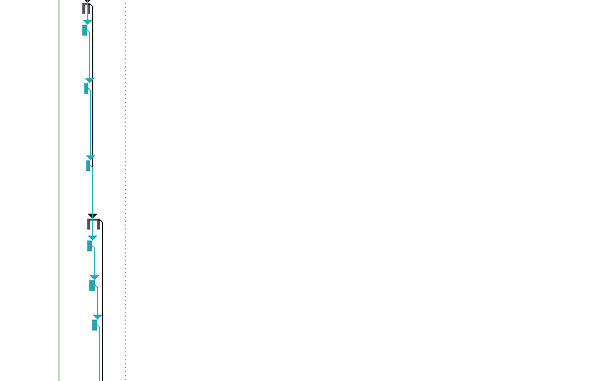


Fig 1. Gantt chart

D. Development Methodology
Agile Scrum is selected because it combines the unpredictability of the user needs and the creation of AI models in the iterative way. The development will be divided into small steps into short sprints to support requirement, data preparation, modelling, interface development and testing. Prioritised product backlog will also make sure that the high-value functionality is met first and user feedback will be used to keep on the subsequent iterations. Waterfall may provide superior sequential documentation and predictable stage development, however, because of their inflexibility, requirement change would be more costly [22]. Agile would therefore be more appropriate but uncontrolled iteration can lead to scope creep. Project control will be ensured by having a defined minimum viable product, sprint objectives and acceptance criteria.
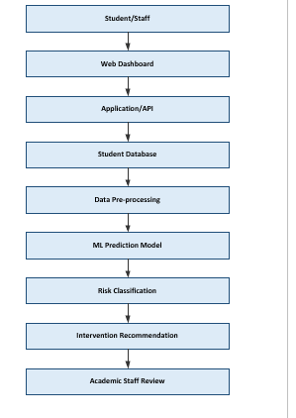
Fig 2: Proposed System Architecture
Data storage, processing, prediction, and presentation are separated by the architecture, which enhances maintainability and provides controlled access to sensitive information [3]. Above all, the end product of the prediction does not necessarily suggest intervention. Risk indicator and context are reviewed by academic personnel, which minimizes the risk of making incorrect automated decisions.
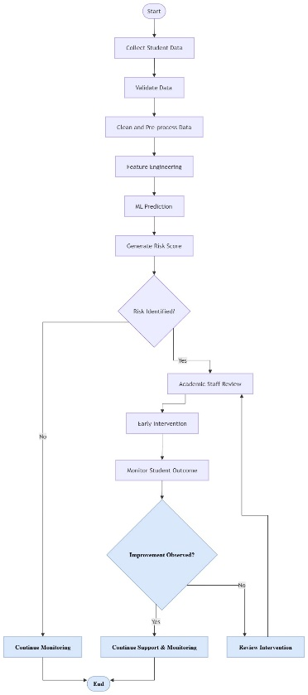

FIG 3: STUDENT PERFORMANCE PREDICTION AND INTERVENTION WORKFLOW
Data validation and preprocessing are essential as wrong, absent or erroneous records may bias predictions. The human-review step is also beneficial to responsible AI since it recognizes that a statistical risk score is not a sufficient indicator of individual student circumstances [4]. Through this, privacy, security, explainability and human supervision are integrated in the design of technical functionality rather than focusing on the accuracy of prediction as the sole measure of project success.

III. TASK 2: INNOVATION

A. PEST Analysis
The suggested AI-Powered Student Performance Prediction and Early Intervention System will operate within the parameters of education technology that is subject to political, economical, social and technological requirements. A PEST analysis can consequently be used in the explanation of the external forces that could either be helpful in innovation or constrain the execution of innovation in the responsible way.
Factor | Key consideration | Critical implication for the project
Political | Government emphasis on digital education, AI governance and data protection | Institutional interest in AI may be greater, and more governance demands add to compliance burdens.
Economic | Cloud infrastructure, development costs and institutional technology budgets | Predictive analytics has potential to streamline student support, though the implementation costs need to be compared to quantifiable benefits to education.
Social | Student trust, accessibility, digital inequality and acceptance of AI-supported decisions | A technically accurate system may still fail if students perceive it as surveillance or unfair profiling.
Technological | Machine learning, cloud computing, predictive analytics and cybersecurity | The fast technological evolution opens the opportunities of better prediction, whereas model obsolescence, cybersecurity, and complexity of integration demand ongoing control.
Table 2: PEST Analysis
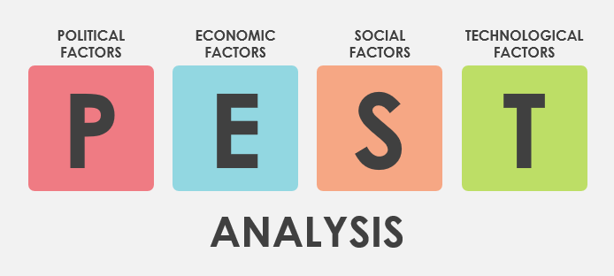
Fig 4: PEST Analysis
The discussion presents one of the key conflicts of innovation: technological capability is not necessarily a producer of educational value. As an illustration, more advanced machine-learning methods might enhance predictive accuracy, yet higher complexity might decrease explainability and human trust [5]. Technical effectiveness and the capacity to generate credible, practical support should therefore be used to evaluate innovation.

B. SWOT Analysis
Strengths | Weaknesses
Earlier identification of potential academic risk | Dependence on high-quality data
Data-informed intervention | Prediction errors
Potentially scalable architecture | Technical complexity
Supports targeted staff intervention | Requires staff adoption and training

Opportunities | Threats
Growth of AI-enabled education | Data breaches and cyberattacks
Integration with institutional systems | Algorithmic bias
Cloud-based scalability | Regulatory changes
Development of wider EdTech services | Low student or staff trust
Table 3: SWOT Analysis
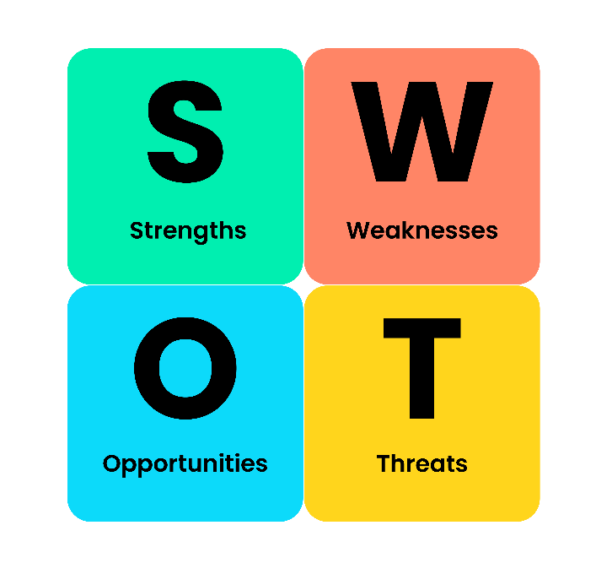
Fig 5: SWOT Analysis
The associations among these factors are more important than the separate categories. Despite the fact that predictive analytics can provide a scalable procedure of identifying the potential risk, it is essential to the quality and representativeness of past records [6]. Biased datasets can recreate the current disparities and there is a tension between scalability and fairness. Likewise, cloud scalability can also decrease infrastructure limitations at the expense of being more dependent on secure third-party services [7]. Therefore, the competitive value of the project is not only in the ability to forecast but the credibility of implementation.

C. Legal and Ethical Considerations
The system would contain educational data which can be sensitive and therefore requires a strong governance. In the UK case, the UK GDPR and Data Protection Act 2018, in particular, lawful processing, data minimisation, security, transparency and proper access controls principles should be considered [8]. The system would only have to collect the information required to achieve its desired purpose and only access the information necessary to the staff depending on their responsibilities.
Ethically, algorithmic bias, explainability, false positives and false negatives require certain attention. False positive can wrongly state that the student is a weak student and false negative can deprive the student of the chance to help him/her in time. Hence, the system must not automatically term students as failures or underprivileged. Instead, predictions should be used as risk alerts that will prompt qualified personnel to consider contextual information to decide whether intervention will be necessary or not [9]. Such a human-in-the-loop approach enhances responsible innovation since it retains professional judgement and employs AI to enhance decision support.

D. Development, Deployment, Maintenance and Evolution
The system should be perceived as a continuous managed socio-technical service rather than just a software product when being introduced in a large organisation. Agile Scrum, requirements, Python, Scikit-learn, Git/GitHub, unit testing and version control would help in delivering iteratively during the development. The predictive model should be evaluated using appropriate measures of performance rather than accuracy because the imbalance in the classes may lead to a model that can seem accurate yet ineffective in identifying actually at-risk students [10].
The secure cloud infrastructure, authenticated APIs, HTTPS, database controls and CI/CD would result in a reliable delivery in deployment [11]. This must be put in place by initially having a controlled pilot to test the technical performance and staff acceptance before it is adopted on a broader scale.
Maintenance would include the software and security updates, database administration, bug fixes, model-performance monitoring and the unanticipated prediction change exploration [12]. Evolution would involve incorporating feedback by the staff, which would be more approachable and understandable and retraining models where it is justified, adding functionality and integration with institutional systems that are thoughtful.
This lifecycle method recognizes the fact that students behaviour, institutional practices and datasets may change over time. Consequently, a model reasonably effective during its preliminary testing may experience data drift or decreasing reliability upon its application in practice [13]. Ongoing observation, regular validation and human control is thus paramount to the ongoing provision of educational value by technological innovation as opposed to augmented automation.

IV. TASK 3: PROJECT REFLECTION

A. Development of New Skills
The project will provide me with an opportunity to change the theoretical knowledge about computing to practical development of an AI application. I already know programming and machine learning, which will act as a platform, but the prototype would require additional mastery over Python, data pre-processing, machine-learning evaluation, database management and API development [14]. In particular, building and testing the predictive model would help me to improve both my abilities to distinguish a technically working model and predictions that are reliable enough to be applied in an educational context.
In the project, practical skills would also be acquired using Microsoft Visio and Microsoft project. Visio would give me a better ability to transform technical requirements into architecture and workflow diagrams as compared to Microsoft project, which would strengthen the process of scheduling, dependency management and milestone control [15]. The implementation of Agile Scrum would also improve the prioritisation of requirements, iterative process of problem-solving and feedback responsiveness. The skills would be applicable to professional software-development environments as good computing practice is both technical and structural in terms of decision delivery.
Most importantly, my critical thinking and professional judgement would be developed as a result of the project. Instead of taking model outputs at face value, I would have to doubt the quality of data, prediction error, bias and potential impact of false classifications. This changes my learning, which is “Can I build the system?” towards the more professionally important question of “Should the system's output be trusted and how should it be used?”

B. Contribution to Society and Value Creation
The project's principal social value is its potential to enable earlier and more targeted academic support. Students The primary social value of the project is that it can enable the provision of earlier and more specific academic assistance. Potentially at-risk students may get the proper academic guidance before they begin to perform poorly. Risk indicators might also be used by academic staff to focus limited support resources instead of solely on the results of retrospective examination [16]. This can assist in improving institutional level of engagement, development and/or retention.
But I realize that technological innovation does not always impact society positively. In cases of systematic inequalities in historical education data, the model can reproduce it and label some groups as high risk in an unequal manner. This leads to a major dilemma between fair treatment and data-efficiency. I would therefore include the testing of fairness, scrutiny by humans, clear explanations and accessibility and other supportive channels. The predictions would be decision-support as opposed to judgements of the ability of a student.
The project can thus be a means of generating value at various levels: students can receive earlier support; staff can receive better information on which they should focus their support and institutions can develop more proactive support processes. The wider benefit to society is that AI can be applied to educational problems provided that human responsibility and moral safeguard is preserved [17].

C. Risks, Challenges and Mitigation
Risk | Probability | Impact | Mitigation
Poor-quality data | Medium | High | Data validation and cleaning
Prediction error | Medium | High | Model evaluation and validation
Algorithmic bias | Medium | High | Fairness testing and human review
Data breach | Medium | High | Encryption and access controls
Scope creep | High | Medium | MVP and prioritised backlog
Low user adoption | Medium | High | User testing and feedback
API/system failure | Medium | Medium | Backup and fallback mechanisms
Limited resources | Medium | Medium | Prioritisation and phased development
The most important risk is data privacy because the illegal release of the information about students can have serious ethical and institutional consequences. Data minimisation, role-based access, secure storage and controlled processing will minimise this [18]. The second important threat is prediction error and algorithm bias. Performance of models will thus be judged through more than accuracy alone with checks of fairness and review of the staff prior to the intervention.
Lastly, the scope and resource constraints might not allow the given functionality implementation within the academic time frame. I would solve this by outlining a minimum viable product, concentrating on the key prediction and dashboard features in an Agile backlog, and delaying unnecessary features. This reflection demonstrates that the technical delivery sufficiency is not sufficient to make the delivery of a project successful and the responsible judgement, prioritisation and continuous evaluation is required.

V. Conclusion
The project has identified the late recognition of students at risk of poor academic performance as a specific problem and provided an AI-Powered Student Performance Prediction and Early Intervention System to facilitate the earlier and more evidence-based intervention. Agile Scrum is appropriate because the iterative development enables testing, feedback and refinement to happen constantly with a regulated minimum viable product. The project innovation is that educational data available can be converted into risk indicators that can be acted without removing the academic judgement. Its possible worth includes higher-timely student assistance and improved resource prioritisation. Nonetheless, the quality of data, accuracy of predictions, bias in algorithms, privacy and resource scarcity is a major limitation. The second phase should then be generalized on controlled prototyping, stringent evaluation and accountable execution.

VI. REFERENCING
- Mehta, R., 2026, February. AI-POWERED EARLY ALERT SYSTEMS FOR IDENTIFYING AT-RISK STUDENTS. In ACE-International Conference (pp. 160-160).
- Wang, C., Zou, J. and Xie, Z., 2024, August. AI-powered educational data analysis for early identification of learning difficulties. In The 31st International scientific and practical conference “Methodological aspects of education: achievements and prospects”(August 06–09, 2024) Rotterdam, Netherlands. International Science Group. 2024. 252 p. (p. 223).
- Arévalo Cordovilla, F.E. and Peña Carrera, M., 2025. AI-driven predictive models and chatbots for early intervention and student success in higher education: A systematic review. International journal of engineering education, 41(6), pp.1473-1488.
- Ullah, N., Akram, S. and Hanif, A., 2025. Ai-powered adaptive learning systems: Personalizing education through real-time data analytics and student behavior modeling. Computing and Applications reviews, 2(01), pp.41-51.
- Gharkan, H.K., Radif, M.J. and Alsaeedi, A.H., 2025. Analysis of AI-Empower Predictive Models for Predicting Student Performance in Higher Education. Journal of Al-Qadisiyah for Computer Science and Mathematics, 17(1), pp.103-121.
- Wang, Y., 2025. Artificial intelligence in student management systems to enhance academic performance monitoring and intervention. Scientific Reports, 15(1), p.35122.
- Herath, D., Dinuwan, C., Ihalagedara, C. and Ambegoda, T., 2024. Enhancing educational outcomes through AI powered learning strategy recommendation system. Int. J. Adv. Comput. Sci. Appl, 15(10), pp.739-748.
- Shete, S.G., Koshti, P. and Pujari, V.I., 2024, April. The impact of AI-powered personalization on academic performance in students. In 2024 5th International Conference on Recent Trends in Computer Science and Technology (ICRTCST) (pp. 295-301). IEEE.
- Luo, Q.Z. and Hsiao-Chin, L.Y., 2023. The influence of AI-powered adaptive learning platforms on student performance in Chinese classrooms. Journal of Education, 6(3), pp.1-12.
- Ilyas, S., Umar, M., Riaz, K. and Tariq, Z., 2025. Emotion recognition in AI-powered classrooms impacts on student engagement and learning outcomes. The Critical Review of Social Sciences Studies, 3(3), pp.86-103.
- Dhanasekaran, P. and Sudha, M., 2026. M., & Forcier, LB (2016). Intelligence Unleashed: An Argument for AI in Education. Pearson.• Zawacki-Richter, O., Marín, VI. Empowering Minds through Smart Knowledge, 71(6), p.211.
- Alam, A., 2023, June. Intelligence unleashed: An argument for AI-enabled learning ecologies with real world examples of today and a peek into the future. In International Conference on Innovations in Computer Science, Electronics & Electrical Engineering-2022 (Vol. 2717, No. 1, p. 030001). AIP Publishing LLC.
- Rodney, B., 2024. Unmoored: The Case for and Confounding of Educational Foundations in the Age of Artificial Intelligence. Journal of Philosophy & History of Education, 74, p.xix.
- Bulathwela, S., Pérez-Ortiz, M., Holloway, C., Cukurova, M. and Shawe-Taylor, J., 2024. Artificial intelligence alone will not democratise education: On educational inequality, techno-solutionism and inclusive tools. Sustainability, 16(2), p.781.
- Sariyya, S., 2026. AI Integration into Secondary Education: Teaching Transformation, Digital Skills Challenges, and the Azerbaijan Case. Dunakavics, 14(7), pp.19-28.
- Russell, S., 2022. Artificial intelligence and the problem of control. Perspectives on digital humanism, 19, pp.1-322.
- Nyholm, S., 2023. A new control problem? Humanoid robots, artificial intelligence, and the value of control. AI and Ethics, 3(4), pp.1229-1239.
- Kutakhov, V.P. and Meshcheryakov, R.V., 2022. Group control of unmanned aerial vehicles: a generalized problem statement of applying artificial intelligence technologies. Control Sci, 1, pp.55-60.
- Yampolskiy, R.V., 2022. On the controllability of artificial intelligence: An analysis of limitations. Journal of Cyber Security and Mobility, 11(3), pp.321-403.
- Ali, A., Ullah, M. and Khan, M.T., 2026. Impact of artificial intelligence-based predictive analytics on improving academic performance in Pakistani universities: The moderating role of digital literacy. Spectrum of Engineering Sciences, 4(3), pp.167-178.
- Almubarak, A., Alhalabi, W., Albidewi, I. and Alharbi, E., 2025. An AI-powered framework for assessing teacher performance in classroom interactions: a deep learning approach. Frontiers in Artificial Intelligence, 8, p.1553051.
- Rızvı, M., 2023. Investigating AI-powered tutoring systems that adapt to individual student needs, providing personalized guidance and assessments. The Eurasia Proceedings of Educational and Social Sciences, 31, pp.67-73.

