

ACADEMIC AND EMPLOYABILITY REPORT
MIHAELA BODE 1916537
ACADEMIC AND EMPLOYABILITY SKILLS
PETER ALLEN

CONTENTS

INTRODUCTION……………………………………………..1
SWOT……………………………………………………………….2
PERSONAL DEVELOPMENT PLAN ANALYSED.
………………………………………………………………………….5

INTRODUCTION

All that I dreamed that maybe I will be able to fulfill a dream that provides for the completion of my studies. And there will not remain a dream hidden in my dream.
In this I will write about Academic and Employability Skill and how this course has helped me to make some decision about my future and set my horizons and ambition me to lead them to fulfillment.
The course help me to analyse me as a person and also to help me to create a SWOT and Personal Development Plan where I set my goals which I want to achieved on the end of this course and also the end of university year.
In this report you will discover all my opinions and goals that I was worked and now are completed.
Everything I was learning at Academic and Employability Skills course I applied at my work place and helped me a lot to understand and to managed the difficult moments easily then before. And also I work a lot at my weaknesses and I become more confident in my self and my attitude is more professional.

SWOT
S-strengths
W-weaknesses
O-opportunities
T-threats
SWOT-is a strategic planning technique used to help a person on organization your plan with your important opportunities.
STRENGTHS
-I have a good organization skills.
-I have ability to work under pressure.
-I am good in what I doing at work.
-I have diversity of experience in different jobs.
-I am enthusiastic person.
-I am highly dedicated person at work.

WEAKNESSES
-I am very emotional person.
-I am very shy in front of large groups.
-I can get stressed easily.
-I am poor at dealing with conflicts.
OPPORTUNITIES
-I have been offered this opportunity to study and to complete my studies.
-I have been offered this occasion to improve my communication and writing skills on English.
-I have the chance to get up from the cleaner position to supervisor or more….
-Also I have the opportunity to learn the digital skills and how to use the modern technologies (laptop, computers etc,).
THREATS
-Life is to expensive and really I need to have a good job and to take care about my family and to offer them a decent life.
-I need to find a job closure because is expensive to traveling.
-Focused on study and on the opportunities and not to leave nothing to disturb me.
-And to leave nothing to disturb me from reaching my goals on this university years.

PERSONAL AND DEVELOPMENT PLAN ANALYSED.
PDP(personal development plan)- is the process of creating an action plan based on awareness, values, reflection, goal- setting and planning for personal development with a context about a career, education and goals for self-improvement.
AUTO EVOLUATION.
I am a simple, dynamic person with a major interest in learning everything new I am a organized person and I have good skills to work under the pressure plus I have a diverse experience in different jobs. And I am always a person dedicated to what I do and ambition helps me never fail.
I never gave up even through I found it was hard even I can say that is a good think for me. But as a person I have some weaknesses to advance in the objectives that I propose and these are:
-I am very emotional.
-I am very shy in front of large groups.
- I can get stressed easily.
-Sometimes I am poor at dealing with conflict.
SETTING THE OBJECTIVES
Plus I will have first to solving the weaknesses of my personality and what expectations I have following my courses at the university and also to following the direction I have chosen.
I am going to create exact a picture in mind with my future and focus it. Plus establishing energy routine on learning and writing exactly a list of objectives that I will have to carry out.
Thanks to the new work place I understand that I can do more and I can advance in my career. Of that I took the decision to study which it give me the opportunity to improve my communication and the writing skills in English and also the chance to learn about the digital skills.
Career and family are the most important aspect and I will use them in my plan to achieve the goals I have set. And also I want to make a aspect also the family and University studies are match perfect when I have all the support from my lovely family.

OBJECTIVES FOR FOLLOWING THE COURSES AT THE UNIVERSITY AND THEIR INFLUENCE ON MY CAREER.
When I started going to University I was afraid and also ii was something new for me and plus this experience is different from school experience I have in past years on my birth country.
Following these courses gives me the chance to learn many things and develop some ideas and that I can apply them at work, and yes I follow the courses and I have also a job at same time.
I made a list with the goals I want to achieve during the University year as;
-as going to improve my oral presentation.
-as going to develop my writing skills.
-as going to spend more time for learning and also to meet new people.
-as going to more with others as groups.
-as going to develop my reading, research and confidence skills.
ACTION PLAN:
Closely following this report plan in career which can be achieved through hard work, perseverance and by showing that I am the best, and to stand through work in the chosen field.
And not choosing the direction to start from one function to another by achieving my set goals only to following just one way. That the direction to successful career will be safer than meeting the criteria that each employer are looking for.
REFERENCES:
Stella Cortell( Palgrave study skills) SKILLS FOR SUCCESS.. The personal development planning handbook 2003.

FEEDBACK LECTURER:
Thank you for your hard work in supporting us and to explain the lessons to us to understand well. To show us where to find materials for find more information. Also you show to us how to be more confidents and not to leave nothing to stay in our way. You are very kind and lovely person. Thank you for your support during this term.

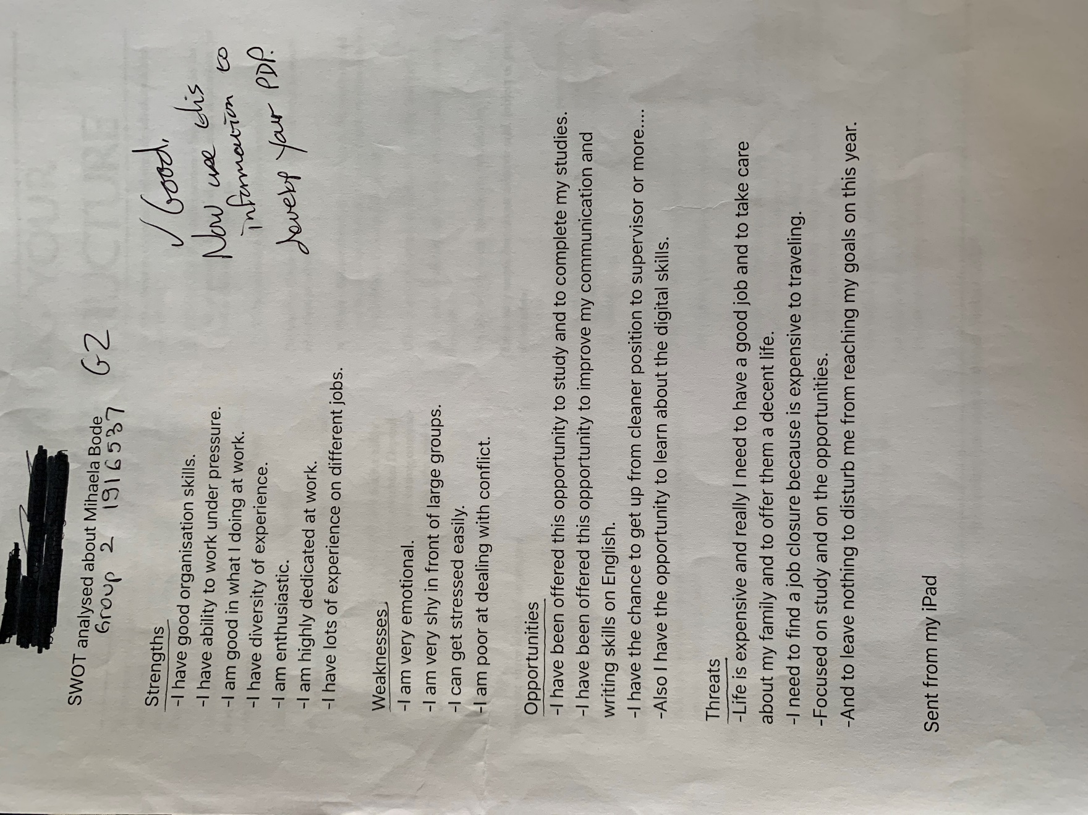

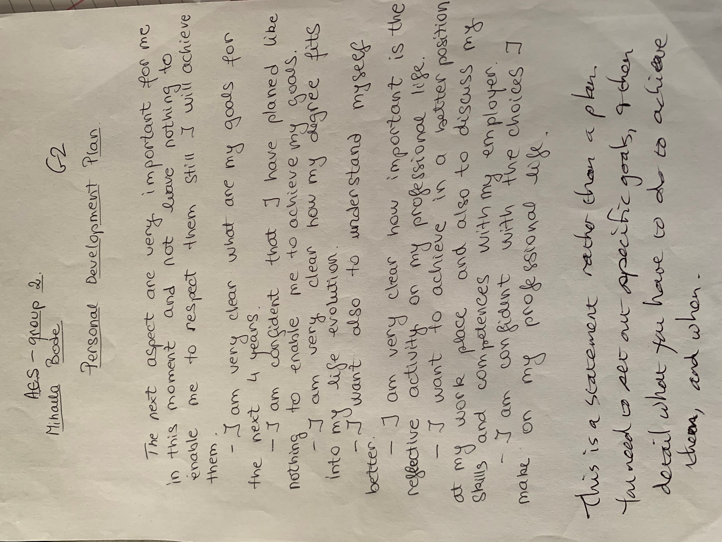

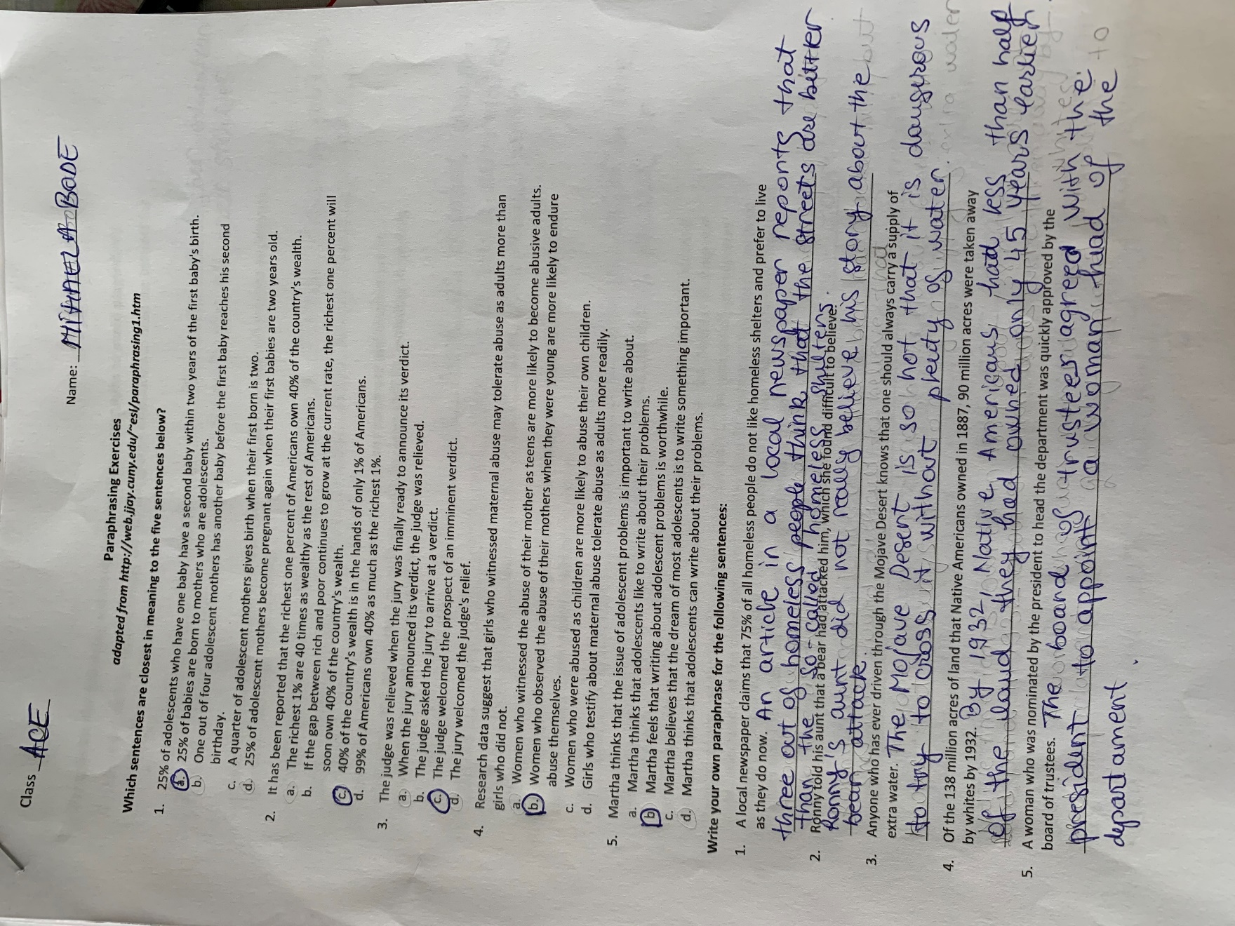

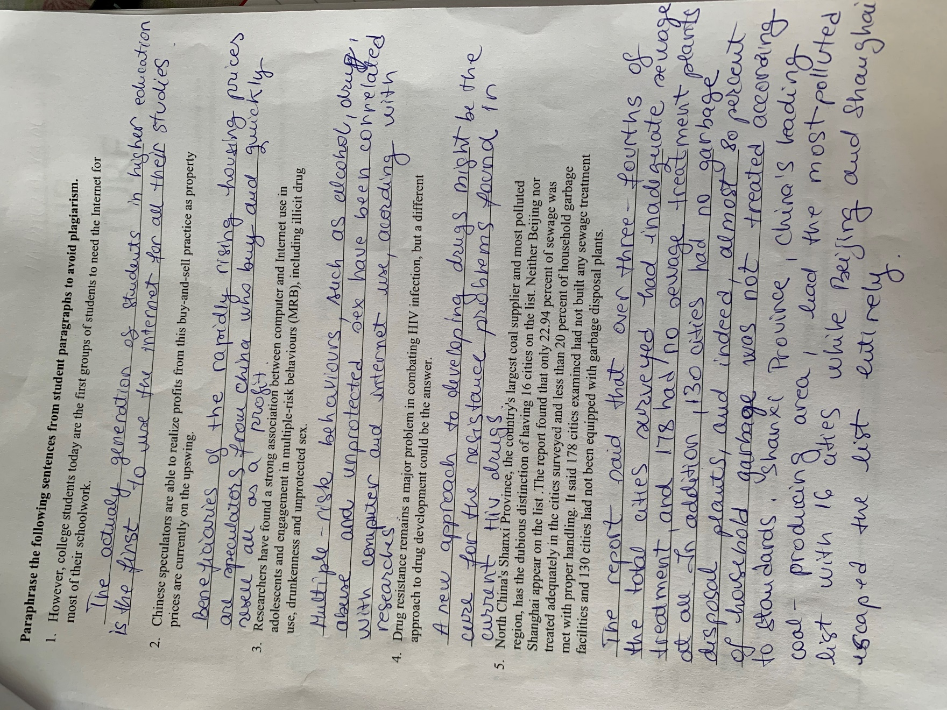 | |



