Digital Skills and Research Methods

ID:1914789

Table of Contents
Table of Contents 2
Introduction 3
Tittle 3
Background and Rationale 3
Aim and Objectives 3
Aim 3
Objectives 3
Methodology 4
Philosophy 4
Approach 4
Data Collection and analysis 4
Primary Data Analysis and Results 5
Secondary Data Analysis 12
Conclusion and Recommendation 13
References 14
Appendix 15
Questionnaire 15

Introduction

Tittle
An analysis of the impact of Virtual Learning Environment (VLE) – Moodle on students’ learning experience at the University of Wales Trinity Saint David London

Background and Rationale
VLE stands for Virtual Learning Environment which is a modern technique of learning and transferring information in a virtual way which aims to provide a good learning experience to the students. In this era of globalization, the necessity of VLE is increasing rapidly as the institutions and students are looking for it. Generally, students and institutes are communicating via the internet and the whole learning process here is done via different online activities (Hiscock, 2020). This online-based learning environment is now becoming very useful for students, advisors, and institutes. University of Wales Trinity Saint David London is also using VLE for the process of learning and it is a very good initiative from the institute. The importance of VLE is a very useful thing to know and the impact of it needs to be analyzed. There are some researches made to know the impact of VLE but it was not enough to have a clear knowledge about VLE (Jackson and Fearon, 2013). This made a scope for the researcher of this research to analyze the impact of Virtual Learning Environment (VLE) – Moodle on students’ learning experience and the researcher has made an analysis over the students and educators of UWTSDL.

Aim and Objectives

Aim
The aim of this research is to find out and analyze the significant impact of VLE Moodle on the learning experience of the students of UWSDL.

Objectives
- To find out the necessary techniques of VLE to ensure appropriate learning to the students.
- To recognize the effects of VLE technique from the view of the UK students.
- To analyze the significant impact of VLE Moodle on the learning experience of the students of UWSDL
- To recommend the appropriate use of VLE for the students of UWSDL and the necessary techniques of it.

Methodology

Philosophy
The researcher wants to have positive thinking and the study of the impact of VLE Moodle on the students of UWSDL has used the positivism philosophy to achieve the objectives of it. The reason for selecting this philosophy is that the researcher wants a positive outcome from the research and wants to think like positivists. The research topic is related to social science and positivism has helped to keep the value of it (Kothari and Garg, 2011). However, the use of positivism philosophy has helped to bring proper outcomes using reliable data and having positive results.

Approach
To find out the significant impacts that VLE Moodle has over the students of UWSDL, the researcher has used the deductive approach. As the researcher has used both primary and secondary sources of data, the qualitative method has been used for the purpose of the research and it is supported by the deductive approach. The strategy of collecting data for the deductive approach is the survey and questionnaire where 100 students of UWSDL have participated. The deductive approach will also help for prevailing literature, values, and perceptions to find out the outcomes of the research (Ellingsen, Størksen and Stephens, 2010).

Data Collection and analysis
For this research, required data has been collected from various sources and both primary data sources and secondary data sources have been used in this research report. For collecting primary data, a questionnaire is developed to collect data in a survey method where 100 students of UWSDL have participated. Primary data will be presented in different graphs, charts, and tables which will make it easy for the user to understand. Again, secondary data has been collected from various reliable and dependable sources such as books, journals, newspapers, reports, websites, etc.

Primary Data Analysis and Results
Primary data was collected through a questionnaire where there were 8 questions for the students of UWSDL. The survey was taken place from 100 students who were selected randomly from UWSDL to get to the research aim and objectives. There were students of different ages, gender, and classes. The reliability and dependability of data were ensured for the research and the survey was made online. For analyzing the collected primary data, all the data has been shown below in different graphs and charts.
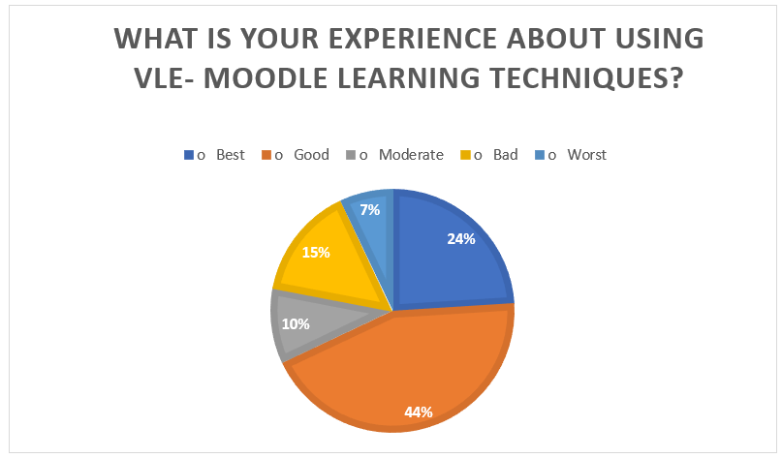
Figure 1: Students' experience using VLE- Moodle learning techniques?
The graph is showing that most of the students are having good experience in using VLE in their learning system. There are 44% of students to get a good feeling about it. Besides, 24% are preferring best and some are thinking that VLE is not good or event it is the worst. However, students have a good experience of using VLE, but it needs to be better or even best. Thus, the Virtual Learning Environment VLE needs to be developed to provide better student experience.
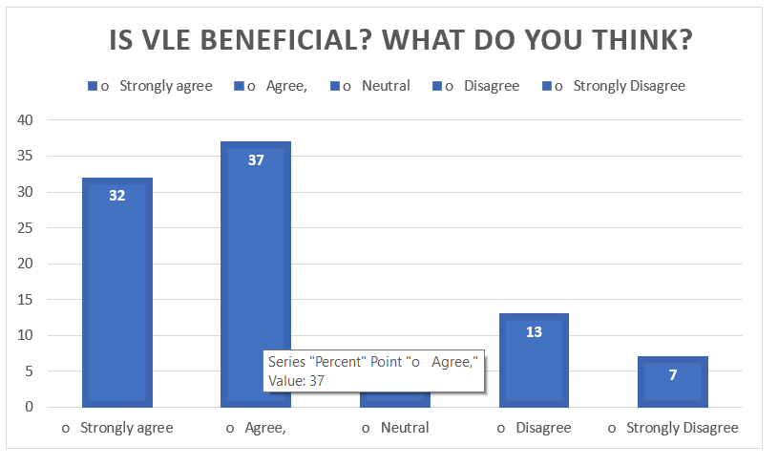
Figure 2: Is VLE beneficial? What the students think.
Most of the students are agreed that VLE is beneficial and the perrhenate is 37% who believed or agreed that VLE is beneficial. Besides, a large number of participants are strongly agreed with it and the graph is showing that 32% of the participants of the survey are strongly agreed. So, we can consider VLE as a beneficial tool for learning. But there are some students who are disagreed and they do not think that VLE is beneficial. So, there are some improvements required for VLE to make it beneficial for all.
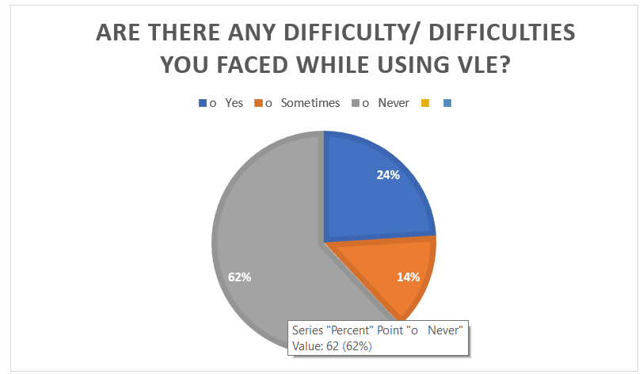
Figure 3: The difficulties faced by students while using VLE

The graph is showing that if the students faced any difficulties while using VLE or not. Here, a large number of students have never faced a problem while using VLE for their learning purpose. But some people really faced some problems. Likewise, 24% of the students have faced problems while using it which is not acceptable at all. Besides, 14% of the students have sometimes faced difficulty which needs to be overcome. However, the use of VLE should be simple, easy, and there should not be any difficulties in using it.
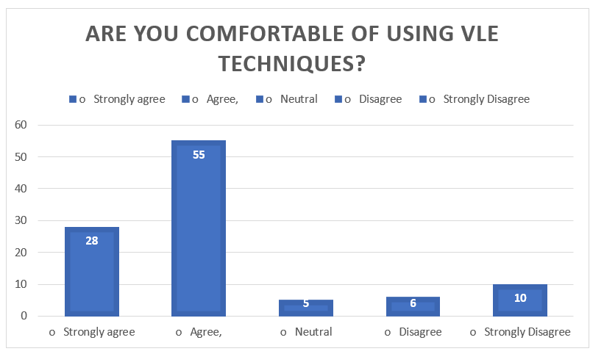
Figure 4: Are students comfortable using VLE techniques?
The above graph is showing that 55% of the students are agreed with the question if they are comfortable with using VLE for their learning system. So, most of the students are comfortable with using VLE. Besides, 28% are strongly agreed which means they are very comfortable with using VLE learning techniques. But there are some students who are not comfortable with it and for this, it needs further development to make it comfortable for all.
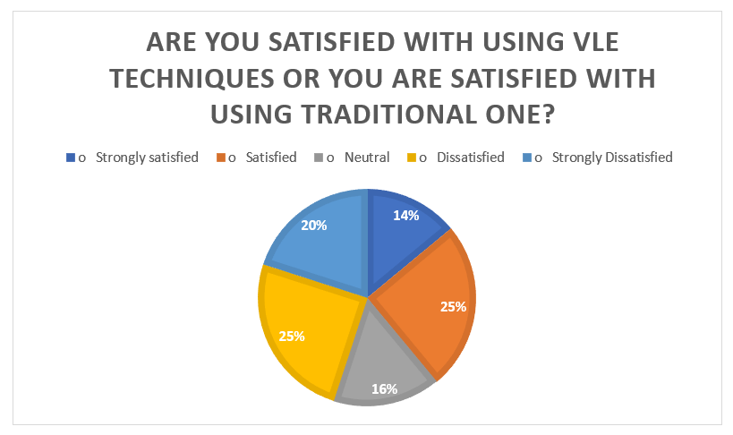
Figure 5: Students satisfaction on VLE Moodle or Traditional way
The chart is showing a mixed reaction of the students about their satisfaction while using VLE for the purpose of learning. Here, 14% of the students are very much satisfied with the learning techniques of VLE and 25% are satisfied with it. But there are almost half of the students who are not satisfied with VLE. From them 25% are dissatisfied and 14% are strongly dissatisfied which is not a good sign at all. However, VLE needs to improve the satisfaction level of the students and provide a better learning environment for them.
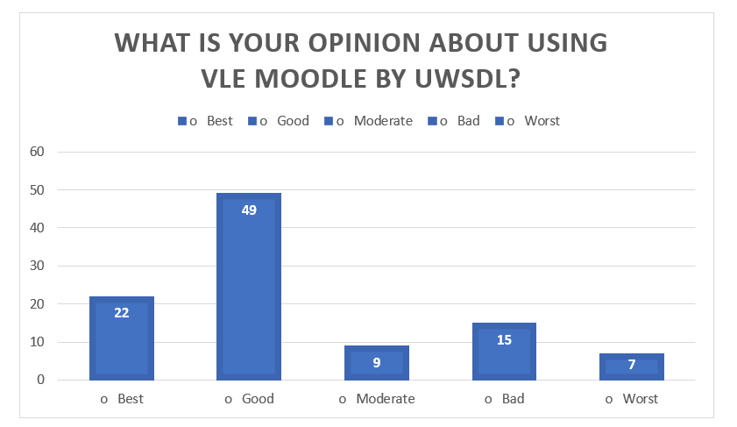
Figure 6: Students opinion about using VLE Moodle by UWSDL
The above graph is showing the opinion of the students of UWSDL about using VLE in their learning system. Here, it is clear that most of the students are feeling good about using VLE in the learning system. In the graph, 49% of the students are having a good experience and 22% are having the best opinion about VLE which is satisfactory. Besides, 15% are having a bad experience and 7% of students are having the worst opinion about VLE Moodle used by UWSDL. So, it makes a scope for VLE for further development according to the student's want.
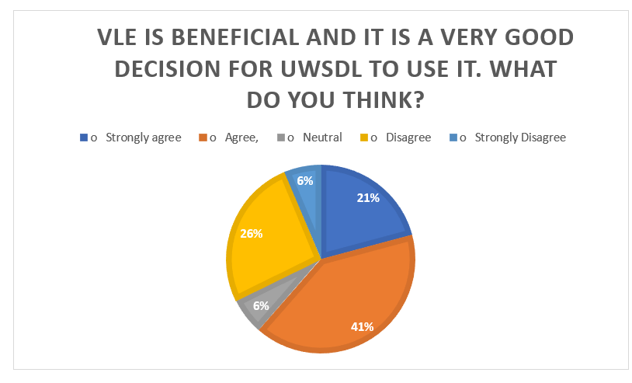
Figure 7: Is VLE beneficial and it is a very good decision for UWSDL to use it.
The chart is showing that 41% of the students are agreed with the decision of UWSDL to bring VLE Moodle in their learning system and they think it is beneficial. Besides, 21% are strongly supporting the decision of implementing VLE in the learning system. On the other hand, 26% of the students have disagreed with the decision and they do not want VLE in UWSDL.
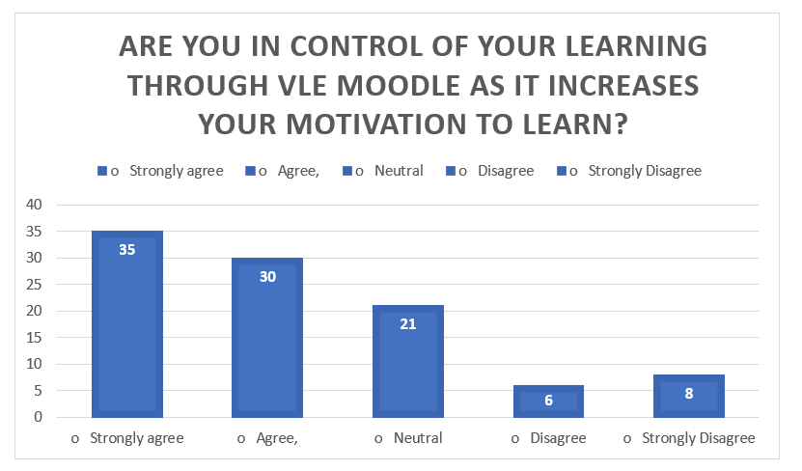
Figure 8: Are the students in control of their learning through VLE Moodle as it increases their motivation to learn?
The graph is showing that most of the students are strongly agreed with the statement that they are in control of using VLE and VLE is increasing their motivation for learning. Besides, 30% are agreed which means they are also getting motivated. 21% of the students are neutral about the statement. On the other side, 6% of the students have disagreed and 8% are strongly disagreed.

Secondary Data Analysis
The world is now becoming very fast and technology is used everywhere. In this modern era, one cannot think of a moment without technology. The use of technology is increasing, and technology is making very simple and tasks easy. VLE (Virtual Learning Environment) is a blessing of the Information and Communication Technology and it is playing a very significant role in the modern learning system. The aim of VLE is to transfer the information which is necessary for learning and it is making the way of learning easy. According to (Livingstone, Kemp and Edgar, 2008) VLE is a suitable system of learning which is very beneficial and will influence the learning system greatly.
There are some significant impacts of VLE on the learning process of the students of the UK. As being a modern and technology-based learning system, the students and the tutors are willing to use the techniques of VLE for the learning process. The students want to have a new and advanced system to get knowledge instead of having the traditional system of learning. A study of (Sun and Liu, 2015) has found that most of the students are willing to use the modern and advanced learning system (VLE). In this modern era, the traditional way is not enough for the students and so they want some additional advanced learning system and VLE can take this place.
The students are getting more interest in using VLE in the learning system which is a great impact on it. Again, VLE is motivating the students in their learning and they are doing well with it. A study of (Manojkumar and Sivaprakash, 2019) has found that the use of VLE is easy and suitable for the students of the UK and it can be very effective. So, there is a very good future of VLE in the UK and VLE has positive impacts on the students of UWSDL.

Conclusion and Recommendation
To conclude, the use of VLE has some positive impacts on the students of UWSDL which is great for the overall learning system, of the UK. The students of UK can get many advantages from the use of VLE and it is much needed. Students need to make the best use of VLE for enriching their knowledge and learning experiences. But there are some negative impacts of VLE too as some of the students are not satisfied with it and they are not convinced with using it. However, VLE needs to be developed within UWSDL in order to get 100% satisfaction from the students.

References
Ellingsen, I., Størksen, I. and Stephens, P., 2010. Research methodology in social work research. International Journal of Social Research Methodology, 13(5), pp.395-409.
Hiscock, C., 2020. International Student Voices and the VLE. International Journal of Computer-Assisted Language Learning and Teaching, 10(3), pp.16-27.
Jackson, S. and Fearon, C., 2013. Exploring the role and influence of expectations in achieving VLE benefit success. British Journal of Educational Technology, 45(2), pp.245-259.
Kothari, C. and Garg, G., 2011. Research Methodology.
Livingstone, D., Kemp, J. and Edgar, E., 2008. From Multi-User Virtual Environment to 3D Virtual Learning Environment. Research in Learning Technology, 16(3).
Manojkumar, M. and Sivaprakash, B., 2019. VLE Prediction of Azeotropic Systems using UNIQUAC and UNIFAC Models and Experimental Validation using Othmer VLE Still. Research Journal of Applied Sciences, 13(3), pp.216-224.
Sun, Y. and Liu, Z., 2015. The study of binary interaction parameters on VLE for alternative refrigerant mixtures. Asia-Pacific Journal of Chemical Engineering, 10(3), pp.476-482.

Appendix

Questionnaire


