

Assessment 1 – Reading Task Template
PART 1: Upload your photo of your A3 in-class notes here:
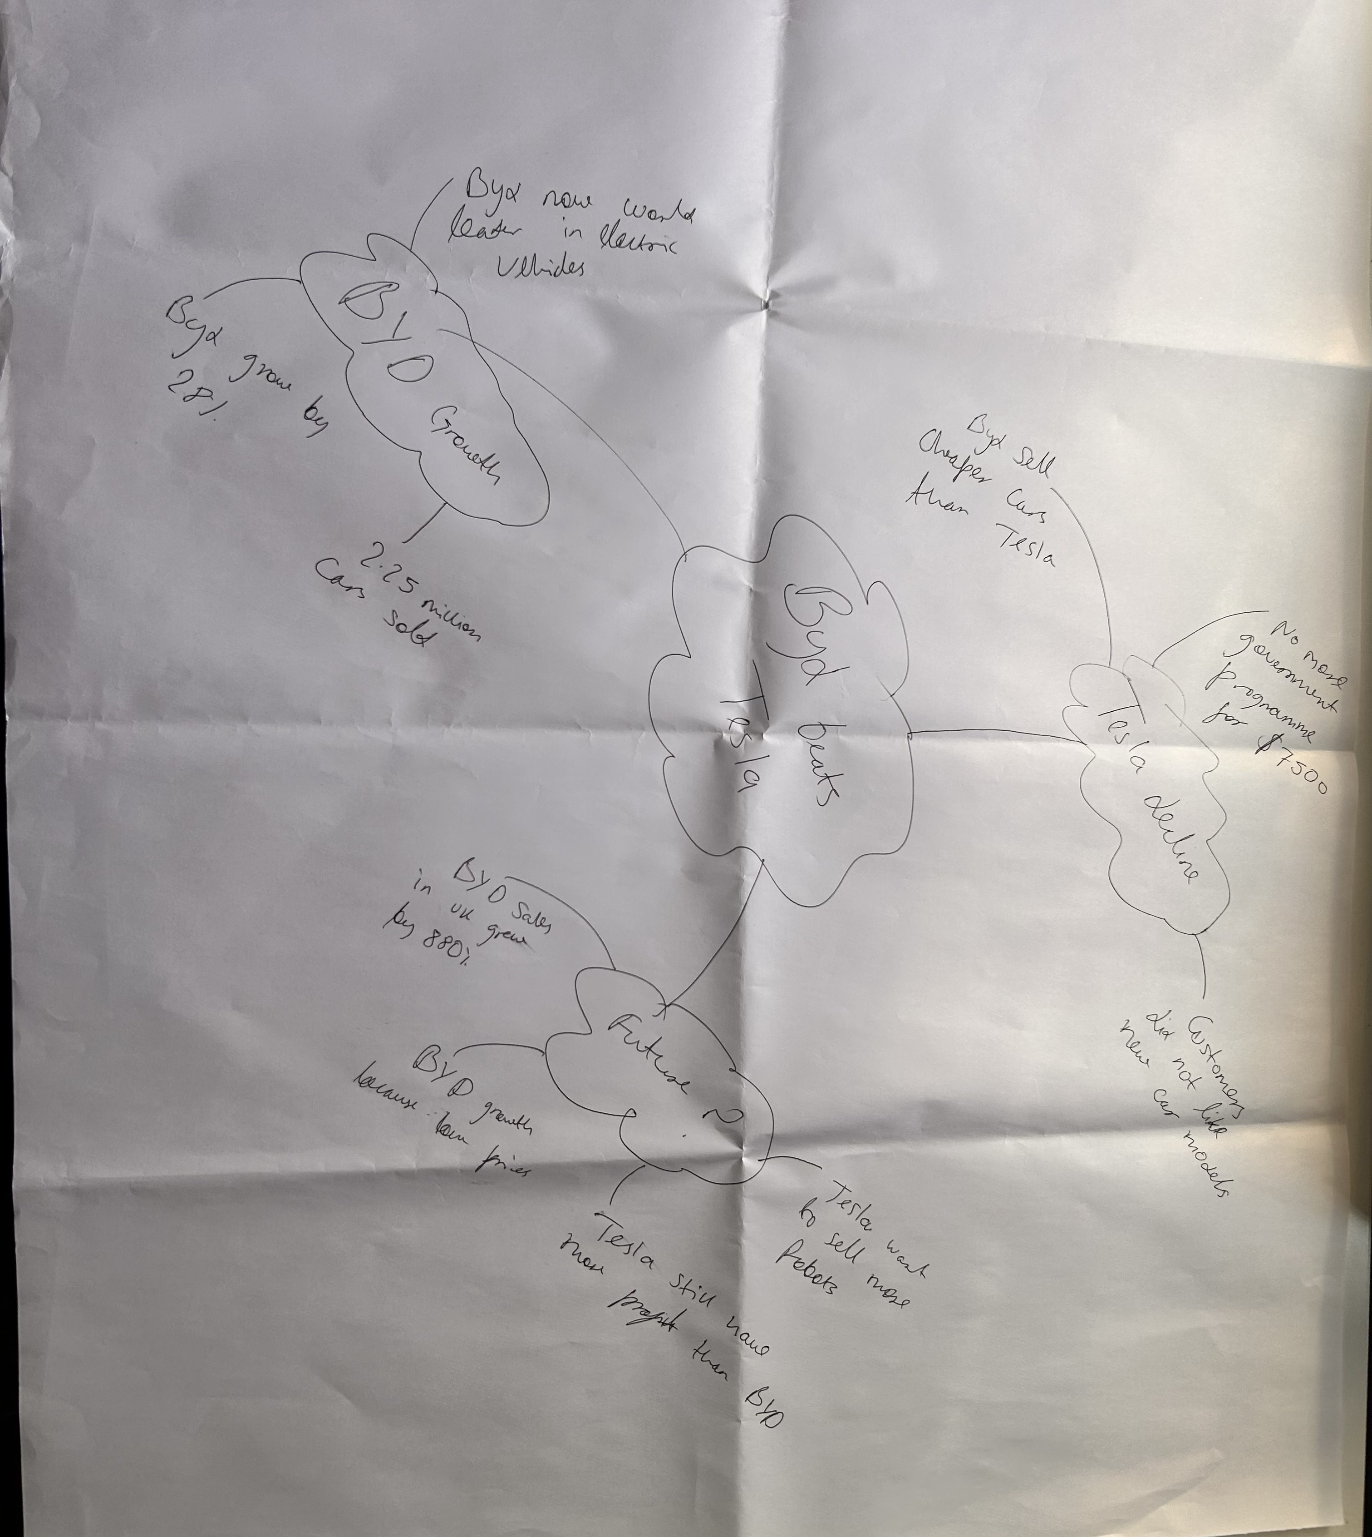

PART 2:
- Answer every question below in 1-3 full sentences.
- Use your own words. Do not use generative AI to answer these questions.
- Include a specific detail from the text when asked.
REMINDER
- The main idea is the overall message of the whole text.
- A key point helps to explain the main idea.
- A specific detail or example from the text shows that the key point is true.

- What is the main idea of the whole text?

The main idea of this text is that social media platforms like TikTok and Instagram have helped small businesses get customers. They can really change how good business perform.

- What is one key point that supports the main idea, and which specific example from the text shows this?

Social media can make people travel from far for shops. Like when customers travelled three hours for chicken burger at Honywood sandwich shop.

- What is a different key point that supports the main idea, and which specific example from the text shows this?

Another example of social media helping is Linda Hunter. She start by selling clothes on Tiktok and now sells across the whole world.

- Which part of the text do you think is most important, and why?

I think part about Linda Hunter is most important because she went from selling on Tiktok and market stall to having a warehouse. She also said this has taken over my life.

Reflection:
- What did you find difficult in this task (including in-class components), and why was it difficult?

I found it hard to pick the main idea of the text because there are so many different stories. It was hard what connected all of them.

- What helped you with this difficulty, and how did it help you?

I tried to see if same words were mentioned again and again to see if I could pick up on the main idea of the text.

