RESEARCH & DIGITAL FORENSIC INVESTIGATION REPORT
Case QT-AI-2025 — Quantum Tech Patent Misappropriation
Module ACCA7031 — Digital Forensics Analysis (Tasks 1 & 2)
Field | Complete before submission
Student name | Diyaben Patel
Student ID | 2523935
Investigator / Examiner
Date | 12/08/26
Word count | Task 1 -1000 · Task 2 report -2,100

PART A — TASK 1: RESEARCH REPORT

Introduction
Digital forensics is the branch of forensic science concerned with the identification, preservation, examination and presentation of digital evidence in a legally admissible manner (SentinelOne, 2025). As everyday life and criminal activity have become increasingly digitised, the discipline has grown from a niche law-enforcement capability into a core element of both criminal justice and corporate security. This report critically reviews the current state of the field and its tools, the intersection of digital forensics with cybersecurity, emerging trends, key challenges, and the national and international job market.

1. Current State of the Field and Tools
The digital forensics market is expanding rapidly and is projected to reach approximately US$18.2 billion by 2030, at a compound annual growth rate of around 12.2%, driven by the proliferation of connected devices, cloud computing, artificial intelligence and the Internet of Things (SalvationData, 2025). The contemporary toolset reflects a division between powerful commercial suites and capable open-source alternatives. Cellebrite remains the market leader in mobile forensics: its UFED and Physical Analyzer platforms extract and parse data from locked handsets, and in 2025 the platform introduced a cloud collaboration version alongside AI enhancements that reduce case-review time and can even detect AI-modified images (TechTarget, 2025). Magnet AXIOM offers a unified processing engine that ingests computer, mobile, cloud and vehicle data into a single case file, with strong automation and an accessible interface (TechTarget, 2025). At the open-source end, Autopsy and FTK Imager provide effective disk imaging and file-system analysis at no cost, although they are comparatively weak on mobile and cloud acquisition (TechTarget, 2025). Tools in common use in 2025 include FTK Imager, Autopsy, EnCase, Wireshark and Cellebrite UFED/Physical Analyzer (TechTarget, 2025), and modern platforms increasingly rely on data carving, indexing and parallel processing to manage growing data volumes. The central trade-off is capability against cost: commercial suites are powerful but expensive, whereas open-source tools are accessible but narrower in scope — a trade-off encountered directly in the practical investigation reported in Part B, where Cellebrite's automated parsing was combined with free tools (DB Browser for SQLite, FTK Imager) for cross-verification.

2. The Intersection of Digital Forensics and Cybersecurity
Digital forensics and cybersecurity converge most clearly in the discipline of Digital Forensics and Incident Response (DFIR), which combines forensic investigation with structured incident handling to detect, analyse, contain and recover from security incidents (SentinelOne, 2025). Although related, the two functions are distinct: incident response is concerned with real-time detection, containment and recovery, whereas forensics focuses on the systematic collection and analysis of evidence after an event (TechTarget, 2025). They are nonetheless interdependent, because forensic findings inform containment decisions while response actions must be conducted so as to preserve the evidential trail for root-cause analysis and any subsequent legal proceedings (CrowdStrike, 2025). This work is typically delivered by computer security incident response teams comprising forensic analysts, incident responders, malware reverse-engineers and threat hunters (SentinelOne, 2025). A persistent tension exists between the operational pressure to contain an incident quickly and the forensic requirement to preserve volatile evidence intact, and managing that tension is central to effective DFIR.

3. Emerging Trends
Several trends are reshaping the field. The most significant is the adoption of artificial intelligence and machine learning to automate triage, filter large log sets and detect anomalies, substantially reducing the time investigators spend manually sifting data (Belkasoft, 2025) — a capability directly reflected in Cellebrite Physical Analyzer's automated app-decoding and insights modules used in Part B. Cloud forensics is growing in importance as evidence becomes dispersed across multiple platforms, devices and jurisdictions, complicating acquisition and preservation (SalvationData, 2025). The expansion of the Internet of Things and connected vehicles has created new sources of evidence but also new difficulties, owing to device heterogeneity, limited on-device resources and dispersed data (Oxygen Forensics, 2025). Finally, moves towards greater international legal harmonisation are influencing how cross-border evidence is collected and preserved (SalvationData, 2025). These developments are double-edged: while AI accelerates analysis, it also raises concerns about the explainability and admissibility of AI-assisted findings and the risk of AI-generated or manipulated evidence.

4. Key Challenges
The field faces several enduring challenges. Encryption is foremost: it is estimated that around 68% of cybercriminals use encryption to conceal evidence, and encrypted applications and secure storage can render data effectively inaccessible without the relevant keys (SalvationData, 2025). This challenge was encountered directly during the practical investigation reported in Part B, where WhatsApp data on three of the four seized devices was stored in encrypted .crypt14 form and could not be read. The sheer volume and diversity of data present a second challenge, as modern smartphones hold vast and varied datasets and newer devices ship with stronger encryption and more complex operating systems (SalvationData, 2025). Anti-forensic techniques such as steganography and secure data wiping actively frustrate investigations (IJRASET, 2024), while the volatility of digital data, cloud and IoT jurisdictional complexity, and the need for strict legal compliance further constrain practitioners (SalvationData, 2025). Together these factors mean that even a technically thorough investigation may recover only part of the available evidence.

5. National and International Job Market
Demand for digital forensic skills is strong but the supply of qualified practitioners is constrained. In the United Kingdom, the annual shortfall in the cyber workforce is estimated at around 11,200 people, and 28% of cyber-sector businesses report a technical skills gap, up from 18% in 2021 (GOV.UK, 2025). Digital forensics remains a specialised niche, employed by only around 8% of firms, yet demand is rising across policing, government and the private sector (GOV.UK, 2025). UK salaries range from approximately £29,000 for entry-level analysts to between £40,000 and £61,000 for senior investigators (IT Jobs Watch, 2025), and around 67% of cyber employers expected to grow their workforce over the following year (GOV.UK, 2025). Internationally, the persistent global cybersecurity workforce gap reported by industry bodies such as (ISC)² indicates comparable demand worldwide. Professional certifications, such as EnCE, GIAC GCFA/GCFE and Cellebrite's own certifications, are valued by employers and improve employability. For new entrants, the skills gap represents a clear opportunity.

Conclusion
In summary, digital forensics is a maturing and fast-growing discipline that is converging with cybersecurity through DFIR, being transformed by artificial intelligence, cloud and IoT, and constrained above all by encryption and the sheer volume of data. For those willing to specialise, it offers strong and durable career prospects in both national and international markets, as the practical investigation in Part B demonstrates.

References (Task 1)
Belkasoft (2025) Top Trends in Digital Forensics and Incident Response for 2025. Available at: https://belkasoft.com (Accessed: August 2026).
CrowdStrike (2025) Digital Forensics and Incident Response (DFIR). Available at: https://www.crowdstrike.com (Accessed: August 2026).
GOV.UK (2025) Cyber security skills in the UK labour market 2025. Available at: https://www.gov.uk (Accessed: August 2026).
IJRASET (2024) Digital Forensic: Techniques, Challenges, and Future Direction. Available at: https://www.ijraset.com (Accessed: August 2026).
IT Jobs Watch (2025) Forensic Analyst Job Trends, Salaries & Skill Sets. Available at: https://www.itjobswatch.co.uk (Accessed: August 2026).
Oxygen Forensics (2025) Key Trends Shaping the Future of Digital Forensics in 2025. Available at: https://www.oxygenforensics.com (Accessed: August 2026).
SalvationData (2025) Key Trends in Digital Forensics for 2025. Available at: https://www.salvationdata.com (Accessed: August 2026).
SentinelOne (2025) What is Digital Forensics and Incident Response (DFIR)? Available at: https://www.sentinelone.com (Accessed: August 2026).
TechTarget (2025) Digital forensics tools experts use. Available at: https://www.techtarget.com (Accessed: August 2026).

PART B — TASK 2: DIGITAL FORENSIC INVESTIGATION REPORT

1. Case Background and Scope
Quantum Tech's IT security team detected unauthorised access to its proprietary patent database, specifically the AI chip design patent identified as QT-AI-2025. Initial enquiries identified Emma, a recently appointed senior engineer, as the primary suspect, believed to have attempted to steal and sell the patent to a competitor through an intermediary. Four mobile devices were seized under continuity-of-evidence protocols: a Huawei P Smart, a Samsung Galaxy A13, a Nokia C2 2nd Edition and a Ulefone Note 14. The company referred the matter to law enforcement, and these findings are intended to support any subsequent legal action for corporate espionage and theft of intellectual property. The scope of the investigation was to verify evidence integrity, analyse the communications, contacts, email, social media, location and file data on each device, reconstruct a timeline, and determine each party's role — confined strictly to the evidence provided, with no inference drawn beyond what the data supports.

2. Evidence Inventory and Chain of Custody
The four devices were acquired on 28 October 2025 using Cellebrite UFED 4PC on examiner workstation UOW3609, with the case identifier, examiner name and evidence number recorded for each device before any data was pulled (Figure 3) — the first entry in the chain of custody, and a prerequisite for admissibility (ACPO, 2012). All analysis was conducted on forensic copies rather than the seized media. Integrity was verified twice, independently: the SHA-256 hash of each extraction was recomputed using the Windows PowerShell Get-FileHash cmdlet and compared with the value recorded in the corresponding Cellebrite acquisition (.ufd) file (Figure 1), and each extraction was separately re-verified inside Cellebrite Physical Analyzer's own Extraction Summary module (Figure 2). As Tables 1 and 2 show, every extraction matched under both tools — confirming the evidence had not been altered since acquisition, and providing a stronger basis for admissibility than reliance on a single utility.
Table 1. Devices examined.
Device | Acquisition type | IMEI | Integrity
Huawei P Smart (POT-LX1) | Full filesystem | 860962043462662 | PASS
Samsung Galaxy A13 (SM-A137F) | ADB backup | 357898921470825 | PASS
Nokia C2 2nd Edition | ADB backup | 353766763818217 | PASS
Ulefone Note 14 | ADB backup | 355617730545771 | PASS
Table 2. SHA-256 hash verification — recomputed value equals the value documented in the .ufd file and independently confirmed in Physical Analyzer, for every extraction.
Extraction | SHA-256 (documented = recomputed = Physical Analyzer) | Result
Huawei — Full filesystem | D5193DBF8246C09FDDE73BE8558343985AB24A2E1C142E4D64E16E2B6507E31F | MATCH
Huawei — ADB backup | D2A9A46FC50EC06C51AABDB1448E5DE65E9394729A34FBF0AA8261A5771413DE | MATCH
Samsung Galaxy A13 | 0E585C4FE8160254253BE515A16FF94B7FDF88B248B67D45CFDEF8753A9A3195 | MATCH
Nokia C2 2nd Edition | A693656C260E339069756BE8005346E97033D0CCF2F79ADD56CD69C9EADE13AB | MATCH
Ulefone Note 14 | 630724E2F8863ADB9C4F7DF1AB645E56C19A832D546FE7AB55B0CEBF8EA7BEFD | MATCH
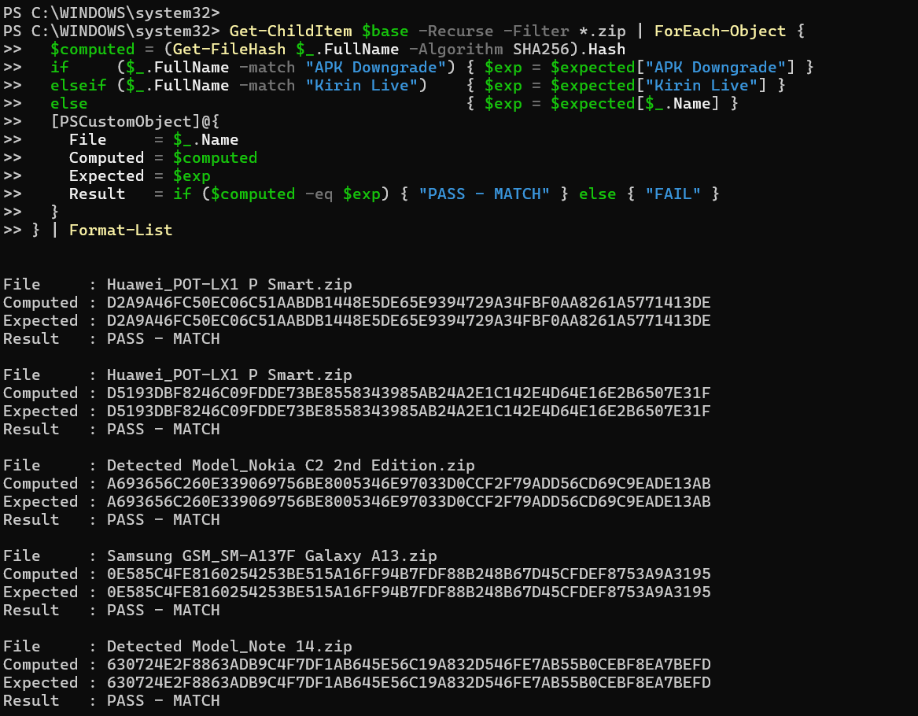
Figure 1. PowerShell SHA-256 verification — all five extractions returned an exact match against the .ufd record.
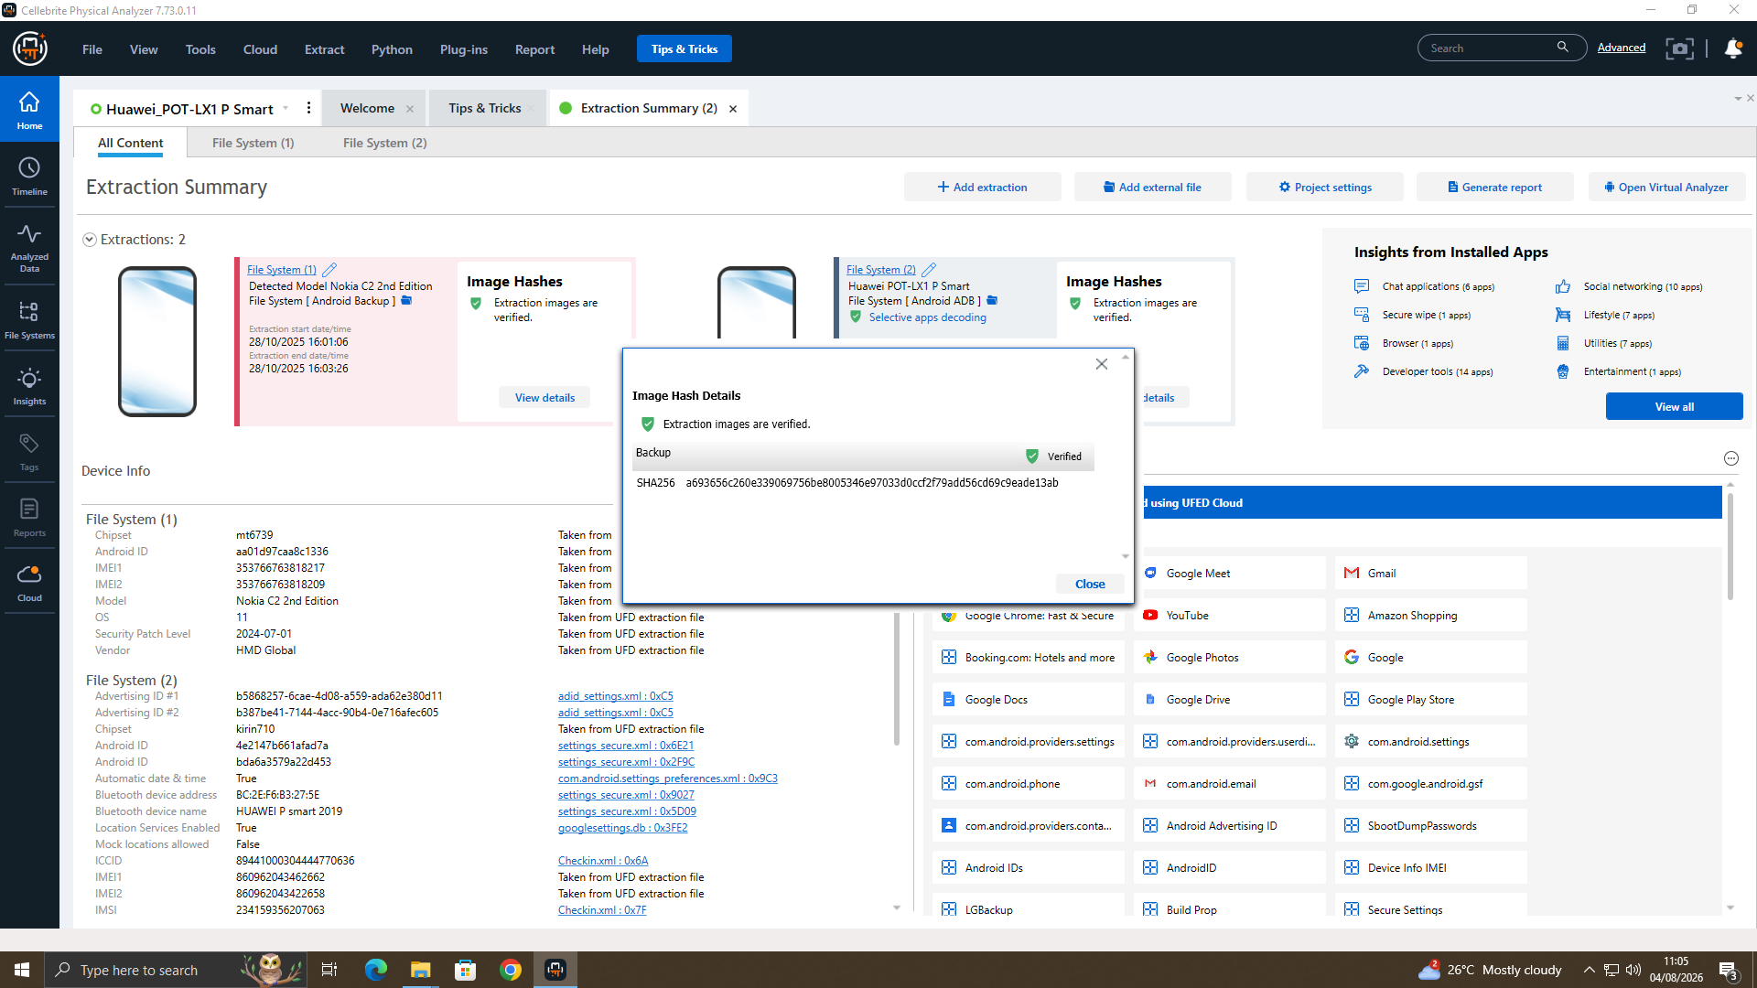
Figure 2. Cellebrite Physical Analyzer — Extraction Summary and Image Hash Details for the Nokia C2 extraction, independently confirming the SHA-256 verified above.

3. Methodology
A consistent workflow was followed for every device: Create case → Acquire → Verify → Examine → Correlate → Report (Figure 5 shows all four extractions loaded together at the Examine stage). Acquisition used Cellebrite UFED 4PC (Cellebrite, 2025): each device was connected through UFED's guided Device Wizard, with the case identifier, examiner name and evidence number recorded before any data was pulled (Figure 3), and a broad content-type selection used so no relevant category was excluded. Only the Huawei returned a full filesystem image; the Samsung, Nokia and Ulefone were ADB backups, with consequences examined in Section 4.10. Figure 4 shows the resulting Huawei extraction summary — 1,053 contacts, 1,240 SMS, 3,000 call logs, 443 calendar entries and completed location data — confirming sufficient scope for the analysis below. Examination was carried out in Cellebrite Physical Analyzer (Cellebrite, 2025), whose Analysed Data pane automatically categorises chats, contacts, emails, social media, calls and locations, and which was configured with hash-set screening and selective app decoding. Where automated parsing was incomplete or a finding needed verifying against raw data — notably WhatsApp and Instagram — the underlying application databases (msgstore.db, direct.db, calls.db) were cross-checked directly in DB Browser for SQLite in read-only mode, and individual artefacts were exported and re-hashed (MD5/SHA-1) in FTK Imager. Combining automated triage with manual database cross-checking is consistent with established practice (NIST, 2014) and ensured that no single finding relied on one tool's interpretation alone.
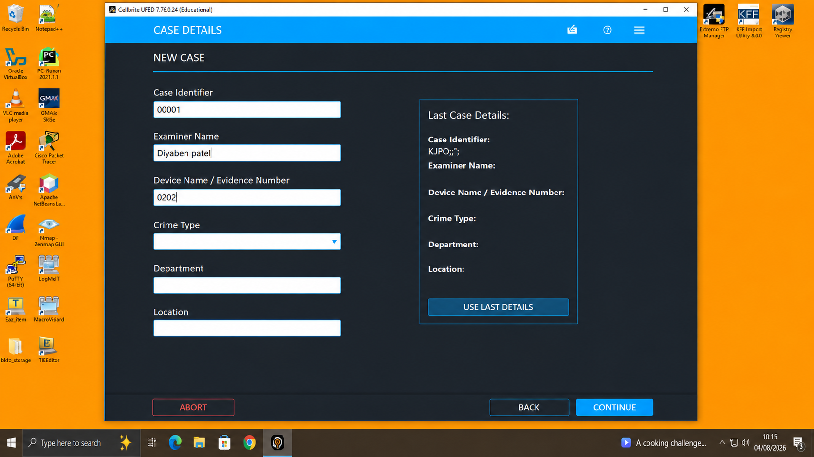
Figure 3. Cellebrite UFED 4PC — case identifier, examiner name and evidence number recorded before acquisition.
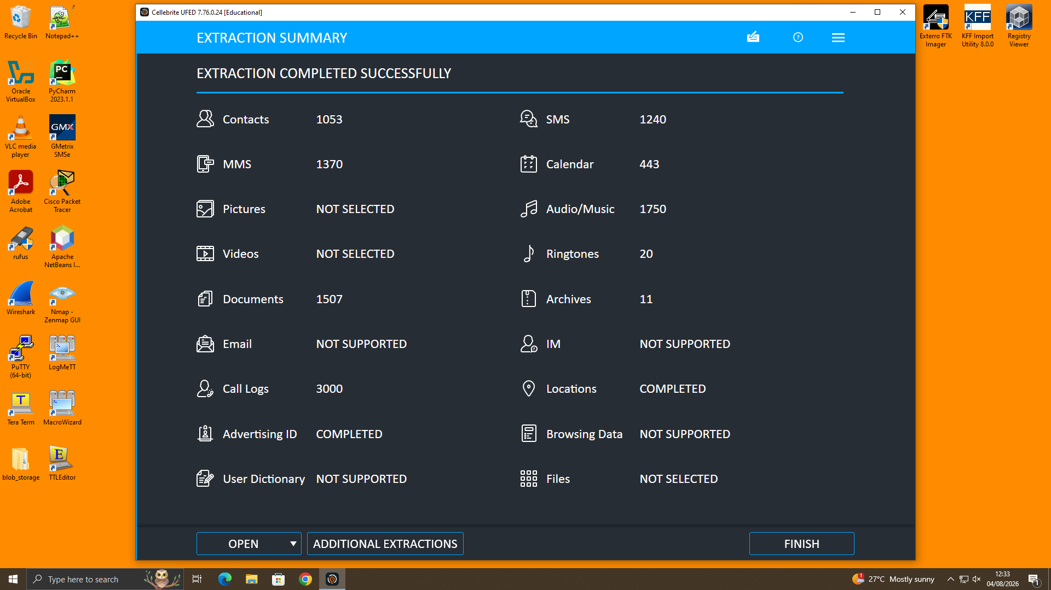
Figure 4. UFED extraction summary — 1,053 contacts, 1,240 SMS, 3,000 call logs and 443 calendar entries recovered.
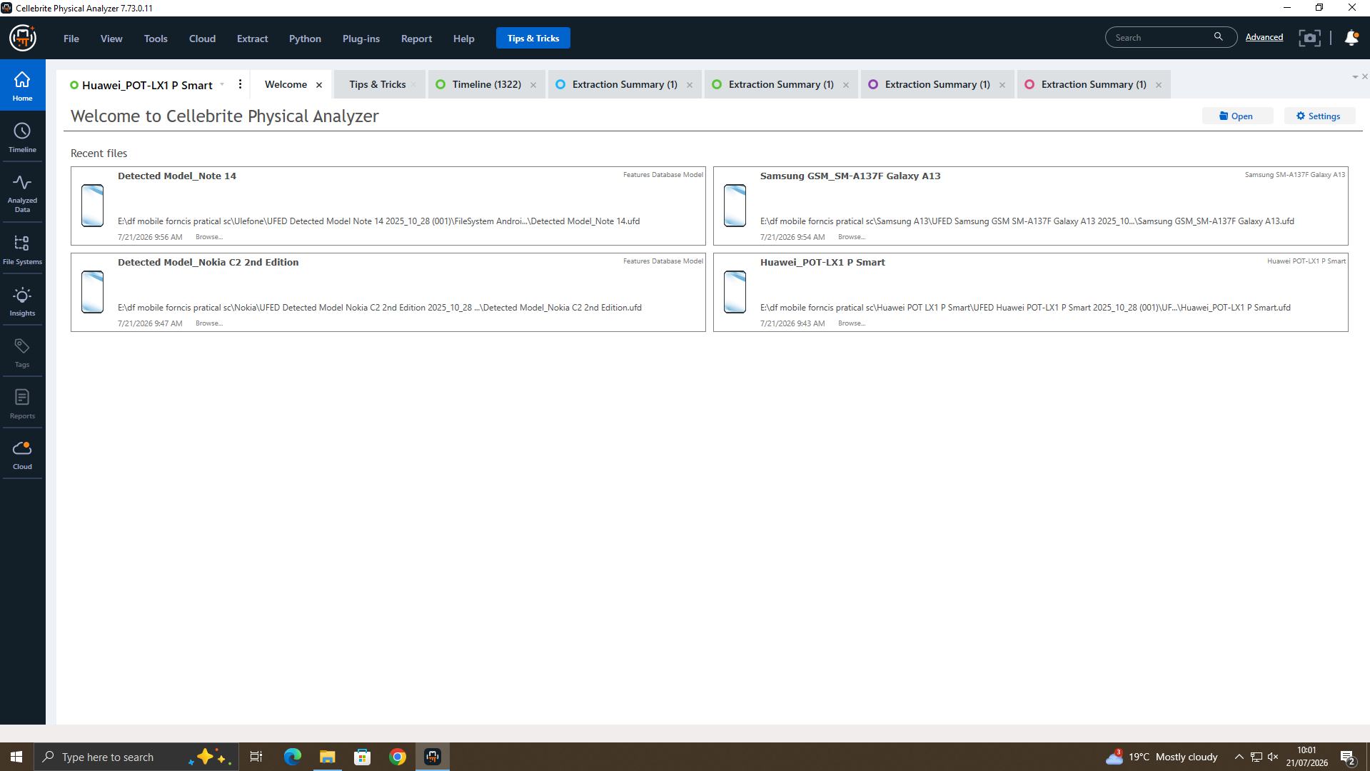
Figure 5. All four extractions loaded together in Cellebrite Physical Analyzer for examination.

4. Findings

4.1 Device Attribution
Only the Huawei P Smart yielded readable, patent-relevant communications, because it alone was acquired as a full filesystem image, with application-private databases captured in an unencrypted state. Physical Analyzer's Chats module lists the device owner as 'Peter Dover (owner)' across all four recovered threads (Figure 6). Cross-checked against the WhatsApp database, the owner's contacts included 'Joe Marsh', and Joe repeatedly addresses the device's owner as 'Emma' in the recovered messages (Section 4.3). The device was accordingly attributed to Emma, and underpins the findings in Sections 4.2 to 4.9.
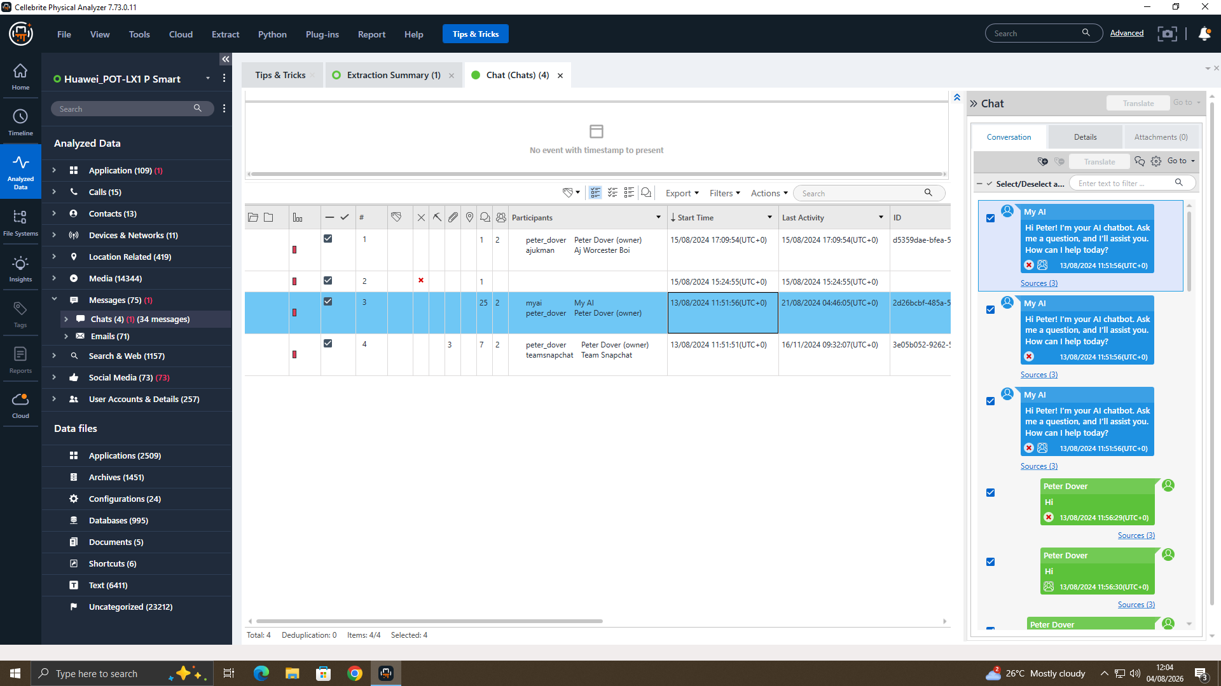
Figure 6. Physical Analyzer Chats module — the device owner recorded as 'Peter Dover (owner)'.

4.2 Contacts and Identity Corroboration
The Contacts module recovered 13 entries from the Huawei device (Figure 7), including 'Joe Marsh' (saved as 0044 7476 5386…) and an entry saved only as 'SA No.' (+447917162891). Both numbers corroborate identities already suggested by the message content: Joe Marsh as the party engaged in the WhatsApp conspiracy (Section 4.3), and 'SA No.' as the contact linked to the repeated call attempts and personal images examined in Section 4.7 — matching a saved contact name to a number seen in conversation is what ties an intermediary to a real identity rather than a bare phone number.
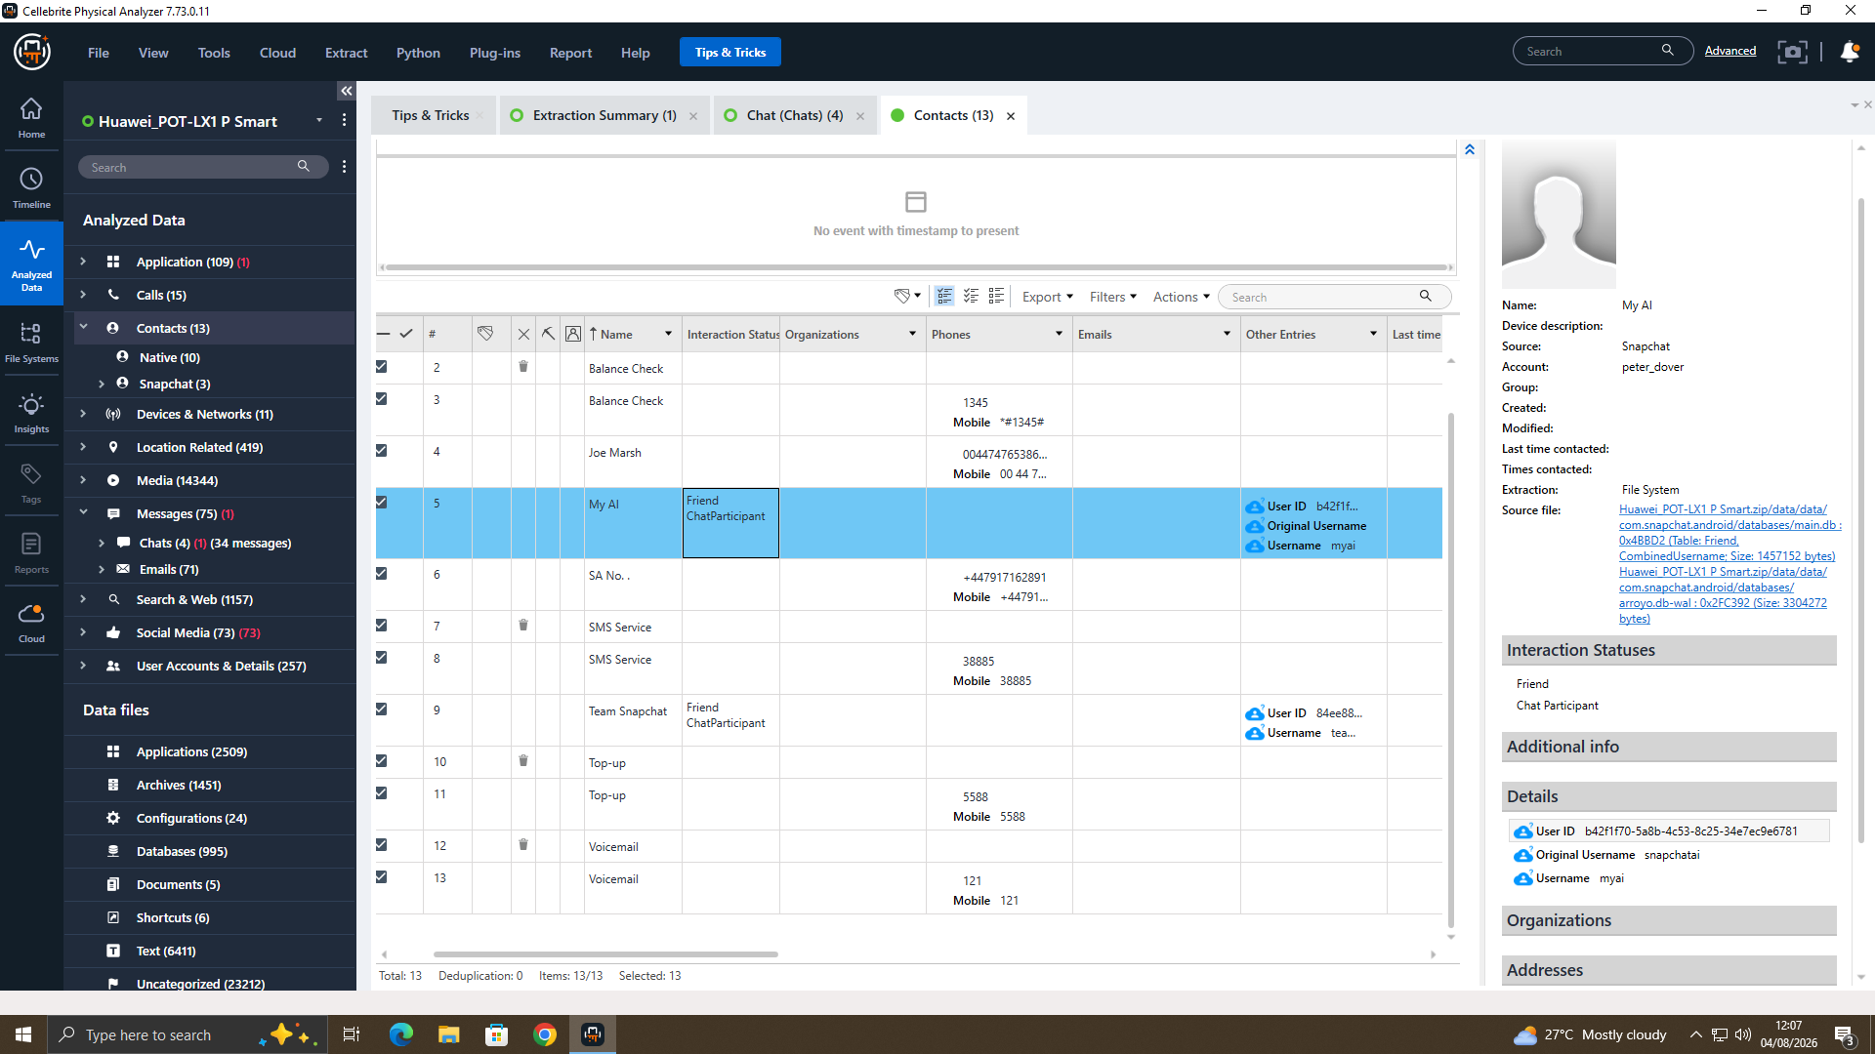
Figure 7. Physical Analyzer Contacts (13) — 'Joe Marsh' and 'SA No.' saved on the Huawei device.

4.3 WhatsApp Communication Analysis (Emma and Joe)
The core evidence is a WhatsApp conversation between Emma and Joe Marsh (+447476538686), comprising 26 messages between 21 August 2024 and 31 January 2025, recovered from msgstore.db and cross-checked in DB Browser for SQLite (Figure 8). On 21 August 2024 Emma stated she needed help 'with something sensitive': 'I have access to some highly valuable information … our new AI based Neuro product. I'm thinking about selling it to someone interested,' asking Joe to 'find the right buyer' and to 'keep this under wraps'. Joe subsequently reported sourcing potential buyers in Glasgow, Manchester and Paris. The negotiation culminated on 31 January 2025 (Figure 9): Joe asked whether Emma could provide 'a demo sample'; she replied 'Impossible. But a detailed breakdown? Yes. How's the offshore arrangement?'; Joe answered 'He's good with it. 5M secured. Waiting for confirmation.' These exchanges establish sustained intent to misappropriate and sell proprietary intellectual property for financial gain — the five-month span indicating deliberate, ongoing planning rather than an isolated remark.
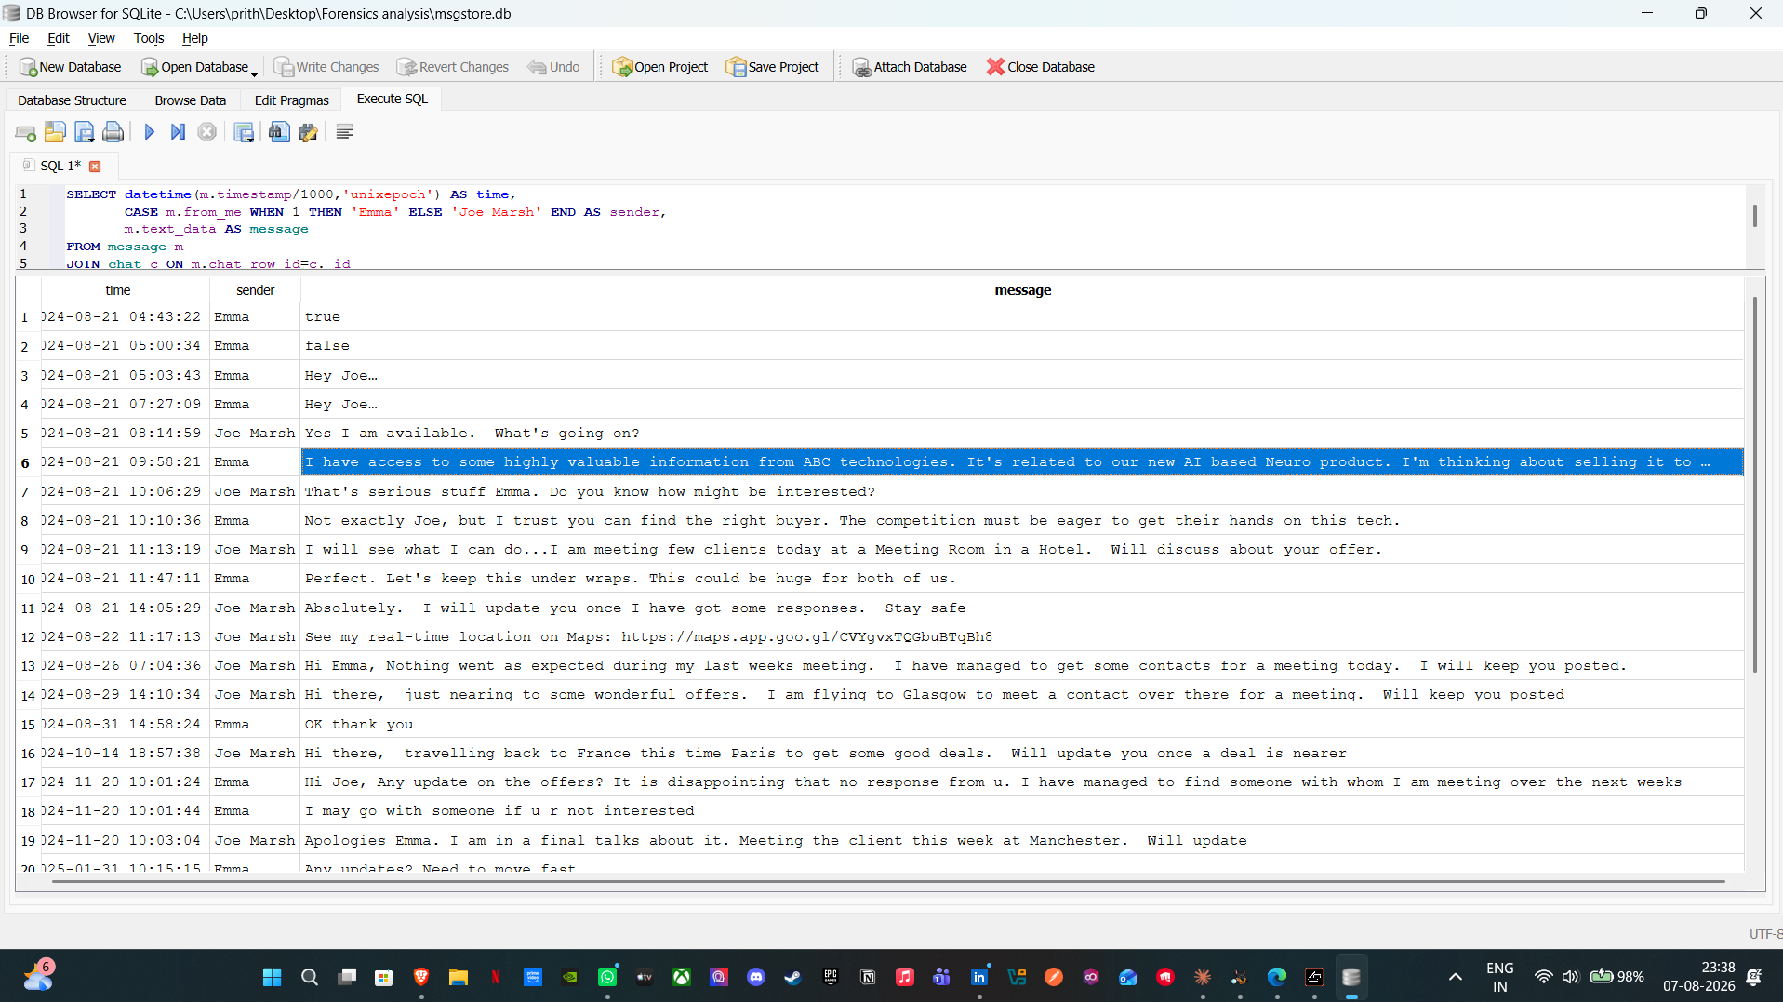
Figure 8. WhatsApp conversation between Emma and Joe Marsh (msgstore.db, cross-checked in DB Browser for SQLite).
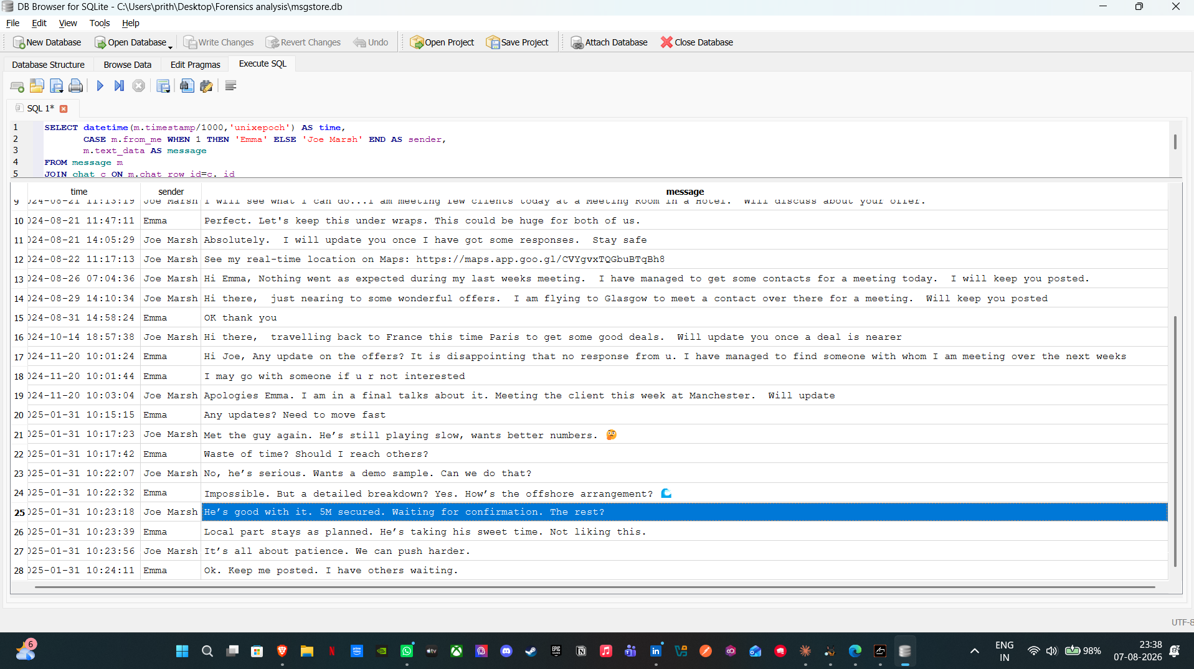
Figure 9. The 31 January 2025 negotiation, including the '5M secured' and 'offshore arrangement' messages.

4.4 Instagram Direct Messages
Physical Analyzer's automated Social Media module surfaced only Snapchat content (Section 4.6) and did not decode the Instagram direct-message store into the Chats view — a limitation of the automated parsing for this app version, not an absence of evidence, and one addressed by cross-checking the Instagram database (direct.db) directly (Figure 10). Joe, using the handle hamster.184397, wrote to Emma on 9 September 2024: 'I found someone in NSI compa[ny]. He is interested. He needs to know the level of information you would be willing to share' — independent confirmation that Joe was actively brokering a buyer. The thread further showed Emma communicating under the alias 'Peter Dover' (handle peterdover2), consistent with the owner name recorded in Figure 6, and a separate thread linked her to 'Norman Smith' (handle normansmith1987), the prospective buyer.
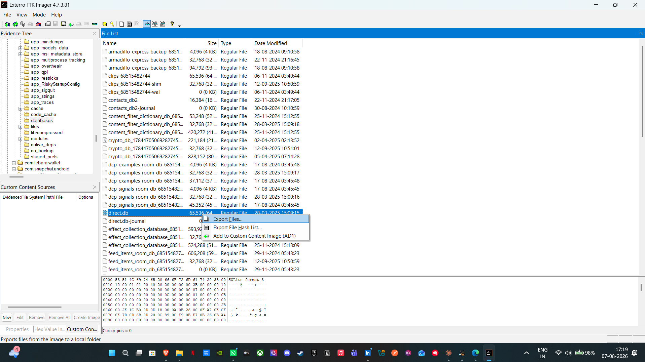
Figure 10. Instagram direct messages recovered from direct.db, showing Joe's 'NSI company' message.

4.5 Email Analysis
The Emails module recovered 71 messages from the Gmail account dovp59@gmail.com (Figure 11). Most are automated notifications, but two are evidentially significant: a reminder that 'It's Joe Marsh's birthday today', which independently links the account to Joe Marsh outside of WhatsApp or Instagram, and repeated Instagram notifications addressed to 'peterdover2', which tie the Gmail account, the Peter Dover alias and the Instagram handle together across a third, independent data source. No email in the mailbox contained an attachment or reference to QT-AI-2025 or a completed data transfer — the mailbox corroborates identity, not a completed act, a distinction maintained throughout this report.
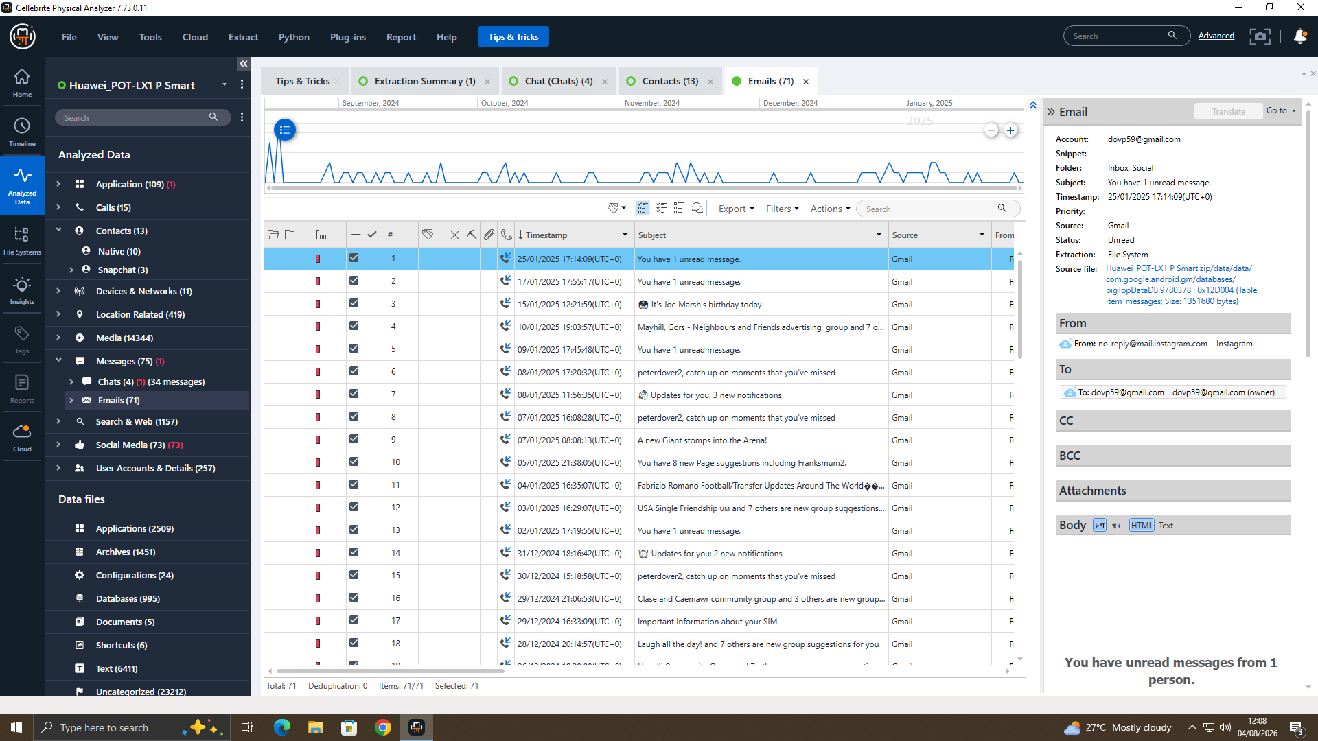
Figure 11. Physical Analyzer Emails (71) — account dovp59@gmail.com, including the 'Joe Marsh's birthday' reminder.

4.6 Social Media Review — Snapchat
For completeness, the 73 Snapchat items recovered under account peter_dover were reviewed in full (Figure 12). The content is ordinary story metadata — for example 'Terrance's story' and 'B's story' — and shows no connection to Quantum Tech, the patent, or any named party. Being explicit about what a data source does not show is as important as reporting what it does: treating this material as evidence of the conspiracy would overstate the case.
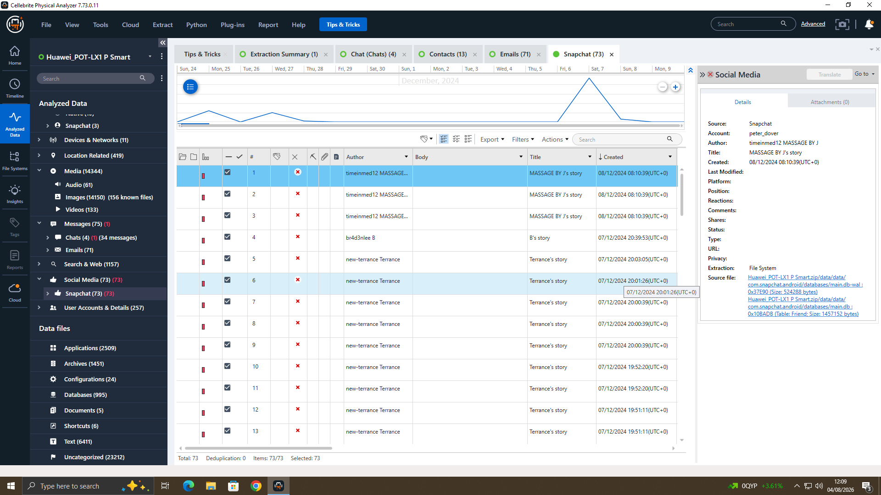
Figure 12. Social Media — Snapchat (73) reviewed for completeness; unrelated everyday content.

4.7 Call Log and SMS Analysis
The device call log recorded repeated but unconnected (zero-second) call attempts to +447917162891 — the number saved as 'SA No.' in Figure 7 — between 2 and 19 August 2024, together with calls to an Indian number (Figure 13). The SMS store consisted largely of Lebara network messages and international roaming alerts (India, Qatar, the UAE and South Africa, among others), together with application verification codes for WhatsApp, Snapchat and Google that corroborate the account-setup dates. While none of this content refers directly to the patent, it corroborates Emma's frequent international travel during the relevant period and establishes a pattern of repeated contact attempts with 'SA No.' in the days immediately before the conspiracy messages began.
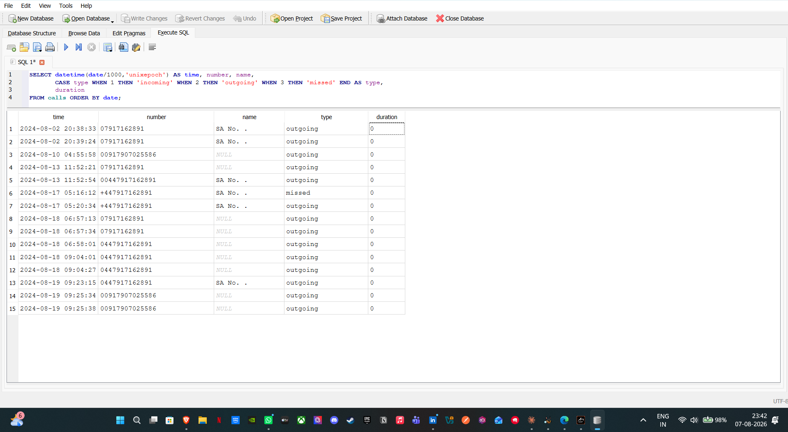
Figure 13. Call log (calls.db) showing repeated contact attempts to +447917162891.

4.8 File and Metadata Analysis (Huawei)
On 19 August 2024 Emma sent seven images via WhatsApp to +447917162891. Examination of these files (Figure 14) established that they are ordinary personal photographs rather than proprietary material, a conclusion supported by their file metadata (all timestamped 19 August 2024, 09:21). A systematic search of the Huawei's storage found no PDF, Office or CAD/design files in any location, and the Download folder was empty (Figure 15) — consistent with the design files residing on Emma's USB drive, referenced in the case briefing but not provided within this evidence set. Accordingly, while the communications establish clear intent to sell proprietary data, no completed transfer of the design files was recovered from the device.
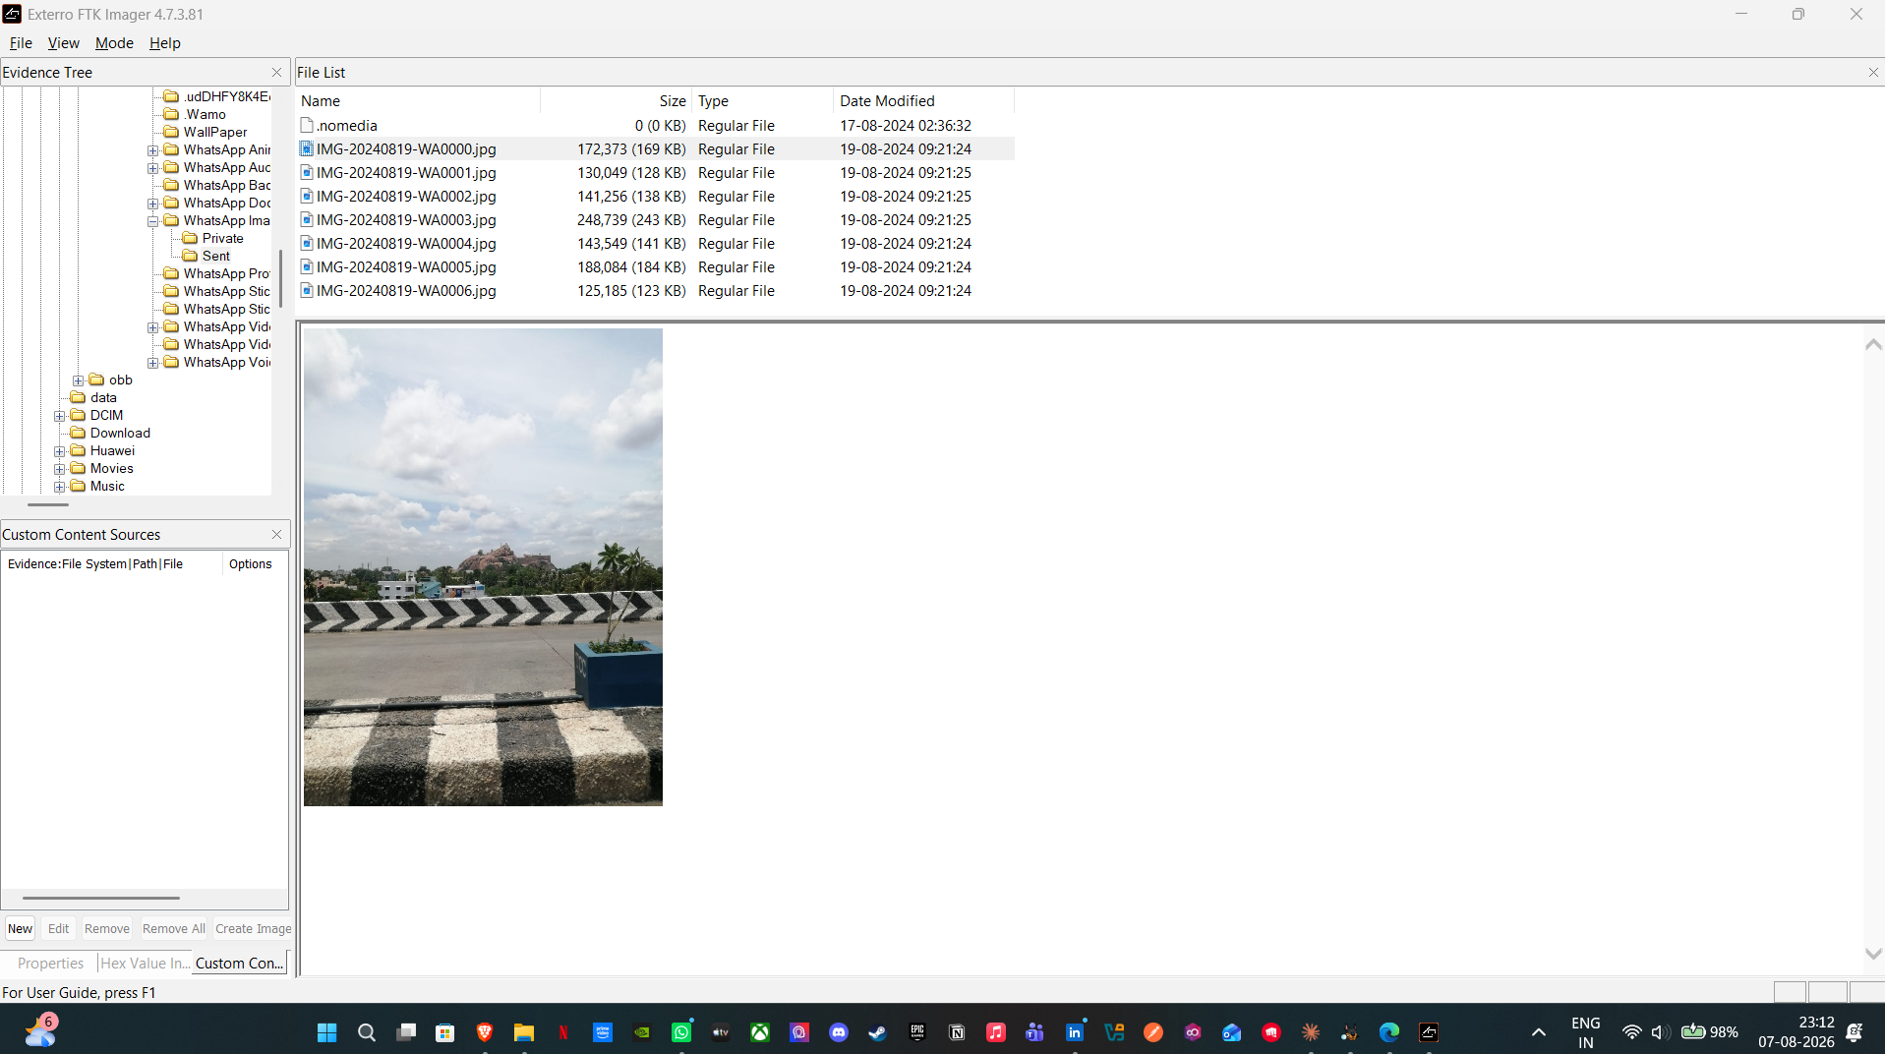
Figure 14. Images sent on 19 August 2024 — personal photographs, not proprietary material.
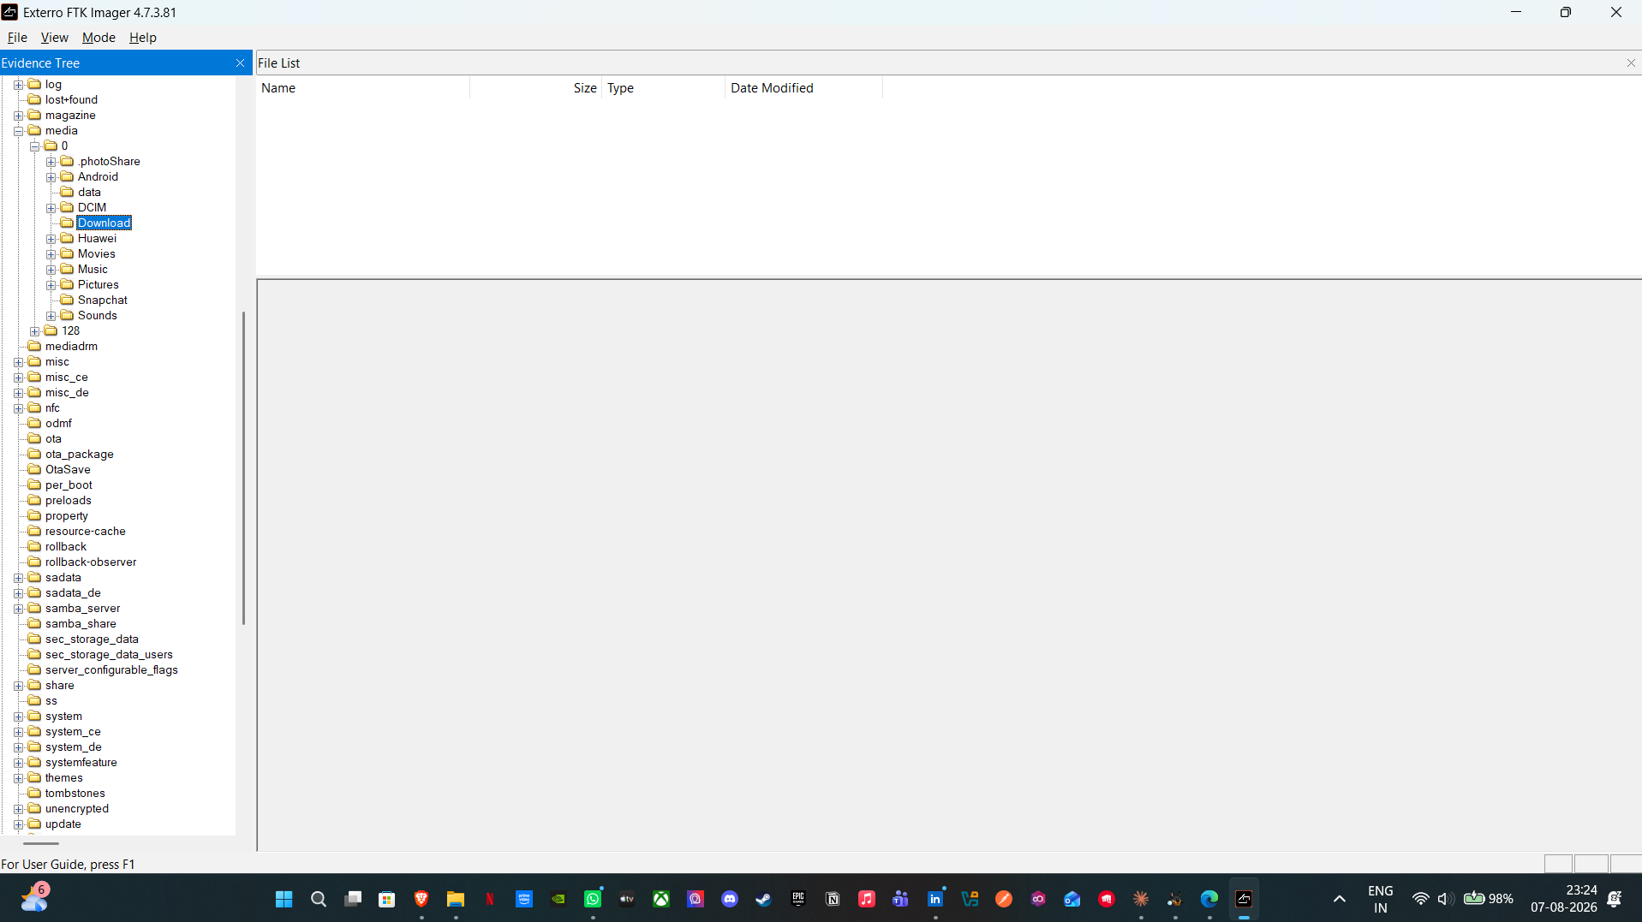
Figure 15. The Huawei Download folder, containing no documents or design files.

4.9 Location and Movement Analysis
Physical Analyzer's Insights module recovered 1,322 geotagged location points from the Huawei device, spanning 2005 to 2025 (Figure 16), clustering sharply around the case period — consistent with continuous device use throughout the conspiracy and corroborating the travel pattern already inferred from the roaming SMS alerts (Section 4.7). The Samsung Galaxy A13, which held no readable communications (Section 4.10.1), nonetheless yielded 1,465 geotagged media locations (Figure 17), clustering mainly around the United Kingdom (738 points near London) with a smaller cluster of 49 near the Netherlands/Germany border. As the Samsung is not attributed to any named party in this evidence set, its location data is reported here for completeness rather than as proof of a specific meeting or journey tied to the conspiracy.
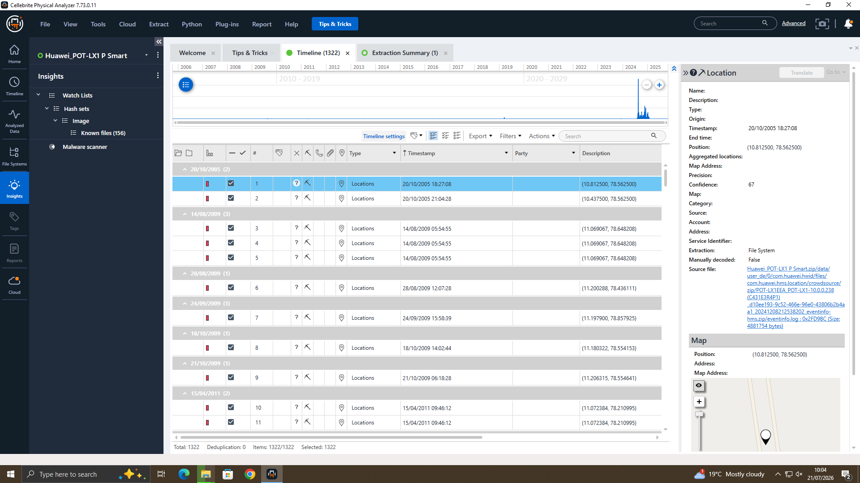
Figure 16. Huawei location timeline (1,322 points, 2005–2025) — a marked spike around the case period.
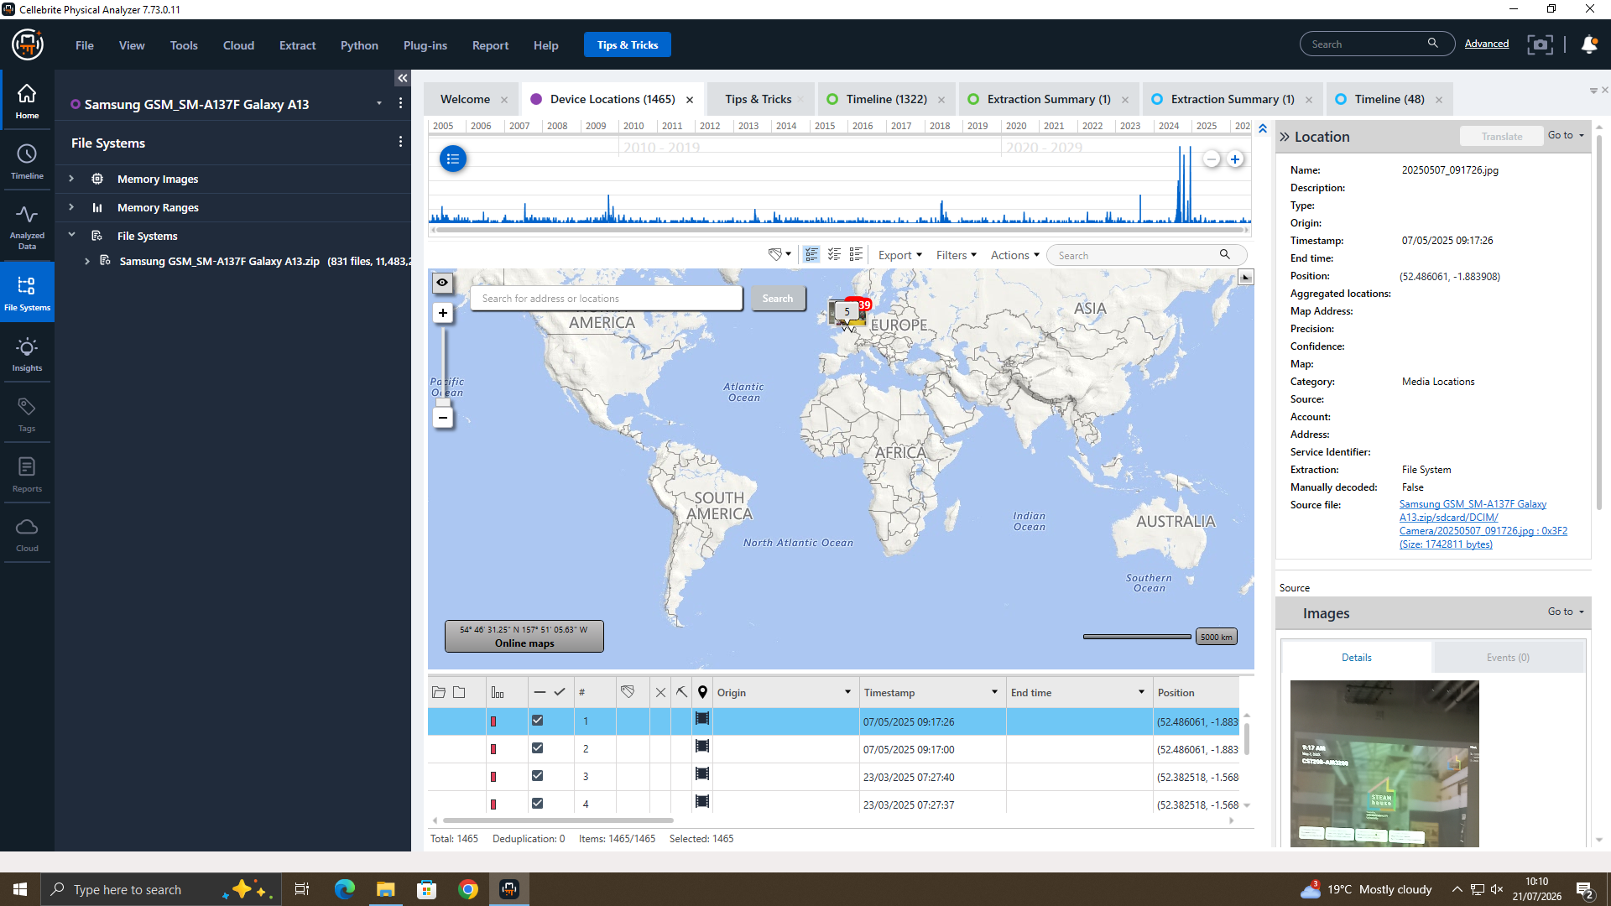
Figure 17. Samsung device locations (1,465 points) — clustered mainly over the UK and continental Europe.

4.10 Examination of the Remaining Three Devices
The Samsung, Nokia and Ulefone were each acquired as ADB backups, which reliably capture user-accessible storage but not application-private databases in an unencrypted form. Each device was nonetheless fully examined, to confirm that no relevant evidence was overlooked and to document precisely why none yielded readable communications.

4.10.1 Samsung Galaxy A13
The Samsung extraction, loaded into FTK Imager (Figure 18), held user media and a number of Download-area documents — mobile-network contract PDFs, restaurant menus and an Android application package (Figure 19) — none related to QT-AI-2025 or Quantum Tech, and no WhatsApp or other messaging database was present on the device at all. The Samsung therefore held no communications evidence relevant to the investigation; its location data is discussed in Section 4.9.
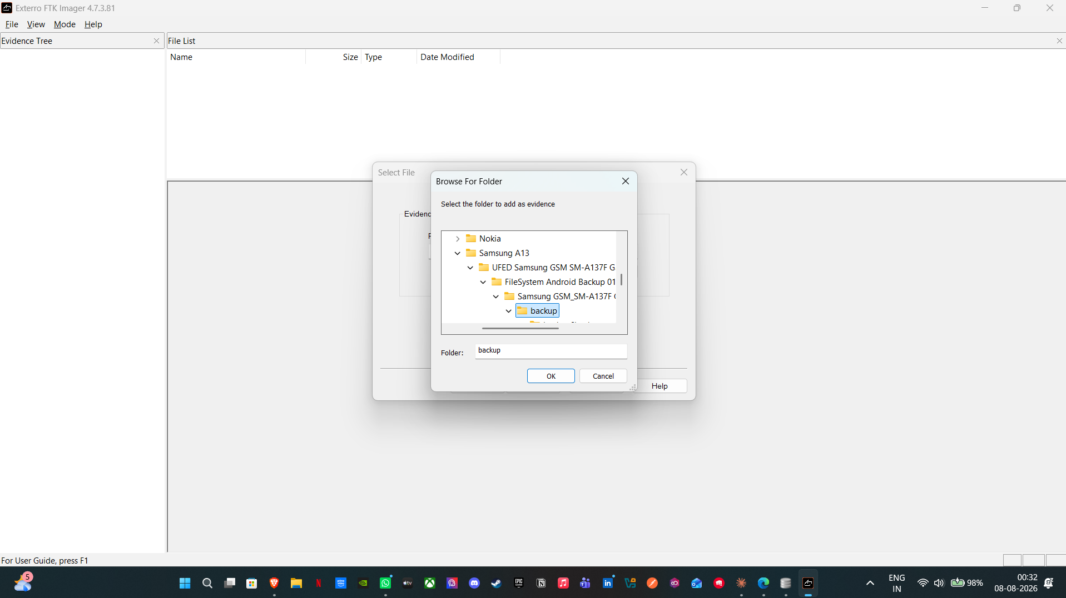
Figure 18. Samsung Galaxy A13 extraction loaded into FTK Imager for examination.
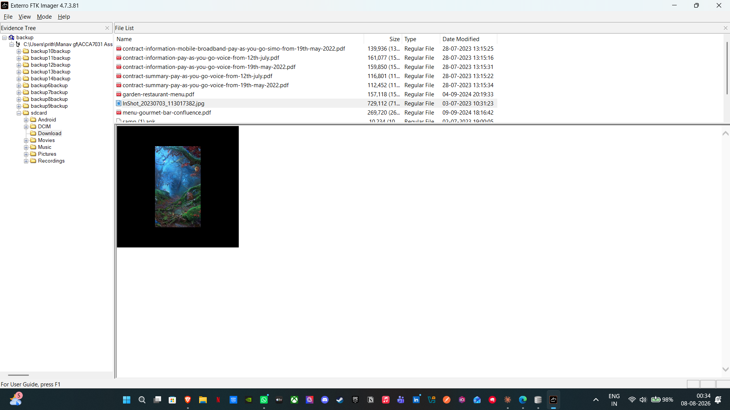
Figure 19. Documents in the Samsung Download area — mobile-network contracts and restaurant menus, unrelated to the patent.

4.10.2 Nokia C2 2nd Edition
Physical Analyzer's Installed Applications module confirmed that WhatsApp, Instagram and Snapchat were all present on the Nokia (Figure 20), but its message store existed only as encrypted .crypt14 databases (Figure 21), for which no decryption key was recoverable from an ADB backup; call log, contacts, wireless-network and browsing data were still recoverable. This confirms that the absence of readable messages reflects the acquisition method and WhatsApp's own encryption, not a gap in the examination.
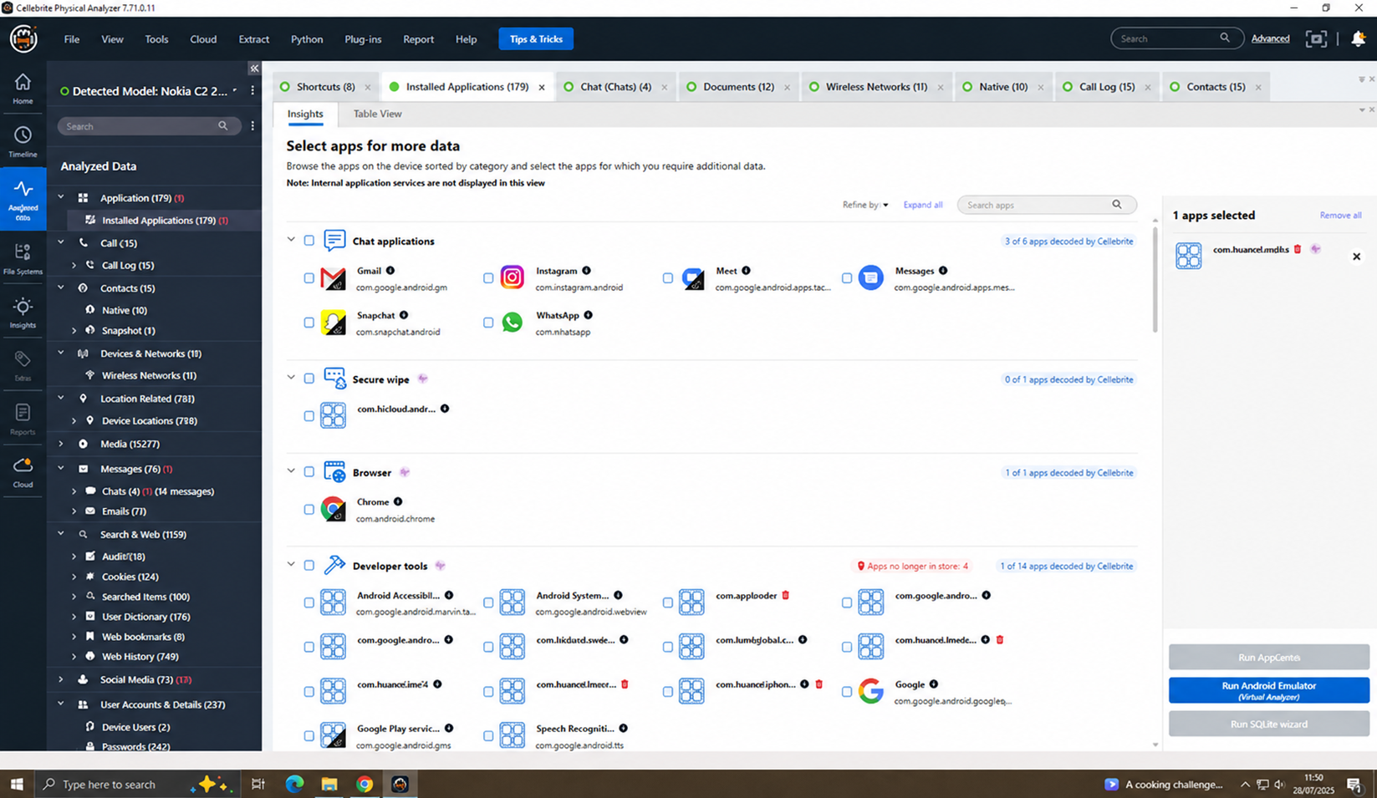
Figure 20. Nokia — Installed Applications confirming WhatsApp, Instagram and Snapchat present on the device.
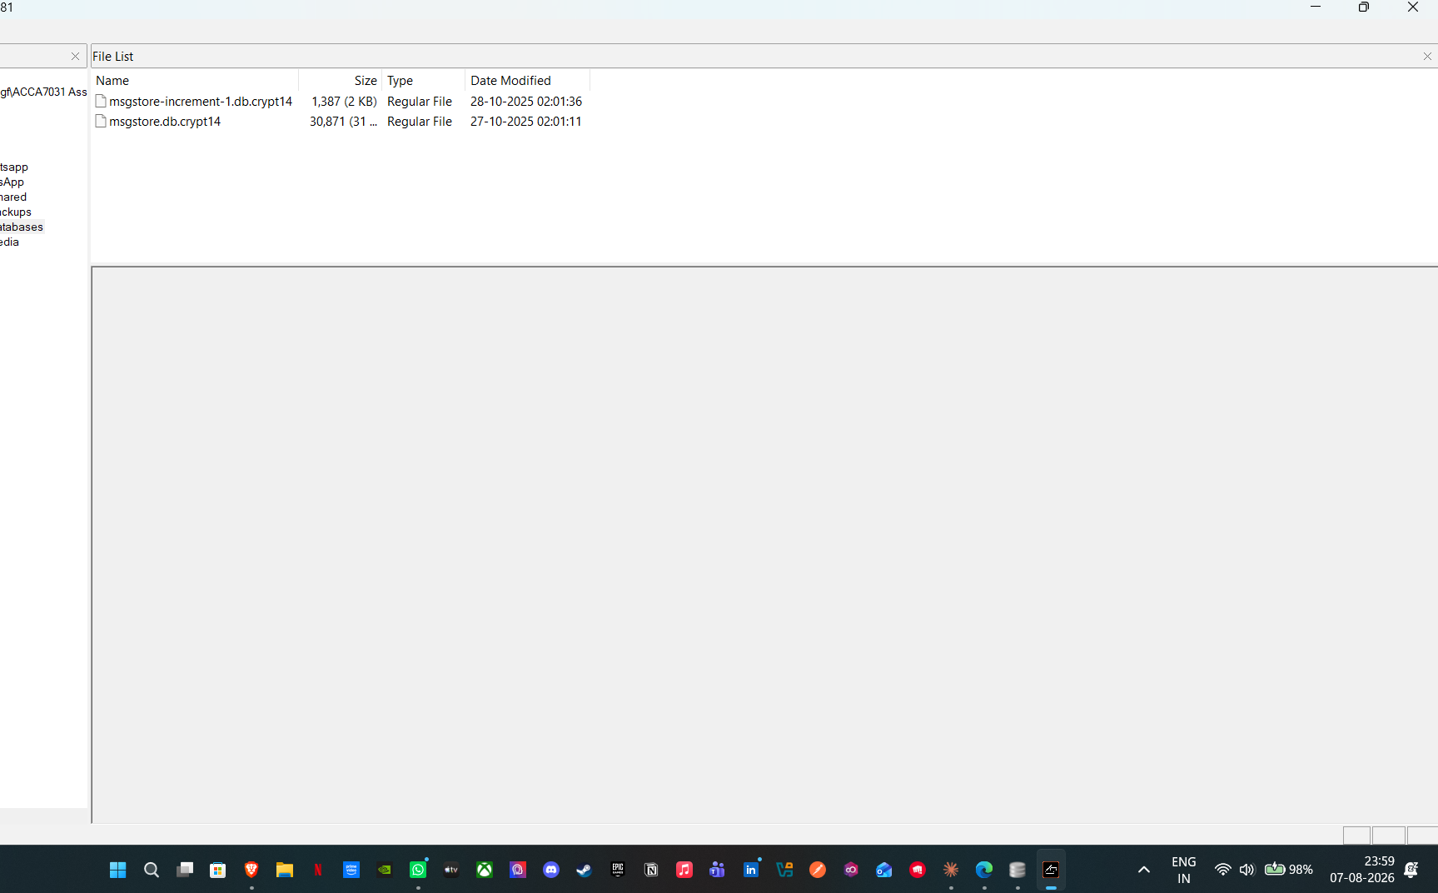
Figure 21. Nokia C2 — WhatsApp data present only as encrypted .crypt14 databases.

4.10.3 Ulefone Note 14
The Ulefone showed the same pattern: WhatsApp data limited to encrypted .crypt14 databases, confirmed by a hexadecimal view of the file (Figure 22) showing encrypted binary content rather than readable records — encryption, not any oversight in examination, being the reason its messages could not be recovered. No patent-related material was present on the device.
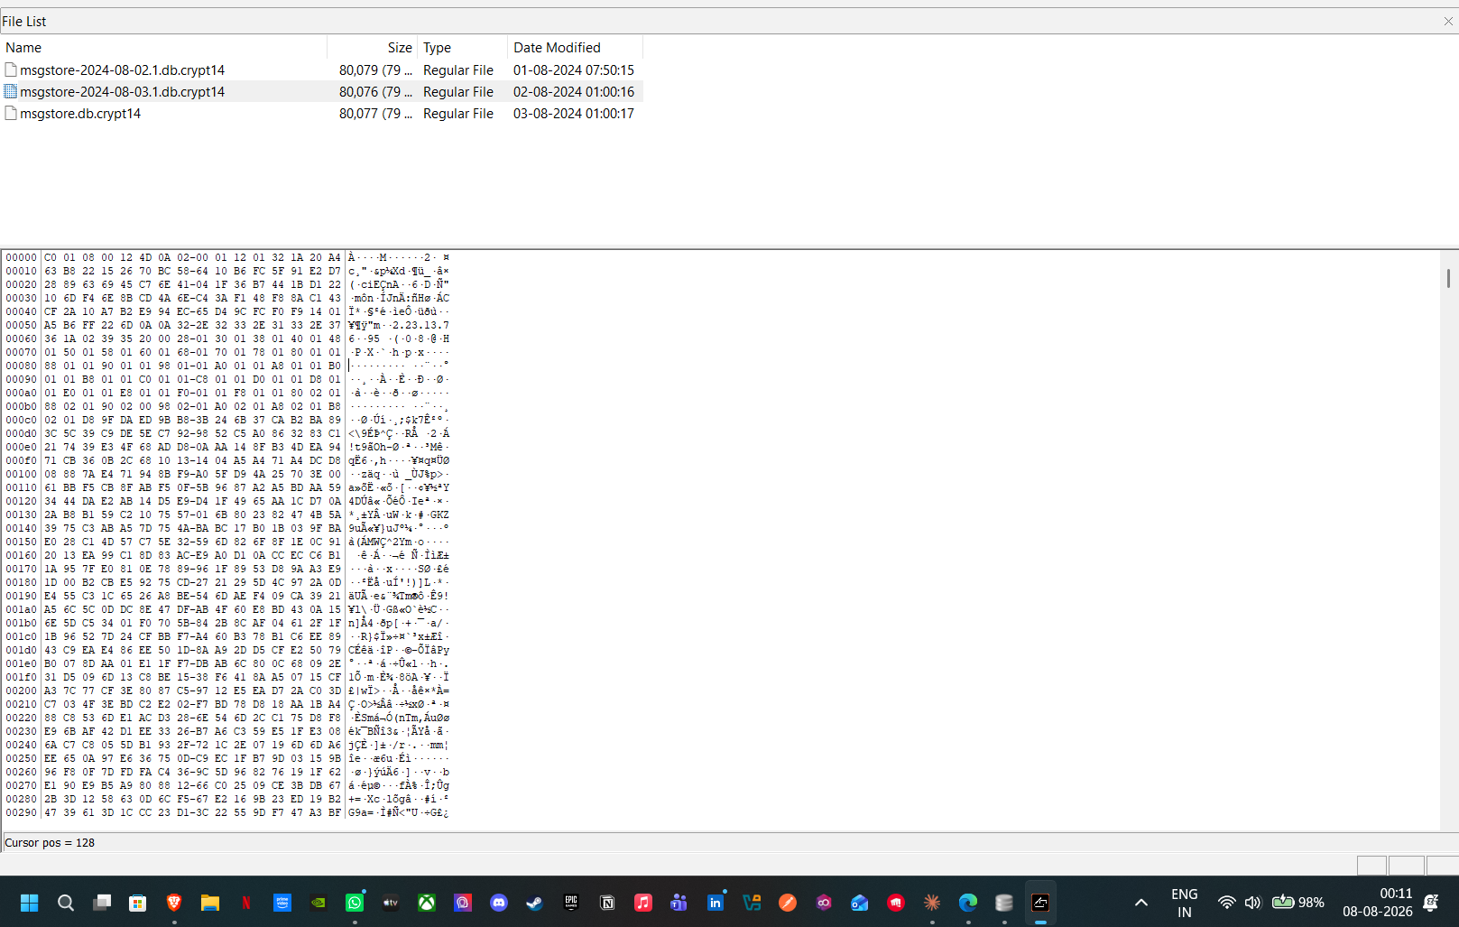
Figure 22. Ulefone Note 14 — hexadecimal view confirming encrypted, unreadable WhatsApp data.
In summary, although all three devices were fully examined, their ADB-backup acquisition meant that any WhatsApp evidence was encrypted and unrecoverable without the per-device key, and none held patent-related files. Full physical or filesystem extraction — as used for the Huawei — would very likely have recovered this data; this is a documented limitation of the evidence set, not of the examination performed.

5. Suspect Profiling — Roles and Motives
Drawing the evidence together across all four devices, the roles and motives of those involved are summarised in Table 3. Emma is the perpetrator: an insider who, operating under the cover identity 'Peter Dover', offered to sell Quantum Tech's proprietary AI intellectual property. Joe Marsh acted as intermediary and broker, sourcing buyers on Emma's behalf across WhatsApp, Instagram and email, and negotiating terms. Norman Smith, associated with the 'NSI company' referenced by Joe, is identified as the prospective buyer. The contact saved as 'SA No.' (+447917162891) remains a person of interest whose role could not be confirmed from the available data. The evident motive is financial gain, reflected in the '5M' figure and the discussion of an 'offshore' arrangement. What the evidence proves — intent, brokering and buyer contact — is kept distinct from what it does not: a completed transfer of the design files, and the identity behind 'SA No.', both of which remain unproven on the current evidence.
Table 3. Suspect roles.
Person / entity | Role | Key evidence
Emma | Perpetrator (insider) | Huawei owner; offered to sell 'AI Neuro' IP; alias 'Peter Dover' / dovp59@gmail.com
Joe Marsh | Intermediary / broker | WhatsApp +447476538686, Instagram hamster.184397, saved contact; sourced buyers; 'NSI company'
Norman Smith | Prospective buyer | Instagram normansmith1987; buyer-side contact
'NSI company' | Buyer organisation | Named by Joe as the interested competitor
+447917162891 ('SA No.') | Unidentified associate | Repeated call attempts and 7 personal images; role unconfirmed

6. Limitations and Legal / Ethical Practice
Three limitations qualify these findings. The ADB-backup acquisition of three devices left their WhatsApp data encrypted and unrecoverable (Section 4.10); re-acquisition by full physical extraction is recommended below. No completed transfer of the design files was recovered — the communications prove intent and brokering, not a finished handover, a distinction maintained deliberately throughout rather than inferred. The identity behind 'SA No.' and 'NSI' remain unconfirmed on the available data and would require further enquiry, potentially including subpoenaed platform records.
All analysis was performed on hash-verified forensic copies, never on the original seized media, with a documented chain of custody maintained from acquisition — case identifier, examiner name and evidence number — through to analysis (Section 2). This approach follows recognised standards for digital evidence handling, including the ACPO Good Practice Guide for Digital Evidence (ACPO, 2012) and the principles of ISO/IEC 27037 for the identification, collection, acquisition and preservation of digital evidence, so that the findings remain usable in a legal context. Real acquisition of this kind requires lawful authority; for the purposes of this exercise, devices were treated as provided under the case briefing, with case and examiner details recorded throughout, consistent with the ethical requirement to handle evidence appropriately and not exceed the scope of the authorisation given.

7. Conclusion
On the balance of the recovered, integrity-verified evidence, Emma conspired with an intermediary, Joe Marsh, to misappropriate and sell Quantum Tech's proprietary AI intellectual property to a prospective buyer, Norman Smith, associated with a competitor referred to as 'NSI'. The intent to sell, the brokering of buyers, and the negotiation of a financial and 'offshore' arrangement are documented across corroborating WhatsApp, Instagram, contacts and email evidence recovered from Emma's device, and are further supported by call-log and location data from the same period. The principal limitations are that no completed transfer of the design files was recovered, and that the ADB-backup acquisition of the three remaining devices left their WhatsApp data encrypted and unreadable. Subject to these limitations, the evidence provides a sound and defensible basis for further action.

8. Recommendations
It is recommended that Quantum Tech immediately revoke Emma's access to all systems, secure and audit the patent database, and preserve all relevant access logs. For law enforcement, it is recommended that consideration be given to charges for corporate espionage and theft of trade secrets; that Emma's USB drive and the three remaining handsets be seized and subjected to full physical extraction in order to decrypt their WhatsApp data; that platform-level records be sought from Google, Meta and Snap for the identified accounts to corroborate the recovered data; and that further enquiries be made to establish the identities behind 'NSI company', Norman Smith and the 'SA No.' contact. Preserving the verified forensic copies and this documented chain of custody will support the admissibility of the evidence in any subsequent proceedings.

9. Personal and Technical Reflection
Working through Cellebrite UFED acquisition and Physical Analyzer examination on case-specific data, rather than a generic training set, showed concretely how much a full-filesystem extraction adds over an ADB backup: the Huawei was usable precisely because of how it was acquired, while the other three yielded nothing readable for exactly that reason. Cross-referencing WhatsApp against Instagram, email, contacts and location data, rather than reading any one source in isolation, is what turned a single suspicious chat into a corroborated case; the email and location evidence in particular only became significant once every module was checked deliberately, rather than stopping at the first useful thread. The three encrypted devices were a genuine limitation, not a shortcut to analyse around, and the right response was to document that clearly rather than overstate what was recoverable. Distinguishing proven intent from an unproven completed act — the missing design-file transfer — was the most important judgement call in the investigation, and one I would apply to any future case. In practice I will keep prioritising full-filesystem acquisition wherever possible, verifying hashes across more than one tool before relying on them, and reporting limitations as clearly as findings.

References (Task 2)
ACPO (2012) Good Practice Guide for Digital Evidence. Association of Chief Police Officers.
Cellebrite (2025) UFED and Physical Analyzer — mobile device forensics. Available at: https://cellebrite.com (Accessed: August 2026).
Exterro (2025) FTK Imager. Available at: https://www.exterro.com (Accessed: August 2026).
ISO/IEC (2012) ISO/IEC 27037:2012 — Guidelines for identification, collection, acquisition and preservation of digital evidence. International Organization for Standardization.
NIST (2014) SP 800-101 Rev. 1: Guidelines on Mobile Device Forensics. National Institute of Standards and Technology.
SQLite Browser (2025) DB Browser for SQLite. Available at: https://sqlitebrowser.org (Accessed: August 2026).

