

University of Wales Trinity Saint David

Module: International Business Concepts
Module code: LCMB7034
Assessment Title: Report
Student name: Sherife Aleksieva
Student ID:2211682
Lecturer: Mansoob Murshed
Word count: 5272
Submission date: 31 July 2026

International Business Strategy and Foreign Direct Investment
Analysis: Rivian Automotive's Potential Market Entry into Romania

Table of Contents
1. Introduction 3
1.1 Background to Rivian Automotive 4
1.2 Rationale for Selecting Romania 6
1.3 Aim and Structure of the Report 8
2.Organisational Classification and Global Strategy 8
2.1 Organisational Identity and International Orientation 8
2.2 EPRG and Bartlett & Ghoshal Analysis 9
2.3 Geographic Footprint and Competitive Advantage 11
3. Macro-Environmental Appraisal and Market Attractiveness of Romania 12
3.1 Political Environment 12
3.2 Economic Environment, Foreign Direct Investment (FDI) Trends 13
3.3 Legal Environment 14
3.4 Cultural Environment 15
3.5 Market Attractiveness and Entry Implications 16
4. Market Entry Analysis Using Dunning's OLI Framework 16
4.1 Ownership Advantages 17
4.2 Location Advantages 18
4.3 Strategic Implications of the OLI Framework 19
5. Entry Mode Strategy and Strategic Synthesis 19
5.1 Historical Expansion Pattern 19
5.2 Evaluation of Entry Mode Options 20
5.3 Recommended Entry Mode Strategy for Romania 21
5.4 Strategic Justification 21
6. Conclusion and Final Recommendation 22
7. Reflective Account Using Gibbs Reflective Cycle 23
Description 24
Feelings 24
Evaluation 24
Analysis 25
Conclusion 25
Action Plan 25
8. Reference List 26
9. Appendices 28

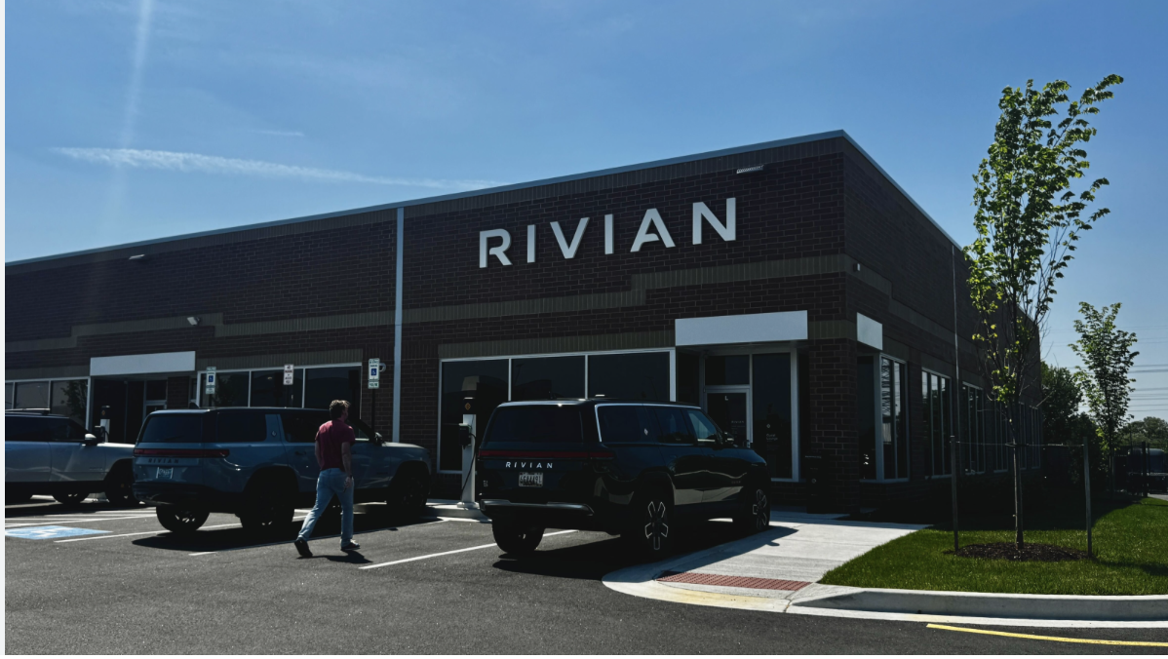

1. Introduction
The electric vehicle (EV) industry has become one of the most dynamic sectors of international business, shaped by technological innovation, sustainability regulation, global competition and changing consumer expectations. International business involves commercial transactions across national borders, including sales, investment, production, sourcing and transportation (Daniels et al., 2022). Therefore, when an EV manufacturer considers entering a new foreign market, the decision requires more than identifying potential customers. It also requires evaluation of the host-country environment, competitive conditions, regulatory requirements and the most appropriate mode of market entry.
This report examines Rivian Automotive’s potential entry into Romania as part of a wider European expansion strategy. Romania has been selected because the company currently has no significant operational presence, production facilities or established consumer vehicle operations in the country. As an EU member state, Romania offers access to the European Single Market, an established automotive manufacturing base, growing interest in electric mobility and a proven ability to attract foreign direct investment (FDI). However, challenges such as purchasing power constraints, developing charging infrastructure and increasing market competition must also be considered.
The aim of this report is to critically evaluate Romania’s suitability as a potential expansion market for Rivian and recommend an appropriate market entry strategy. To achieve this, the report applies key international business frameworks, including organisational classification, the EPRG framework, Bartlett and Ghoshal’s model, macro-environmental analysis, Dunning’s OLI paradigm and entry mode theory. The analysis focuses on identifying the opportunities and risks associated with the company’s potential entry into Romania and determining whether the country represents a strategically attractive location for future European growth.

1.1 Background to Rivian Automotive
Rivian Automotive, Inc. is a United States-based electric vehicle manufacturer and automotive technology company. Founded in 2009 and headquartered in Irvine, California, the company designs and manufactures premium all-electric vehicles, including the R1T pickup truck, the R1S sport utility vehicle and electric commercial delivery vans. Its brand identity is strongly associated with adventure, utility, sustainability and software-enabled mobility, differentiating it from traditional mass-market vehicle manufacturers and lower-cost EV competitors (Rivian, 2025).



The company is relevant for international business analysis because it operates in an industry shaped by global supply chains, rapid technological innovation, environmental regulation and increasing international competition. Although Rivian has developed a strong reputation in the United States and has strategic partnerships with organisations such as Amazon and Volkswagen Group, its operational footprint remains largely domestic (Volkswagen Group, 2024).
This makes Rivian an appropriate case for examining early-stage internationalisation. Its technological capabilities, premium brand positioning and growing global ambitions provide a foundation for future European expansion, but its limited international presence also creates challenges relating to market knowledge, infrastructure, service networks and local responsiveness.

1.2 Rationale for Selecting Romania

Romania has been selected as the target market because it offers several potential advantages for Rivian’s European expansion. As an EU member state, the country provides access to the wider European Single Market and operates within a regulatory environment shaped by sustainability and transport policies (European Commission, 2024). Romania also has an established automotive sector, competitive operating costs compared with many Western European economies and a strategic location that could support regional distribution across Central and Eastern Europe.


In addition, Romania has demonstrated an increasing capacity to attract foreign direct investment (FDI), particularly within the automotive and manufacturing sectors. Investments by major firms such as Renault-Dacia, Ford Otosan, Bosch and Continental have contributed to the development of industrial capabilities, supplier networks and automotive expertise. This suggests that Romania offers not only a potential consumer market for electric vehicles, but also a business environment capable of supporting future operational expansion.
However, Romania also presents important challenges. These include lower consumer purchasing power compared with Western Europe, the ongoing development of EV charging infrastructure, regulatory adaptation requirements, exchange-rate and financial risks, and growing competition from established European, American and Asian EV manufacturers. Consequently, the Romanian market should not be viewed as an automatic growth opportunity, but rather as a location that requires careful assessment of both opportunities and constraints.
From an international business perspective, the key question is whether Romania’s advantages are sufficient to outweigh the risks associated with entering an emerging EV market. Therefore, a systematic evaluation of the country’s political, economic, legal and cultural environment is required to determine its overall attractiveness and strategic suitability for Rivian’s expansion.

1.3 Aim and Structure of the Report
The aim of this report is to critically evaluate Rivian Automotive’s potential entry into Romania and recommend an appropriate market entry strategy. To achieve this, the report applies key international business concepts and frameworks, including organisational classification, the EPRG framework, Bartlett and Ghoshal’s model, macro-environmental appraisal, Dunning’s OLI framework and entry mode evaluation.
The report first examines Rivian’s organisational identity, international orientation, geographic footprint and competitive advantages. It then evaluates Romania’s political, economic, legal and cultural environment, with particular attention to FDI conditions, industry attractiveness and factors that may support or constrain market entry.
Building on this analysis, the report applies Dunning’s OLI framework to assess the strategic fit between Rivian’s ownership advantages and Romania’s location advantages. The findings are then used to evaluate alternative entry modes and justify the recommended strategy. Finally, a reflective account using Gibbs’ Reflective Cycle evaluates the research process, challenges encountered, and learning developed during the preparation of the assignment.

2.Organisational Classification and Global Strategy

2.1 Organisational Identity and International Orientation
This section examines Rivian Automotive’s organisational identity and international orientation, evaluating how the company’s current geographic footprint supports and constrains its competitive position. Rivian operates in a globally interconnected industry where success is shaped by international supply chains, technological innovation, cross-border partnerships and evolving regulatory standards. However, despite these global links, its operational footprint remains heavily concentrated in the United States (Rivian, 2025).
Unlike established automotive corporations such as Toyota, Volkswagen and BMW, Rivian has not yet developed an extensive network of international manufacturing facilities, subsidiaries or regional operating centres. The company is therefore better characterised as an emerging multinational enterprise rather than a mature transnational corporation. This concentrated model allows greater control over product quality, technology development, intellectual property and brand consistency, which are important sources of advantage in the EV industry.
However, Rivian’s limited international presence also creates strategic constraints. A narrow geographic footprint can reduce exposure to foreign consumer preferences, regulatory environments and local market conditions. It may also restrict international economies of scale and the development of regional service networks. Nevertheless, the company’s strategic partnership with Volkswagen Group represents an important step towards a more international orientation by strengthening its technology base and access to global automotive expertise (Volkswagen Group, 2024).
Understanding this balance between domestic concentration and emerging international collaboration is important when assessing Rivian’s readiness for entry into Romania.

2.2 EPRG and Bartlett & Ghoshal Analysis
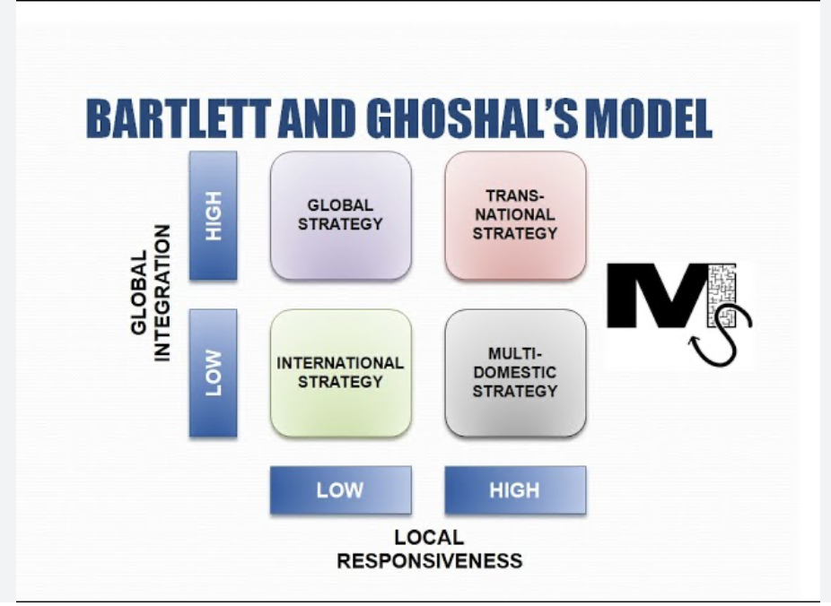
Figure 1: Bartlett and Ghoshal's International Strategy Framework
Source: Adapted from Bartlett and Ghoshal (1989).

The EPRG framework developed by Perlmutter provides a useful perspective for understanding Rivian's international orientation. The framework classifies organisations according to four managerial approaches: ethnocentric, polycentric, Regio centric and geocentric. Based on its current organisational structure, Rivian's orientation is most closely aligned with an ethnocentric approach, as the company's strategic decision-making, product development, manufacturing operations and technological capabilities remain concentrated within the United States. Knowledge, innovation and managerial control continue to flow primarily from the home market, while the company's international activities remain relatively limited.
This orientation reflects Rivian's current stage of internationalisation. By maintaining a strong domestic focus, the company is able to preserve control over product quality, technological innovation, intellectual property and brand consistency. These factors are particularly important within the electric vehicle industry, where software capabilities, battery technology and customer experience represent key sources of competitive advantage. However, continued reliance on a predominantly home-country perspective may become increasingly challenging as Rivian expands internationally and encounters diverse consumer preferences, regulatory requirements and market conditions.
Further insight into Rivian's strategic position can be obtained through Bartlett and Ghoshal's framework, which evaluates firms according to the pressures for global integration and local responsiveness (Bartlett and Ghoshal, 1989).
As illustrated in Figure 1, Rivian's current strategy is most closely aligned with an international strategy, where pressures for both global integration and local responsiveness remain relatively low.
This classification is appropriate because Rivian's vehicle design, software architecture, manufacturing expertise and brand identity have largely been developed within the United States and subsequently leveraged across its limited international activities. The company does not currently exhibit the characteristics of a multidomestic strategy, as there is little evidence that products, operations or marketing activities are significantly adapted to individual foreign markets. Similarly, Rivian cannot yet be classified as a fully global strategy organisation because it lacks the extensive international production network and large-scale worldwide sales operations associated with established automotive manufacturers such as Toyota, Volkswagen and BMW.
Nevertheless, Rivian demonstrates elements of emerging transnational potential. The company's strategic partnership with Volkswagen Group, particularly in the development of software-defined vehicle architecture and future electric vehicle technologies, illustrates an increasing willingness to engage in international collaboration, resource sharing and cross-border knowledge transfer (Volkswagen Group, 2024; Rivian and Volkswagen Group Technologies, 2025). Such initiatives indicate that Rivian is gradually moving beyond a purely domestic focus while seeking to preserve the ownership advantages that underpin its competitive position.
Overall, Rivian can be classified as pursuing an emerging international strategy with early transnational characteristics. While the company possesses valuable technological capabilities, strong brand differentiation and growing international ambitions, it has not yet developed the globally dispersed operations typically associated with mature multinational or transnational corporations. This creates opportunities for controlled international expansion but also highlights the importance of selecting host markets that offer favourable business conditions, manageable levels of risk and long-term growth potential. Consequently, assessing Romania's external environment becomes essential in determining whether the country represents a strategically suitable destination for Rivian's future expansion.

2.3 Geographic Footprint and Competitive Advantage
Rivian's geographic footprint creates both advantages and limitations. The company's concentration in the United States enables it to maintain strong control over production quality, technology development, software integration and brand identity. These capabilities are particularly important because Rivian's competitive advantage is built upon premium electric vehicle design, sustainability positioning, software-enabled mobility and its distinctive adventure-oriented brand image. Maintaining centralised control helps protect these ownership advantages while ensuring a consistent customer experience across markets.
However, Rivian's limited international presence also creates strategic challenges. A relatively narrow geographic footprint may restrict global brand awareness, after-sales service capability, regulatory responsiveness and understanding of local consumer preferences. Such limitations are particularly relevant in Romania, where market success would depend not only on product quality, but also on infrastructure readiness, service accessibility and consumer confidence in a relatively new automotive brand.
Overall, Rivian's current geographic configuration supports a cautious approach to internationalisation. While the company's competitive advantages appear transferable to Romania, international expansion would require a market entry strategy that balances control with flexibility. A phased approach may allow Rivian to build local market knowledge, evaluate long-term demand and reduce exposure to unnecessary financial and operational risks while protecting its core technological and brand assets (Hill, 2023).

3. Macro-Environmental Appraisal and Market Attractiveness of Romania

3.1 Political Environment
Romania's political environment provides both opportunities and challenges for Rivian's potential market entry. As a member of the European Union since 2007, Romania operates within a relatively stable political and institutional framework that supports cross-border trade, investment and business operations. EU membership also aligns Romania with broader European objectives relating to sustainability, carbon reduction and the transition towards low-emission transport systems, creating a favourable policy environment for electric vehicle manufacturers (European Commission, 2024).
Government support for green mobility has increased in recent years through a range of national and EU-backed initiatives designed to encourage electric vehicle adoption. Programmes such as Romania's vehicle incentive schemes have contributed to growing consumer interest in electric mobility while supporting the wider transition towards sustainable transportation. For Rivian, these policies may help reduce barriers to initial market acceptance and improve the long-term outlook for EV demand.
Romania's political position also offers strategic advantages beyond its domestic market. Located at the intersection of Central and Eastern Europe, the country provides access to both established EU economies and emerging regional markets. This geographic position may enhance Romania's attractiveness as a future distribution or operational hub supporting wider regional expansion.
However, political and policy-related risks should not be overlooked. Although Romania benefits from EU regulatory stability, national policies relating to taxation, infrastructure investment and environmental incentives may change over time. For Rivian, long-term success would depend not only on policy support for electric vehicles, but also on Romania’s ability to maintain a stable investment climate and continue developing the infrastructure necessary for EV adoption.

3.2 Economic Environment, Foreign Direct Investment (FDI) Trends

Figure 2: Foreign Direct Investment (FDI) and International Business Expansion
Source: Adapted from Corporate Finance Institute (CFI, 2025).

As illustrated in Figure 2, foreign direct investment (FDI) plays an important role in international business expansion by enabling firms to establish operations, access new markets and develop long-term competitive advantages in host countries.
Romania’s economic environment presents a combination of growth opportunities and market limitations for Rivian’s potential expansion. As one of the developing economies in Central and Eastern Europe, Romania has experienced economic growth supported by manufacturing, services, foreign investment and increasing integration within the European Union. The country’s automotive industry is particularly important, contributing to exports, employment and industrial development.
A key advantage for Rivian is Romania’s established automotive ecosystem. The presence of major manufacturers such as Renault-Dacia and Ford Otosan has supported the development of supplier networks, engineering expertise and manufacturing capabilities. These industrial foundations reduce some of the operational barriers associated with entering an emerging market and provide access to an experienced automotive workforce.
FDI has also contributed significantly to Romania’s economic development. The country has attracted investment from international automotive and industrial firms, including Bosch, Continental, Renault and Ford. Continued FDI inflows suggest investor confidence in Romania’s business environment and indicate that the country possesses several characteristics sought by multinational enterprises, including EU market access, competitive labour costs and an established industrial base.
From Rivian’s perspective, Romania’s FDI attractiveness is particularly relevant because it suggests that the country may support future operational expansion beyond simple vehicle sales. While the company’s initial objective would likely focus on market entry and brand development, Romania’s investment environment may create longer-term opportunities for regional distribution, logistics operations or future assembly activities if demand develops sufficiently.
However, several economic challenges remain. Compared with Western European countries, Romania’s average income levels and consumer purchasing power are lower. This may limit the immediate addressable market for Rivian’s premium-priced vehicles, particularly because the company targets higher-income consumers. In addition, inflationary pressures, exchange-rate fluctuations and wider economic uncertainty could affect consumer spending and vehicle purchasing decisions.
Overall, the economic environment presents a mixed picture. Romania offers an attractive investment climate, established automotive capabilities and a proven track record of attracting automotive FDI. However, lower purchasing power may constrain short-term demand for Rivian’s premium product range. This suggests that potential market entry would need to balance long-term operational opportunities against short-term demand limitations.

3.3 Legal Environment
Romania's legal environment is largely shaped by its membership in the European Union, providing a relatively predictable framework for foreign investment, competition policy, consumer protection and environmental regulation (European Commission, 2024). For Rivian, this reduces some of the uncertainties commonly associated with entering emerging markets and provides access to a regulatory system that is broadly aligned with other EU member states.
The European Union's commitment to decarbonisation and sustainable transport further supports the long-term development of the electric vehicle sector. Regulations relating to vehicle emissions, battery sustainability and environmental performance are expected to continue encouraging the transition towards electric mobility. However, compliance with evolving EU legislation may increase operational and administrative costs for manufacturers entering the European market.
Overall, Romania offers a relatively stable and transparent legal environment for international business operations. While regulatory compliance will require ongoing investment, the country's alignment with EU standards provides a level of legal certainty that may support Rivian's long-term expansion objectives. This suggests that legal barriers are unlikely to represent the primary obstacle to market entry, shifting attention towards consumer behaviour and market acceptance.

3.4 Cultural Environment
Cultural factors are an important consideration when evaluating Rivian's potential entry into Romania. Consumer attitudes towards sustainability, technology adoption and electric mobility have become increasingly favourable as environmental awareness has grown across Europe. This may create opportunities for Rivian's sustainability-focused brand positioning and technologically advanced vehicle offerings.
However, Romanian consumers remain more price-sensitive than consumers in many Western European markets. As Rivian primarily targets the premium vehicle segment, affordability may influence purchase decisions and limit the scale of early adoption. In addition, brand familiarity and trust may present challenges, as Rivian remains significantly less established in Europe than competitors such as Tesla, BMW, Volkswagen and BYD.
Despite these challenges, changing consumer preferences and growing interest in sustainable transportation suggest potential opportunities for future market development. The key issue for Rivian is therefore not simply whether demand for electric vehicles exists, but whether sufficient demand exists for a premium-priced electric vehicle brand with limited recognition in the Romanian market. This makes overall market attractiveness and competitive positioning critical factors in assessing the viability of market entry.

3.5 Market Attractiveness and Entry Implications
Romania appears to offer a favourable environment for Rivian's potential expansion due to its EU membership, established automotive sector, supportive sustainability policies and ability to attract significant foreign direct investment (FDI) (European Commission, 2024). The continued growth of the electric vehicle market and improving charging infrastructure further strengthen the country's long-term potential.
However, market attractiveness must be considered alongside existing constraints. Romania's lower purchasing power compared with Western European markets may limit demand for Rivian's premium-priced vehicles, while competition from established EV manufacturers such as Tesla, Volkswagen and BYD is increasing.
Despite these challenges, Romania's strategic location, automotive capabilities and investment climate provide opportunities that extend beyond vehicle sales alone. The country could potentially support future distribution, logistics or operational activities as Rivian expands within Europe.
Overall, Romania demonstrates moderate-to-high market attractiveness for Rivian. While short-term demand may remain constrained, the combination of economic growth, FDI attractiveness and long-term EV development suggests that the market warrants further consideration. The key challenge is therefore not whether opportunities exist, but which market entry strategy would allow Rivian to capture these opportunities while managing risk effectively (Hill, 2023; European Commission, 2024).

4. Market Entry Analysis Using Dunning's OLI Framework

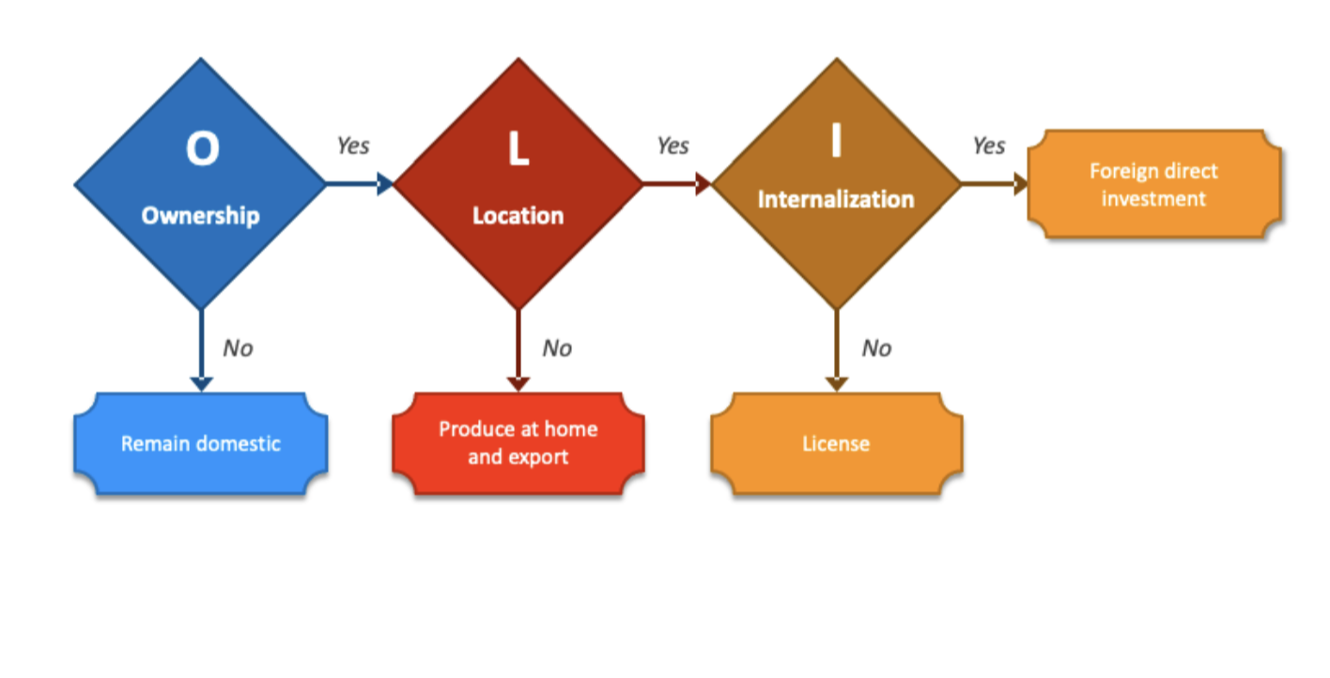

Figure 3: Dunning's Eclectic Paradigm (OLI Framework)
Source: Adapted from Dunning (1988).

Dunning's Eclectic Paradigm (OLI Framework) provides one of the most widely used approaches for analysing international expansion decisions. The framework proposes that successful foreign market entry depends upon three interrelated factors: ownership advantages, location advantages and internalisation advantages (Dunning, 1988). By applying the OLI framework, it is possible to assess whether Rivian possesses the capabilities necessary for international expansion and whether Romania offers conditions that support long-term market entry and investment.
As illustrated in Figure 3, firms are more likely to undertake foreign direct investment when they possess valuable ownership advantages, can benefit from location-specific advantages within the host country and gain greater value through internalising activities rather than relying on external market transactions (Dunning, 1988).
The framework is particularly relevant to Rivian's potential expansion into Romania because it combines both firm-specific and host-country factors. The previous analysis demonstrated that Romania offers a relatively supportive political, economic, legal and cultural environment, while also presenting several challenges associated with market size, purchasing power and competition. Consequently, the OLI framework provides a useful mechanism for evaluating whether the strategic fit between Rivian and Romania is sufficient to justify market entry.

4.1 Ownership Advantages
Ownership advantages refer to the unique resources, capabilities and assets that provide a firm with a competitive advantage in foreign markets (Dunning, 1988). Rivian possesses several ownership advantages that may support its international expansion strategy.
First, the company has developed strong capabilities in electric vehicle engineering, battery technology and software integration. Unlike many traditional automotive manufacturers, Rivian's vehicles are built around a software-centred platform that allows continuous updates, enhanced vehicle performance and a differentiated customer experience. These technological capabilities represent valuable proprietary assets that may be difficult for competitors to replicate.
Second, Rivian has established a distinctive premium brand identity based on adventure, innovation and sustainability. This positioning differentiates the company from traditional vehicle manufacturers while also appealing to environmentally conscious consumers seeking premium electric mobility solutions. In addition, strategic partnerships with organisations such as Amazon and Volkswagen Group strengthen Rivian's technological resources, financial capabilities and international credibility (Volkswagen Group, 2024).
These ownership advantages provide a strong foundation for international expansion. However, their effectiveness ultimately depends on whether the host country offers sufficient conditions for Rivian to leverage and protect these capabilities successfully. Therefore, evaluating Romania's location advantages becomes essential in determining the viability of future market entry.

4.2 Location Advantages

Location advantages refer to the benefits that a host country offers foreign investors through its economic, institutional and strategic characteristics (Dunning, 1988). Romania provides several location advantages that support Rivian's potential expansion.
As a member of the European Union, Romania offers access to the EU Single Market, reduced trade barriers and a relatively stable regulatory framework (European Commission, 2024). The country also possesses an established automotive industry supported by manufacturers such as Renault-Dacia and Ford Otosan, creating access to experienced suppliers, skilled labour and industry expertise.
Romania's continued ability to attract Foreign Direct Investment (FDI) further demonstrates confidence in its business environment. In addition, relatively competitive operating costs and its strategic location within Central and Eastern Europe may support future distribution and regional expansion opportunities.
However, lower purchasing power and the developing nature of the EV market may limit short-term demand for Rivian's premium vehicles. Despite these constraints, Romania's overall combination of market access, automotive capabilities and investment attractiveness represents a strong location advantage for potential market entry.
Consequently, the remaining issue is not whether Romania offers favourable location advantages, but whether Rivian would benefit from maintaining direct control over its activities in the market, making internalisation advantages the final element of the OLI framework.

4.3 Strategic Implications of the OLI Framework

Overall, the OLI analysis indicates a positive strategic fit between Rivian and Romania. Rivian possesses significant ownership advantages through its technology, software capabilities and premium brand positioning, while Romania offers attractive location advantages including EU market access, automotive expertise and a supportive investment environment. Furthermore, the importance of protecting proprietary technology and maintaining brand consistency strengthens the case for internalisation.
Consequently, the OLI framework supports the view that Romania represents a potentially attractive destination for Rivian's future expansion. However, while the analysis suggests that market entry may be strategically justified, the choice of entry mode remains critical. The following section therefore evaluates Rivian's historical expansion pattern and identifies the most suitable entry strategy for the Romanian market.

5. Entry Mode Strategy and Strategic Synthesis

5.1 Historical Expansion Pattern
Historically, Rivian has adopted a cautious and highly controlled approach to expansion. The company has primarily focused on strengthening its domestic market position within the United States while maintaining direct control over manufacturing, technology development and customer relationships (Rivian, 2025). Unlike many established automotive manufacturers, Rivian has not relied heavily on licensing agreements, franchising arrangements or large-scale foreign production facilities.
The company's international activities have largely centred on strategic partnerships and technology collaborations, most notably its joint venture with Volkswagen Group, rather than extensive overseas operations (Volkswagen Group, 2024). This suggests a preference for protecting proprietary technology, maintaining brand consistency and preserving operational control during the early stages of internationalisation.
Consequently, Rivian's historical expansion pattern indicates a strategy that prioritises control and gradual market development rather than rapid international expansion.

5.2 Evaluation of Entry Mode Options
Several entry modes could be considered for Rivian's potential expansion into Romania.
Exporting would require relatively low investment and allow the company to test market demand with limited risk. However, this approach may restrict customer support capabilities, limit market responsiveness and reduce control over the overall customer experience.
Licensing would enable rapid market access with minimal investment. Nevertheless, this option may expose Rivian to intellectual property risks and weaken control over its technology, software systems and brand positioning.
Joint Venture arrangements could provide access to local knowledge, distribution channels and operational resources. However, shared ownership may create management challenges and reduce Rivian's ability to control strategic decision-making.
Wholly Owned Subsidiary entry would provide maximum control over operations, customer experience and brand management. While this option requires greater resource commitment, it aligns more closely with Rivian's existing business model and emphasis on protecting proprietary capabilities.
Given Rivian's strong ownership and internalisation advantages identified through the OLI analysis, low-control entry modes appear less suitable than approaches that allow greater strategic control.

5.3 Recommended Entry Mode Strategy for Romania
Based on the findings of the macro-environmental and OLI analyses, the recommended strategy is the establishment of a wholly owned sales subsidiary combined with a regional distribution hub in Romania.
This approach would allow Rivian to maintain direct control over branding, customer experience, after-sales services and technology while limiting the financial risks associated with immediate large-scale manufacturing investment. It would also provide an opportunity to evaluate market demand and develop local market knowledge before committing additional resources.
Rather than pursuing immediate production activities, a phased-market-entry strategy would enable Rivian to establish a presence gradually while maintaining flexibility in response to future market developments.

5.4 Strategic Justification
The recommended entry mode aligns closely with Rivian's current organisational capabilities and international expansion objectives. The company's ownership advantages, including advanced EV technology, software integration and a premium brand identity, are most effectively protected through a high-control entry approach (Dunning, 1988).
Furthermore, Romania's location advantages, including EU market access, automotive expertise, FDI attractiveness and strategic geographic position, support the establishment of a regional presence without requiring an immediate large-scale manufacturing commitment (European Commission, 2024).
A wholly owned sales subsidiary would allow Rivian to build brand awareness, develop customer relationships and assess long-term demand while reducing exposure to unnecessary operational and financial risk. If market performance proves favourable, the company could subsequently consider additional foreign direct investment through expanded logistics, assembly or operational activities.
Overall, this strategy offers the strongest balance between control, flexibility and long-term growth potential, making it the most appropriate entry mode for Rivian's potential expansion into Romania.

6. Conclusion and Final Recommendation
This report evaluated Rivian Automotive's potential entry into Romania through the application of key international business frameworks, including organisational classification, macro-environmental analysis, Dunning's OLI framework and entry mode evaluation. The findings indicate that Rivian represents an emerging multinational enterprise with strong ownership advantages derived from its electric vehicle technology, software capabilities, premium brand positioning and strategic partnerships.
The analysis further demonstrates that Romania offers several favourable conditions for international expansion. EU membership, a well-established automotive industry, continued inflows of foreign direct investment (FDI), competitive operating costs and a strategic geographic location contribute to the country's attractiveness as a potential host market. However, challenges relating to purchasing power, infrastructure development and increasing competition suggest that market entry should be approached cautiously rather than through immediate large-scale investment.
The OLI analysis identified a positive strategic fit between Rivian and Romania. While Rivian possesses valuable ownership and internalisation advantages, Romania provides location-specific advantages capable of supporting future growth and regional expansion opportunities. Nevertheless, the company's current stage of internationalisation indicates that a gradual and controlled approach is more appropriate than high-risk investment commitments.
Therefore, this report recommends that Rivian enter Romania through a wholly owned sales subsidiary supported by a regional distribution hub. This strategy would enable the company to maintain control over its technology, brand and customer experience while limiting financial and operational risk. If market conditions prove favourable over time, the company could subsequently expand its presence through additional foreign direct investment and operational activities within the region.

7. Reflective Account Using Gibbs Reflective Cycle


Figure 4: Gibbs Reflective Cycle
Source: Adapted from Gibbs (1988).

This reflective account evaluates the process followed in researching, analysing and preparing this report. Gibbs' Reflective Cycle (1988) was selected as the analytical framework because it provides a structured approach to reviewing experiences, evaluating learning outcomes and identifying opportunities for future development. The reflection considers the research process, the application of international business theories and the challenges encountered during the completion of the assignment.

Description
The purpose of this assignment was to evaluate Rivian Automotive's potential entry into Romania using key international business concepts and frameworks. The report required the analysis of Rivian's organisational strategy, Romania's macro-environment, Dunning's OLI framework and appropriate market entry strategies. To complete the task, information was gathered from academic literature, company reports, industry publications and institutional sources such as the European Commission.

Feelings
At the beginning of the assignment, I felt confident about selecting Rivian because the company operates within an innovative and rapidly growing industry. However, I was initially uncertain about identifying a suitable target country that met the assessment requirements. As the research progressed, Romania emerged as a strong candidate due to its automotive industry, FDI attractiveness and strategic location within the European Union. My confidence increased as I developed a deeper understanding of the relationship between international business theory and real-world market entry decisions.

Evaluation
One positive aspect of the research process was the ability to integrate multiple international business frameworks into a single analysis. The use of Bartlett and Ghoshal's model, the EPRG framework and Dunning's OLI paradigm helped transform the report from a descriptive exercise into a more analytical evaluation. In addition, examining economic, legal, political and cultural factors provided a broader understanding of how organisations assess foreign markets before investing.
A challenge encountered during the assignment was the availability and interpretation of current information regarding Rivian's international activities. As the company's global expansion remains relatively limited, it was necessary to evaluate future strategic possibilities rather than relying solely on historical international operations.

Analysis
The assignment significantly improved my understanding of international business strategy. One key learning outcome was recognising that successful market entry depends on more than identifying an attractive market. Companies must also evaluate ownership advantages, investment risks, regulatory conditions and long-term strategic objectives before committing resources.
The analysis also demonstrated the importance of Foreign Direct Investment (FDI) as a driver of international expansion. Before undertaking this research, I largely associated market entry with exporting and sales activities. However, the module and this assignment highlighted the broader strategic role of FDI in supporting international growth, competitive advantage and value creation.
Furthermore, the application of the OLI framework showed how company-specific capabilities and host-country conditions must align before international expansion becomes viable. This understanding strengthened my ability to evaluate international business decisions from both organisational and market perspectives.

Conclusion
Overall, the assignment enhanced my understanding of international business concepts and their practical application. The research process demonstrated how theoretical frameworks can be used to evaluate complex market-entry decisions and develop evidence-based strategic recommendations. It also strengthened my ability to undertake independent research, critically evaluate information sources and apply academic theory to real business situations.

Action Plan
In future academic and professional work, I intend to strengthen my research skills further by engaging with a wider range of peer-reviewed academic sources and industry reports. I also aim to develop a deeper understanding of international investment strategies, foreign direct investment and global market-entry decision-making.
Additionally, I will continue improving my ability to apply theoretical frameworks critically rather than descriptively. This experience highlighted the importance of connecting evidence, theory and strategic recommendations in a logical and systematic manner. Developing these skills will support both my academic progression and my future career within international business and management.

8. Reference List
Bartlett, C.A. and Ghoshal, S. (1989) Managing Across Borders: The Transnational Solution. Boston: Harvard Business School Press.
Daniels, J.D., Radebaugh, L.H. and Sullivan, D.P. (2022) International Business: Environments and Operations. 17th ed. Harlow: Pearson.
Dunning, J.H. (1988) 'The Eclectic Paradigm of International Production: A Restatement and Some Possible Extensions', Journal of International Business Studies, 19(1), pp. 1–31.
European Commission (2024) European Green Deal and Sustainable Transport Policy. Brussels: European Commission. Available at: https://commission.europa.eu
Gibbs, G. (1988) Learning by Doing: A Guide to Teaching and Learning Methods. Oxford: Oxford Polytechnic.
Hill, C.W.L. (2023) International Business: Competing in the Global Marketplace. 15th ed. New York: McGraw-Hill Education.
Perlmutter, H.V. (1969) 'The Tortuous Evolution of the Multinational Corporation', Columbia Journal of World Business, 4(1), pp. 9–18.
Rivian (2025) About Rivian. Available at: https://www.rivian.com (Accessed: July 2026).
Rivian (2025) Investor Relations. Available at: https://investors.rivian.com (Accessed: July 2026).
Rivian and Volkswagen Group Technologies (2025) Joint Venture Overview. Available at: https://stories.vw.com (Accessed: July 2026).
Volkswagen Group (2024) Volkswagen Group and Rivian Strategic Partnership Announcement. Available at: https://www.volkswagen-group.com (Accessed: July 2026).
UNCTAD (2024) World Investment Report 2024. Geneva: United Nations Conference on Trade and Development.
World Bank (2025) Romania: Economic Overview. Washington, DC: World Bank. Available at: https://www.worldbank.org (Accessed: July 2026).
Organisation for Economic Co-operation and Development (OECD) (2025) FDI Statistics. Paris: OECD. Available at: https://www.oecd.org (Accessed: July 2026).
Ford Otosan (2025) Company Profile and European Operations. Available at: https://www.fordotosan.com.tr (Accessed: July 2026).
Renault Group (2025) Dacia and Romania Operations. Available at: https://www.renaultgroup.com (Accessed: July 2026).
Statista (2025) Electric Vehicle Market in Romania. Available at: https://www.statista.com (Accessed: July 2026).
International Energy Agency (IEA) (2025) Global EV Outlook 2025. Paris: IEA.
Corporate Finance Institute (CFI) (2025) Foreign Direct Investment (FDI). Available at: https://corporatefinanceinstitute.com (Accessed: July 2026).

9. Appendices
Appendix A – Romania Automotive Industry Overview

Company | Industry Presence in Romania
Renault-Dacia | Vehicle manufacturing
Ford Otosan | Vehicle manufacturing
Bosch | Automotive components
Continental | Automotive technology and components

Appendix B – Key FDI Indicators for Romania

Indicator | Observation
EU Membership | Yes
Automotive FDI | High
Labour Costs | Lower than Western Europe
Strategic Location | Central and Eastern Europe
Manufacturing Base | Established

Appendix C – PELC Summary Matrix

Factor | Opportunity | Risk
Political | EU support for EVs | Policy changes
Economic | FDI attraction | Lower purchasing power
Legal | EU regulatory framework | Compliance costs
Cultural | Growing EV awareness | Price sensitivity

Appendix D – OLI Framework Summary

OLI Element | Application to Rivian
Ownership | EV technology, software, brand
Location | Romania’s EU access, FDI, automotive cluster
Internalisation | Protection of technology and customer experience

Appendix E – Recommended Entry Mode Comparison

Entry Mode | Control | Risk | Cost | Suitability
Exporting | Low | Low | Low | Medium
Licensing | Low | Low | Low | Low
Joint Venture | Medium | Medium | Medium | Medium
Wholly Owned Subsidiary | High | Medium | High | High

