University of Wales Trinity Saint David London

BMSK5004 Managing Projects in the Organization

Student’s Name: Mamunur Rashid Chowdhury
Student’s ID: 1604640

Lecturer’s Name: Dr. Rexon Nting

Contents
Introduction: 1
AC1 Critically assessing the efficacy of tools used in project management: 1
AC 2 Planning the implementation of a project within Tesco: 7
AC 3 Critically evaluating the ability of the learner to manage projects. 12
Conclusion: 15
References 16

Introduction:
In this globalized world organizations need to perform at their peak to advance in their respective industries. In order to do so they have to manage their resources and working functions to increase efficiency. Projects are integral parts of all organization (A guide to the project management body of knowledge, 2017). Projects help to realize a program which gradually ensures the achievement of the organizational goal. This projects are to be managed to bring out the best outcomes form them. Project management mainly involves strategizing, planning, executing, monitoring resource allocation etc. This report focuses on explaining different aspect of project management in regards to the operations of Tesco. In this pursuit the tools and techniques of project management will be assessed, a project contextual to the work place will be planned and th learner’s ability to manage projects will be evaluated. Tesco is a large entity in the retail chain industry operating form the UK. The employ more than 400,000 employees in thousands of outlets placed all over the world. Though their operations are international, the majority of the income is generated from the UK. They have to undertake lots of operations and programs. In order to execute those, they have to take short term projects which would eventually facilitate broader goals. As a result they have to manage the aspects of projects rigorously for attaining most rewarding outcomes.

AC1 Critically assessing the efficacy of tools used in project management:
Project management is a multidimensional function which requires involving various tools and techniques for ensuring effective execution. These tools and techniques usually assess the progress of the project and also determines how the surrounding factors aid in the achievement of the ultimate goal. The tools and techniques used in Tesco for managing projects are discussed in detail in the following segment.
Project methodology in Tesco:
PERT:
Tesco’s operations are quite dynamic and adaptive to different project methodologies. But they follow the PERT method for executing most of their projects. PERT is the abbreviation for project evaluation review technique. It takes into account, the time required to complete projects, the value created through these projects and helps to analyze the progress against defined criteria. It is also determinant of the budget that is involved in any project.
Agile:
As Tesco’s projects are often big, they require ascertain degree of flexibility so that changes can be easily implemented and external force can be coped with ease. The agile project management process helps to do so by breaking down the projects in smaller units which work as milestones for accomplishing the whole project (Agile Project Management, 2013). These milestones are considered by Tesco as Sprints. The main goal of these sprints is to be adaptive against the feedback received from the parties affected.
To satisfy these project management methodologies. Tesco uses some tools and techniques. These tools and techniques are discussed as follows.
SWOT
In Tesco the projects are always carried out based on the capabilities of the workforce and the threats associated with it. For this reason they use SWOT analysis. SWOT is the abbreviation for Strengths, weaknesses, opportunities and threats. It outlines what the internal aspects associated with the project are and can be easily understood and communicated to others. It mainly provides insight in the status for competition and the capacity or the ability of the workforce involved to cope with these opportunities and threats. Consequently SWOT provides insight about the position in market and helps to determine the vulnerability towards the market dynamics (Baguley, 2008).
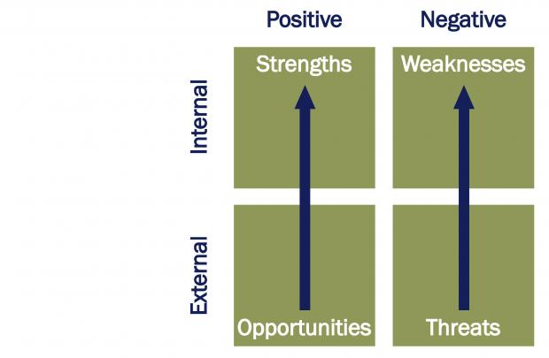
Source :(Baguley, 2008)
The projects of Tesco are often quite elaborate and require significant amount of resources and labor for execution. In such cases, there is very little room for error. So, by using the SWOT analysis tool, Tesco is allowed to forecast the accomplishment dynamics of the projects. These dynamics are then addressed with other strategies which increases the chances of the project’s success. Though the strengths and weaknesses of Tesco can be easily identified, it is difficult to accurately identify the opportunities and threats. This provides a certain degree of uncertainty which might induce arbitrary outcomes.
PEST analysis:
PEST analysis is the tool which analyzes the macro environment or the external environmental factors. These include political factors, social factors, economic factors and technological factors. The analysis helps to address the direct and indirect affects the factors have on the projects of Tesco. This adds depth to the projects as more variables come into play and the risks and opportunities associated with it can be speculated with more authenticity and justification. But these dynamics are not with in the control of Tesco. But its pattern can be predicted through past trends and present data. When the capabilities of Tesco are analyzed against these factors, then their position in the market is determined.
RACI diagram:
Tesco uses the RACI Diagram to outline the roles and functions of each individuals against the outcomes that are predefined. The tasks and individuals are categorized in four main categories these are:
- Responsible: the individual who is responsible for undertaking the action sin a particular project of Tesco.
- Accountable: the individuals who are supposed to be accountable for the actions to be performed. In other words those who will be held accountable for failure of success of the task. So that individual will have to play a managerial role to accomplish the tasks as intended.
- Consulted: in projects, many professional and expert individuals are required. They provide opinion and insight on how to cope with the dynamics (Blackstone, 2009).
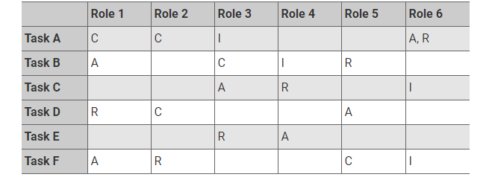
Source: (Blackstone, 2009)
By outlining the roles associated with each task, employees are given a preliminary outline about what to do. This keeps employees focused during executing individual functions while carrying out a project. Sometimes these responsibilities might be quite blurred for newer employees to understand. As a result the project function associated with them might not be executed properly. In such cases the management has to get involved in person to solve the problems faced by the employees.
Stake holder matrix:
Tesco also uses stake holder matrix to identify the most influential stakeholders associated with the projects and by speculating their interest and decision making ability. Tesco prioritizes the needs of the most influential and powerful stake holders while keeping the less powerful ones informed.
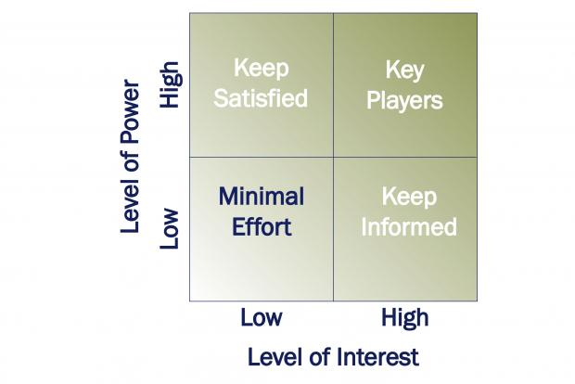
Source: (Bruce and Langdon, 2009)
From this the stakeholders can make informed choices and contribute to the project. The stakeholders are the groups of people are directly or indirectly affected by the project outcomes.
When the stake holders are analyzed and their influencing power are determined, more focused approach can be taken to address the project goals. The stake holders with most influence should be satisfied with performance ad outcomes and the ones with the lowest concern and influence should only be informed. This tool is appropriate for managing Tesco’s projects as it helps to identify the important stake holders and work towards their satisfaction rather than producing a mediocre outcome. This enables the outcomes to be quite effective in terms of satisfying the needs of the organization (Bruce & Langdon, 2009).
Fishbone diagram or cause and effect diagram:
Tesco uses the cause and effect diagram to identify the causes of actions and their impact on projects. The impacts are represented graphically within a starting point and an end point. The A point being the beginning of the project and the B point being the final outcome of the project.
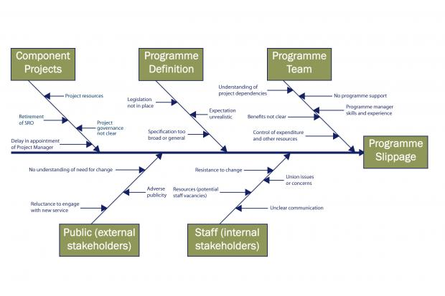
Source: (Carayannis, Kwak and Anbari, 2005)
The fishbone diagram helps to identify the causes of actions associated with the Project in Tesco and their results. This provides a more clarified path towards selecting the most effective actions in terms of producing value. But assessing the cause and effect of each action is quite difficult and takes up a lot of time to complete accurately (Carayannis et al., 2005).
Decision tree:
Lastly Tesco uses decision tree for enabling project managers to choose from different outcomes. It helps to produce a comprehensive picture of the risks and rewards associated with decisions in the project. It also helps to choose between different strategies and opportunities.
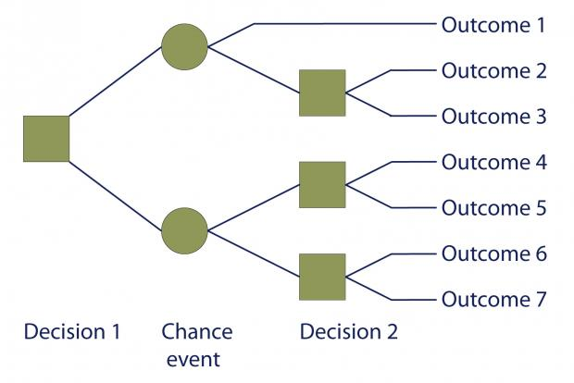
Source: (Chapman & Ward, 2003)
The outcome oriented decision making helps to speculate the domain within which the decisions are to be taken. These limits the playing field and the makes the execution much more efficient. On the other hand, as the outcomes are affected by several dynamics, it is quite difficult to assess the outcomes of certain decisions accurately, which might prove to be quite difficult to cope with if the deviations in predictions and reality show polar characteristics.
The decision tree can be used effectively if the speculated outcomes are accurate and can be researched rigorously to find the most authentic and realistic information. Otherwise the, chances of different anomalies with potential to affect project outcomes negatively is present (Chapman & Ward, 2003).
The following chart can be considered for analyzing if Tesco’s project management operations are effective.
Factors | Adherence
Commercially successful | Yes
Budget oriented | Yes
Meets intended outcome | Yes
Serves intended purpose | Yes
Time oriented | Yes
Accepted by clients | Yes
Safety standards maintained | No
Happiness of teams ensured | No
Quality ensured | yes

Here it is seen that all the criteria except safety standards and happiness of the individuals involved in projects are met. To ensure these, Tesco should employ trouble shooting and effective communication tools into their projects. By trouble shooting the flaws can be easily identified and actions can be taken accordingly to minimize the risk to individuals and property. And by introducing proper communication methods the employees will be allowed to get rid of their grievances and be happier in their work. Grievance counselling and addressing the problems faced by the employees can drastically increase the productivity and is definitely beneficial for the long run (Davies & Hobday, 2005).

AC 2 Planning the implementation of a project within Tesco:
In this section a project will be planned in reference to the operations of Tesco. Prince 2 will be used to plan the project and will be followed by presentation of the project to relevant individuals. Prince 2 approach will be used for planning the implementation process. The prince2 approach is originally from UK and it has experienced massive success in different organizations. It stands for Projects in controlled Environment. The defining characteristics of this approach is that the outputs of every project are clarified beforehand and the rest of the actions associated with the project are formulated around the outcome. It focuses on budgeted outcomes which are acquired within allocated time. Moreover, each and every member has defined roles before the project starts.
The planning process will be done on a Project of Tesco. The name project is “Establishing a new store in Putney district of London”. This project will be planned in the following segment.
To establish a new store, first the real estate has to be designed. Then the land has to be identified for building the outlet. Suppliers should be contacted for establishing delivery schedules. Employees should be recruited and most importantly marketing strategies should be undertaken for attracting customers from the local community. The details are discussed in the following segment.
Planning:
The new outlet has to be around 30,000 square feet which can accommodate 500 isles for displaying Tesco’s products as well room for parking 200 cars at a time. In order to build such a large structure a land is required with open spaces, preferably beside a parking lot. The blue print has to be designed and raw materials for the building should be sourced from reliable vendors. When the building process is complete the necessary utilities like electric lines, plumbing facilities, ventilation shafts, air conditioners, fire safety systems and heaters are to be installed. After that the electronic components such as the refrigeration units, the lights and the scanners are to be installed. The central checking system should be installed as well. The opening date for the store is set at 1st January of 2021. The suppliers should be reached and negotiated for supplying the intended products. Meanwhile the facilities of the new shop should be advertised to the local community which will intrigue potential customers. Finally the outlet should be launched and the transactions should start.
Project appraisal techniques:
The project will be appraised by a dedicated team who will be responsible to monitor the progress and make midterm assessment during the project and making any changes necessary. As the project is to establish a new outlet, all the steps included in the project planning process will be considered as criteria for performance when coupled with a definite time period. For example, the building process should be done with in 1 year. The rest of the process should also be done with in specific period of time within the completion target date. The performance of individuals will be assessed against the individuals roles assigned to them prior to the project by the project managers. The store should be ready for business, 1 week prior to the target date (Davila et al., 2007).
Risk analysis:
The local community of Putney, is already content with the local vendors for their daily purchases. Tesco’s services might not be appealing to these customers if they are not able to delivery something extraordinary and unique. In other words the local vendors have the upper hand in regards to customer loyalty than Tesco. This risk can be minimized by providing customers with lucrative alternatives at decent prices. The small time vendors can also be acquired in order to capture their existing customer base. This ill potentially create a win-win situation. Moreover, the local vendors might also protests the establishment as it might potentially decrease the area for the community park. This effect can be minimized by freeing up space from the park or even introducing a play are within the outlet. In addition, the needs of the customers of Putney is not extravagant, the products offered in the store of Tesco might not sell as there is no significant demand, subjecting the outlet to losses. So Tesco should focus on the value brands and sell products that are within the purchasing power of the local community. The weather conditions might also produce anomalies in case of the building process. Proper weather forecast should be done and protective measures like weather sealed paint, water resistant cement etc. might be adopted. The local workforce should be trained properly before employing which is a challenge. They should be trained by experience professionals. Hands on training should be given while on the job. If they are not able to meet standards with in an allocated time then other means of sourcing employees should be availed.
Stake holder analysis:
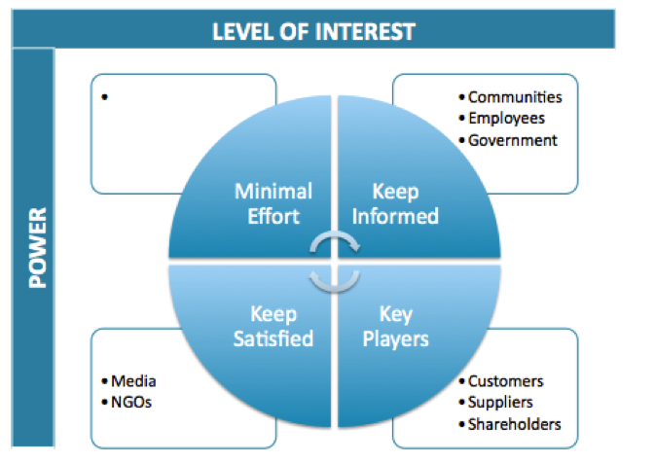
Source: (Frame, 2003)
The stake holders are categorized on the basis of their level of interest and the level of power they hold to influence decision making. Now, the stake holders which have highest interest and highest power are customers, shareholders and board of directors. The customers want quality service and fulfillment of their needs, the board of directors want increased sales and revenue generation and the shareholders want increased profit form their shares. All these groups should be kept satisfied through the project. The project of establishing new outlet will generate more revenue for Tesco, at a certain point if business is good they will reach cash flow positive status which will satisfy both the board of directors and shareholders. And when the customers will get all the products they need at their convenience then their needs will also be satisfied.
The second category of stake holders are the ones which have low interest and low power to influence. These are civil society and different community pressure groups. Minimal effort should be given to their maintenance (Frame, 2003).
Thirdly, there are individuals who have high power of influence but low interest. These include different media and NGOs. They are to be kept satisfied by maintaining a friendly relationship and refraining from breaking any law, social norm or harming the environment.
Lastly, the groups with high interest and low power are to be dealt with information so that they do not pose any threat. These involve the employees, community groups etc.
Communication needs:
There has to be a proper channel of communication between all the individuals involved in the execution of the project. The project manager has to be in touch with the construction contractor and all the suppliers through emails and cell phones. They should also establish contact on site regularly for inspection. The manager should also be aware of the employees and should be connected to them via pagers and online media. Moreover, the board of directors should receive regular updates from the project managers and all the relevant details should be published online for the shareholders and customers. Customer feedback should also be taken in terms of developing the design and incorporating new features to the outlet. It should also concern introducing new products and facilities based on the customer feedback.
Project stake holders:
The main stake holders are contractors, board of directors, suppliers and the staff working for the project. Moreover, as it is being built for potential customers, they are also the stake holders whose opinions will affect the future of the outlet. If the board of directors are not happy with the decision of establishing the outlet, then they will be reluctant to allocate funds. If the contractors are not capable of making the outlet building as required then the final outcome might be severely hampered. The suppliers also influence the project by ensuring that quality raw materials are provided for construction. Finally if the customers are not intrigued by the project the whole purpose would be nullified (HEALEY, 2017).
Project plan:
The project plan can be demonstrated by the following Gantt chart.
Activities | 5th month | 10th  month | 15th month | 20th month | 25th month | 30th month | 35th month | 40th month | 45th month
Making blue prints and negotiating with contractors for building the outlet.
Constructing the building
Installing electric, water and other components
Purchasing different components for running operations
Monitoring the project
Contacting suppliers and sourcing products
Advertising the new outlet and its services
Opening the outlet

AC 3 Critically evaluating the ability of the learner to manage projects.
Managing projects requires significant experience and skills to be conducted flawlessly. The learner has demonstrated the process of managing a project. There are many aspects which were commendable and may aspects which needed more work to be completely flawless. In the following segment these aspects are discussed in detail with the focus of establishing a balance between the learner’s knowledge and shortcomings.
The learner demonstrated his ability to plan a project from inception to completion. But the planning process lacked detailed approach. The plan was made to be an overall plan which give an overview of the whole project. If the plan was more detailed and all the minute aspects of the project were addressed then the planning would have been quite exhaustive and could have helped in focusing different work functions easier. The learner also didn’t back up his estimates and speculations with any solid evidence. If the evidence was provided, then the planning would have acquired a greater degree of legitimacy and similar procedures could have been adopted to maximize chances of success. Without including such evidence the process has become subjected to a wide range of choices which have not been proved to be effective for this particular project. The planning process also missed some essential parts like the vendors of electronics and third party hedge funds which could be used to minimize the risk of increasing prices of raw materials. On the positive side, the learner showed significant focus and gradual advancement of processes in the planning phase. This shows that the learner is aware of the basics of what needs to be done. With a bit of work, the learner would most definitely be able to channel his knowledge to produce more effective plans (Heerkens, 2015).
In the project appraisal techniques, the learner failed to mention the key measures for appraising the project other than task time and task goal. The appraisal could have been more effective if KPI’s were included and the credentials of the appraising tem was given. Moreover, in this section, the appraisal for only the construction phase was mentioned. Other phases like communicating with suppliers, advertising etc. should also be included.
Risk analysis was done exhaustively. The learner was able to identify several real world risks associated with the project. This risks were not just identified, rather their probable solutions were also provided. All the aspects including, customer orientation, local competition, pressure groups etc. were included in the risk analysis. But the solutions are quite linear. More complex and effective solutions could have been provided which could not be subjected to any loopholes.
The stake holder analysis was done with significant amount of finesse. All the aspects of relevant stake holders were covered. All the relevant stake holders were mentioned. The strategies which is required to handle those stake holders were also included in the analysis. The only shortcoming is, that the analysis could have been more exhaustive and detail and more attention could have been given to identifying more relevant stake holders.
The communication needs were addressed properly. But the incorporation of contemporary technologies were not observed in it.
Lastly, the implementation of the project plan were distinctly demonstrated through the Gantt chart. This provided an exhaustive picture about what is to be achieved with in a definite period of time. This shows that the end goal is quite clear for the learner and he is able to visualize the chronology and consequence of each step (Pinto & Morris, 2010).
From the aforementioned criticism, it is evident that the learner’s project management skills are good but not perfect. To address these shortcomings, some measures should be taken. The first measure is to develop a self-improvement plan for the learner. This is provided as follows:
Objectives | Activity | means | Target fate of achievement.
Understanding the details of a project | Observe different projects and read about different project formats | Time | 20th January,2019
Be able to appraise projects successfully | Acquire project reports and make appraisals, then compare it with actual appraisal reports. | Time, money and clearance for acquiring documents. | 10th may , 2019
Understanding contemporary means of communication and their application | Reading books and applying the techniques as test projects at own workplace | Time and authority | 10th June, 2019

The objectives of the self-improvement plan is quite specific and. They are also measurable and realistic. More importantly they are time bound and achievable. These characteristics make SMART objectives which are more likely to induce sustainable and effective outcomes for the learner. Moreover, this objectives are most definitely equipped to address the shortcomings of the learner in the project planning and implementation.
If these aspects are developed then the learner will be able to produce significant value in producing project plans for implementation. Moreover, the implementation phase will be able to focus only on the execution as the planning is exhaustive enough to cut out the work for every functional unit for particular projects (Sandred, 2001).

Conclusion:
Project management is a crucial skill for all individuals as all organizations are undertaking individual projects and it is of the utmost importance that the projects reap significant outcomes which are able to create value for the organization. This report has addressed different aspects of project management. It has assessed different tools and techniques used in managing projects. It also has enabled the learner to create a project plan for implementation and finally it reflected on the abilities of the learner in terms of successfully conducting the planning process for implementation. Lastly, the report also included a self-improvement plan for the learner which can be utilized to mitigate shortcomings in the planning phase. From all this information it can be inferred that, project management is not a linear skill, rather it is a multifarious skill which is the amalgamation of knowledge, technique and executive capabilities. Having these aspects does not only help to advance in the professional life but also helps to enrich personal and social life (Shackelford, 2005).

References
A guide to the project management body of knowledge. (2017). Newtown Square, Pennsylvania, USA: Project Management Institute.
Agile Project Management. (2013). [Place of publication not identified]: J. Wiley & Sons.
Baguley, P. (2008). Project management. London: Hodder Education.
Blackstone, W. (2009). Commentaries on the laws of England. Clark, NJ: The Lawbook Exchange.
Bruce, A. and Langdon, K. (2009). Project management. London: Dorling Kindersley.
Carayannis, E., Kwak, Y. and Anbari, F. (2005). The story of managing projects. Westport, Conn.: Praeger Publishers.
Chapman, C. and Ward, S. (2003). Managing Project Risk and Uncertainty. Chichester: John Wiley & Sons.
Davies, A. and Hobday, M. (2005). The business of projects. Cambridge: Cambridge University Press.
Davila, T., Epstein, M. and Shelton, R. (2007). The creative enterprise. Westport, CT.: Praeger.
Frame, J. (2003). Managing projects in organizations. San Francisco, CA: Jossey-Bass.
HEALEY, P. (2017). PROJECT MANAGEMENT. [S.l.]: ROUTLEDGE.
Heerkens, G. (2015). Project management. [Place of publication not identified]: Mcgraw-Hill Education.
Pinto, J. and Morris, P. (2010). The Wiley guide to managing projects. Hoboken, N.J: John Wiley & Sons.
Sandred, J. (2001). Open source business. New York: Wiley.
Shackelford, B. (2005). Project managing e-learning. Alexandria: ASTD.

