Agonistic and Antagonistic Drug Effects

Agonistic is defined as:

Antagonistic is defined as:

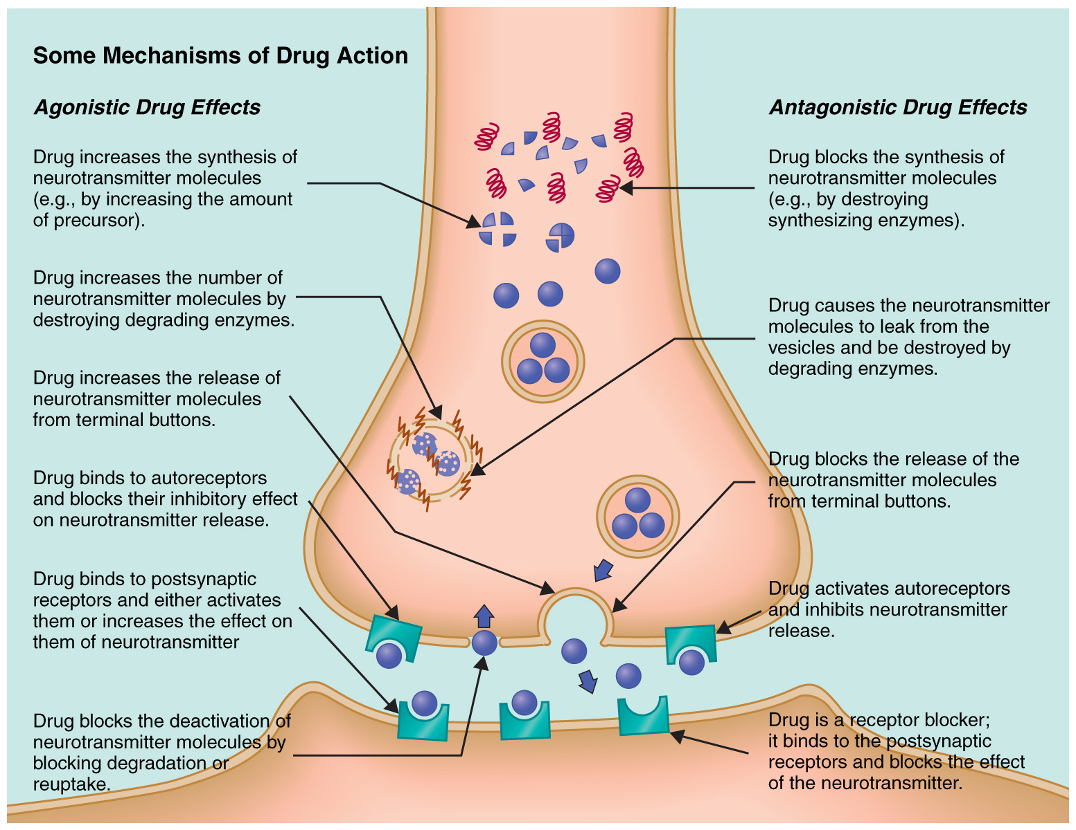

2.
3.
4.
5.
6.

