Ballistics Report
ACDB 4007
David Tolhurst
2222916

Contents
Introduction: 1
Model setup: 1
Material properties 2
Results: 3
Discussion: 7
Conclusion: 7

Introduction:
This report is an overview of the process of generating stress/strain data from ABAQUS. In this example the data was extracted from an impact simulation. This report will discuss the properties of the materials involved in the impact and how the materials reacted. Also, the difference between stress on strain and strain rate values between the different materials used throughout the simulations and some of the steps taken to create the models used in the process. The simulations that will be discussed in this report involve a steel and tungsten bullet impacting an aluminium plate at 1200 m/s. The results gathered from these simulations show the deformation and eventual failure of the models. These results will be supported by visual screenshots taken in the lab from ABAQUS software.

Model setup:
Premade models were provided for this experiment. As mentioned above the models were a steel projectile (Bullet) and an aluminium plate. To create comparable data the material values of the steel projectile were changed to tungsten and the simulation was repeated identically. The steel bullet and aluminium plate were created using the following dimensions.
Figure 1 - Bullet (Revolved 360° around centre axis)
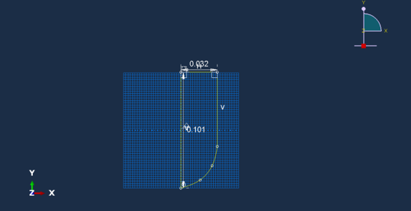
Figure 2 - Plate (Extruded to thickness 26.3mm)
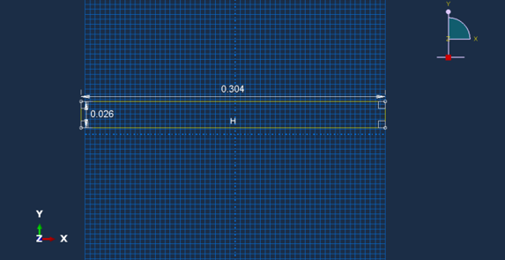

After the models had been sketched, extruded and positioned correctly mesh values had to be assigned so that the simulation would run smoothly and display accurate deformation and strain data. This was done seeding the edges of the projectile that would meet the plate on impact. Maximum and Minimum distances could then be specified.
Material properties [1]:
The materials used in this experiment were steel, aluminium and tungsten. Research was carried out to gain appropriate values to recreate these materials within ABAQUS. The main aim of the research was to find values such as Johnson cook damage values, Mass density, Young’s modulus & Poisson’s ratio and Plasticity values. The values for steel and aluminium were provided by the university. The tungsten values found are as follows. [2]
Johnson cook damage values | 2 | 1.77 | 3.4 | 0 | 0 | 1723 | 300 | 1

Mass Density | 17600

Young’s modulus | 314000000000

Poisson’s ratio | 0.29

Plasticity values | 1506000000 | 177000000 | 0.12 | 1 | 1723 | 300

Simulation setup:
To complete the simulation and get it ready for testing. The pre-set velocities had to be changed to replicate a bullet leaving a firearms barrel upon firing.
Velocity (m/s) | V1 – 0 | V2 - 1200

The above values were applied to the simulation and the only step left was to create a job, this would allow the impact to be saved and repeated as many times as needed to gain adequate results. These results could then be accessed easily. A job was created by opening the job module and selecting job manager and create job. This submits a job into the software and using the earlier entered values to start rendering results. The amount of step increments was increased to allow for finer adjusting of the moments of impact. Now the simulation can be tested to make sure it is running smoothly and the ABAQUS software has computed all the entered data correctly. Some problems were encountered during the testing process, but these were easily rectified by looking at the error code that had a corresponding time and step number. Changes were made to the values resulting in a successful simulation. The results presented were accessed in different stress views. The view used in this report is Max principle.

Results:
Steel bullet impact on aluminium plate
The first screenshot of the simulation (figure 3) shows initial impact of the steel bullet on the aluminium plate. Immediately multiple stress waves can be seen traveling just ahead of the projectile. These waves start to dissipate towards the edge of the material and the back side of the plate starts to deform due to the strain caused by impact. A yellow spot of high stress +3.106e+ 08 can be seen building up on the back of the plate.
Figure 3 – Steel bullet initial impact
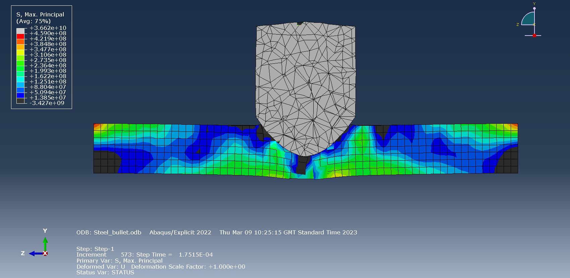
The next screenshot of the simulation (figure 4) shows how the back of the aluminium plate has suffered from major deformation due to the increasing levels of tension across the surface. The failure within the material is indicated by the change in colour at back of the plate which has changed to a blue colour representing stress of +1.385e+ 07.
Figure 4 – Steel bullet midpoint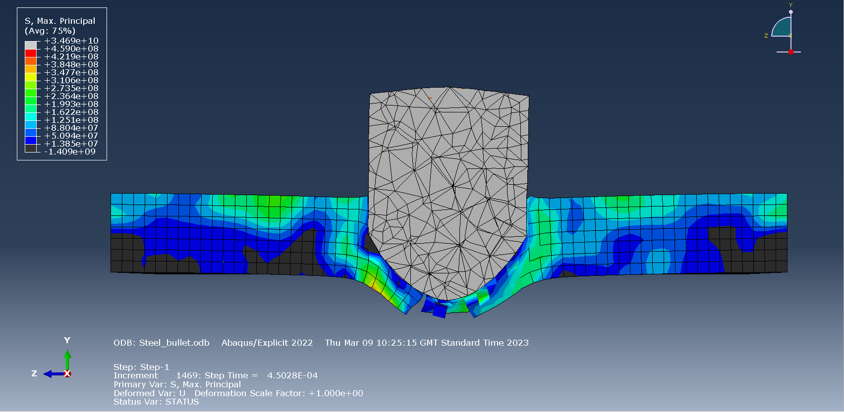
A final screenshot of the simulation (figure 5) shows how the projectile has suffered huge levels of stress. Also the stress waves caused by initial impact seen in figure 3 can be observed to have totally dissipated. Fragmentation can be seen caused by the energy transfer on the back side of the plate where the majority of the deformation occurred.
Figure 5 – Steel projectile comes to a stop
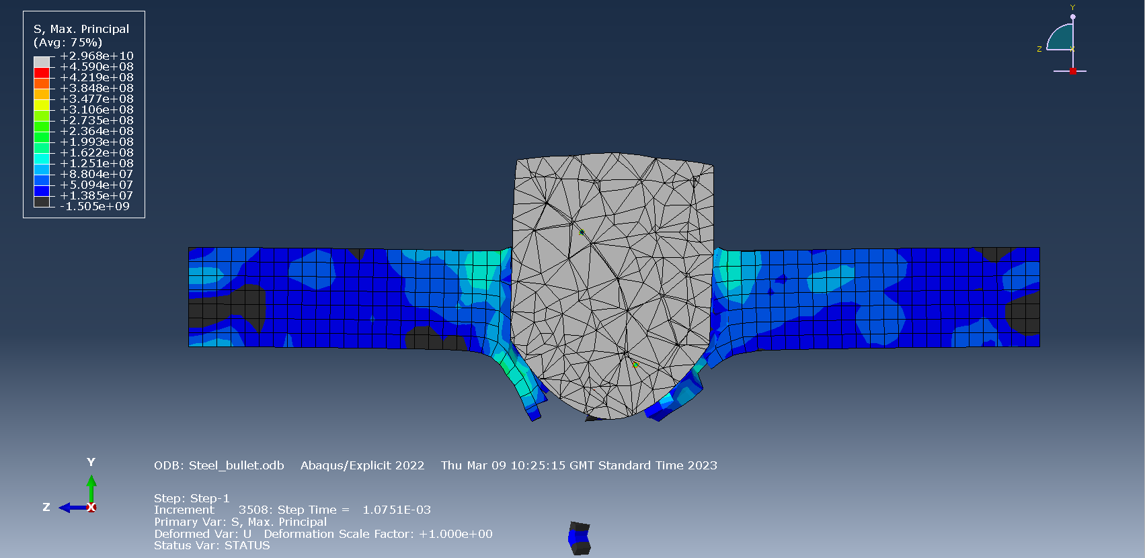

Tungsten bullet impact on aluminium plate
The first screenshot of the second simulation shows a more uniform stress wave that travels into the plate from the tip of the bullet. Unlike the first simulation immediate deformation can be seen as the much denser tungsten bullet easily penetrates the softer aluminium. It can be observed that the stress levels are much higher in this simulation. This is indicated by the red colour which represents levels of approximately 7.000e+ 04.
Figure 6 – Tungsten bullet initial impact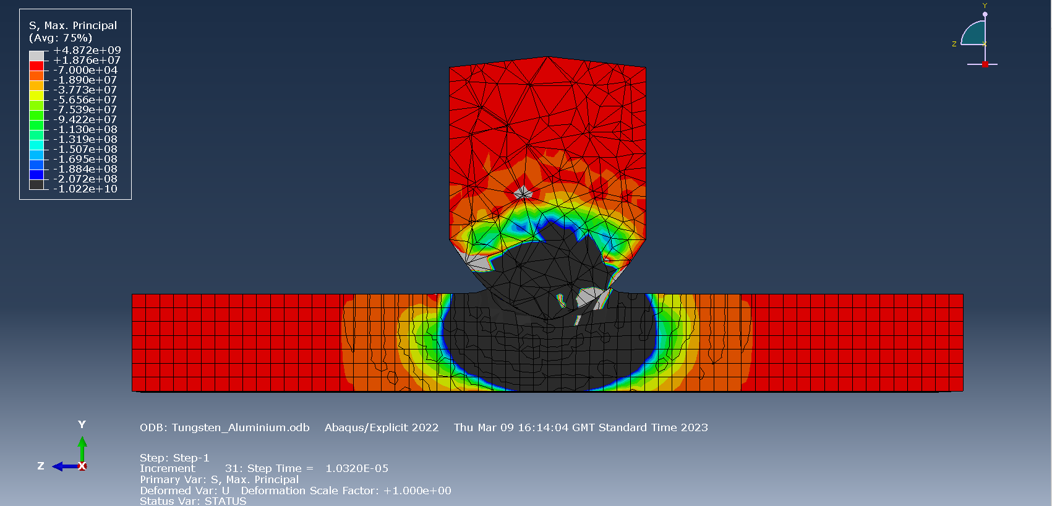

In the second screenshot of this simulation (figure 7) the projectile can be seen withstanding a high level of stress , around 7.182e+ 08 – 9.208e+ 08. However the plate can be seen to have had a catastophic failure and cannot with stand the impact at all, this was to be expected as tungsten is at least 3x stronger than steel. This failure within the material is shown surrounding the dark areas of the screenshot.
Figure 7 – Tungsten bullet midpoint
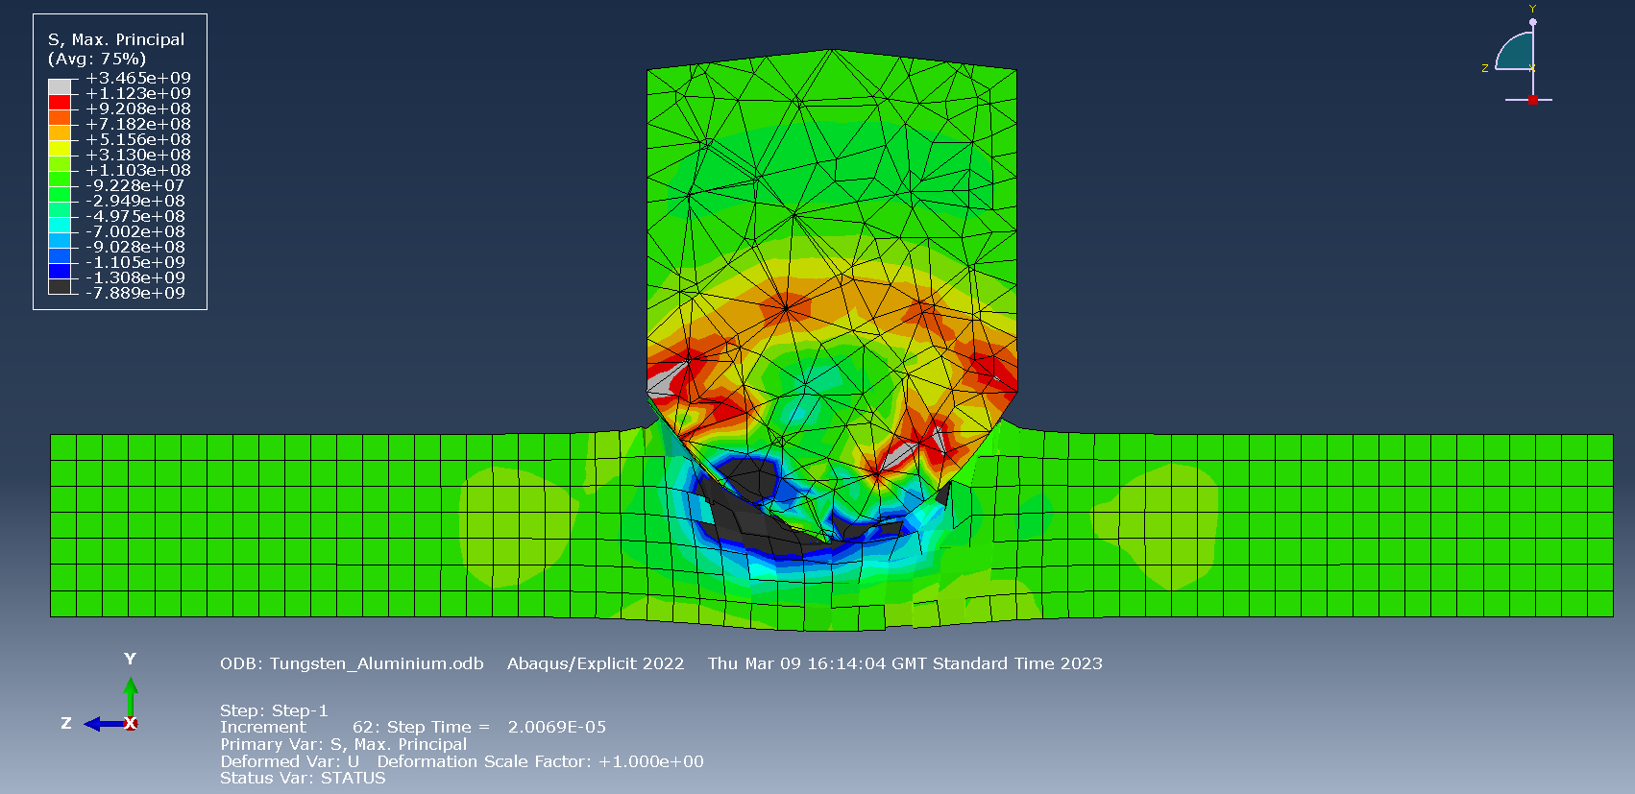

In the final screenshot of the second simulation (figure 8) the projectile can be seen to have totally penetrated the aluminium plate. The stress waves along side the bullet can be seen dissipating out towards the edges of the plate, these waves appear to be at a low stress value of approximately 2.628e+ 07. This could be a result of the loss of integral strength of the plate after suffering such extensive deformation. Also, much more fragmentation was observed in this simulation compared to the last.
Figure 8 – Tungsten bullet total penetration
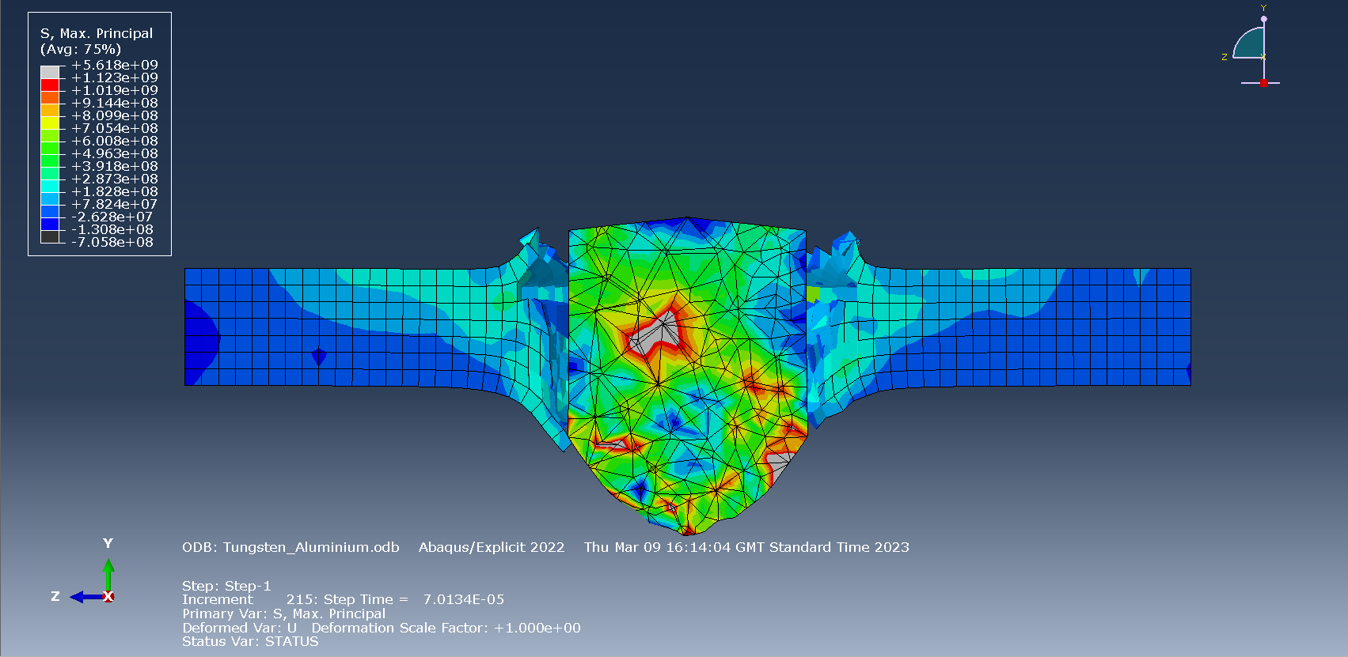
Figure 9 – Velocity graph steel bullet
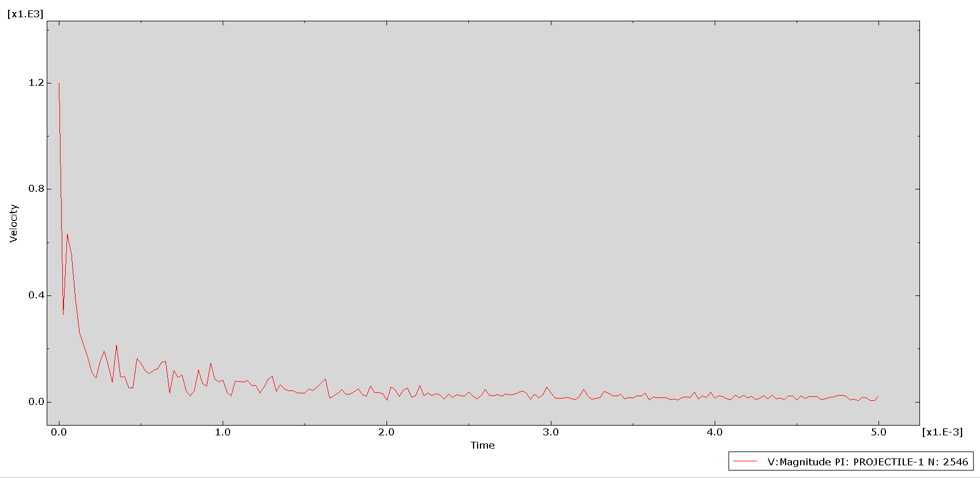
Figure 10 – Velocity graph tungsten bullet
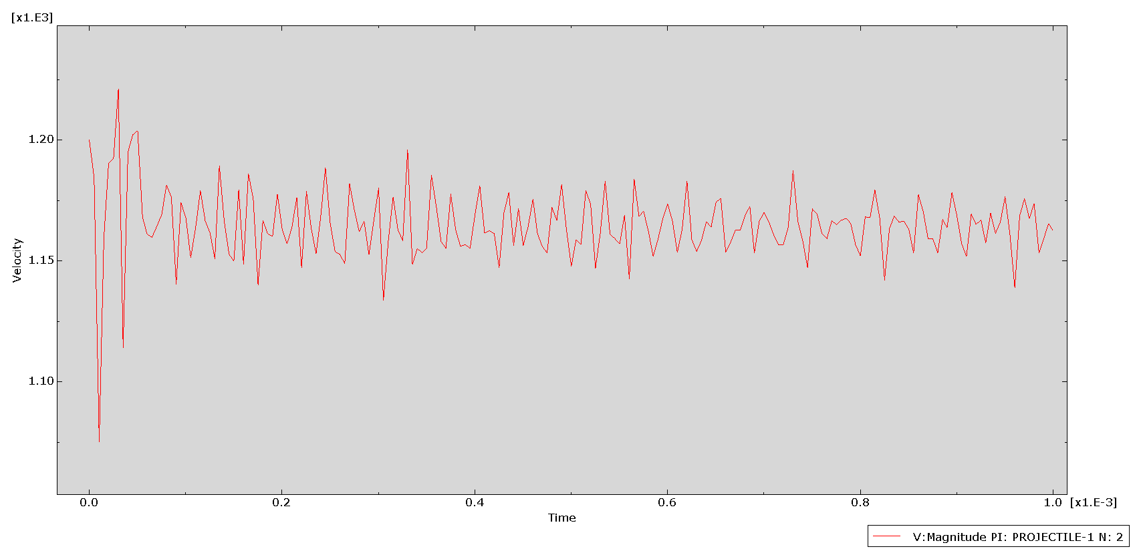
The two graphs shown above (figures 9 & 10) describe the differences between the velocities in the simulations. It can be observed that the steel bullet lost almost all its velocity upon impact as it met substantial resistance form the aluminium plate. On the other hand, the tungsten bullet’s velocity can be observed to be fluctuating between 1100-1200 m/s. This inconsistency may be a result of user error on ABAQUS software, but it still represents well how little resistance was encountered when the tungsten bullet hit the soft aluminium plate.

Discussion:
From the results gathered it can be stated that some variables within the experiment such as the data used to make up the material properties may have caused issues throughout the simulation process. These issues led to some inconsistencies in results but overall, the experiment was still conclusive and yielded a variety of results. During the testing phase multiple jobs were aborted, this could have been due to the meshing being constructed to a very small tolerance. This could have caused the software to encounter errors in computing stresses throughout the simulation. As mentioned before some of the problems may have been caused by the Johnson cook damage values, Young’s modulus & Poisson’s ratio and plasticity values entered by the user.

Conclusion:
In conclusion this experiment yielded useful results but limited observations. It was observed that the stress waves encountered with the tungsten bullet were more uniform and easily identifiable. This could have been because of the difference in the material density. It was also observed that the areas of stress/strain were more concentrated in the tungsten simulation compared to the steel bullet which appeared to have more gradual areas of stress that quickly dissipated to the edge of the aluminium plate. If the experiment was to be repeated it may be worthwhile making changes to the models and their properties, this could lead to gaining more beneficial and accurate data. User error also played a big part in the limit of observations but substantial knowledge surrounding CAD and FEA software was gained. Overall, the experiment was a success and a great learning experience for the user as a better understanding of ballistics and modelling was developed.

References:

[1] | S. Feli, “Finite element simulation of ceramic/composite armor under ballistic impact,” Scienece direct , June 2011. [Online]. Available: https://www.sciencedirect.com/science/article/abs/pii/S1359836811000527. [Accessed 16 March 2023].
[2] | F.-L. Zhu, “Numerical simulation study on penetration performance of depleted Uranium (DU) alloy fragments,” Science direct , Feburary 2021. [Online]. Available: https://www.sciencedirect.com/science/article/pii/S221491471931089X. [Accessed 16 March 2023].

Table of figures:
Figure – 1 Bullet (Revolved 360° around centre axis)
Figure – 2 Plate (Extruded to thickness 26.3mm)
Figure – 3 Steel bullet initial impact
Figure – 4 Steel bullet midpoint
Figure - 5 Steel projectile comes to a stop
Figure – 6 Tungsten bullet initial impact
Figure – 7 Tungsten bullet midpoint
Figure – 8 Tungsten bullet total penetration
Figure – 9 Velocity graph steel bullet
Figure – 10 Velocity graph tungsten bullet

