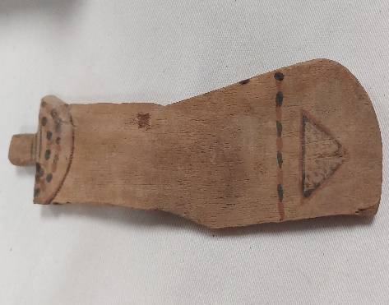
University of Wales Trinity St David in association with York Museum present
“EGYPTIAN PADDLE DOLL: FROM PAST TO PRESENT”
FREE WORKSHOPS FOR CHILDREN 5-11 YEARS
(Using paper images of the doll the children will be colouring their own versions and if want to can write short stories centred around their first impressions of the object – a little bit of history will be explained as well!!)
Workshop A – 10am to 12pm on 10.07.23
Workshop B – 1pm to 3pm on 12.07.23
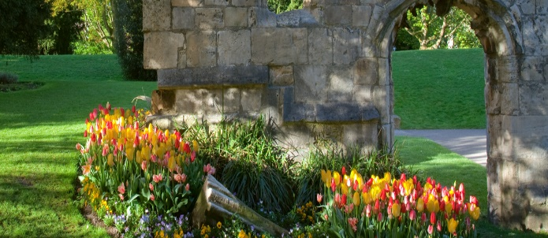
Also, why not enjoy a few hours in the museum or take a walk in the beautiful gardens at York!?

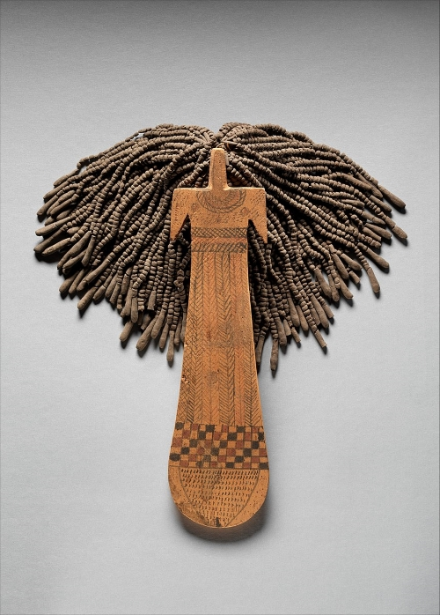
For further details please contact:-
28001865@student.uwtsd.ac.uk / exhibitions@ymt.org.uk (01904 687687)
www.yorkmuseumstrust.org.uk / info@visityork.org / linktr.ee/VisitYork / #yorkcastlemuseum

Friday 14 July – Friday 21 July
“The Paddle Doll Exhibition”
Showcasing this unique object from Ancient Egypt, along with the children’s artwork and imaginative narrations, helping to bring the past back to life for a modern audience

